PGA-UNet: A Lightweight Prompt-Guided Attention U-Net
for Interactive Bone X-Ray Lesion Segmentation
IEEE ACCESS — EDITORIAL REDLINE REVISION
Purpose: this file revises the manuscript to make the claims more defensible and the presentation closer to IEEE Access expectations. Red text identifies revised/added material. Red bracketed AUTHOR ACTION items require new experiments, author information, or verification; they must be resolved and removed before submission.
Important: no experimental values have been invented. Where the current manuscript does not contain evidence needed for a stronger claim, the claim is narrowed or an explicit pre-submission experiment is requested.
Priority | Required before submission | Concrete change
1 | Add fair prompt-matched conventional baselines | Box-channel U-Net/Attention U-Net and crop-then-segment baseline using the same box input.
2 | Strengthen prompt robustness evaluation | Include larger boxes, partial lesion coverage, stronger shifts, and negative/background boxes; do not claim clinical robustness from GT-derived boxes alone.
3 | Make statistical comparison paired | Run PGA-UNet and main prompt baselines on the same repeated splits/seeds and report 95% CI or paired bootstrap; repeat key ablations.
4 | Strengthen related work and baselines | Position against MedSAM, ScribblePrompt, Med-SA/efficient SAM variants; ideally add at least one additional prompt-based experimental baseline.
5 | Fix validity/presentation issues | Resolve affiliation/biography placeholders, metric inconsistency, “50 lesions” vs “50 images”, IEEE template year/DOI placeholders, and patient-level split limitation.

Manuscript revised [AUTHOR TO UPDATE DATE].
PGA-UNet: A Lightweight Prompt-Guided Attention U-Net for Interactive Bone X-Ray Lesion Segmentation
THONG LUC¹, HUU-BINH NGUYEN¹, LY QUOC NGOC²
¹ B.Sc. Program in Computer Science, Faculty of Information Technology, University of Science, VNU-HCM, Vietnam
² [AUTHOR ACTION: replace with the verified affiliation of Ly Quoc Ngoc before submission.]
Corresponding author: Thong Luc (e-mail: 22120196@student.hcmus.edu.vn).
ABSTRACT
Bone X-ray lesion segmentation is challenging when abnormalities are small, low-contrast, or visually entangled with surrounding anatomy. In such cases, localization can be a dominant source of error before boundary refinement begins. We propose PGA-UNet, a lightweight prompt-guided convolutional network for interactive segmentation in which a user-provided bounding box is converted into a Gaussian-smoothed plateau heatmap, injected into encoder features through a Prompt Spatial Gate (PSG), and reused in the decoder through a Conditional Attention Decoder (CAD). The design treats the prompt as a dense spatial prior that remains active across the encoder-decoder pathway. We evaluate PGA-UNet on BTXRD and FracAtlas using controlled simulated covering and off-center box prompts. At 256×256 resolution, PGA-UNet achieves higher Dice than fine-tuned SAM-Med2D under both prompt conditions on both datasets; the advantage is largest on the 50 test images with the smallest total lesion area. At 512×512, PGA-UNet reaches Dice scores of 0.8788 on BTXRD and 0.8286 on FracAtlas under covering prompts. The full PSG+CAD+Gaussian configuration is the best-performing ablation setting on both datasets, and the 2.95M-parameter model is substantially smaller and faster than SAM-Med2D in the tested environment. These findings support the effectiveness of sustained prompt conditioning for small radiographic lesions under the controlled prompt protocol used here. Because the prompts are generated from ground-truth annotations rather than drawn by radiologists, clinical prompt robustness and workflow effectiveness remain to be established in future user-based evaluation.
INDEX TERMS — bone X-ray, interactive segmentation, medical image segmentation, prompt-guided learning, small-lesion segmentation, lightweight neural networks.
I. INTRODUCTION
Bone X-ray imaging is widely used for diagnostic support and follow-up because of its speed, low cost, and broad availability. Lesion segmentation remains difficult when the target occupies only a small fraction of the radiograph, exhibits weak contrast, or overlaps with complex anatomy. In these settings, a segmentation model must first identify the relevant region and then delineate its boundary; errors in localization can therefore dominate the final overlap score.
One way to reduce this search burden is interactive segmentation, in which a user provides coarse spatial guidance such as a click, scribble, or bounding box. The purpose of the prompt is not to replace segmentation but to transfer part of the localization burden from the model to the user. Recent promptable foundation models, including SAM, SAM-Med2D, and MedSAM, have made this interaction paradigm increasingly practical, but their size and general-purpose design may be unnecessary for a task-specific radiographic workflow [1], [2], [9].
This work asks a narrower architectural question: once a coarse box has already indicated the suspicious region, should the prompt be used only as an input cue for mask generation, or can sustained prompt conditioning help preserve weak lesion evidence through downsampling and decoding? We address this question with PGA-UNet, a lightweight prompt-guided CNN that represents the box as a Gaussian-smoothed plateau map, modulates encoder features with PSG, and conditions decoder attention with CAD.
The comparison with prompt-free Attention U-Net is used only to illustrate the difficulty of full-image automatic localization and is not a like-for-like architectural comparison. The principal prompt-matched comparison in the current manuscript is fine-tuned SAM-Med2D, which receives the same box type and is evaluated at the same 256×256 resolution. Accordingly, the paper does not claim that PGA-UNet is intrinsically superior to Attention U-Net when both models receive equivalent spatial information.
The contributions are summarized as follows:
• We propose PGA-UNet, a 2.95M-parameter prompt-guided CNN that keeps a box-derived spatial prior active across both encoder and decoder stages.
• We introduce a prompt-conditioning design combining a Gaussian-smoothed plateau representation, encoder-side PSG, and decoder-side CAD, and evaluate their interaction through component ablation.
• We evaluate the model on two bone-radiograph datasets under matched simulated box prompts, with dedicated small-lesion and efficiency analyses; the conclusions are explicitly limited to this controlled prompt setting.
II. RELATED WORK
Conventional biomedical segmentation methods such as U-Net and Attention U-Net established strong encoder-decoder baselines, while nnU-Net later demonstrated the importance of systematically adapting preprocessing, architecture, and training configuration to the dataset [3], [4], [10]. These methods are fully automatic and therefore must learn both localization and boundary delineation from the image alone.
Interactive segmentation reduces the localization burden by incorporating user input. Early systems used clicks, scribbles, geodesic cues, or related interaction signals [5], [6]. More recently, ScribblePrompt showed that a single interactive framework can support scribbles, clicks, and bounding boxes across diverse biomedical images, including X-rays [11]. Such work is particularly relevant to the present study because it emphasizes that prompt simulation and realistic user interaction are part of the method, not merely implementation details.
Promptable foundation models have further expanded this paradigm. SAM provides general-purpose promptable segmentation [1]; SAM-Med2D and MedSAM adapt promptable segmentation to medical images [2], [9]. Subsequent work has explored parameter-efficient adaptation and smaller medical SAM variants, including Med-SA and EMedSAM [12], [13]. These approaches provide useful reference points for accuracy, efficiency, and prompt handling, although their goals differ from a compact task-specific radiograph model.
PGA-UNet is positioned as a lightweight specialist rather than a universal foundation model. Its distinctive design choice is to convert the box into a dense spatial prior and reuse that prior at multiple encoder and decoder levels. The experimental question is therefore whether this sustained conditioning improves small-lesion segmentation under matched box guidance, not whether prompting in general is superior to fully automatic segmentation.
Work | Setting | Prompt usage | Strength | Limitation/positioning
U-Net / Attention U-Net [3], [4] | Automatic segmentation | No explicit user prompt | Strong conventional baseline | Must localize target automatically
nnU-Net [10] | Self-configuring automatic segmentation | No explicit user prompt | Strong task-adaptive framework | Not designed for interactive guidance
DeepIGeoS [6] | Interactive segmentation | Geodesic/user cues | Explicit interaction | Interaction design is task-dependent
ScribblePrompt [11] | General biomedical interactive segmentation | Scribbles/clicks/boxes | Multiple realistic prompt types | Broader framework than a task-specific bone X-ray model
SAM-Med2D / MedSAM [2], [9] | Medical promptable segmentation | Boxes/points | Broad medical applicability | High computational cost relative to PGA-UNet
Med-SA / EMedSAM [12], [13] | Efficient SAM adaptation | Prompt-conditioned SAM variants | Parameter/computation efficiency | Still foundation-model-derived
PGA-UNet | Task-specific lightweight interactive segmentation | Gaussian box prior + PSG + CAD | Sustained prompt conditioning; 2.95M params | Requires dense masks; current prompts are simulated

III. METHOD
A. Offline and Online Framework
The proposed system has two stages. In the offline stage, the model is trained on radiographs paired with lesion polygons. Each polygon is converted into a simulated training box and then into a Gaussian-smoothed plateau heatmap; the network learns to map the image-prompt pair to the binary lesion mask. In the online stage, a user supplies a coarse box around a suspected region, the same heatmap construction is applied, and the trained network predicts the lesion mask.
The methodological contribution is the way the spatial prior is propagated through the network rather than the offline/online split itself. The present experiments use annotation-derived simulated boxes to provide controlled prompt conditions; they should not be interpreted as a substitute for radiologist-drawn prompts.
B. Problem Setting
Given a grayscale radiograph I and a user-provided bounding box B, the goal is to predict a binary lesion mask. Let H(B) denote the prompt heatmap derived from B. PGA-UNet predicts the final mask by thresholding the output probability map at 0.5.
C. Prompt Representation
The input prompt is not encoded as a hard binary rectangle. The box interior is rasterized into a plateau map at the original image resolution and its boundary is softened using a fixed 31×31 Gaussian kernel before the image and prompt are resized and padded to the target square resolution. During training, a covering box expands each side of the tight lesion box by a random fraction in [0.15, 0.45]. An off-center box applies the same expansion and then adds a translation of up to 30% of the lesion width and height while preserving lesion coverage. Evaluation uses a fixed 30% expansion for the covering condition and the same bounded shift for the off-center condition.
Because both test prompt conditions are generated from the ground-truth lesion extent and are constrained to cover the lesion, they constitute controlled oracle-derived localization cues. Consequently, performance under these prompts measures segmentation after approximate localization has been supplied; it does not measure whether a clinician can identify the correct region or how the model behaves when a prompt partially misses the lesion.
D. Prompt Spatial Gate
At encoder level l, PSG modulates the feature map x_l using a prompt-derived attention map in residual form. The learnable PSG mixing coefficient is initialized to 0.1 and constrained to [0,1], preserving the original feature stream while allowing prompt-relevant spatial responses to be amplified.
E. Conditional Attention Decoder
CAD conditions decoder skip attention on prompt-encoded features at the corresponding scale. The prompt encoder uses two 3×3 convolutions with instance normalization and ReLU; a prompt-confidence scalar is generated by global average pooling, a 1×1 convolution, and a sigmoid. Decoder depth coefficients are fixed to {1.0, 0.7, 0.4, 0.2} from deep to shallow layers.
[AUTHOR ACTION: add a short sensitivity analysis for Gaussian kernel size, box expansion/shift magnitude, and the fixed CAD depth coefficients. At minimum, justify the selected values on the validation set and state that the test set was not used for tuning.]
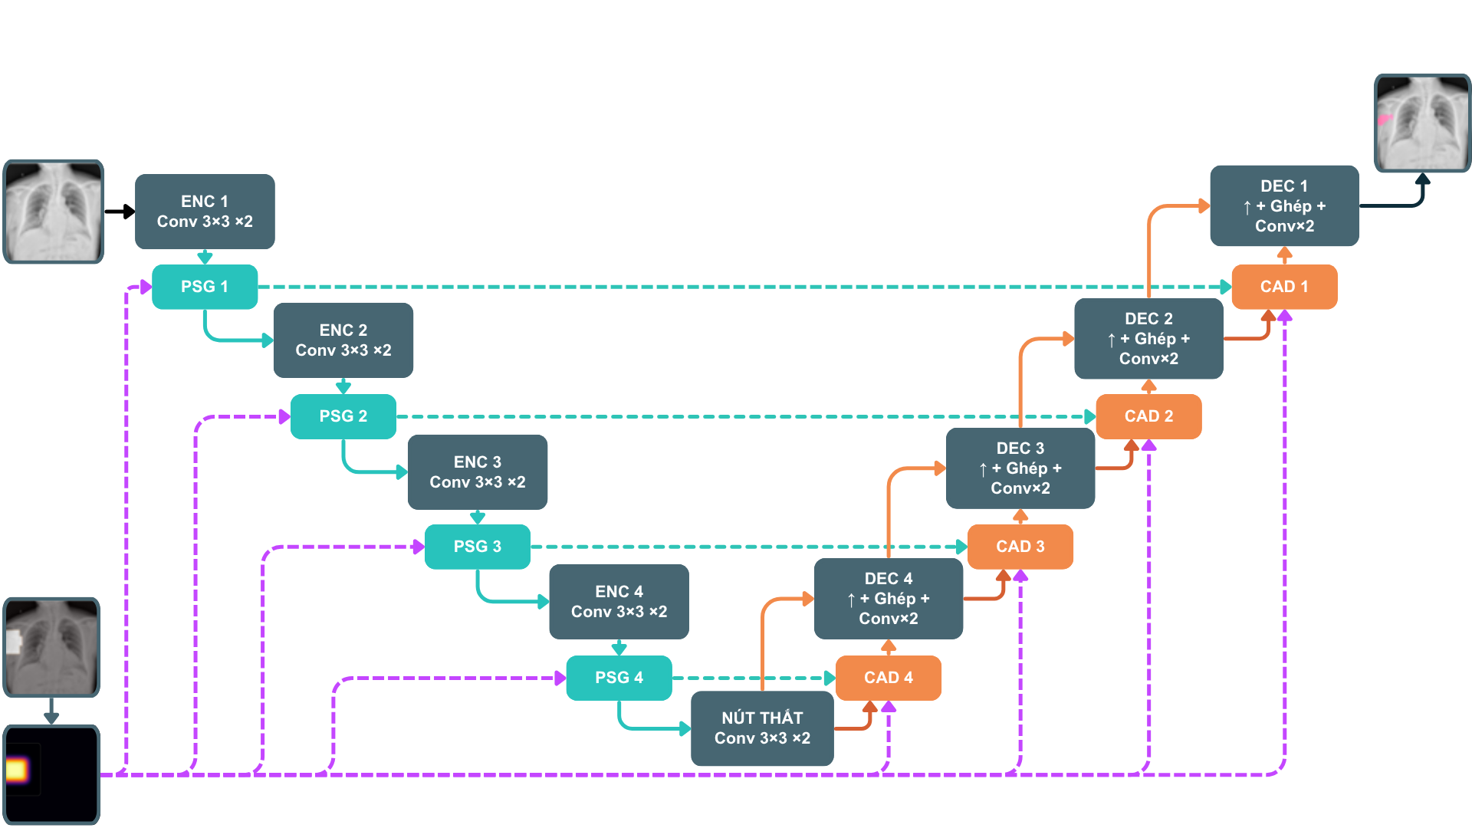
FIGURE 1. Overview of PGA-UNet. Prompt information derived from the bounding box is injected into encoder features through PSG and reused in decoder skip attention through CAD.
IV. EXPERIMENTAL SETUP
A. Datasets
We evaluate on two public bone radiograph datasets. BTXRD is a primary bone tumor X-ray dataset with polygon annotations for classification, localization, and segmentation [7]. The split contains 1,493/187/187 images with 1,848/238/232 lesion polygons for training, validation, and testing. FracAtlas is a fracture radiograph dataset with classification, localization, and segmentation labels [8]. After data cleaning and polygon normalization, the split contains 573/72/72 images with 730/95/92 lesion polygons for training, validation, and testing.
Splits are performed at the image level and all polygons from the same image remain in the same split. Public metadata were insufficient to verify strict patient-level separation; therefore, patient-level leakage cannot be ruled out and is treated as a limitation. Each polygon is one promptable lesion sample during training. For image-level evaluation with multiple lesions, the model is run once per lesion box and probability maps are merged by pixelwise maximum before thresholding; ground-truth masks are merged by union.
Inputs are resized isotropically and padded to 256×256 or 512×512 while preserving aspect ratio; the image, mask, and prompt map undergo identical geometric preprocessing.
B. Training Details
All CNN models were implemented in PyTorch and trained on an NVIDIA Tesla T4 GPU with 16 GB memory. PGA-UNet and Attention U-Net were trained separately for each dataset and resolution. AdamW was used with learning rate 10^-4 and weight decay 10^-4. The loss is binary cross-entropy plus Dice loss, batch size is 4, the maximum training budget is 100 epochs, and early stopping with patience 15 is used. Training augmentation includes horizontal flipping and random rotation within ±15°. PGA-UNet is trained on a 50/50 mixture of covering and off-center prompts.
Fine-tuned SAM-Med2D uses the same dataset splits and the same 50/50 box-prompt mixture. The pretrained image encoder is frozen except for Adapter layers, whereas the prompt encoder and mask decoder are updated. This matched prompt distribution reduces a major source of comparison bias, although optimizer settings and early-stopping patience differ because the models are fine-tuned under different optimization regimes.
C. Baselines and Metrics
Attention U-Net is retained as a prompt-free automatic reference that illustrates the difficulty of full-image localization. It is not used as evidence that the PGA-UNet architecture is superior under equal information. Fine-tuned SAM-Med2D is the current prompt-matched baseline because it receives the same box type and is evaluated at the same 256×256 resolution. Primary metrics reported in the main manuscript are Dice, center-based localization (CBL), and HD95; this wording is aligned with the metrics actually shown in the main result tables.
[AUTHOR ACTION — HIGH PRIORITY: before IEEE Access submission, add at least two fair conventional prompt baselines: (i) U-Net/Attention U-Net with the same box heatmap concatenated as an input channel, and (ii) crop-then-segment U-Net/Attention U-Net using the same bounding box. These baselines are needed to separate the benefit of “having a box” from the benefit of PSG+CAD.]
[AUTHOR ACTION — HIGH PRIORITY: add at least one additional modern prompt-based baseline if computationally feasible (e.g., MedSAM, ScribblePrompt-UNet/SAM, Med-SA, or an efficient SAM variant) under the same box protocol. Do not add a method unless the implementation and prompt protocol are matched and documented.]
D. Statistical and Robustness Analysis
[AUTHOR ACTION: run the main prompt-matched models on the same repeated splits or seeds and report paired differences with 95% confidence intervals (e.g., paired bootstrap over test images). Repeat the key full-vs-ablation comparison across multiple seeds. The current four-split Monte Carlo analysis demonstrates stability of PGA-UNet itself but does not establish statistical superiority over SAM-Med2D.]
[AUTHOR ACTION: extend prompt perturbation beyond boxes that always cover the lesion. Recommended test strata are: (1) box expansion 0–100%; (2) center shifts up to 50% of lesion width/height; (3) partial-coverage boxes at approximately 50%, 75%, and 90% lesion coverage; and (4) negative/background boxes with no lesion overlap. Report Dice versus prompt quality and the rate/area of false-positive masks for negative boxes.]
V. RESULTS
A. Main Performance Across Datasets and Resolutions
Dataset | Resolution | Covering Dice | Off-center Dice
BTXRD | 256×256 | 0.8449 | 0.8111
BTXRD | 512×512 | 0.8788 | 0.8496
FracAtlas | 256×256 | 0.7974 | 0.7619
FracAtlas | 512×512 | 0.8286 | 0.7925

PGA-UNet achieves consistently high Dice on both datasets and both resolutions under the two controlled prompt conditions. Increasing the input resolution improves Dice in every setting. Because the Gaussian prompt is constructed at the original resolution using a fixed 31×31 kernel before resizing, the 256-vs-512 comparison reflects both image-detail preservation and a different effective prompt blur after downsampling; it should therefore not be interpreted as a pure resolution ablation.
B. Monte Carlo Cross-Validation
Dataset | Prompt | Dice (mean±SD) | CBL (mean±SD) | HD95 (mean±SD)
BTXRD | Covering | 0.8715 ± 0.0083 | 0.9600 ± 0.0028 | 8.09 ± 0.67
BTXRD | Off-center | 0.8357 ± 0.0120 | 0.9390 ± 0.0062 | 10.45 ± 0.65
FracAtlas | Covering | 0.8281 ± 0.0052 | 0.9597 ± 0.0039 | 6.93 ± 0.08
FracAtlas | Off-center | 0.7862 ± 0.0114 | 0.9297 ± 0.0054 | 8.75 ± 0.48

Across four repeated image-level splits, the standard deviation of PGA-UNet Dice remains below 0.012 in all rows, providing evidence that the observed PGA-UNet performance is not tied to a single favorable split. This analysis should be described as model-stability evidence; statistical superiority over a baseline requires the baseline to be evaluated on the same repeated splits.
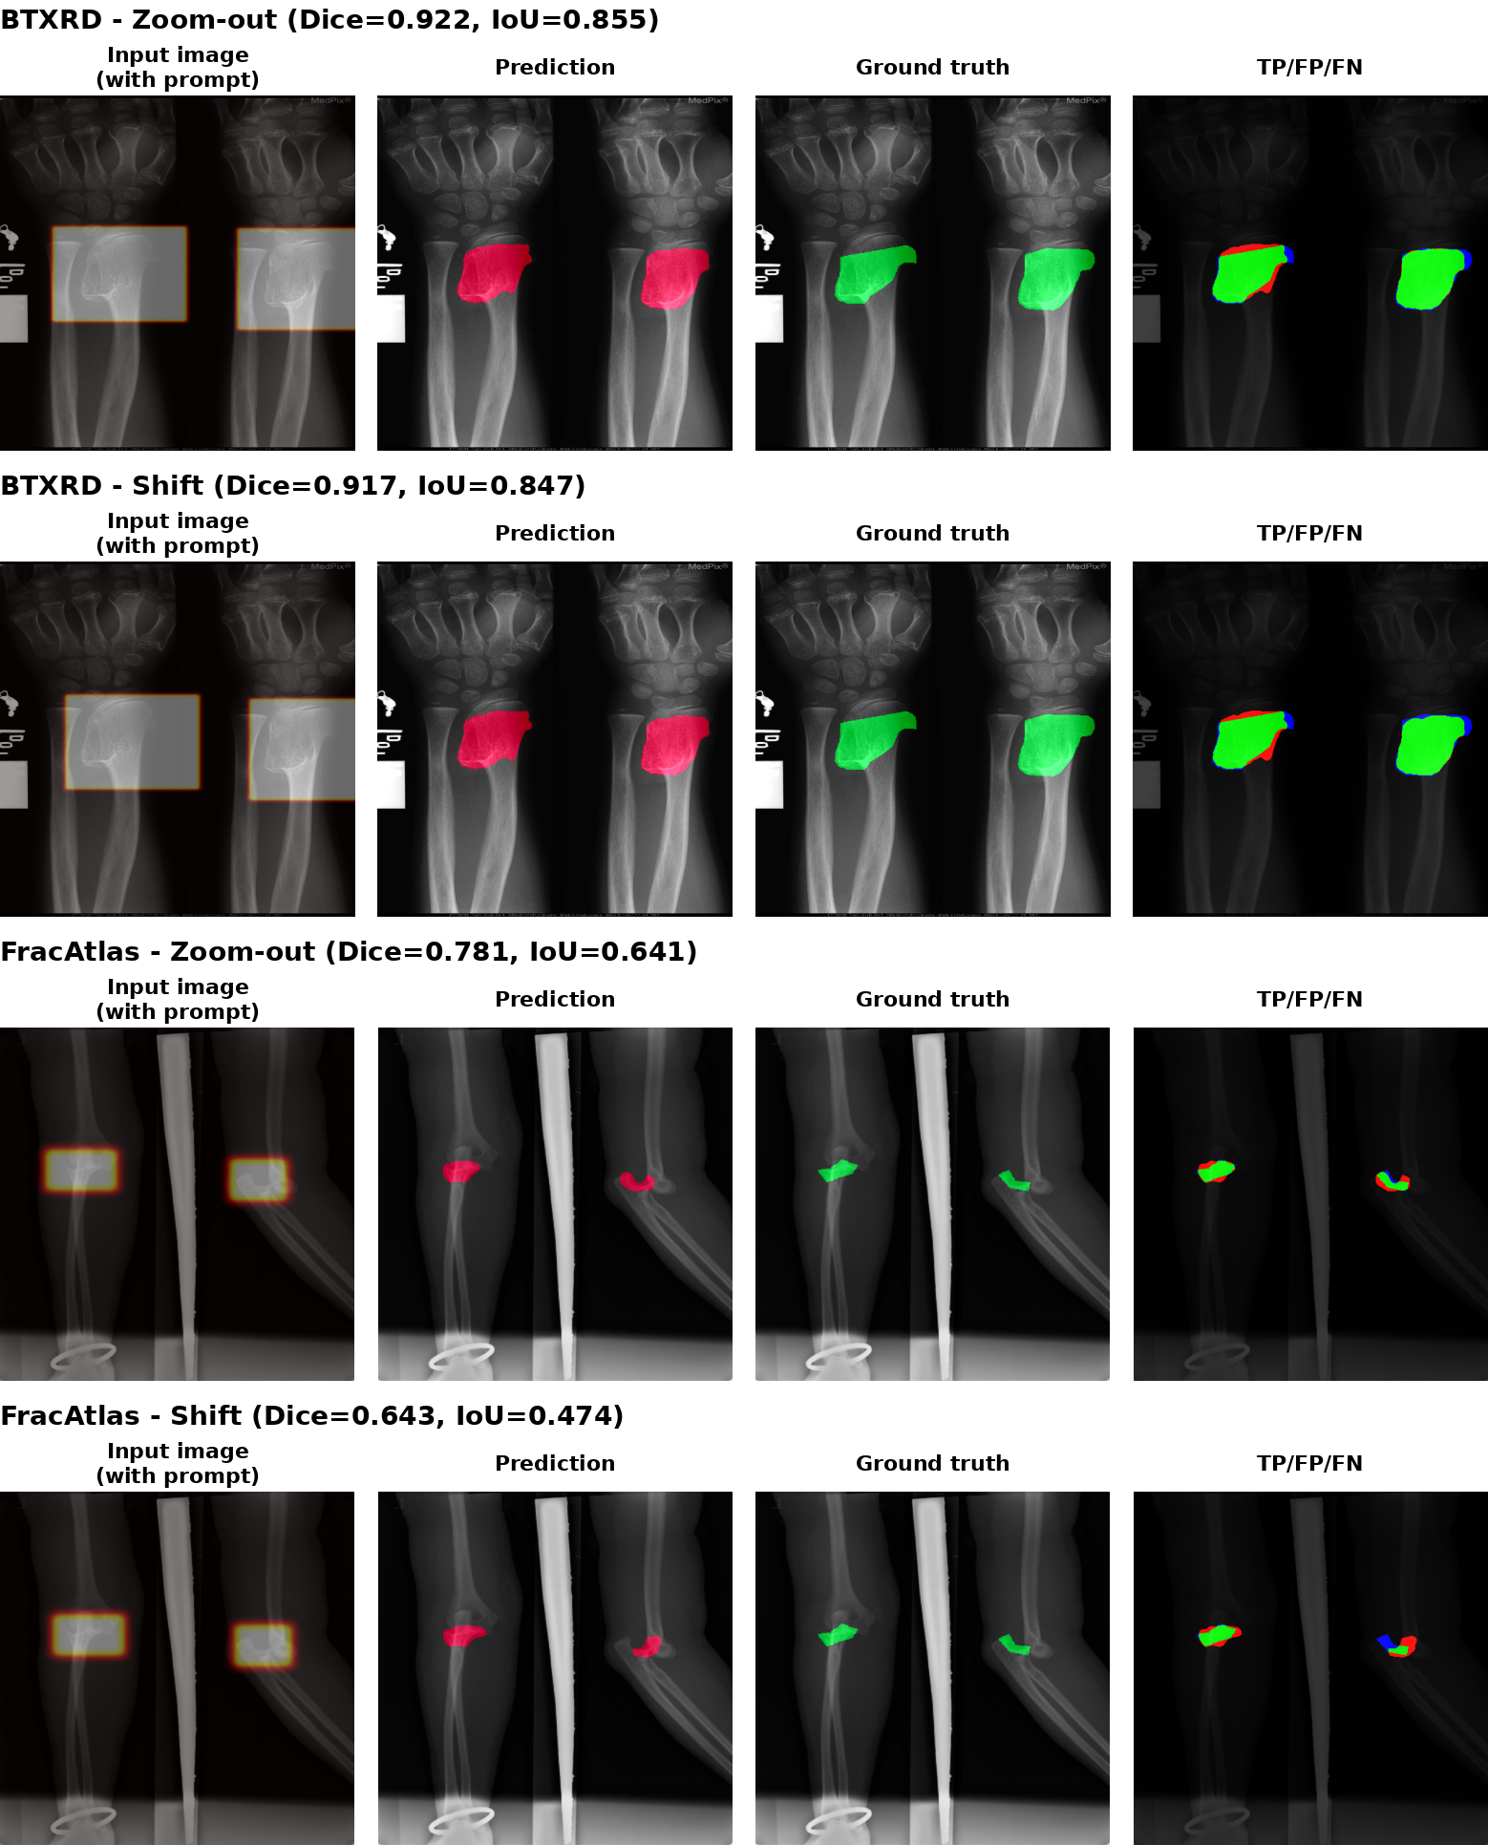
FIGURE 2. Qualitative behavior under prompt perturbation. The examples compare covering and shifted prompt conditions on BTXRD and FracAtlas.
C. Prompt-Free Automatic Reference
Dataset | Model | Dice | CBL | HD95
BTXRD | Attention U-Net | 0.5160 | 0.5995 | 129.67
BTXRD | PGA-UNet + covering box | 0.8788 | 0.9619 | 9.08
FracAtlas | Attention U-Net | 0.3075 | 0.4658 | 110.83
FracAtlas | PGA-UNet + covering box | 0.8286 | 0.9615 | 6.21

The large gap in this table quantifies the practical value of supplying spatial information, but the comparison is intentionally asymmetric because only PGA-UNet receives a lesion box. The table must therefore not be used to claim an architecture-level advantage. A fair estimate of the incremental contribution of PSG+CAD requires a conventional network supplied with the same box information.
D. Attention U-Net Top- and Bottom-Dice Subsets
Dataset | Group | Model | Dice | CBL | HD95
BTXRD | Top-Dice | Attention U-Net | 0.8629 | 0.9436 | 39.32
BTXRD | Top-Dice | PGA-UNet | 0.9036 | 0.9709 | 9.23
BTXRD | Bottom-Dice | Attention U-Net | 0.0335 | 0.0928 | 270.72
BTXRD | Bottom-Dice | PGA-UNet | 0.8521 | 0.9459 | 5.19
FracAtlas | Top-Dice | Attention U-Net | 0.4428 | 0.6277 | 82.08
FracAtlas | Top-Dice | PGA-UNet | 0.8318 | 0.9666 | 6.37
FracAtlas | Bottom-Dice | Attention U-Net | 0.1529 | 0.3345 | 135.76
FracAtlas | Bottom-Dice | PGA-UNet | 0.8151 | 0.9582 | 6.25

These subsets are defined by Attention U-Net performance and therefore characterize cases in which the automatic reference is relatively successful or unsuccessful; they are not objective difficulty groups. The analysis is useful descriptively, but it should remain secondary to prompt-matched comparisons.
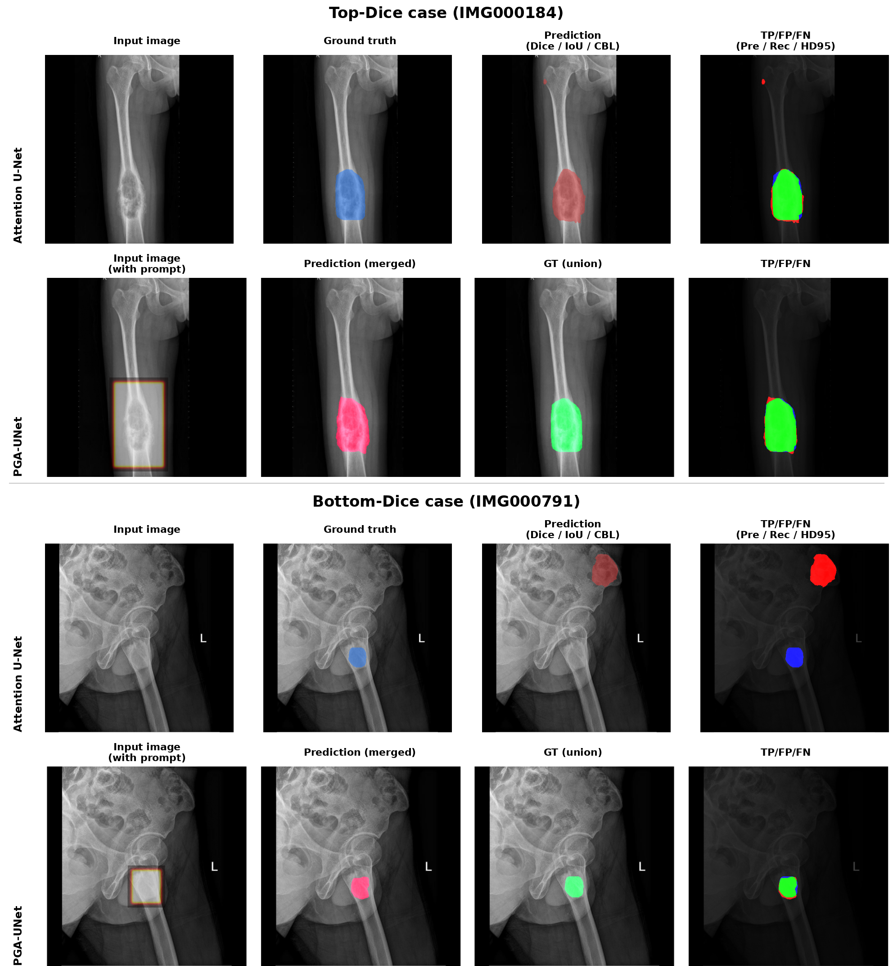
FIGURE 3. Qualitative comparison between Attention U-Net and PGA-UNet on representative BTXRD cases.
E. Matched Comparison With Fine-Tuned SAM-Med2D
Dataset | Prompt | PGA-UNet | SAM-Med2D-FT
BTXRD | Covering | 0.8449 | 0.7624
BTXRD | Off-center | 0.8111 | 0.7542
FracAtlas | Covering | 0.7974 | 0.7439
FracAtlas | Off-center | 0.7619 | 0.7275

Under matched box-prompt conditions at 256×256, PGA-UNet achieves higher absolute Dice than fine-tuned SAM-Med2D in all four dataset/prompt settings. However, the degradation from covering to off-center prompts is larger for PGA-UNet (0.0338 on BTXRD and 0.0355 on FracAtlas) than for SAM-Med2D (0.0082 and 0.0164). The results therefore support higher accuracy under the tested off-center prompts, but they do not support a claim that PGA-UNet is relatively more invariant to prompt shift than SAM-Med2D.
F. Performance on Small-Lesion Images
Dataset | Model | Dice | CBL | HD95
BTXRD | SAM-Med2D-FT 256×256 | 0.1903 | 0.4489 | 240.72
BTXRD | PGA-UNet 256×256 | 0.7650 | 0.9261 | 3.11
BTXRD | PGA-UNet 512×512 | 0.8483 | 0.9451 | 2.32
FracAtlas | SAM-Med2D-FT 256×256 | 0.3736 | 0.7116 | 105.19
FracAtlas | PGA-UNet 256×256 | 0.7973 | 0.9569 | 5.62
FracAtlas | PGA-UNet 512×512 | 0.8348 | 0.9609 | 4.83

For each dataset, this subset contains the 50 test images with the smallest total lesion area, not necessarily the 50 smallest individual lesions. At the matched 256×256 resolution, PGA-UNet substantially exceeds fine-tuned SAM-Med2D in Dice and CBL, and higher-resolution PGA-UNet improves the result further. These data are the strongest evidence in the current manuscript for the practical value of the proposed conditioning strategy on small targets, but they remain conditioned on ground-truth-derived covering boxes.
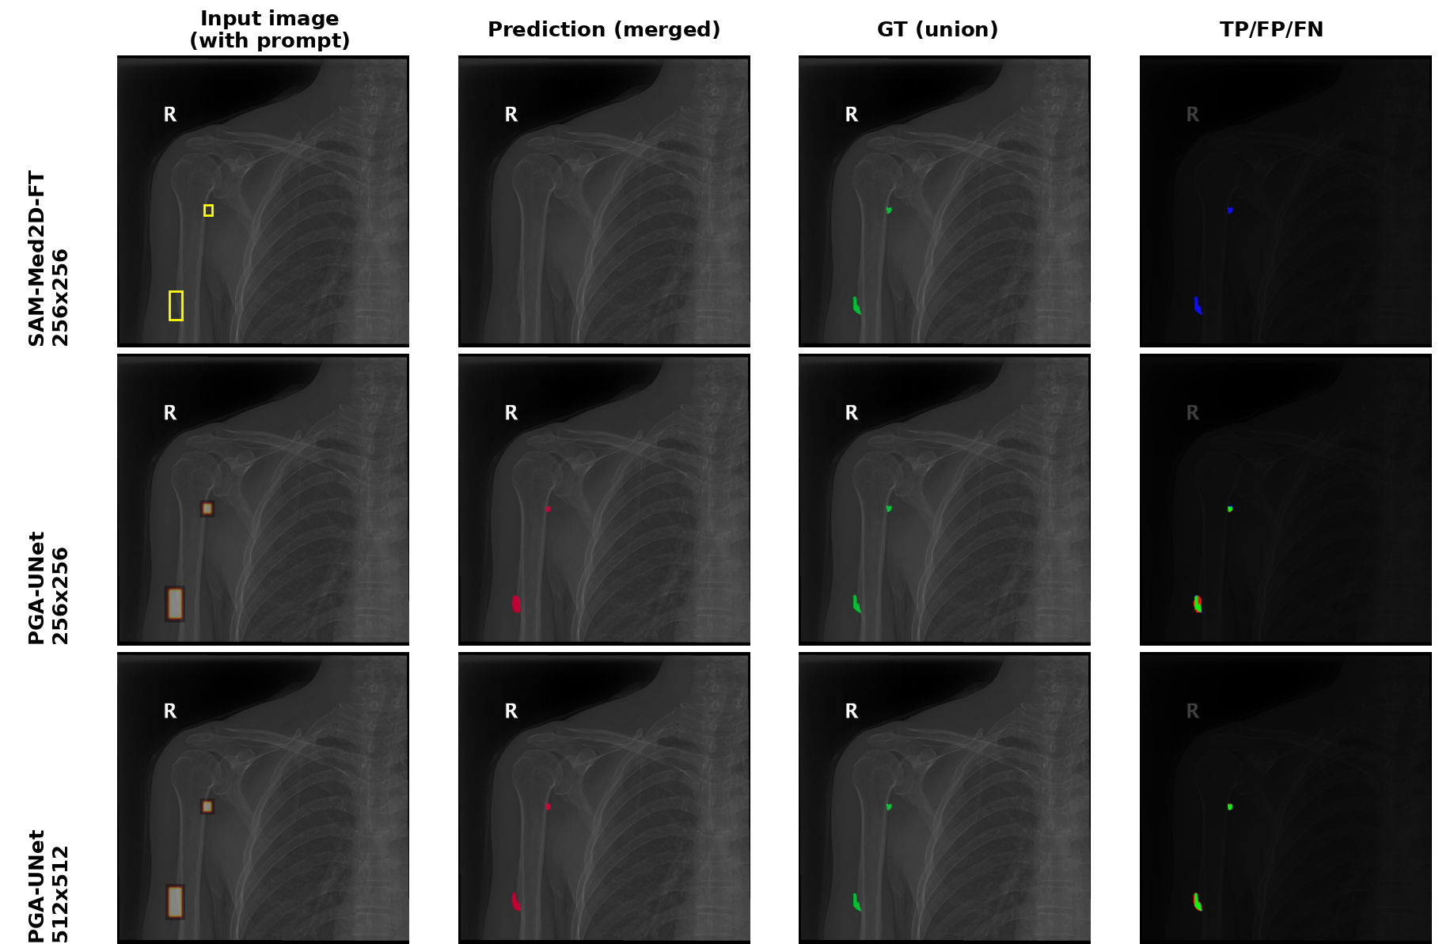
FIGURE 4. Qualitative comparison on a small-lesion BTXRD case. Fine-tuned SAM-Med2D and PGA-UNet are evaluated from the same box prompt.
G. Efficiency Analysis
Model | Params | GFLOPs | Size | GPU ms | CPU ms
PGA-UNet 256 | 2.95M | 7.74 | 11.35 MB | 8.17 | 109.17
PGA-UNet 512 | 2.95M | 30.97 | 11.35 MB | 18.28 | 336.74
SAM-Med2D 256 | 271.24M | 92.02 | 2443.16 MB | 48.75 | 1263.77

In the tested environment, PGA-UNet provides a clear computational advantage over SAM-Med2D. The 256×256 model uses approximately 92× fewer parameters, 11.9× fewer FLOPs, and 6.0× lower GPU forward-pass latency. These measurements support the lightweight-computation claim, provided that the exact software versions, warm-up procedure, number of timed runs, synchronization policy, and CPU specification are reported for reproducibility.
H. Ablation Study
PSG | Decoder attention | Prompt | BTXRD Cover | BTXRD Off | FracAtlas Cover | FracAtlas Off
No | None | Gaussian | 0.8596 | 0.8230 | 0.7727 | 0.7356
No | None | Binary | 0.8597 | 0.8253 | 0.7670 | 0.7199
No | Vanilla gate | Gaussian | 0.8671 | 0.8408 | 0.7560 | 0.7311
No | CAD | Gaussian | 0.8685 | 0.8358 | 0.8158 | 0.7777
Yes | None | Gaussian | 0.8567 | 0.8297 | 0.7115 | 0.6990
Yes | Vanilla gate | Gaussian | 0.8611 | 0.8314 | 0.7372 | 0.7170
Yes | CAD | Binary | 0.8611 | 0.8317 | 0.8132 | 0.7896
Yes | CAD | Gaussian (PGA-UNet) | 0.8788 | 0.8496 | 0.8286 | 0.7925

The full PSG+CAD+Gaussian configuration is the best row in all four dataset/prompt settings on the reported split. The pattern suggests interaction between the components: PSG alone is not consistently beneficial, whereas CAD is more consistently helpful and the full combination performs best. Nevertheless, several pairwise differences are small (for example, the Gaussian-vs-binary gap under FracAtlas off-center prompts is 0.0029 Dice). Such small differences should not be presented as established component effects until repeated-seed uncertainty is reported.
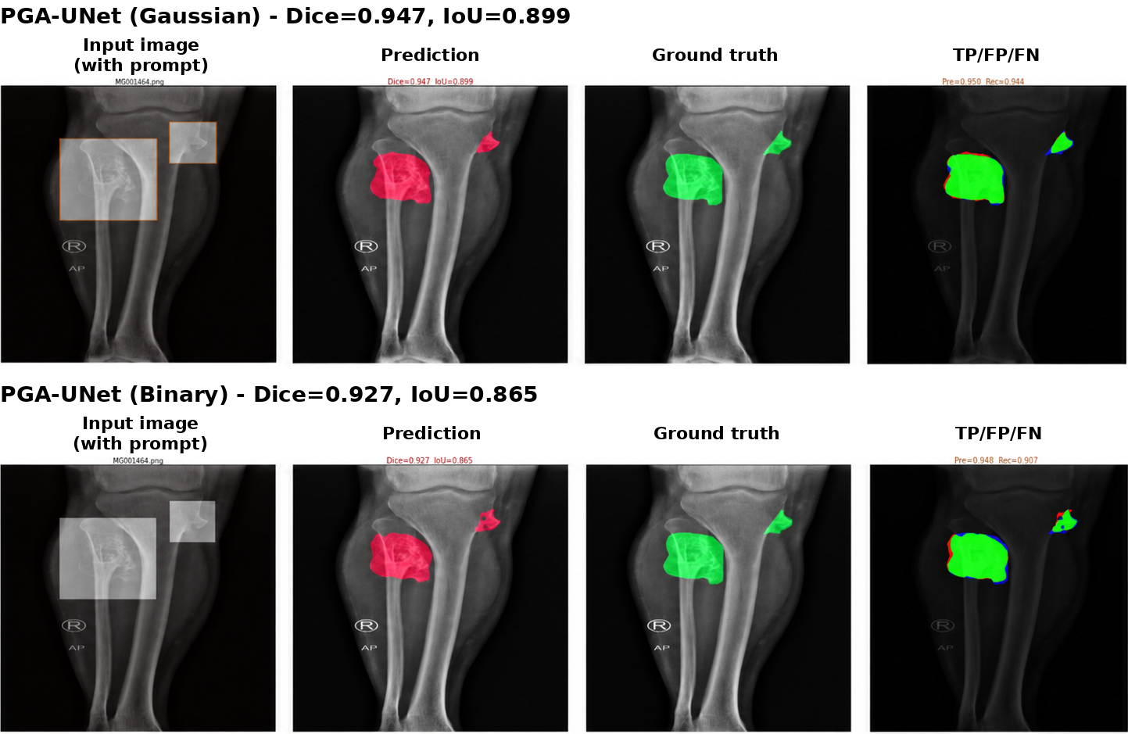
FIGURE 5. Qualitative comparison between Gaussian and binary prompt representations on a representative BTXRD example.
I. Failure Modes
Lower Dice values are observed for elongated or branching targets, anatomically cluttered regions such as the shoulder or clavicle, and weak-contrast lesions. These cases indicate that a spatial prompt can reduce the search space but cannot eliminate ambiguity when the local radiographic evidence is insufficient.
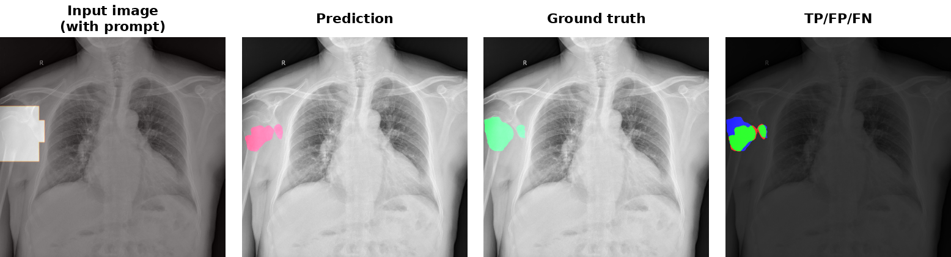
FIGURE 6. Representative failure case in an anatomically overlapping region.
VI. DISCUSSION
The current evidence supports three main conclusions. First, PGA-UNet achieves strong segmentation accuracy under controlled box guidance on both BTXRD and FracAtlas, and its performance remains stable across four random image-level splits. Second, under the matched 256×256 box setting, PGA-UNet achieves higher Dice than fine-tuned SAM-Med2D, with the largest difference on test images containing very small lesion areas. Third, the full PSG+CAD+Gaussian configuration is the strongest observed ablation configuration and the model is substantially lighter than SAM-Med2D.
These conclusions are intentionally narrower than the original manuscript wording. The large gap to prompt-free Attention U-Net primarily demonstrates the value of external localization information and cannot by itself isolate the benefit of the proposed architecture. Moreover, PGA-UNet experiences a larger relative Dice drop than SAM-Med2D when the prompt is shifted, so the current results establish higher absolute accuracy under the tested off-center boxes rather than superior invariance to prompt perturbation.
The most important validity limitation is the prompt-generation protocol. Test boxes are derived from ground-truth masks and are constrained to cover the lesion. Such prompts provide strong information about location and approximate extent and are more favorable than some real clinical interactions. Radiologist-drawn boxes, partial-coverage boxes, large uncertain boxes, and negative/background prompts are required before claiming clinical robustness or workflow effectiveness. Patient-level separation also cannot be verified from the available public metadata, which may introduce optimistic bias if multiple images from the same patient exist.
The ablation evidence should likewise be interpreted at the system level. The observed results are consistent with synergy between PSG, CAD, and Gaussian prompt smoothing, but the current manuscript does not include feature-level probing or repeated-seed ablations that establish a unique causal mechanism. Finally, fixed-resolution preprocessing can remove small-lesion detail, and the fixed Gaussian kernel introduces a resolution-dependent effective blur after resizing.
[AUTHOR ACTION: after adding the fair box-guided baselines and prompt-robustness experiments, update this Discussion with the new numerical evidence and a concise statistical comparison. This is the single most important step for making the paper defensible under IEEE Access review.]
VII. CONCLUSION
This article presents PGA-UNet, a lightweight prompt-guided CNN for interactive bone X-ray lesion segmentation. The method converts a box prompt into a Gaussian-smoothed spatial prior and reuses that prior through encoder-side PSG and decoder-side CAD. On BTXRD and FracAtlas, PGA-UNet achieves strong Dice under controlled covering and off-center box prompts, outperforms fine-tuned SAM-Med2D at the matched 256×256 setting, performs particularly well on images with very small lesion areas, and requires substantially fewer parameters and operations. The ablation results indicate that the full PSG+CAD+Gaussian configuration is more effective than the tested partial variants on the reported split. The conclusions are limited to annotation-derived simulated prompts; evaluation with realistic user boxes, additional prompt-matched baselines, paired statistical analysis, and external or patient-separated validation remains necessary to establish broader clinical robustness and generalizability.
DATA AVAILABILITY
BTXRD and FracAtlas are public datasets cited in this article. The manuscript reports experiments on image-level train/validation/test splits derived from those datasets. Code, exact split files, prompt-generation code, and evaluation scripts should be released with the final reproducibility package.
AUTHOR CONTRIBUTIONS
Thong Luc: conceptualization, methodology, software, investigation, formal analysis, visualization, writing of the original draft. Nguyen Huu Binh: software support, data preparation, experiment verification, review and editing. Ly Quoc Ngoc: supervision, validation, review and editing.
ETHICS STATEMENT
This study used public de-identified radiograph datasets and did not involve prospective data collection, patient contact, or intervention.
ACKNOWLEDGMENT
[AUTHOR ACTION: update the AI-use disclosure to match the exact final workflow and current IEEE policy. Suggested wording if accurate: ‘OpenAI ChatGPT was used to assist with language editing and editorial restructuring of selected manuscript passages. It was not used to generate experimental data or fabricate references. All technical content, numerical results, references, figures, tables, and conclusions were reviewed and verified by the authors, who take full responsibility for the final manuscript.’]
REFERENCES
[1] A. Kirillov et al., “Segment Anything,” in Proc. IEEE/CVF Int. Conf. Comput. Vis., 2023, pp. 4015–4026.
[2] J. Cheng et al., “SAM-Med2D,” arXiv:2308.16184, 2023.
[3] O. Ronneberger, P. Fischer, and T. Brox, “U-Net: Convolutional Networks for Biomedical Image Segmentation,” in MICCAI, 2015, pp. 234–241.
[4] O. Oktay et al., “Attention U-Net: Learning Where to Look for the Pancreas,” in Medical Imaging with Deep Learning, 2018.
[5] N. Xu, B. Price, S. Cohen, J. Yang, and T. S. Huang, “Deep Interactive Object Selection,” in Proc. IEEE Conf. Comput. Vis. Pattern Recognit., 2016, pp. 373–381.
[6] G. Wang et al., “DeepIGeoS: A Deep Interactive Geodesic Framework for Medical Image Segmentation,” IEEE Trans. Pattern Anal. Mach. Intell., vol. 41, no. 7, pp. 1559–1572, 2019.
[7] S. Yao et al., “A Radiograph Dataset for the Classification, Localization, and Segmentation of Primary Bone Tumors,” Scientific Data, vol. 12, no. 1, p. 88, 2025.
[8] I. Abedeen et al., “FracAtlas: A Dataset for Fracture Classification, Localization and Segmentation of Musculoskeletal Radiographs,” Scientific Data, vol. 10, no. 1, p. 521, 2023.
[9] J. Ma et al., “Segment Anything in Medical Images,” Nature Communications, vol. 15, art. 654, 2024.
[10] F. Isensee, P. F. Jaeger, S. A. A. Kohl, J. Petersen, and K. H. Maier-Hein, “nnU-Net: a self-configuring method for deep learning-based biomedical image segmentation,” Nature Methods, vol. 18, pp. 203–211, 2021.
[11] H. E. Wong, M. Rakic, J. Guttag, and A. V. Dalca, “ScribblePrompt: Fast and Flexible Interactive Segmentation for Any Biomedical Image,” in Computer Vision – ECCV 2024, pp. 207–229, 2024, doi: 10.1007/978-3-031-73661-2_12.
[12] G. Dong et al., “An efficient segment anything model for the segmentation of medical images,” Scientific Reports, vol. 14, art. 19425, 2024, doi: 10.1038/s41598-024-70288-8.
[13] J. Wu et al., “Medical SAM adapter: Adapting segment anything model for medical image segmentation,” Medical Image Analysis, vol. 102, art. 103547, 2025, doi: 10.1016/j.media.2025.103547.
AUTHOR BIOGRAPHIES
THONG LUC — [retain the verified biography and author photo from the current manuscript; proofread before submission.]
NGUYEN HUU BINH — [retain the verified biography from the current manuscript; add/confirm photo if required by the final IEEE Access template.]
LY QUOC NGOC — [AUTHOR ACTION: insert complete IEEE Access short biography and author photo; the current manuscript contains a placeholder.]

EDITORIAL CHECKLIST — REMOVE THIS PAGE BEFORE SUBMISSION
• Use the official current IEEE Access double-column, single-spaced Word/LaTeX template; ensure the Word and PDF contents match exactly.
• Resolve all author affiliation and biography placeholders; include short biographies for every author.
• Add fair box-guided U-Net/Attention U-Net baselines; preferably add at least one additional modern prompt-based baseline.
• Run paired multi-seed/repeated-split comparisons and report 95% confidence intervals or paired bootstrap for the main claims and key ablations.
• Add realistic prompt stress tests including partial coverage and negative/background boxes; avoid “clinical robustness” language until these are completed.
• If patient identifiers become available, re-split at patient level; otherwise keep the limitation explicit.
• Report exact latency measurement protocol, software versions, and CPU specification.
• Ensure every metric mentioned in Methods is actually reported; the revised text currently limits primary metrics to Dice, CBL, and HD95.
• Change “50 smallest lesions” to “50 test images with the smallest total lesion area” everywhere unless the subset is recomputed per lesion.
• Validate every added reference and bibliography field in a reference manager; check for retractions.
• Remove template artifacts such as an obsolete “VOLUME 11, 2023” footer and blank DOI placeholders from the final source.
• Update the AI-use acknowledgment to describe the actual final use of AI-assisted editing and comply with the submission-time IEEE policy.
• Release code, exact split files, prompt simulation, and evaluation scripts if possible; reproducibility will materially strengthen the submission.

