**Coding conventions**

1. Conventions controller Blog  
  
Trước khi conventions  
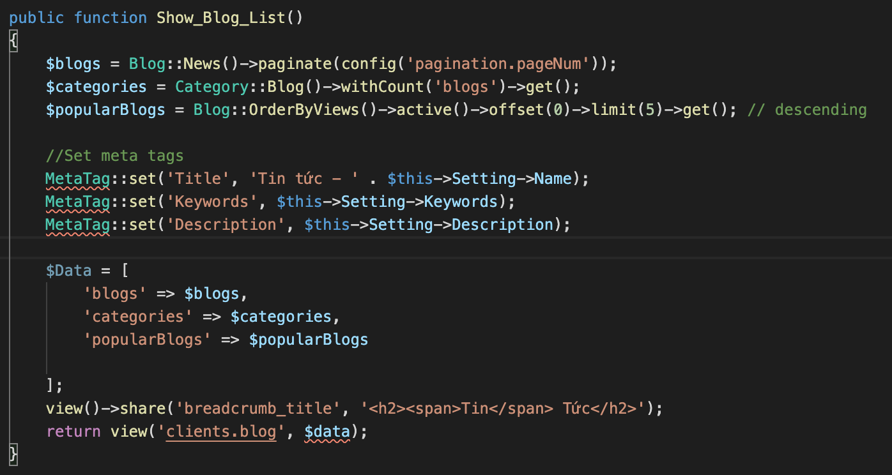  
Sau khi Conventions  
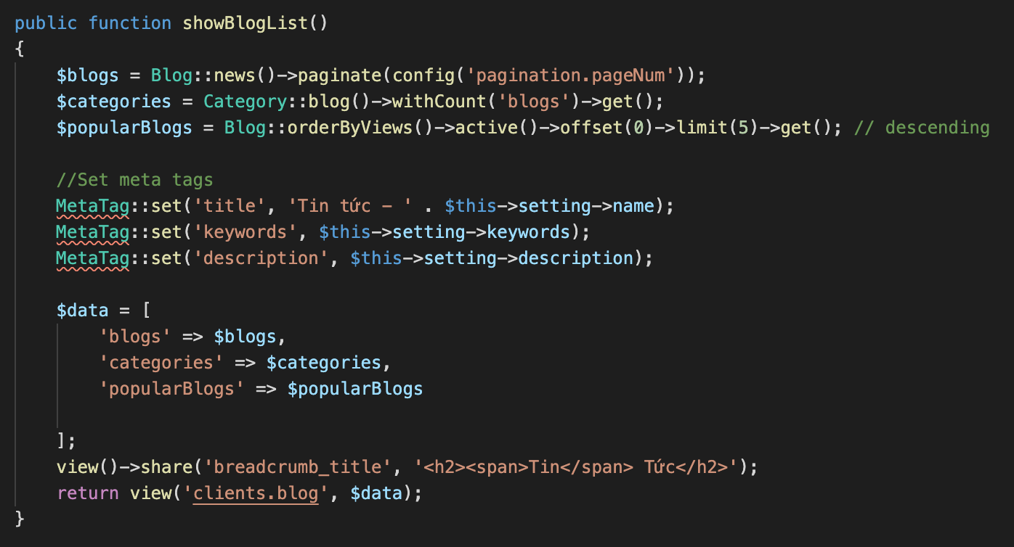  
  
  
  
  
  
  
Trước khi conventions  
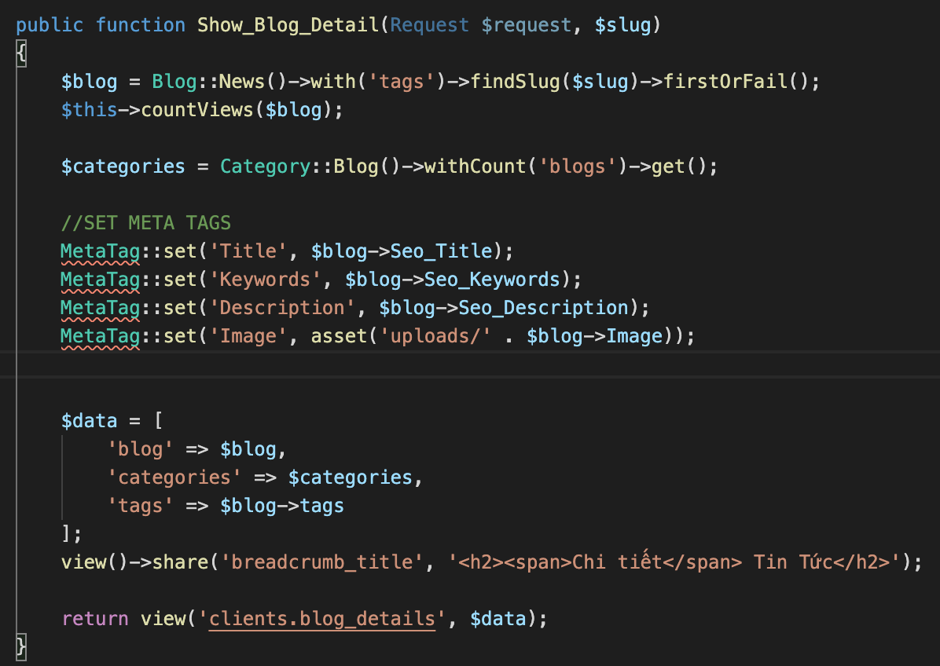  
  
Sau khi Conventions  
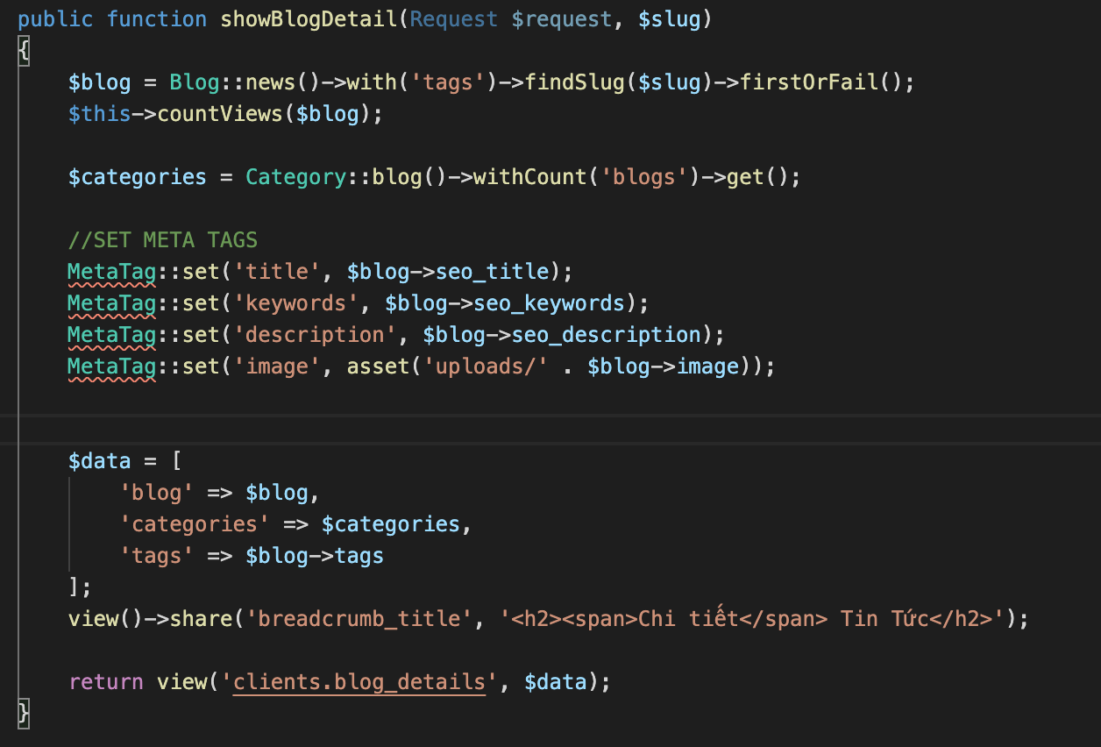  
  
  
Trước khi conventions  
  
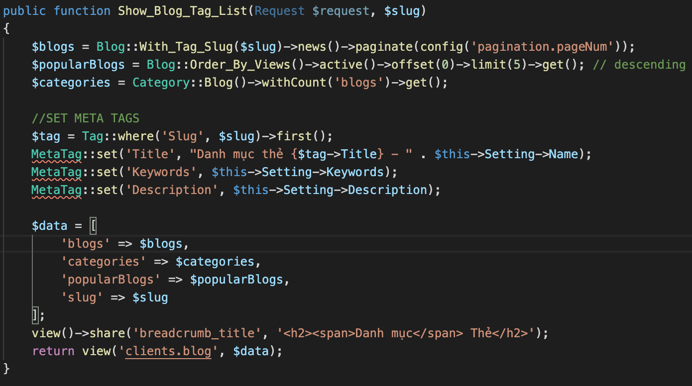  
  
Sau khi conventions  
  
