Driving Question: How can we, as Year-7 Indigo students, develop informational websites that draw attention & introduce the civilians of Myanmar to have an eco-friendly lifestyle and a sustainable future?

Essential Question: How can we develop an informational website that highlights the impact on the over-usage of plastic with alternatives, to help our local community move towards a more sustainable lifestyle?

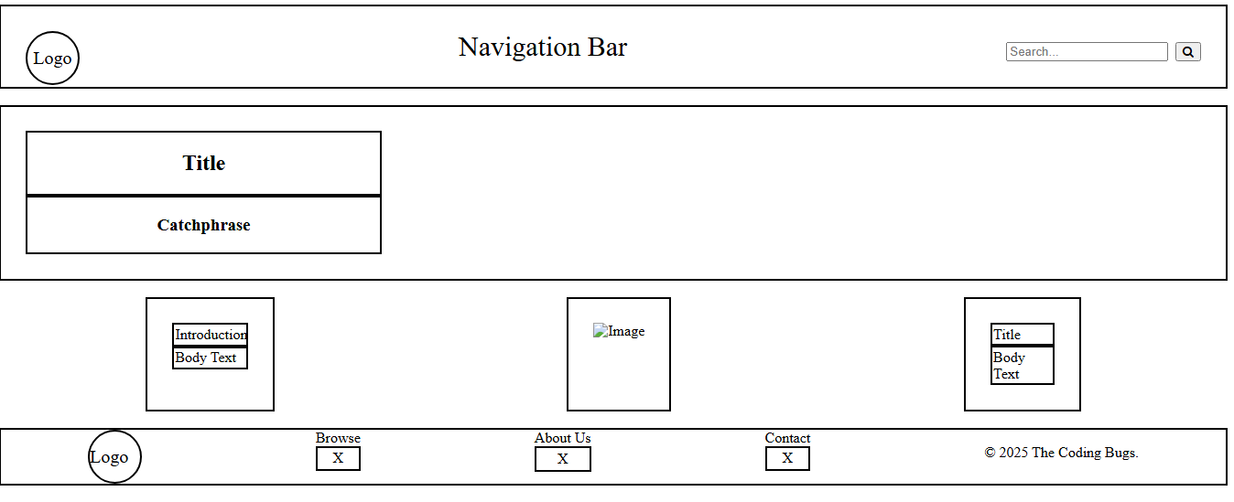

Wireframe and actual website is a bit different, as we had to fix for efficiency of our website coding.

References

[www.treehugger.com](http://www.treehugger.com)

<https://www.w3schools.com/>

<https://codepen.io/t_afif/pen/LYdqGKQ>

<https://education.nationalgeographic.org/resource/marine-pollution/>

<https://eartheclipse.com/environment/environmental-effects-plastic-pollution.html>

<https://www.epa.gov/plastics/impacts-plastic-pollution>

<https://www.freepik.com/photos/plastic-pollution>

<https://pngtree.com/freebackground/row-of-recycle-waste-bins-close-up_15548476.html>

<https://ar.inspiredpencil.com/pictures-2023/effects-of-plastic-pollution>

<https://prismic.io/blog/css-hover-effects>

<https://www.britannica.com/science/plastic-pollution/Plastic-pollution-in-oceans-and-on-land>

<https://www.ciel.org/breathing-plastic-the-health-impacts-of-invisible-plastics-in-the-air/>

<https://www.weforum.org/stories/2020/07/scientists-find-plastic-pollution-in-the-rain-and-in-the-air-we-breathe/>

<https://www.unep.org/news-and-stories/story/plastic-planet-how-tiny-plastic-particles-are-polluting-our-soil>

[Top 10 Eco-friendly Substitutes for Plastic](https://science.howstuffworks.com/environmental/green-tech/sustainable/5-plastic-substitutes.htm)

[The Science Behind Bamboo: Why It’s a Sustainable Choice | by ECOBOO - Change wasteful habits for zerowaste life | Medium](https://medium.com/@ecoboo/the-science-behind-bamboo-why-its-a-sustainable-choice-1f4a5b7bbce9)

[21 Everyday Products Made From Recycled Plastic in 2025](https://theroundup.org/everyday-products-made-from-recycled-plastic/)

[10 Ways To Reduce Plastic Pollution - Greenpeace Africa](https://www.greenpeace.org/africa/en/blogs/53885/10-ways-to-reduce-plastic-pollution/)

[The Benefits of Liquid Wood: How to Use This Sustainable Material - Woodbeaver.net](https://woodbeaver.net/the-benefits-of-liquid-wood-how-to-use-this-sustainable-material)

[Is Bamboo Sustainable? All You Need to Know About Eco-Friendly Bamboo — Sustainable Review](https://sustainablereview.com/is-bamboo-sustainable-all-you-need-to-know-about-eco-friendly-bamboo/)

[w3school.com](https://www.w3schools.com/)

<https://codepen.io/t_afif/pen/LYdqGKQ>

<https://education.nationalgeographic.org/resource/marine-pollution/>

<https://eartheclipse.com/environment/environmental-effects-plastic-pollution.html>

<https://www.freepik.com/photos/plastic-pollution>

<https://pngtree.com/freebackground/row-of-recycle-waste-bins-close-up_15548476.html>

<https://ar.inspiredpencil.com/pictures-2023/effects-of-plastic-pollution>

<https://prismic.io/blog/css-hover-effects>

<https://www.britannica.com/science/plastic-pollution/Plastic-pollution-in-oceans-and-on-land>

<https://www.weforum.org/stories/2020/07/scientists-find-plastic-pollution-in-the-rain-and-in-the-air-we-breathe/>

<https://www.unep.org/news-and-stories/story/plastic-planet-how-tiny-plastic-particles-are-polluting-our-soil>

[Pixabay.com/bamboo-forest](https://pixabay.com/photos/bamboo-forest-bamboo-green-plants-7158934/)

[Pixabay.com/recycling-bins-recycle-environment](https://pixabay.com/photos/recycling-bins-recycle-environment-373156/)

[Pixabay.com/recycled-eco-system-trees-birds](https://pixabay.com/photos/recycled-eco-system-trees-birds-8111001/)

[Pixabay.com/garbage-plastic-cups-recycling](https://pixabay.com/photos/garbage-plastic-cups-recycling-1255244/)

[Pixabay.com/chalk-colorful-dust-school-supply](https://pixabay.com/photos/chalk-colorful-dust-school-supply-4829602/)

[https://www.agriland.ie/farming-news/agriculture-shipping-and-fishing-main-sources-of-plastic-pollution-in-seas/](https://www.agriland.ie/farming-news/agriculture-shipping-and-fishing-main-sources-of-plastic-pollution-in-seas/#:~:text=A%20new%20study%20has%20found%20that%20the%20agriculture%2C,published%20by%20Galway%20Mayo%20Institute%20of%20Technology%20%28GMIT%29.)

[https://ww.unep.org/news-and-stories/story/everything-you-need-to-know-about-plastic](https://www.unep.org/news-and-stories/story/everything-you-need-know-about-plastic-pollution)

<https://www.futurelearn.com/info/blog/how-to-reduce-plastic-waste>

<https://theoceancleanup.com/>

<https://www.cleanoceansinternational.org/>

<https://www.plasticpollutioncoalition.org/>

<https://www.unep.org/news-and-stories/press-release/un-roadmap-outlines-solutions-cut-global-plastic-pollution>

<https://www.unep.org/plastic-pollution>

[Top 10 Countries Leading the Fight Against Plastic Pollution](https://www.plastics-technology.com/articles/top-10-countries-leading-the-fight-against-plastic-pollution#:~:text=Key%20Initiatives%3A%201%20Waste-to-energy%20systems%20that%20convert%20non-recyclable,3%20Promoting%20innovation%20in%20biodegradable%20and%20compostable%20materials.)

[Drink Milk Glass - Free photo on Pixabay](https://pixabay.com/photos/drink-milk-glass-refreshment-7015150/)

[Bamboo Forest Green - Free photo on Pixabay](https://pixabay.com/photos/bamboo-forest-green-nature-japan-4387852/)

<https://www.conservationinstitute.org/the-future-of-plastic-alternatives/>

<https://pixabay.com/photos/sun-beach-garbage-plastic-nature-4269841/>

<https://nexusnewsfeed.com/article/climate-ecology/toxic-chemicals-from-plastic-waste-are-migrating-into-food-and-harming-soil-warn-experts/>

<https://www.plasticsforchange.org/blog/different-types-of-plastic>

<https://pvcindustrialproducts.com/pvc-pipe-and-fittings-ottawa/>

<https://www.britannica.com/science/polyvinyl-chloride>

<https://www.youtube.com/watch?v=9dO6A44co9A>