Classio Educational Intelligence Center
Technical Data Science Report
Technical validation package for authorized internal reviewers.
Validation status: Validated - no robust winner
Generated on 2026-07-17 18:00
Validated run: 866777f1db54
Dataset fingerprint: 2e2973e26148...

Document control and metadata
Field | Value
Run status | Validated - no robust winner
Integrity | Passed NO Robust Winner
Maturity | Exploratory only
Target version | Opened Within 7d V1
Feature schema version | Assigned Resource Open 7d V1
Run ID | 866777f1db54
Dataset fingerprint | 2e2973e26148420c255bec1a2f49e6d66a73ed1a33fc40acd5734843458b10cf
Chronological cutoff | 2026-06-30T17:56:21.615697+00:00

Experiment definition
Can Classio predict whether a student will open an assigned resource within seven days of assignment?
Prediction target: opened_within_7d, based on assignment-open behavior within a seven-day window.

Source tables and extraction logic
- Source tables: teacher_assignments, teacher_assignment_attempts, practice_sessions, resource_exposures, and resource_exposure_events.
- Extraction logic is frozen in the validated run artifacts and summarized in the dataset summary JSON.
- All feature construction is constrained to information known at or before assignment time.

Dataset accounting
Field | Value
Source rows | 127
Included rows | 125
Positives | 72
Negatives | 53
Right-censored | 2
Teachers represented | 1
Students represented | 15
Resources represented | 60
Date range | 2026-04-10T11:54:00.263328+00:00 to 2026-07-12T13:51:10.714517+00:00
Chronological cutoff | 2026-06-30T17:56:21.615697+00:00
Development rows | 100
Holdout rows | 25
Excluded: Observation Window Open | 2

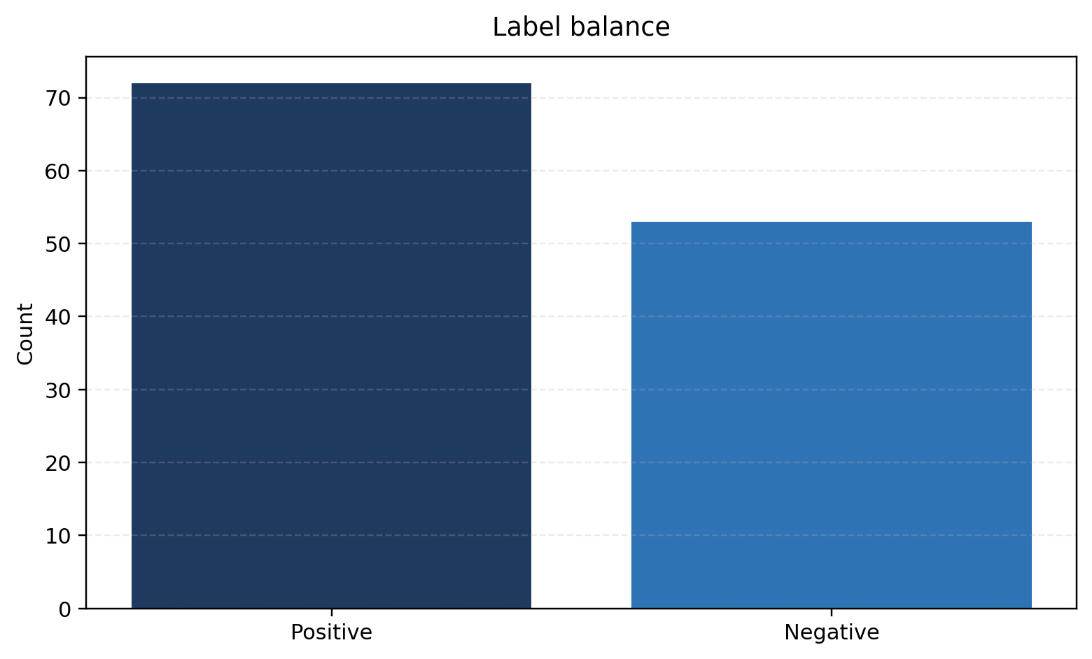
Figure 1. Stored target/class distribution.
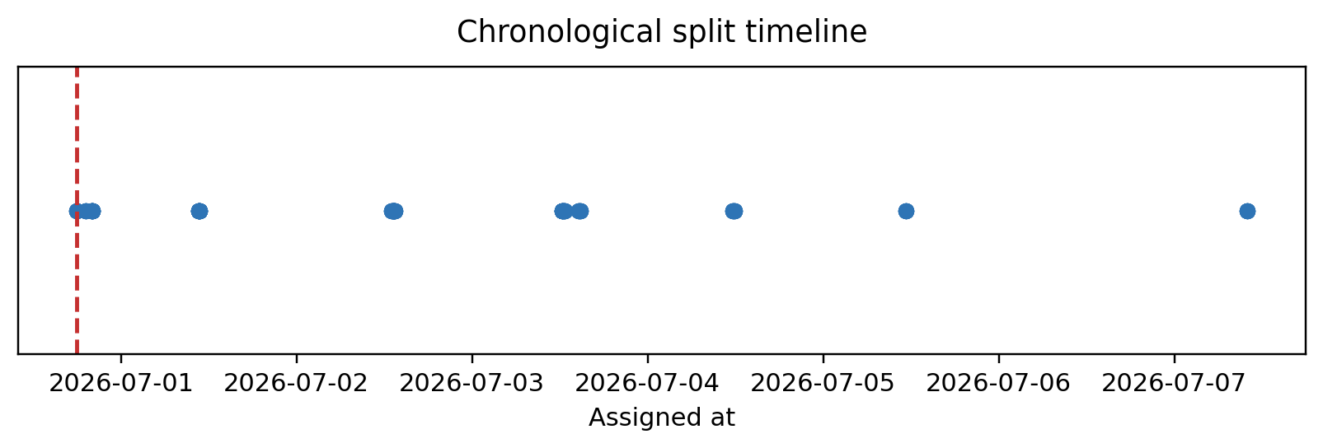
Figure 2. Assignment timeline and chronological split cutoff.

Label construction and reconciliation
Field | Value
Final verdict | Validated - no robust winner
Exact row-level reconciliation | Yes
Legacy audit reconciliation applicable | No
Audit counts | {"negative": 53, "positive": 61, "unknown": 13}
Phase 3 counts | {"negative": 53, "positive": 72, "unknown": 2}

- This run was generated by the current Phase 3.6 pipeline, so historical Phase 3.5 audit-count reconciliation is not required for validation.

Leakage controls
- Chronological holdout keeps future assignments out of development data.
- Feature timestamps are checked against assignment time to enforce past-only availability.
- Feature missingness explanations in the stored review confirm that sparsity comes from history availability rather than identifier mismatch.

Feature schema and feature health
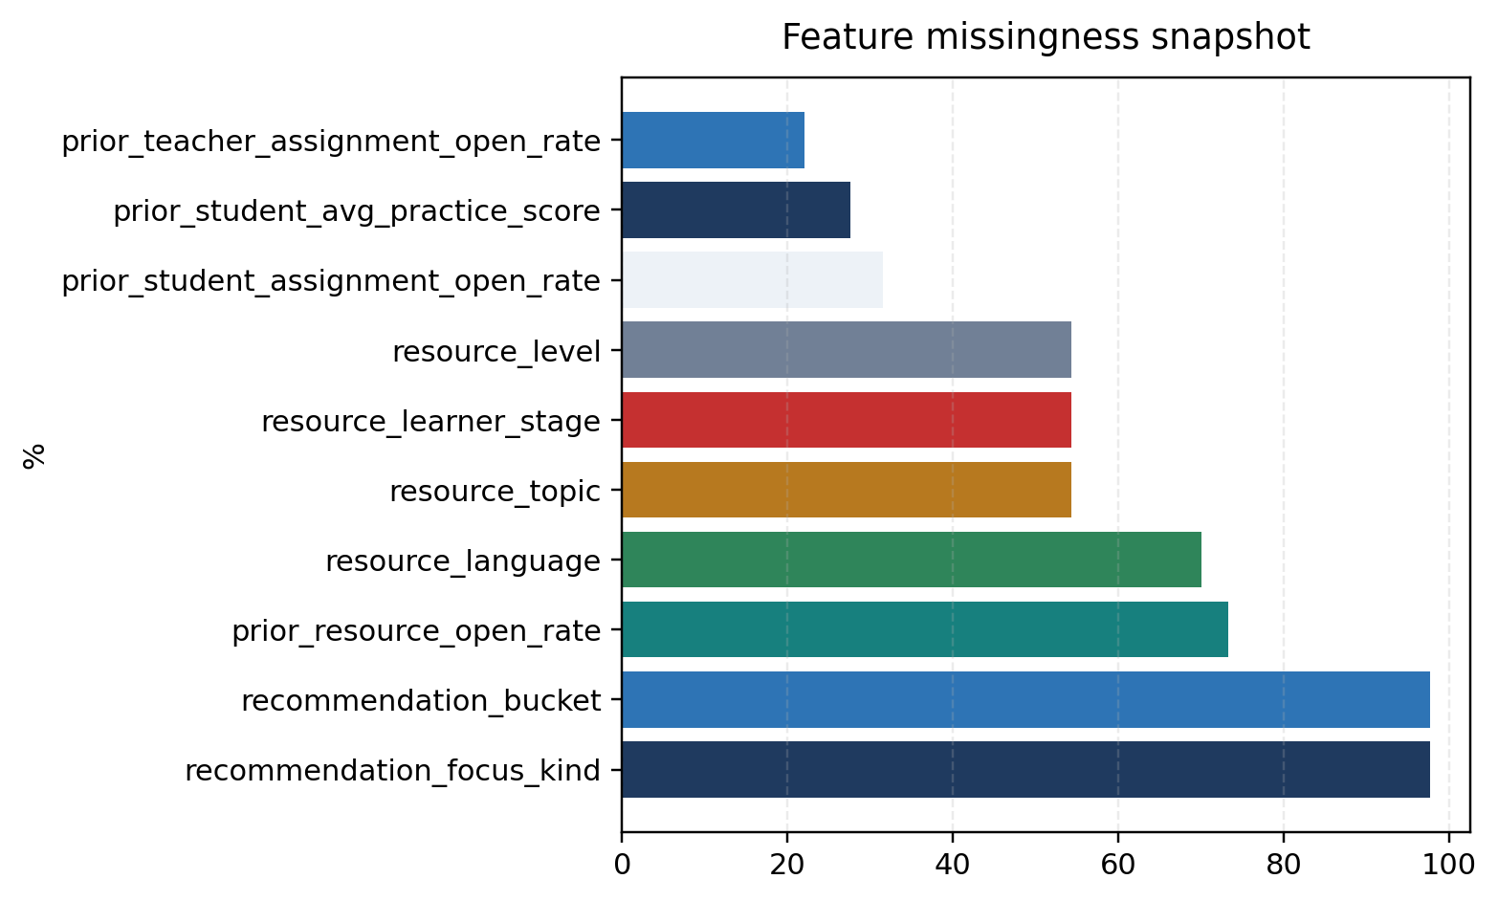
Figure 3. Highest overall missingness rates from the stored feature audit.
Feature | Source | Availability | Overall missing | Dev missing | Holdout missing | Included | Explanation
Prior Student Assignment Open Rate | Stored review | Past-only | 31.5% | 40.0% | 0.0% | Yes | No identifier mismatch was found. Missing values are produced by the feature-construction rule that only uses strictly earlier mature history. For early assignments there is no mature prior history yet; resource-level sparsity is especially severe for prior_resource_open_rate.
Prior Teacher Assignment Open Rate | Stored review | Past-only | 22.05% | 28.0% | 0.0% | Yes | No identifier mismatch was found. Missing values are produced by the feature-construction rule that only uses strictly earlier mature history. For early assignments there is no mature prior history yet; resource-level sparsity is especially severe for prior_resource_open_rate.
Prior Resource Open Rate | Stored review | Past-only | 73.23% | 70.0% | 84.0% | Yes | No identifier mismatch was found. Missing values are produced by the feature-construction rule that only uses strictly earlier mature history. For early assignments there is no mature prior history yet; resource-level sparsity is especially severe for prior_resource_open_rate.
Feature-health table using the stored audit and review output.

Preprocessing pipelines
- Missing values are imputed only when the stored evaluation pipeline marked the feature as retained.
- Categorical features are encoded within the stored pipeline configuration; no report-time transformation modifies model outcomes.
- Fully missing development-slice features are automatically excluded before fitting, as documented in the integrity review.

Chronological split and cross-validation
- Development rows: 100 with 60 positives.
- Holdout rows: 25 with 12 positives.
- Cross-validation fold counts and mean metrics are read directly from the stored model comparison artifact.

Model configurations
Model | Status | Selected hyperparameters
Majority class rule | Success | Strategy: Majority Class Rule
Dummy classifier | Success | Constant: n/a; Random State: n/a; Strategy: prior
Logistic regression | Success | C: 1.0; Class Weight: n/a; Dual: No; Fit Intercept: Yes; Intercept Scaling: 1; L1 Ratio: 0.0; Max Iter: 500; N Jobs: n/a; Penalty: deprecated; Random State: 20260716; Solver: lbfgs; Tol: 0.0001; Verbo
Logistic regression (reduced) | Success | C: 1.0; Class Weight: n/a; Dual: No; Fit Intercept: Yes; Intercept Scaling: 1; L1 Ratio: 0.0; Max Iter: 500; N Jobs: n/a; Penalty: deprecated; Random State: 20260716; Solver: lbfgs; Tol: 0.0001; Verbo
Decision tree classifier | Success | Ccp Alpha: 0.0; Class Weight: n/a; Criterion: gini; Max Depth: 3; Max Features: n/a; Max Leaf Nodes: n/a; Min Impurity Decrease: 0.0; Min Samples Leaf: 4; Min Samples Split: 2; Min Weight Fraction Lea
Random forest classifier | Success | Bootstrap: Yes; Ccp Alpha: 0.0; Class Weight: n/a; Criterion: gini; Max Depth: 4; Max Features: sqrt; Max Leaf Nodes: n/a; Max Samples: n/a; Min Impurity Decrease: 0.0; Min Samples Leaf: 3; Min Sample
Histogram gradient boosting classifier | Success | Categorical Features: From Dtype; Class Weight: n/a; Early Stopping: auto; Interaction Cst: n/a; L2 Regularization: 0.0; Learning Rate: 0.08; Loss: Log Loss; Max Bins: 255; Max Depth: 3; Max Features:
Support vector classifier | Success | C: 1.0; Break Ties: No; Cache Size: 200; Class Weight: n/a; Coef0: 0.0; Decision Function Shape: ovr; Degree: 3; Gamma: scale; Kernel: rbf; Max Iter: -1; Probability: Yes; Random State: 20260716; Shri
K-nearest neighbors classifier | Success | Algorithm: auto; Leaf Size: 30; Metric: minkowski; Metric Params: n/a; N Jobs: n/a; N Neighbors: 5; P: 2; Weights: distance

Baseline and comparison results
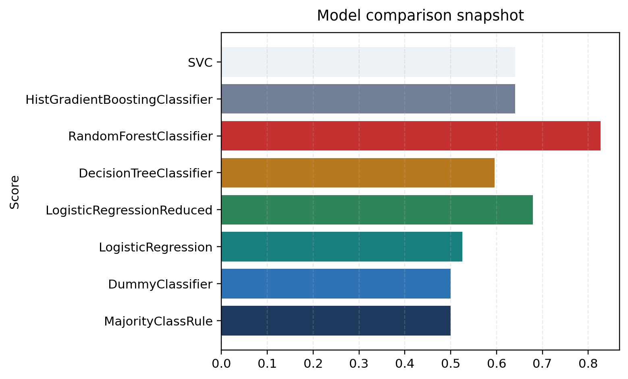
Figure 4. Model metric comparison snapshot using stored ROC AUC values.
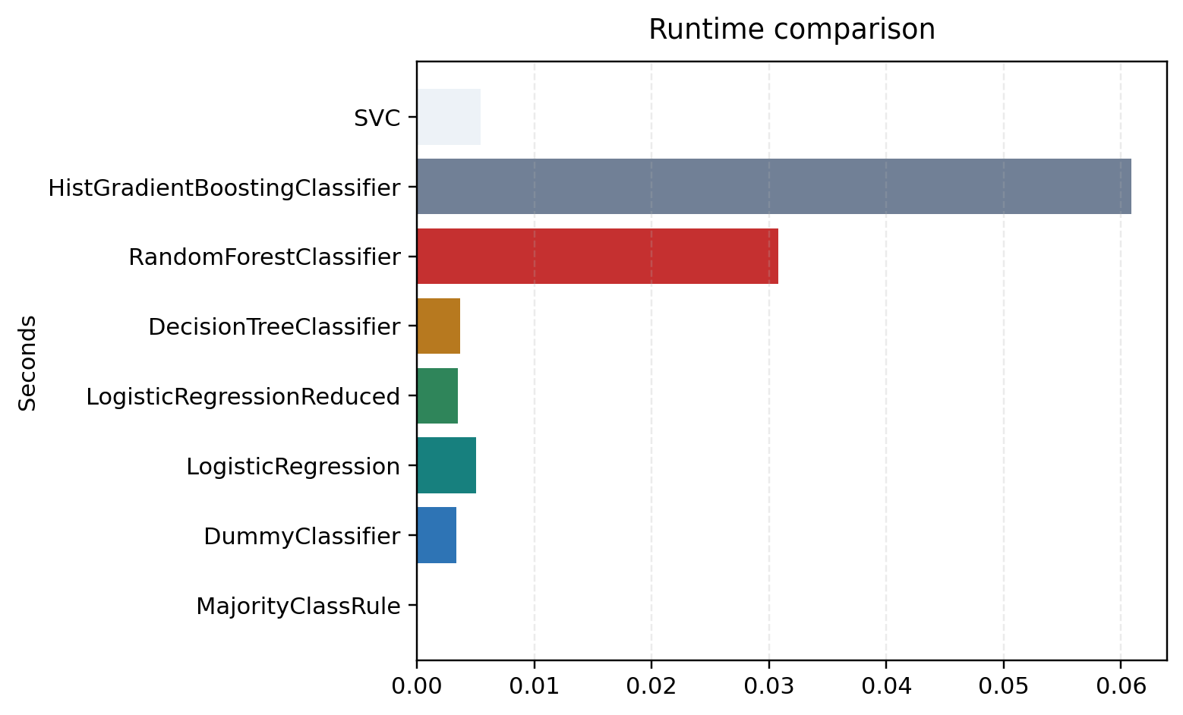
Figure 5. Training-runtime comparison from stored model outputs.

Threshold analysis
Field | Value
Primary ROC leader | Random forest classifier
Best thresholded classifier | Random forest classifier
Calibration leader | Random forest classifier
Best precision-recall ranking | Random forest classifier

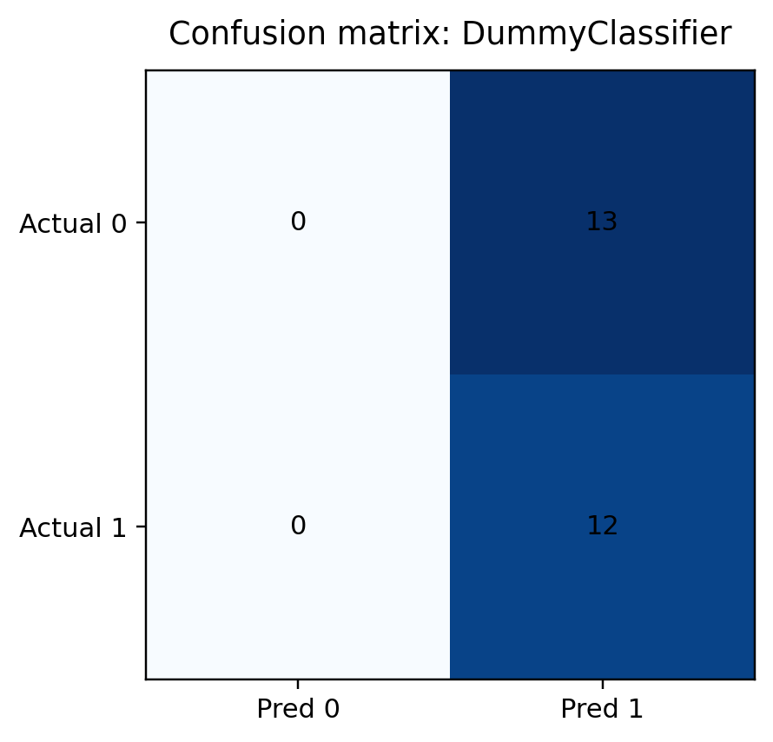
Figure 6. Confusion matrix for the stored baseline.
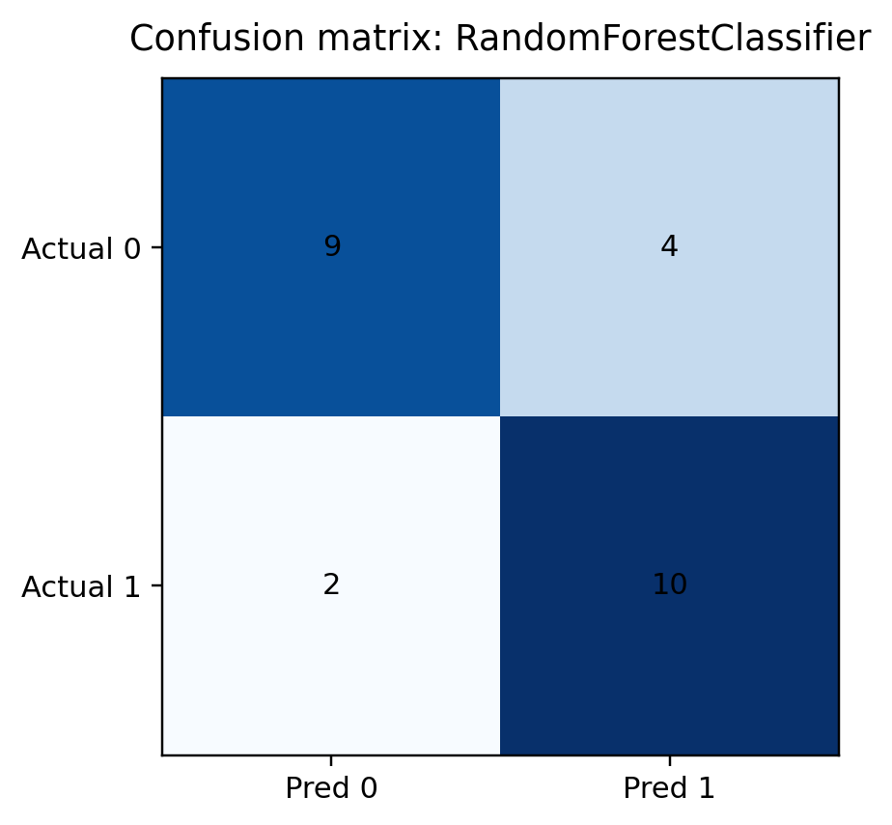
Figure 7. Confusion matrix for the primary ROC leader.

Figure 8. Confusion matrix for the best thresholded classifier.

ROC analysis
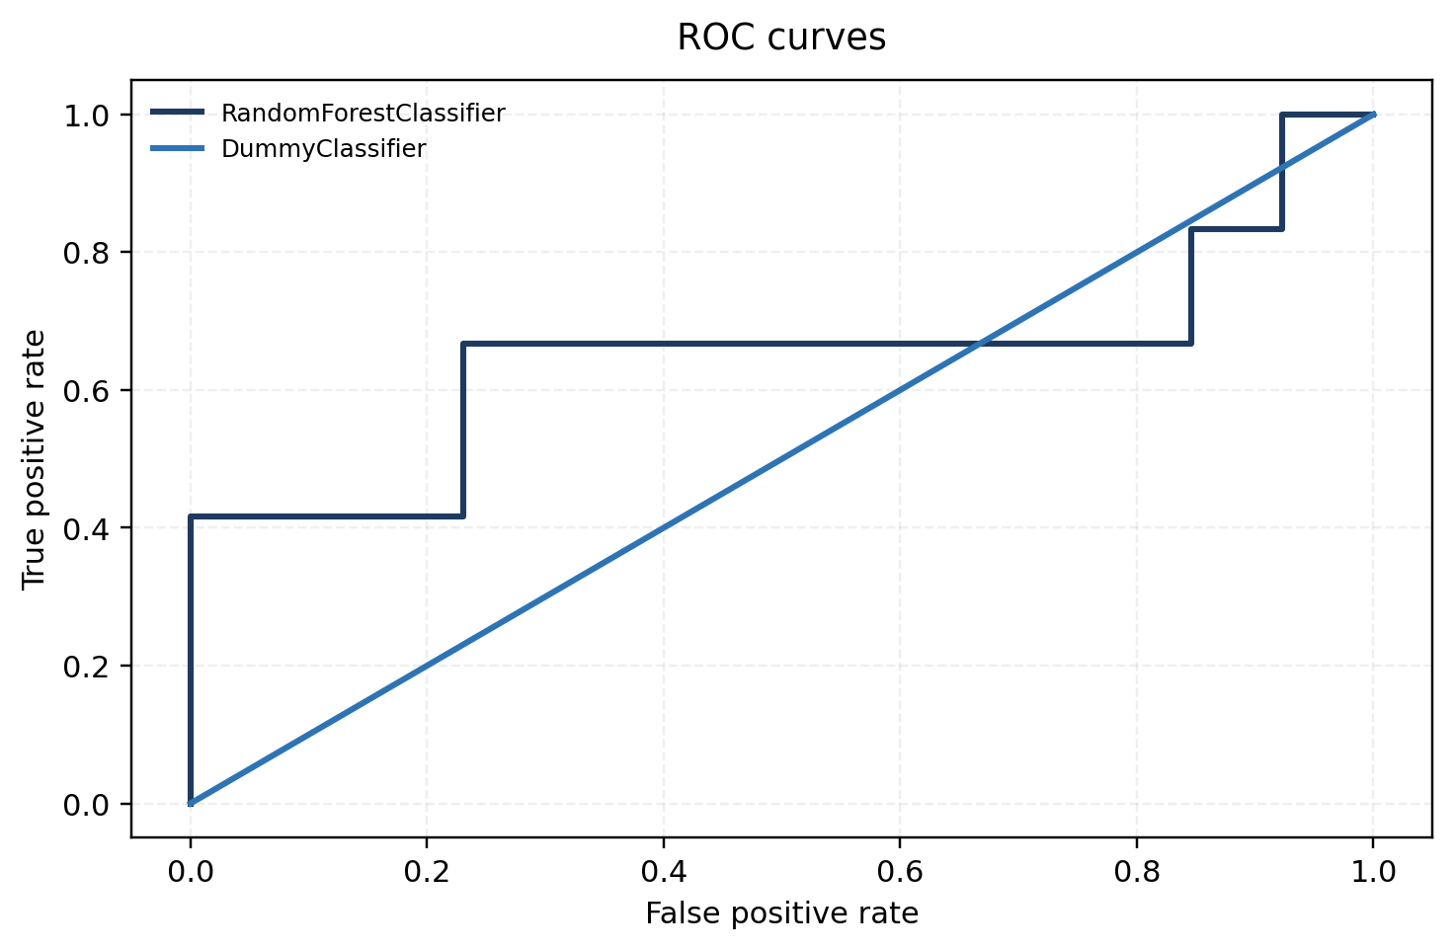
Figure 9. ROC curves for score-capable stored models.
The comparison did not establish a statistically robust overall winner. Random Forest led several stored evaluation criteria, but the small holdout and single-teacher sample prevent a production-level conclusion.

Precision-recall analysis
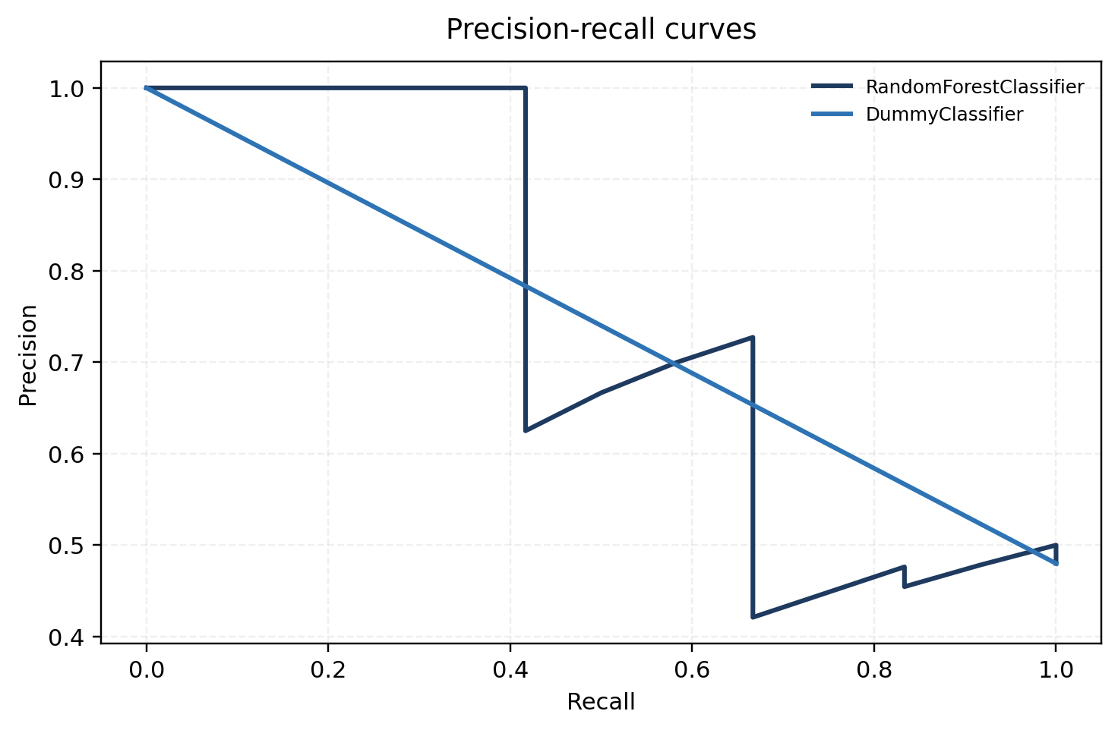
Figure 10. Precision-recall curves for the same stored holdout predictions.

Calibration analysis
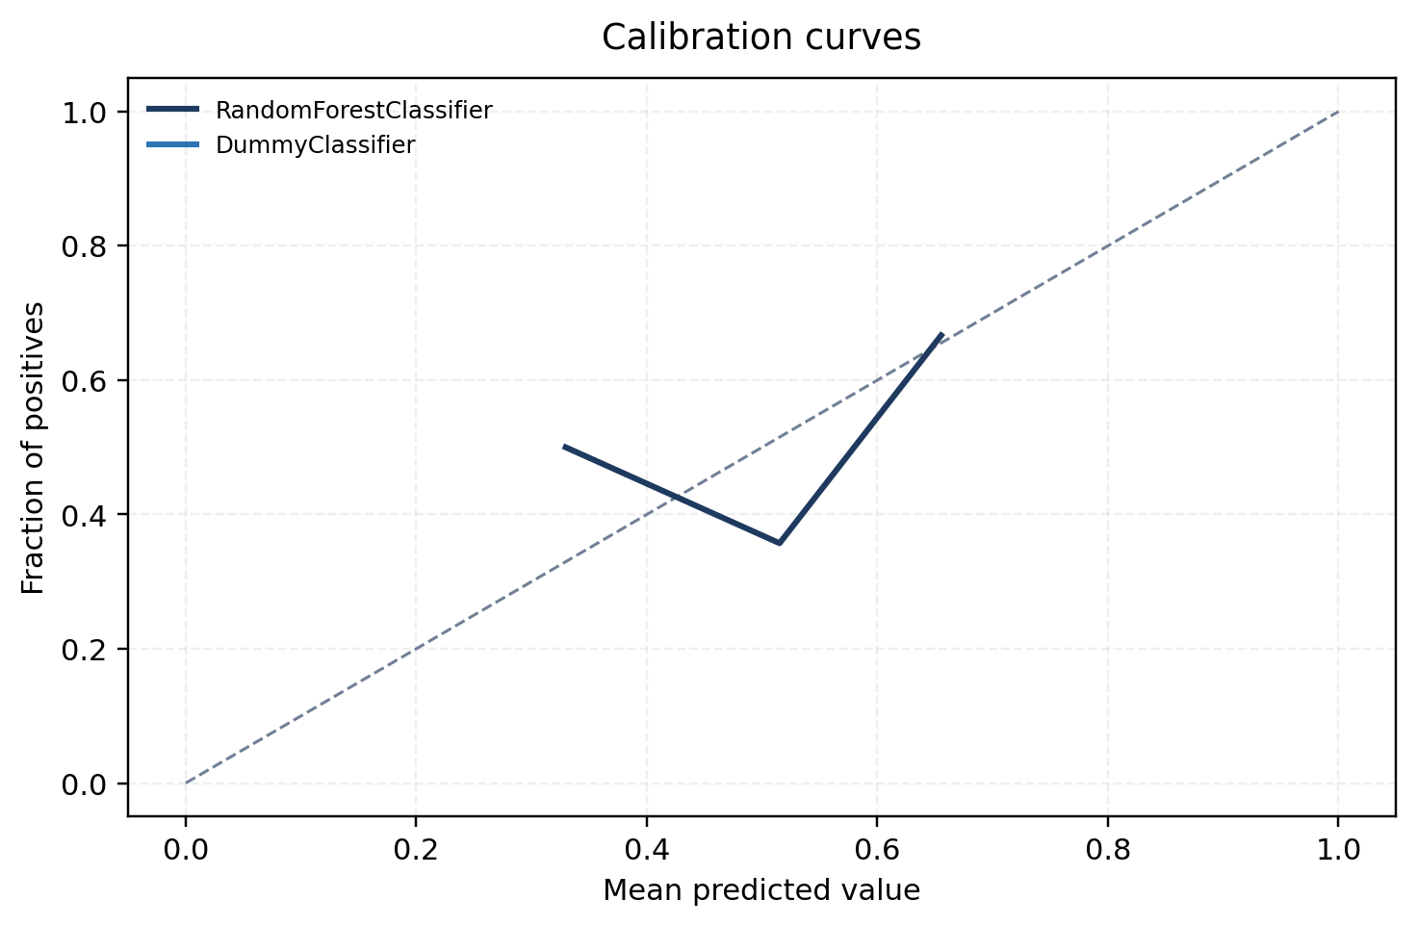
Figure 11. Calibration curves derived from stored probabilities.
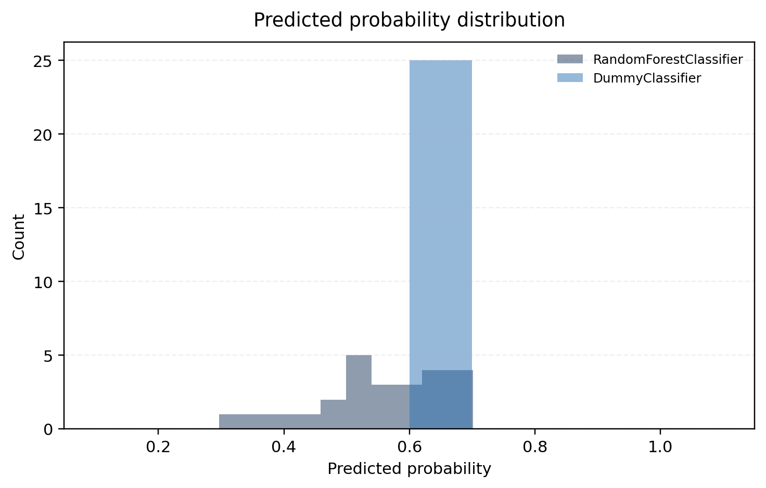
Figure 12. Predicted-probability distributions for the stored leader, threshold leader, and baseline.

Error analysis
- False positives and false negatives can be inspected only through the stored anonymized holdout predictions; no raw user identifiers are exposed.
- Subgroup sample sizes are too small for strong technical claims by topic, student-history bucket, or resource type, so subgroup interpretation should remain descriptive only.
- The confusion matrices show that threshold choice changes the balance between misses and false alarms more than it changes the overall conclusion.

Uncertainty and confidence intervals
- Confidence intervals are read from the stored model comparison CSV.
- Small holdout size and single-teacher coverage mean all uncertainty intervals should be interpreted conservatively.
- Stored overall verdict: Validated - no robust winner.

Runtime and resource performance
Training and inference durations are reported directly from the validated model comparison artifact and shown in Figure 5.

Integrity-review results
- The validated review concludes that this run is suitable as a technical evidence package, but not as a deployment decision.
- All intended models executed successfully in the validated run.
- Artifact consistency checks confirmed shared run ID and data fingerprint across stored outputs.

Conclusions
Interpretation
The comparison did not establish a statistically robust overall winner. Random Forest led several stored evaluation criteria, but the small holdout and single-teacher sample prevent a production-level conclusion.

Reproducibility
- Run ID: 866777f1db54
- Dataset fingerprint: 2e2973e26148420c255bec1a2f49e6d66a73ed1a33fc40acd5734843458b10cf
- Feature schema version: Assigned Resource Open 7d V1
- This report was generated from stored artifacts only; it does not recompute training metrics independently.

Business implementation implications
Interpretation
Recommendation: maintain current production logic, expand teacher coverage, and revisit only after broader validated evidence is available.

Limitations

Appendix

Artifact manifest
Artifact | Purpose | Format | Checksum | Availability
Academic Report Markdown | Academic markdown baseline | md | 6a427e739d | Yes
Dataset Summary JSON | Dataset accounting and counts | json | d308129e29 | Yes
Feature Audit CSV | Feature availability audit | csv | 63a91281e2 | Yes
Frozen Dataset CSV | Stored supporting artifact | csv | 2e2973e261 | Yes
Holdout Predictions CSV | Stored holdout probabilities | csv | 64b7f03690 | Yes
Integrity Review Markdown | Stored supporting artifact | md | 40d44b82ed | Yes
Label Audit CSV | Stored supporting artifact | csv | e48fe47dbe | Yes
Label Reconciliation CSV | Label reconciliation review | csv | 26a345407d | Yes
Model Comparison CSV | Stored model metrics | csv | 00ca70f48d | Yes
Run Summary JSON | Validated run summary | json | e6b8dfd559 | Yes
Technical Report Markdown | Technical markdown baseline | md | 3d0ad6dcea | Yes
Artifact manifest summarizing the technical evidence package without exposing repository paths.

Stored filename: assigned_resource_open_7d_academic_report.md
Stored filename: assigned_resource_open_7d_dataset_summary.json
Stored filename: assigned_resource_open_7d_feature_audit.csv
Stored filename: assigned_resource_open_7d_dataset_frozen.csv
Stored filename: assigned_resource_open_7d_holdout_predictions.csv
Stored filename: assigned_resource_open_7d_integrity_review.md
Stored filename: assigned_resource_open_7d_label_audit.csv
Stored filename: assigned_resource_open_7d_label_reconciliation.csv
Stored filename: assigned_resource_open_7d_model_comparison.csv
Stored filename: assigned_resource_open_7d_run_summary.json
Stored filename: assigned_resource_open_7d_technical_report.md

Full model comparison

Discrimination and ranking
Model | ROC AUC | Average precision | Balanced accuracy | F1 | Delta vs dummy ROC AUC
Majority class rule | 0.5 | 0.710277202668507 | 0.5 | 0.6486486486486487 | —
Dummy classifier | 0.5 | 0.710277202668507 | 0.5 | 0.6486486486486487 | —
Logistic regression | 0.5256410256410257 | 0.4761996037731331 | 0.391025641025641 | 0.2105263157894737 | 0.0256410256410256
Logistic regression (reduced) | 0.6794871794871795 | 0.6472102584234938 | 0.5448717948717949 | 0.2666666666666666 | 0.1794871794871795
Decision tree classifier | 0.5961538461538461 | 0.5540564691299985 | 0.5160256410256411 | 0.4545454545454545 | 0.0961538461538461
Random forest classifier | 0.8269230769230769 | 0.8764753764753763 | 0.7628205128205128 | 0.7692307692307692 | 0.3269230769230768
Histogram gradient boosting classifier | 0.6410256410256411 | 0.5643025754438799 | 0.7243589743589745 | 0.7407407407407408 | 0.141025641025641
Support vector classifier | 0.6410256410256411 | 0.7619506791517662 | 0.6025641025641025 | 0.6153846153846153 | 0.141025641025641
K-nearest neighbors classifier | 0.6538461538461539 | 0.7439451142775951 | 0.5256410256410257 | 0.5714285714285715 | 0.1538461538461538
Readable comparison of stored supervised models using the validated run artifacts.

Calibration and thresholding
Model | Log loss | Brier score | Predicted positive rate | Best F1 | Best balanced accuracy
Majority class rule | 0.7216674799822362 | 0.264 | 1.0 | 0.6486486486486487 | 0.5
Dummy classifier | 0.7216674799822362 | 0.264 | 1.0 | 0.6486486486486487 | 0.5
Logistic regression | 1.052748427570208 | 0.3781862659271294 | 0.28 | 0.7333333333333334 | 0.6891025641025641
Logistic regression (reduced) | 0.843024899127276 | 0.29861011367227 | 0.12 | 0.8 | 0.7692307692307692
Decision tree classifier | 0.9378484235533544 | 0.3374162841607231 | 0.4 | 0.6486486486486487 | 0.7083333333333334
Random forest classifier | 0.604947669170616 | 0.2077426380857454 | 0.56 | 0.6956521739130435 | 0.717948717948718
Histogram gradient boosting classifier | 0.687396449712456 | 0.2429245021301746 | 0.6 | 0.6874999999999999 | 0.6121794871794872
Support vector classifier | 0.6900437279937052 | 0.2471304247730718 | 0.56 | 0.6666666666666666 | 0.75
K-nearest neighbors classifier | 0.6395257728302817 | 0.2393081031335839 | 0.64 | 0.6857142857142856 | 0.7083333333333334
Readable comparison of stored supervised models using the validated run artifacts.

Runtime and status
Model | Status | CV primary metric mean | CV primary metric variance | Train duration (s) | Inference duration (s)
Majority class rule | Success | — | — | — | —
Dummy classifier | Success | 0.5 | — | 0.003332375024911 | 0.0017700829776003
Logistic regression | Success | 0.5574314574314574 | 0.0157121826385895 | 0.0050511250155977 | 0.0019493330037221
Logistic regression (reduced) | Success | 0.5773160173160173 | 0.0178323278132801 | 0.0035093749756924 | 0.0013493750011548
Decision tree classifier | Success | 0.4927272727272728 | 0.0002115702479338 | 0.003642541996669 | 0.0017192079685628
Random forest classifier | Success | 0.5679942279942279 | 0.0265621242313882 | 0.0307852910482324 | 0.003685834002681
Histogram gradient boosting classifier | Success | 0.4985858585858586 | 0.0102559330680542 | 0.0608708329964429 | 0.0048342499649152
Support vector classifier | Success | 0.5438095238095239 | 0.0167736619961728 | 0.0054252080153673 | 0.0019129589782096
K-nearest neighbors classifier | Success | 0.5688600288600287 | 0.0078327900734827 | 0.004272749996744 | 0.0022052080021239
Readable comparison of stored supervised models using the validated run artifacts.

