Centro de Inteligencia Educativa de Classio
Informe Técnico de Ciencia de Datos
Paquete de validación técnica para revisores internos autorizados.
Estado de validación: Validado - sin un ganador concluyente
Generado el 17/07/2026 21:36
Ejecución validada: 866777f1db54
Huella del conjunto de datos: 2e2973e26148...

Control documental y metadatos
Campo | Valor
Estado de la ejecución | Validado - sin un ganador concluyente
Integridad | Passed NO Robust Winner
Madurez | Solo exploratorio
Versión del objetivo | Opened Within 7d V1
Versión del esquema de variables | Assigned Resource Open 7d V1
ID de ejecución | 866777f1db54
Huella del conjunto de datos | 2e2973e26148420c255bec1a2f49e6d66a73ed1a33fc40acd5734843458b10cf
Chronological cutoff | 2026-06-30T17:56:21.615697+00:00

Definición del experimento
Can Classio predict whether a student will open an assigned resource within seven days of assignment?
Prediction target: opened_within_7d, based on assignment-open behavior within a seven-day window.

Tablas fuente y lógica de extracción
- Source tables: teacher_assignments, teacher_assignment_attempts, practice_sessions, resource_exposures, and resource_exposure_events.
- Extraction logic is frozen in the validated run artifacts and summarized in the dataset summary JSON.
- All feature construction is constrained to information known at or before assignment time.

Contabilidad del conjunto de datos
Campo | Valor
Source rows | 127
Included rows | 125
Positives | 72
Negatives | 53
Right-censored | 2
Teachers represented | 1
Students represented | 15
Resources represented | 60
Date range | 2026-04-10T11:54:00.263328+00:00 to 2026-07-12T13:51:10.714517+00:00
Chronological cutoff | 2026-06-30T17:56:21.615697+00:00
Development rows | 100
Holdout rows | 25
Excluded: Observation Window Open | 2

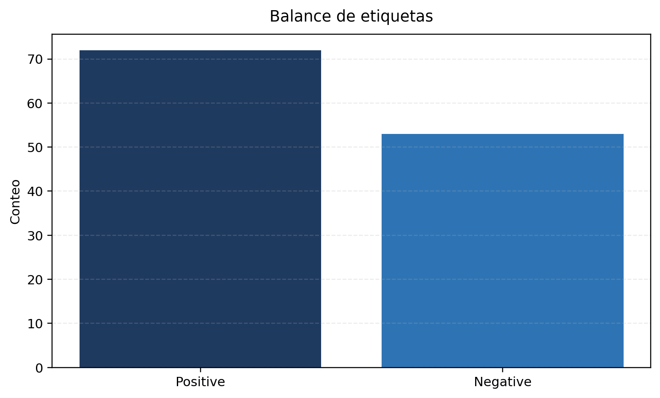
Figure 1. Stored target/class distribution.
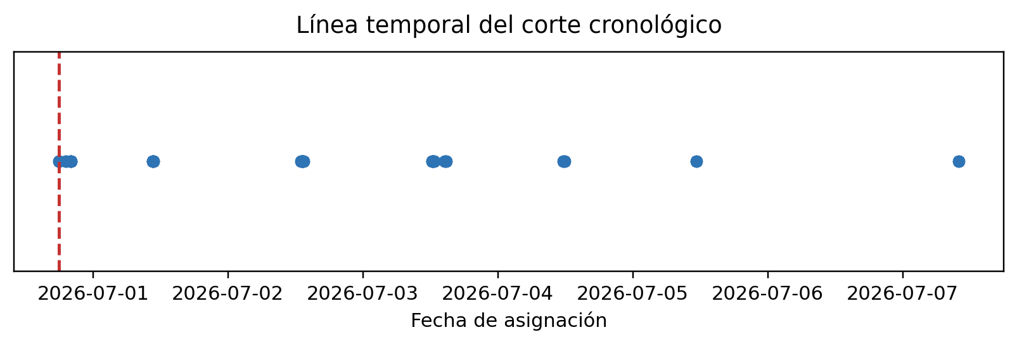
Figure 2. Assignment timeline and chronological split cutoff.

Construcción y conciliación de etiquetas
Campo | Valor
Final verdict | Validado - sin un ganador concluyente
Exact row-level reconciliation | Sí
Legacy audit reconciliation applicable | No
Audit counts | {"negative": 53, "positive": 61, "unknown": 13}
Phase 3 counts | {"negative": 53, "positive": 72, "unknown": 2}

- This run was generated by the current Phase 3.6 pipeline, so historical Phase 3.5 audit-count reconciliation is not required for validation.

Controles contra fuga de información
- Chronological holdout keeps future assignments out of development data.
- Feature timestamps are checked against assignment time to enforce past-only availability.
- Feature missingness explanations in the stored review confirm that sparsity comes from history availability rather than identifier mismatch.

Esquema y salud de variables
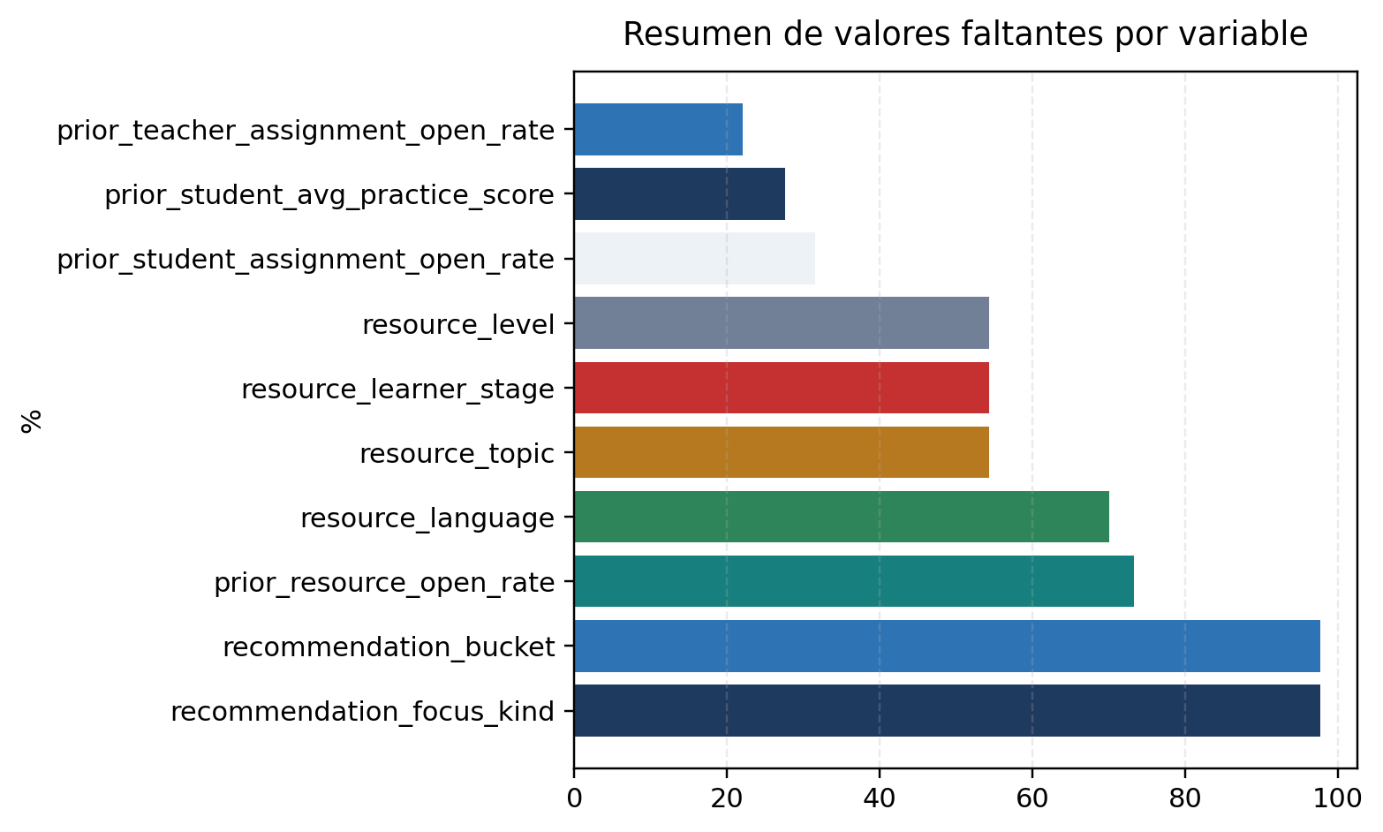
Figure 3. Highest overall missingness rates from the stored feature audit.
Feature | Source | Availability | Overall missing | Dev missing | Holdout missing | Included | Explanation
Prior Student Assignment Open Rate | Stored review | Past-only | 31.5% | 40.0% | 0.0% | Sí | No identifier mismatch was found. Missing values are produced by the feature-construction rule that only uses strictly earlier mature history. For early assignments there is no mature prior history yet; resource-level sparsity is especially severe for prior_resource_open_rate.
Prior Teacher Assignment Open Rate | Stored review | Past-only | 22.05% | 28.0% | 0.0% | Sí | No identifier mismatch was found. Missing values are produced by the feature-construction rule that only uses strictly earlier mature history. For early assignments there is no mature prior history yet; resource-level sparsity is especially severe for prior_resource_open_rate.
Prior Resource Open Rate | Stored review | Past-only | 73.23% | 70.0% | 84.0% | Sí | No identifier mismatch was found. Missing values are produced by the feature-construction rule that only uses strictly earlier mature history. For early assignments there is no mature prior history yet; resource-level sparsity is especially severe for prior_resource_open_rate.
Tabla de salud de variables basada en la auditoría y la revisión almacenadas.

Pipelines de preprocesamiento
- Missing values are imputed only when the stored evaluation pipeline marked the feature as retained.
- Categorical features are encoded within the stored pipeline configuration; no report-time transformation modifies model outcomes.
- Fully missing development-slice features are automatically excluded before fitting, as documented in the integrity review.

Corte cronológico y validación cruzada
- Development rows: 100 with 60 positives.
- Holdout rows: 25 with 12 positives.
- Cross-validation fold counts and mean metrics are read directly from the stored model comparison artifact.

Configuraciones de modelo
Modelo | Status | Selected hyperparameters
Regla de clase mayoritaria | Éxito | Strategy: Majority Class Rule
Clasificador dummy | Éxito | Constant: n/a; Random State: n/a; Strategy: prior
Regresión logística | Éxito | C: 1.0; Class Weight: n/a; Dual: No; Fit Intercept: Yes; Intercept Scaling: 1; L1 Ratio: 0.0; Max Iter: 500; N Jobs: n/a; Penalty: deprecated; Random State: 20260716; Solver: lbfgs; Tol: 0.0001; Verbo
Regresión logística (reducida) | Éxito | C: 1.0; Class Weight: n/a; Dual: No; Fit Intercept: Yes; Intercept Scaling: 1; L1 Ratio: 0.0; Max Iter: 500; N Jobs: n/a; Penalty: deprecated; Random State: 20260716; Solver: lbfgs; Tol: 0.0001; Verbo
Clasificador de árbol de decisión | Éxito | Ccp Alpha: 0.0; Class Weight: n/a; Criterion: gini; Max Depth: 3; Max Features: n/a; Max Leaf Nodes: n/a; Min Impurity Decrease: 0.0; Min Samples Leaf: 4; Min Samples Split: 2; Min Weight Fraction Lea
Clasificador de bosque aleatorio | Éxito | Bootstrap: Yes; Ccp Alpha: 0.0; Class Weight: n/a; Criterion: gini; Max Depth: 4; Max Features: sqrt; Max Leaf Nodes: n/a; Max Samples: n/a; Min Impurity Decrease: 0.0; Min Samples Leaf: 3; Min Sample
Clasificador de boosting por gradiente en histogramas | Éxito | Categorical Features: From Dtype; Class Weight: n/a; Early Stopping: auto; Interaction Cst: n/a; L2 Regularization: 0.0; Learning Rate: 0.08; Loss: Log Loss; Max Bins: 255; Max Depth: 3; Max Features:
Clasificador de vectores de soporte | Éxito | C: 1.0; Break Ties: No; Cache Size: 200; Class Weight: n/a; Coef0: 0.0; Decision Function Shape: ovr; Degree: 3; Gamma: scale; Kernel: rbf; Max Iter: -1; Probability: Yes; Random State: 20260716; Shri
Clasificador de k vecinos más cercanos | Éxito | Algorithm: auto; Leaf Size: 30; Metric: minkowski; Metric Params: n/a; N Jobs: n/a; N Neighbors: 5; P: 2; Weights: distance

Resultados base y comparación
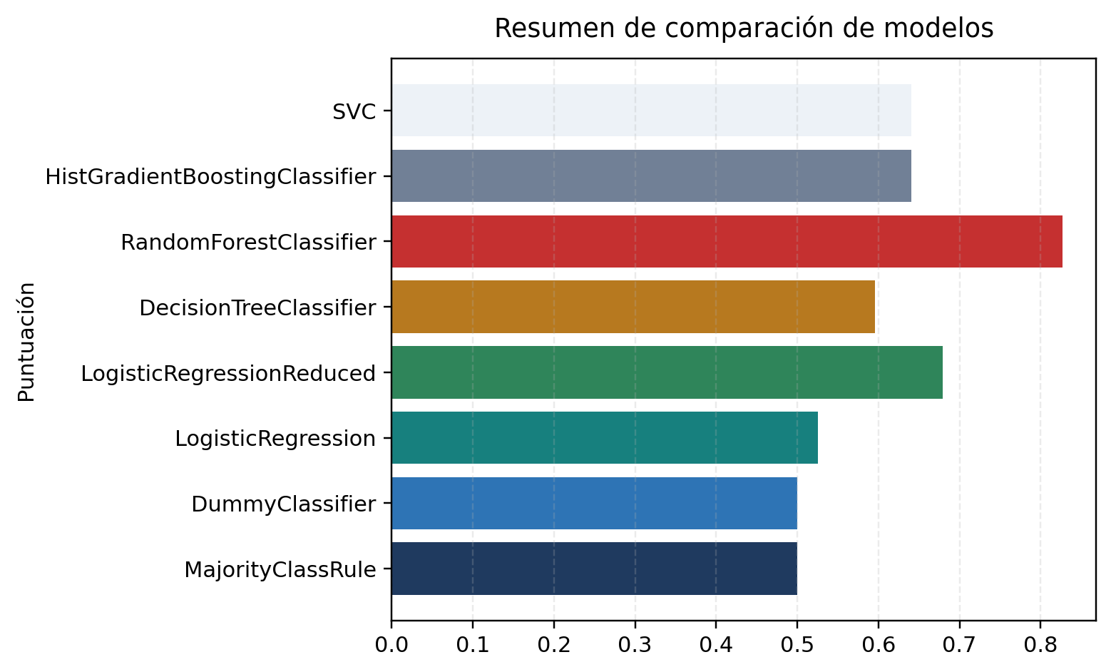
Figure 4. Model metric comparison snapshot using stored ROC AUC values.
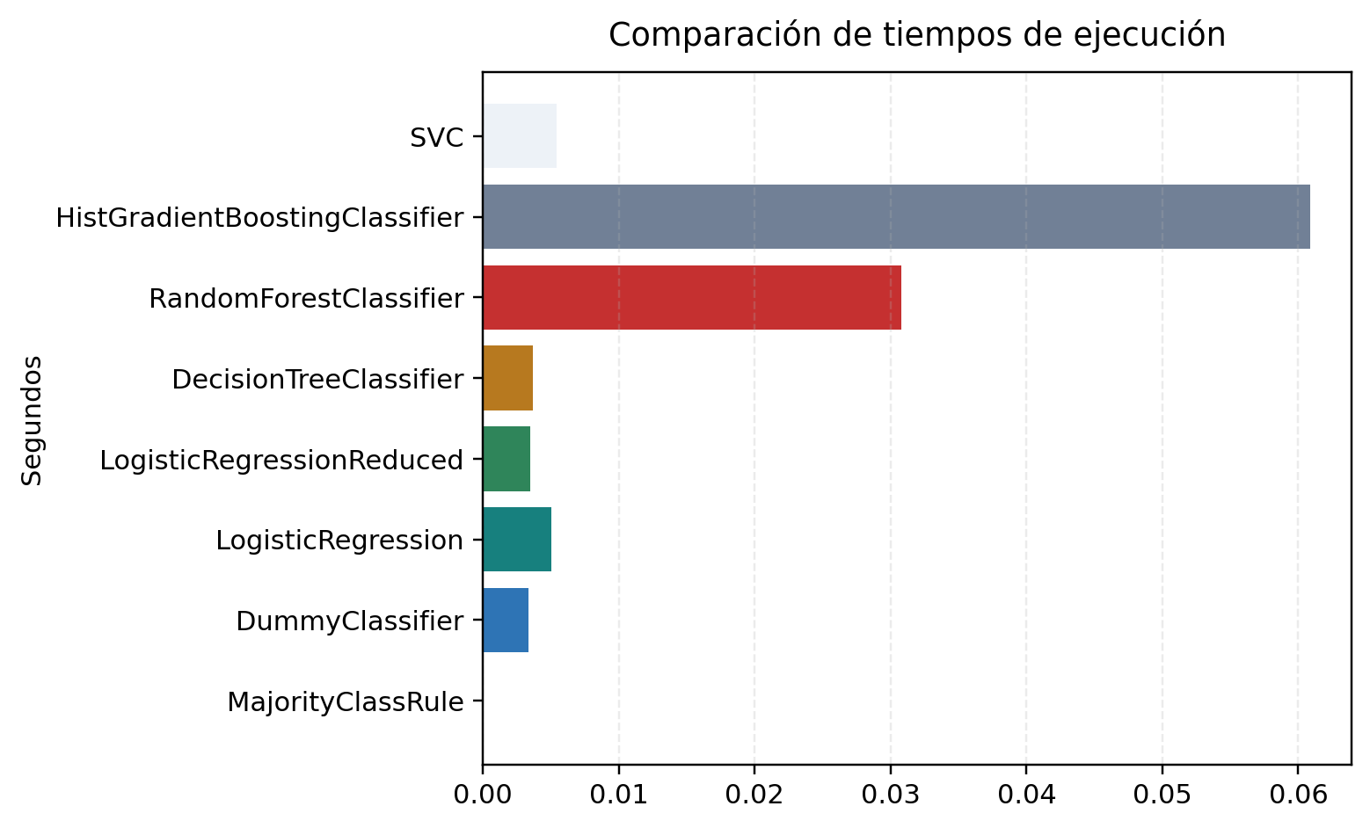
Figure 5. Training-runtime comparison from stored model outputs.

Análisis de umbrales
Campo | Valor
Primary ROC leader | Clasificador de bosque aleatorio
Best thresholded classifier | Clasificador de bosque aleatorio
Calibration leader | Clasificador de bosque aleatorio
Best precision-recall ranking | Clasificador de bosque aleatorio

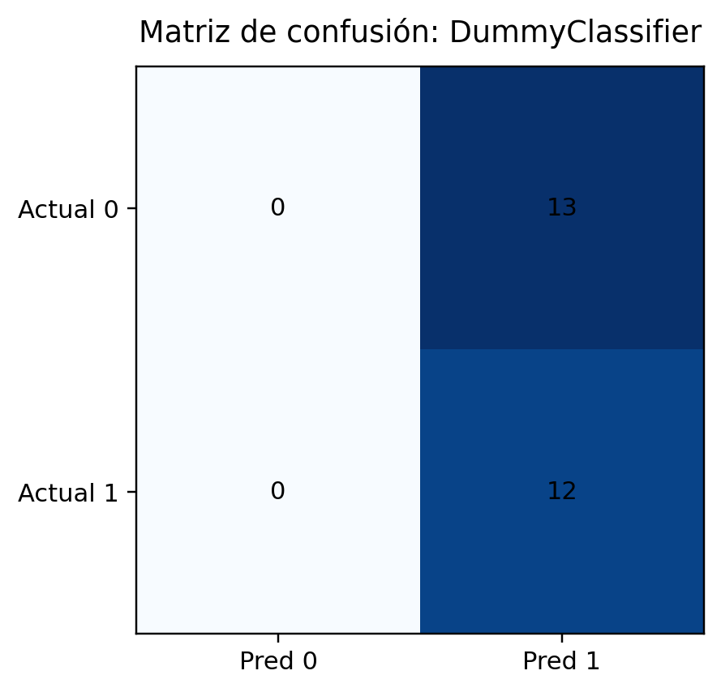
Figure 6. Confusion matrix for the stored baseline.
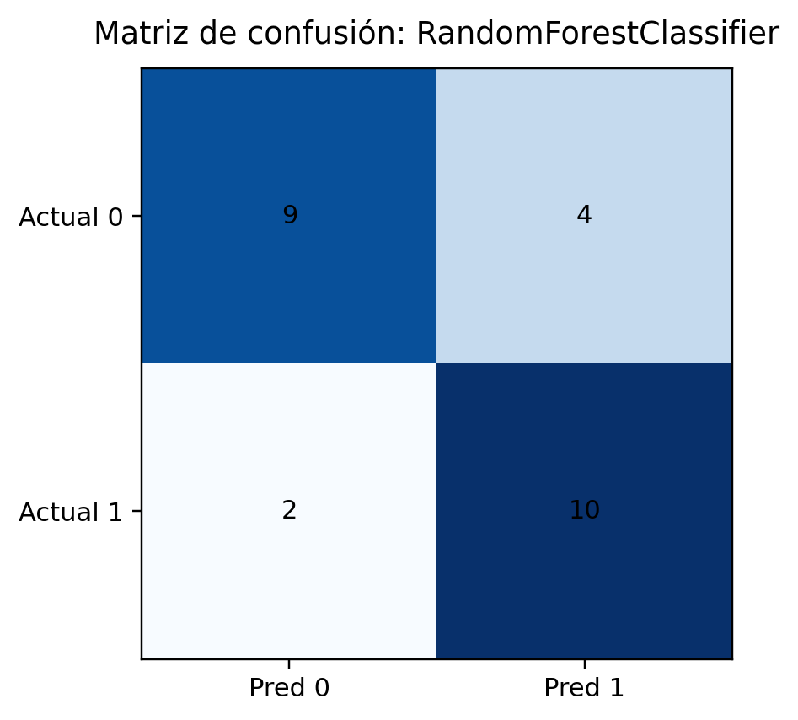
Figure 7. Confusion matrix for the primary ROC leader.

Análisis ROC
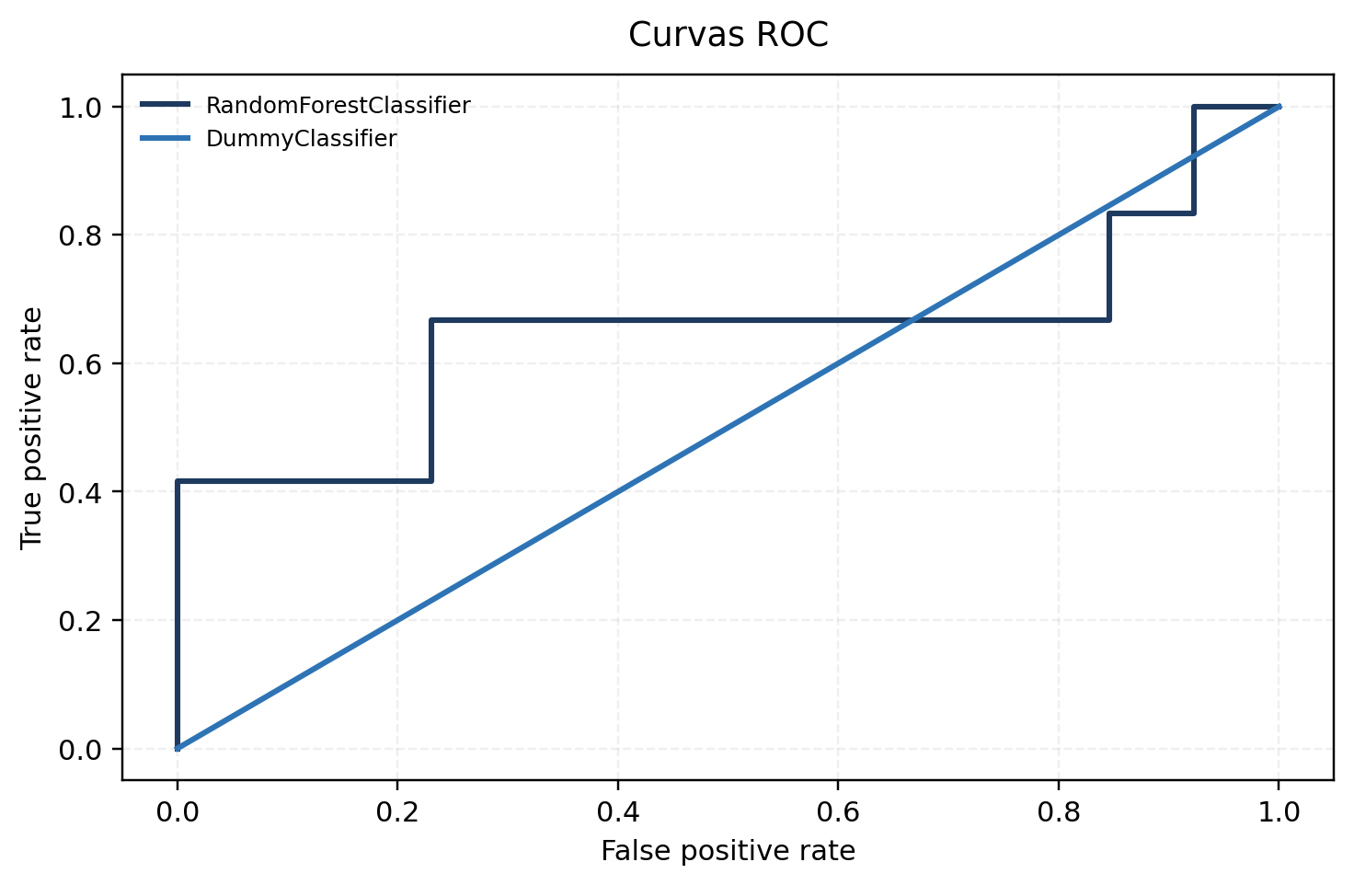
Figure 9. ROC curves for score-capable stored models.
La comparación no estableció un ganador global estadísticamente robusto. Random Forest lideró varios criterios almacenados, pero el holdout pequeño y la muestra de un solo docente impiden una conclusión apta para producción.

Análisis precision-recall
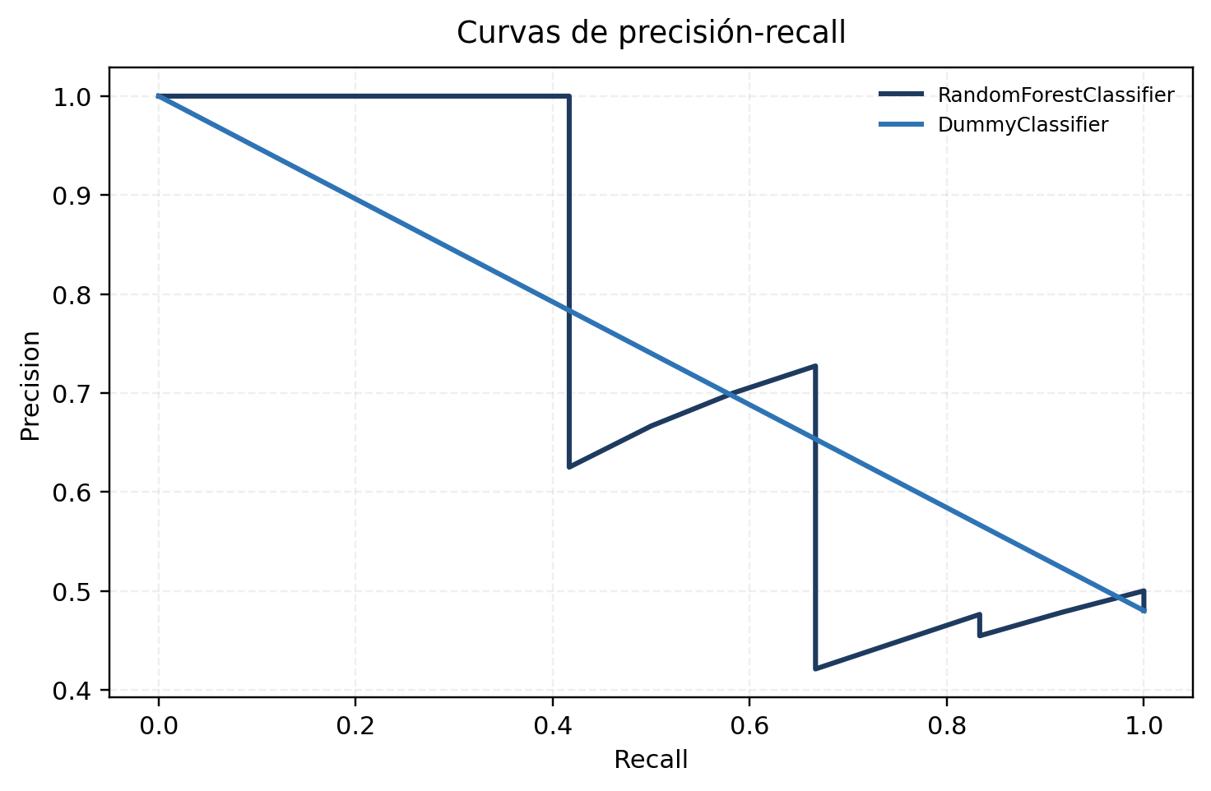
Figure 10. Precision-recall curves for the same stored holdout predictions.

Análisis de calibración
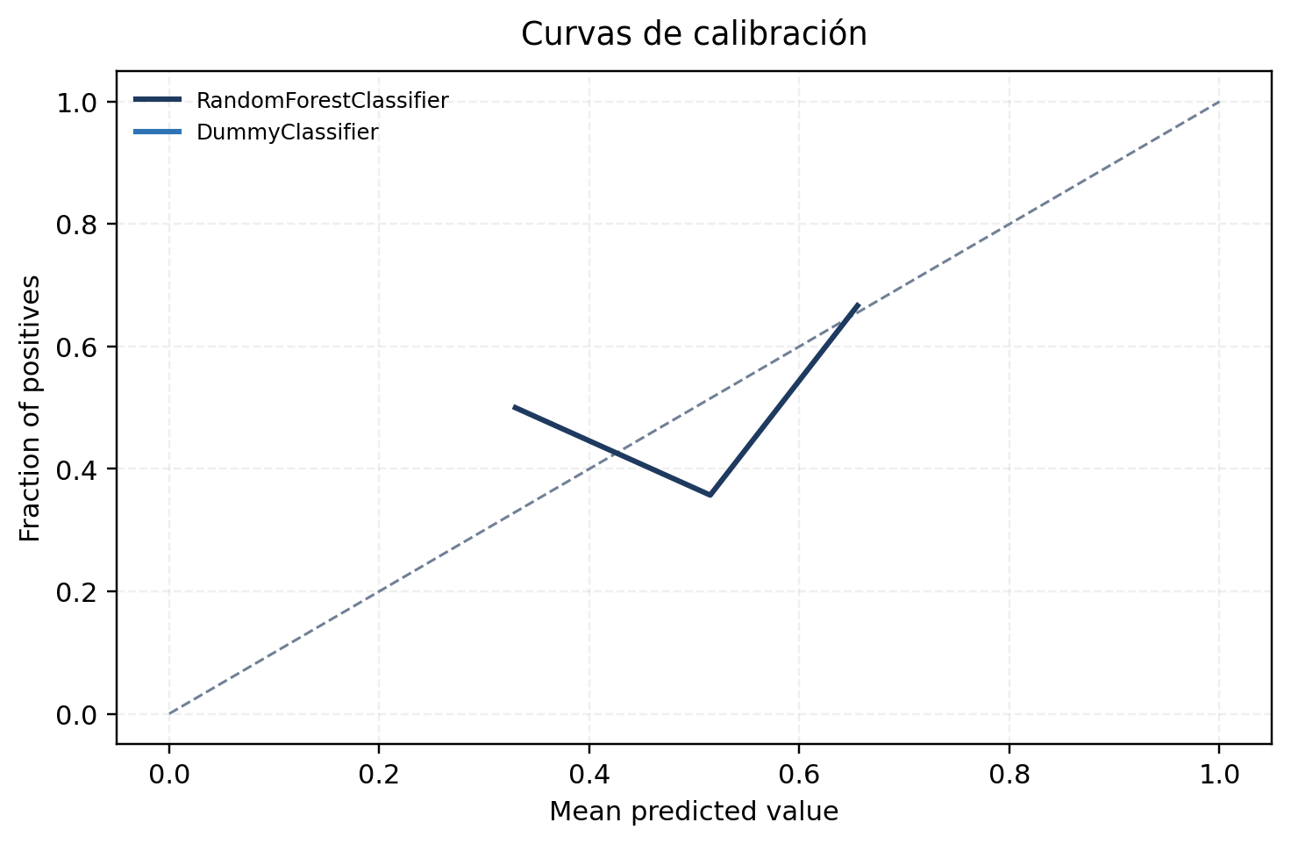
Figure 11. Calibration curves derived from stored probabilities.
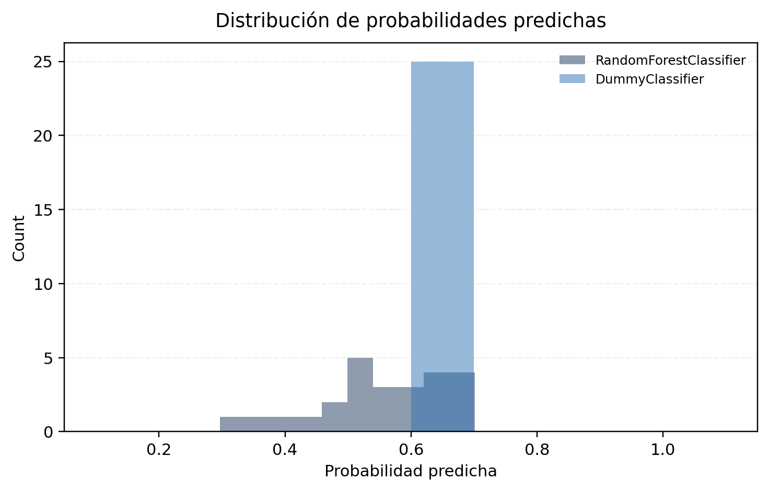
Figure 12. Predicted-probability distributions for the stored leader, threshold leader, and baseline.

Análisis de errores
- False positives and false negatives can be inspected only through the stored anonymized holdout predictions; no raw user identifiers are exposed.
- Subgroup sample sizes are too small for strong technical claims by topic, student-history bucket, or resource type, so subgroup interpretation should remain descriptive only.
- The confusion matrices show that threshold choice changes the balance between misses and false alarms more than it changes the overall conclusion.

Incertidumbre e intervalos de confianza
- Confidence intervals are read from the stored model comparison CSV.
- Small holdout size and single-teacher coverage mean all uncertainty intervals should be interpreted conservatively.
- Stored overall verdict: Validado - sin un ganador concluyente.

Rendimiento temporal y recursos
Training and inference durations are reported directly from the validated model comparison artifact and shown in Figure 5.

Resultados de la revisión de integridad
- La revisión validada concluye que esta ejecución sirve como paquete de evidencia técnica, pero no como decisión de despliegue.
- All intended models executed successfully in the validated run.
- Artifact consistency checks confirmed shared run ID and data fingerprint across stored outputs.

Conclusiones
Interpretación
La comparación no estableció un ganador global estadísticamente robusto. Random Forest lideró varios criterios almacenados, pero el holdout pequeño y la muestra de un solo docente impiden una conclusión apta para producción.

Reproducibilidad
- Run ID: 866777f1db54
- Dataset fingerprint: 2e2973e26148420c255bec1a2f49e6d66a73ed1a33fc40acd5734843458b10cf
- Feature schema version: Assigned Resource Open 7d V1
- This report was generated from stored artifacts only; it does not recompute training metrics independently.

Implicaciones de implementación
Interpretación
Recommendation: maintain current production logic, expand teacher coverage, and revisit only after broader validated evidence is available.

Limitaciones
- No se registraron riesgos validados adicionales para esta ejecución.

Apéndice

Manifiesto de artefactos
Artefacto | Propósito | Formato | Checksum | Disponibilidad
Findings Interpretation Report Markdown | Findings interpretation markdown baseline | md | 6a427e739d | Sí
Dataset Summary JSON | Dataset accounting and counts | json | d308129e29 | Sí
Feature Audit CSV | Feature availability audit | csv | 63a91281e2 | Sí
Findings Interpretation Report Markdown | Findings interpretation markdown baseline | md | 6a427e739d | Sí
Frozen Dataset CSV | Stored supporting artifact | csv | 2e2973e261 | Sí
Holdout Predictions CSV | Stored holdout probabilities | csv | 64b7f03690 | Sí
Integrity Review Markdown | Stored supporting artifact | md | 40d44b82ed | Sí
Label Audit CSV | Stored supporting artifact | csv | e48fe47dbe | Sí
Label Reconciliation CSV | Label reconciliation review | csv | 26a345407d | Sí
Model Comparison CSV | Stored model metrics | csv | 00ca70f48d | Sí
Run Summary JSON | Validated run summary | json | e6b8dfd559 | Sí
Technical Report Markdown | Technical markdown baseline | md | 3d0ad6dcea | Sí
Manifiesto de artefactos del paquete técnico sin exponer rutas del repositorio.

Nombre almacenado: assigned_resource_open_7d_academic_report.md
Nombre almacenado: assigned_resource_open_7d_dataset_summary.json
Nombre almacenado: assigned_resource_open_7d_feature_audit.csv
Nombre almacenado: assigned_resource_open_7d_academic_report.md
Nombre almacenado: assigned_resource_open_7d_dataset_frozen.csv
Nombre almacenado: assigned_resource_open_7d_holdout_predictions.csv
Nombre almacenado: assigned_resource_open_7d_integrity_review.md
Nombre almacenado: assigned_resource_open_7d_label_audit.csv
Nombre almacenado: assigned_resource_open_7d_label_reconciliation.csv
Nombre almacenado: assigned_resource_open_7d_model_comparison.csv
Nombre almacenado: assigned_resource_open_7d_run_summary.json
Nombre almacenado: assigned_resource_open_7d_technical_report.md

Full model comparison

Discrimination and ranking
Modelo | ROC AUC | Precisión media | Exactitud balanceada | F1 | Delta vs dummy en ROC AUC
Regla de clase mayoritaria | 0.5 | 0.710277202668507 | 0.5 | 0.6486486486486487 | —
Clasificador dummy | 0.5 | 0.710277202668507 | 0.5 | 0.6486486486486487 | —
Regresión logística | 0.5256410256410257 | 0.4761996037731331 | 0.391025641025641 | 0.2105263157894737 | 0.0256410256410256
Regresión logística (reducida) | 0.6794871794871795 | 0.6472102584234938 | 0.5448717948717949 | 0.2666666666666666 | 0.1794871794871795
Clasificador de árbol de decisión | 0.5961538461538461 | 0.5540564691299985 | 0.5160256410256411 | 0.4545454545454545 | 0.0961538461538461
Clasificador de bosque aleatorio | 0.8269230769230769 | 0.8764753764753763 | 0.7628205128205128 | 0.7692307692307692 | 0.3269230769230768
Clasificador de boosting por gradiente en histogramas | 0.6410256410256411 | 0.5643025754438799 | 0.7243589743589745 | 0.7407407407407408 | 0.141025641025641
Clasificador de vectores de soporte | 0.6410256410256411 | 0.7619506791517662 | 0.6025641025641025 | 0.6153846153846153 | 0.141025641025641
Clasificador de k vecinos más cercanos | 0.6538461538461539 | 0.7439451142775951 | 0.5256410256410257 | 0.5714285714285715 | 0.1538461538461538
Comparación legible de los modelos supervisados almacenados en la ejecución validada.

Calibration and thresholding
Modelo | Pérdida logarítmica | Puntuación de Brier | Tasa positiva predicha | Mejor F1 | Mejor exactitud balanceada
Regla de clase mayoritaria | 0.7216674799822362 | 0.264 | 1.0 | 0.6486486486486487 | 0.5
Clasificador dummy | 0.7216674799822362 | 0.264 | 1.0 | 0.6486486486486487 | 0.5
Regresión logística | 1.052748427570208 | 0.3781862659271294 | 0.28 | 0.7333333333333334 | 0.6891025641025641
Regresión logística (reducida) | 0.843024899127276 | 0.29861011367227 | 0.12 | 0.8 | 0.7692307692307692
Clasificador de árbol de decisión | 0.9378484235533544 | 0.3374162841607231 | 0.4 | 0.6486486486486487 | 0.7083333333333334
Clasificador de bosque aleatorio | 0.604947669170616 | 0.2077426380857454 | 0.56 | 0.6956521739130435 | 0.717948717948718
Clasificador de boosting por gradiente en histogramas | 0.687396449712456 | 0.2429245021301746 | 0.6 | 0.6874999999999999 | 0.6121794871794872
Clasificador de vectores de soporte | 0.6900437279937052 | 0.2471304247730718 | 0.56 | 0.6666666666666666 | 0.75
Clasificador de k vecinos más cercanos | 0.6395257728302817 | 0.2393081031335839 | 0.64 | 0.6857142857142856 | 0.7083333333333334
Comparación legible de los modelos supervisados almacenados en la ejecución validada.

Runtime and status
Modelo | Estado | Media de la métrica principal en VC | Varianza de la métrica principal en VC | Duración de entrenamiento (s) | Duración de inferencia (s)
Regla de clase mayoritaria | Éxito | — | — | — | —
Clasificador dummy | Éxito | 0.5 | — | 0.003332375024911 | 0.0017700829776003
Regresión logística | Éxito | 0.5574314574314574 | 0.0157121826385895 | 0.0050511250155977 | 0.0019493330037221
Regresión logística (reducida) | Éxito | 0.5773160173160173 | 0.0178323278132801 | 0.0035093749756924 | 0.0013493750011548
Clasificador de árbol de decisión | Éxito | 0.4927272727272728 | 0.0002115702479338 | 0.003642541996669 | 0.0017192079685628
Clasificador de bosque aleatorio | Éxito | 0.5679942279942279 | 0.0265621242313882 | 0.0307852910482324 | 0.003685834002681
Clasificador de boosting por gradiente en histogramas | Éxito | 0.4985858585858586 | 0.0102559330680542 | 0.0608708329964429 | 0.0048342499649152
Clasificador de vectores de soporte | Éxito | 0.5438095238095239 | 0.0167736619961728 | 0.0054252080153673 | 0.0019129589782096
Clasificador de k vecinos más cercanos | Éxito | 0.5688600288600287 | 0.0078327900734827 | 0.004272749996744 | 0.0022052080021239
Comparación legible de los modelos supervisados almacenados en la ejecución validada.

