Classio Educational Intelligence Center
Technical Data Science Report
Technical validation package for authorized internal reviewers.
Validation status: Validated - no robust winner
Generated on 2026-07-20 10:19
Validated run: ebcf382089d2
Dataset fingerprint: 6725ffb449de...

Decision Summary
Field | Value
Experiment | assigned_resource_open_within_7d
Business problem | Teachers frequently assign resources that students ignore. If Classio can predict ignored assignments before they occur, the platform can recommend alternative resources or suggest teacher intervention. The core question is whether Classio can predict if a student will open an assigned resource within seven days of assignment.
Decision supported | Improve the teacher recommendation system.
Current evidence status | Validated evidence
Robust winner | No
Model leader | Random forest classifier
Next review trigger | When teacher usage of the application increases.
Responsible person or team | Anthony Gonzalez
Main limitation | The dataset is currently constrained by the participation of only a single teacher.

Interpretation
The decision to continue collecting data is supported. The primary objective is to enhance the teacher recommendation system to drive higher student retention.

What the evidence says
The experiment evaluated the predictive capability of the RandomForestClassifier in determining whether a student will open an assigned resource within seven days of assignment. Based on 126 rows of data involving 15 students and 61 resources, the model achieved validated results; however, the experiment yielded no robust winner, resulting in an exploratory-only maturity verdict.

What it does not prove
The current results do not definitively prove whether specific resource content is the primary driver for non-engagement.

What Classio should do next
Implementation is currently limited to exploratory testing. Future deployment should focus on expanding teacher coverage to increase dataset volume and improve model maturity.

Business and educational context
Field | Value
Why this experiment is being evaluated | Teachers frequently assign resources that students ignore. If Classio can predict ignored assignments before they occur, the platform can recommend alternative resources or suggest teacher intervention. The core question is whether Classio can predict if a student will open an assigned resource within seven days of assignment.
Decision supported | Improve the teacher recommendation system.
Expected value | Increased retention.
Product impact | Improvements to the recommendation system.
Success definition | The predictive capability itself.
Minimum evidence required | The predictive capability itself.
Risks | Variability in student class frequency.

Business readiness scorecard
Dimension | Status | Interpretation
Data coverage | Moderate | 126 labels
Teacher diversity | Limited | 1 teacher(s)
Feature readiness | Moderate | Stored feature audit available.
Model discrimination | Moderate | The comparison did not establish a statistically robust overall winner. Random Forest led several stored evaluation criteria, but the small holdout and single-teacher sample prevent a production-level conclusion.
Calibration | Moderate | Random forest classifier
Production readiness | Insufficient | Validated - no robust winner
Business-context completeness | Moderate | 17/17

Action plan
Priority | Action | Reason | Owner | Trigger or deadline | Status
High | Expand teacher coverage | Current evidence comes from one teacher. | Anthony Gonzalez | At least five teachers represented | Open
Medium | Continue collecting labels | Current validated sample is still limited. | Anthony Gonzalez | 500 additional mature labels | Open
Medium | Regenerate report after context review | Business context improves meeting readiness. | Anthony Gonzalez | cuando más profesores utilicen la app | Open

Document control and metadata
Field | Value
Run status | Validated - no robust winner
Integrity | Passed no robust winner
Maturity | Exploratory only
Target version | Opened Within 7d V1
Feature schema version | Assigned Resource Open 7d V1
Run ID | ebcf382089d2
Dataset fingerprint | 6725ffb449deb229c08f83469e2d3b0a32c68fea72e519a1d18f621f9028c5a4
Chronological cutoff | 2026-06-30T17:56:21.615697+00:00
Business context supplied by | e109dd3c-8e12-4db4-bf64-91a856719317
Context last updated | 2026-07-20T05:57:08.397491+00:00
AI-assisted wording | Yes
Report language | EN
Report version | 6

Experiment definition
Can Classio predict whether a student will open an assigned resource within seven days?
Prediction target: opened_within_7d, based on assignment-open behavior within a seven-day window.

Source tables and extraction logic
- Source tables: teacher_assignments, teacher_assignment_attempts, practice_sessions, resource_exposures, and resource_exposure_events.
- Extraction logic is frozen in the validated run artifacts and summarized in the dataset summary JSON.
- All feature construction is constrained to information known at or before assignment time.

Dataset accounting
Field | Value
Source rows | 128
Included rows | 126
Positive labels | 73
Negative labels | 53
Right-censored | 2
Teachers represented | 1
Students represented | 15
Resources represented | 61
Date range | 2026-04-10T11:54:00.263328+00:00 to 2026-07-17T17:21:47.105912+00:00
Chronological cutoff | 2026-06-30T17:56:21.615697+00:00
Development rows | 100
Holdout rows | 26
Observation Window Open | 2

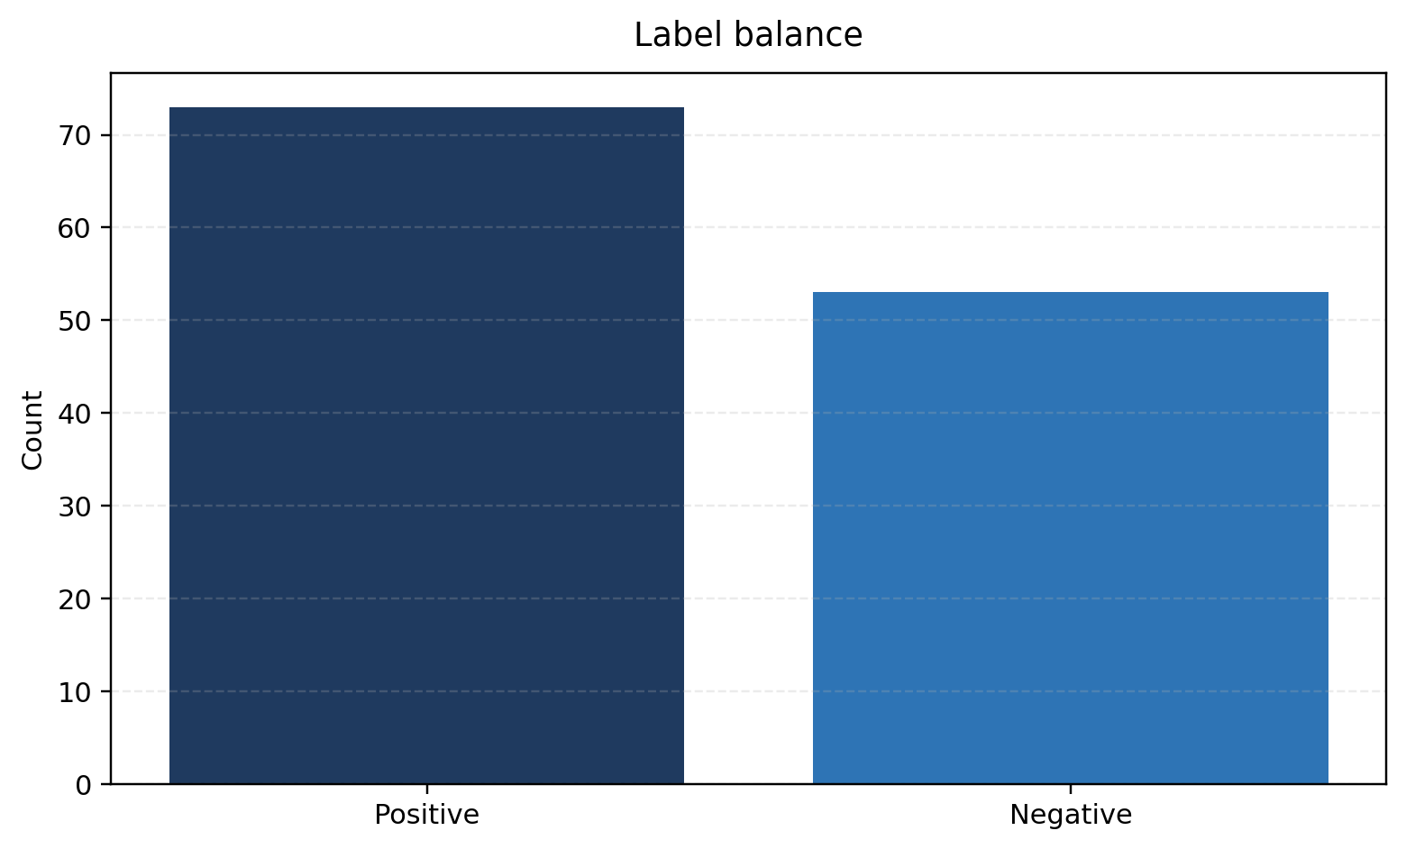
Figure 1. Stored target/class distribution.
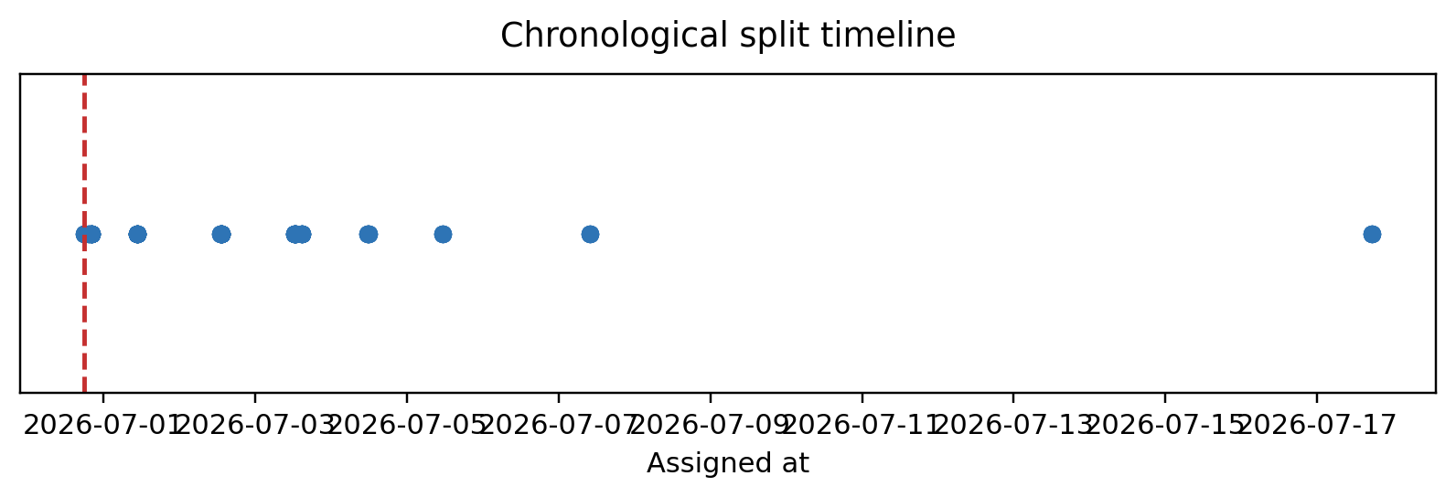
Figure 2. Assignment timeline and chronological split cutoff.

Label construction and reconciliation
Field | Value
Final verdict | Validated - no robust winner
Exact row-level reconciliation | Yes
Legacy audit reconciliation applicable | No
Audit counts | {"negative": 53, "positive": 61, "unknown": 13}
Phase 3 counts | {"negative": 53, "positive": 73, "unknown": 2}

- This run was generated by the current Phase 3.6 pipeline, so historical Phase 3.5 audit-count reconciliation is not required for validation.

Leakage controls
- Chronological holdout keeps future assignments out of development data.
- Feature timestamps are checked against assignment time to enforce past-only availability.
- Feature missingness explanations in the stored review confirm that sparsity comes from history availability rather than identifier mismatch.

Feature schema and feature health
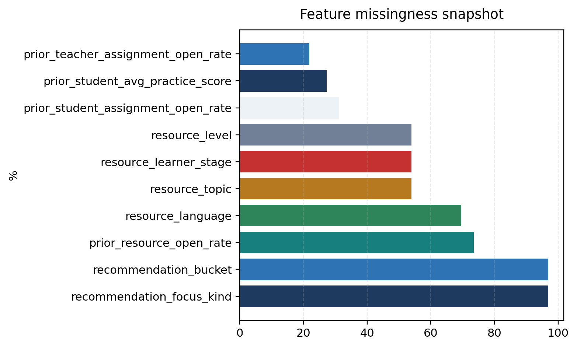
Figure 3. Highest overall missingness rates from the stored feature audit.
Feature | Source | Availability | Overall missing | Dev missing | Holdout missing | Included | Explanation
Prior Student Assignment Open Rate | Stored review | Past-only | 31.25% | 40.0% | 0.0% | Yes | No identifier mismatch was found. Missing values are produced by the feature-construction rule that only uses strictly earlier mature history. For early assignments there is no mature prior history yet; resource-level sparsity is especially severe for prior_resource_open_rate.
Prior Teacher Assignment Open Rate | Stored review | Past-only | 21.88% | 28.0% | 0.0% | Yes | No identifier mismatch was found. Missing values are produced by the feature-construction rule that only uses strictly earlier mature history. For early assignments there is no mature prior history yet; resource-level sparsity is especially severe for prior_resource_open_rate.
Prior Resource Open Rate | Stored review | Past-only | 73.44% | 70.0% | 84.62% | Yes | No identifier mismatch was found. Missing values are produced by the feature-construction rule that only uses strictly earlier mature history. For early assignments there is no mature prior history yet; resource-level sparsity is especially severe for prior_resource_open_rate.
Feature-health table using the stored audit and review output.

Preprocessing pipelines
- Missing values are imputed only when the stored evaluation pipeline marked the feature as retained.
- Categorical features are encoded within the stored pipeline configuration; no report-time transformation modifies model outcomes.
- Fully missing development-slice features are automatically excluded before fitting, as documented in the integrity review.

Chronological split and cross-validation
- Development rows: 100 with 60 positives.
- Holdout rows: 26 with 13 positives.
- Cross-validation fold counts and mean metrics are read directly from the stored model comparison artifact.

Model configurations
Model | Status | Selected hyperparameters
Majority class rule | Success | Strategy: Majority Class Rule
Dummy classifier | Success | Constant: n/a; Random State: n/a; Strategy: prior
Logistic regression | Success | C: 1.0; Class Weight: n/a; Dual: No; Fit Intercept: Yes; Intercept Scaling: 1; L1 Ratio: 0.0; Max Iter: 500; N Jobs: n/a; Penalty: deprecated; Random State: 20260716; Solver: lbfgs; Tol: 0.0001; Verbo
Logistic regression (reduced) | Success | C: 1.0; Class Weight: n/a; Dual: No; Fit Intercept: Yes; Intercept Scaling: 1; L1 Ratio: 0.0; Max Iter: 500; N Jobs: n/a; Penalty: deprecated; Random State: 20260716; Solver: lbfgs; Tol: 0.0001; Verbo
Decision tree classifier | Success | Ccp Alpha: 0.0; Class Weight: n/a; Criterion: gini; Max Depth: 3; Max Features: n/a; Max Leaf Nodes: n/a; Min Impurity Decrease: 0.0; Min Samples Leaf: 4; Min Samples Split: 2; Min Weight Fraction Lea
Random forest classifier | Success | Bootstrap: Yes; Ccp Alpha: 0.0; Class Weight: n/a; Criterion: gini; Max Depth: 4; Max Features: sqrt; Max Leaf Nodes: n/a; Max Samples: n/a; Min Impurity Decrease: 0.0; Min Samples Leaf: 3; Min Sample
Histogram gradient boosting classifier | Success | Categorical Features: From Dtype; Class Weight: n/a; Early Stopping: auto; Interaction Cst: n/a; L2 Regularization: 0.0; Learning Rate: 0.08; Loss: Log Loss; Max Bins: 255; Max Depth: 3; Max Features:
Support vector classifier | Success | C: 1.0; Break Ties: No; Cache Size: 200; Class Weight: n/a; Coef0: 0.0; Decision Function Shape: ovr; Degree: 3; Gamma: scale; Kernel: rbf; Max Iter: -1; Probability: Yes; Random State: 20260716; Shri
K-nearest neighbors classifier | Success | Algorithm: auto; Leaf Size: 30; Metric: minkowski; Metric Params: n/a; N Jobs: n/a; N Neighbors: 5; P: 2; Weights: distance

Baseline and comparison results
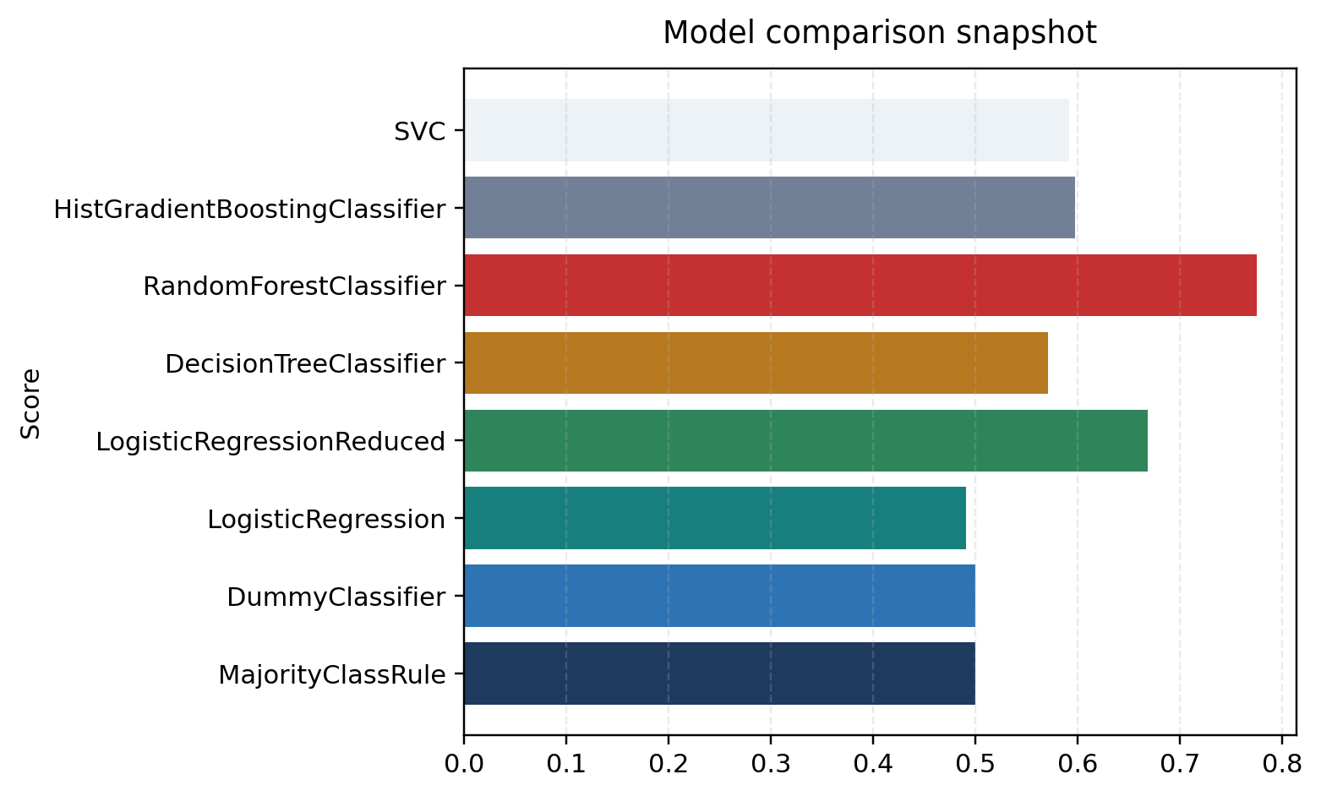
Figure 4. Model metric comparison snapshot using stored ROC AUC values.
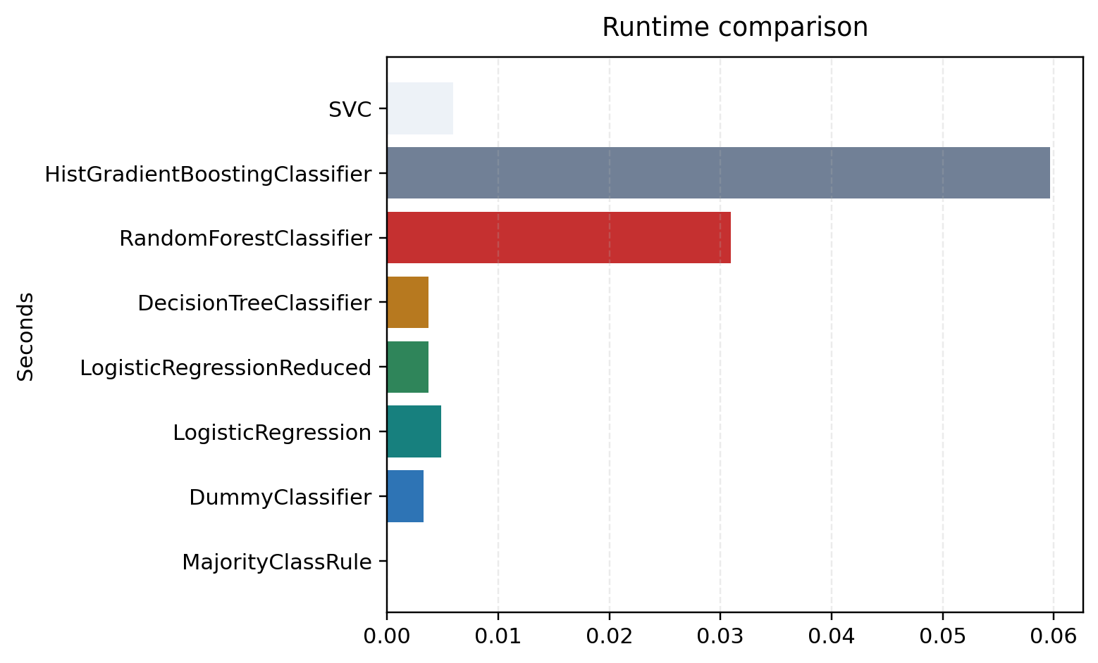
Figure 5. Training-runtime comparison from stored model outputs.

Threshold analysis
Field | Value
Primary ROC leader | Random forest classifier
Best thresholded classifier | Random forest classifier
Calibration leader | Random forest classifier
Best precision-recall ranking | Random forest classifier

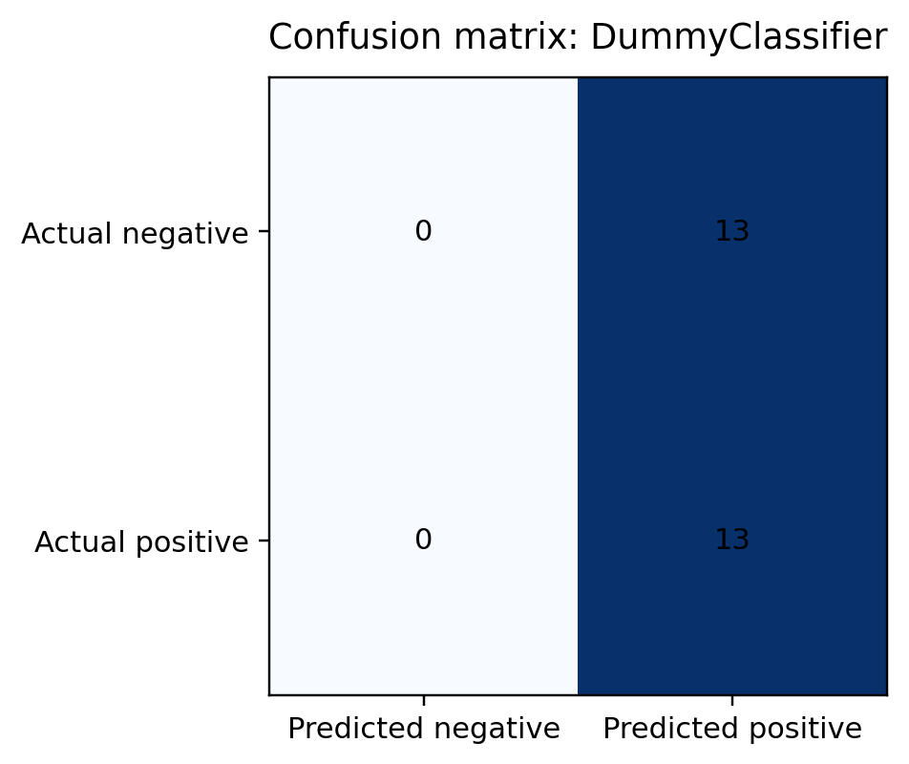
Figure 6. Confusion matrix for the stored baseline.
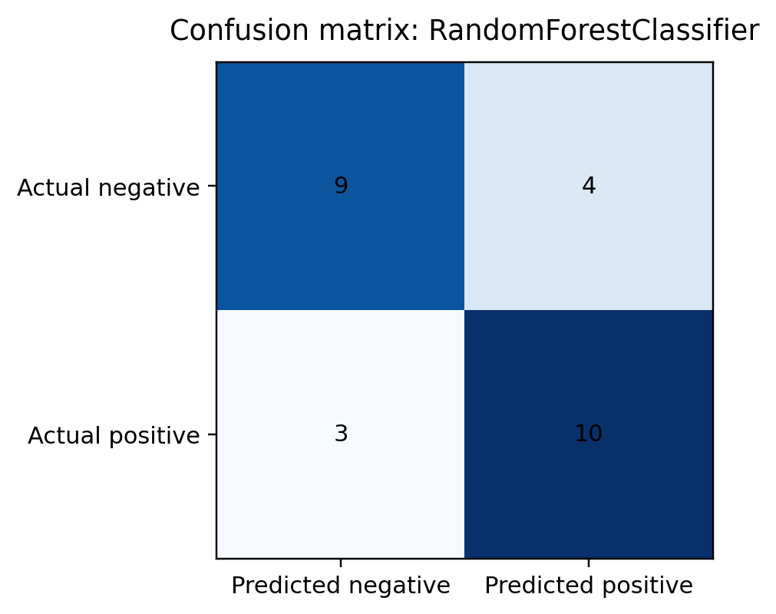
Figure 7. Confusion matrix for the primary ROC leader.

ROC analysis
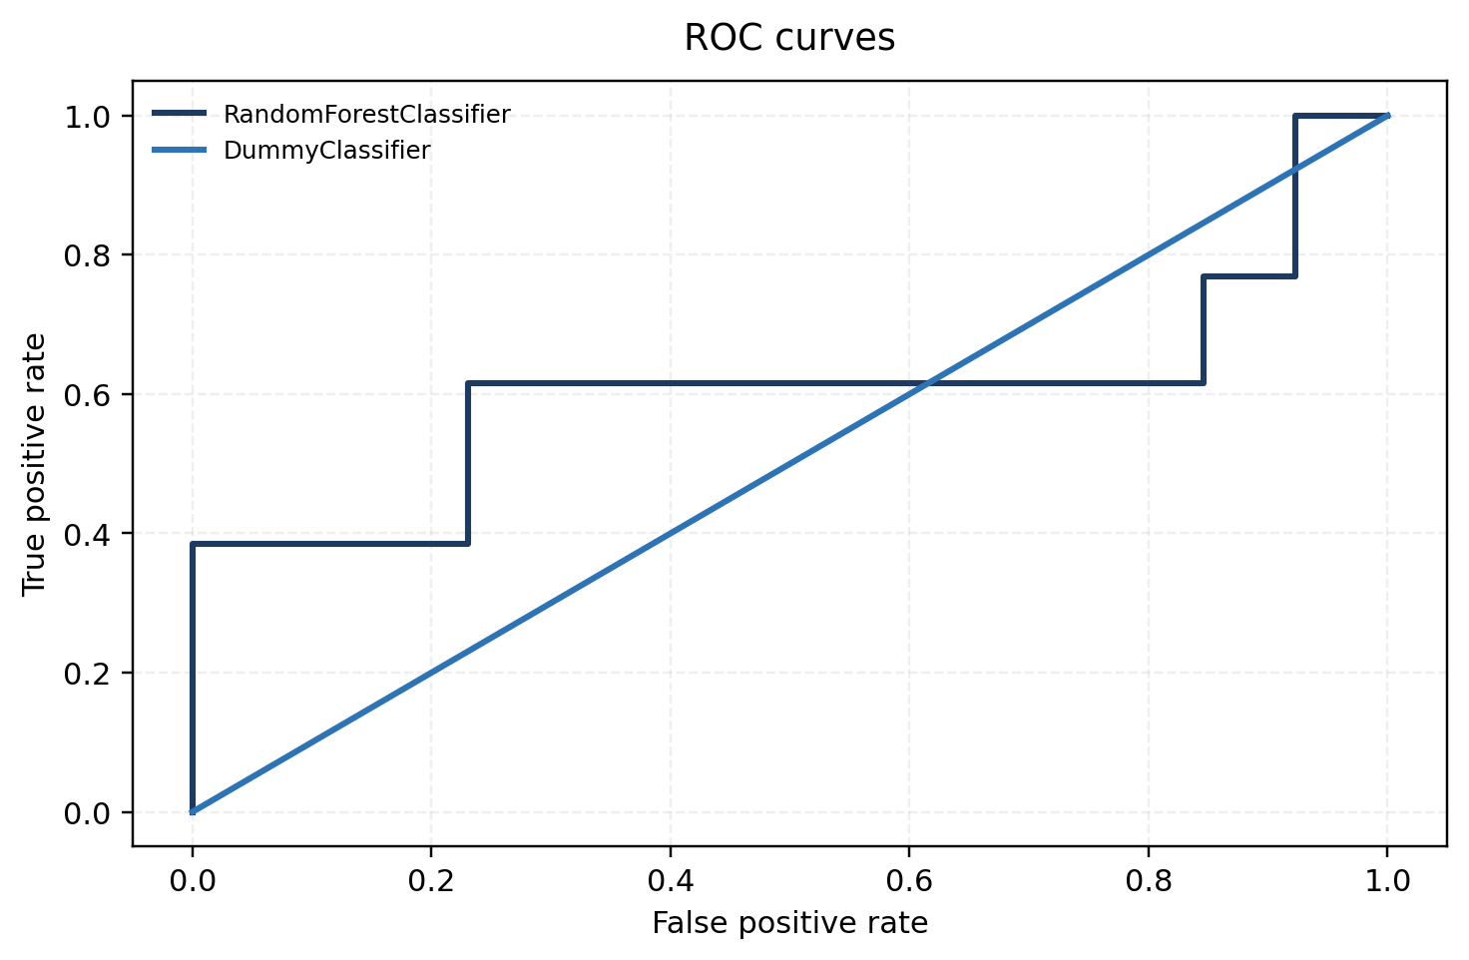
Figure 9. ROC curves for score-capable stored models.
The comparison did not establish a statistically robust overall winner. Random Forest led several stored evaluation criteria, but the small holdout and single-teacher sample prevent a production-level conclusion.

Precision-recall analysis
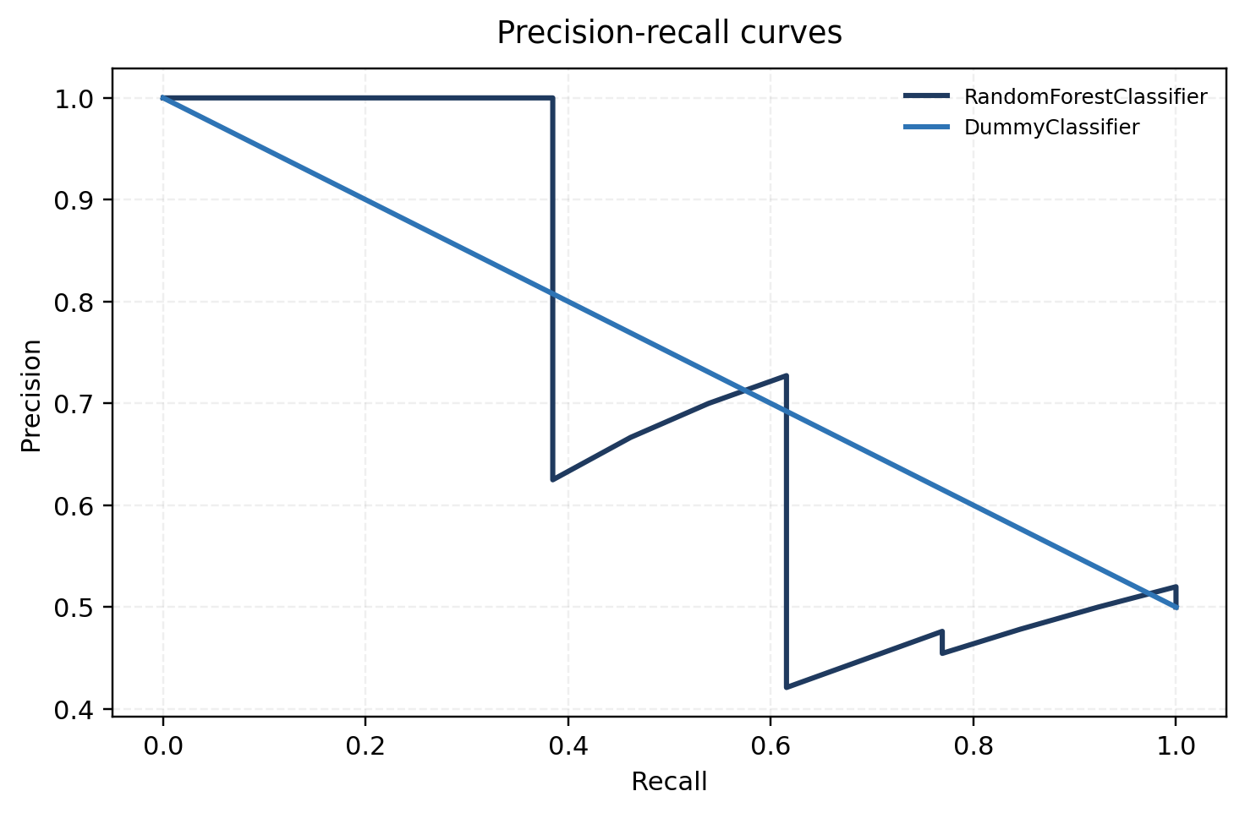
Figure 10. Precision-recall curves for the same stored holdout predictions.

Calibration analysis
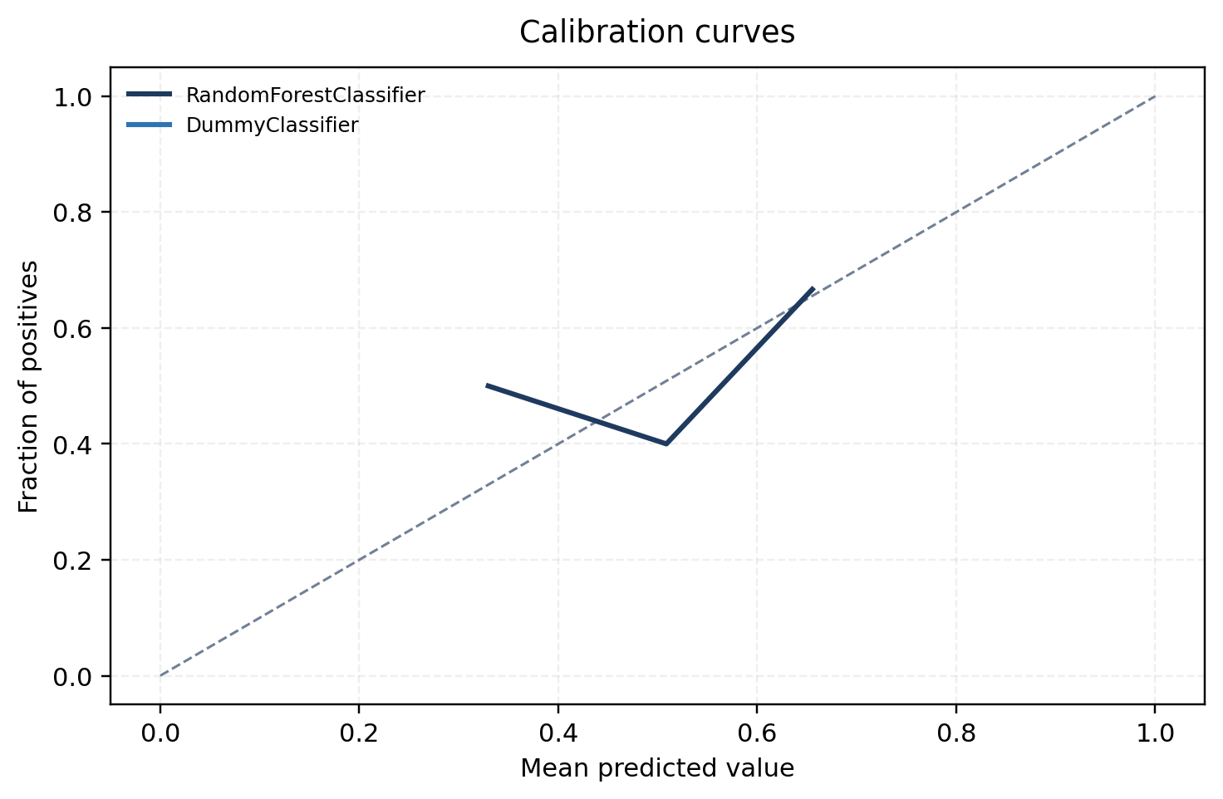
Figure 11. Calibration curves derived from stored probabilities.
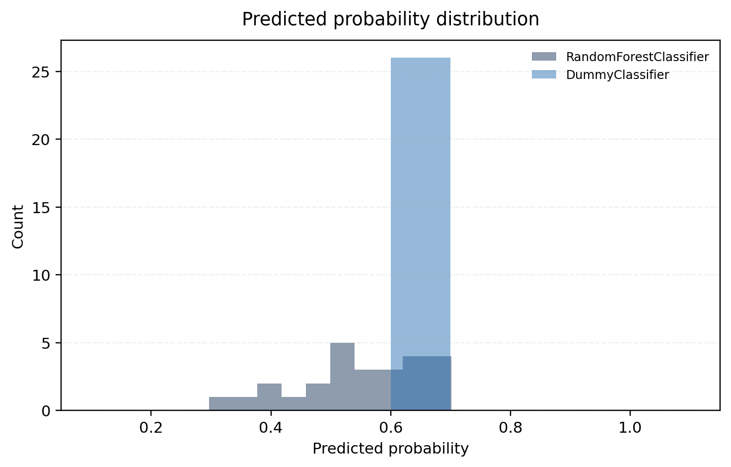
Figure 12. Predicted-probability distributions for the stored leader, threshold leader, and baseline.

Error analysis
- False positives and false negatives can be inspected only through the stored anonymized holdout predictions; no raw user identifiers are exposed.
- Subgroup sample sizes are too small for strong technical claims by topic, student-history bucket, or resource type, so subgroup interpretation should remain descriptive only.
- The confusion matrices show that threshold choice changes the balance between misses and false alarms more than it changes the overall conclusion.

Uncertainty and confidence intervals
- Confidence intervals are read from the stored model comparison CSV.
- Small holdout size and single-teacher coverage mean all uncertainty intervals should be interpreted conservatively.
- Stored overall verdict: Validated - no robust winner.

Runtime and resource performance
Training and inference durations are reported directly from the validated model comparison artifact and shown in Figure 5.

Integrity-review results
- The validated review concludes that this run is suitable as a technical evidence package, but not as a deployment decision.
- All intended models executed successfully in the validated run.
- Artifact consistency checks confirmed shared run ID and data fingerprint across stored outputs.

Conclusions
Interpretation
The current results are exploratory and do not support a definitive conclusion due to the limited dataset. While the model structure is functional for future evaluation, the current evidence is insufficient to confirm high-confidence predictive performance across broader populations.

Reproducibility
- Run ID: ebcf382089d2
- Dataset fingerprint: 6725ffb449deb229c08f83469e2d3b0a32c68fea72e519a1d18f621f9028c5a4
- Feature schema version: Assigned Resource Open 7d V1
- This report was generated from stored artifacts only; it does not recompute training metrics independently.

Business implementation implications
Interpretation
Implementation is currently limited to exploratory testing. Future deployment should focus on expanding teacher coverage to increase dataset volume and improve model maturity.

Limitations
- No additional validated risks were recorded for this run.

Appendix

Artifact manifest
Artifact | Purpose | Format | Checksum | Availability
Dataset Summary JSON | Dataset accounting and counts | json | 905c78f640 | Yes
Feature Audit CSV | Feature availability audit | csv | 6292c9064a | Yes
Findings Interpretation Report Markdown | Findings interpretation markdown baseline | md | a08e1b6e6b | Yes
Frozen Dataset CSV | Stored supporting artifact | csv | 6725ffb449 | Yes
Holdout Predictions CSV | Stored holdout probabilities | csv | 56781ff543 | Yes
Integrity Review Markdown | Stored supporting artifact | md | 901c6fcc8d | Yes
Label Audit CSV | Stored supporting artifact | csv | eae2a413ad | Yes
Label Reconciliation CSV | Label reconciliation review | csv | dc324cf04e | Yes
Model Comparison CSV | Stored model metrics | csv | c3908eadda | Yes
Run Summary JSON | Validated run summary | json | e7cca38047 | Yes
Technical Report Markdown | Technical markdown baseline | md | 2a2eb389f3 | Yes
Artifact manifest summarizing the technical evidence package without exposing repository paths.

Stored filename: assigned_resource_open_7d_dataset_summary.json
Stored filename: assigned_resource_open_7d_feature_audit.csv
Stored filename: assigned_resource_open_7d_findings_interpretation_report.md
Stored filename: assigned_resource_open_7d_dataset_frozen.csv
Stored filename: assigned_resource_open_7d_holdout_predictions.csv
Stored filename: assigned_resource_open_7d_integrity_review.md
Stored filename: assigned_resource_open_7d_label_audit.csv
Stored filename: assigned_resource_open_7d_label_reconciliation.csv
Stored filename: assigned_resource_open_7d_model_comparison.csv
Stored filename: assigned_resource_open_7d_run_summary.json
Stored filename: assigned_resource_open_7d_technical_report.md

Meeting Notes and Decision Record
Field | Value
Proposed decision | mejorar el sistema de recomendación del profesor
Decision owner | Anthony Gonzalez
Review date | enero de 2027
Additional comments | La base de datos es muy limitada de momento, pero la estructura funciona bien para evaluar el modelo en el futuro.

Full model comparison

Discrimination and ranking
Model | ROC AUC | Average precision | Balanced accuracy | F1 | Delta vs dummy ROC AUC
Majority class rule | 0.5 | 0.7233416342111993 | 0.5 | 0.6666666666666666 | —
Dummy classifier | 0.5 | 0.7233416342111993 | 0.5 | 0.6666666666666666 | —
Logistic regression | 0.4911242603550296 | 0.4795688650213536 | 0.3846153846153846 | 0.2 | -0.0088757396449704
Logistic regression (reduced) | 0.6686390532544378 | 0.6500564328767473 | 0.5384615384615385 | 0.25 | 0.1686390532544378
Decision tree classifier | 0.5710059171597633 | 0.5491823869020821 | 0.5 | 0.4347826086956522 | 0.0710059171597633
Random forest classifier | 0.7751479289940828 | 0.8507264344722537 | 0.7307692307692308 | 0.7407407407407408 | 0.2751479289940828
Histogram gradient boosting classifier | 0.5976331360946746 | 0.5608946850251199 | 0.6923076923076923 | 0.7142857142857142 | 0.0976331360946746
Support vector classifier | 0.591715976331361 | 0.7418006269093227 | 0.5769230769230769 | 0.5925925925925927 | 0.0917159763313609
K-nearest neighbors classifier | 0.6094674556213018 | 0.7267185670254724 | 0.5 | 0.5517241379310345 | 0.1094674556213017
Readable comparison of stored supervised models using the validated run artifacts.

Calibration and thresholding
Model | Log loss | Brier score | Predicted positive rate | Best F1 | Best balanced accuracy
Majority class rule | 0.713558177820073 | 0.26 | 1.0 | 0.6666666666666666 | 0.5
Dummy classifier | 0.713558177820073 | 0.26 | 1.0 | 0.6666666666666666 | 0.5
Logistic regression | 1.180388592324232 | 0.4011212271393161 | 0.2692307692307692 | 0.7096774193548387 | 0.6538461538461539
Logistic regression (reduced) | 0.942149463018076 | 0.3231121058664956 | 0.1153846153846153 | 0.8125000000000001 | 0.7692307692307692
Decision tree classifier | 0.9636787885103064 | 0.3490541193853108 | 0.3846153846153846 | 0.6666666666666666 | 0.6923076923076923
Random forest classifier | 0.6113182513397637 | 0.2108542582106922 | 0.5384615384615384 | 0.6842105263157895 | 0.6923076923076923
Histogram gradient boosting classifier | 0.7080518565629549 | 0.2527560426022929 | 0.5769230769230769 | 0.6842105263157895 | 0.576923076923077
Support vector classifier | 0.7038006156870968 | 0.2538600452369084 | 0.5384615384615384 | 0.6666666666666666 | 0.7307692307692308
K-nearest neighbors classifier | 0.6648033018425353 | 0.2504107988805867 | 0.6153846153846154 | 0.6842105263157895 | 0.6923076923076923
Readable comparison of stored supervised models using the validated run artifacts.

Runtime and status
Model | Status | CV primary metric mean | CV primary metric variance | Train duration (s) | Inference duration (s)
Majority class rule | Success | — | — | — | —
Dummy classifier | Success | 0.5 | — | 0.0033144589979201 | 0.0025230830069631
Logistic regression | Success | 0.5574314574314574 | 0.0157121826385895 | 0.0048862919793464 | 0.0017651669913902
Logistic regression (reduced) | Success | 0.5773160173160173 | 0.0178323278132801 | 0.0037060829927213 | 0.0013539590290747
Decision tree classifier | Success | 0.4927272727272728 | 0.0002115702479338 | 0.0037010840023867 | 0.001708583033178
Random forest classifier | Success | 0.5679942279942279 | 0.0265621242313882 | 0.0309458749834448 | 0.0037122500361874
Histogram gradient boosting classifier | Success | 0.4985858585858586 | 0.0102559330680542 | 0.0596622499870136 | 0.0038669999921694
Support vector classifier | Success | 0.5438095238095239 | 0.0167736619961728 | 0.00595775002148 | 0.0020606670295819
K-nearest neighbors classifier | Success | 0.5688600288600287 | 0.0078327900734827 | 0.0047499579959549 | 0.0022733340156264
Readable comparison of stored supervised models using the validated run artifacts.

