Contravariance
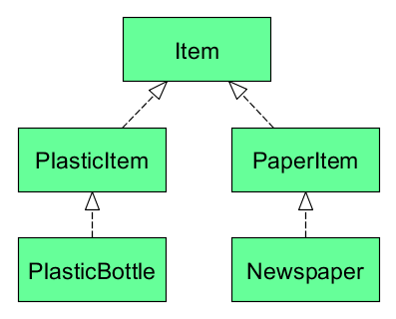

class GarbageCan[-A] {
// .. don't worry about implementation yet
}

def setGarbageCanForPlastic(gc: GarbageCan[PlasticItem]): Unit = {
// sets garbage can for PlasticItem items
}

The method setGarbageCanForPlastic accepts a GarbageCan of type PlasticItem or supertype of PlasticItem (Item). This is possible because type parameter A is prefixed with a -. It indicates that subtyping is contravariant in that parameter. It can be said that class GarbageCan is contravariant in its type parameter.

// contravariant subtyping
setGarbageCanForPlastic(new GarbageCan[Item])
// invariant
setGarbageCanForPlastic(new GarbageCan[PlasticItem])
// Compile error ! covariant subtyping
setGarbageCanForPlastic(new GarbageCan[PlasticBottle])

Contravariant subtyping

A <: B
GarbageCan[B] <: GarbageCan[A]

If A is a subtype of B then GarbageCan[B] should be a subtype of GarbageCan[A]. This property is called contravariant subtyping.

