**Pattern matching**

What is case class? What is case object? What are the Advantages of case class?

-Scala Compiler adds toString, hashCode and equals methods and copy metohds.  
-Scala Compiler adds companion object with apply and unapply methods that’s why we don’t need new keyword to create instances of a case class.  
-We can use case classes in Pattern Matching.  
-By default, Case class and Case Objects are Serializable.

Pattern matching is the act of checking a given sequence of tokens for the presence of a exact pattern.Once the match took place and associated action will be performed.

**Pattern matching is generally used for decomposition of class hierarchies.**

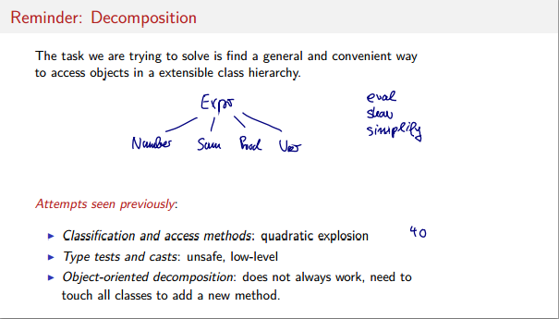

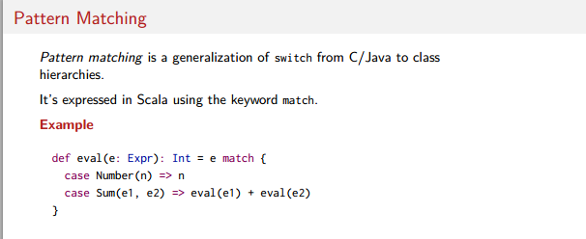

*) Every match will create a new varible with the match value. Number(n)

if a match is Number(1) n will 1 and it can be used in the match scope after the =>.

*) A MatchError is thrown if there is not any match.

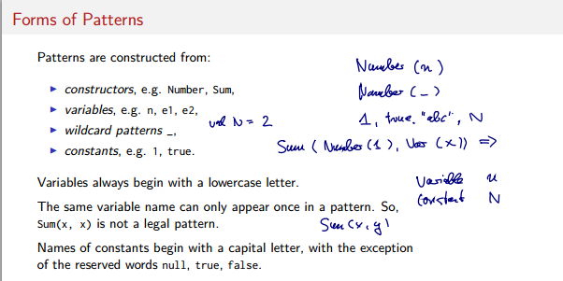

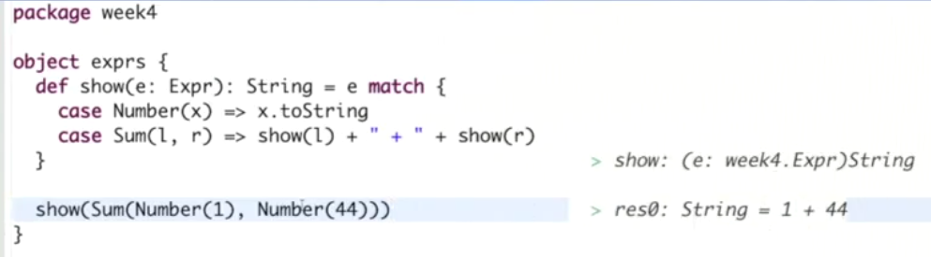

**Constructor Helpers**

Classes that wants to be included patter matching should be created with the case key word. It will mention to the scala interpreter to create all helper constructors.

**case class** Num (number: Int) **extends** Expr{  
}

It will create this helper method.

**object** Num {  
 **def** apply(n: Int ) = **new** Number(n)  
}

Then we can use it in the patter matching

**def** eval : Int ={ **this match** { **case** *Num* (n) => n } }