**Collections**

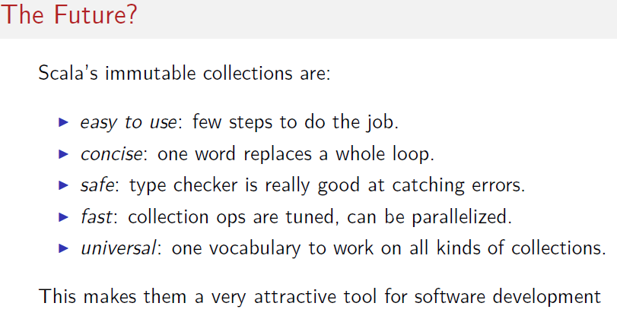

Safe: there are some typical errors which are already cover at compile time. Such us key not found.

Immutable collections are faster than mutable collections. These can be parallelized.