**For-expressions**

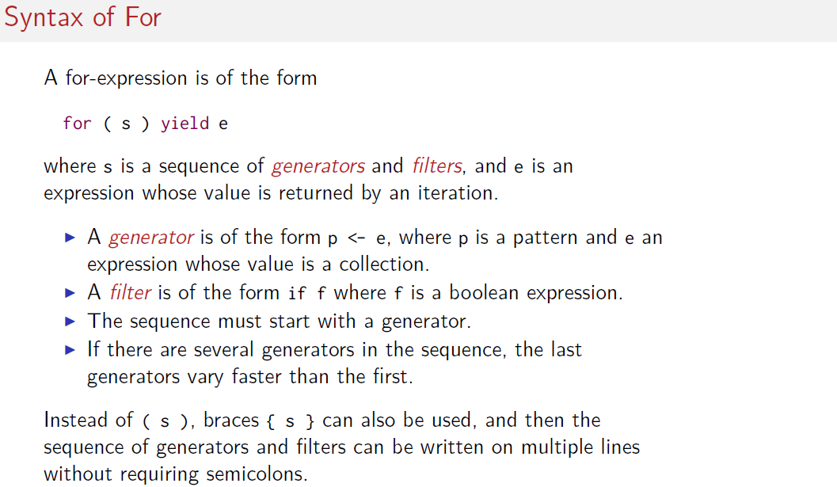

**\*) The statement in the yield is an accumulator that return the result of all iteration.**

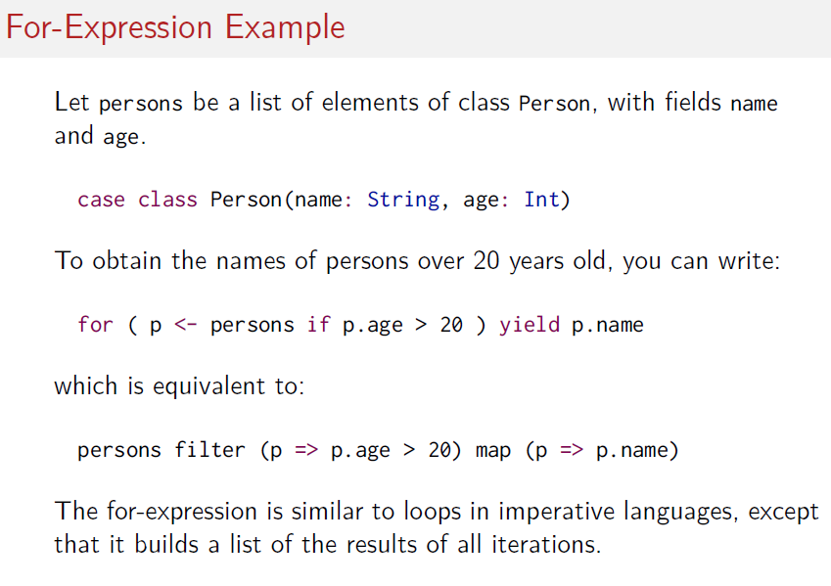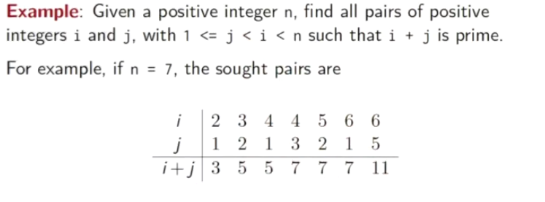****

This will iterate all elements produce x1 + y1 and select the results which are prime

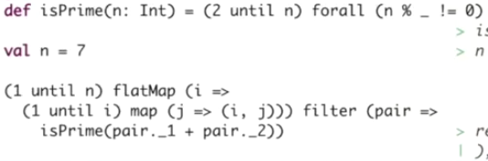

1) (1 until n ) returns an sequence called "A". And then we apply a flatMap with a function f to this secuence

2) i=> (1 until I) .map ( f() ) for each element of A we execute code that create another sequence B from 1 to I and we apply map with a function f() to each element of B.

3) this function f() is code that creates tuples with values of each index of A and B. j=>(i,j)

4) when map ( f() ) it returns a pair we apply a filter (isPrime ()) to the tuple values summary

5) if filter (isPrime)== true then it can accumulate the pairs

**Equivalent to**

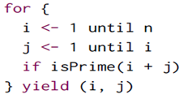

**This is similar to 2 fors i to n and second for each i it perform j to i . Then condition and yield each result in the acumulator**

