**Queries-with-for**

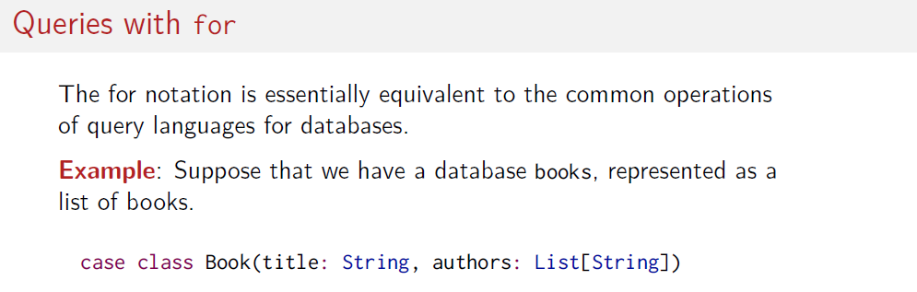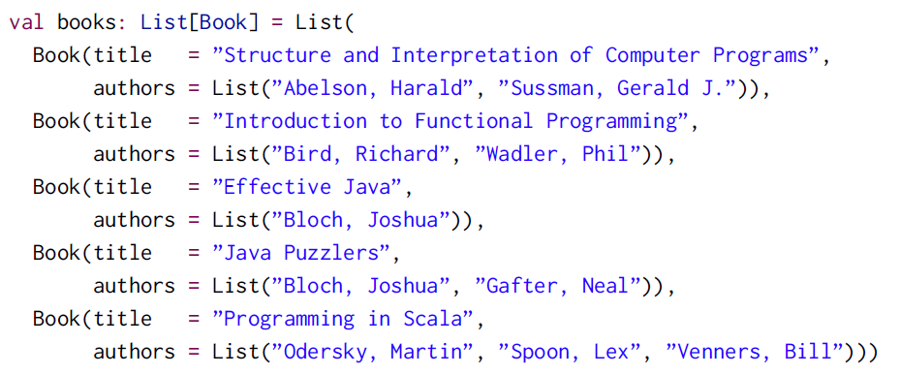

For example1: Find the tittles which its author start with "Bird"



This is the iteration b <- books; this is where attribute is extracted a<-b.authors and "if a .." is the conduction

For example2:

There are 2 iterations here b<-*books*; a <- b.*authors we use ; for each iteration*

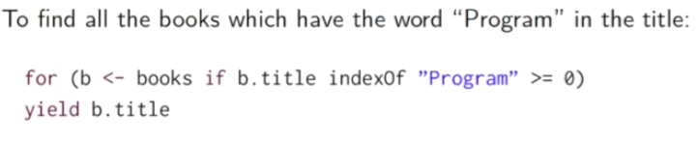

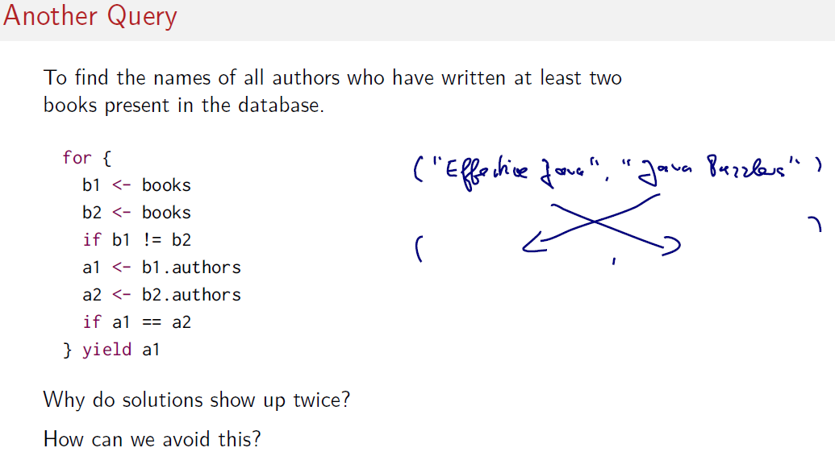**Here we create 2 iterations in books. b1 and b2 then we compare each autors**

