**List**

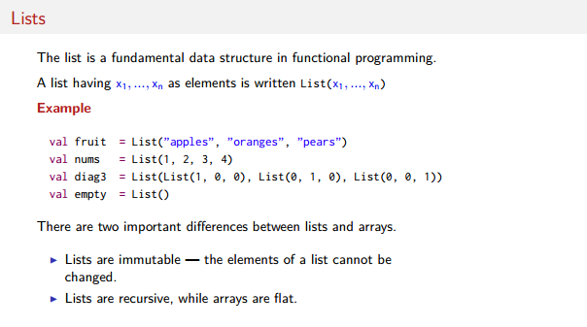

**The graph below shows that List a are recursive and immutable. Head holds the element and tail the next list.**

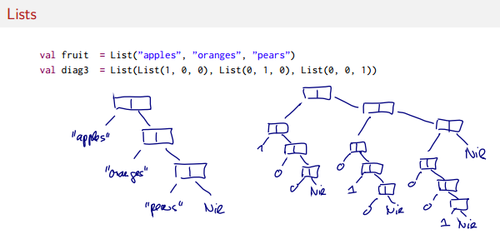

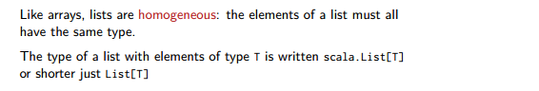

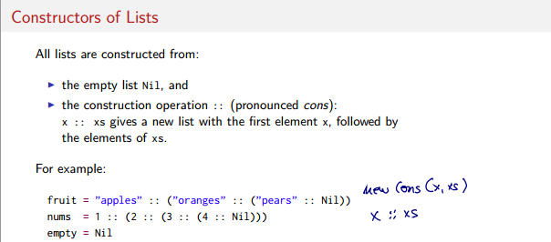

**We can omit the parentheses so 1:: (2 ::(3::Nill) is the same to 1::2::3::Nil**

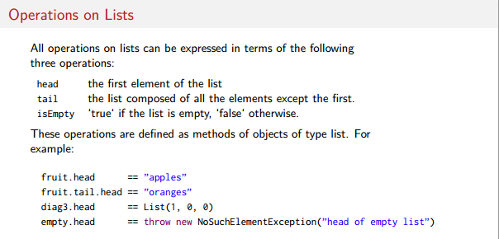

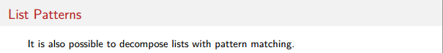

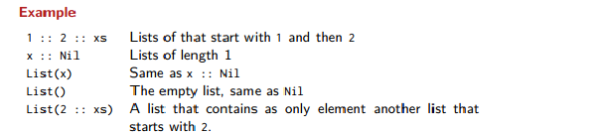

More examples with **:::**

scala> List(1, 2) ::: List(3, 4, 5)

res0: List[Int] = List(1, 2, 3, 4, 5)

scala> List() ::: List(1, 2, 3)

res1: List[Int] = List(1, 2, 3)

**val** *xs* = *List*(**"x"**)  
val *ys* = *List*(**"y"**)  
val *zs* = *List*(**"z"**)   
val *l1* =*xs* ::: *ys* ::: *zs*  
*val* l2 = *xs* ::: (*ys* ::: *zs*)  
l1 == l2 --> true