**Pairs and Tuples**

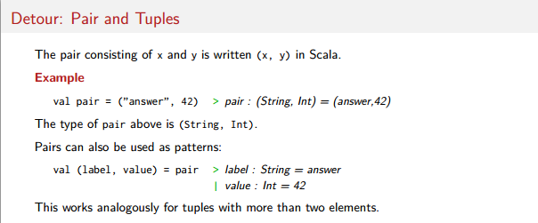**For example:**

**val** pair = (**"key1"**,1)

//assing the values to 2 variables directly.  
val (label,value) = pair;  
println(label)-->key1  
println(value)-->1  
  
//accessing to the values to variables manually  
val label1 = pair._1  
val value1= pair._2  
println(label1)-->key1  
println(value1)-->1  
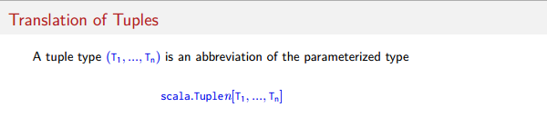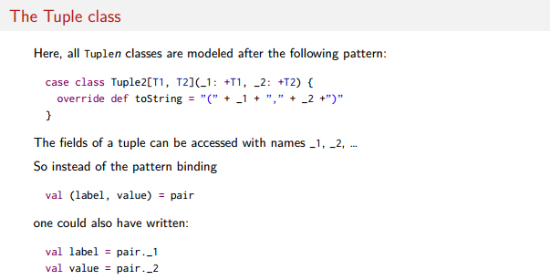

**The sliptAt function return two list as tuples base on index**

