**Higher-order-list-functions**



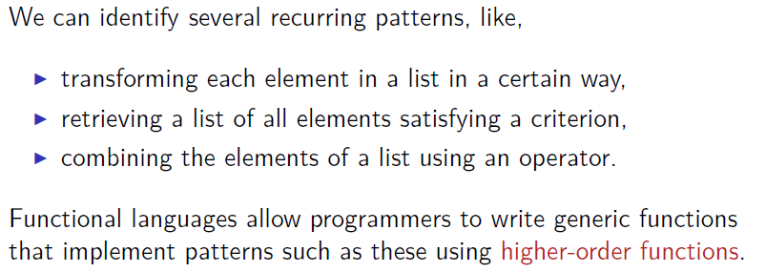



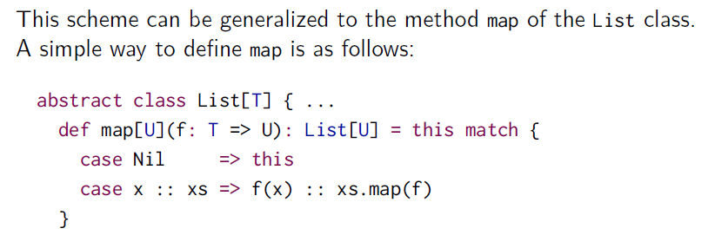

Map function is defined inside the List class. For example here a is a function that iterate all elements of a List and perform element * factor. We use map to resolve this problem.

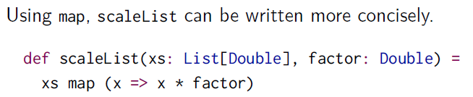

**Sometimes is easier write functions using the map function directly instead of writing the whole function.**

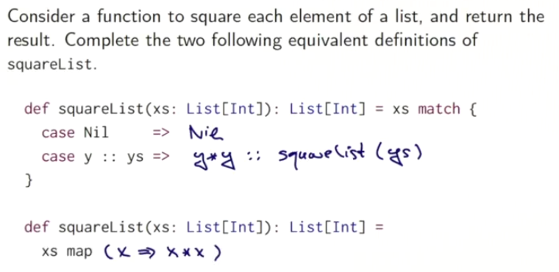

**Here we can see that map is easier**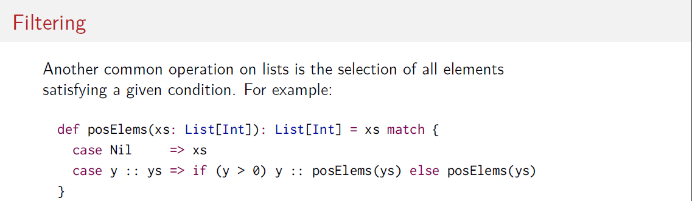

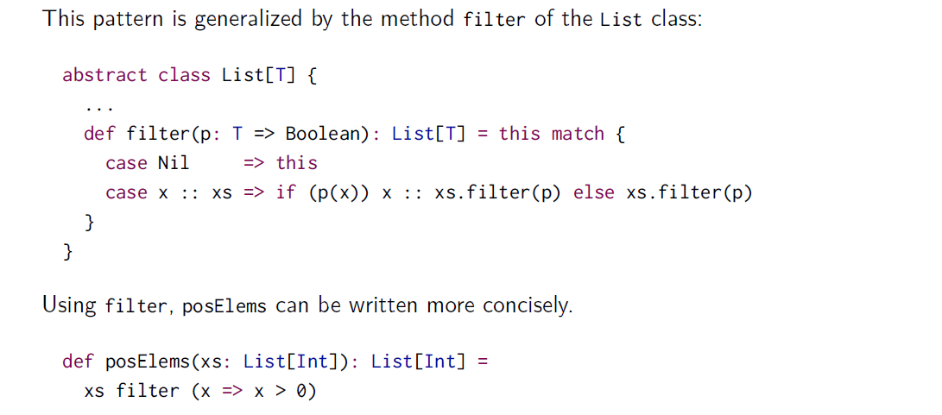

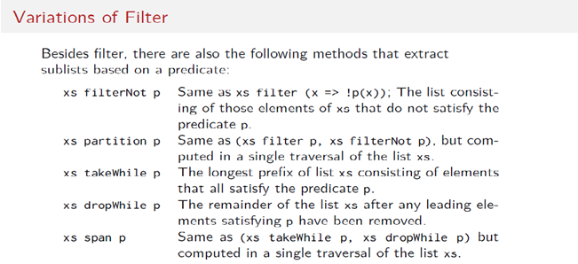

**val** *number* = *List*(1,3,4,-1)

*number* partition (x=> x>0)--> res2: (List[Int], List[Int]) = (List(1, 3, 4),List(-1))

*number* takeWhile (x=> x>0)--> res3: List[Int] = List(1, 3, 4)

number dropWhile (x=> x>0)-->res4: List[Int] = List(-1)

number span (x=> x>0)--> res2: (List[Int], List[Int]) = (List(1, 3, 4),List(-1))

