**Streams can lead to infinite loops.**

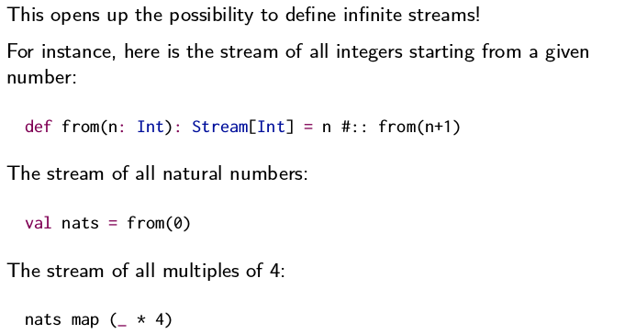**In this example n #:: from (n +1) can lead to a infinitive recursive call. Because #:: is lazy in the right operand the second element will be calculated only if someone request it.**

**val nats= from (0) represent all natural numbers … Thanks to that we can write expression for infinite representations**

**All natural numbers multiples of 4 nats map (_ * 4)**

For example:

Val numbers= from(0)

print(numbers) --> Stream(0,?)

print (numbers.take(10).toList)-> List(1,2,3..) by doing take and toList this is where the lazy " #:: is " executed