74-HSRM-001

General Purpose
8x8 Bit Pattern Memory Player
https://github.com/ThorKn/tinytapeout_pattern_player

FEATURES  - Input more than 60 bits to store them.  - Get the bits out of the chip via eight pins.  - Play crazy patterns with a 3-bit player.  - Address the three wires for more output.  APPLICATIONS  - Perpetuum mobiles.  - Improbable improbability drives.  - Moms pacemaker.  - Paps automobile breaking system.  PACKAGING  - Zip locks 1 liter.  - Pancake /w sirup packages.  - All pins soldered to one big pckg.  - Amazon cheap cartons. | DESCRIPTION  The 74-HSRM-001 consists of a general purpose,  8x8 Bit memory for pattern playing.  It can be programmed with serial data and has two modes for playback: addressed and clockdriven 3-bit player. The 8 outputs can be directly connected to a standard 7-segment display or everything else.  The 74-HSRM-001 is manufactured by using the  SkyWater SKY130 process through the TinyTapeout  programme (MPW-7) by Matthew Venn  (@matthewvenn). Design by Thorsten Knoll (@mostlymoss) for Hardware Labs @ HSRM.  ORDERING INFORMATION  - For sample requests, attach a copy of your company's audited financial statements for the past 5 years.
CIRCUIT
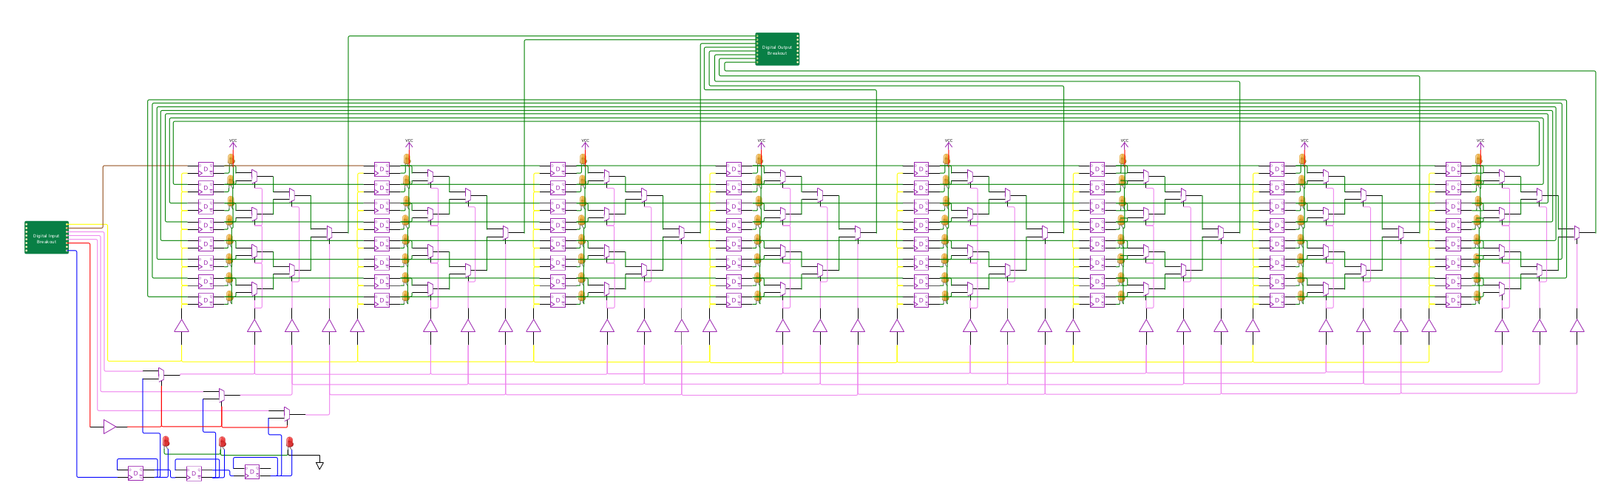
VOLTAGE DIAGRAM
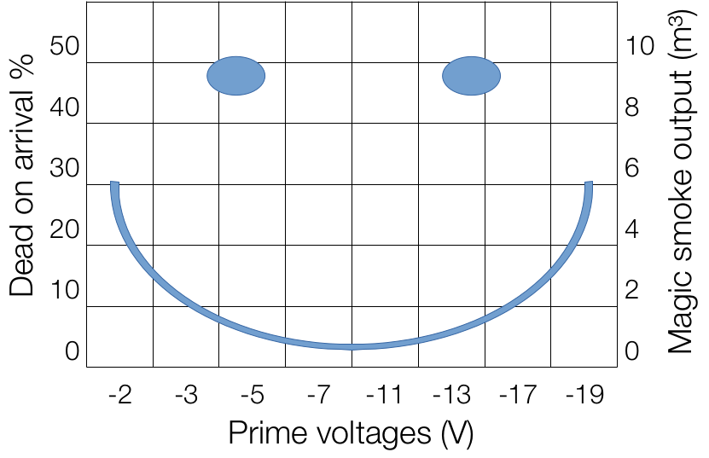


1
https://hwlabs.cs.hs-rm.de

