Report Go in Java

This report serves as a reflection of the process I underwent while developing the game Go as a final assignment for the first module of the Nedap University. The report will discuss the development of the protocol. The approach in designing the application, the benefits that this provided and the downfalls it created. Finally the actual development and implementation of the code is discussed.

Protocol development
On the first day of the project, after the presentation, we as the student got together to discuss the protocol that was going to be used for communicating about the game. A large part of the protocol was based around the protocol suggested for the Dots and Boxes games that the TCS students were assigned with.

We came to a disagreement when discussing what should trigger a client to make a new move, if any trigger is required. Some of the students wanted to implement clients such that they constantly try to make a move, regardless of if it is their turn or not. I did not agree with this approach, and suggested a trigger message from the server that indicates the client to make a move. To me this trigger seemed necessary to prevent a spamming clients move to be parsed by the server while the move does not reflect what the client wants to do given the new position of the board. We compromised such that either waiting for the “MAKE MOVE” call or spamming a next move would be allowed.

On the Monday of the second week of the project, we reconvened to discuss possible changes to the protocol, and ambiguity that was still in the protocol. This showed that even though the protocol was discussed quiet extensively that there were still different interpretations. This day was also used to test connecting to the server and try to play a game. This was very useful as it immediately showed what parts of the protocol needed to be discussed better. This also lead to the creation of a diagram similar to swim-lanes that depicted and specified the protocol.

Design
Before I started working on the actual code of the application, I started with a class diagram. A large part of the design that I implemented was based of combining the design of the ChatServer assignment from week 7 of the module and the Tic-Tac-Toe game made in week 4.

I spend a good day thinking about possible methods that I would need and different attributes that would be required to store the necessary data.
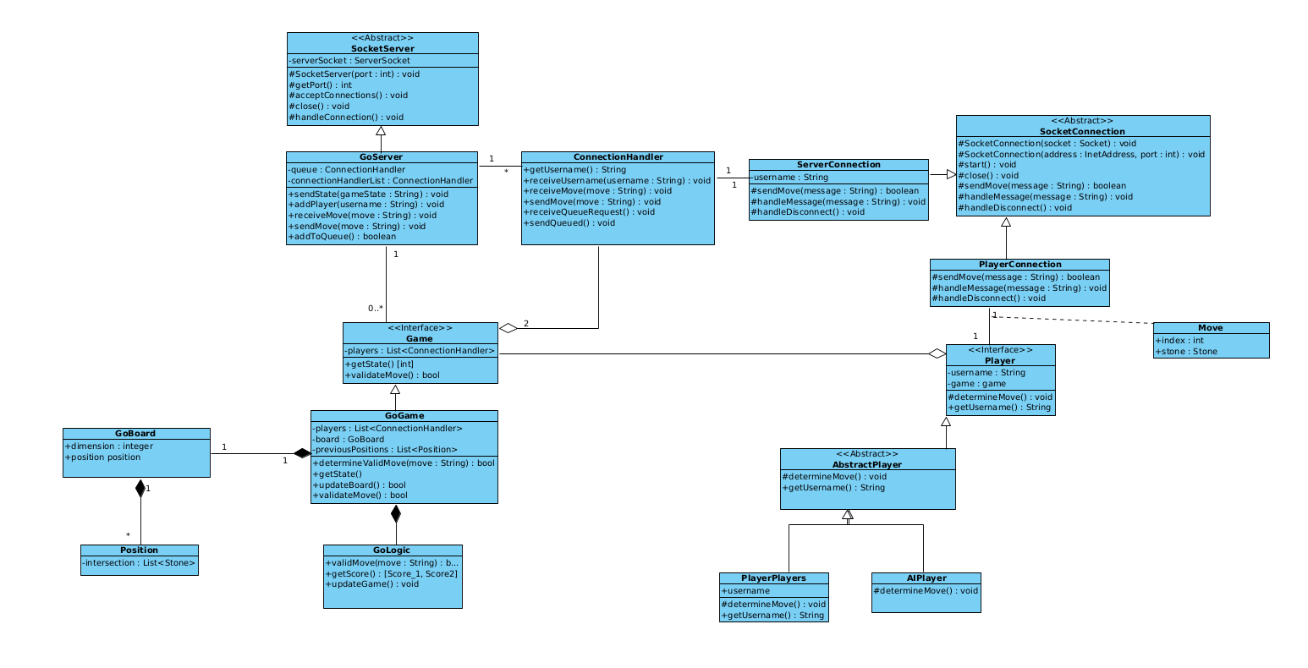

Looking back at this phase of the project feels a bit double sided. Thinking about the design certainly helped me with constructing the application. While creating the classes and connecting them where needed having this to reflect on prevented me from doing this double, or overcomplicated it. However, I also think that I might have spend a little too long on this which caused stress later on.

While the main structure is still reflected in the design shown above, the number of classes in the project is far more extensive. The same can be said for methods available in the interfaces that are implemented. While writing the code and constructing the different methods it became apparent that certain pieces of data were required. When needed I added methods that fixed this requirement as needed.

Code development
I started writing the code for the application after spending the first day (maybe and a half) on the design. From the assignment made throughout the first module I knew that the sever/client connection through a socket was something I might struggle with. However this part went a lot smoother than I had expected, possible due to making the server/client assignment multiple times.

After confirming that communication was established I started implementing the game and the different parts that make up a game. Initially this went reasonably quick as the setup of a game and control over the state is a straightforward problem.

With the game and board setup it was time to work on the logic of the game. This is were I encountered my first issues. Initially I had constructed an algorithm that would look up clusters in a linear fashion. This approach showed to not be capable of dealing with more interesting board situations, such a cluster that has a territory within itself, or multiple territories. Most of the Friday in the second week was spent on trying to hammer in the nail. On Monday I decided to start from scratch as over the weekend I had formulated an idea to solve my problem recursively. This approach proved much easier and was quickly realized.

The second issue I encountered was in finding the actual territories. Again I initially started out with a linear solution but I was unable to get this to work. This is where I was very grateful that my coach contacted me to see how things were going. It had not occurred to me to ask for help, I was also not entirely sure if this was allowed. But the guidance helped with realizing that I had already solved my issue when implementing the recursive approach to finding clusters.

When I got to processing captures I immediately took the recursive approach as I was more confident in my ability to do so, already having formulated one before.

Looking back at this process I come to realize that a straightforward (linear) approach, while easier to visualize is not the quickest when implementing it. I also did not have to much experience with recursion, which could be why it is not the first solution that comes to mind.

As of the time of writing the only aspect of the project that is not implemented completely is an AI that actually thinks about its moves. Due to spending a long time trying to fruitlessly construct the method to find clusters, time has become rather short at the end. This is also a point of reflection that I will take along and discuss my issues earlier rather than working on a road with marginal improvement.

Code review
The assignment also indicated that we were required to perform code review as you would when working on a larger project with different people. Due to the time being limited, and not having done any reviewing before, I have not done a formal code review.

All the code has been checked that it is actually being used at some stage of the application. The majority of the warnings that are reported by Intellij have been resolved and there are no errors. Some of the warnings, i.e. printing the stack trace on an exception have not been resolved as the printing of the stack trace still seems of value to me. Everything compiles as expected and key aspects of the code have been tested.

