WEEK 1 REPORT

Data Acquisition, Cleaning, and Preprocessing
Indian E-Commerce Customer Behaviour and Purchase Dataset

Prepared as part of the Week 1 Data Science / Machine Learning Internship Task
Tools: Python, Pandas, NumPy, KaggleHub, Seaborn, Matplotlib
Dataset size observed in the notebook: 25,000 rows × 29 columns

Prepared from the supplied Week 1 Jupyter Notebook

1. Executive Summary
This report documents the Week 1 workflow for acquiring, inspecting, cleaning, and preprocessing the Indian E-Commerce Customer Behaviour and Purchase dataset. The supplied notebook uses KaggleHub to obtain the public dataset, loads the CSV into a Pandas DataFrame, performs structural exploration, checks missing values and duplicates, converts the visit date into a proper datetime type, maps selected coded categorical variables to readable labels, visually investigates numerical outliers using boxplots, inspects high-revenue observations, and exports the resulting DataFrame as a cleaned CSV file.
The notebook evidence shows that the dataset contains 25,000 records and 29 columns. All 29 columns have 25,000 non-null observations, and the duplicate-row check returns zero duplicates. The preprocessing therefore focuses primarily on datatype correction and categorical-code interpretation rather than missing-value imputation or duplicate removal.
An important methodological point is that the notebook identifies potential outliers through boxplots and examines records with revenue above 4,000, but it does not remove, cap, transform, or otherwise modify those observations. This report preserves that distinction: outlier detection was performed, while outlier treatment was not applied in the supplied workflow.

2. Objectives
- Acquire a relevant public dataset from a reliable public source.
- Understand the dataset's structure, dimensions, datatypes, and basic statistical properties.
- Identify missing values and determine whether imputation or row removal is necessary.
- Check for duplicate records and determine whether duplicate removal is required.
- Identify and correct important data inconsistencies, especially date and coded categorical fields.
- Investigate potential numerical outliers using visual methods and inspect unusually high-revenue records.
- Produce a cleaned CSV suitable for subsequent exploratory analysis and machine-learning work.
- Document the process, rationale, challenges, and potential downstream effects of preprocessing decisions.

3. Dataset and Data Acquisition
The notebook states that the selected dataset is the “Indian E-Commerce Customer Behaviour and Purchase” dataset. It is acquired from Kaggle using the KaggleHub Python package.
Dataset identifier used by the notebook:
kundanbedmutha/indian-e-commerce-customer-behavior-and-purchase
The acquisition method is programmatic rather than manual: KaggleHub downloads the dataset and returns a local path. The notebook then reads the CSV file with Pandas.

3.1 Data acquisition code
import kagglehub
path = kagglehub.dataset_download("kundanbedmutha/indian-e-commerce-customer-behavior-and-purchase")
The notebook also records a warning that the installed KaggleHub version was outdated (0.3.13) compared with the version suggested by the package at execution time. The download nevertheless completed successfully in the recorded run.

3.2 Loading the CSV
data = pd.read_csv("C:\\Users\\User\\.cache\\kagglehub\\datasets\\kundanbedmutha\\indian-e-commerce-customer-behavior-and-purchase\\versions\\1\\Ecommerce.csv")
The CSV is loaded into a Pandas DataFrame named data. The notebook subsequently uses head(), shape, info(), and describe() for initial inspection.

4. Python Libraries Used
The workflow uses Pandas for tabular data manipulation and NumPy for numerical operations. Seaborn and Matplotlib are introduced later for visual outlier inspection.
import numpy as numpy
import pandas as pd
import seaborn as sns
import matplotlib.pyplot as plt

5. Initial Data Exploration
Initial exploration is important because preprocessing decisions should be based on the actual structure and quality of the dataset rather than assumptions. The notebook checks the first five rows, dimensions, schema, and descriptive statistics.

5.1 First five rows
data.head(5)
The recorded output shows examples containing customer/session identifiers, visit dates, coded device and user types, product information, pricing and quantity variables, engagement measures, review-related variables, temporal features, a session-duration bucket, normalized revenue, and a location code.

5.2 Dataset dimensions
data.shape
(25000, 29)
The dataset contains 25,000 observations and 29 columns. This is large enough to support subsequent exploratory analysis and supervised or unsupervised modelling exercises.

5.3 Schema and data types
data.info()
Before preprocessing, the recorded schema contains 23 integer columns, 4 floating-point columns, and 2 object columns. The visit_date column is initially stored as an object/string, while session_duration_bucket is also textual.
Property | Observed value | Interpretation
Rows | 25,000 | Dataset records
Columns | 29 | Features/fields
Non-null status | 25,000 in every column | No missing values recorded
Initial numeric types | 23 int64 + 4 float64 | 27 numeric columns
Initial object types | 2 | visit_date and session_duration_bucket
Memory usage | 5.5+ MB | Reported by DataFrame info()

5.4 Descriptive statistics
data.describe()
The descriptive output shows, among other values, unit_price ranging from 50.05 to 1,999.83, quantity from 1 to 4, discount_percent from 0 to 30, rating from 1 to 5, review_helpful_votes from 0 to 49, and revenue_normalized from 0 to 1. The full statistical output is retained in the original notebook and is represented here through the main ranges relevant to preprocessing.

6. Missing-Value Analysis
Missing values can affect statistical summaries, visualizations, and machine-learning algorithms. The notebook checks every column using isnull().sum().
data.isnull().sum()
The recorded output contains 0 missing values for every one of the 29 columns. Therefore, no imputation or row deletion was required in this workflow.
The notebook's commentary correctly identifies common alternatives—imputation or dropping rows—but neither was applied because the observed dataset did not contain missing entries.

7. Duplicate-Value Analysis
data.duplicated().sum()
0
No exact duplicate rows were found. Consequently, duplicate records were not removed. This preserves all 25,000 observations for subsequent analysis.

8. Data Inconsistency and Type Handling
The most explicit inconsistencies handled in the notebook are representation-related: the visit date is initially textual, while device_type and user_type are encoded numerically. Converting or mapping these fields improves interpretability and reduces ambiguity for later analysis.

8.1 Date conversion
data['visit_date'] = pd.to_datetime(data['visit_date'], dayfirst=True)
The original dates are displayed in day-month-year form, for example 20-09-2024. The conversion changes the field to datetime64[ns], allowing reliable chronological operations such as sorting, filtering, grouping by date, and extracting temporal components.
data['visit_date'].value_counts()
After conversion, the value-count output displays dates in ISO-like YYYY-MM-DD representation. The notebook records 365 distinct dates, covering the daily observations present in the dataset.

8.2 Device-type mapping
device_mapping = {
0: 'Desktop',
1: 'Mobile',
2: 'Tablet'
}
data['device_type'] = data['device_type'].map(device_mapping)
The numeric device codes are replaced with human-readable labels. The resulting distribution recorded by the notebook is:
Device type | Records
Mobile | 12,600
Desktop | 9,887
Tablet | 2,513

8.3 User-type mapping
users_mapping = {
0: 'New',
1: 'Returning'
}
data['user_type'] = data['user_type'].map(users_mapping)
The resulting counts recorded by the notebook are:
User type | Records
Returning | 13,782
New | 11,218

8.4 Session-duration bucket
data['session_duration_bucket'].value_counts()
The session-duration bucket already uses readable text labels. The recorded counts are approximately balanced across four categories:
Bucket | Records
Very Short | 6,270
Long | 6,254
Very Long | 6,240
Short | 6,236

8.5 Final datatype check
data.dtypes
After preprocessing, visit_date is datetime64[ns], device_type and user_type are object/string labels, session_duration_bucket remains an object/string field, four columns remain float64, and the other fields remain numeric. This is a more interpretable representation for subsequent analysis.

9. Outlier Detection
Outliers may represent legitimate high-value customers or transactions, data-entry errors, unusual behaviour, or rare business events. The supplied notebook therefore investigates several continuous variables visually before deciding whether any treatment is necessary.
The variables examined with boxplots are:
- unit_price
- time_on_site_sec
- discount_amount
- revenue

9.1 Unit price
plt.figure(figsize=(8,4))
sns.boxplot(x=data['unit_price'])
plt.title('Outlier Detection for Unit Price')
plt.show()

9.2 Time on site
plt.figure(figsize=(8,4))
sns.boxplot(x=data['time_on_site_sec'])
plt.title('Outlier Detection for Time on Site')
plt.show()

9.3 Discount amount
plt.figure(figsize=(8,4))
sns.boxplot(x=data['discount_amount'])
plt.title('Outlier Detection for Discount Amount')
plt.show()

9.4 Revenue
plt.figure(figsize=(8,4))
sns.boxplot(x=data['revenue'])
plt.title('Outlier Detection for Revenue')
plt.show()
The notebook also explicitly inspects high-revenue observations using a threshold of 4,000:
high_revenue_customers = data[data['revenue'] > 4000]
high_revenue_customers.head()
The recorded output shows example high-revenue records with revenue-normalized values and varied customer, device, user, product, review, and location attributes. These observations are not automatically treated as errors. In an e-commerce dataset, unusually high revenue may be a legitimate business event.
Important limitation: the supplied notebook performs outlier detection and inspection, but it does not calculate IQR-based thresholds, remove observations, winsorize values, apply transformations, or replace outliers. Therefore, the correct conclusion for Week 1 is that potential outliers were investigated and retained pending further domain analysis.

9.5 Outlier visual evidence
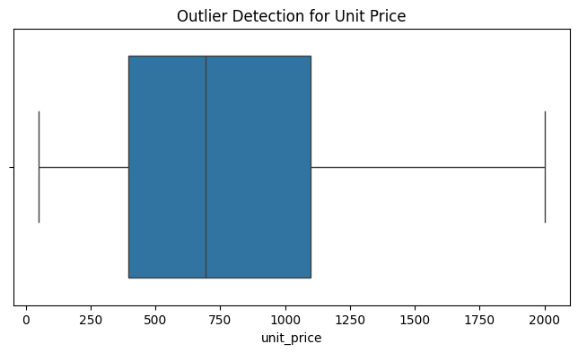
Figure 5. Notebook-generated boxplot for Unit Price.
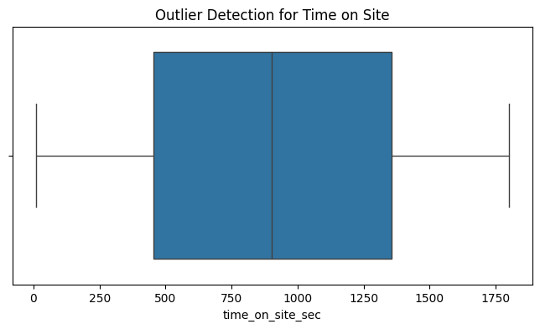
Figure 6. Notebook-generated boxplot for Time on Site.
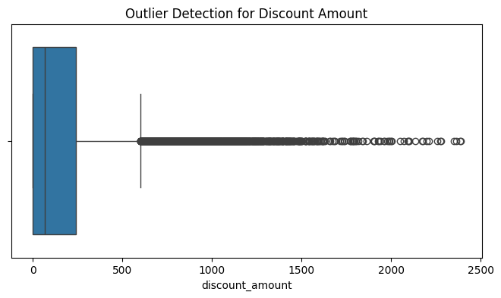
Figure 7. Notebook-generated boxplot for Discount Amount.
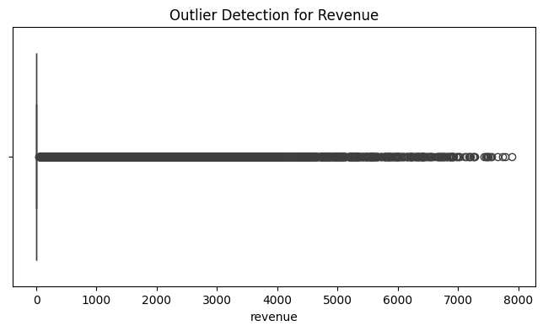
Figure 8. Notebook-generated boxplot for Revenue.

10. Final Validation
The notebook performs a final info() and dtypes check after preprocessing. The final schema confirms that the intended type conversions and categorical mappings have been applied while preserving the same number of records and columns.
data.info()
data.dtypes
The final info() output again reports 25,000 entries across 29 columns with no null values. The main datatype changes are the conversion of visit_date to datetime64[ns] and the conversion of device_type and user_type from integer codes to readable object/string categories.

11. Exporting the Cleaned Dataset
data.to_csv('Data/cleaned_data_week1.csv', index=False)
The cleaned DataFrame is exported as cleaned_data_week1.csv. The index=False argument prevents the Pandas row index from being added as an unnecessary extra column.
For reproducibility, the Data folder should exist before running this line. If it does not exist, a practical improvement is to create it first with os.makedirs('Data', exist_ok=True).

12. Cleaning and Preprocessing Summary
Area | Method | Result
Dataset acquisition | KaggleHub download | Completed
CSV loading | Pandas read_csv() | Completed
Initial exploration | head(), shape, info(), describe() | Completed
Missing values | isnull().sum() | 0 missing values; no imputation required
Duplicates | duplicated().sum() | 0 duplicate rows; no deletion required
Date consistency | pd.to_datetime(..., dayfirst=True) | visit_date converted to datetime
Device coding | Mapping 0/1/2 to Desktop/Mobile/Tablet | Completed
User coding | Mapping 0/1 to New/Returning | Completed
Outlier detection | Boxplots + revenue > 4000 inspection | Completed
Outlier treatment | Removal/capping/transformation | Not applied in supplied notebook
Export | to_csv(..., index=False) | Completed in notebook

13. Challenges Faced and How They Were Addressed
Challenge | Response
Encoded categorical variables | device_type and user_type were stored as numeric codes. Mapping dictionaries were used to convert the codes into readable labels.
Date stored as text | visit_date was initially an object/string field. pd.to_datetime(..., dayfirst=True) converted it into a proper datetime type.
Potential outliers | Boxplots were used to identify unusually distributed values, and high-revenue records were separately inspected rather than automatically deleted.
No missing data | Because every column contained zero null values, the workflow avoided unnecessary imputation and preserved all observations.
No duplicate data | The duplicate check returned zero, so deleting rows would have been inappropriate.
KaggleHub environment warning | The recorded run produced an outdated-version warning. The dataset was still downloaded successfully, but updating KaggleHub would improve reproducibility in a fresh environment.

14. Potential Impact on Subsequent Analysis
- Datetime conversion makes temporal analysis more reliable and allows future feature extraction such as month, weekday, or season without repeatedly parsing strings.
- Human-readable device and user categories make exploratory charts and group-based summaries easier to interpret.
- Because missing values and exact duplicates were absent, no observations were lost through imputation or duplicate removal.
- Retaining potential outliers preserves legitimate rare business behaviour, but future modelling should consider whether extreme values have disproportionate influence on algorithms sensitive to scale or distribution.
- The existing revenue_normalized field can be useful for models that benefit from normalized numerical inputs, while the raw revenue field remains useful for business interpretation.
- Preprocessing changes the representation of the data but, in this workflow, does not intentionally reduce the number of records.

15. Reflective Commentary
The main principle followed in this preprocessing workflow is to avoid changing data without evidence. Since the dataset contains no missing values and no exact duplicate rows, deleting or imputing observations would introduce unnecessary changes. Similarly, the presence of an extreme revenue value is not by itself proof of an error. The notebook therefore investigates unusual values visually and through a targeted query rather than automatically removing them.
The strongest transformations in the workflow are representation-level improvements: converting dates to datetime values and converting coded categorical variables into meaningful labels. These changes preserve the underlying observations while making the dataset easier to interpret.
For later weeks, a more rigorous outlier analysis could quantify the IQR or percentile thresholds for each continuous feature, investigate domain constraints, and compare model behaviour with and without an outlier treatment strategy. Such a decision should be based on the modelling objective rather than applying a generic rule automatically.

16. Conclusion
The Week 1 preprocessing workflow successfully acquires and prepares the Indian E-Commerce Customer Behaviour and Purchase dataset for further analysis. The notebook establishes that the dataset has 25,000 rows and 29 columns, contains no missing values, contains no exact duplicate rows, and requires important representation improvements for dates and selected categorical variables. Potential outliers are visually investigated and high-revenue observations are inspected without automatically deleting them.
The resulting dataset is exported as a cleaned CSV and provides a suitable starting point for subsequent EDA, clustering, supervised learning, deep learning, and capstone work. The most important consideration for later stages is to treat outlier handling as a domain- and model-dependent decision rather than an automatic cleaning rule.

