
wede5020
Thoriso Mosoatsi

August 10, 2026
Rosebank international
ST10472463

Table of Contents
Proposal: 2
Organisational overview: 2
Website goals and objectives: 3
Proposed website features and functionality: 3
Design and user experience: 3
Technical requirements: 4
Timeline and milestones: 4
Budget: 4
Reference list: 5

Proposal:

Organisational overview:
Name:
Into Yarn
Background
Into Yarn is a Pretoria-based yarn and craft business serving the local knitting and crochet community. Pretoria has an involve craft culture maintained by local industries and experts in yarn traders (The Citizen, 2024; The Yarn Room, 2026).
Mission
Into Yarn intents to offers quality and affordable yarn, materials and craft supplies while supporting crafters of all levels of skills through guidance, and patterns.
Vision
The vision is to create a welcoming community centre where the community can enjoy creativity, social connection and the healing benefits of knitting and crochet.
Target Market
Knitters and crocheters, social crafters, and craft admirers.
The focus on community and craft activities reflects Pretoria's established local craft culture (The Citizen, 2024).

Website goals and objectives:
Based on the 7 Qualities of a Great Website a well designed website should be visually desirable, easy to use, device-friendly, quick, inclusive, and frequent updates with quality content.

Proposed website features and functionality:
- Home Page: Is the front door. It welcomes visitors, explains what you do, and guides potential customers to other parts of the site.
- About Page: Explains the brand story. It builds trust by sharing who you are, your mission, and why you do what you do.
- Services or Products Page: Show cases what you sell. It lists your offers, prices, features, and how customers can buy.
- Contact Page: Gives ways to reach you. It includes a form, email address, phone number, and physical location map.
- Legal Pages: Protects your business. This includes your Privacy Policy and Terms of Service to handle data and rules safely (Ladanan, 2026).

Design and user experience:
- Colour Scheme: White or soft cream background so yarn colours pop (Ideas On Purpose, 2024; W3C, 2024).
- Typography: Clear, readable fonts and different heading sizes will create a strong visual hierarchy.
- Layout: Header, hero banner, category grid, product feed, footer (Hanak, 2024).
- User Experience: Simple navigation, consistent layouts and responsive design will help users find information easily on all devices (Ideas On Purpose, 2024).
- Wireframes: Low-fidelity wireframes will show the basic layout, navigation and content structure before development.

Technical requirements:
The yarn website should be responsive, secure, and easy to use on different devices. It should have database to manage products and orders. Responsive design will ensure that the website works properly on any device (MDN, 2026).

Timeline and milestones:

Item | Estimated Cost
Website design and development | R20 000
Domain | R150
Hosting | R1200
Maintenance/testing | R3 650
Total | R25 000

Budget:

Item | Estimated Cost
Website design and development | R20 000
Domain | R150
Hosting | R1200
Maintenance/testing | R3 650
Total | R25 000
(Procompare, 2026; Skilld Design, 2026).

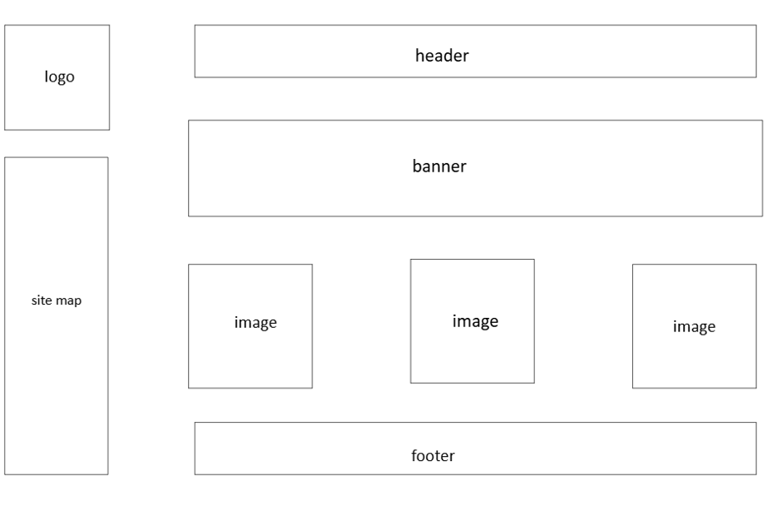

Reference list:
Black Snow Agency (2026) Website Design Costs Guide South Africa (2026), 11 June. Available at: https://blacksnowgroup.co.za/website-design-costs-in-south-africa-2026/ (Accessed: 10 August 2026).
Hanak, A. (2024) 20 Eye-Catching Fashion Website Designs for 2025. Digital Silk, 19 December. Available at: https://www.digitalsilk.com/web-design/web-trends/best-fashion-website-designs/ (Accessed: 11 August 2026).
Ideas On Purpose (2024) 7 Qualities of a Great Website. Available at: https://www.ideasonpurpose.com/on/7-qualities-great-website/ (Accessed: 10 August 2026).
Ladanan, L.L. (2026) Pages on a website: Key business pages to include. Network Solutions, 27 February. Available at: https://www.networksolutions.com/blog/business-website-pages/ (Accessed: 9 August 2026).
MDN (2026) Responsive web design. Available at: https://developer.mozilla.org/ (Accessed: 10 August 2026).
The Citizen (2024) Yarns of fun at the monthly Pretoria Stoepmark. 2 April. Available at: https://www.citizen.co.za/rekord/news-headlines/2024/04/02/yarns-of-fun-at-the-monthly-pretoria-stoepmark-2/ (Accessed: 8 August 2026).
The Yarn Room (2026) The Yarn Room. Available at: https://theyarnroom.co.za/ (Accessed: 10 August 2026).
W3C (2024) Designing for Web Accessibility. Available at: https://www.w3.org/WAI/tips/designing/ (Accessed: 10 August 2026).

