*ASEAN Journal of Science and Engineering 2* (1) (2022) 19-46

Journal homepage: <http://ejournal.upi.edu/index.php/AJSE/>

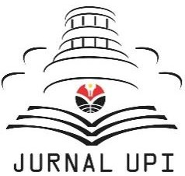

ASEAN Journal of Science and Engineering

Bibliometric Using Vosviewer with Publish or Perish (using Google Scholar data):

From Step-by-step Processing for Users to the Practical Examples in the Analysis of Digital Learning Articles in Pre and Post Covid-19 Pandemic

*Dwi Fitria Al Husaeni1, Asep Bayu Dani Nandiyanto2,\**

1Departemen Pendidikan Ilmu Komputer, Universitas Pendidikan Indonesia, Indonesia

2Departemen Kimia, Universitas Pendidikan Indonesia, Indonesia Correspondence: E-mail: [nandiyanto@upi.edu](mailto:nandiyanto@upi.edu)

|  |  |  |
| --- | --- | --- |
| **A B S T R A C T S** |  | **A R T I C L E I N F O** |
| The purpose of this study is to analyze and demonstrate step- by-step bibliometric data analysis using VOSViewer completely and systematically. Step-by-step analysis was provided to make first-time users easily following the way how to use VOSviewers. This report allows and provides an easy way of data analysis by utilizing mapping tools and provide analysis of research developments regarding digital learning media. The method used in this research is to perform bibliometric analysis to produce network visualization of co-work maps and density maps of co-works. The analysis was carried out with the number of publications obtained, relating to the predetermined topics totaling 88 documents in 2017-2021. As practical examples, we evaluated the analysis of digital learning articles in pre and  post covid. We found that VOSviewer can be used to give suggestions in the data analysis results. |  | *Submitted/Received 15 Jun 2021*  *First revised 18 Jul 2021*  *Accepted 18 Sep 2021*  *First available online 20 Sep 2021*  *Publication date 01 Mar 2022*  ***Keyword:*** *Bibliometric, Data analysis, Database,*  *Digital learning media, Mapping,*  *Publish or Perish, VOSviewer.* |

***Article History:***

© 2021 Universitas Pendidikan Indonesia

# INTRODUCTION

Analysis of bibliometric data that is displayed visually through mapping tools is very much needed in this era of technological growth which is developing so rapidly as it is today (Nandiyanto et al., 2020a; Nandiyanto et al., 2020b). Mapping tools are used to get the results of the description and various information on the development of the field of science and the performance of research that has been carried out. One of the tools that can be used to perform bibliometric data analysis mapping and an example of mapping tools is VOSViewer (Gracia, 2020).

VOSViewer is a computer program developed to build and view bibliometric maps (Van Eck & Waltman, 2010). VOSViewer offers a text-mining function that can be used to build and visualize a correlation in a citation of an article or publication (Shen & Wang, 2020). The publication map can be displayed in several ways and functions, such as mapping the zoom system, scrolling, and searching. Thus, articles can be mapped in more detail. VOSviewer presents and represents specific information about bibliometric graphic maps (Baier-Fuentes et al., 2019).

VOSViewer is very popularly used lately in analyzing the position of the research to be carried out and measuring the novelty of a study (Triwahyuningtyas et al., 2021). We can display a large bibliometric map in an easy way to interpret a relationship via the VOSViewer. VOSViewer has several characteristics, including being able to map various types of bibliometric analysis, supporting several major bibliographic databases, ignoring the time dimension, being limited to analyzing small to medium amounts of data, intended for text- processing functions, using layout and cluster techniques, using overlay and density visualization features.

Many studies on VOSViewer include research discussing the manual VOSviewer (Van Eck and Waltman, 2013), research on the VOSViewer software survey as a bibliometric mapping computer program (Van Eck and Waltman, 2010), research regarding the grouping of citation- based publications with CitnetExplorer and VOSViewer (Van Eck and Waltman, 2017), trend analysis and convergence of science and technology using VOSViewer (Jeong & Koo, 2016), bibliometric analysis and visualization of scientific publications on atlantoaxial spine surgery based on Web of Science and VOSviewer (Xie et al., 2020), and research on bibliometric analysis of Covid-19 research using VOSviewer (Hamidah et al., 2020). However, no research discusses how to make a Bibliometric analysis using VOSViewer which is discussed in detail with several pictures of the steps with providing examples of analysis regarding the use of digital learning before and after Covid-19.

Therefore, this research was conducted to be able to display the steps of bibliometric data analysis regarding research on digital learning before and after Covid-19 using VOSViewer completely and systematically to see the development of research on this matter from 2017- 2021 and provide a way easy data analysis with the use of mapping tools. Thus, it is hoped that this research can be used as a reference to be able to do big data analysis more easily with the use of VOSViewer. This report can be also used as a reference by first-time users since we provided step by step process when using VOSviewer.

# METHOD

## Analysis Tool Preparation

In conducting data analysis using VOSViewer, we must prepare several applications. First, we used namely the Mapping tool, which can be obtained from the open-source application VOSviewer (**Figure 1**). In this study, VOSviewer is used as a tool that can visualize the analyzed

data to be mapped. The second tool to set up is a references manager application. References manager applications that can be used include Publish or Perish as shown in **Figure 2** and Mendeley as shown in **Figure 3**. This reference manager application is used to collect research data which will later be analyzed bibliometrically using VOSviewer.

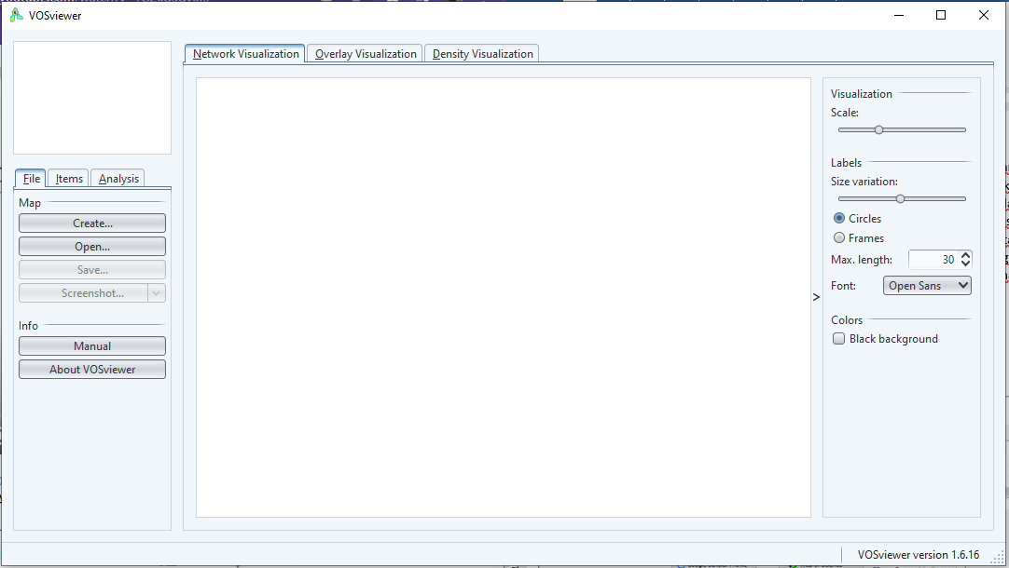

**Figure 1.** VOSviewer application.

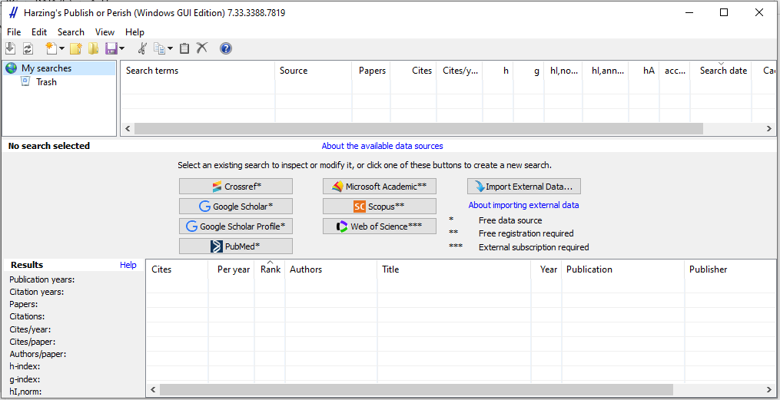

**Figure 2.** Publish or Perish application.

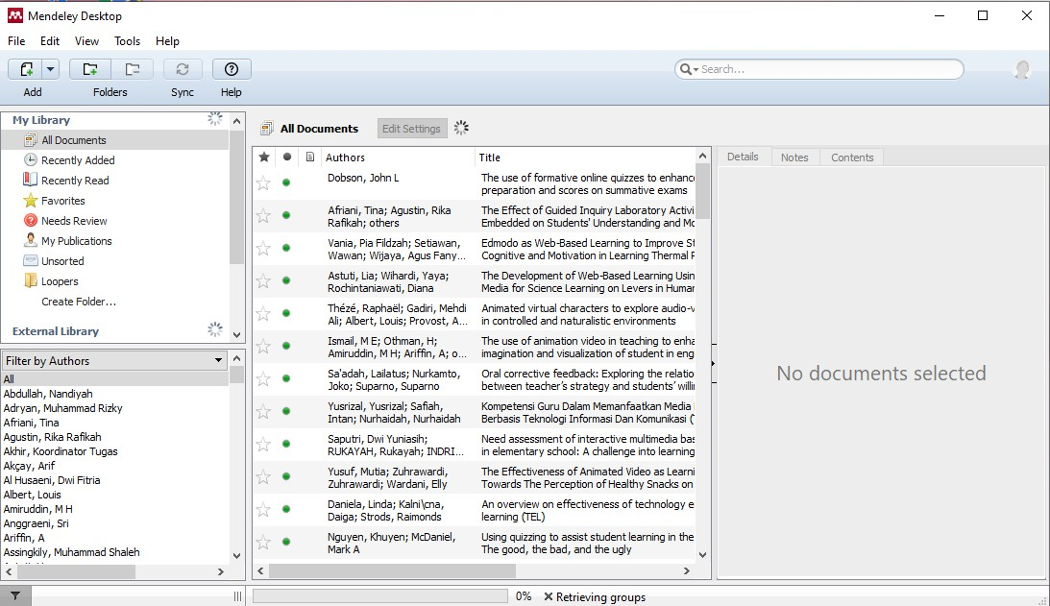

**Figure 3.** Mendeley Application.

## Data Retrieval

The data used in this study is journal publication data on digital learning media in Indonesia which was obtained by using the reference managers application. The reference manager application used in this research is Publish or Perish. Publish or Perish is used to conduct a literature review of the chosen theme. Thus, so that a database of similar research themes is obtained.

Publish or Perish is used to find out which author is cited the most, the oldest and most recent year of an article and we will get a bibliometric record of each research that will be used. Publish or Perish provides several choices of research data sources to be used such as from Crossref, Google Scholar, Google Scholar Profile, PubMed, Microsoft Academic, Scopus, and Web of Science as shown in **Figure 4**. In this study used data from the Google Scholar database.

## Research Data Mapping

The data mapping in this study used a digital mapping application that is VOSviewer. The data that has been obtained is processed in such a way that it matches the desired keywords. After that the data is inputted into the VOSviewer application which will then convert the data into an interconnected data map.

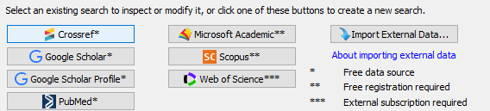

**Figure 4.** Choice of data sources on Publish or Perish.

# RESULTS AND DISCUSSION

This section discusses how to analyze the results of data mapping using VOSviewer with data on the development of the number of journal publications with the main theme of digital learning media in the Google Scholar database from 2017-2021.

## Data Used

As an example of this research, the data will be taken through Google Scholar. This means that every data article contained in Google Scholar and in accordance with the theme search needed in this study will be backed up into a file that will be used in using VOSviewer. The steps to get the data are as follows.

1. Open the Publish or Perish App

The first step to get data via publish or perish is to open the application as shown in the **Figure 5**. After publish or perish is open, we can see the initial application window as shown by the **Figure 6**.

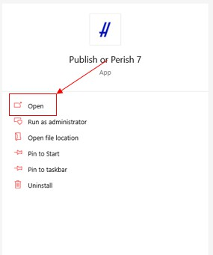

**Figure 5.** Open the Publish or Perish app.

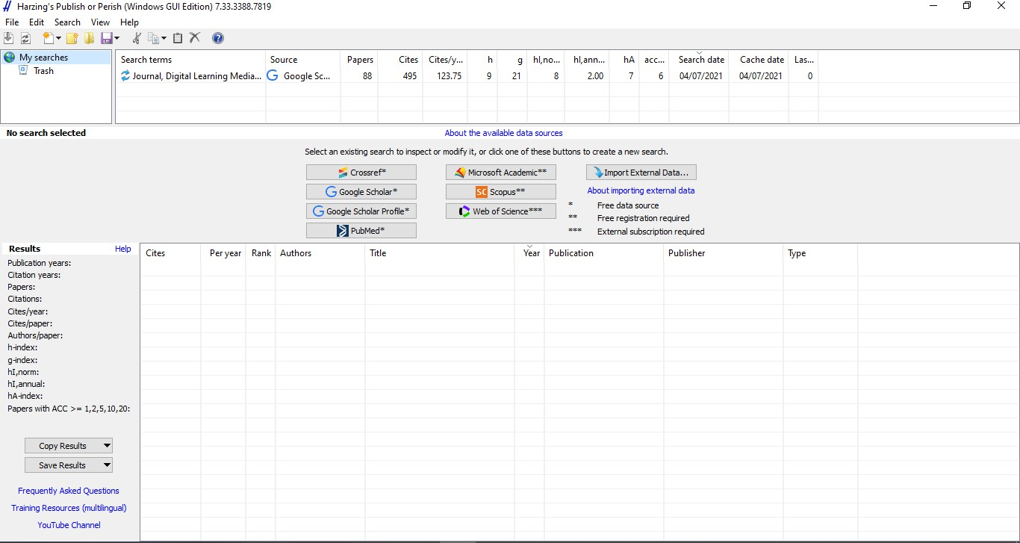

**Figure 6.** The initial window of publish or perish.

1. Click on the Google Scholar button

**Figure 7** shows the location of the Google Scholar button on Publish or Perish. The step that must be done at this stage is to press the button.

1. Fill in Google Scholar Search

As shown in **Figure 8**, there are several sections in Google Scholar Search, including author, publication name, title word, and keywords. In this study, the theme sought is digital learning media with a range of years from 2017-2021 or research conducted 5 years ago. The publication name is filled with Journal. Next, we can set the maximum number of results. In this research, the maximum number of papers produced is 200 articles.

If the required fields on the Google Scholar search form have been completed, click the search button in the upper right corner as shown in **Figure 8**. After the display on Publish or Perish as shown in **Figure 9**, we just have to wait for the search process to complete.

1. Search result

**Figure 10** shows the search results from Publish or Perish. If we look at the results section which is on the left side of the screen, **Figure 10** shows some data information from the data that has been obtained. In this study, it is known that the publication years from 2017-2021, Citation years for 4 years, namely (2017-2021).

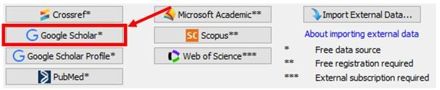

**Figure 7.** Location of the Google Scholar button.

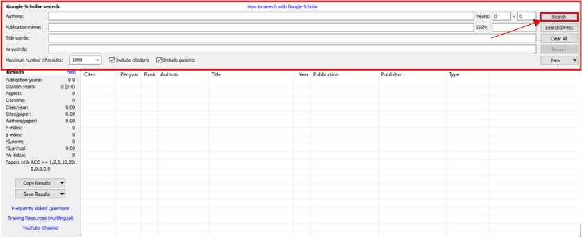

**Figure 8.** Google Scholar Search Section.

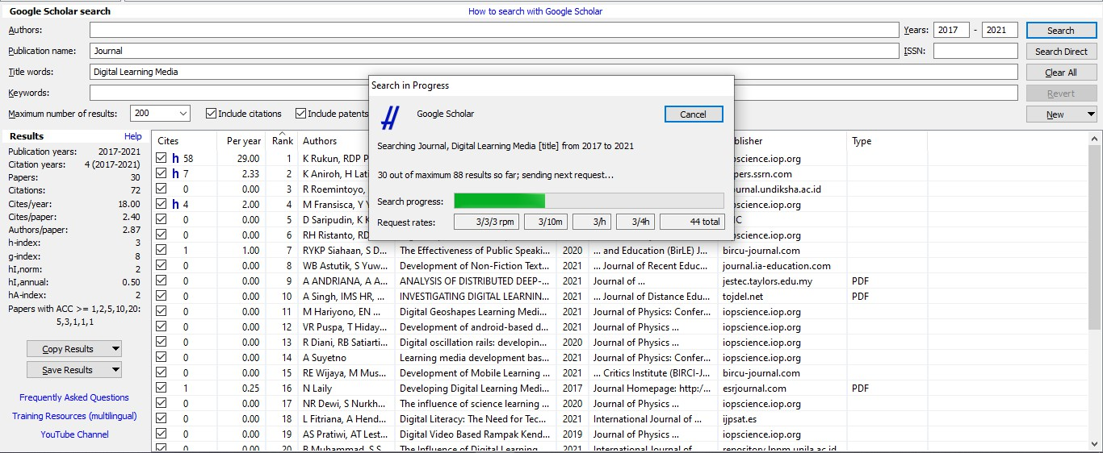

**Figure 9.** The process of searching for articles on Publish or Perish.

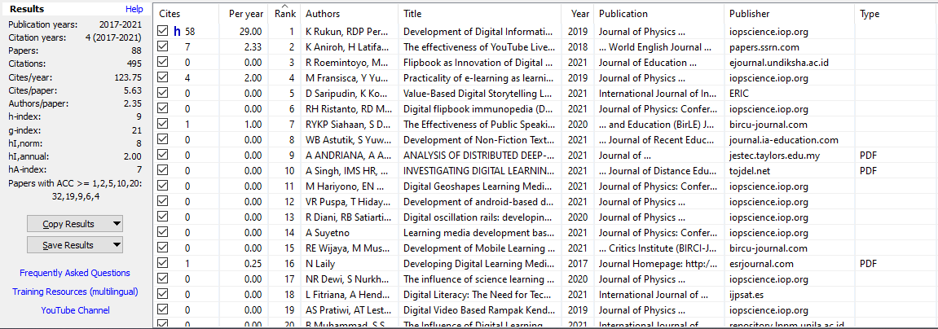

**Figure 10.** Search results by Publish or Perish

1. Save Data from Publish or Perish

The next step is for each result that is saved by clicking the Save Result button. After that save the result in the form of RIS (**Figure 11**). Because the file is in the form of RIS which can be read by VOSviewer.

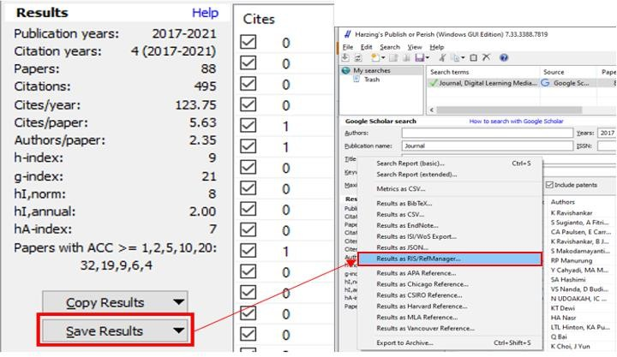

**Figure 11.** How to save search data Publish or Perish.

The articles found in Publish or Perish are mapped using VOSviewer. The data displayed in Publish or Perish is in the form of metadata, not full-text, namely the author's name, title, year, the journal that publishes it, and also the publisher of the article that has been found.

**Table 1** shows a data of search from publish or perish that used in the VOSviewer analysis of this study. We got 88 articles, the number of citations is 495, the number of citations per year is 123.75, the number of citations per article is 5.63, the author of each article is 2.35, the h-index is 9, the g-index is 21, h1, the annual is 2.00, the h-index is 7.

**Table 1.** Digital learning research data.

|  |  |  |  |  |  |  |  |
| --- | --- | --- | --- | --- | --- | --- | --- |
| **No** | **Authors** | **Title** | **Year** | **Author Count** | **Cites** | **Cites Per Year** | **Cites Per Author** |
| 1 | EM Dalton | Beyond Universal Design for Learning: Guiding Principles to Reduce Barriers to Digital & Media  Literacy Competence. | 2017 | 1 | 35.00 | 0.38 | 35.00 |
| 2 | A Widodo, Y  Wiyatmo | Benda Tegar Pocket  Book Learning Media Development Based On Digital Android To Increase Interest And Outcomes Learning Of Physics Students | 2017 | 2 | 12.00 | 3.00 | 6.00 |
| 3 | AM Leach | Digital media production to support literacy for secondary students with diverse  learning abilities | 2017 | 1 | 8.00 | 2.00 | 8.00 |

|  |  |  |  |  |  |  |  |
| --- | --- | --- | --- | --- | --- | --- | --- |
| **No** | **Authors** | **Title** | **Year** | **Author Count** | **Cites** | **Cites Per Year** | **Cites Per Author** |
| 4 | JV Pavlik | Experiential Media and Disabilities in Education: Enabling Learning through Immersive, Interactive, Customizable, and Multi-sensorial Digital  Platforms. | 2017 | 1 | 7.00 | 0.09 | 7.00 |
| 5 | VE Meidasari | The Using of Digital  Media to Enhance Teaching and Learning English on the Well- being of Indonesian  Students | 2017 | 1 | 7.00 | 0.09 | 7.00 |
| 6 | M Matijević, T  Topolovčan, V Rajić | Teacher assessment  related to the use of digital media and constructivist learning in primary and  secondary education | 2017 | 3 | 7.00 | 0.09 | 2.00 |
| 7 | D Herro, M Qian, L  Jacques | Increasing digital media  and learning in classrooms through school–university partnerships | 2017 | 3 | 5.00 | 0.06 | 2.00 |
| 8 | N Laily | Developing Digital  Learning Media in Accounting | 2017 | 1 | 1.00 | 0.02 | 1.00 |
| 9 | AM Wijaya, N  Suryani | Digital Media Based  Macromedia Flash to Increase the Historical Learning Interest of Senior High School  Students | 2017 | 2 | 1.00 | 0.02 | 1.00 |
| 10 | R Cole, D McHugh,  FH Netter | Assessing Emotional  Stress, Active Recall and Digital Spaced‐ Learning Media in the Study of Thoracic Gross Anatomy by Medical Students | 2017 | 3 | 0.00 | 0.00 | 0.00 |
| 11 | LD Rohmatunnisa | Developing Character-  Based Digital Magazine as A Learning Media For Accounting Cycle of Service Company on Accounting Students | 2017 | 1 | 0.00 | 0.00 | 0.00 |

|  |  |  |  |  |  |  |  |
| --- | --- | --- | --- | --- | --- | --- | --- |
| **No** | **Authors** | **Title** | **Year** | **Author Count** | **Cites** | **Cites Per Year** | **Cites Per Author** |
| 12 | P Pérez-Paredes | Mobile Learning through Digital Media Literacy | 2017 | 1 | 0.00 | 0.00 | 0.00 |
| 13 | B Gleason, S Von  Gillern | Digital citizenship with  social media: Participatory practices of teaching and learning in secondary  education | 2018 | 2 | 125.00 | 41.67 | 63.00 |
| 14 | B Huber, K  Highfield, J Kaufman | Detailing the digital  experience: Parent reports of children's media use in the home learning environment | 2018 | 3 | 41.00 | 0.59 | 14.00 |
| 15 | K Aniroh, H Latifah, A Abdul Ghoffar Ariyanto | The effectiveness of YouTube Live streaming as digital learning media in tourism and guiding  subject | 2018 | 3 | 7.00 | 0.11 | 2.00 |
| 16 | MO Finucane, L  Seiter, NC Gehlert | Teaching Social Justice:  Intergenerational Service Learning in a Digital Media Course | 2018 | 3 | 2.00 | 0.05 | 1.00 |
| 17 | R Sefriani, I Wijaya, P Radyuli | Development of android based learning media on the subjects of digital photo composition for vocational high school  student | 2018 | 3 | 0.00 | 0.00 | 0.00 |
| 18 | V Oberoi, F  Hosseini, M Doroudi, L Vo | Anatomy in a New  Curriculum: Using Digital Media to Facilitate the Learning  of Anatomy in the Medical Curriculum | 2018 | 4 | 0.00 | 0.00 | 0.00 |
| 19 | K Ravishankar, B  Jeyaprabha, H MoideenBatcha, VRD Sagunthala | Intention And  Awareness on Digital Media and E-Learning Solutions Among Management Students In Education | 2018 | 3 | 0.00 | 0.00 | 0.00 |

|  |  |  |  |  |  |  |  |
| --- | --- | --- | --- | --- | --- | --- | --- |
| **No** | **Authors** | **Title** | **Year** | **Author Count** | **Cites** | **Cites Per Year** | **Cites Per Author** |
| 20 | K Choi, J Yun | An Analytic Study about the Effect of Flipped learning Class at Universities used for  Digital Media Usage Exploration | 2018 | 2 | 0.00 | 0.00 | 0.00 |
| 21 | K Rukun, RDP  Permatasari, BH Hayadi | Development of Digital  Information Management Learning Media Based on Adobe Flash in Grade X of Digital Simulation  Subject | 2019 | 3 | 58.00 | 1.21 | 19.00 |
| 22 | S Pereira, J Fillol, P  Moura | Young people learning  from digital media outside of school: the informal meets the  formal | 2019 | 3 | 55.00 | 1.16 | 18.00 |
| 23 | M Daumiller, M  Dresel | Supporting self-  regulated learning with digital media using motivational regulation and metacognitive  prompts | 2019 | 2 | 28.00 | 0.58 | 14.00 |
| 24 | SD Kincey, ED  Farmer, CY Wiltsher, D McKenzie, ST Mbiza | From chalkboard to  digital media: The evolution of technology and its relationship to minority students'  learning experiences | 2019 | 4 | 10.00 | 0.21 | 3.00 |
| 25 | MI Rahmatullah | Pengembangan Konsep  Pembelajaran Literasi Digital Berbasis Media E-Learning Pada Mata Pelajaran PJOK di SMA Kota Yogyakarta | 2019 | 1 | 9.00 | 0.20 | 9.00 |
| 26 | MB Richards, SW Marshall | Experiential learning theory in digital marketing communication:  Application and outcomes of the applied marketing & media education norm  (AMEN) | 2019 | 2 | 8.00 | 0.17 | 4.00 |

|  |  |  |  |  |  |  |  |
| --- | --- | --- | --- | --- | --- | --- | --- |
| **No** | **Authors** | **Title** | **Year** | **Author Count** | **Cites** | **Cites Per Year** | **Cites Per Author** |
| 27 | M Fransisca, Y Yunus, AD Sutiasih, RP Saputri | Practicality of e- learning as learning media in digital simulation subjects at  vocational school in Padang | 2019 | 4 | 4.00 | 0.08 | 1.00 |
| 28 | D Hikmah | Quizlet: A digital media  for learning informatics terms | 2019 | 1 | 4.00 | 0.08 | 4.00 |
| 29 | D Lestari, S  Siswandari, C Indrawati | The Development of  Digital Storytelling Website Based Media for Economic Learning in Senior High School | 2019 | 3 | 3.00 | 0.08 | 1.00 |
| 30 | M Chen | Children and families in the digital age: learning together in a media saturated world | 2019 | 1 | 3.00 | 0.08 | 3.00 |
| 31 | S Radha, J Michael Mariadhas, AK Subramani, N Akbar Jan | Role of e-learning and digital media resources in employability of management students | 2019 | 4 | 3.00 | 0.08 | 1.00 |
| 32 | M Ranieri | Professional development in the digital age. Benefits and constraints of  social media for lifelong learning | 2019 | 1 | 3.00 | 0.08 | 3.00 |
| 33 | A Basit, RC  Puspitarini | Extension of Digital  Media to Strengthen Learning Outcome with Online Approach in Inclusive School  Students | 2019 | 2 | 1.00 | 0.03 | 1.00 |
| 34 | D Hikmah | Media For Language  Teaching and Learning in Digital Era | 2019 | 1 | 1.00 | 0.03 | 1.00 |
| 35 | JT Feezell | An Experimental Test of Using Digital Media Literacy Education and Twitter to Promote Political Interest and Learning in American  Politics Courses | 2019 | 1 | 1.00 | 0.03 | 1.00 |

|  |  |  |  |  |  |  |  |
| --- | --- | --- | --- | --- | --- | --- | --- |
| **No** | **Authors** | **Title** | **Year** | **Author Count** | **Cites** | **Cites Per Year** | **Cites Per Author** |
| 36 | F Fujiati, SL Rahayu | Penerapan Digital Game Based Learning Pada Media Pembelajaran  “LABIRIN” | 2019 | 2 | 1.00 | 0.03 | 1.00 |
| 37 | KT Dewi | Developing local  wisdom based digital storytelling through blended learning method as an innovative media for teaching writing at eight grade students of SMP Negeri 2 Singaraja | 2019 | 1 | 1.00 | 0.03 | 1.00 |
| 38 | AS Pratiwi, AT  Lestari, B Hendrawan, MF Nugraha, M Nurfitriani, M Nurkamilah, F  Nugraha | Digital Video Based  Rampak Kendang Learning Media for Deaf Students | 2019 | 4 | 0.00 | 0.00 | 0.00 |
| 39 | R Mufidah, A  Efendi, C Budiyanto | The Effectiveness of  Android Based Digital Arithmetic Learning Media with Discovery- Based Learning Model to the Learning Achievement of Computer System Subject of Grade X of Multimedia Class at  Vocational High School in Surakarta | 2019 | 3 | 0.00 | 0.00 | 0.00 |
| 40 | A Yustina, NF  Isneni, D Risaldi | The Transition Of I La  Galigo Epos Into a Webtoon Serial Form as a Learning Media of Buginese Classical Literature Creation In  The Digital Era | 2019 | 3 | 0.00 | 0.00 | 0.00 |
| 41 | AF Hayati, MA  Zona, JE Marna | Pelatihan Media  Pembelajaran Berbasis Digital Learning Pada Guru Ekonomi Sekolah Menengah Atas (Sma) Di Kota Padang | 2019 | 3 | 0.00 | 0.00 | 0.00 |

|  |  |  |  |  |  |  |  |
| --- | --- | --- | --- | --- | --- | --- | --- |
| **No** | **Authors** | **Title** | **Year** | **Author Count** | **Cites** | **Cites Per Year** | **Cites Per Author** |
| 42 | L Gales | From Media to Transmedia: Transforming Teaching and Learning Strategies  in a Digital Culture | 2019 | 1 | 0.00 | 0.00 | 0.00 |
| 43 | S Sugianto, A  Fitriani, S Anggraeni, W Setiawan | Media needs of plant  anatomy practicum on digital microscope blended learning system on student naturalist intelligence | 2019 | 4 | 0.00 | 0.00 | 0.00 |
| 44 | Q Bai | Media Assisted  Teaching Environment on Students Digital Media Music Education Cooperative Learning and Learning | 2019 | 1 | 0.00 | 0.00 | 0.00 |
| 45 | A Dutta | Impact of digital social media on Indian higher education: alternative approaches of online learning during Covid- 19 pandemic crisis | 2020 | 1 | 25.00 | 1.04 | 25.00 |
| 46 | D Gandasari, D  Dwidienawati | Evaluation of Online  Learning with Digital Communication media during the COVID 19 Pandemic | 2020 | 2 | 6.00 | 0.25 | 3.00 |
| 47 | N Hazizah, I Ismaniar | Teachers' Strategies in Preparing Online Learning Digital Media for Developing Children's Literacy  Skills | 2020 | 2 | 3.00 | 0.13 | 2.00 |
| 48 | L Miculescue | Digital Media: Friend or  Foe? Preschool teachers' experiences on learning & teaching  online” | 2020 | 1 | 3.00 | 0.13 | 3.00 |
| 49 | S Waljinah, K  Dimyati, H Joko | The Study of  Euphemism in Social Media: Digital Learning  Media Innovation | 2020 | 3 | 2.00 | 0.08 | 1.00 |
| 50 | RYKP Siahaan, S  Daulay, W Hadi | The Effectiveness of  Public Speaking Learning Media Based on Digital Multimodal in Indonesian Language Courses at Politeknik  Pariwisata Medan | 2020 | 3 | 1.00 | 0.04 | 0.00 |

|  |  |  |  |  |  |  |  |
| --- | --- | --- | --- | --- | --- | --- | --- |
| **No** | **Authors** | **Title** | **Year** | **Author Count** | **Cites** | **Cites Per Year** | **Cites Per Author** |
| 51 | DFK Dwiputra, TM Budiyanto, TA Dzakiyyah, M Igbal | Textbooks Transformation Into Digital Comics As Innovative Learning Media for Social Science Studies in  Junior High School | 2020 | 3 | 1.00 | 0.04 | 0.00 |
| 52 | S Makodamayanti,  D Nirmala, C Kepirianto | The Use of Digital  Media as a Strategy for Lowering Anxiety in  Learning English as a Foreign Language | 2020 | 3 | 1.00 | 0.04 | 0.00 |
| 53 | RP Manurung | The utilization of  WhatsApp media as a student's digital literation media in distance learning in SMA Private Santo  Thomas 2 Medan | 2020 | 1 | 1.00 | 0.04 | 1.00 |
| 54 | R Diani, RB Satiarti,  N Lestari, NB Haka, D Reftyawati, A Padillah, H Komikesari | Digital oscillation rails:  developing physics learning media to determine the acceleration value of earth's gravity | 2020 | 5 | 0.00 | 0.00 | 0.00 |
| 55 | NR Dewi, S Nurkhalisa, EN Savitri, I Dwijayanti, SWA Wibowo | The influence of science learning media based digital storytelling towards metacognition ability | 2020 | 4 | 0.00 | 0.00 | 0.00 |
| 56 | N Khairani, H Maksum | Development of Android-Based Learning Media in Simulation and Digital Communication  Subjects | 2020 | 2 | 0.00 | 0.00 | 0.00 |
| 57 | SM Ulfa, AW  Sinrang, S Syarif, AN Usman | The Use Of Digital  Partograph As A Learning Media For Normal Childbirth Care | 2020 | 4 | 0.00 | 0.00 | 0.00 |
| 58 | R Purnamasari, Y Suchyadi, N Karmila, N Nurlela, M Mirawati, R Handayani, D Kurnia | Student Center Based Class Management Assistance Through The Implementation of Digital Learning Models and Media | 2020 | 4 | 0.00 | 0.00 | 0.00 |

|  |  |  |  |  |  |  |  |
| --- | --- | --- | --- | --- | --- | --- | --- |
| **No** | **Authors** | **Title** | **Year** | **Author Count** | **Cites** | **Cites Per Year** | **Cites Per Author** |
| 59 | C Saxena | A Study on Digital Learning for Media Students in The Covid- 19 Outbreak | 2020 | 1 | 0.00 | 0.00 | 0.00 |
| 60 | EA Rachma, R Nurdiana, A Ghofur | The Effect of The Implementation of Google Classroom Digital Media for the Easy of Teachers In Assessing Learning Outcomes | 2020 | 3 | 0.00 | 0.00 | 0.00 |
| 61 | Y Cahyadi, MA Mansyur, H Hasanah | Digital Media Based Stad+ 3r as an Innovative Methods For Writing Explanation Text Teaching Learning | 2020 | 3 | 0.00 | 0.00 | 0.00 |
| 62 | SA Hashimi | Enhancing the creative learning experience through harnessing the creative potential of digital and social media platforms in art and design educational contexts | 2020 | 1 | 0.00 | 0.00 | 0.00 |
| 63 | VS Nanda, D Budimansyah | Strengthening of Digital Media Literacy-Based Character Education on Hoax News Spreading to Students (Case Study on Citizenship  Education Learning in SMP Negeri 2 Bandung) | 2020 | 2 | 0.00 | 0.00 | 0.00 |
| 64 | N Udoakah, IC Nda | Acquisition and  Utilisation of Digital Media in the Teaching and Learning of Mass Communication in Tertiary Institutions in Akwa Ibom State.  Nigeria | 2020 | 2 | 0.00 | 0.00 | 0.00 |
| 65 | HA Nasr | Competences in digital  online media literacy: Towards convergence with emergency remote EFL learning | 2020 | 1 | 0.00 | 0.00 | 0.00 |

|  |  |  |  |  |  |  |  |
| --- | --- | --- | --- | --- | --- | --- | --- |
| **No** | **Authors** | **Title** | **Year** | **Author Count** | **Cites** | **Cites Per Year** | **Cites Per Author** |
| 66 | LTL Hinton, KA Putra | Reclaiming and Learning Indigenous Languages on Social Media with Digital Activists: Insights from Lampung. Mayangna and Miskitu Youth | 2020 | 2 | 0.00 | 0.00 | 0.00 |
| 67 | C Nolkhom, Y  Saifah | Effect of Using Social  Media Activities Package Based on Phenomenon-based Learning and Reflective Thinking on Digital Literacy Behavior for Primary School Students | 2020 | 2 | 0.00 | 0.00 | 0.00 |
| 68 | K Ravishankar | Impact of digital Media  and E-Learning Solutions on Contemporary Management Education–Faculty Perspective | 2020 | 1 | 0.00 | 0.00 | 0.00 |
| 69 | JW Wicaksono, M Japar, E Utomo | Development of Digital Based Comic Media for  Primary V-Class Student Learning | 2021 | 3 | 1.00 | 0.04 | 0.00 |
| 70 | R Roemintoyo, MK  Budiarto | Flipbook as Innovation  of Digital Learning Media: Preparing Education for Facing and Facilitating 21st  Century Learning | 2021 | 2 | 0.00 | 0.00 | 0.00 |
| 71 | D Saripudin, K  Komalasari, DN Anggraini | Value-Based Digital  Storytelling Learning Media to Foster Student Character. | 2021 | 3 | 0.00 | 0.00 | 0.00 |
| 72 | RH Ristanto, RD  Mahardika | Digital flipbook  immunopedia (DFI): A learning media to improve conceptual of immune system | 2021 | 2 | 0.00 | 0.00 | 0.00 |
| 73 | WB Astutik, S Yuwana | Development of Non- Fiction Text Digital Learning Media in Narrative Writing Skills for Fourth Grade Elementary School  Students | 2021 | 2 | 0.00 | 0.00 | 0.00 |

|  |  |  |  |  |  |  |  |
| --- | --- | --- | --- | --- | --- | --- | --- |
| **No** | **Authors** | **Title** | **Year** | **Author Count** | **Cites** | **Cites Per Year** | **Cites Per Author** |
| 74 | A Andriana, A Ana, H Puspita, IY Wulandari | Analysis of Distributed Deep-Learning Based Digital Learning Media Using Thin Client Devices For Inclusion Vocational School  Students | 2021 | 4 | 0.00 | 0.00 | 0.00 |
| 75 | A Singh, IMS HR, S  Singh | Investigating Digital  Learning Media For Skill Enhancement Programmes | 2021 | 3 | 0.00 | 0.00 | 0.00 |
| 76 | M Hariyono, EN Widhi, N Ulia | Digital Geoshapes Learning Media In Supporting  Mathematics Education II PGSD | 2021 | 3 | 0.00 | 0.00 | 0.00 |
| 77 | VR Puspa, T  Hidayat, B Supriatno | Development of  android-based digital determination key application (e- KeyPlant) as learning media for plant  identification | 2021 | 3 | 0.00 | 0.00 | 0.00 |
| 78 | A Suyetno | Learning media  development based on CNC simulator as the digital tool to support the CNC practice learning during COVID- 19 new normal | 2021 | 1 | 0.00 | 0.00 | 0.00 |
| 79 | RE Wijaya, M  Mustaji, H Sugiharto | Development of Mobile  Learning in Learning Media to Improve Digital Literacy and Student Learning Outcomes in Physics Subjects: Systematic Literature Review | 2021 | 3 | 0.00 | 0.00 | 0.00 |
| 80 | L Fitriana, A Hendriyanto, S Sahara, FN Akbar | Digital Literacy: The Need for Technology- Based Learning Media in the Revolutionary Era 4.0 for Elementary  School Children | 2021 | 4 | 0.00 | 0.00 | 0.00 |
| 81 | B Muhammad, S  Sumargono | The Influence of Digital  Learning Media Towards Students' Historical Learning  Interests | 2021 | 2 | 0.00 | 0.00 | 0.00 |

|  |  |  |  |  |  |  |  |
| --- | --- | --- | --- | --- | --- | --- | --- |
| **No** | **Authors** | **Title** | **Year** | **Author Count** | **Cites** | **Cites Per Year** | **Cites Per Author** |
| 82 | IB Ma'arif, I Sunniyah | Developing English Digital Book as Learning Media For Xi Grade Students | 2021 | 2 | 0.00 | 0.00 | 0.00 |
| 83 | S Syahminan, CW Hidayat | Development of digital engineering learning with proteus software media and emulators department of informatics engineering Kanjuruhan University | 2021 | 2 | 0.00 | 0.00 | 0.00 |
| 84 | RA Rahma, S  Sucipto, Y Affriyenni, M Widyaswari | Cybergogy as a digital  media to facilitate the learning style of millennial college students | 2021 | 4 | 0.00 | 0.00 | 0.00 |
| 85 | NV Stanley | Poetry and digital  media for improving upper elementary African American science learning | 2021 | 1 | 0.00 | 0.00 | 0.00 |
| 86 | NC Phillips, VK  Lund | Leveling Up: Connected  Mentor Learning in a Digital Media Production After- School Space | 2021 | 2 | 0.00 | 0.00 | 0.00 |
| 87 | AI Citra, AH  Pulungan, M Oktora | Developing English  Digital Conversation Media for Speaking Activities Based on Task-Based Learning | 2021 | 3 | 0.00 | 0.00 | 0.00 |
| 88 | CA Paulsen, E Carroll, O, Paulsen, JR Adrews | Engaging Children and Families in Active.  Environmental Science Learning through Digital Media | 2021 | 4 | 0.00 | 0.00 | 0.00 |

## The Development of Publications Regarding Digital Learning Media

Based on the search results on the Google Scholar database, it shows that the development of research on digital learning media is shown in **Table 2**. From the table data, it can be seen that there are 90 studies on digital learning media. The number of studies on learning media fluctuated but tends to increase as shown by **Figure 12**. there was only a decrease in research interest on this theme in 2018, namely from 12 studies throughout 2017 to 8 studies in 2018. Throughout 2019 and 2020, there were many studies on the same topics. The number of studies in 2019 is 25, and the number is likely to increase in 2021. This is because there are researches on digital learning media.

The level of research interest in digital learning media which increased rapidly in 2019- early July 2021 was due to the current condition of society which was in the period of the Covid-19 pandemic. Learning is done at home which causes the need for the use of digital learning media so that teaching and learning activities can still be carried out. without a time limit. place and distance (Scully et al., 2021).

## Bibliometric Map Research on Digital Learning Media

From the search results through the Google Scholar database, 88 research documents related to digital learning media were obtained. then the document is exported to RIS format. inputted and analyzed with VOSViewer. There are several steps to doing research mapping using VOSviewer, which are as follows:

1. Open the VOSviewer App

The first step that must be done is to open the VOSviewer application that is already installed on the device. Once you open it, the initial VOSviewer window will appear as shown in **Figure 1**.

1. Click the create button to start creating a new mapping

After opening the VOSviewer click create to start creating a new mapping. As shown in **Figure 13**, there are three choices of data types, namely making maps based on network data, bibliographic data, and text data. In this study, the map was made based on text data, because in this study the research mapping was carried out based on the research title. After that, click the next button.

**Table 2.** The development of research on digital learning media.

|  |  |
| --- | --- |
| **Years of Publication** | **Number of Publication** |
| 2017 | 12 |
| 2018 | 8 |
| 2019 | 25 |
| 2020 | 25 |
| 2021 | 20 |
| **Total** | **90** |

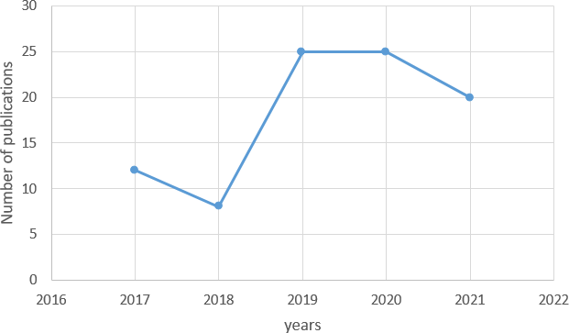

**Figure 12.** Graph of the level of research development on digital learning media.

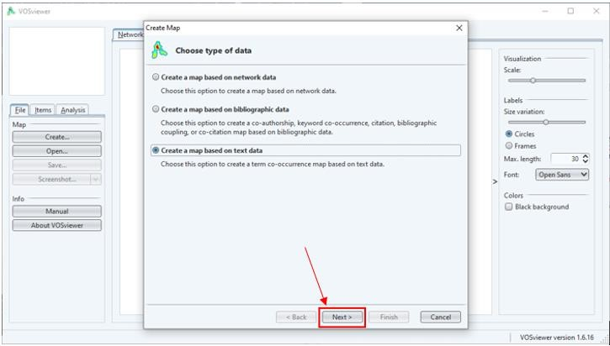

**Figure 13.** Create a map in VOSviewer.

1. Choose and select data source

**Figure 14** shows the next step in making a research map, there are 4 choices of data sources, namely reading data from VOSviewer files, bibliographic database files, reference manager files, and downloading data via API. In the previous data retrieval stage, we used the Publish or Perish application which is one of the reference manager applications, and the type of data that we saved previously was in the form of RIS. Thus, in this section, we select read data from reference manager files, then click Next.

In the section shown in **Figure 15**, select the RIS section and enter the file that has been obtained via Publish or Perish, by pressing the three dots button. Then click the next button to proceed to the next stage.

1. Choose fields to extract

Next, the Choose field page appears as shown in **Figure 16**. This page displays 3 types of data options that can be extracted, namely title and abstract fields, title fields, and abstract fields. In this study, the title and abstract data from the articles that have been collected are used. Thus, VOSviewer maps each keyword taken from the titles and abstracts of articles that have been collected. Once done, the next step is to click the next button.

1. Choose counting method

**Figure 17** shows the selection of the calculation method. There are two methods, namely binary counting and full counting. Binary counting displays data in the form of a value of 0 or 1, meaning that if the same word appears in the title repeatedly, it is counted as one. While the full count method means that in this method the total number that appears is still counted as much as it appears.

1. Choose Threshold

**Figure 18** shows the Choose Threshold page. This page is used to set the minimum number of words that appear so that they can be presented in a folder. In this study, the number of words that appear at least three times, so that the appropriate keywords and the number of occurrences of 3 or more times are included in the mapping. Then the number of words found is 51, and for the part shown in **Figure 19,** we maximize the data display by 51.

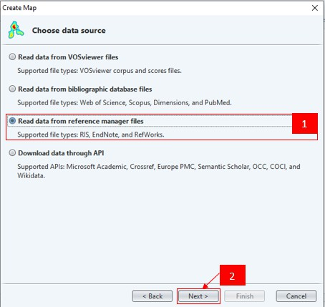

**Figure 14.** Selection of data sources on VOSviewer.

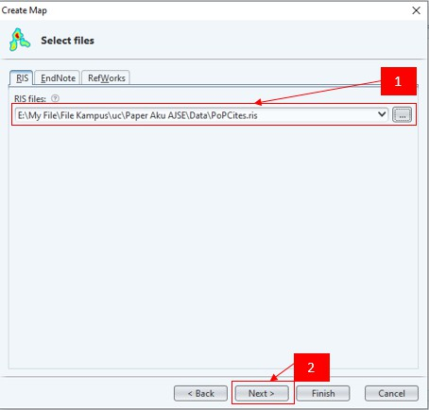

**Figure 15.** Selection of the file to be used as the source of mapping data in VOSviewer.

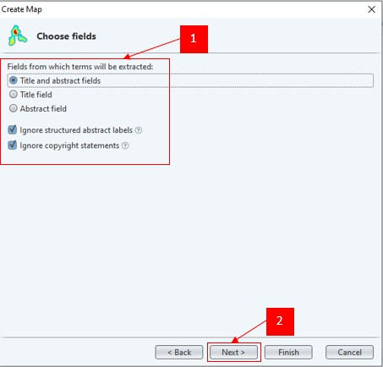

**Figure 16.** Selection of the type of data to be extracted into a map on VOSviewer.

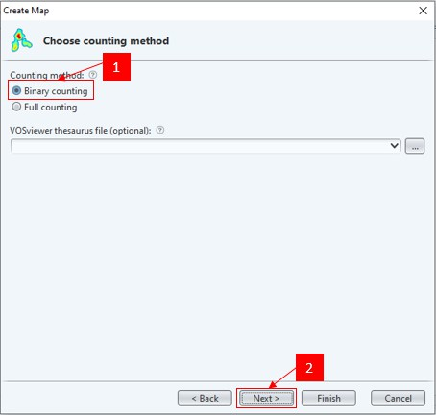

**Figure 17.** Choosing the counting method in VOSviewer.

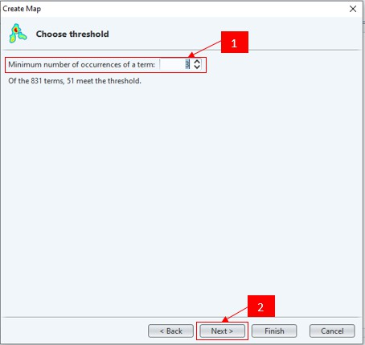

**Figure 18.** Choosing the threshold section on VOSviewer.

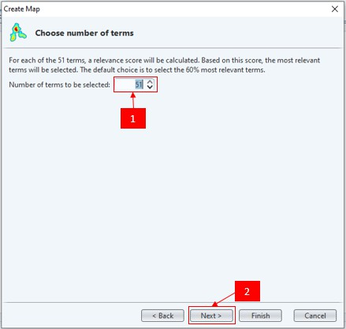

**Figure 19.** Putting the number of terms.

1. Verify selected terms and Click Finish Button

In **Figure 20**, we choose the words that are used and appear on the research mapping created, then click the finish button. After that, we can see the results of the mapping of the research theme regarding digital learning media that showed in **Figure 21**.

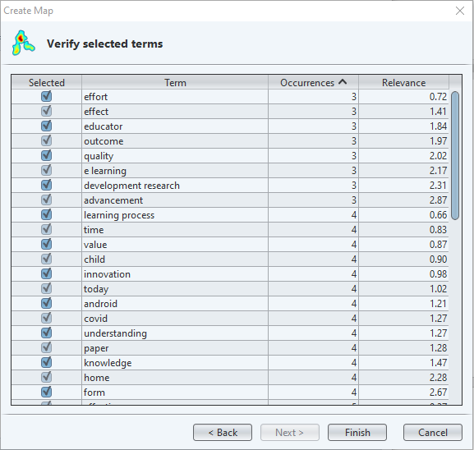

**Figure 20.** Verification of word selection on VOSviewer.

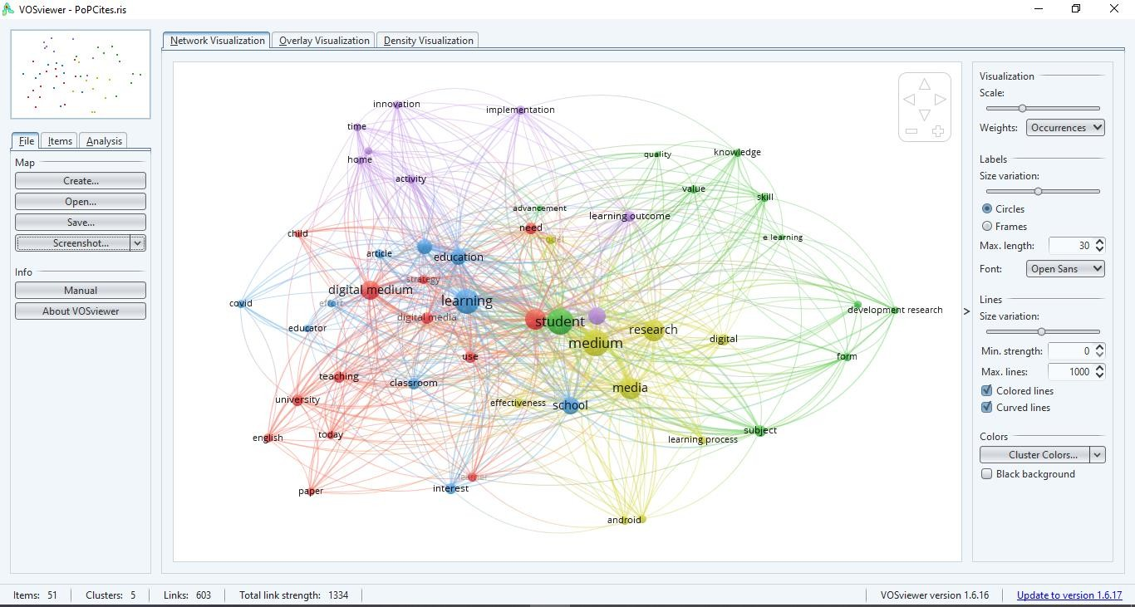

**Figure 21.** The results of the mapping of the research on VOSviewer.

## Co-Word Map network visualization

The results of the visualization of the co-word map network of research developments regarding digital learning media are divided into 5 clusters as shown in **Figure 22** below.

* + - * Cluster 1. The red color consists of 13 items including child, digital media, digital medium, English, learner, need, paper, strategy, study, teaching, today, university and use.
      * Cluster 2**.** Green color consists of 11 items including advancement, development research, e-learning, form, knowledge, outcome, quality, skill, student, subject and value.
      * Cluster 3. Blue color consists of 10 items including article, classroom, covid, education, educator, effort, interest, learning, school and technology.
      * Cluster 4. Yellow color consists of 9 items, namely android, digital, effectiveness, learning process, media, medium, model, research and understanding.
      * Cluster 5. Purple color consists of 8 items including activity, development, effect, home, implementation, innovation, learning outcome, and time.

## Co-Word map density visualization

The cluster density view are items that are marked the same as the visible item. The item point has a color depending on the density of the item at the time. It can identify that the color of the dots is fixed depending on the item associated with other items. Density Co-Word maps are useful for obtaining an overview of the general structure of bibliometric maps by showing which items are considered important for analysis (Muñoz-Leiva et al., 2021). Based on the research results shown in **Figure 23**, it can be interpreted that the most widely used keywords in a publication that show the visualization of the density map co-word research developments on digital learning media.

**Figure 23** shows a density map which is the result of an analysis using all articles on digital learning media in 2017-2021. The density map means that the more yellow the color is with the diameter of the largest circle, the denser the keyword means it appears more often and if the color fades, it blends in with the green background, the less often it occurs (Tupan, 2019).

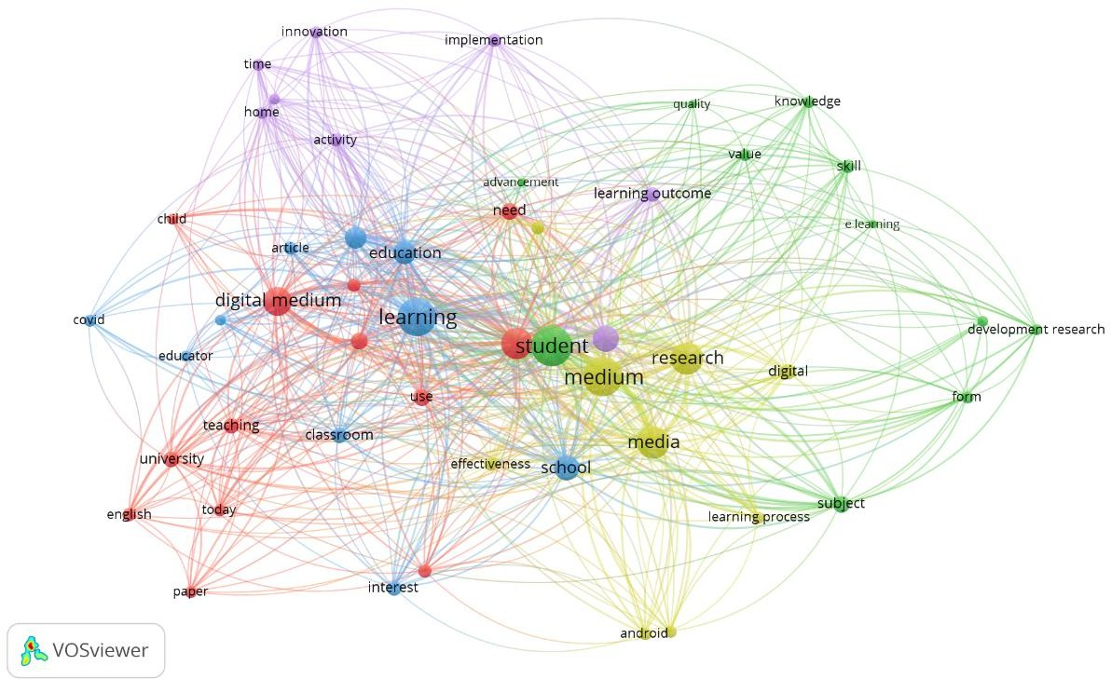

**Figure 22.** Co-word map network visualization

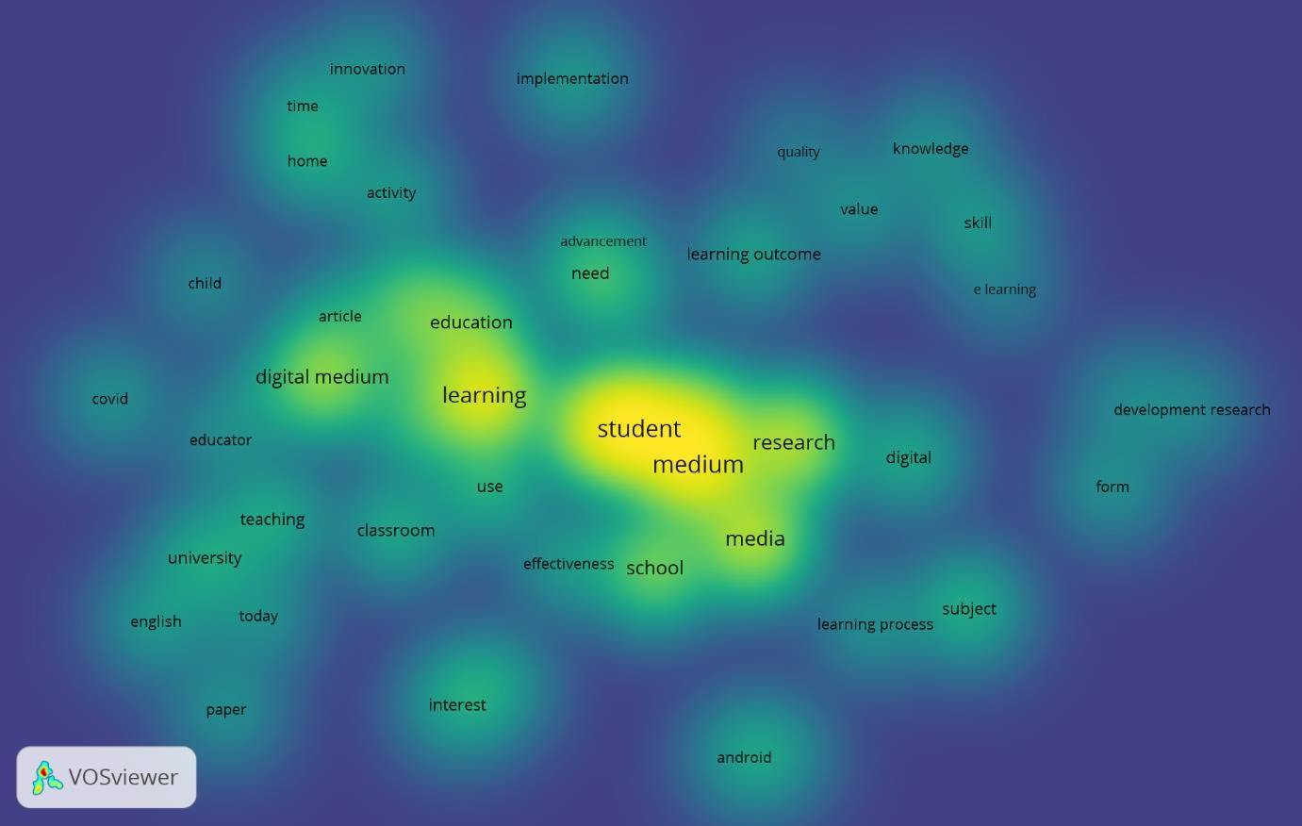

**Figure 23**. Co-Word Map Density Visualization.

# CONCLUSION

Based on the results and discussion above, it can be concluded that VOSviewer can be used as a mapping tool to analyze data bibliometrically. In this study, the data used in analyzing data with VOSviewer is research on digital learning media taken from the Google Scholar database. The number of publications obtained and related to the theme amounted to 90 documents with a range of years from 2017-2021. Changes in the number of publications in this period experienced fluctuating changes but tended to increase rapidly from 2019 to 2021. Through network visualization, it is shown that the development map of research on digital learning media is divided into 5 clusters. Cluster 1 consists of 13 topics, cluster 2 consists of 11 topics, cluster 3 consists of 10 topics, cluster 4 consists of 9 topics and cluster 5 consists of

8 topics.

# ACKNOWLEDGMENTS

We acknowledged Bangdos Universitas Pendidikan Indonesia.

# AUTHORS’ NOTE

The authors declare that there is no conflict of interest regarding the publication of this article. The authors confirmed that the paper was free of plagiarism.

# REFERENCES

Baier-Fuentes. H., Merigó. J. M., Amorós. J. E. and Gaviria-Marín. M. (2019). International entrepreneurship: a bibliometric overview. *International Entrepreneurship and Management Journal*, *15*(2), 385-429.

Garcia. I. (2020). e-Leadership: A Bibliometric Analysis. *International Journal of Advanced Corporate Learning*, *13*(1), 19-34.

Hamidah. I., Sriyono. S. and Hudha. M. N. (2020). A Bibliometric analysis of Covid-19 research using VOSviewer. *Indonesian Journal of Science and Technology*, *5*(2), 209-216.

Jeong. D. H., and Koo. Y. (2016). Analysis of Trend and Convergence for Science and Technology using the VOSviewer. *International Journal of Contents*, *12*(3), 54-58.

Muñoz-Leiva. F., Viedma-del-Jesús. M. I., Sánchez-Fernández. J., and López-Herrera. A. G. (2012). An application of co-word analysis and bibliometric maps for detecting the most highlighting themes in the consumer behaviour research from a longitudinal perspective. *Quality and Quantity*, *46*(4), 1077-1095.

Nandiyanto, A. B. D., Biddinika, M. K., & Triawan, F. (2020a). How bibliographic dataset portrays decreasing number of scientific publication from Indonesia. *Indonesian Journal of Science and Technology*, *5*(1), 154-175.

Nandiyanto, A. B. D., Biddinika, M. K., & Triawan, F. (2020b). Evaluation on research effectiveness in a subject area among top class universities: a case of Indonesia’s academic publication dataset on chemical and material sciences. *Journal of Engineering Science and Technology*, *15*(3), 1747-1775.

Scully. D., Lehane. P. and Scully. C. (2021). ‘It is no longer scary’: digital learning before and during the Covid-19 pandemic in Irish secondary schools. *Technology. Pedagogy and Education*, *30*(1), 159-181.

Shen. X. and Wang. L. (2020). Topic evolution and emerging topic analysis based on open source software. *Information Science*, *5*(4), 126-136.

Triwahyuningtyas. D., Sundaygara. C., Widiaty. I., Nandiyanto. A. B. D., Aji. S. D. and Hudha.

M. N. (2021). Bibliometric analysis of the term ‘STEM module’. In *IOP Conference Series: Materials Science and Engineering*, *1098*(3), 032031.

Tupan. T. (2019). Pemetaan Bibliometrik Dengan Vosviewer Terhadap Perkembangan Hasil Penelitian Bidang Pertanian Di Indonesia. *VISI PUSTAKA: Buletin Jaringan Informasi Antar Perpustakaan*, *18*(3), 217-230.

Van Eck. N. J. and Waltman. L. (2010). Software survey: VOSviewer. a computer program for bibliometric mapping. *Scientometrics*, *84*(2), 523-538.

Van Eck. N. J., and Waltman. L. (2013). VOSviewer manual. *Leiden: Univeristeit Leiden*, *1*(1), 1-53.

Van Eck. N. J., and Waltman. L. (2017). Citation-based clustering of publications using CitNetExplorer and VOSviewer. *Scientometrics*, *111*(2), 1053-1070.

Xie. L., Chen. Z., Wang. H., Zheng. C. and Jiang. J. (2020). Bibliometric and visualized analysis of scientific publications on atlantoaxial spine surgery based on Web of Science and VOSviewer. *World Neurosurgery*, *137*, 435-442.