Results of all the Variations of Models

- Random Mosaic (https://colab.research.google.com/drive/11eZAXwvyKUEznOptSyqd90wwArZE8Xj2?usp=sharing )
Both losses:
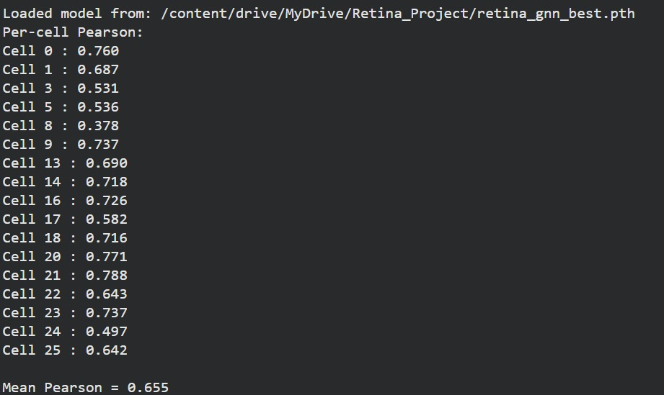
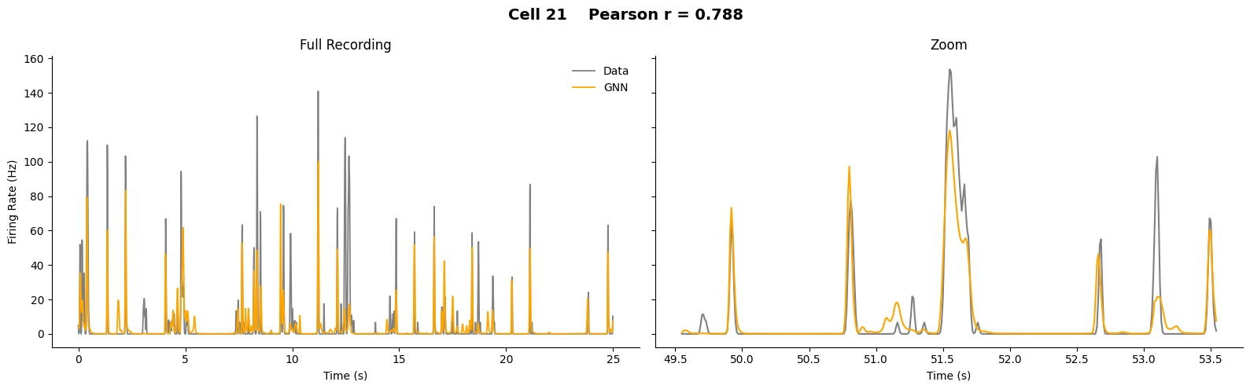
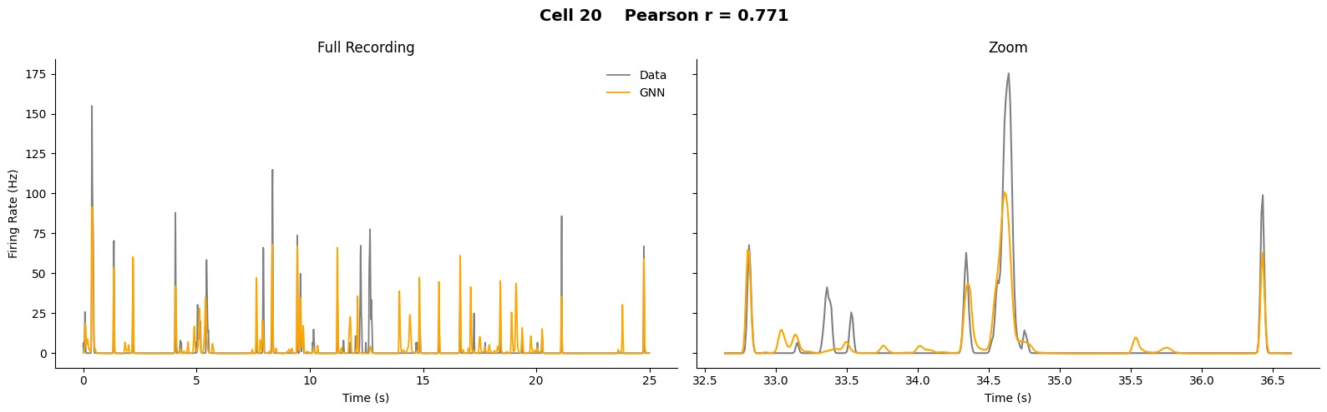

Only Poisson loss:
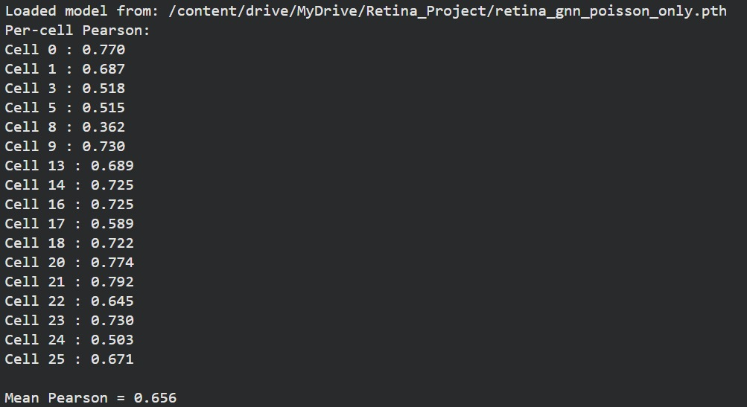
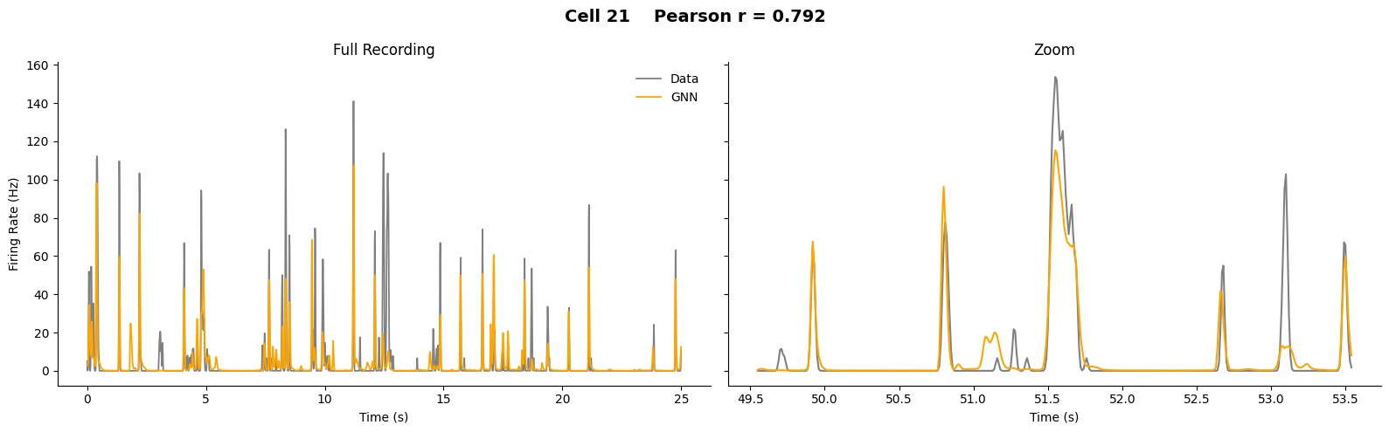
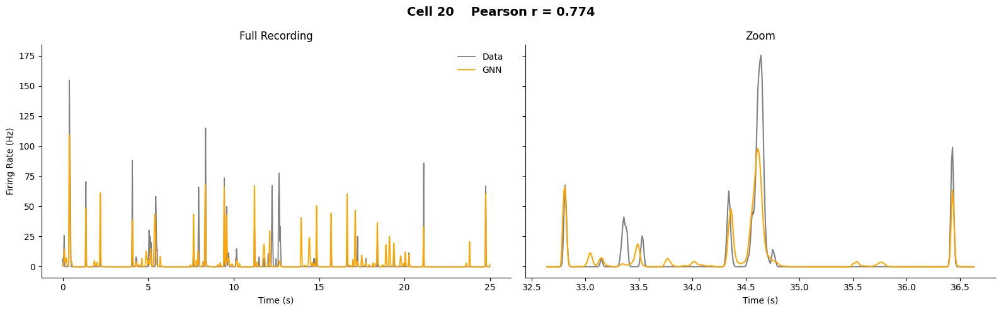

- Uniform Grid for every cell (https://colab.research.google.com/drive/1ksr5ym6UcomuQ7g4ojIgL9X7ix2bsv3J?usp=sharing )

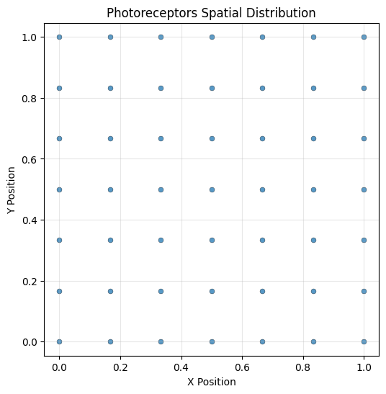
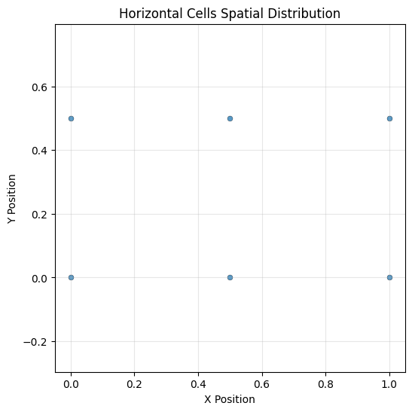
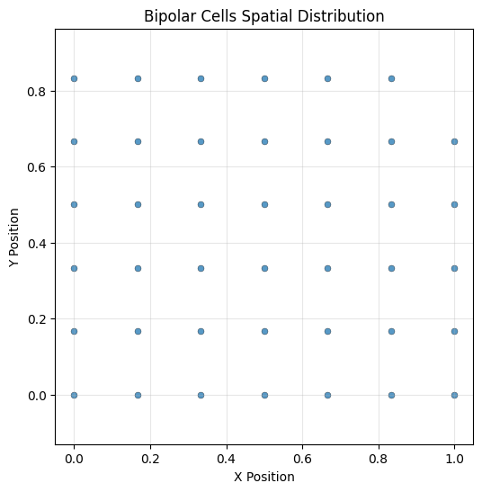
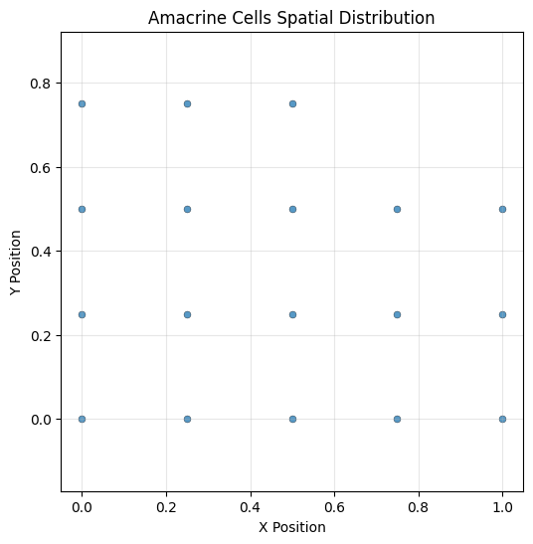
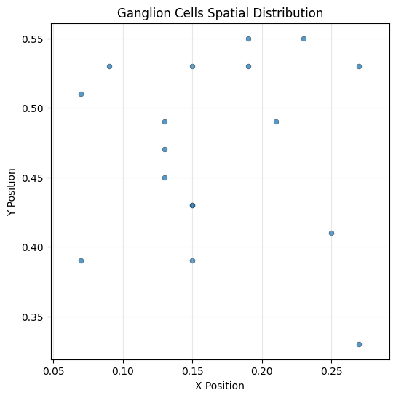

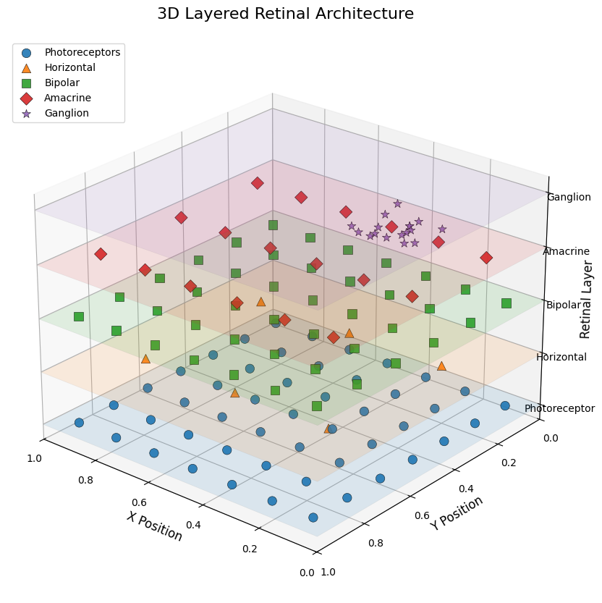
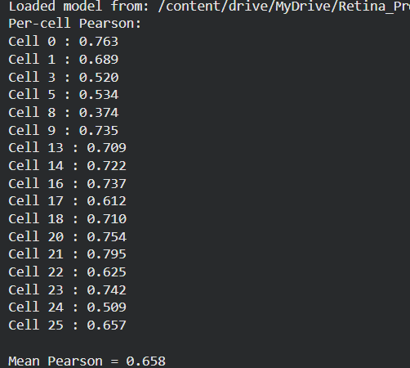
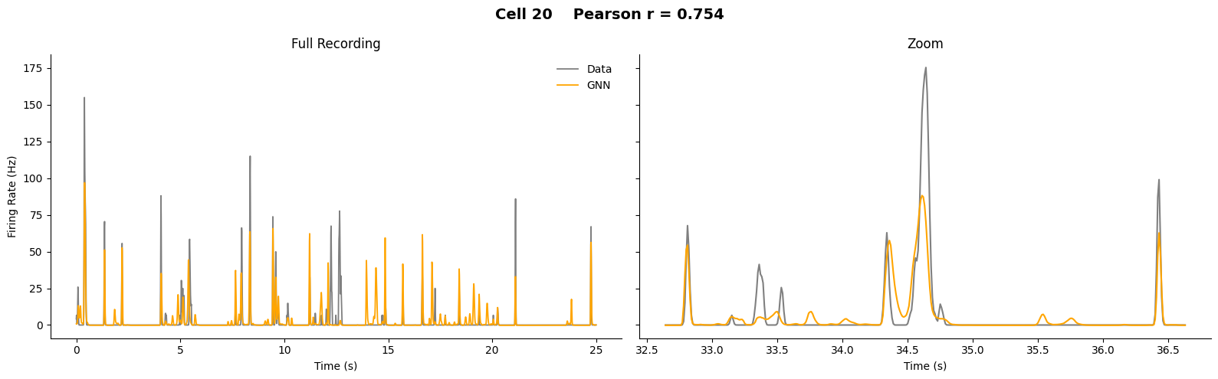
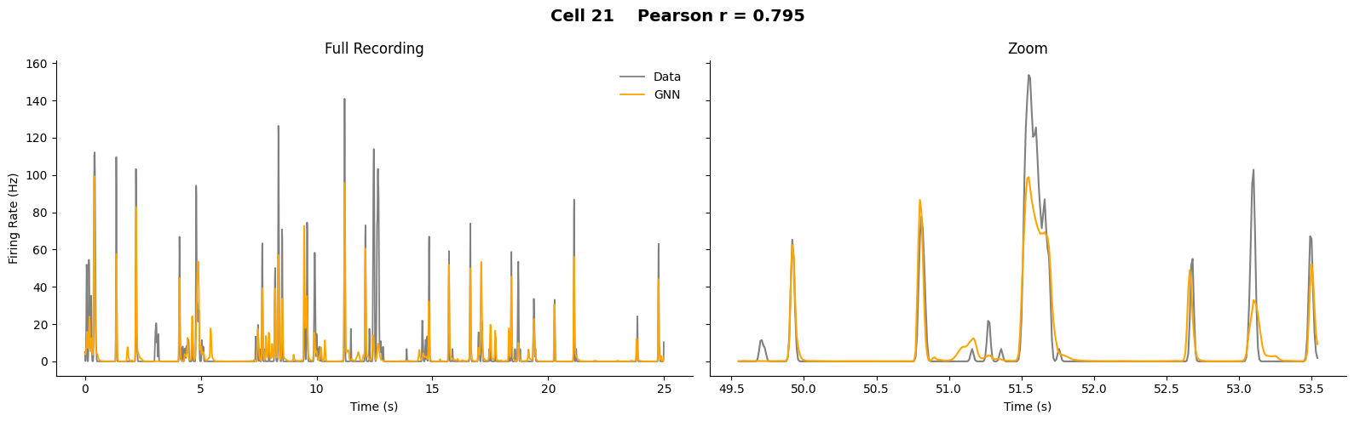

- New Algo (https://colab.research.google.com/drive/1OwhMXLmGXnirquLhxtZoj6n-0CUvaFqN?usp=sharing )
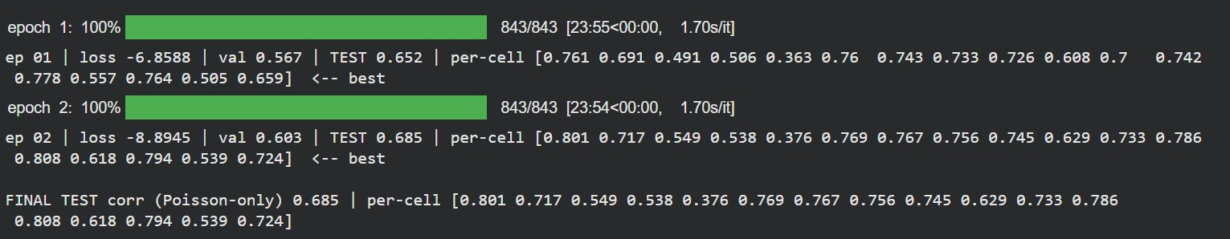
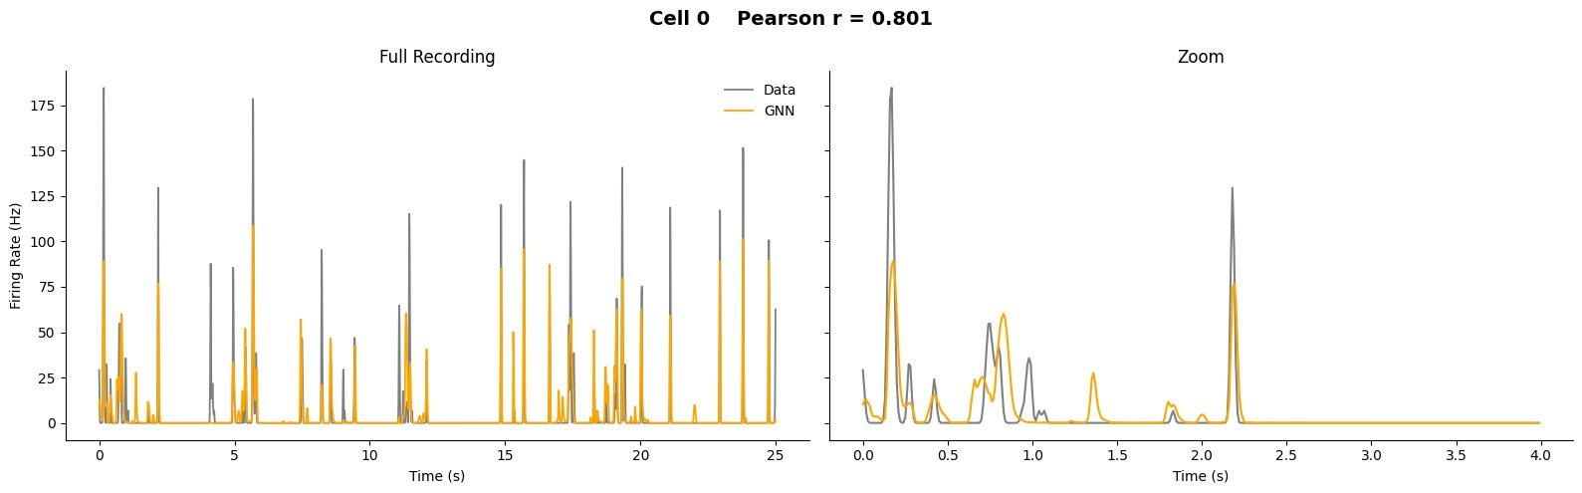

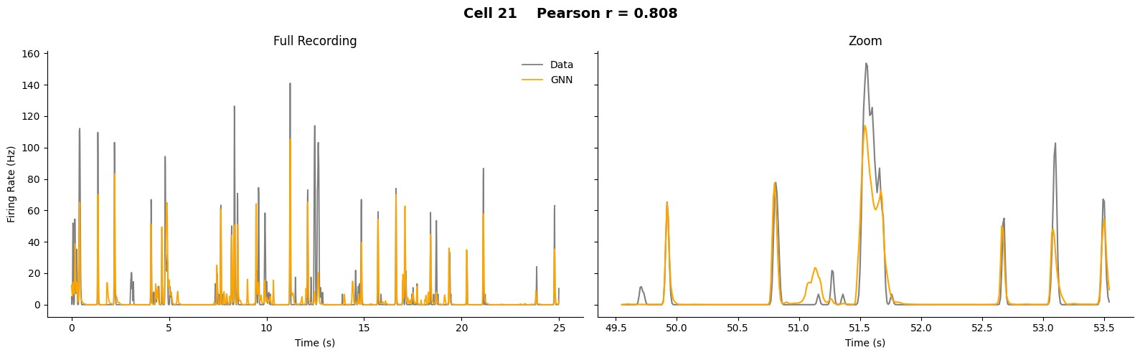
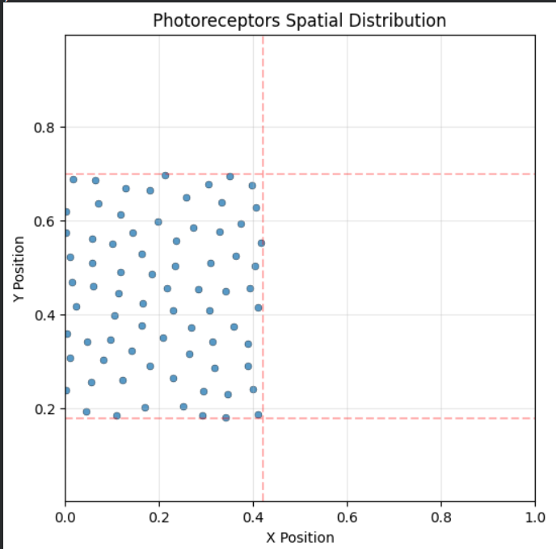
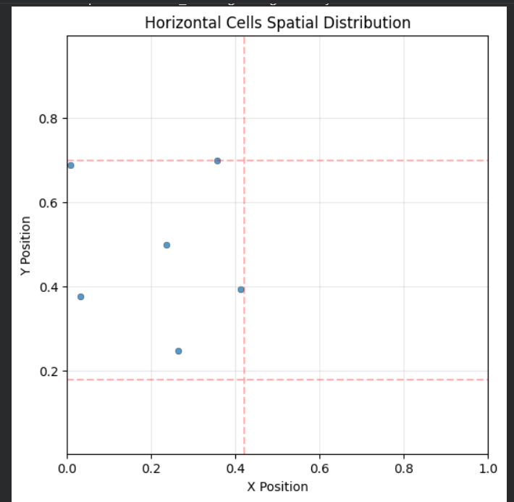
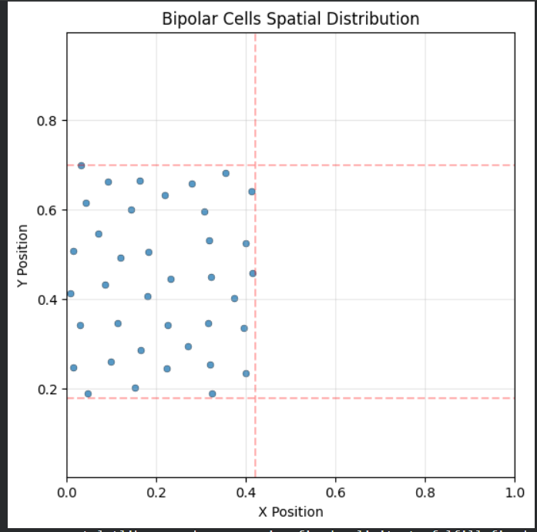
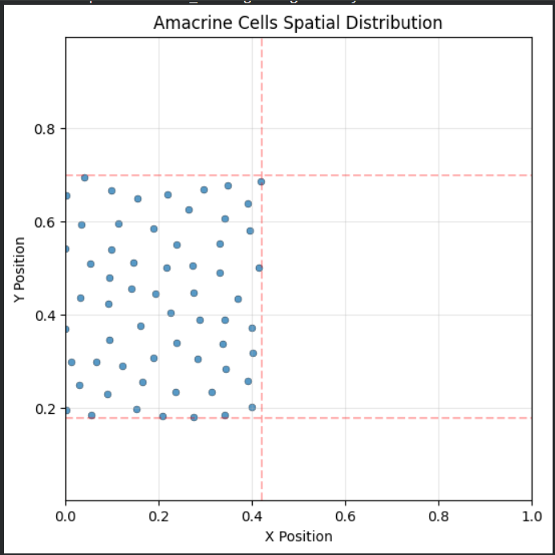
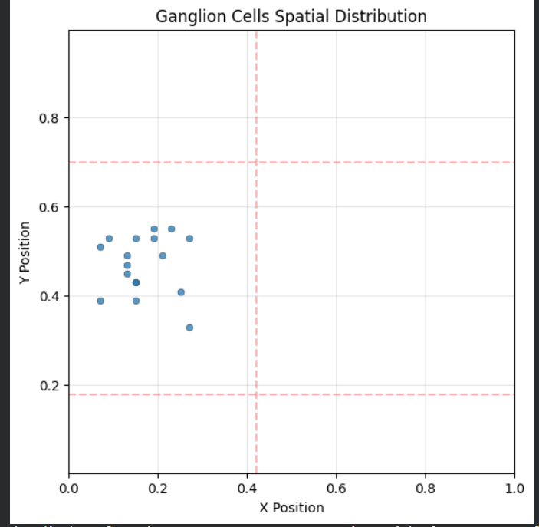
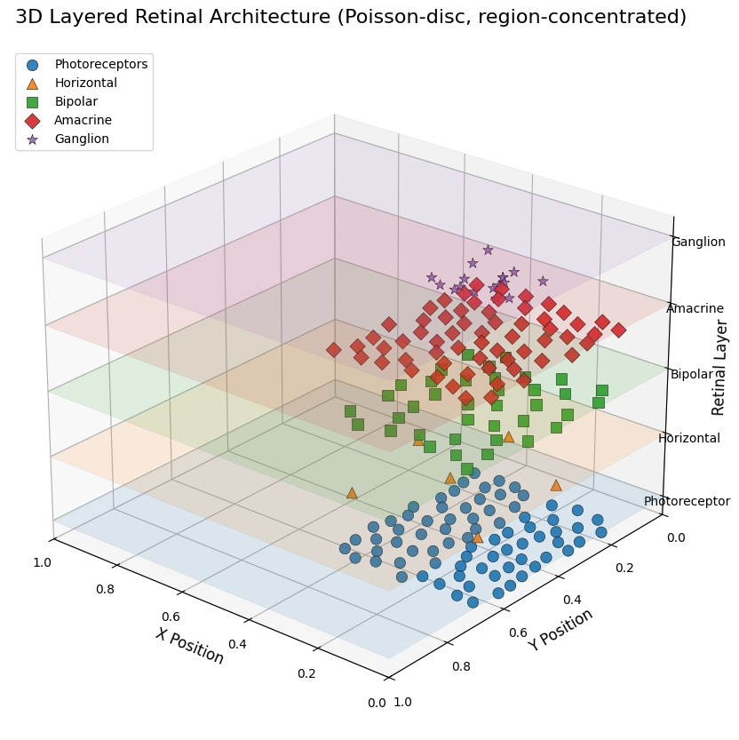

- PINN based model (https://colab.research.google.com/drive/1-oZkrYEHpjXIQfAYHeq5HztvpUx3ZLdz?usp=sharing )

for lambda = 0.01
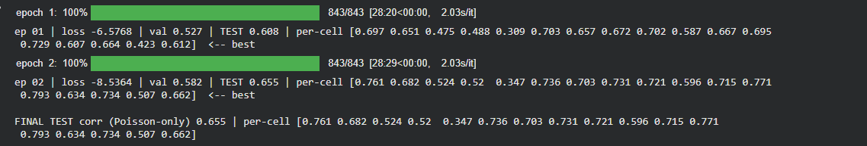

for lambda = 0.1
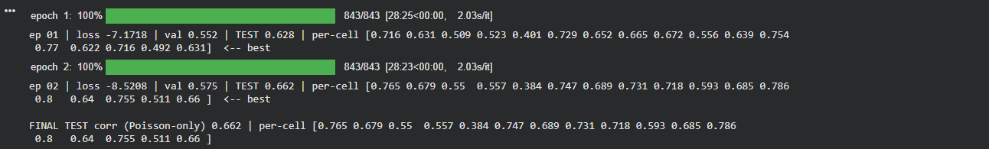

for lambda = 1
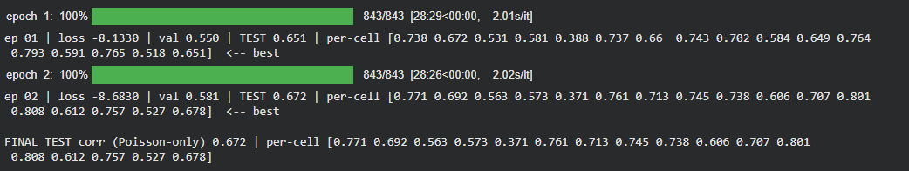

for lambda = 10
