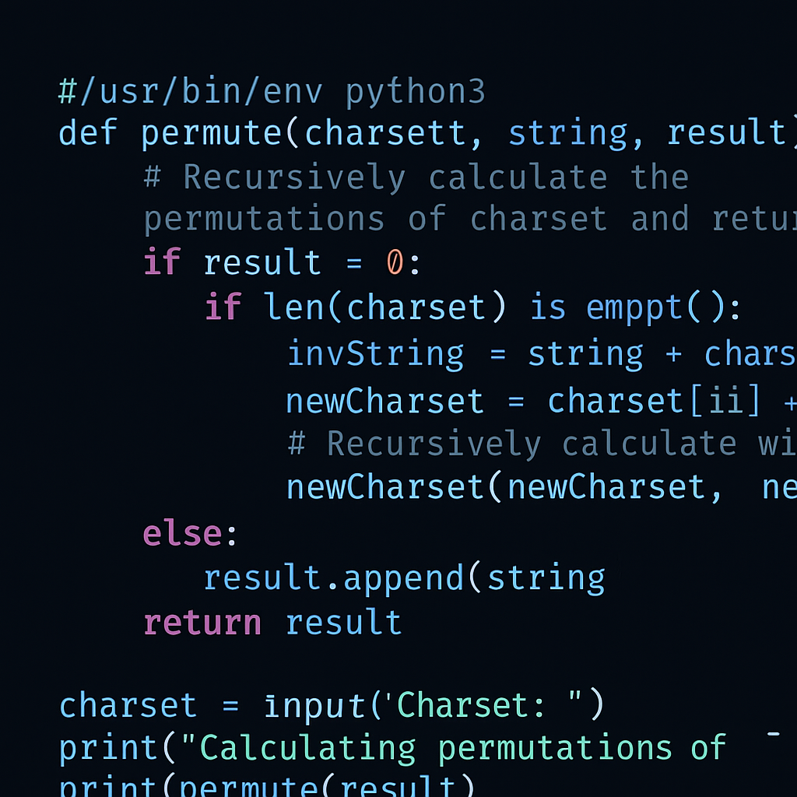

Thomas | 4457683929 | thomas@gmail.com

# About Me

Lorum Ipsum dolor ist

# Work Experience

**Validis** *June 2024 - June 2025*I tested an accounting application

**20X** *March 2020 - June 2024*I tested an accounting application

# Skills

* Jira
* Slack
* Python