An Introduction to the Layout Definition Format of VideoDashboard
Or how to design your own overlays

This document describes the general format, usage and functionality of the Dashboard Layout Format used by the VideoDashboard overlay renderer. For better understanding it is recommended that you look at the layout files provided with the software while reading this document. Small example snippets are shown in the elements sections though.

Table of Content
1 Introduction 2
2 Key value types 3
3 Data Log properties and channels 4
4 The layout of a dashboard 5
4.1 Common keys 6
5 Elements 8
5.1 Gauge element 8
5.2 TextBox element 10
5.3 GCircle element 11
5.4 Indicator element 12
5.5 RingGauge element 13
5.6 Slider element 14
5.7 Sweeper element 15
5.8 Ruler element 17

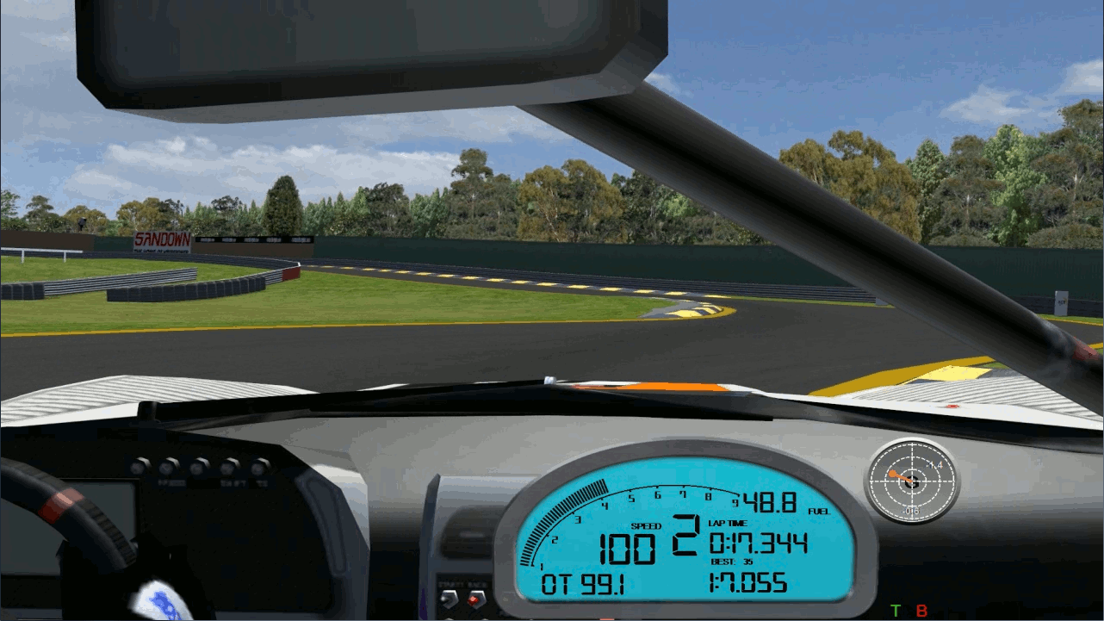

- Introduction

A layout definition (.layout) file is a simple, structured and easy to read text file which defines all the properties of a dashboard. The structure and syntax are based on Cascading Style Sheets (CSS) know from HTML web sites.
It supports a wide range of display elements to show data values, text labels and much more.
The elements defined in the layout file and the specified data values are rendered on each successive frame of the input video file.
The layout file is structured into several sections which share the same basic format, although each section provides different information.

The basic format for each section has the form:

section_name {
key0 = value0; -> each key value line must end with a semicolon!
key1 = value1; -> otherwise the line is not recognized by the application
...
keyN = valueN;
}

Section and key names are not case sensitive. So dashboard or DaShBoArD are equivalent.
The same applies to keys. However there are some key-values that are case sensitive.

- Key value types

There are different key value types used to define data for the overlay. These values are described in this section. The names described here correspond to the “key values” shown in the tables in all subsequent sections.

String | A simple alpha-numeric character sequence. Strings must be enclosed in quotation marks.  So “LABEL” defines a string whereas LABEL does not.
Integer | An arbitrary integer number like 1,3,123…
Tuple | These specify ranges of values enclosed in angle brackets.  Example: <min,max> for minimum and maximum value or <x,y> for positions.
Color | This is one of the special values which are used to define a color.  It can be either in the form of a hexadecimal number (like a html color code: #AAAAAA) or a tuple specifying the amount of RGB colors.
Float | An arbitrary decimal number like 1.23

IMPORTANT: Regardless of the regional and cultural settings of your PC the decimal delimiter must be a dot ‘.’
Otherwise the number is interpreted as integer by the software.

- Data Log properties and channels

This section describes how to display telemetry data values in VideoDashboard overlays. The data log importer currently only supports disk based telemetry data in the .ibt format (iRacing Binary Telemetry) introduced by iRacing and publicly available through the OpenGameAPI to be implemented by other simulations.
Refer to http://www.opengameapi.net for further information.

Supported simulations so far:
- iRacing
- rFactor (plugin needed – available at http://video-dashboard.com)
- rFactor2 (plugin needed – available at http://video-dashboard.com)
- Assetto Corsa (plugin needed – not available yet)

Telemetry values are available through channels. To get a list of available channels you can choose “Show Channels List” from the Tools menu in the VideoDashboard GUI.

This channel list changes based on the availability of data channels for the various sims, because not all of them export the exact same set of data. However channel names remain the same for most of the channels.
It is possible that some channels report always -1. In this case the channel is either not yet implemented or unused.

To add a channel to a dashboard element you use the key: channel = channel_name

Example: channel = “RPM”; The channel name must be specified as string!

NOTE: channel names are case-sensitive and must be written exactly as shown in the channels list. The same applies for special channels.

Special channels
In addition to the exported channels present in a data log file some “special” channels are available. Most of these channels are converted or calculated values based on basic channel data. (e.g. Speed_Kph, LatG, laptime, …)

For a list of special channels refer to Appendix A at the end of this document.

- The layout of a dashboard

Header
All default layout files begin with a header. These are comment lines which are only used for documentation purposes.

Dashboard section
Defines general properties of the dashboard and default properties for all subsequent elements. Each layout file must contain only one dashboard section.

dashboard {

shortname = ”RedCarbon_300kph”;
prettyname = ”RedCarbon 300kph version”;
imagefile = ”images\RedCarbon.png”;;

… optional keys
}

Mandatory keys for the dashboard section
key name | key value | description
ImageFile | String | File name of the optional background image that will be used.  The path to the image file can be either relative (to the layout file location) or absolute.
PrettyName | String | An optional descriptive name. Not used for anything
ShortName | String | The name of the dashboard that is shown in the selection list.

Additionally there are optional keys that can be used
These keys define default properties for all elements within a dashboard if not overwritten by single elements. In this case the element properties overwrite the default ones.

key name | key value | description
background | Color | The default background color. If no image file is used the defined dashboard area will be filled with this color.  default: <0,0,0> = black
fontheight | Integer | The default font size.  default: 10
fontname | String | The name of the default font used by elements. The font must be installed on your system.  default: “Arial”
fontstyle | [ regular |  bold | italic | bold_italic ] | The default fontstyle.  default: regular
foreground | Color | The default text color used by all elements.  default: <255,255,255> = white
height | Integer | Height of the dashboard. (If no background image is used)  NOTE: width and height must be used together
justify | [ center |  left |  right ] | The default text justification.  default: center
width | Integer | Width of the dashboard. (If no background image is used)

  - Common keys
The layout format defines a set of properties that are common to all elements.

key name | key value | description
background | Color | see dashboard keys section  (Only for the element that defines this key)
channel | String | the actual data channel provided by the data logger
fontheight | Integer | see dashboard keys section  (Only for the element that defines this key)
fontname | String | see dashboard keys section  (Only for the element that defines this key)
fontstyle | [ regular |  bold | italic | bold_italic] | see dashboard keys section  (Only for the element that defines this key)
foreground | Color | see dashboard keys section  (Only for the element that defines this key)
id | String | element ID. should be unique within the layout file  (Used in conjunction with the ruler element)
justify | [ center |  left |  right ] | see dashboard keys section  (Only for the element that defines this key)
layer | Integer | layer on which this element is to be rendered  default: 0
rectangle | <l,t,w,h> | the elements bounding box.  The format is <left, top, width, height>  so <10, 10, 100, 20> positions the element 10 pixels from the left and top of the top-left corner with a width of 100 pixels and a height of 20 pixels
scale | Float | scaling factor for data values. This scaling factor is applied first before rendering  default: 1.0

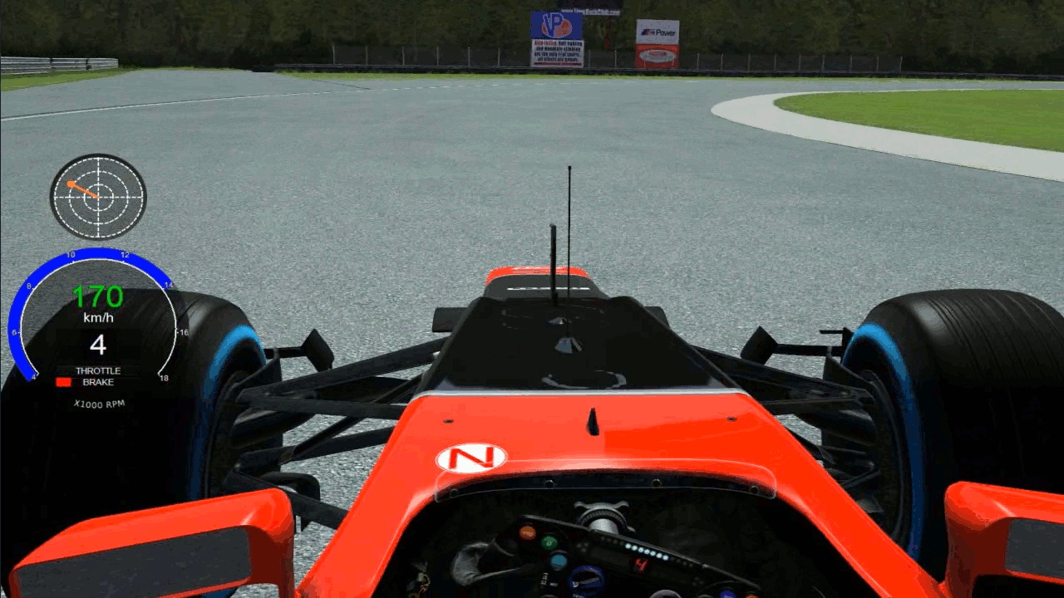

- Elements
The following sections describe each available element in detail and give some examples on how to design and use the different element properties.

  - Gauge element
The gauge element is a complex element which is capable of rendering a variety of different gauge styles.

key name | key value | description
divisions | Integer | the number of tick marks when VideoDashboard renders the complete gauge
draw_face | [ yes | no,  true | false ] | if yes or true the face_image is drawn, otherwise the default gauge is rendered  Default: true
face_image | String | file name of the gauge background image.
needle_center | <x,y> | the position of the needles pivot point relative to the top-left corner of the gauges bounding box.  Only needed if it is not in the center of the image.
needle_image | String | file name of the needle image
needle_offset | <x,y> | the position of the needles pivot point in the needle image  relative to the top-left corner
position | <x,y> | the position of the gauge, if a face image is used without declaring a bounding rectangle
radius | Integer | the length of the needle, if no needle image is used and VD renders the needle
range | <min,max> | the value range that the gauge element displays
sweep | <start angle, end angle> | the start and end position of the needle rotation from min to max value.  0 is along the x-axis (3 o’clock) and increases counter-clockwise. Positive and negative values are valid.  (see description of sweep angles above)

Examples

A simple Gauge completely drawn by VideoDashboard.

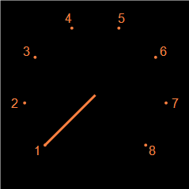
gauge {
variable = "RPM"; // variable name
range = <1000, 7000>; // range of gauge
divisions = 7; // show range as ten divisions
rectangle = <50,50,240,240>; // size & position
foreground = < 255, 128, 64 >; // orange text and pointer
background = <0,0,0>;
fontheight = 12; // size of division values
radius = 90; // length of pointer
sweep = <225,-45>;
scale = 0.001; scaling factor (x1000)
}

A gauge rendered with needle and background image
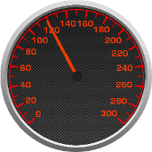
gauge {
id = "Speed";
face_image = "images\RedCarbon_Speed_300KPH.png";
needle_image = "images\RedCarbon_Needle_L.png";
needle_offset = <119,10>;
variable = "Speed_Kph"; // variable name
range = <0, 300>; // range of gauge
position = <10,10>; //,240,240>; // position on the dash
sweep = <225,-45>;
}

  - TextBox element

Key name | Key value | Description
format | [ text | integer | real | time | laptime ] | The format in which the data is displayed
label | String | Static text displayed by the textbox
precision | Integer | The number of decimal places behind the decimal sign (dot)
signed | [ yes | no ] | If a + sign is shown for a positive value

Examples

This example shows two textboxes

This is the upper textbox (red)

textbox {
rectangle = <689,180,40,22>; // position & size
format = integer; // value format
channel = "lap"; // data channel used
foreground = <255,0,0>; // text color
fontname = Arial; // text font
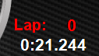
fontstyle = bold;
fontheight = 16;
}

This is the lower textbox (white)

textbox {
rectangle = <635,205,100,22>;
format = laptime; // format data from channel as lap time
channel = "laptime"; // one of the 'special' channels
foreground = <255,255,255>;
fontname = "Arial";
fontstyle = bold;
fontheight = 16;
}

  - GCircle element

This element provides a circular gauge for displaying lateral and longitudinal G forces. It consists of concentric circles as grid lines and an “indicator ball” which is connected to the center with a line.

key name | key value | description
divisions | Integer | The number of concentric circles drawn as grid lines
line_width | Integer | Width of grid lines
pointer | Color | The color of the connecting line
pointer_size | Integer | Diameter of the “indicator ball”
pointer_width | Integer | The width of the connecting line
radius | Integer | G value for full scale display (from center to outer edge)
scale_lat_accel | Float | Scaling factor  ex: use -1 to invert the displayed value
scale_long_accel | Float | Scaling factor

Example

The background is drawn in the dashboard background image file. VideoDashboard only
draws the grid lines and indicator.
Note: the values shown are textboxes defined in the layout file.

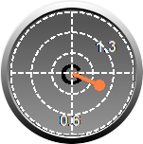
gcircle {
rectangle = <605,32,130,130>; // position & size
foreground = <255, 255, 255>; // grid color
line_width = 2;
pointer = < 255, 128, 64 >;
radius = 3;
pointer_width=4;
pointer_size=12;
divisions=3;
layer = 1; // layer of this element
}

  - Indicator element

The indicator element displays a fixed shaped that is either in on or off state depending on its corresponding channel value. It can be either filled by a solid color or represented by an image.

key name | key value | description
filled | [ yes | no ] | Whether the indicator should be filled with rgbon and rgboff color.  Default is yes
image_off | String | File name of image for OFF state
image_on | String | File name of image for ON state
outlined | [ yes | no ] | Outlines the indicator shape with foreground color  Default is yes
rgboff | Color | Color for the OFF state
rgbon | Color | Color for the ON state
shape | [ ellipse |rectangle | line | image ] | Shape of the indicator  Use rectangle for position and size. In case of image use position. If rectangle is used the image is scaled to the size specified by the rectangle
thickness | Integer | Width in pixels if shape “line” is used
threshold | Float | When channel value is > threshold the indicator is ON otherwise it's OFF

Note: currently it is not possible to use indicator elements with the sweeper element.

Examples

  - RingGauge element

This is a gauge element that renders all or part of an annulus. It is typically used with the Ruler element providing the calibration marks.

key name | key value | description
foreground | color | color of the ring
range | <min,max> | the minimum and maximum value
rectangle | < x, y, w, h > | position and size of the ringgauge. shape can be either a circle (width=height) or an ellipse
sweep | <start,end> | start and end angle
width | integer | width of the ring in pixels

Examples

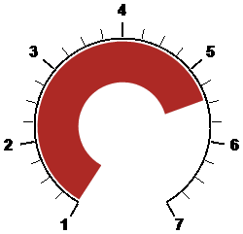
ringgauge {
id = "rpm"; // associated ruler element
channel = “RPM”;
rectangle = < 50, 50, 175, 175>;
width = 42; // width of the ring
foreground = #ad2925; // color of the ring
range = < 1000, 7000 >; // value range
sweep = < 120, 60 >; // start and end angle
rotation = cw; // direction of rotation
layer = 1; // layer
}

This ringauge is the same as the above, except the direction parameter is changed to ccw.

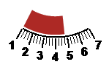
ringgauge {
id = "rpm";
variable = "RPM";
rectangle = < 50, 50, 175, 175>;
width = 25;
foreground = #ad2925;
range = < 1000, 7000 >;
sweep = < 120, 60 >;
shaded = yes;
rotation = ccw;
layer = 1;
}

  - Slider element

The slider element displays a horizontal or vertical sliding value. Slider can display most data ranges including center zero, 0 to + or – values, + or – values to zero.

key name | key value | description
id | string | used to associate this element to a ruler element
range | < min, max > | min and max value. can be in the form of <0,+x>, <0,-x>,  <+x,0>, <-x,0>, or <-x,+x> or vice versa
rgbnegative | color | the color used when channel value is < 0
rgbpositive | color | the color used when channel value is > 0

The orientation, horizontal or vertical, is determined automatically by VideoDashboard based on the rectangle property. If width is larger that height the slider is drawn horizontal, otherwise vertical

Examples

0 to negative horizontal slider

slider {
channel = "LatG";
rectangle = <710,130,90,18>; // width > height
range = <-3,0>; // min, max range
rgbNegative = <0,0,255>; // blue for negative values
}

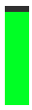
0 to positive vertical slider

slider {
channel = "Throttle";
rectangle = <169,139,25,100>; // height > width
range = <0,100>;
rgbPositive = <0,255,37>;
}

negative to positive horizontal slider

slider {
id = "slider1";
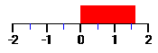
variable = "LongG";
range = <-2,2>;
rectangle = <50,50,150,20>;
rgbpositive = <255,0,0>; // red for positive values
rgbnegative = <0,255,0>; // green for negative
layer = 2;
}

  - Sweeper element

The sweeper element is one of the most complex elements along with the ruler element. It renders a set of indicators equidistant along either an elliptical, circular or linear path. As most other elements it can be combined with a ruler element to provide a scale.

key name | key value | description
divisions | integer | number of indicators shown when max value is displayed
extend | integer | length of the indicator line for shape line  radius of indicator ellipse for shape ellipse  width/height of indicator rectangle for shape rectangle
line_end | < x, y > | x/y position where line path ends
line_start | < x, y > | x/y position where line path starts
path | [ sweeper | arc | line ] | path shape of the sweeper element  default is sweeper
range | < min, max > | value range
rectangle | < l, t, w, h > | bounding box of the sweeper. see description of angles for details
rgboff | color | color of indicators when in off state
rgbon | color | color of indicators when in on state
shape | [ line | rectangle | ellipse ] | shape of the sweepers indicator elements.  default is line
sweep | < start, end > | start and end angles of the sweeper. Positive and negative values are valid.
taper | integer | the amount of taper to apply to indicators. the first indicator has length of taper, the last one length of extend.
thickness | integer | width of indicator line when shape line is specified

Examples

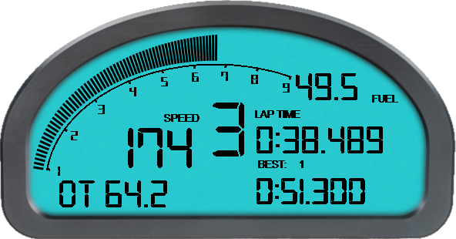
sweeper {
id = "RPM";
channel = "RPM";
rectangle = <83, 98, 225, 160>;
extend = 42; // length of last indicator line
taper = 13; // length of first line indicator
thickness = 3;
rgbon = <0, 0, 0 >;
range = <1000, 9000 >;
sweep = < 175, 55 >;
divisions = 90; // 90 divs for full value range
scale = 0.001; // scale to 1/1000
}

sweeper {
id = "RPM";
variable = "Throttle";
extend = 30; // length of last indicator line
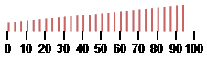
taper = 10; // length of first indicator line
thickness = 2; // width of lines
rgboff = transparent; // special color value
rgbon = #ffe71e; // color in HTML value format
range = <0, 100 >;
divisions = 30; // number of indicators shown
shape = line;
path = line; // render along (horizontal) line
line_start = <5,20>; // X,Y coordinate of path line start point
line_end =<200,20>; // X,Y coordinate of path line end point
}

sweeper {
id = "RPM";
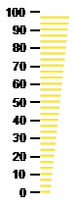
variable = "Throttle";
extend = 30;
taper = 10;
thickness = 2;
rgboff = transparent;
rgbon = #ffe71e;
range = <0, 100 >;
divisions = 30;
shape = line;
path = line;
line_start = <50,20>;
line_end =<50,200>;

  - Ruler element

The ruler element provides some kind of automatic scale for the element to which it is connected. It receives its values needed for calculation and rendering from the bound element. But a ruler can also be used as standalone element.
The ruler draws tick marks and labels equidistant along a specified path shape which can be a line, an arc or an elliptical shape.
key name | key value | descriptions
arc_sweep | < start, end > | start and end angle for path shape arc and ellipse. Positive and negative values are valid.  see above
background | color | ruler elements background color
draw_label | [ yes no |  true | false ] | whether to draw tick mark labels
draw_major | [ yes | no |  true | false ] | whether to draw major tick marks
draw_minor | [ yes | no |  true | false ] | whether to draw minor tick marks. (sub steps between major ticks)
draw_path | [ yes | no  true | false ] | whether the path shape should be drawn or not
fontheight | integer | font size
fontstyle | string | name of the font used to draw labels.  the font must be installed on the system!
foreground | color | text color used for labels
label_margin | integer | “gap” between label and tick marks
layer | integer | layer on which to draw the ruler element
line_end | < x, y > | position where the line path ends.  see above
line_start | < x, y > | position where the line path starts.  only used if path is line and no other element is referenced by the using property.
major_color | color | color of major tick marks
major_divisions | integer | number of major tick marks.
major_length | integer | length of major tick marks when shape line is used.
major_margin | integer | “gap” between tick marks and the path line
major_radius | integer | radius of major tick marks when shape circle is used
major_shape | [ line | circle ] | shape of major tick marks
major_units | integer | value step used to calculate the number of major tick marks.  either use this property or the divisions property above.
major_width | integer | width of tick marks line
minor_color | color | see major above
minor_divisions | integer | same as for major ticks but for minor tick marks
minor_length | integer | see major above
minor_margin | integer | see major above
minor_radius | integer | see major above
minor_shape | [ line | circle ] | see major above
minor_units | integer | see major above
minor_width | integer | see major above
path | [ line | arc | sweeper ] | the path shape along which the tick marks and labels are drawn
path_color | color | color of the path
path_offset | integer | offset of the paths rectangle in relation to its bound element. this creates a “gap” between the element and the path.  Positive and negative values are valid.
path_position | [ inside | outside | above | below | left | right ] | direction of the paths tick marks relative to the path itself.  example: if you have an path shape [arc] and specify inside for the path_position property, the paths tick marks and labels are drawn inside (towards the center of the arc) of the path line itself.
path_range | < min, max > | value range which the path displays.  this is only needed if no other element is referenced by the using property. otherwise this value is received by the referenced element.
path_width | integer | width of the path
scale | float | scaling factor applied to the values used.  example: 0.001 = 1/1000  only used if no other element is referenced by the using property.
using | string | element id to which this ruler element is bound

Examples

This ruler element is bound to the sweeper element with id: RPM
sweeper {
id = "RPM";
...
}

ruler {
layer = 1;
using = "RPM"; // referenced element
draw_path = yes; // draw the path line
path_color = <0,0,0>; // color of path line
path_offset = 4; // create a 4px “gap”
path_width = 2; // path line width
path_position = inside; // draw tick marks and labels toward the inside

draw_major = yes;
major_units = 1000; // create a major tick each 1000 rpm
major_shape = line;
major_length = 5;
major_width = 3;
major_margin = 0; // no “gap” between path line and tick marks
major_color = <0,0,0>;

draw_label = yes;
label_margin = 12;
fontheight = 14;
foreground = <0,0,0>;
fontname = "digital-7";
}

Here is an example of a ruler without a bound element

ruler {
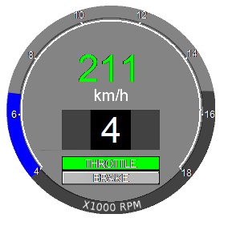
rectangle = <27, 172, 225, 225>; // position and size of ruler
range = <4000, 18000>; // value range
draw_path = true;
path_position = outside; // draw towards outside
path_color = #ffffff;
path_width = 2;
path_range = <4000, 18000>; // value range mapped to the path
arc_sweep = <220, -40>; // start and end angle

draw_major = yes;
major_width = 2;
major_length = 2;
major_margin = 0;
major_color = #ffffff;
major_units = 2000; // tick mark each 2000 rpm
draw_minor = false; // no minor ticks

draw_label = true; // use default font
label_margin = 1;
fontheight = 9;
foreground = #ffffff;
scale = 0.001; // scaling factor applied to value range
}

