VideoDashboard Users Guide

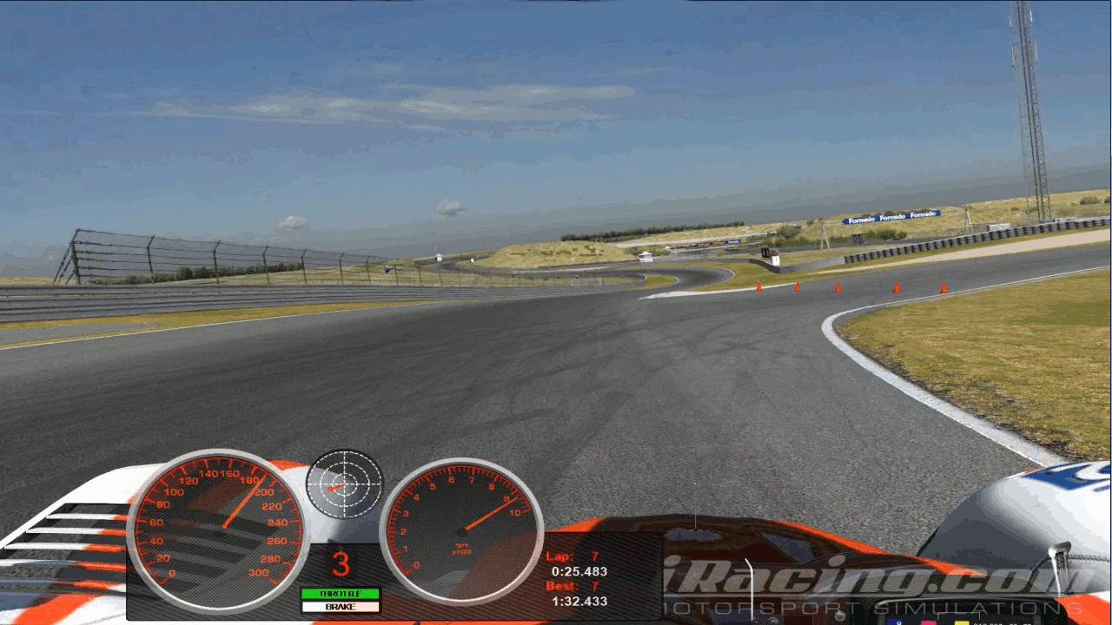

This document gives you detailed instructions on how to make a video with data overlay using VideoDashboard.

It's fairly easy to use the VideoDashboard application. The GUI is structured in an easy to follow way. Basically you just follow the GUI from the top-left to the bottom-right.
All additional dialog boxes are pretty much self-explanatory.
But let's get started.

After you launched the the application it will present an empty window with just a toolbar at the top, as shown on the image below

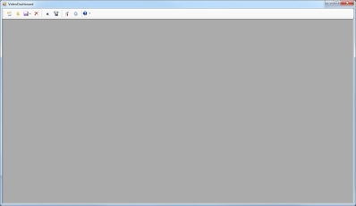

The Toolbar:

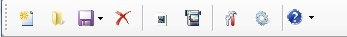

From left to right:
- Create new project
- Open existing project
- Save project / Save to new file
- Close project
- Render a short preview video - 30s (to check if everything is as you want it to be; no need to wait to render a full length video)
- Render full video to file
- Tools
- Options
- Help Menu

Now it's time to create the first project. Simply click the button on the toolbar and enter a project name and a short description, in the new opened window. After that
a new window will appear with the actual GUI. Multiple projects can be open at the same time.

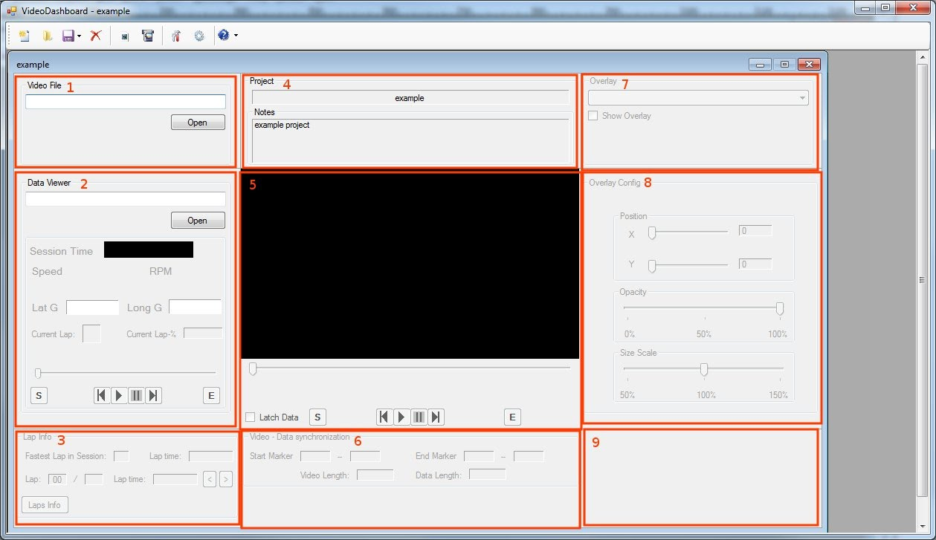
The work flow through the GUI is simply from number 1 to 9. But every section is described in detail below.

1 - Input video file
Select your recorded video file. At the moment only RAW- or color compressed AVI files are supported!

2 - Input data file and data viewer
Select your telemetry data file. You can browse through the information in the file with the slider or by using the play and pause buttons. You can also use the left and right arrow keys on your keyboard to scroll in single data sample intervals or the Page-Up and Page-Down keys to scroll in 10 sample intervals. The Home and End keys set the slider to the absolute start or end position.
The buttons labeled with "S" and "E" are used to set the start and end markers of the data which should be used with the overlay in the resulting video file.
NOTE: In the current version only iRacing ibt-files can be used as data source!

3 - Lap info
Here you can see more detailed information about the laps in your data file. If, for example, you know which lap of the session you recorded as video you can jump straight to the begin of that lap with the "arrow" buttons.

4 - Project information area
Simply just the name and the description you entered when you created this project. A double-click in the Notes area here, opens a window where the text can be changed.

5 - Input video player
A simple video player. Pretty much the same as the data viewer. The buttons "S" and "E" set the start and stop markers for the video. With the "|<" and "|>" buttons
you can jump directly to the start and stop marker positions in the video. As in the data viewer section you can also use the arrow keys, Page-up, -Down, Home and End keys of your keyboard to scroll through the video.
The "Latch Data" check-box, connects the video to the data viewer, so that if you run or scroll the video the data viewer updates with the video position.
This becomes useful in the synchronization process between video and data.

6 - Sync markers
Just an overview of the set marker positions. The marker positions and lengths values are shown as video frames and data samples respectively.

7 - Overlay list
All available overlays show up in this list. With the check-box the overlay image can be shown in the video player as a preview.

8 - Overlay configuration
The position of the overlay an be adjusted here, as well as the opacity and the size. The size is a scaling factor of the original overlay image size.
If you right click in this area you can reset all the configuration settings to their initial values.

9 - Rendering progress
When everything is finished and ready to render, the progress of the rendering operation is shown here.

Example:

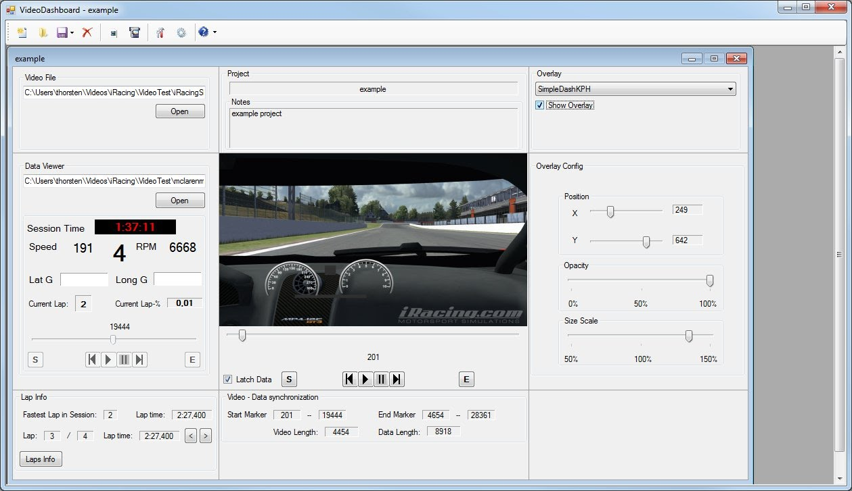

If you are satisfied with all your settings and selections, either click on the "Render preview" button or the "Render to file" button to open the video render settings dialog. The preview renders a short 30 sec video, so you can check if all settings are the way you want them without waiting for the full video to be rendered.

The render settings window:

For video rendering currently only WindowsMedia9 codec and RAW-AVI files are supported for now. VideoDashboard comes with a few predefined profiles for the WindowsMedia9 codec. These profiles are created for direct use with YouTube and follow the recommended settings.
NOTE: You can't change or add profiles in the current version. (This is a planned feature in the future though)

If you want to edit your video further in a video editing software (e.g. Vegas) it's recommended that you download and install one of the compression codecs available at the VideoDashboard homepage. These allow you to reduce the file size of the output video without loosing any quality.
Settings for these codecs can be changed by clicking on the Configure button, after you have selected the desired codec in the drop-down list.

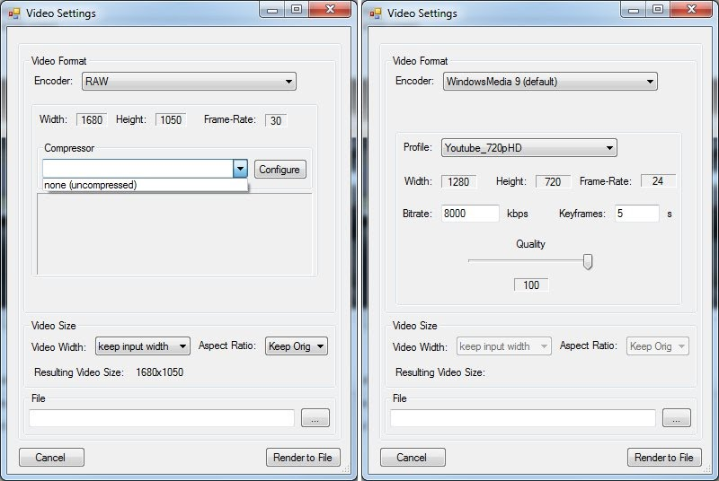

How to synchronize the video and data:

Synchronization is done by hand. There is no automatic way of doing this. The synchronization process is fairly simple and not that hard. Basically there are two ways of doing this.

1. Scroll the video and data to the position where the car crosses the S/F line. In the video you can see this by eye, for the data you can use the "Current-Lap %" in the data viewer part of the GUI to find that point. Enable the data latch and play the video to see if video and data are in sync. Then continue as described above.

2. The second method is pretty much the same as the first, except that you use the gear change as a reference for synchronization. Play the video until you hear a gear change and immediately stop the video. Now scroll through the data until you reach the point of that gear change. Enable the data latch and scroll through the video again to check if your selection fits for the rest of the lap. The continue as described above.

For both methods you don't need to be 100% precise. This means if you are a frame or sample off, it won't hurt your final video much. With a little fiddling you can achieve a pretty decent accuracy.

