Adactin cucumber framework

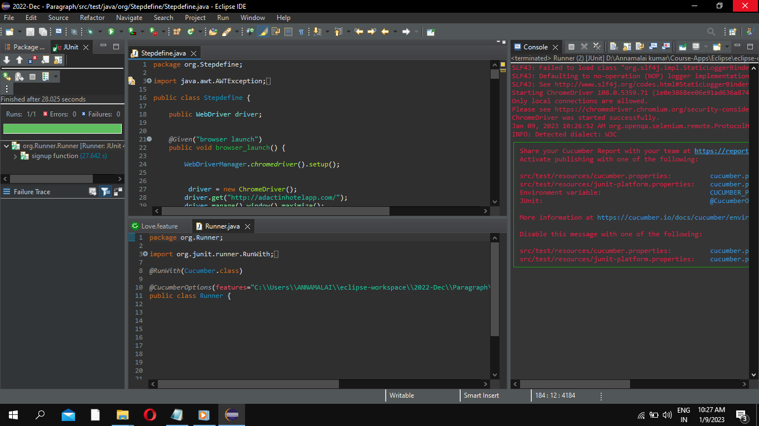

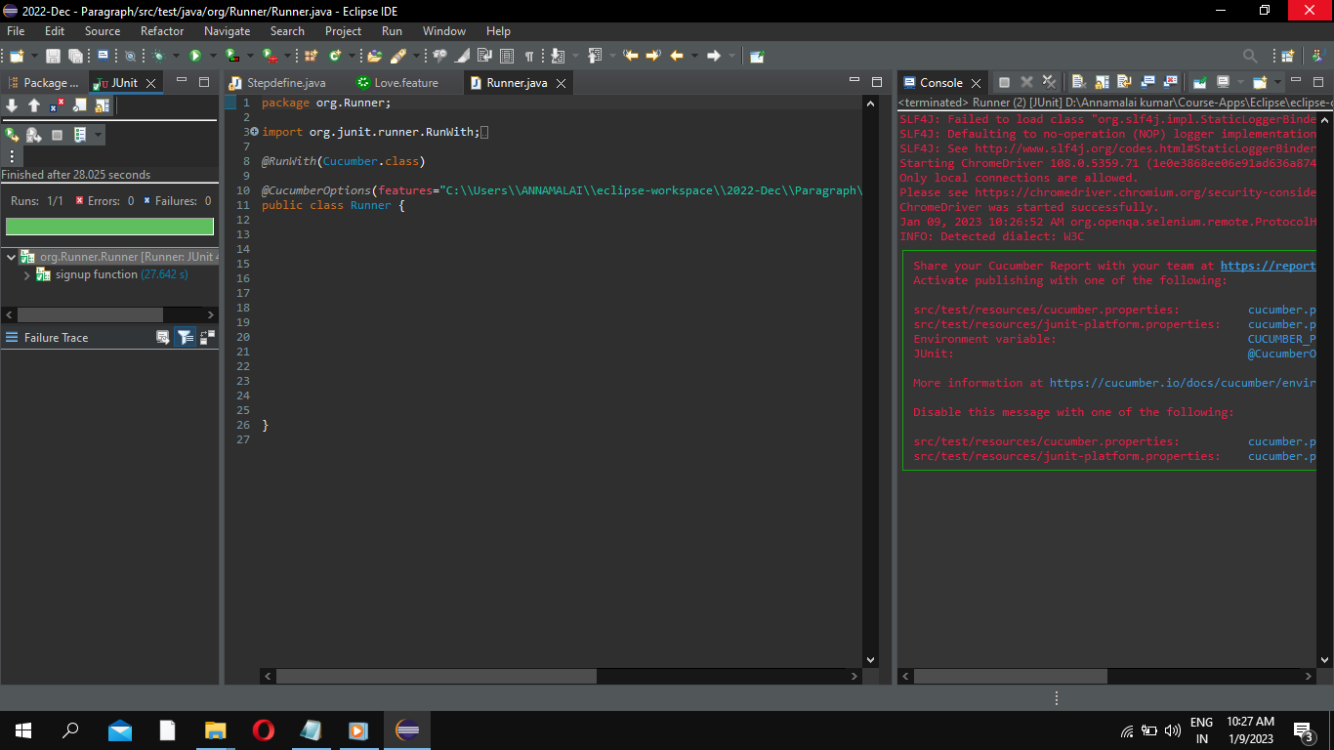

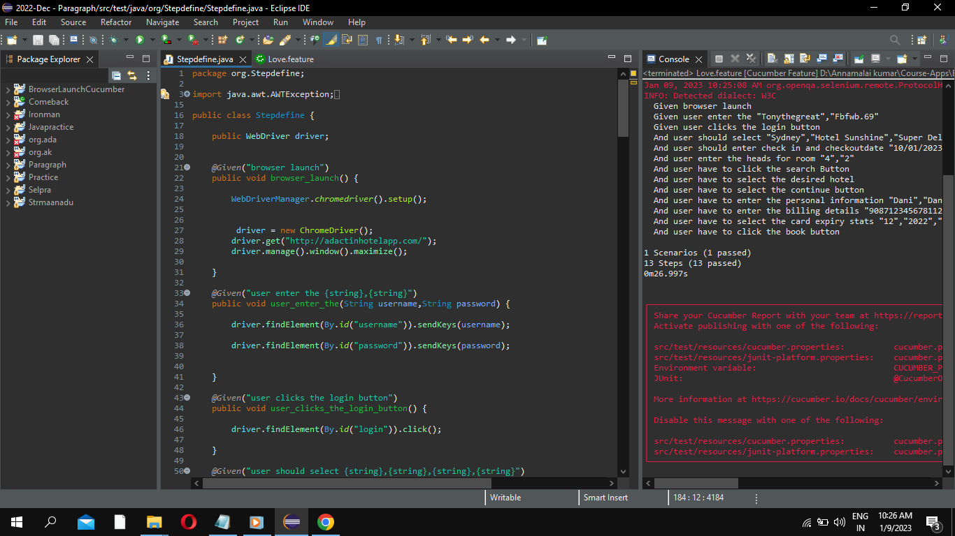

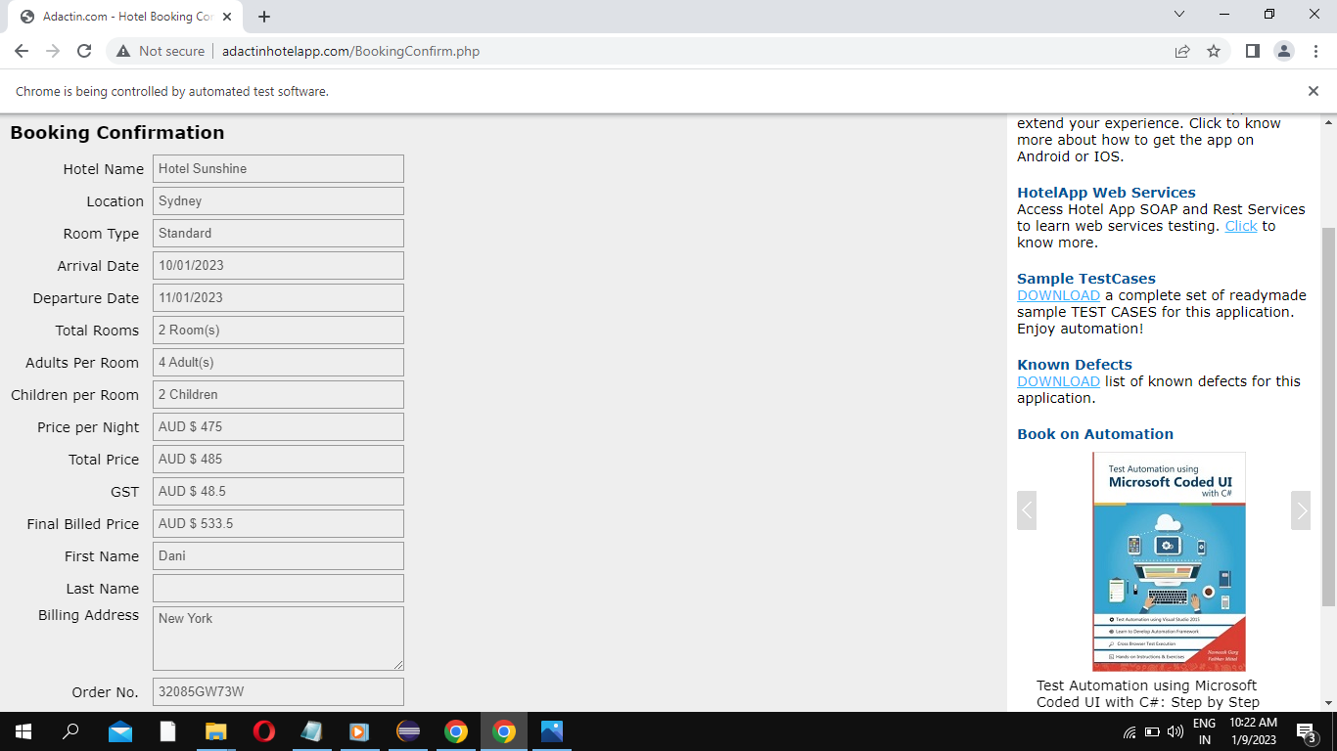

The code I am executed is:

Feature:

Feature: signup function

Scenario Outline: check the positive way

Given browser launch

Given user enter the "<username>","<password>"

Given user clicks the login button

And user should select "<location>","<hotel>","<roomtype>","<numberofrooms>"

And user should enter check in and checkoutdate "<check-in>","<check-out>"

And user enter the heads for room "<adults>","<children>"

And user have to click the search Button

And user have to select the desired hotel

And user have to select the continue button

And user have to enter the personal information "<firstName>","<secondName>","<billingAddress>"

And user have to enter the billing details "<creditcardNumber>","<creditcardType>"

And user have to select the card expiry stats "<expiryMonth>","<expiryyear>","<cvvNumber>"

And user have to click the book button

Examples:

|username ||password| |location||hotel| |roomtype| |numberofrooms| |check-in| |check-out| |adults| |children| |firstName| |secondName| |billingAddress| |creditcardNumber| |creditcardType| |expiryMonth| |expiryyear| |cvvNumber|

|Tonythegreat||Fbfwb.69| |Sydney| |Hotel Sunshine| |Super Deluxe| |2| |10/01/2023| |11/01/2023||4 | |2| |Dani| |Daniels| |New York| |9087123456781123| |VISA| |12| |2022| |567|

Runner:

package org.Runner;

import org.junit.runner.RunWith;

import io.cucumber.junit.Cucumber;

import io.cucumber.junit.CucumberOptions;

@RunWith(Cucumber.class)

@CucumberOptions(features="C:\\Users\\ANNAMALAI\\eclipse-workspace\\2022-Dec\\Paragraph\\src\\test\\resources\\Lovefff\\Love.feature",glue="org.Stepdefine")

public class Runner {

}

Stepdefinition:

package org.Stepdefine;

import java.awt.AWTException;

import java.awt.Robot;

import java.awt.event.KeyEvent;

import org.openqa.selenium.By;

import org.openqa.selenium.WebDriver;

import org.openqa.selenium.WebElement;

import org.openqa.selenium.chrome.ChromeDriver;

import org.openqa.selenium.support.ui.Select;

import io.cucumber.java.en.Given;

import io.github.bonigarcia.wdm.WebDriverManager;

public class Stepdefine {

public WebDriver driver;

@Given("browser launch")

public void browser_launch() {

WebDriverManager.chromedriver().setup();

driver = new ChromeDriver();

driver.get("http://adactinhotelapp.com/");

driver.manage().window().maximize();

}

@Given("user enter the {string},{string}")

public void user_enter_the(String username,String password) {

driver.findElement(By.id("username")).sendKeys(username);

driver.findElement(By.id("password")).sendKeys(password);

}

@Given("user clicks the login button")

public void user_clicks_the_login_button() {

driver.findElement(By.id("login")).click();

}

@Given("user should select {string},{string},{string},{string}")

public void user_should_select(String location, String hotel, String roomtype, String numberofrooms) {

WebElement loca = driver.findElement(By.id("location"));

Select s = new Select(loca);

s.selectByValue(location);

WebElement hotels = driver.findElement(By.id("hotels"));

Select s1 = new Select(hotels);

s1.selectByValue(hotel);

WebElement roomty = driver.findElement(By.id("room_type"));

Select s2 = new Select(roomty);

s2.selectByValue(roomtype);

WebElement noOfRooms = driver.findElement(By.id("room_nos"));

Select s3= new Select(noOfRooms);

s3.selectByValue(numberofrooms);

}

@Given("user should enter check in and checkoutdate {string},{string}")

public void user_should_enter_check_in_and_checkoutdate(String checkin, String checkout) throws AWTException {

WebElement checkingin = driver.findElement(By.id("datepick_in"));

checkingin.clear();

checkingin.sendKeys(checkin);

// Robot r = new Robot();

//

// r.keyPress(KeyEvent.VK_1);

//

// r.ke

//

//

//

// checkingin.sendKeys(checkin);

// Select s4= new Select(checkingin);

// s4.selectByValue(checkin);

//

WebElement checkingOut = driver.findElement(By.id("datepick_out"));

checkingOut.clear();

checkingOut.sendKeys(checkout);

// Select s5= new Select(checkingOut);

// s5.selectByValue(checkout);

////

}

@Given("user enter the heads for room {string},{string}")

public void user_enter_the_heads_for_room(String adults, String children) {

WebElement aduroom = driver.findElement(By.id("adult_room"));

Select s4= new Select(aduroom);

s4.selectByValue(adults);

WebElement childroom = driver.findElement(By.id("child_room"));

Select s5= new Select(childroom);

s5.selectByValue(children);

}

@Given("user have to click the search Button")

public void user_have_to_click_the_search_button() {

WebElement submit = driver.findElement(By.id("Submit"));

submit.click();

}

@Given("user have to select the desired hotel")

public void user_have_to_select_the_desired_hotel() {

driver.findElement(By.id("radiobutton_0")).click();

}

@Given("user have to select the continue button")

public void user_have_to_select_the_continue_button() {

driver.findElement(By.id("continue")).click();

}

@Given("user have to enter the personal information {string},{string},{string}")

public void user_have_to_enter_the_personal_information(String firstName, String secondName, String billingAddress) {

WebElement fname = driver.findElement(By.id("first_name"));

fname.sendKeys(firstName);

// Select s8= new Select(fname);

// s8.selectByValue(firstName);

//

WebElement lname = driver.findElement(By.id("last_name"));

lname.sendKeys(secondName);

//

// Select s9= new Select(lname);

// s9.selectByValue(secondName);

//

WebElement invoice = driver.findElement(By.id("address"));

invoice.sendKeys(billingAddress);

// Select s10= new Select(invoice);

// s10.selectByValue(billingAddress);

}

@Given("user have to enter the billing details {string},{string}")

public void user_have_to_enter_the_billing_details(String creditcardNumber, String creditcardType) {

WebElement ccno = driver.findElement(By.id("cc_num"));

ccno.sendKeys(creditcardNumber);

// Select s11= new Select(ccno);

// s11.selectByValue(creditcardNumber);

//

WebElement ccType = driver.findElement(By.id("cc_type"));

Select s12= new Select(ccType);

s12.selectByValue(creditcardType);

}

@Given("user have to select the card expiry stats {string},{string},{string}")

public void user_have_to_select_the_card_expiry_stats(String expiryMonth, String expiryyear, String cvvNumber) {

WebElement expirm = driver.findElement(By.id("cc_exp_month"));

Select s13= new Select(expirm);

s13.selectByValue(expiryMonth);

WebElement expireYear = driver.findElement(By.id("cc_exp_year"));

Select s14= new Select(expireYear);

s14.selectByValue(expiryyear);

WebElement cvvNnumber1 = driver.findElement(By.id("cc_cvv"));

cvvNnumber1.sendKeys(cvvNumber);

// Select s15= new Select(cvvNnumber);

// s15.selectByValue(cvvNumber);

}

@Given("user have to click the book button")

public void user_have_to_click_the_book_button() {

driver.findElement(By.id("book_now")).click();

}

}