Name : Tanish Dogra  
 Reg Number : 12113391

Task 2

To : ALLO HEALTH

Report on : Google Ads & Facebook ADs

Date of submission: 26th May 2024

Task 2   
Line graph  
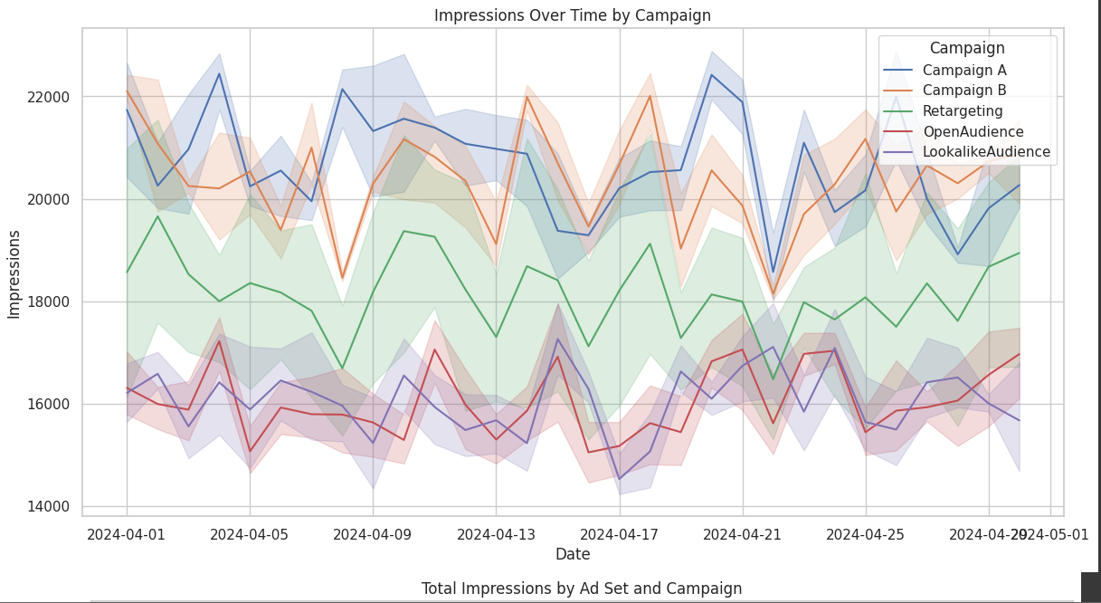

Bar chart

