Name : Tanish Dogra  
 Reg Number : 12113391

Task 3

To : ALLO HEALTH

Report on : Google Ads & Facebook ADs

Date of submission: 27th May 2024

Task 3

industry_benchmarks_google = {

    'ctr_min': 0.08,

    'ctr_max': 0.10,

    'traffic_to_lead_min': 0.07,

    'traffic_to_lead_max': 0.08,

    'lead_to_call_min': 0.25,

    'lead_to_call_max': 0.30

}

industry_benchmarks_facebook = {

    'ctr_min': 0.02,

    'ctr_max': 0.03,

    'traffic_to_lead_min': 0.12,

    'traffic_to_lead_max': 0.15,

    'lead_to_call_min': 0.12,

    'lead_to_call_max': 0.15

}

revenue_per_call = {

    'offline': 2000,

    'online': 1200

}

offline_consultation_capacity = 100

After giving benchmark details   
  
We filtered the data according to benchmarks  
def calculate_performance_diff_google(df):

    df['ctr_diff'] = df['ctr'].apply(lambda x: x - industry_benchmarks_google['ctr_min'] if x < industry_benchmarks_google['ctr_min'] else (x - industry_benchmarks_google['ctr_max'] if x > industry_benchmarks_google['ctr_max'] else 0))

    df['traffic_to_lead_diff'] = df['traffic_to_lead'].apply(lambda x: x - industry_benchmarks_google['traffic_to_lead_min'] if x < industry_benchmarks_google['traffic_to_lead_min'] else (x - industry_benchmarks_google['traffic_to_lead_max'] if x > industry_benchmarks_google['traffic_to_lead_max'] else 0))

    df['lead_to_call_diff'] = df['lead_to_call'].apply(lambda x: x - industry_benchmarks_google['lead_to_call_min'] if x < industry_benchmarks_google['lead_to_call_min'] else (x - industry_benchmarks_google['lead_to_call_max'] if x > industry_benchmarks_google['lead_to_call_max'] else 0))

    return df

def calculate_performance_diff_facebook(df):

    df['ctr_diff'] = df['ctr'].apply(lambda x: x - industry_benchmarks_facebook['ctr_min'] if x < industry_benchmarks_facebook['ctr_min'] else (x - industry_benchmarks_facebook['ctr_max'] if x > industry_benchmarks_facebook['ctr_max'] else 0))

    df['traffic_to_lead_diff'] = df['traffic_to_lead'].apply(lambda x: x - industry_benchmarks_facebook['traffic_to_lead_min'] if x < industry_benchmarks_facebook['traffic_to_lead_min'] else (x - industry_benchmarks_facebook['traffic_to_lead_max'] if x > industry_benchmarks_facebook['traffic_to_lead_max'] else 0))

    df['lead_to_call_diff'] = df['lead_to_call'].apply(lambda x: x - industry_benchmarks_facebook['lead_to_call_min'] if x < industry_benchmarks_facebook['lead_to_call_min'] else (x - industry_benchmarks_facebook['lead_to_call_max'] if x > industry_benchmarks_facebook['lead_to_call_max'] else 0))

    return df

And calculated the difference   
  
google_ads_campaigns = ['Campaign A', 'Campaign B']

facebook_ads_campaigns = ['Retargeting', 'OpenAudience', 'LookalikeAudience']

google_ads_df = aligned_df[aligned_df['campaign_name'].isin(google_ads_campaigns)]

facebook_ads_df = aligned_df[aligned_df['campaign_name'].isin(facebook_ads_campaigns)]

google_comparison_df = calculate_performance_diff_google(google_ads_df)

facebook_comparison_df = calculate_performance_diff_facebook(facebook_ads_df)

comparison_df = pd.concat([google_comparison_df, facebook_comparison_df], ignore_index=True)

print(comparison_df)

output :

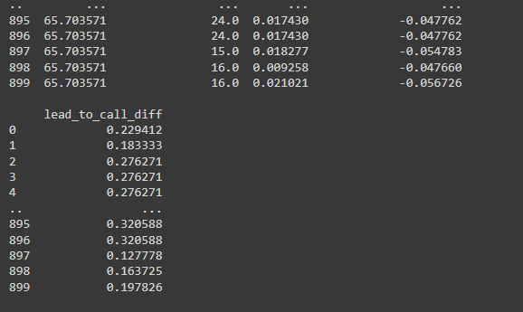

Summary

Now we will do visuilzation:

2nd   
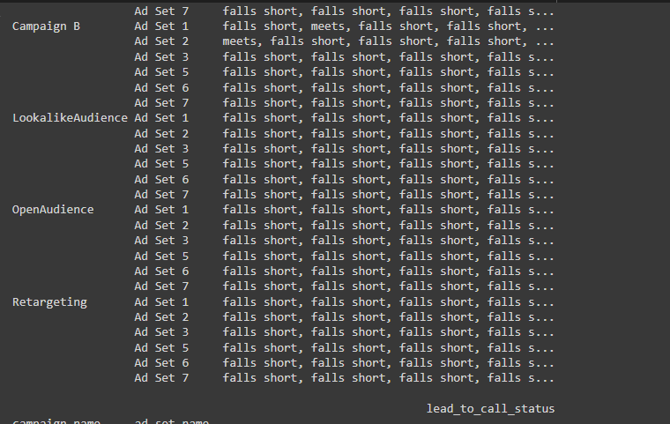

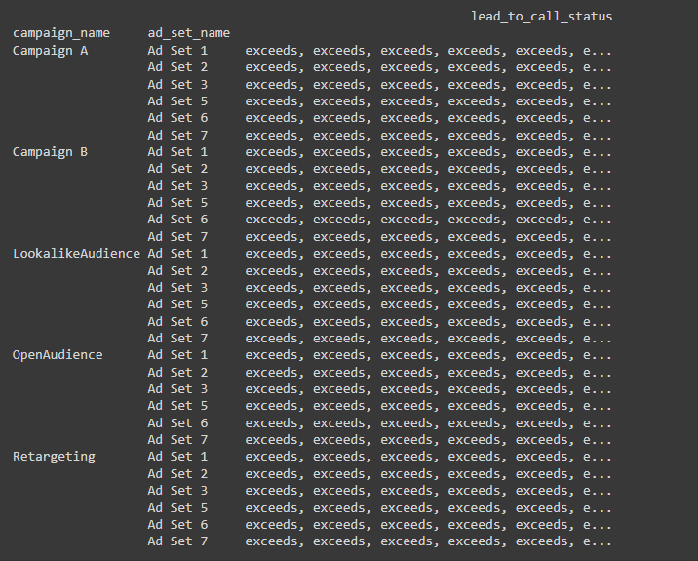

Performance visuilization



