Name : Tanish Dogra  
 Reg Number : 12113391

Task 1

To : ALLO HEALTH

Report on : Google Ads & Facebook ADs

Date of submission: 26th May 2024

**1. Data Analysis Overview**

The Allo health conducted an in-depth analysis of advertising campaign performance to assess its effectiveness and identify areas for improvement. The analysis was divided into four main steps:

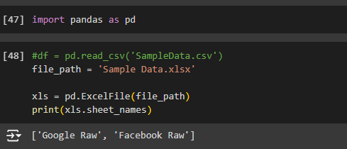

Here we done basic steps for data cleaning   
and then saved that file to new cleaned file.

Here we merged both the sheets of facebook ads and google ads in one

And replaced there default column names with adding _ to them so that it will be easy to recall them

combined_df = pd.concat([df_google, df_facebook], ignore_index=True)

combined_df['date'] = pd.to_datetime(combined_df['date'])

required_columns = ['date', 'campaign_name', 'ad_set_name']

missing_columns = [col for col in required_columns if col not in combined_df.columns]

if missing_columns:

    raise ValueError(f"Missing columns in combined data: {missing_columns}")

all_dates = pd.date_range(start=combined_df['date'].min(), end=combined_df['date'].max())

campaigns = combined_df['campaign_name'].unique()

ad_sets = combined_df['ad_set_name'].unique()

index = pd.MultiIndex.from_product([all_dates, campaigns, ad_sets], names=['date', 'campaign_name', 'ad_set_name'])

full_df = pd.DataFrame(index=index).reset_index()

# Merge

aligned_df = full_df.merge(combined_df, on=['date', 'campaign_name', 'ad_set_name'], how='left')

# Fill missing values

aligned_df.fillna(method='ffill', inplace=True)

aligned_df.fillna(method='bfill', inplace=True)

print("Aligned DataFrame (after cleaning):")

print(aligned_df.head())

cleaned_file_path = 'level_2_cleaned_file.xlsx'

with pd.ExcelWriter(cleaned_file_path) as writer:

    aligned_df.to_excel(writer, sheet_name='AlignedData', index=False)

print(f"Data cleaning complete and saved to {cleaned_file_path}.")

After applying this I completed my 1st task removed duplicate values

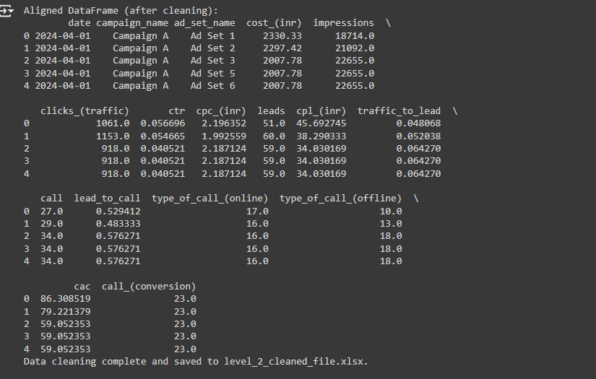

**2. Benchmark Comparison**

The project compared the performance of advertising campaigns and ad sets against industry benchmarks to gauge their effectiveness. Key metrics such as Click-Through Rate (CTR), Traffic to Lead ratio, and Lead to Call ratio were evaluated to determine how well the campaigns aligned with industry standards.

**3. Performance Evaluation**

Each campaign and ad set was evaluated based on its performance relative to the established benchmarks. Areas where performance met or exceeded benchmarks were identified, as well as areas where it fell short. Insights were generated to understand the factors contributing to both successful and underperforming campaigns.

**4. Insight Generation**

Based on the analysis, actionable insights were generated to inform decision-making and optimization strategies. Opportunities for scaling up successful campaigns were identified, along with recommendations for addressing issues and rationalizing underperforming campaigns. Predictability of campaign performance was also assessed to guide forecasting efforts and improve planning.

**Conclusion**

The analysis provided valuable insights into the performance of advertising campaigns, highlighting areas of success and areas for improvement. By leveraging these insights and implementing the recommended strategies, the Allo health aims to optimize campaign performance and achieve its advertising objectives.