

**Java Institute for Advanced Technology**

OBJECT ORIENTED SYSTEMS ANALYSIS AND DESIGN

H7DV 04

H7DV 04/AS/05

S K A D RUKSHAN NIMANTHA PERERA

167342299

950432985v

Colombo



Software Requirements Specification for **Hotel Management System**

Version **1.0**

Prepared by

**S K A D R N Perera**

|  |  |
| --- | --- |
| Instructor: | **Mrs.Narmada Harischandra** |
| Course: | **Software Engineering** |
| Batch: | **Eagles** |
| Teaching Assistant: | **Mrs.narmada** |
| Date: | **2022/03/01** |

Contents

Introduction 03

Document Purpose 03

Product Scope 03

Definitions, Acronyms and Abbreviations 04

References and Acknowledgments 04

Overall Description 05

Software Perspective 05

Users and Characteristics 05

Operating Environment 06

Design and Implementation Constraints 06

User Documentation 06

Assumptions and Dependencies 06

Specific Requirements 07

External Interface Requirements 07

Functional Requirements 07

Behaviour Requirements 08

Other Non-functional Requirements 08

Performance Requirements 09

Safety and Security Requirements 09

Appendix A - Group Log 09

# Introduction

The Hotel Management System is a tool for booking the rooms of Hotel through online by the Customer. It provides the proper management tools and easy access to the customer information.

## Document Purpose

This Hotel Management System Software Requirement Specification (SRS) main objective is to provide a base for the foundation of the project. It gives a comprehensive view of how the system is supposed to work and what is to be expected by the end users. Client’s expectation and requirements are analyzed to produce specific unambiguous functional and non-functional requirements, so they can be used by development team with clear understanding to build a system as per end user needs.This SRS for HMS can also be used for future as basis for detailed understanding on how project was started. It provides a blueprint to upcoming new developers and maintenance teams to assist in maintaining and modifying this project as per required changeability.

## Product Scope

The HMS project is intended for the reservations for room that can be made through online. It will be able to automate the various operations of the Hotel. Our Hotel Management System will have three end users: Customer, Receptionist, and Owner. Hotel Management System will consists of Booking Management System, DBMS Server, and Payment Gateway. While doing reservations, a customer can provide reservation dates, lodging duration, room type, room count and lodging count. Receptionist will have access to register a new customer,update or modify booking details. Owner will able to view the financial report and able to update room information such as cost and category.

The main goal of this introduced automated HMS software is to simplify every day process of hotel. Day to day Hotels are increasing and they need to automate to provide customer ease of access. It will be able to take care of services to customer in a quick manner. This automation will be able to replace the drawbacks of large customer information physical files which were difficult to handle. Secure Transaction, quick retrieval of information, ease of use, quick recovery of errors, fault tolerance are some of the benefits that development team will be working on to achieve end

user satisfaction.

## Definitions, Acronyms and Abbreviations

**SRS -**Software Requirement Specifications

**HMS -**Hotel Management System

**DBMS -**Database Management System

**Blueprint -**A design technical plan

**Database-**A info could be an assortment of data that's organized in order that it may be simply accessed, managed and updated. Data is organized into rows, columns and tables, and it's indexed to form it easier to search out relevant info. information gets updated, expanded and deleted as new info is more. Databases method workloads to form and update themselves, querying the information they contain and running applications against it. Computer databases generally contain aggregations of information records or files, like sales transactions, product catalogues and inventories, and client profiles. Typically, an information manager provides users with the power to manage read/write access, specify report generation and analyse usage. Some databases supply ACID (atomicity, consistency, isolation and durability) compliance to ensure that information is consistent which transactions are complete. Databases are current in massive mainframe systems, however also are gift in smaller distributed workstations and midrange systems, like IBM's AS/400 and private computers.

**Actor –** Is the person who directly involve with the system.

## References and Acknowledgments

1] Software Engineering 9 th Edition, Ian Sommerville

[2] Fundamentals of Database System, 6 th Edition, Ramez Elmasri, Shamkant B. Navathe

[3]ER DiagramTutorial:https://www.tutorialspoint.com/dbms/er_diagram_representation.htm

[4] Requirement Engineering: http://morse.inf.unideb.hu/valseg/gybitt/07/ch02.html

[5] Hotel Management System: https://www.scribd.com/doc/63824633/Hotel-Management-

System

# Overall Description

## Software Perspective

## Users and Characteristics

There are 3 user Levels in our Hotel Management System:

A. Hotel Manager

B. Receptionist

C. Customers

Hotel Owner

Manager have every access to the hotel system. Owner is solely responsible for managing hotel resources and staffs. Owner can view any report such as financial report, customer information, booking information, and room information, analyze them and take the decision accordingly.

Receptionist

Hotel Receptionist sole purpose is to provide the quality customer service. She have least access than owner. She/he can manage the booking details. She can search for availability of rooms, add the customer, confirm the booking, update the booking details and levy the payment.

Customer

Customer are vital part of the system. Customer can provide reservation dates, lodging duration, room type, room count and lodging count. They should be able to confirm the booking and cancel it if necessary. Customers have access to customer service desk portal to forward their inquiry.

## Operating Environment

* Up to 5th Generation Intel® Core™ i7 Processor
* Windows 10 Home
* Up to NVIDIA® GeForce® GT 9400 2 GB graphics
* Up to 8 GB DDR3 memory
* Up to 1 TB HDD
* 15L volume
* 2 x USB 2.0 and 2 x USB 3.0 Rear Ports

## Design and Implementation Constraints

* Up to 4th Generation Intel® Core™ i5 Processor
* Windows 10 Home
* Up to NVIDIA® GeForce® GT 9400 2 GB graphics
* Up to 16 GB DDR3 memory
* Up to 1 TB HDD
* 15L volume
* 2 x USB 2.0 and 2 x USB 3.0 Rear Ports

## Assumptions and Dependencies

It is assumed that system developed will work perfectly that’s going to be developed under the Windows OS, and Apache Server with MYSQL database. If in case of any difficulties, SRS should be flexible enough to change accordingly.

# Specific Requirements

## External Interface Requirements

### User Interfaces

The user interface for system shall be compatible to any type of web browser such as Mozilla

Firefox, Google Chrome, and Internet Explorer.

### Hardware Interfaces

|  |  |  |  |
| --- | --- | --- | --- |
| Server Side | | | |
| Monitor | Processor | RAM | Disk Space |
| Resolution:  1024x768 | Intel or AMD 2GHZ | 16 GB | 1TB |
| Client Side | | | |
| Monitor | Processor | RAM | Disk Space |
| Resolution:  1024x768 | Intel or AMD 2GHZ | 4GB DDR3 | 10GB |

### Software Interfaces

Web Server

Apache Tomcat Server , OS (Windows)

Database Server

MYSQL, OS (Windows)

HTML,PHP,XML,JavaScript, OS(Windows)

## Functional Requirements

Registration

* The Customer should be able to register with their details
* The system should record following customer details into member database.

Name,Email,Password,Address,DOB

Logging In

* The system should verify the customer email & password against the member database when logging in
* After login, member should be directed to Home screen

Reservation

* The system should enable customer to check for availability of rooms
* The system should display rate for all rooms
* The system should allow customer to confirm or cancel the booking
* The system should record booking details into database
* The system should record booking details into database
* The system should allow customer to provide reservation dates, lodging duration, room type, room count and lodging count

Receptionist Access

* The system should allow Receptionist to register a new customer
* The system should allow Receptionist to update, add or delete booking information
* The system should allow Receptionist provide invoice

Owner Access

* The system should generate financial and customer report for owner
* The system should enable owner full modification access to customer ,booking and

room information

Payment Management System

* The system should allow customer to pay bill via online using credit or debit card

## Behaviour Requirements

### Use Case View

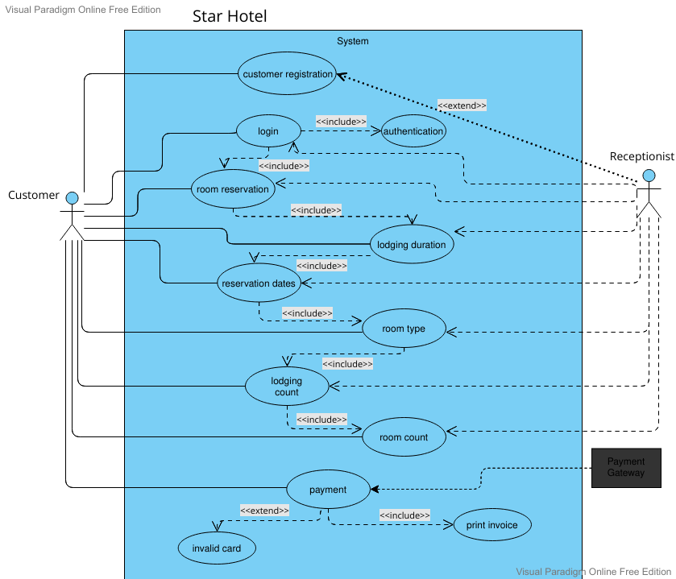

# Other Non-functional Requirements

## Performance Requirements

* Data in database should be updated within 2 seconds.
* Query results must return results within 5 seconds
* Load time of UI Should not take more than 2 seconds
* Login Validation should be done within 3 seconds

## Safety and Security Requirements

* All external communications between the data’s server and client must be encrypted
* All data must be stored, protected or protectively marked.
* Payment Process should use HTTP over Secure protocol to secure the payment transactions
* Database should be backed up every hour.
* Under failure, system should be able to come back at normal operation under an hour.