**Case Study On PowerBI**

**By Thosic Tarun Bellana**

**Requirement 1 : Loading the data**

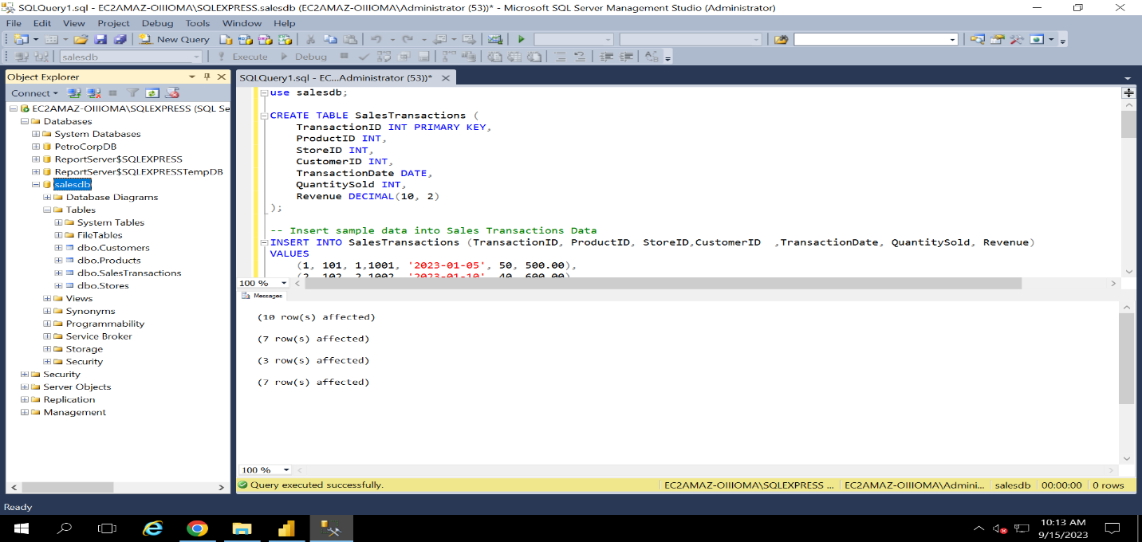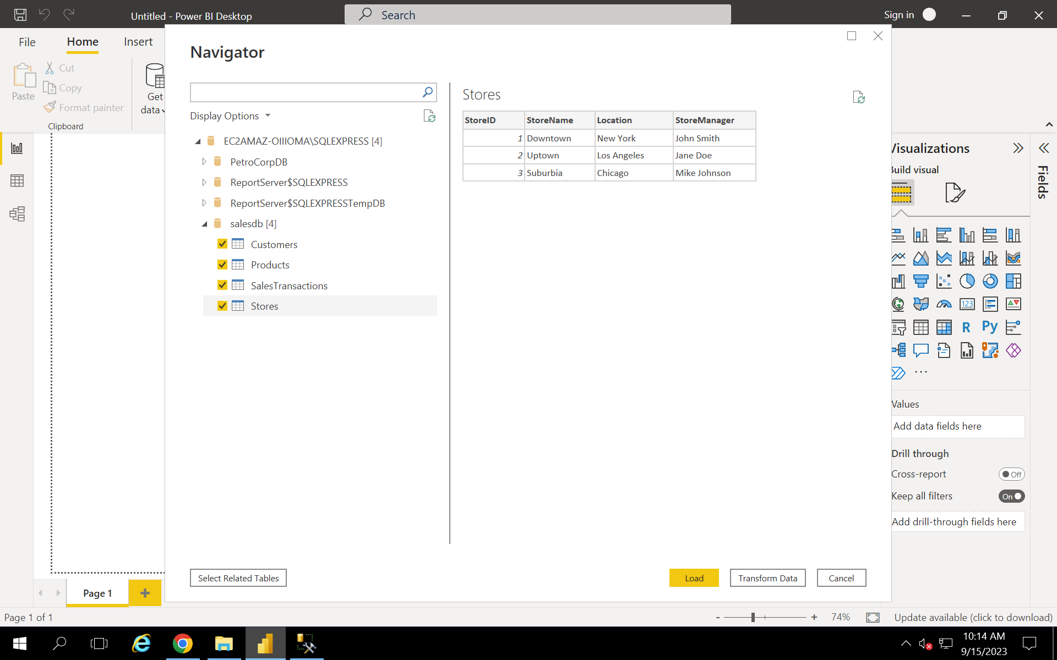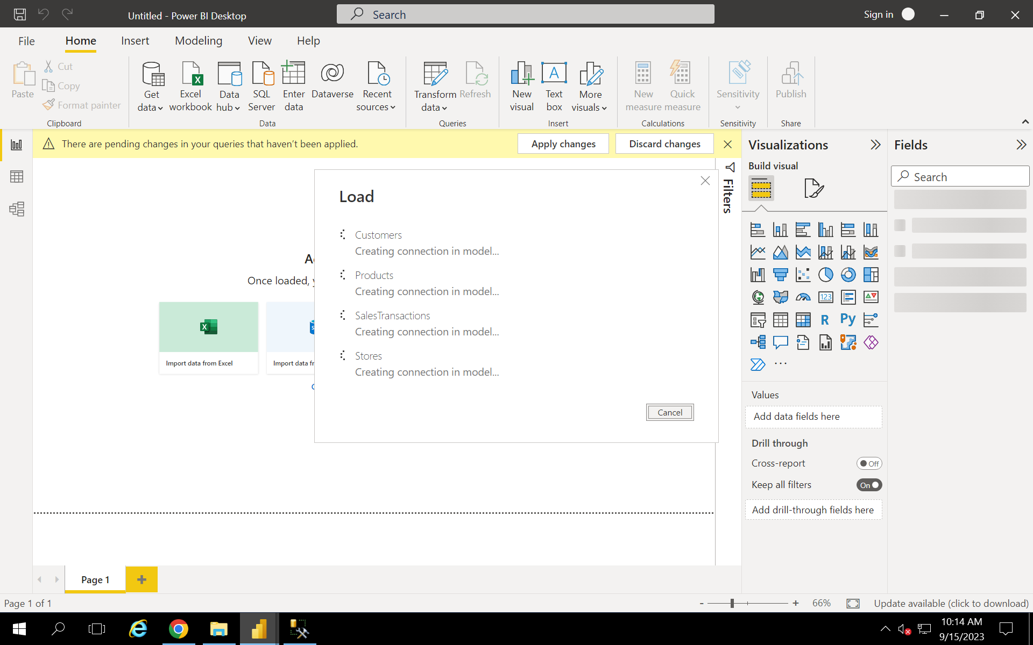

**Requirement 2 Data Transformation:**

**Requirement 4:**

**4.3: average price of products by category**

