Name : Thota Neha
Roll No : CB.SC.U4CSE23165
Date : 07/01/26

Use Database
test> use MentalHealthDB
Output:
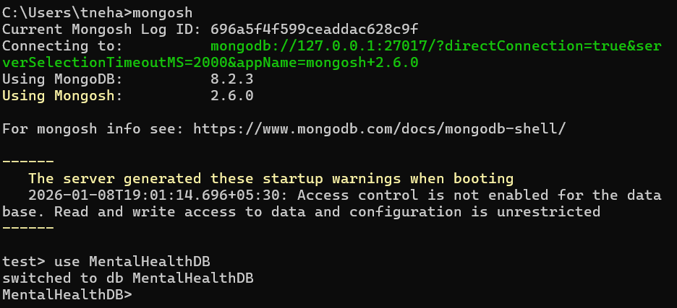
Create Collections
MentalHealthDB> db.createCollection("user_profiles")
Output: MentalHealthDB> db.createCollection("appointment_records")
Output:
View Collections
MentalHealthDB >show collections
Output:

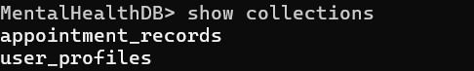
MASTER TABLE: user_profiles
Insert One
MentalHealthDB> db.user_profiles.insertOne({
user_id: 201,
name: "Neha",
age: 19,
gender: "F",
mental_health_issue: "Anxiety",
email: "neha@gmail.com",
phone_no: "9876543210"
})
Output:
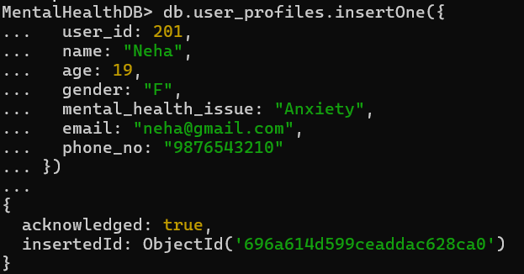
Insert Many
MentalHealthDB> db.user_profiles.insertMany([
{
user_id: 202,
name: "Aarav",
age: 22,
gender: "M",
mental_health_issue: "Depression",
email: "aarav@gmail.com",
phone_no: "9123456789"
},
{
user_id: 203,
name: "Fatima",
age: 20,
gender: "F",
mental_health_issue: "Stress",
email: "fatima@gmail.com",
phone_no: "9988776655"
}
])
Output:
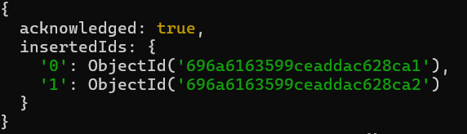

Find
MentalHealthDB> db.user_profiles.find()
Output:
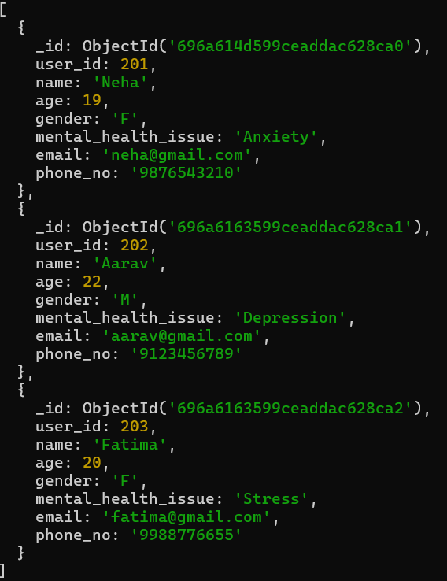

AND Operation
MentalHealthDB> db.user_profiles.find({
gender: "F",
age: { $gt: 18 }
})
Output:
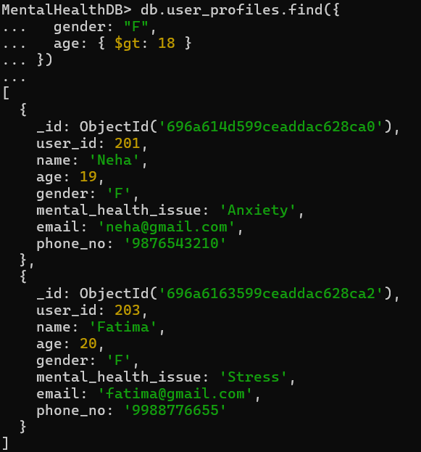

OR Operation
MentalHealthDB> db.user_profiles.find({
$or: [{ age: 19 }, { age: 22 }]
})
Output:
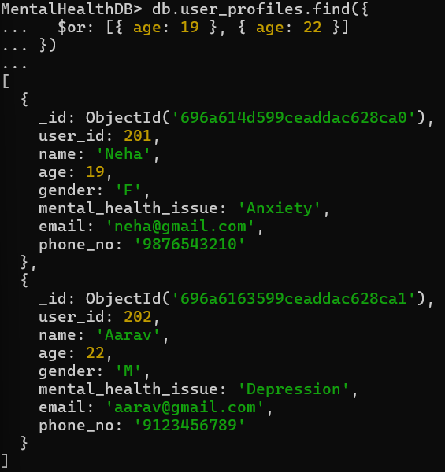
NOT Operation
MentalHealthDB> db.user_profiles.find({
gender: { $ne: "M" }
})
Output:
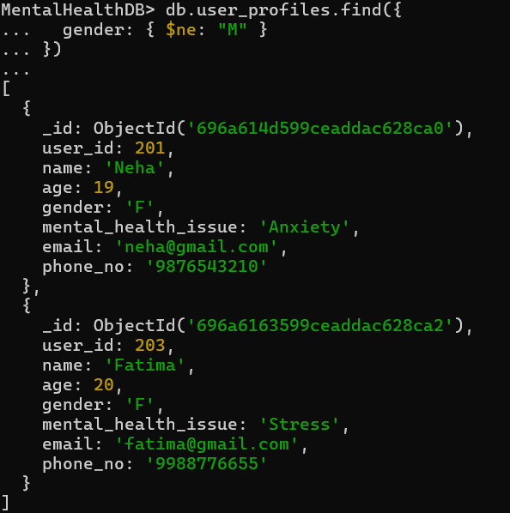
Find using >
MentalHealthDB> db.user_profiles.find({
age: { $gt: 20 }
})
Output:
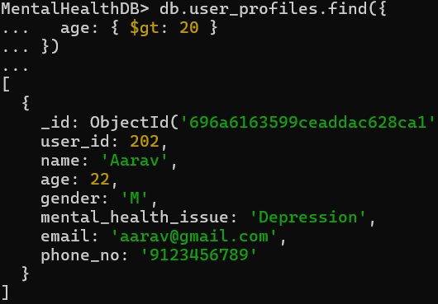

Find using <=
MentalHealthDB> db.user_profiles.find({
age: { $lte: 20 }
})
Output:
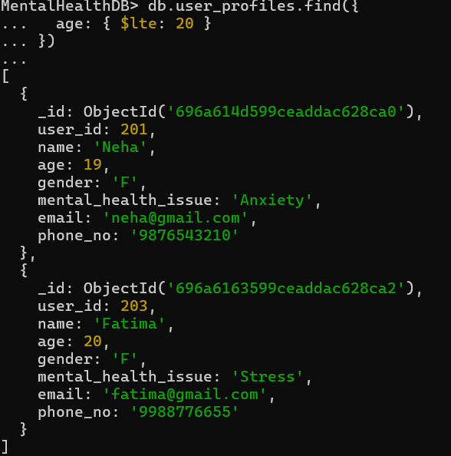
TRANSACTION TABLE: appointment_records
Insert One
MentalHealthDB> db.appointment_records.insertOne({
appointment_id: 1,
user_id: 201,
doctor_name: "Dr. Sharma",
specialization: "Psychiatrist",
appointment_date: "2026-01-05",
appointment_time: "10:30 AM",
consultation_mode: "Online"
})
Output:
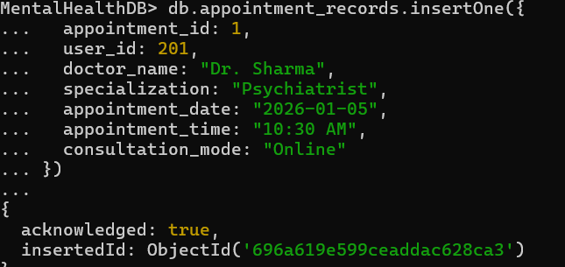
Insert Many
MentalHealthDB> db.appointment_records.insertMany([
{
appointment_id: 2,
user_id: 202,
doctor_name: "Dr. Meera",
specialization: "Psychologist",
appointment_date: "2026-01-06",
appointment_time: "12:00 PM",
consultation_mode: "Offline"
},
{
appointment_id: 3,
user_id: 203,
doctor_name: "Dr. Rao",
specialization: "Therapist",
appointment_date: "2026-01-07",
appointment_time: "04:00 PM",
consultation_mode: "Online"
}
])
Output:
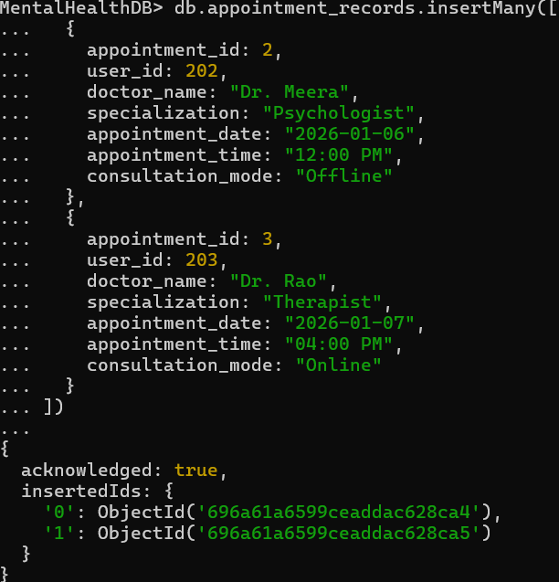

Delete One
MentalHealthDB> db.user_profiles.deleteOne({ user_id: 203 })
Output:
Delete Many
MentalHealthDB> db.appointment_records.deleteMany({
consultation_mode: "Online"
})
Output:
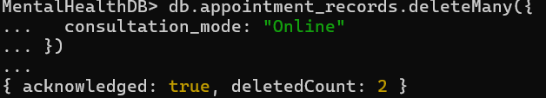
Drop Collection
MentalHealthDB> db.appointment_records.drop()
Output:
Drop Database
MentalHealthDB> db.dropDatabase()
Output:
