Software Engineering Mini Project · Team E15

Software Requirements Specification
Railway Reservation System
Prepared by Mohit Singh P
PES1UG24CS273
Version 1.1 · 29 September 2026
ISO/IEC/IEEE 29148-aligned structure
Submission Copy

Document Control
Document | Software Requirements Specification (SRS)
System | Railway Reservation System (RRS)
Owner | Mohit Singh P — PES1UG24CS273
Team | Team E15
Version / status | 1.1 / Submission copy
Date | 29 September 2026

Revision History
Version | Date | Change | Author
1.0 | 29 Sep 2026 | Initial Part 1 requirements baseline. | Mohit Singh P
1.1 | 29 Sep 2026 | Separated submission document; strengthened traceability, verification wording and UML presentation. | Team E15 review
Baseline rule. “Shall” statements are mandatory and verifiable. A change to any FR, NFR or SEC identifier requires review of the architecture mapping and test traceability matrix.

Table of Contents
- 1. Introduction
- 1.1 Purpose
- 1.2 Scope
- 1.3 Intended audience and conventions
- 1.4 Definitions and references
- 2. Overall Description
- 3. External Interface Requirements
- 4. Specific Requirements
- 4.1 Functional requirements
- 4.2 Non-functional requirements
- 4.3 Security objectives and requirements
- 5. UML Use Cases
- 6. Acceptance Basis

1. Introduction

1.1 Purpose
This specification defines the observable behavior, interfaces, constraints, quality attributes and security requirements of the Railway Reservation System prototype. It is the requirements baseline for architecture, design and testing.

1.2 Scope
Passengers register, sign in, search trains, inspect seat availability, create a reservation after simulated payment, view their bookings and cancel an eligible booking. Administrators maintain train trips and seat capacity and review audit events. The prototype excludes live railway-network integration, real money movement, dynamic pricing and wait-list allocation.

1.3 Intended Audience and Conventions
This document is intended for the project team, instructors, reviewers and testers. Requirement identifiers use FR for functional requirements, NFR for non-functional requirements and SEC for security requirements. Times are measured at the service boundary under the Test Plan’s stated conditions.

1.4 Definitions and References
Term | Definition
PNR | A unique booking reference.
Seat hold | A temporary exclusive claim on one seat during a booking transaction.
Confirmed booking | A booking with one allocated seat and successful simulated payment.
Administrator | An authenticated user authorized to manage schedules, inventory and audit review.
Idempotency key | A caller-supplied unique key that makes a retried booking request return the original result rather than create another booking.
References: SE Mini Project Deliverables Part-1; ISO/IEC/IEEE 29148:2018 requirements-engineering guidance.

2. Overall Description

2.1 Product Perspective
RRS is a browser-based client backed by a REST API and relational database. The browser never accesses the database directly. A deterministic payment simulator provides success, failure and refund responses for testing.

2.2 Product Functions
- Account registration, authentication, sign-out and lockout.
- Train search, ordered results and current seat availability.
- Idempotent booking, simulated payment and unique PNR generation.
- Passenger-owned booking history and eligible cancellation.
- Administrator trip/inventory management and audit review.

2.3 User Classes
User class | Permitted responsibilities
Passenger | Manage own account session; search; view availability; book; view and cancel own eligible bookings.
Administrator | Create, edit and disable trips and capacity; review audit events. Administrator permissions are enforced server-side.

2.4 Operating Environment
A current desktop or mobile browser connects to the application over HTTPS. The API and database run as separate server processes. Timestamps are stored in UTC and displayed with an explicit timezone label.

2.5 Assumptions and Constraints
- A trip has a train number, origin, destination, departure/arrival time, travel date, fare and finite capacity.
- One seat is booked per transaction. A cancellation is eligible only before departure.
- Test accounts, seeded trip data and configurable payment-simulator responses are available.
- No real payment credentials or real passenger identities are processed.

3. External Interface Requirements

3.1 User Interfaces
Passenger screens support registration, sign-in, search, availability, checkout, booking history and cancellation. Administrator screens support trip management and audit review. Forms identify required fields, expose programmatic labels and show actionable validation messages.

3.2 Software Interfaces
The UI exchanges JSON with the REST API over HTTPS. The payment simulator exposes authorization and refund operations. The database persists users, trips, seats, bookings, payment events and audit events.

3.3 Communication Interfaces
Authenticated traffic uses HTTPS. JSON dates use ISO 8601 with an explicit UTC offset. Sessions are represented by secure tokens whose lifecycle is defined in SEC-03.

4. Specific Requirements

4.1 Functional Requirements
FR-01 — Registration. The system shall create a passenger account when a unique email, a name and a password of at least 12 characters are submitted. It shall reject an 11-character password and a duplicate email without creating an account.
FR-02 — Authentication. The system shall issue an authenticated session only after valid credentials are supplied and shall reject an invalid password with a generic error that does not reveal whether an account exists.
FR-03 — Train search. Given an origin, destination and travel date, the system shall return only trips matching all three values, ordered by departure time.
FR-04 — Availability. For every returned trip, the system shall show the number of unreserved seats; the displayed count shall remain between zero and the trip capacity inclusive.
FR-05 — Booking. When an authenticated passenger selects an available trip and the payment simulator returns success, the system shall allocate exactly one available seat and create exactly one confirmed booking with a unique PNR. If payment fails, it shall release the hold and create no confirmed booking. Retrying the same idempotency key shall not create another booking.
FR-06 — Booking history. The system shall show a passenger only that passenger’s bookings, including PNR, trip, seat, fare and status.
FR-07 — Cancellation. For a confirmed booking owned by the signed-in passenger and requested before departure, the system shall mark it cancelled, release its seat exactly once and record a simulated refund reference. It shall reject late, repeated and non-owner cancellation attempts without a second inventory change.
FR-08 — Administration. An administrator shall create, edit or disable a train trip and its seat capacity; a non-administrator request to these operations shall receive HTTP 403.
FR-09 — Audit. The system shall record successful and failed sign-ins, booking confirmations, booking cancellations and administrator trip changes with timestamp, actor identifier, action and outcome.

4.2 Non-Functional Requirements
NFR-01 — Search performance. With 10,000 stored trips and 50 concurrent users, 95% of 200 valid search requests shall complete within 2 seconds in the stated test environment.
NFR-02 — Booking performance. With 50 concurrent users, 95% of 100 booking requests shall complete within 3 seconds, excluding any injected simulator delay above 1 second.
NFR-03 — Concurrency. When 20 concurrent requests attempt to reserve the final seat, at most one booking shall be confirmed and availability shall finish at zero, never below zero.
NFR-04 — Availability and recovery. After an application-process restart, committed bookings shall remain available and the service shall answer a health request within 60 seconds.
NFR-05 — Accessibility. Required passenger and administrator workflows shall support keyboard-only operation and every input and button shall expose an accessible programmatic name.
NFR-06 — Compatibility. Required workflows shall work in the latest stable Chrome, Edge and Firefox at 375-pixel and 1280-pixel viewport widths without horizontal scrolling of primary forms.

4.3 Security Objectives and Requirements

Security Objectives
- SO-01: Prevent unauthorized access to passenger records and administrator functions.
- SO-02: Protect credentials and booking data in transit and at rest.
- SO-03: Preserve a trustworthy audit history of security-sensitive actions.

Security Requirements
SEC-01 — Access control. Every booking read, cancellation and administrator API request shall validate the authenticated user and role on the server. A request for another passenger’s booking shall return HTTP 403 or 404 without booking details.
SEC-02 — Credential protection. Passwords shall be stored only as salted adaptive hashes. Plaintext passwords shall not appear in the database, logs or API responses.
SEC-03 — Transport and session. Authenticated API traffic shall use HTTPS. Session tokens shall expire after 30 minutes of inactivity and be invalid after sign-out.
SEC-04 — Abuse resistance and audit. After five failed sign-in attempts for one account within 15 minutes, further attempts shall be rejected for 15 minutes and logged without the submitted password.

5. UML Use Cases
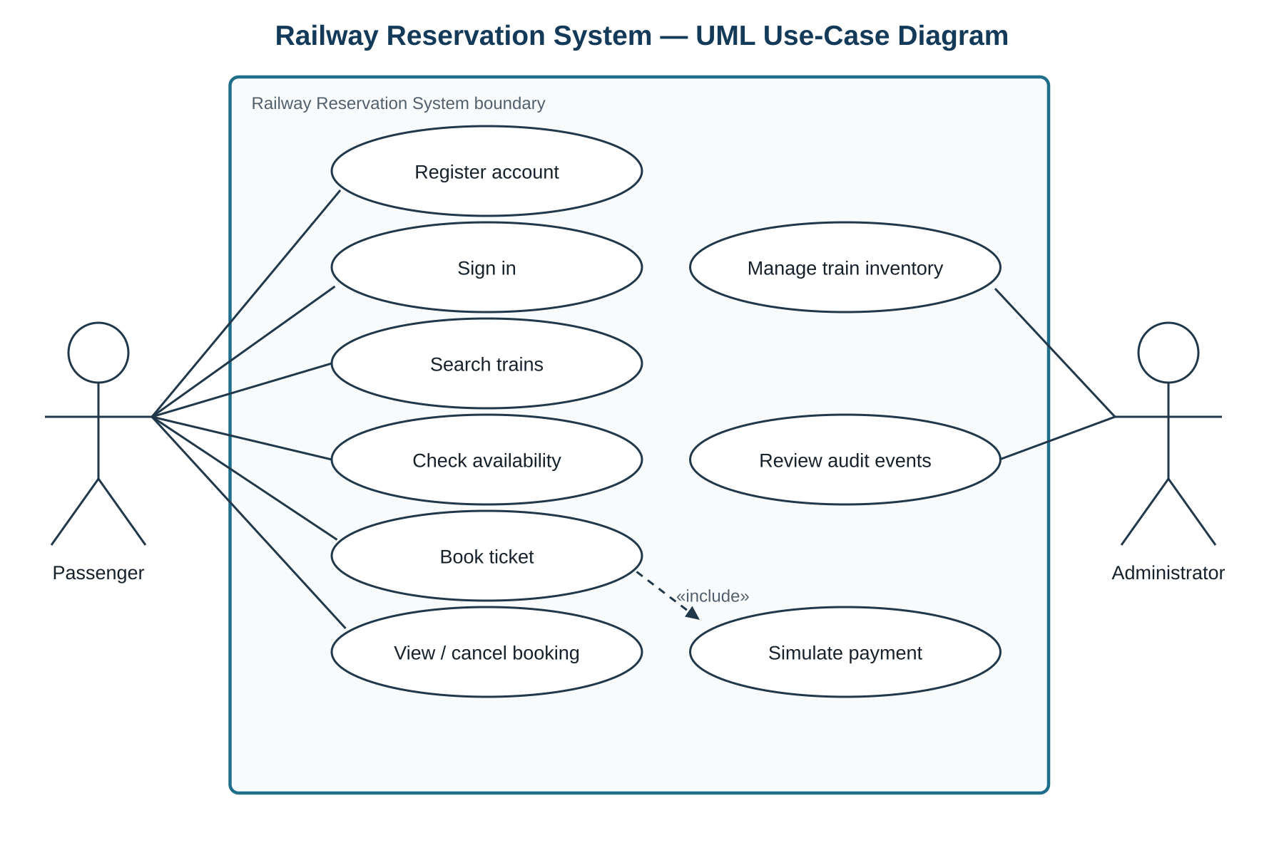 Figure 1. Passenger and administrator use cases with separate UML actor associations.

5.1 UC-01 — Book Ticket
Primary actor | Passenger
Preconditions | The passenger is authenticated; the selected trip is enabled.
Main flow | Search trip → check availability → submit booking with idempotency key → reserve one seat → simulate payment → create confirmed booking and PNR → record audit event.
Alternatives | Sold-out inventory returns conflict. Payment failure releases the hold. A duplicate idempotency key returns the original result.
Postcondition | Exactly one confirmed booking exists on success; none exists after payment failure.

5.2 UC-02 — Cancel Booking
Primary actor | Passenger
Preconditions | The booking belongs to the passenger, is confirmed and its trip has not departed.
Main flow | Select booking → validate ownership/status/time → cancel once → release seat once → record refund reference and audit event.
Alternatives | Non-owner receives 403/404. Late or repeated cancellation is rejected without an additional seat change.
Postcondition | The booking is cancelled and the inventory change is idempotent.

6. Acceptance Basis
The SRS baseline is acceptable for Part 1 when every FR, NFR and SEC identifier maps to at least one planned test, the required UML diagrams are present across the submission, and the booking/cancellation invariants are explicitly verified. The Test Plan’s requirement traceability matrix is the authoritative coverage record.

