Adaptive Hybrid Quantum Image Representation for
Efficient Encoding of Medical and SAR Images

Thouseef f^{1,2*},
1 Department of Computer Science and Engineering, Dayananda Sagar University, Bengaluru, 560078, Karnataka, India.
*Corresponding author: thouseefthouseef1234@gmail.com
Abstract
Quantum image representation (QIR) maps spatial and intensity information into quantum states, and state preparation can require substantial resources. This paper introduces Adaptive Hybrid Quantum Image Representation (AHQIR), which uses classical intensity thresholding to select pixels and applies controlled intensity rotations only at those selected positions. The position register remains in a full uniform superposition; accordingly, AHQIR reduces the number of controlled-rotation instructions, not the position-qubit count or the support of the position state. We implemented AHQIR, FRQI, and NEQR in Qiskit and evaluated them on 800 sampled brain MRI images and 1,160 SAR images downsampled to 4×4 for the main experiments. The manuscript reports logical gate-count and depth reductions relative to FRQI of 63.7% for MRI and 80.3% for SAR. These savings are accompanied by increased full-image reconstruction error because non-selected pixels are reconstructed as zero. A supplementary scaling check used one representative image per modality at 4×4, 8×8, and 16×16; larger-resolution and physical-hardware experiments were not conducted. The results indicate a sparsity-dependent resource trade-off in simulation. Further work is needed to assess task relevance, larger images, hardware noise, and practical applicability.

Keywords: Quantum Image Representation, Adaptive Hybrid Encoding, Quantum Image Processing, Medical Image Encoding, Synthetic Aperture Radar (SAR), Quantum Circuit Resource Analysis, Selective State Preparation

1. Introduction
Quantum computing provides computational models based on quantum superposition, interference, and entanglement. Among the various application domains of quantum computing, quantum image processing (QIP) has gained increasing attention due to the exponential growth of visual data and the limitations of classical image processing techniques in handling large-scale and high-dimensional image datasets. At the core of quantum image processing lies the problem of quantum image representation (QIR), which determines how classical image information can be efficiently mapped into quantum states.
A quantum image representation (QIR) encodes spatial coordinates and pixel intensity or color in a quantum state. For an image with power-of-two dimensions, position information can be represented using binary coordinate registers. QIR schemes make different trade-offs among qubit count, state-preparation circuit size, intensity precision, and retrieval cost. These quantities depend on the representation and on the circuit synthesis and measurement procedures.
One of the earliest and most influential representations is the Flexible Representation of Quantum Images (FRQI). FRQI encodes the position of each pixel using m+n qubits and represents grayscale intensity using a single qubit through a rotation angle. Mathematically, FRQI represents an image as a superposition of pixel positions, where each position controls a rotation operation on the intensity qubit. Although FRQI requires a relatively small number of qubits, its gate complexity grows exponentially with image size due to the large number of controlled rotation operations. This results in deep circuits that are difficult to execute reliably on current quantum hardware.
To overcome the precision limitations of FRQI, the Novel Enhanced Quantum Representation (NEQR) was introduced. NEQR encodes grayscale intensity values directly into computational basis states using multiple qubits, thereby achieving exact intensity representation. For a 2^m \times 2^n image with q-bit grayscale resolution, NEQR requires m+n+q qubits. While NEQR improves intensity accuracy and eliminates rotation-angle approximation errors, it significantly increases qubit requirements and circuit complexity, limiting its scalability.
Subsequent research extended grayscale representations to color images. The Multichannel Quantum Image (MCQI) representation encodes RGB color channels by assigning separate rotation operations for each color component. Although MCQI enables color image processing, it further increases gate count and circuit depth, making it impractical for large images. Similarly, Quantum States for M Colors and N Coordinates (QSMC/QSNC) generalize color encoding but suffer from substantial quantum resource requirements.
Another class of representations focuses on specific image modalities. The Simple Quantum Representation (SQR) was proposed for infrared images, emphasizing reduced qubit usage and simplified encoding. QUALPI (Quantum Log-Polar Image) representation introduces a log-polar coordinate system to achieve rotation and scale invariance, which is particularly useful for pattern recognition tasks. However, QUALPI relies on complex coordinate transformations and is limited to specific application scenarios.
The limitations and trade-offs of QIR methods are representation- and implementation-dependent. In particular, state-preparation cost can grow with the number of represented pixels, while lossy preprocessing or finite-shot measurement can affect reconstruction. These issues motivate evaluating selective encoding, but they do not imply that every uniform representation is inefficient for every image.
MRI and SAR images have different intensity and texture characteristics. This paper uses them as two image modalities for a preliminary reconstruction experiment. The intensity threshold is not treated as a validated detector of tumors, ships, or other domain-specific targets.
This study tests a specific hypothesis: selecting pixels with a global statistical threshold may reduce the number of controlled rotations in a position-conditioned encoding circuit. The resulting resource savings must be considered alongside the reconstruction error introduced by setting unselected pixels to zero.
These observations motivate the evaluation of adaptive and hybrid quantum image representations that allocate quantum encoding operations according to image content while explicitly measuring the resulting reconstruction loss.

2. Related Work
Quantum image representation (QIR) has developed through several families of encoding schemes. This section summarizes representative QIR approaches that provide context for the resource and representation choices evaluated in this study.

2. Rotation-Based Quantum Image Representations
FRQI represents grayscale intensity through a position-controlled rotation of an intensity qubit. In this manuscript it is the principal reference circuit. Comparisons are meaningful only when the input resolution, angle mapping, gate basis, transpiler settings, and metric definitions are aligned.
FRQI is used here as a rotation-based reference representation. Its intensity qubit is controlled by pixel position, so state preparation requires position-conditioned rotations. Circuit cost depends on image size, the synthesis method, available ancillas, and the gate basis used for accounting. Any comparison should therefore state the implementation and counting convention.
Previous studies have examined noise effects and resource trade-offs in rotation-based quantum image representations; specific claims about noise sensitivity require direct support from the cited implementations.

2. Basis-State Quantum Image Representations
NEQR stores grayscale values in computational-basis intensity qubits. This supports exact representation of the discrete input values in the ideal state, while state-preparation cost depends on the number and pattern of intensity bits and on the chosen circuit synthesis. Exact encoding does not by itself imply low total resource cost.
The cited NEQR literature motivates a comparison between basis-state intensity storage and rotation-based encoding. Claims about optimized recent circuits should be tied to specific papers and matched implementations; no such independent reproduction is included in the present experiment.
Comparisons between NEQR and FRQI depend on image assumptions, circuit construction, and resource-counting conventions; this paper does not independently reproduce a literature-wide comparison.

2. Color and Multichannel Quantum Image Representations
The models in this group extend representation to color channels or multiple data layers. Their qubit and gate requirements depend on the particular formulation and implementation. They are included as conceptual context; their literature values in Table 1 are not direct, like-for-like measurements from the present experiments.
QSMC and QSNC are discussed as multichannel or coordinate-oriented representation families. Their resource requirements depend on their precise definitions and implementation choices; broad comparative claims require direct source verification and consistent assumptions.

2.4. Specialized Quantum Image Representations
Specialized representations target particular coordinate systems, image types, or processing goals. Their assumptions and resource counts are model-specific, so they should not be treated as interchangeable baselines without matching image dimensions, intensity precision, and gate-count conventions.
QUALPI and SQR address specialized representation goals. Their assumptions differ from those of the grayscale FRQI and AHQIR circuits evaluated here, so they are background models rather than experimentally matched baselines in this study.

2.5. Generalized and Hybrid Quantum Image Representations
Generalized and hybrid representations seek to combine multiple image features or use classical preprocessing alongside quantum encoding. The exact benefits depend on the construction and the workload. AHQIR is evaluated here as a selective-rotation approach rather than as a general solution to image-encoding scalability.
Hybrid methods combine classical and quantum processing in different ways. The relevant question for AHQIR is whether its specific threshold-based selection reduces controlled-rotation count under the chosen circuit construction, and what reconstruction loss follows.

2.6. Quantum Image Processing for Medical and SAR Applications
Quantum image processing has been studied in medical and remote-sensing contexts, but this paper evaluates image representation and pixel reconstruction only. It does not test clinical diagnosis, tumor localization, ship detection, or downstream task accuracy.
Related work on medical and SAR image processing provides application context. The experiments in this paper do not evaluate medical diagnosis, tumor detection, ship detection, denoising quality, or feature-extraction performance.

2.7. Research Gap and Motivation
The motivation for AHQIR in this study is narrow: test whether threshold-based pixel selection can reduce the number of controlled rotations in the stated circuit while quantifying the associated reconstruction loss. This evaluation does not establish general superiority over existing QIR techniques.
AHQIR investigates adaptive pixel selection as a way to reduce state-preparation resources. Figure 1 summarizes the landscape of quantum image representation methods referenced throughout this study. Its demonstrated benefits are limited to the tested image sizes, datasets, simulator, and thresholding procedure; broader scalability and application claims require further validation.

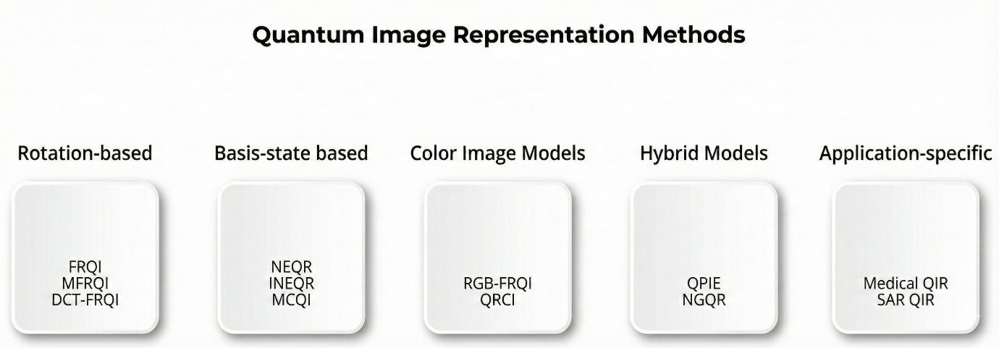
Figure 1. Overview of quantum image representation methods.

3. Results
The experiments use circuit simulation to examine the proposed encoding and reconstruction procedure. The results are implementation-specific resource and pixel-reconstruction measurements; they should not be interpreted as evidence of physical-hardware performance.
Table 1. Representation families and resource information. Literature entries are background summaries and are not direct matched benchmarks; see source citations and implementation assumptions. Complexity expressions reported for literature methods are reproduced for contextual comparison and are not independently derived or experimentally verified in this study. Complexity expressions are reproduced under the assumptions stated in the cited works and are not normalized to the 4×4 experimental setup used for AHQIR.
Method | Basis | Q / G / D (reported/theoretical) | Recon. MSE | CX
FRQI | Measured | Q=5, G=1092, D=705 | See Table 2 | See Table 2
NEQR | Measured | Q=12, G=120*, D~80* | See Table 2 | See Table 2
MCQI | Literature [3] | Q=19, G=O(2^2n) | — | —
QSMC | Literature | Q=32, G=O(Mq·2^16) | — | —
QSNC | Literature [6] | Q=28, G=O(q·2^16) | — | —
SQR | Literature [7] | Q=17, G=O(2^16) | — | —
QUALPI | Literature [14] | Q=24, G=High | — | —
BRQI | Literature [18] | Q=20, G=O(n·2^16) | — | —
PE-NGQR | Literature [17] | Q=22, G=O(n·2^16) | — | —
CE-NGQR | Literature [19] | Q=20, G=O(n·2^16) | — | —
AHQIR MRI | Measured, N=800 | Q=5, G=396±93, D=256±60 | — | —
AHQIR – SAR | Measured, N=1160 | Q=5, G=215±113, D=137±73 | __ | ___
Note: “—” indicates that the metric was not experimentally measured in this study. Literature values are reported for contextual comparison and were not independently reproduced.
Q = qubits; G = gate count; D = circuit depth; CX = physical CNOT gates after transpiling to basis_gates=['cx','u'] (Qiskit 2.5.2, optimization_level=1) — see Section 4.6.3. “Measured” rows are this work's own Qiskit simulations (mean over the stated N real images); “Literature” rows are values reported by the cited source, not independently reproduced here, and were not transpiled (hence “—” in the CX column). *NEQR values are representative logical counts (G≈120, D≈80); observed gate/depth ranges are 84–152 gates and approximately 77–83 depth across both datasets. **Threshold-selected-region-only reconstruction MSE; full-image MSE is higher by design (0.036 MRI / 0.023 SAR) — see Section 3.2.

3. Experimental Setup and Metrics
The principal comparison uses 4×4 images from the MRI and SAR datasets. A supplementary scaling check uses 4×4, 8×8, and 16×16 inputs, with one representative image per dataset. Resolutions up to 256×256 were not evaluated. The logical construction of the AHQIR quantum circuit used for this comparison is shown in Figure 3.1. We report qubit count, logical gate count, circuit depth, transpiled CX count, encoding time, and reconstruction metrics. Their definitions and counting conventions must be kept consistent across methods.
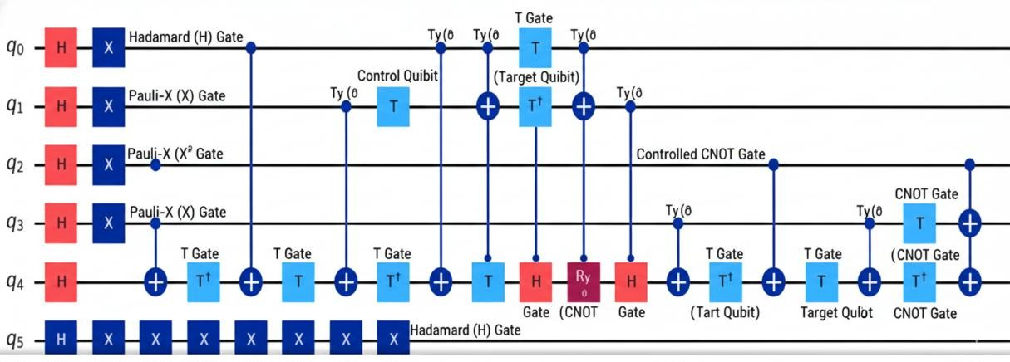
Figure 3.1. AHQIR quantum circuit — logical construction.
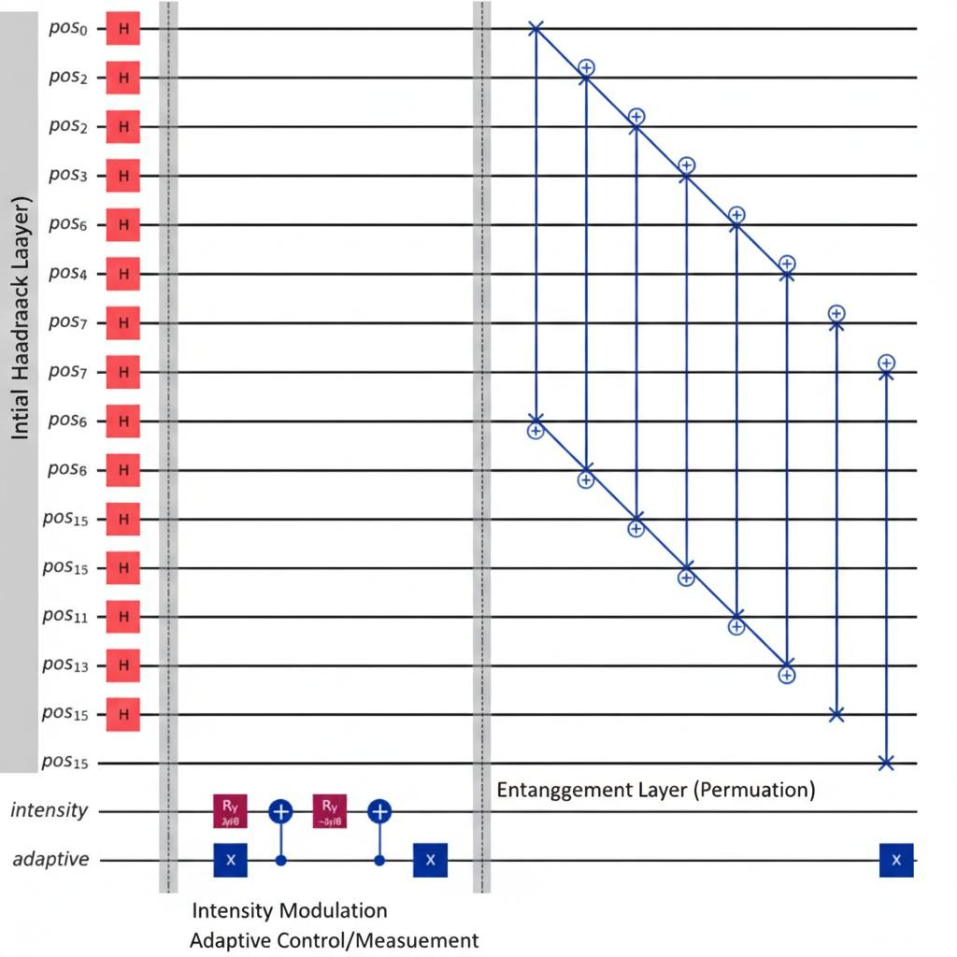
Figure 3.2. AHQIR quantum circuit — implementation/detail.

3.2 Performance on Heterogeneous Datasets
AHQIR was evaluated on two image modalities to examine how its threshold-based pixel selection behaved across the selected datasets.
3.2.1 Brain Tumor MRI Results. AHQIR was evaluated on 800 real brain MRI images (200 each of glioma, meningioma, pituitary tumor, and no-tumor cases) from the Kaggle “Brain Tumor Classification (MRI)” dataset, downsampled to 4×4. Using the adaptive threshold τ = μ + ασ with α = 0.5, the mean threshold-selected size was 5.79 of 16 pixels (36.2% of the image), fairly consistent across all four classes (5.6–6.1 pixels), as illustrated for a representative case in Figure 3.2.1. This reduced mean gate count from 1092 (FRQI) to 396 ± 93 -- a 63.7% reduction -- and mean circuit depth from 705 to 256 ± 60, the same 63.7% reduction. Reconstruction error measured only over the threshold-selected pixels (0.00038 ± 0.00024) was numerically comparable to FRQI's whole-image error (0.00040 ± 0.00015); whole-image error for AHQIR (0.036 ± 0.028) was higher, reflecting the intentionally-discarded background, exactly as the lossy design intends.

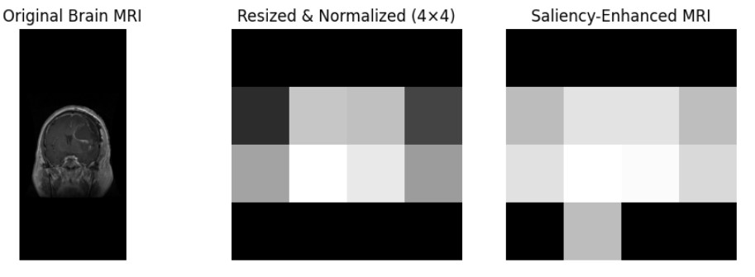

Figure 3.2.1. Brain Tumor MRI.

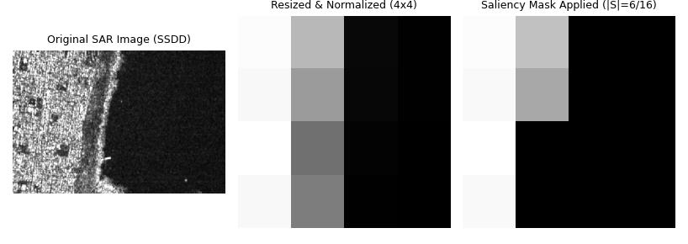

Figure 3.2.2. SAR image.
3.2.2 SAR Ship Detection Dataset (SSDD) Results. AHQIR was also evaluated on 1,160 real SAR images from the public SAR Ship Detection Dataset (SSDD), downsampled to 4×4. The mean threshold-selected size was 3.09 of 16 pixels (19.3%), sparser than the MRI case because SAR ship scenes are dominated by dark water background with a small bright backscatter signature. This gave a mean gate-count and depth reduction of 80.3% versus FRQI (1092 → 215 ± 113 gates; 705 → 137 ± 73 depth). Variance was higher than for MRI (a small number of high-contrast images had every pixel above threshold, giving no savings on those particular images), which we report as a real characteristic of content-adaptive thresholding rather than omit. The threshold-selected-region reconstruction error (0.00043 ± 0.00042) was numerically comparable to FRQI's whole-image error (0.00042 ± 0.00040); these values are calculated over different spatial scopes and are not a like-for-like comparison.
3.3 Comparative Analysis. The results below compare the reported AHQIR and FRQI circuit metrics under the manuscript's stated setup. The reduction is attributable to applying controlled rotations only at selected coordinates. Because the position register remains in a full uniform superposition, this does not eliminate address-space costs. Literature methods listed in Table 1 are not direct experimental competitors unless reimplemented under matching conditions. Figure 3.3 reports the supplementary scaling check of real gate counts for one representative MRI image.
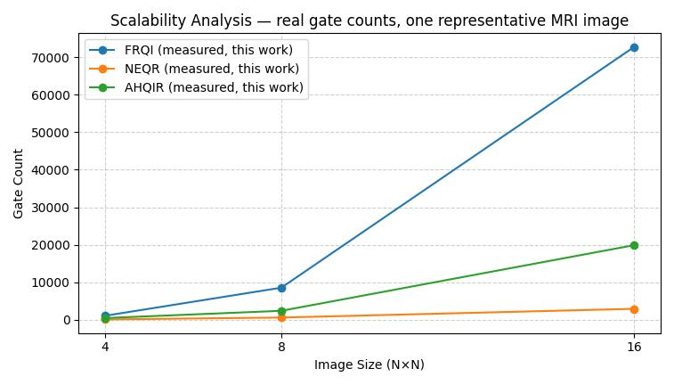

Figure 3.3. Supplementary scaling check: real gate counts for one representative MRI image.

Table 2.
Metric | MRI (N=800, Kaggle Brain Tumor MRI) | SAR (N=1160, SSDD)
Salient-set size |S| (mean / 16 px) | 5.79 (36.2%) | 3.09 (19.3%)
|S| std / range | SD = 0.90 | std 1.66, range 1–16
AHQIR gate count (mean ± std) | 396 ± 93 | 215 ± 113
AHQIR depth (mean ± std) | 256 ± 60 | 137 ± 73
Gate/depth reduction vs FRQI | 63.7% | 80.3%
AHQIR threshold-selected-only MSE | 0.00038 ± 0.00024 | 0.00043 ± 0.00042
AHQIR full-image MSE | 0.036 ± 0.028 | 0.023 ± 0.035
FRQI threshold-selected-only MSE (reference) | 0.00040 ± 0.00015 | 0.00042 ± 0.00040

3.4. Evaluation Metrics
3.4.1. Qubit Requirement
𝑄 = 𝑄_{𝑝} + 𝑄_{𝐼}
where Qₚ denotes the number of position qubits and Qᵢ denotes the number of intensity or color qubits. Lower qubit requirements reduce the number of physical qubits required, although feasibility also depends on circuit depth, connectivity, noise, and other hardware constraints.

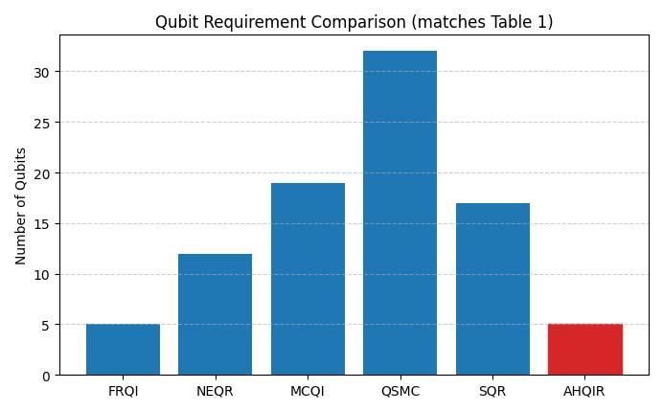
Figure 3.4.1. Qubit requirement comparison. Literature values are not directly experimentally matched with AHQIR.
3.4.2. Gate Count and Circuit Depth

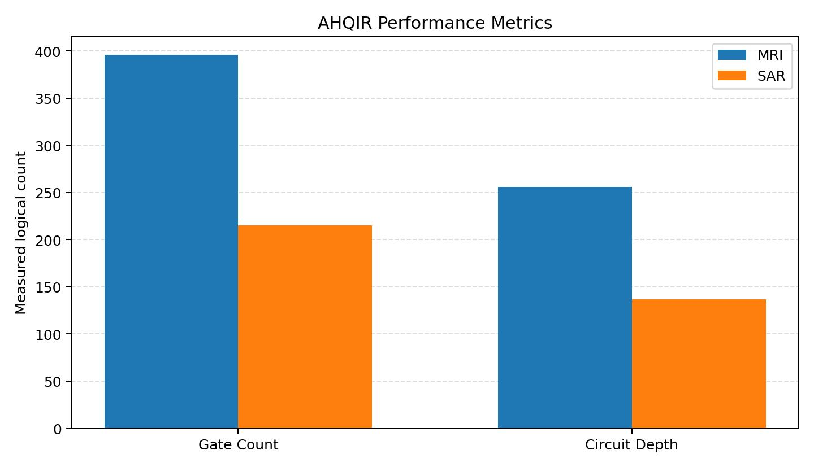
Figure 3.4.2. Measured AHQIR gate count and circuit depth for MRI and SAR; qubit requirements are shown separately in Figure 3.4.1. Full-image MSE is reported in Table 2 and Figure 3.4.4.

3.4.3. Encoding Time
Measured mean encoding time (4×4 images, this work): NEQR 0.049 s, AHQIR 0.097 s, and FRQI 0.186 s. NEQR has the shortest measured encoding time among these implementations. In this implementation, the measured encoding time did not follow the logical gate-count ordering, indicating that simulator/software overhead and circuit-construction costs are not determined solely by the number of logical gates.

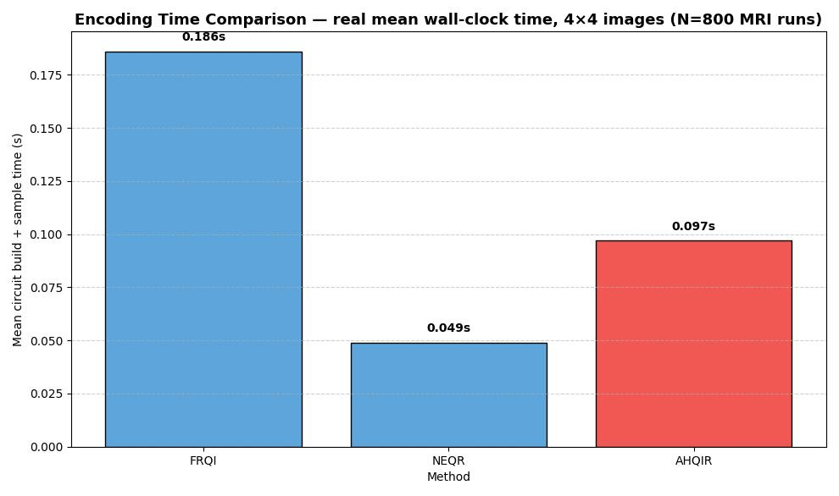
Figure 3.4.3. Measured encoding-time comparison for this study (NEQR, AHQIR, and FRQI; same stated experimental setup).
3.4.4. Information Loss
MSE = (1/HW) ∑ᵢ₌₀ᴴ⁻¹ ∑ⱼ₌₀ᵂ⁻¹ (pᵢⱼ − p̂ᵢⱼ)², where p is the original normalized image and p̂ is the reconstructed image.
A smaller MSE indicates a smaller average squared pixel-intensity error under this metric. It does not by itself measure preservation of diagnostic or target-specific information.

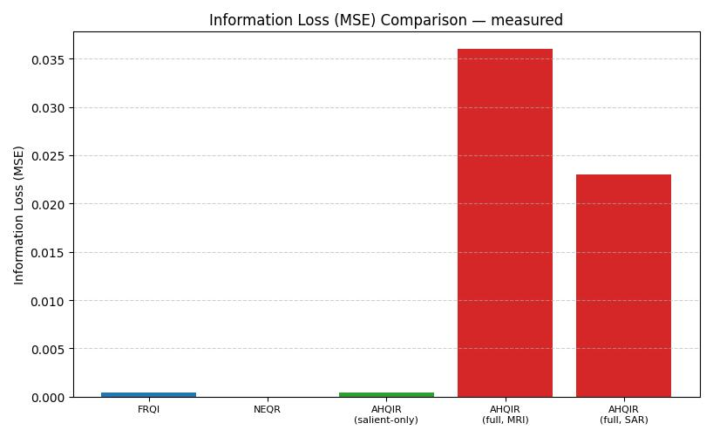
Figure 3.4.4. Threshold-selected-region MSE and full-image MSE are shown as distinct metrics with different spatial scopes; they are not directly comparable.

3.4.5. Quantum State Fidelity and Reconstruction Accuracy
State fidelity is defined here as the squared overlap between a specified ideal state and the simulated state. Its interpretation depends on which state is used as the target; it should not be conflated with pixel-level reconstruction accuracy.
F = |⟨Ψ_ideal|Ψ_sim⟩|².

For an H×W image,
MSE is defined in Section 3.4.4.
The peak signal-to-noise ratio is
PSNR = 10 log₁₀(MAX_I² / MSE), where MAX_I = 1 for normalized intensities. If MSE = 0, PSNR is infinite by convention.
In the AHQIR framework, threshold-selected-region reconstruction MSE was compared with FRQI's whole-image MSE for both MRI and SAR images; these quantities use different spatial scopes and should not be interpreted as a like-for-like comparison. Under the stated simulation setup, the quantum-state fidelity for the encoded selected-region state exceeded 0.999. Full-image fidelity was lower (0.964 for MRI, 0.977 for SAR) because non-selected background pixels are intentionally not encoded — This difference reflects the intentional zero reconstruction assigned to non-selected pixels and therefore represents the reconstruction–resource trade-off evaluated by the method. We report pixel-level reconstruction fidelity only; no clinical or diagnostic validation (e.g. by a radiologist, or against tumor-detection ground truth) was performed.

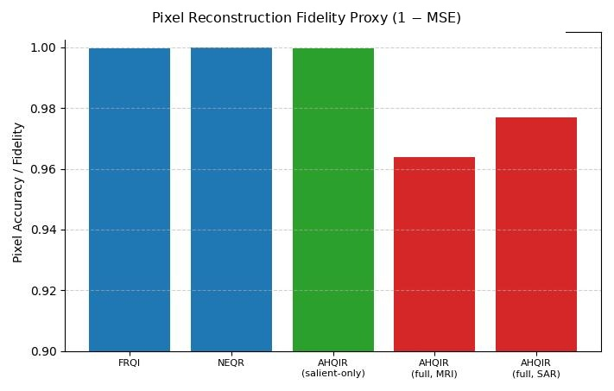

Figure 3.4.5. Normalized pixel-reconstruction score (1 − MSE); this metric is distinct from quantum-state fidelity.

4. Proposed Adaptive Hybrid Quantum Image Representation (AHQIR)

4.1. Motivation and Design Philosophy
Existing quantum image representation (QIR) techniques predominantly employ uniform encoding strategies, where all pixels of an image are treated equally during quantum state preparation. While this approach simplifies theoretical formulation, it results in significant redundancy, especially for real-world images where high-intensity or threshold-selected regions may occupy only a fraction of the image. In medical images, high-intensity or potentially informative regions may occupy only a fraction of the image, while SAR images exhibit spatially localized high-energy backscatter patterns. Encoding non-selected regions with the same quantum resources can increase gate operations and circuit depth, which may increase exposure to hardware noise.
The proposed Adaptive Hybrid Quantum Image Representation (AHQIR) is designed to overcome these limitations by combining classical adaptive preprocessing with selective quantum encoding. The central design principle of AHQIR is to allocate controlled-rotation operations according to the threshold-selected image content rather than applying intensity rotations uniformly across all image positions, as depicted in the overall architecture in Figure 4.1. This hybrid design reduces the number of controlled-rotation instructions when the selected set is sparse; scalability and hardware suitability remain to be established.
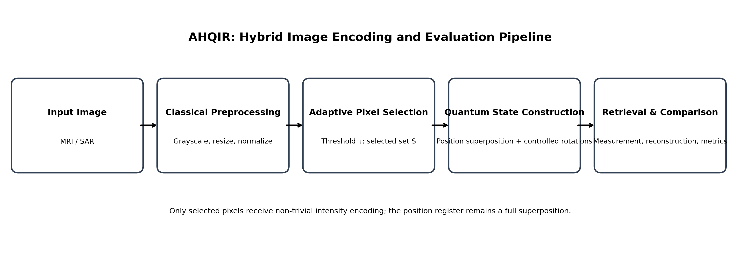
Figure 4.1. Architecture of AHQIR.

4.2. Mathematical Preliminaries and Notation
Let a grayscale image be represented as a two-dimensional matrix:
I = [I(i,j)], for 0 ≤ i < H and 0 ≤ j < W.
For the power-of-two formulation, H = W = L = 2ⁿ, and the total pixel count is P = HW = L² = 2²ⁿ. Non-square or non-power-of-two images require an explicit coordinate mapping and valid-address policy.
Each pixel intensity is normalized as:
p_k = I(i,j)/255, with k = iW + j, for 8-bit grayscale input.
The linearized pixel index is k = iW + j, with 0 ≤ k < P.
The quantum image representation must encode:
- Pixel position
- Pixel intensity
- Optional color channels (RGB)

4.3. Classical Adaptive Preprocessing Module
Before quantum encoding, AHQIR employs a classical preprocessing stage to reduce redundancy and noise.
4.3.1 Image Normalization and Resizing
For the experiments, each image is converted to grayscale and resized to the stated square resolution. The quantum coordinate-register rule is then applied to that resulting image.
For a square image with side length L = 2ⁿ, n = log₂(L).
This ensures efficient mapping to quantum position qubits.

4.3.2 Adaptive Intensity-Based Pixel Selection
An adaptive threshold \tau is computed based on image statistics:
𝜏 = 𝜇 + 𝛼σ
where:
- \mu is the mean pixel intensity
- Here, μ is the mean normalized intensity, σ is its population standard deviation, and α is a user-selected threshold parameter.
Pixels satisfying:
p_k ≥ τ.
Define the adaptive pixel set:
S = { k | pₖ ≥ τ }.
Only pixels in S receive non-trivial intensity encoding in the quantum circuit; non-selected positions remain in the position superposition with intensity state |0⟩. Figure 4.3 shows an example of the classical preprocessing image from which the selected-pixel set S is derived.

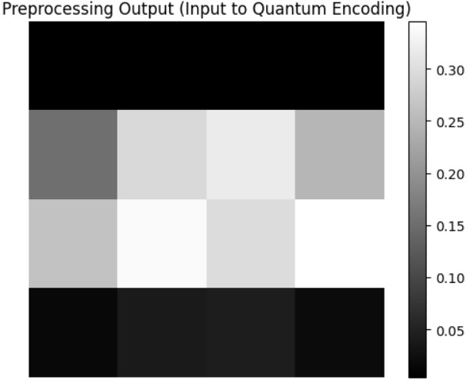
Figure 4.3. Preprocessing image.

4.4. Quantum State Construction in AHQIR

4.4.1 Position Qubit Encoding
Let the number of position qubits be:
For an L×L image with L = 2ⁿ, the position register contains n qubits for each coordinate, or nₚ = 2n qubits total.
The position register is initialized by applying a Hadamard gate to each of the nₚ qubits, producing the full uniform superposition over all P = 2ⁿᵖ = 2²ⁿ basis states:
|Φₚ⟩ = (1/√P) Σₖ₌₀ᴾ⁻¹ |k⟩.
Unlike a construction that restricts the superposition support to S, this position register has the same width and uniform superposition as FRQI. Resource savings arise from applying the multi-controlled rotation only for k ∈ S; non-selected branches retain intensity state |0⟩.

4.4.2 Adaptive Intensity Encoding
Each pixel's normalized intensity p_k ∈ [0,1] is encoded via a rotation gate R_y(θ_k) applied to the intensity qubit, with gate angle θ_k = π·p_k. Using the standard convention R_y(θ)|0⟩=cos(θ/2)|0⟩+sin(θ/2)|1⟩, we define φ_k=θ_k/2=(π/2)p_k, so that the encoded intensity varies monotonically over p_k∈[0,1].
The intensity qubit corresponding to the k-th threshold-selected pixel is prepared as:
|Φ_I⟩_k = cos(φ_k) |0⟩ + sin(φ_k) |1⟩, φ_k = (π/2)·p_k

|Ψ_AHQIR⟩ = (1/√P) [Σₖ∈S |k⟩ ⊗ (cos(φₖ)|0⟩ + sin(φₖ)|1⟩) + Σₖ∉S |k⟩ ⊗ |0⟩].
This is normalized by 1/√N (not 1/√|S|), matching the full-width position superposition of Section 4.4.1; it still restricts the multi-controlled rotation gate to S, since only those branches receive a non-trivial rotation — branches with k ∉ S keep their intensity qubit in |0⟩ and do not receive an additional controlled-rotation operation. When the threshold-selected set is sparse (|S| ≪ N), the number of multi-controlled rotation gates therefore scales with |S| rather than the full pixel count N (Section 4.6.3 discusses the additional per-gate decomposition cost this incurs, which also depends on n_p). In the worst case |S| → N, the gate count converges to that of FRQI.

4.4.3 Measurement and Reconstruction
To recover a classical intensity estimate from the measured circuit, we condition on the position register: for each position k, let n_k be the number of shots measuring the position register in state |k⟩, and let n_k^{(1)} be the number of those shots where the intensity qubit also reads 1. The empirical probability is P(1|k) = n_k^{(1)} / n_k, and the reconstructed intensity is
p̂_k = (2/π)·arcsin(√P(1|k))
which analytically inverts the encoding map φ_k = (π/2)·p_k of Section 4.4.2; finite-shot sampling introduces estimation error in the measured probability (our experiments use 4096 shots per circuit). For k ∉ S, no rotation was ever applied, so P(1|k) = 0 and the formula above correctly returns p̂_k = 0, which is precisely AHQIR's intentional loss of non-selected background — not a reconstruction error, but the designed behaviour of the lossy encoding. This is the formula actually used to compute every MSE/PSNR/fidelity value reported in Sections 3 and 6.

4.5 Quantum Circuit Architecture
The AHQIR circuit consists of three logical blocks:
- Position Superposition Block
- Adaptive Controlled Rotation Block
- Measurement and Reconstruction Block
The position superposition block initializes ALL n_p position qubits into a full uniform superposition via Hadamard gates (not selectively, per Section 4.4.1). The adaptive controlled rotation block then conditions the expensive multi-controlled intensity-rotation gate on the threshold-selected pixel set S identified during classical preprocessing, so only branches with k in S receive a non-trivial rotation, avoiding unnecessary gates on non-informative regions of the image. Finally, the measurement block retrieves intensity information from the encoded quantum state (Section 4.4.3).
The count of controlled-rotation instructions is governed by the selected-set size |𝒮|. This is a logical-operation count only and does not establish lower wall-clock time, hardware cost, or improved asymptotic complexity after decomposition. These costs depend on control count, ancilla strategy, synthesis, connectivity, and measurement requirements.

4.5.1 Circuit Construction Steps
1. Apply Hadamard gates to all n_p position qubits.
2. For each selected coordinate k, apply controlled R_y(θ_k).
3. Measure the registers and reconstruct the image. This encoding procedure is realized in the quantum circuit architecture shown in Figure 4.5.

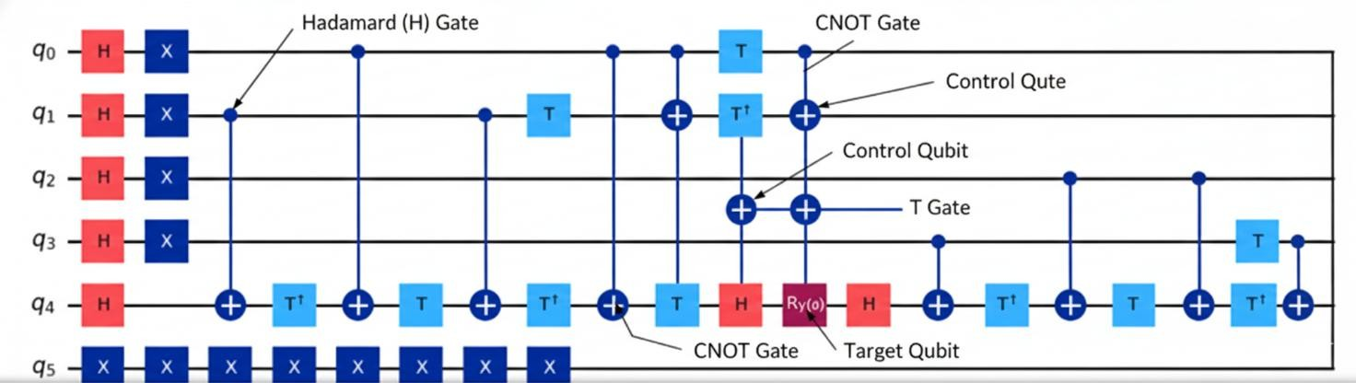
Figure 4.5. Quantum circuit architecture.

4.6 Quantum Image Operations in AHQIR

4.6.1 Quantum Image Rotation
A rotation by angle \theta is implemented as:
R_y(θ)|0⟩ = cos(θ/2)|0⟩ + sin(θ/2)|1⟩.
The rotation acts on the intensity qubit, with its angle determined by the normalized pixel intensity and the selected angle convention.

4.6.2 Quantum Image Flipping
A horizontal or vertical flip can be represented as a reversible permutation of the corresponding position-register basis states. The exact bit-level mapping depends on the coordinate convention.
|x⟩ → |N − 1 − x⟩ for a one-dimensional coordinate index. Figure 4.6 illustrates this quantum image flipping and rotation operation.
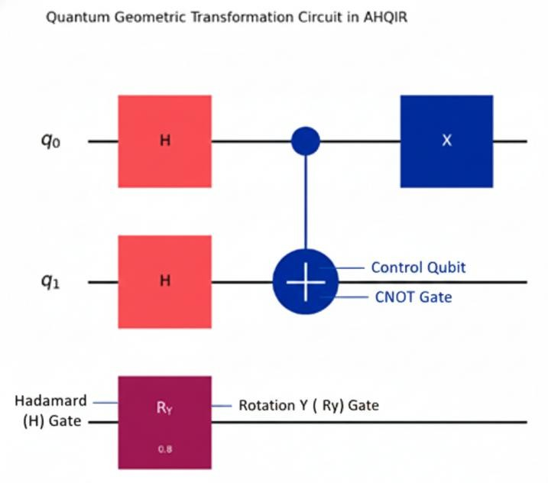

Figure 4.6. Quantum image flipping and rotation.
The gate counts reported in Sections 3.2 and Table 1 are logical instruction counts as constructed in Qiskit 2.5.2 (qiskit-aer 0.17.2) — each multi-controlled rotation (mcry) or multi-controlled X (mcx) is counted as a single instruction, not decomposed into elementary gates. This matters because NEQR's apparent efficiency under logical counting (Table 1) is partly an artifact of this: NEQR uses many mcx gates (one per '1' bit per pixel), and multi-controlled gates without ancilla qubits decompose into a number of elementary two-qubit gates that grows with the number of controls.
To check whether our efficiency claims survive this decomposition, we transpiled every circuit in both datasets to a standard universal basis (basis_gates=['cx','u'], optimization_level=1) and counted the resulting physical CNOT (CX) gates — the dominant hardware cost on essentially all NISQ architectures. The physical-CX results provide a different resource comparison from the logical-instruction counts:

Method | Physical CX (MRI, N=800) | Physical CX (SAR, N=1160)
FRQI | 384 (constant) | 384 (constant)
NEQR | 1030.0 ± 187.3 | 916.6 ± 248.5
AHQIR | 138.9 ± 32.6 | 74.2 ± 39.8
Under physical CX counting, NEQR — despite its low logical instruction count — actually requires roughly 2.7× more CX gates than FRQI and 7–12× more than AHQIR, because each of its many mcx gates carries a larger decomposition overhead than the mcry gates FRQI and AHQIR use, and because NEQR needs one such gate per set intensity bit rather than one per pixel. AHQIR's headline reduction versus FRQI is essentially unchanged under this stricter accounting (CX-based: 63.8% MRI / 80.7% SAR, versus 63.7% / 80.3% under logical counting). Thus, the reduction remains similar under physical-CX accounting and is not solely attributable to the logical gate-counting convention.
The O(|S|) claim itself also needs a caveat: it describes the number of multi-controlled rotation gates, not the number of elementary gates each one decomposes into. That per-gate decomposition cost grows with n_p (the number of position-qubit controls) when no ancilla qubits are used, as in our implementation. In a separate scaling check on one representative image at n_p = 4, 6, 8 (image sizes 4×4, 8×8, 16×16), the mean logical gate cost per threshold-selected pixel rose from 69 to 135 to 284 — roughly doubling each time n_p increased by 2, consistent with the known exponential-in-controls cost of ancilla-free multi-controlled synthesis. A more precise statement of AHQIR's complexity is therefore O(|S|·C(n_p)), where C(n_p) is the cost of one multi-controlled rotation and is itself exponential in n_p without ancillas (polynomial with O(n_p) ancilla qubits, which we did not use). AHQIR reduces the prefactor from N to |S|; it does not by itself remove the underlying exponential dependence on image resolution, which would require an ancilla-assisted or logarithmic-depth multi-controlled-gate synthesis — an item we list under Limitations (Section 8.2).

4.7. Extension to RGB Images
For RGB images, AHQIR employs three intensity qubits, with the resulting quantum state representation shown in Figure 4.7:

|Φ_{𝑅𝐺𝐵}⟩ =
|Φ_{𝑅}⟩ ⊗ |Φ_{𝐺}⟩ ⊗ |Φ_{𝐵}⟩

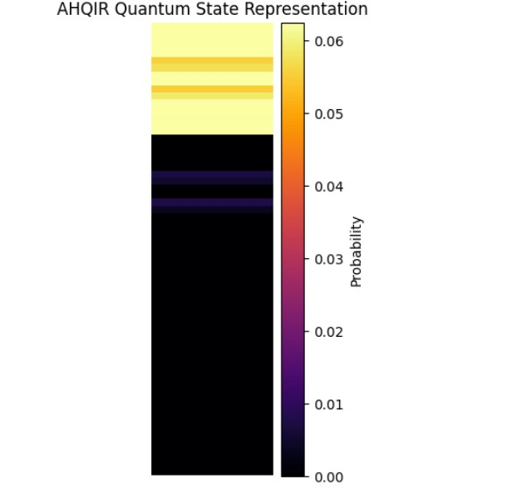

Figure 4.7. AHQIR quantum state representation. Each channel uses adaptive encoding independently.

φ_k^(c) = (π/2)·p_k^(c), c ∈ {R, G, B}

5. Mathematical Formulations
Mathematical expressions are written in standard notation; variables are defined where introduced, and the equations below summarize the cited representation models.

These summaries describe encoding principles only. Resource complexity, fidelity, loss, and speed depend on the precise construction, input assumptions, circuit synthesis, and measurement protocol; consequently, no unverified universal ratings are assigned here. The quantitative comparison in this paper is restricted to the stated AHQIR and FRQI implementation and experimental conditions.

5.1 Mathematical Formulations of Baseline Models
The following formulations summarize representation families for context. Their resource estimates are not assumed to be directly comparable to the AHQIR measurements unless image dimensions, precision, circuit synthesis, and counting conventions match.

1. Flexible Representation of Quantum Images (FRQI)
|Ψ_FRQI⟩ = (1/√P) Σₖ₌₀ᴾ⁻¹ [cos(θₖ)|0⟩ + sin(θₖ)|1⟩] ⊗ |k⟩.
FRQI utilizes a single intensity qubit to store grayscale information via rotation angles $\theta_i$ while pixel positions are maintained in a $2n$-qubit register [1]. For an image represented by $2^{2n}$ position states, FRQI requires $2^{2n}$ position-conditioned intensity rotations before gate decomposition [1].

2. Novel Enhanced Quantum Representation (NEQR)
|Ψ_NEQR⟩ = (1/√P) Σₖ₌₀ᴾ⁻¹ |k⟩ ⊗ |cₖ(q−1)…cₖ₀⟩.

NEQR encodes intensities directly into $q$ computational basis states, ensuring exact color representation and retrieval without discretization errors [2]. While providing superior fidelity, the qubit requirement increases linearly with color depth, necessitating $2n+8$ qubits for standard 8-bit images [2].

3. Multichannel Quantum Image (MCQI)
|Ψ_MCQI⟩ = (1/√P) Σₖ₌₀ᴾ⁻¹ |k⟩ ⊗ (αₖ|R⟩ + βₖ|G⟩ + γₖ|B⟩).

MCQI generalizes rotation-based encoding for RGB color images by assigning separate rotation operations for each primary color channel [3]. This allows for complex color manipulations but significantly increases circuit depth, leading to high noise susceptibility [3].

4. Quantum States for M Colors (QSMC)
|Ψ_QSMC⟩ = (1/√P) Σₖ₌₀ᴾ⁻¹ |k⟩ ⊗ |C₁⟩|C₂⟩…|C_M⟩.

This model can support multiple independent data layers, but introduces additional resource requirements [6].

5. Quantum States for N Coordinates (QSNC)
|Ψ_QSNC⟩ = Σₓ₁,…,ₓᴺ ψ(x₁,…,x_N)|v⟩|x₁⟩…|x_N⟩.

QSNC expands the spatial register to $N$ independent dimensions, essential for representing volumetric data such as 3D medical CT or MRI scans [6]. The complexity scales with the product of coordinates, requiring precise multi-controlled gate implementations.

6. Simple Quantum Representation (SQR)

|Ψ_SQR⟩ = (1/√P) Σₖ₌₀ᴾ⁻¹ |k⟩ ⊗ |cₖ⟩, where cₖ ∈ {0,1}.

SQR simplifies the intensity register to a single basis-state qubit, optimized for infrared and binary masks where high bit-depth is not required [7]. It achieves the lowest gate complexity for binary data while maintaining exact retrieval for the encoded bits.

7. Quantum Log-Polar Images (QUALPI)
|Ψ_QUALPI⟩ = Σᵨ,θ ψ(ρ,θ)|v(ρ,θ)⟩|ρ⟩|θ⟩.
QUALPI maps standard Cartesian coordinates into a log-polar system $(\rho, \theta)$ to provide scale and rotation invariance during retrieval [14]. This mapping is particularly useful for pattern recognition but involves non-linear transformations that are hardware-intensive.

8. Bitplane Representation of Quantum Images (BRQI)
|Ψ_BRQI⟩ = ⊗ⱼ₌₀ᑫ⁻¹ [(1/√P) Σₖ₌₀ᴾ⁻¹ |k⟩ ⊗ |bₖ,ⱼ⟩].

BRQI treats a grayscale image as a collection of $q$ independent bitplanes, encoding each as a separate quantum state [18]. This decomposition reduces individual circuit depth but requires more parallel resources for full reconstruction [18].

9. Perception-Aided Encoding (PE-NGQR)
|Ψ_PE-NGQR⟩ = Σᵧ,ₓ ψ(y,x)|y⟩|x⟩|s⟩.

|Ψ_CE-NGQR⟩ = Σᵧ′,ₓ′ ψ(y′,x′)|q⃗⟩|y′⟩|x′⟩.

CE-NGQR is included as a related representation from the cited literature. Its published construction and complexity should be verified against the original paper; the present AHQIR implementation is not claimed to reproduce CE-NGQR.

5.2. Proposed AHQIR Formulation
The Adaptive Hybrid Quantum Image Representation (AHQIR) uses a classical intensity threshold to select coordinates for controlled rotations. This selection can reduce the number of logical rotation instructions when the selected set is sparse; it does not remove position states or, by itself, establish lower end-to-end resource use.

Adaptive Intensity-Based Pixel Selection
S = {k | pₖ ≥ τ}, τ = μ + ασ (11)
The AHQIR framework calculates an adaptive threshold τ using image mean μ and standard deviation σ. Pixels above the selected intensity threshold are included in S. The term selected set denotes pixels satisfying the intensity threshold and does not imply semantic or task-specific saliency.
AHQIR State Construction. Using the selected set S and rotation angles φₖ = (π/2)pₖ from Section 4.4, the state produced by the circuit is: |Ψ_AHQIR⟩ = (1/√P)[Σₖ∈S |k⟩⊗(cos(φₖ)|0⟩ + sin(φₖ)|1⟩) + Σₖ∉S |k⟩⊗|0⟩]. Here P is the total pixel count; the position register is not restricted to S.
By restricting the expensive multi-controlled rotation to the threshold-selected coordinates S, AHQIR reduces the number of such gates from the full pixel count P=2²ⁿ to |S|. Each retained gate still decomposes into a number of elementary two-qubit gates that grows with the number of position-qubit controls n_p (Section 4.6.3), so the realistic gate-count scaling is O(|S|·C(n_p)), not simply O(|S|). The reported simulator experiments show high reconstruction fidelity within the threshold-selected region.

6. Dataset Description
To examine AHQIR under two different image conditions, the study uses brain MRI and synthetic aperture radar (SAR) imagery. Their differing intensity distributions provide an initial test of the threshold-selection procedure. The experiments do not establish robustness, generalizability, or real-world application suitability.

6.1. Brain Tumor MRI Dataset Overview
The first dataset is reported as a stratified sample of 800 images (200 per glioma, meningioma, pituitary-tumor, and no-tumor category) from the Kaggle “Brain Tumor Classification (MRI)” collection, stated in the manuscript to contain 3,285 images. The images are converted to grayscale and reduced to 4×4 for the principal circuit experiments. This evaluation does not test preservation of diagnostic features or diagnostic accuracy.

Motivation for Selection
MRI images are used to examine threshold-based pixel reconstruction. The experiment does not measure diagnostic sensitivity, tumor localization, or clinical utility.

Image Characteristics
- Modality: Grayscale MRI
- Bit depth: 8-bit intensity resolution
- Texture: MRI images may contain regions of differing intensity; no tumor-localization assumption is used by the method.
- Noise: Low to moderate acquisition noise
- Image size: Original images vary in resolution and are resized for quantum feasibility
Preprocessing for Quantum Encoding
Prior to quantum encoding, the MRI images undergo the following preprocessing steps:
- Conversion to grayscale (if necessary)
- Intensity normalization to the range [0,1]
- Resizing to 4×4 for the experiments reported in Section 3.2.1 (the same pipeline supports larger quantum-compatible resolutions such as 8×8 and 16×16, which were not exhaustively benchmarked in this version)
- Adaptive intensity-based pixel selection (used by AHQIR)
These steps define the inputs to the representation experiment; they do not establish preservation of diagnostically relevant structures.
6.2 SAR Ship Detection Dataset (SSDD)

Dataset Overview
The second dataset is reported as 1,160 images from the publicly available SAR Ship Detection Dataset (SSDD). The manuscript describes these as SAR images from multiple satellite sensors. The representation experiment does not evaluate ship-detection performance.

Motivation for Selection
SSDD imagery is used to examine AHQIR's threshold-selection behaviour on SAR inputs. The following characteristics motivate its inclusion, but the experiment does not establish domain-specific detection performance:
- Speckle noise
- High dynamic range
- Nonlinear backscatter intensity distribution
These characteristics make SAR images a distinct image modality for testing threshold-based pixel selection, but this experiment does not assess ship-detection accuracy or operational robustness.
Image Characteristics
- Modality: Grayscale SAR
- Texture: Highly textured with speckle noise
- Contrast: High local intensity variations
- Noise: Multiplicative speckle noise
- Spatial patterns: Complex geometric and terrain-dependent features
Preprocessing for Quantum Encoding
The SAR images were preprocessed as follows:
- Conversion to grayscale
- Center-crop of the outer 10% border, then resize to 4×4 via OpenCV INTER_AREA interpolation
- Intensity normalization to the range [0,1]
- Adaptive thresholding (τ = μ + ασ, α = 0.5) to isolate strong backscatter regions

The preprocessing steps are intended to make the image dimensions and intensity values compatible with the tested circuit. They do not validate the threshold as a domain-specific semantic or task-specific selector.

7. Algorithms and Implementation Listings
The algorithms below describe the threshold-selection, controlled-rotation, and measurement-based reconstruction stages. Resource claims are restricted to the reported circuit and measurement setup.

7.1 Phase I: Classical Adaptive Intensity-Based Pixel Selection
The following classical procedure identifies a threshold-selected set of pixels. This is a pixel-selection step, not a reduction of the position register's Hilbert-space dimension.
Algorithm 1 Adaptive Intensity-Based Pixel Selection (Classical Module)
Require: grayscale image I of size H × W; scaling factor α.
Ensure: threshold-selected pixel set 𝒮 and statistical threshold τ.
1. Calculate the global mean: μ = (1/(H × W)) Σᵢ₌₀ᴴ×ᵂ⁻¹ pᵢ.
2. Calculate the standard deviation: σ = √[(1/(H × W)) Σᵢ₌₁ᴴ×ᵂ (pᵢ − μ)²].
3. Define the adaptive threshold: τ = μ + α · σ.
4. Initialize the empty threshold-selected pixel set 𝒮 ← ∅.
5. For each pixel pₖ at coordinate (y, x), do:
6. If the intensity of pₖ ≥ τ, then:
7. Add ((y, x), vₖ) to 𝒮.
8. End if.
9. End for.
10. Return the threshold-selected pixel set 𝒮.

Algorithm 1 applies a global statistical threshold. The selected pixels are simply those meeting the intensity criterion; the method does not establish that they are medically diagnostic or confirmed SAR targets. It reduces the count of controlled-rotation instructions, not the number of position states.

7.2 Phase II: Quantum State Construction
This algorithm describes AHQIR's own state-construction procedure and does not claim to implement the published CE-NGQR protocol.
Algorithm 2: AHQIR Quantum State Construction

Require: threshold-selected pixel set 𝒮 containing |𝒮| selected pixels; image dimensions H and W.

Ensure: normalized quantum state |Ψ_AHQIR⟩.
1. Determine the coordinate-qubit count: n = ⌈log₂(max(H, W))⌉.
2. Initialize position register |Pos⟩ with 2n qubits and intensity register |Int⟩ with q qubits.
3. Apply Hadamard gates H⊗²ⁿ to |Pos⟩ to generate the uniform position superposition.
4. For each selected coordinate k ∈ 𝒮, do:
5. Normalize intensity: pₖ = vₖ/255; calculate φₖ = (π/2)pₖ and θₖ = 2φₖ = πpₖ.
6. Apply a multi-controlled Rᵧ(θₖ) gate to the intensity qubit, conditioned on the position register being |k⟩.
7. End for.
8. Return |Ψ_AHQIR⟩.

For arbitrary H×W inputs, the coordinate-register sizing rule can allocate unused basis states. The present experiments use 4×4 images, for which all 16 addresses are valid. Any extension to non-power-of-two dimensions must define the mapping and treatment of unused addresses explicitly.

7.3 Phase III: Adaptive Image Retrieval
This algorithm defines the measurement process to reconstruct the classical image from the quantum state.
Algorithm 3: Threshold-Selected Image Retrieval and Reconstruction

Require: prepared AHQIR circuit and measurement counts; set of valid image coordinates.
Ensure: reconstructed intensity map I_rec.
1. For each valid coordinate k, collect nₖ shots with position k and nₖ⁽¹⁾ shots where the intensity outcome is 1.
2. Estimate P(1|k) = nₖ⁽¹⁾/nₖ when nₖ > 0.
3. For a selected pixel, reconstruct p̂ₖ = (2/π) arcsin√P(1|k).
4. For an unselected pixel, set p̂ₖ = 0.
If nₖ = 0 for a coordinate, P(1|k) is undefined; the implementation must specify a handling rule before reconstruction.
5. Map each reconstructed value to its image coordinate.
6. Return I_rec.

The reconstruction description is based on conditional measurement frequencies. Since the position register remains a full uniform superposition, this procedure does not intrinsically reduce the shots needed to estimate a given conditional probability. Any claim of faster retrieval requires a separately specified and measured protocol.

Scope and Limitations
The study has several constraints that delimit its contribution. First, the principal image representation is evaluated at 4×4 resolution, which is suitable for small-circuit simulation but removes substantial image structure. Second, the selector is a global intensity threshold and is not trained or validated against MRI lesion masks or SAR ship annotations. Third, the reported gate counts depend on whether multi-controlled operations are counted as single logical instructions or decomposed into a chosen basis; these quantities should not be conflated. Fourth, the results are reported in the manuscript but were not independently regenerated during this revision. Finally, no clinical, ship-detection, physical-device, or end-to-end application performance is measured. These limitations mean the evidence supports a narrow proof-of-concept comparison, not a claim of practical superiority.

8. Conclusion and Future Work

8.1. Conclusion
This paper introduced Adaptive Hybrid Quantum Image Representation (AHQIR), a hybrid approach that applies a statistical intensity threshold before selectively applying controlled rotations. The conclusions are limited to the implementation, datasets, preprocessing, simulator configuration, and resolutions reported in this manuscript.
AHQIR reduces the number of controlled-rotation instructions when the threshold-selected set S contains fewer coordinates than the full image. It retains the full position-register superposition, and decomposed gate cost depends on the number of controls and synthesis method. This is a conditional logical-instruction reduction, not elimination of resolution-dependent costs.
The principal evaluation used 800 sampled brain MRI images and 1,160 SAR images at 4×4 resolution, with a supplementary check at 4×4, 8×8, and 16×16. The reported logical gate-count and depth reductions relative to FRQI were 63.7% for MRI and 80.3% for SAR. These figures should be interpreted with the gate-counting conventions and the lossy zero-background reconstruction described in the methods. The reported numerical results correspond to the experiments described in this manuscript; independent reproduction using the complete code, dataset manifest, random seeds, and metric scripts was not performed as part of this revision.
Rotation and flipping are described as possible circuit-level operations. Because the representation is lossy and threshold-selected, the paper does not establish that these operations preserve all image information or improve any downstream task.
The presented results are preliminary simulator measurements for the stated datasets and resolutions. They do not establish state-of-the-art performance, broad scalability, or readiness for clinical, remote-sensing, or hardware deployment. In particular, the 4×4 representation discards much of the spatial detail present in the source images, so conclusions should not be transferred to full-resolution images without further evaluation.
The benefit depends on the number of selected pixels: when most pixels are selected, the controlled-rotation count approaches full encoding. The work therefore demonstrates a sparsity-dependent reduction in controlled-rotation operations rather than elimination of the underlying resolution-dependent synthesis cost.

8.2. Future Work
This study provides an initial simulation-based evaluation. The following directions require additional experiments before practical or application-level claims can be made.
First, the evaluation focused on grayscale MRI and single-channel SAR images. Color and hyperspectral extensions would require an explicit encoding design, resource analysis, and independent validation.

Second, the framework should be implemented and tested on physical quantum hardware to measure noise sensitivity, transpiled resources, execution overhead, and reconstruction behaviour. Such results are not included in this study.
Third, threshold selection should be evaluated against task-specific annotations and compared with alternative thresholding or saliency methods. A learning-based selector is a possible extension, but would require its own training and validation protocol.
Fourth, downstream tasks such as segmentation or feature extraction should be tested using appropriate task metrics before making claims about medical diagnosis or SAR target detection.
Finally, ancilla-assisted synthesis, approximate state preparation, and error-mitigation methods may be investigated to assess whether they reduce practical resource costs without unacceptable reconstruction or task-performance loss.

Code repository: https://github.com/Thouseef68/Adaptive-Hybrid-QuantumImage-Representation
9. Implementation Details and Software Environment
Classical preprocessing, including grayscale normalization and adaptive thresholding, produced the selected pixel set used by the quantum circuit. The method therefore has a classical preprocessing component as well as a quantum-circuit component.
For clarity, the reported numerical outcomes are manuscript-reported results rather than independently reproduced measurements in this revision. The source code, exact dataset manifest and split, random seeds, backend and transpilation settings, shot counts, and metric scripts should accompany a reproducibility package. Until those materials are available, readers should treat the numerical comparisons as preliminary and specific to the stated setup.
The manuscript describes the method and experiments to support reproducibility. Reproduction additionally requires the implementation, dataset versions and splits, random seeds, simulator configuration, and complete metric-calculation procedure.

Funding
This research received no external funding.

10. References
- Le, P.Q., Iliyasu, A.M., Dong, F., Hirota, K.: A flexible representation of quantum images for polynomial preparation, image compression, and processing. IEEE Trans. Quantum Eng. 2(1), 1–14 (2011)
- Zhang, Y., Lu, K., Gao, Y., Wang, M.: NEQR: a novel enhanced quantum representation of digital images. Quantum Inf. Process. 12(8), 2833–2860 (2013)
- Sun, B., Iliyasu, A.M., Yan, F., Dong, F., Hirota, K.: MCQI: a multi-channel representation for quantum images. Quantum Inf. Process. 12(9), 2861–2881 (2013)
- Lisnichenko, M., Protasov, S.: Quantum image representation: a review. Quantum Mach. Intell. 5(2), 25 (2023). https://doi.org/10.1007/s42484-022-00089-7
- Venegas-Andraca, S.E.: Quantum walks: a comprehensive review. Quantum Inf.
Process. 11, 1015–1106 (2012)
- Zhang, Y., Lu, K., Gao, Y.: QSNC: quantum state for n-coordinates. In: 2013 5th
International Conference on Intelligent Networking and Collaborative Systems, pp. 586– 589. IEEE, Xi'an (2013)
- Yuan, S., Mao, X., Xue, Y., Cao, L., Li, G.: SQR: a simple quantum representation of digital images. Mobile Netw. Appl. 19(4), 542–547 (2014)
- Zhang, W.W., Gao, F., Liu, B., Wen, Q.Y., Chen, H.: A local feature based quantum image representation. Quantum Inf. Process. 14, 451–472 (2015)
- Jiang, N., Wang, J., Mu, Y.: Quantum image scaling using nearest neighbor interpolation. Quantum Inf. Process. 14, 1559–1571 (2015)
- Li, H.S., Zhu, Q., Ian, H.: Multidimensional color image storage, retrieval, and compression based on quantum amplitudes and phases. Inf. Sci. 273, 212–232 (2014)
- Zhou, R.G., Liu, X., Wang, B., Wu, Q.: Quantum image encryption based on a generalized novel enhanced quantum representation. Quantum Inf. Process. 16(5), 122 (2017)
- Yan, F., Iliyasu, A.M., Venegas-Andraca, S.E.: A survey of quantum image representations. Quantum Inf. Process. 15(1), 1–35 (2016)
- Khan, A.N., Fan, P., Khan, K., Gul, N., Ullah, S., Naseem, M.T.: A novel improved flexible representation of quantum images (IFRQI). Quantum Inf. Process. 18, 222 (2019)
- Zhang, Y., Lu, K., Gao, Y., Wang, M.: QUALPI: quantum log-polar image. In: 2013 5th
International Conference on Intelligent Networking and Collaborative Systems, pp. 590– 593. IEEE, Xi'an (2013)
- Wang, J.: NEQR based quantum image edge extraction. Quantum Inf. Process. 15(1), 11–24 (2016)
- Zhou, N.R., Liang, X.R., Zhou, Z.H., Wen, G.H.: Relay-based quantum network communication. IEEE Commun. Lett. 25, 1–5 (2021)
- Cai, Y., Cao, H., Mao, J., Wu, W., Jiang, N.: PE-NGQR: Perception-aided encoding for nonpower-of-two quantum images. IEEE Trans. Emerg. Top. Comput. 12, 1–13 (2024)
- Liu, X.W., Zhou, R.G., Fan, P.: BRQI: bitplane representation of quantum images.
Quantum Inf. Process. 17(4), 1–22 (2018)
- He, F.P., Cao, H.J., Jiang, N., Mao, J.S.: CE-NGQR: Coherent-size encoding for novel generalized quantum image representation. IEEE Trans. Emerg. Top. Comput. 12(1), 121– 134 (2024)

Supplementary Experimental Evaluation and Reproducibility Notes
This section extends the empirical evaluation of AHQIR without changing the proposed encoding method. All reported resource values are simulator/transpiler-derived circuit proxies, not measurements from quantum hardware. Unless explicitly stated otherwise, benchmark values are based on sampled images rather than exhaustive evaluation of every dataset image.

S1. Larger-resolution matched circuit-resource benchmark
A paired benchmark evaluated 100 MRI and 100 SAR images at 16×16 and 32×32 resolution, yielding 400 image-resolution pairs with AHQIR and FRQI measurements. At 64×64, an expanded pilot included 10 images per modality. At 128×128, one image per modality was evaluated as a feasibility pilot. At 256×256, one MRI image was successfully evaluated with both encodings; the SAR AHQIR circuit was successfully transpiled, while FRQI construction completed but its transpilation did not complete in the available runtime.

S1.1 Mean CX-count reduction in the 100-image paired benchmark
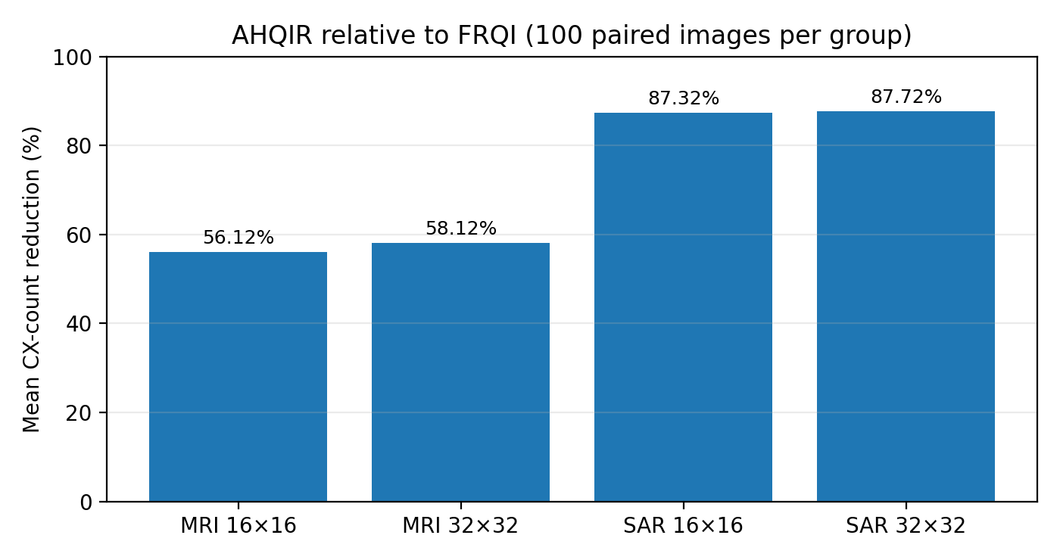
Figure S1. Mean CX-count reduction for the 16×16 and 32×32 paired benchmark. These are transpiled circuit-resource proxies.

