
REPORT
ThoxOS Ginux Edition 0.1.0
Ginux review, ThoxOS on an independent Rust kernel, Docker demo and KnightHub SSD image
Field | Value
Owner | Odette Lark, memory-sync node and fleet librarian
Audience | Tommy Xaypanya (CTO), Craig Ross (CEO)
Date | 2026-10-29
Version | 0.1.0
Classification | Internal
Your AI. Your Data. Your Rules.

SUMMARY
ThoxOS now boots on Ginux, Gregory Kurtzer's Rust kernel that runs Linux programs with no Linux kernel underneath. In the Docker demo a ThoxOS userspace pulled from a private local registry reached systemd multi-user and the login prompt, and the ThoxOS shell ran typed commands on the Ginux kernel. An 8 GiB external-SSD image boots a Debian host that runs Ginux on tty1. Real hardware and KVM are the next gate.
Measure | Value | Note
Docker boot gate | Pass | welcome, multi-user, login prompt
OCI pull in Ginux | 38.5 s | 4 layers, 110 MB, TCG
SSD host checks | 6 of 6 | QEMU USB-disk boot
Automated tests | 80 | pytest; shellcheck clean

01 What shipped
Branch ginux-edition-0.1.0 of ttracx/thoxos-ginux, directory ginux-edition/. It sits beside, not over, the record a ChatGPT/Codex session pushed the same evening.
Layer | What it does
AI | thox ask sends prompts to any OpenAI-compatible server on the host through 10.0.2.2; thox status reports identity, kernel and endpoint. No model ships in the image.
Kernel | Upstream Ginux at 36503bd with three patches: 48-bit IOMMU and firmware discovery, ThoxOS banner, and one per-build registry root accepted only for registry.thoxos.internal.
Userspace | Rocky Linux 10 UBI init (the digest upstream validated) with a ThoxOS identity overlay: os-release, issue, motd, thox, thox-shell.
Backend | Read-only TLS registry and DNS forwarder on host loopback; thoxos-g owns the QEMU profile and drives the Ginux controller.
Frontend | Serial console, browser console (ttyd, one client, generated credential), and tty1 on KnightHub.
Install | 8 GiB GPT image (systemd-boot, Debian 13 host, KVM launcher, first-boot growth), Linux writer with guards, Windows writer.

02 Ginux review
Ginux is real and runs Linux userspace. It is also a research prototype: virtio-only devices, one CPU, a 4 GiB identity map, a public development signing key and no security audit.
Finding | Impact | ThoxOS action
QEMU before 9.1 uses a 39-bit IOMMU; Ginux panics | Blocks boot | Patch 0001
QEMU 10.0.13 panics in virtio-net init; 10.2 and 11.1 pass | Blocks boot | Pin QEMU 11.1; doctor flags 10.0
Embedded minimal-system domain panics (stale auxv fixture check) | Upstream defect | Traced; upstream issue queued
Guest RAM above 2.75 GiB panics (identity map) | Limit | Launcher caps at 2816 MiB
Controller seal uses a public test key; no audit | Security | Research-preview label; no guest ports exposed
Console has no line discipline: login and an interactive bash end at the first read | Usability | thox-shell line editor (shell domain)
OCI cache answers by tag: a kept volume boots the previous build's userspace | Stale boot | Volume stamped with the manifest digest; replaced on change

Fit
High demo value, low product value today. THOX device kernels stay Linux; Ginux shows what one expert plus an agent can build.

03 Validation
Check | Evidence | Status
Docker selftest, system domain | make selftest exit 0; systemd welcome, multi-user.target, login: | Verified
Shell domain session | uname -srm prints Ginux 6.12.0-ginux.0.1 x86_64; thox status runs | Verified
SSD image boots as USB disk | Kernel, root, growroot 11.5 GiB, registry, DNS, console service; tty1 capture | Verified
Writer guards and write | Refusals for loop, wrong confirmation, THOXOS label; 8 GiB written and verified | Verified
Web console | 401 without credential, 200 with; systemd boot and shell-session captures | Verified
Stale cache after a rebuild | Failed on a reused volume; after the fix the same volume resets and the shell session passes | Verified
Unit and static checks | 80 pytest, shellcheck clean | Verified
KVM boot on KnightHub | Hardware not reachable from this runtime | Pending
Windows writer | No Windows host in this runtime | Pending
Console password login in the domain | Ginux console reads end the session | Blocked

04 Previews
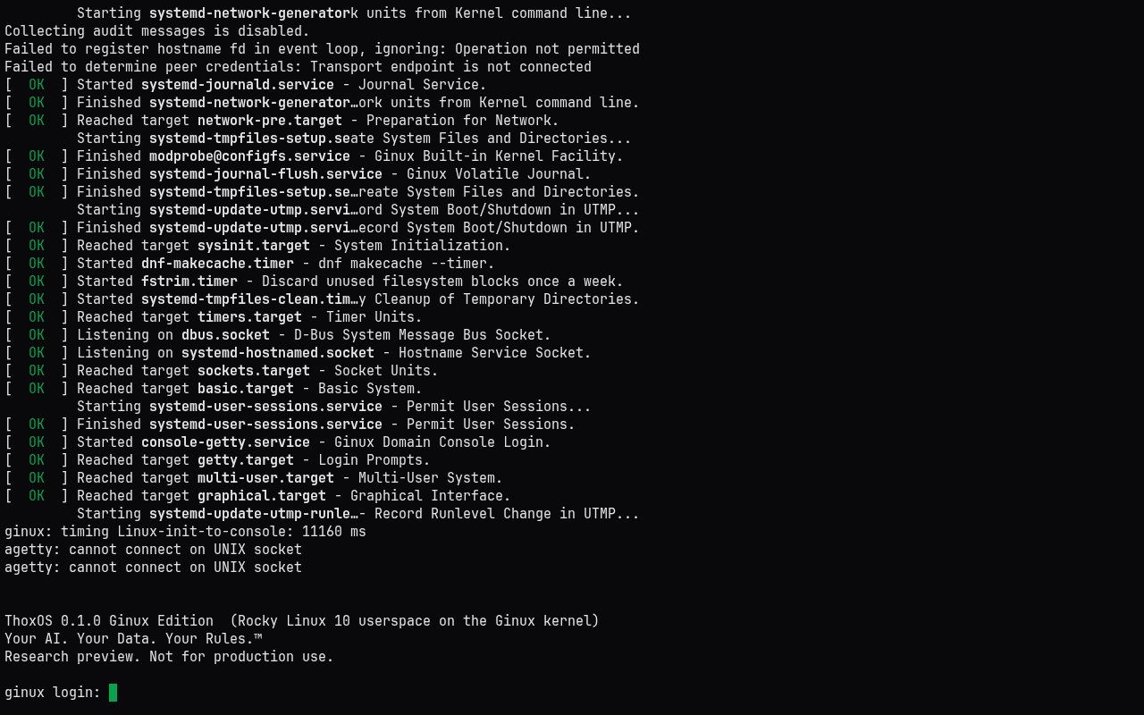
Docker demo, browser console: ThoxOS on the Ginux kernel (QEMU TCG)
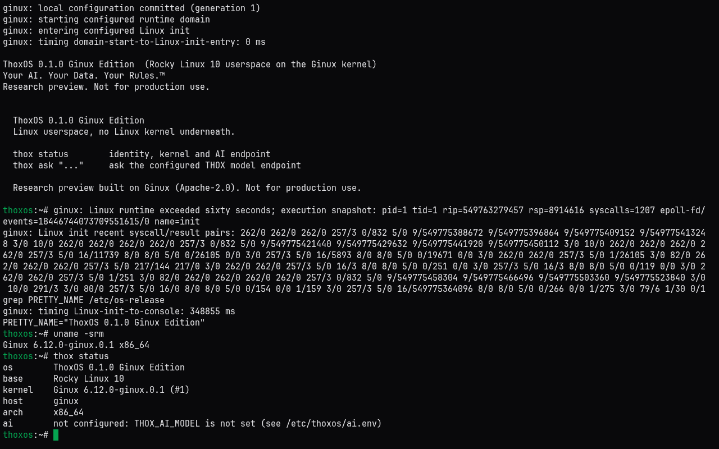
Docker demo, browser console in shell mode: commands typed into ThoxOS run on the Ginux kernel (QEMU TCG)
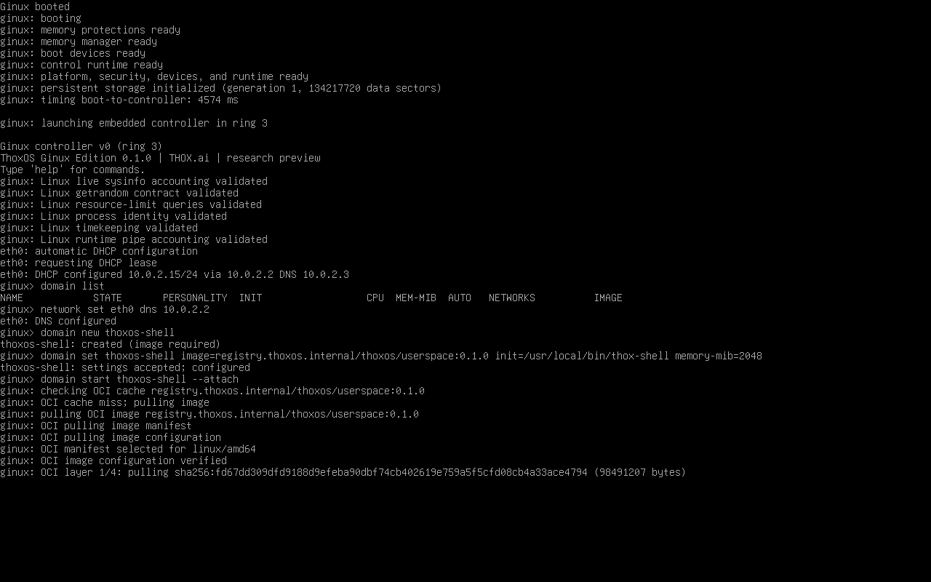
KnightHub SSD image booted as a USB disk in QEMU: tty1 runs Ginux and pulls ThoxOS from the host registry (simulation, not hardware)

05 Install on KnightHub
- Build: make ssd-image (or use the image from this delivery's build host).
- Write to a spare USB SSD: installer/install-to-ssd.sh on Linux, or Install-ThoxOSGinux.ps1 or Rufus DD mode on Windows.
- Disable Secure Boot, open the boot menu, choose the SSD.
- tty1 shows ThoxOS; Ctrl-Alt-F2 is the host admin login (user thox, new password at first login).

Disk rule
The writer refuses the THOXOS-labeled 500 GB SSD that carries ThoxOS Vibe unless told to erase it. Use a spare SSD.

06 Two records, kept apart
A ChatGPT/Codex session pushed a controller-only research record to main the same evening. It confirms the IOMMU width, the identity-map limit and the embedded-domain panic. This record adds the OCI userspace boot, the Docker run and the SSD image. One summary field there reads Linux domain execution failed; here the OCI domain passes and only the embedded path fails. docs/RECONCILIATION_2026-10-28.md lists every agreement and disagreement for a ruling.

Next steps
- Write the SSD image to a spare USB SSD and boot KnightHub; capture tty1 and thoxos-g doctor.
- Rule on the two records and the SSD target (spare disk or ThoxOS Vibe host).
- Open the upstream pull request for patch 0001 and issues for the QEMU 10.0, auxv and OCI cache findings.

