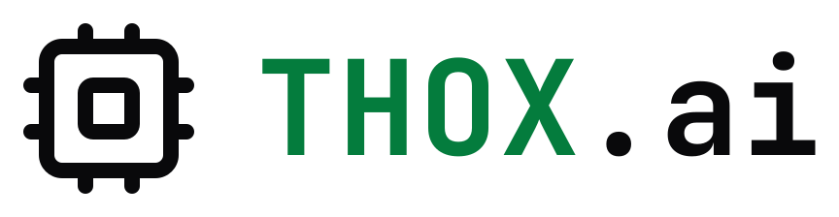
REPORT
ThoxOS Ginux Edition 0.2.0
Azure images with ThoxOS Desktop: cold-built Ginux kernel, cloud host kernel, three TXF looks, real screenshots
Field | Value
Owner | Odette Lark, memory-sync node and fleet librarian
Audience | Tommy Xaypanya (CTO), Craig Ross (CEO)
Date | 2026-10-29
Version | 0.2.0
Classification | Internal
Your AI. Your Data. Your Rules.

SUMMARY
ThoxOS Ginux Edition now builds Azure VM images. The desktop image boots a Debian 13 host with the Azure cloud kernel into ThoxOS Desktop, the TXF 5.2 desktop with three looks, and each RDP user runs ThoxOS on the Ginux kernel from the dock. Booted in QEMU the way Azure provisions a VM, it passed 23 of 23 checks, and every screenshot here comes from that run. Azure Virtual Desktop cannot host Linux session hosts, so the image follows Microsoft's golden-image flow as a standard Azure VM. Nothing has run on Azure yet.
Measure | Value | Note
Azure bench checks | 23 of 23 | desktop VHD in QEMU, cloud-init
Boot to SSH | 43 s | software emulation, 2 vCPU
Looks over RDP | 3 of 3 | Slate, Porcelain, Console Pro
Automated tests | 137 | pytest; shellcheck clean

01 What shipped
Host images move to 0.2.0; the Ginux guest stays 0.1.0. One Dockerfile builds every host root, with a target (KnightHub or Azure) and a desktop option (headless or ThoxOS Desktop).
Component | What it is
Ginux kernel | Cold rebuild from gmkurtzer/ginux 36503bd with patches 0001-0003: GINUX.EFI 12,497,920 bytes, SHA-256 6ff22d32...56a1 (1 min 59 s for the whole demo image without cache)
Azure host kernel | Debian 13 linux-image-cloud-amd64 6.12.113 with hv_vmbus, hv_storvsc and hv_netvsc in the initrd
Azure desktop VHD | 8 GiB fixed VHD, MiB-aligned, footer checked; ThoxOS Desktop over RDP, LightDM on the console. SHA-256 d6134d1a...80a7
Azure headless VHD | Same host without the desktop, for SSH and the serial console. SHA-256 aa01d70c...b13d
ThoxOS Desktop | TXF 5.2 on XFCE 4.20: GTK 3, window, dock, terminal, splash, wallpaper and icon themes generated from the TXF token file; looks TXF Slate, Porcelain and Console Pro; thoxos-look switcher
Provisioning | cloud-init 25 with the Azure datasource, Azure Linux Agent 2.12 with provisioning handed to cloud-init, no account or key in the image
Deployment | publish-image.sh (page blob, Compute Gallery, generalized V2 image) and azuredeploy.json (VM, NSG limited to one source range, VNet, public IP, first-boot settings)
Hosted AI | thox-ai-relay on host loopback 11434: thox ask on the host and inside ThoxOS on Ginux reaches an operator-configured model such as Azure OpenAI; the key stays on the host
KnightHub | Same Dockerfile; 0.2.0 SSD image rebuilt (SHA-256 fc6246a4...3c3d) and can carry the desktop too

02 Azure Virtual Desktop and this image
Microsoft's guide prepares a Windows golden image for AVD host pools. AVD session hosts run Windows 11 or 10 Enterprise and Windows Server only, so a Linux image cannot join a host pool. The ThoxOS image follows the same golden-image steps and deploys as a standard Azure VM reached over RDP.
Guide step (Windows) | ThoxOS image (Linux)
Windows 10 Enterprise multi-session | Debian 13 with the Azure cloud kernel
Generation 1 VM, fixed VHD | Generation 2 (UEFI), fixed VHD built offline, MiB-aligned
Office, FSLogix, Defender, Windows Update | Hyper-V drivers, cloud-init, Azure agent, serial console, PTP time
Sysprep generalize | Never booted before upload: empty machine-id, no host keys, no account
Upload and create an image | Page blob and Azure Compute Gallery image version
Host pool | azuredeploy.json VM; a Windows host pool can publish a RemoteApp to it if AVD is required

Security type
Standard, not Trusted Launch: the systemd-boot loader is unsigned. A signed loader is queued before Trusted Launch can be claimed.

03 Validation
Check | Result | Status
Desktop VHD booted in QEMU like Azure provisions it (cloud-init, NoCloud seed) | 23 of 23 checks: SSH after 43 s, cloud-init done, no failed units, per-machine keys and machine ID, Hyper-V initrd, agent settings | Verified
Console | Plymouth ThoxOS splash and LightDM greeter captured from the VGA console | Verified
RDP | Branded xrdp login; one session per look, look confirmed through xfconf | Verified
ThoxOS on Ginux in the desktop | User's Ginux VM pulled ThoxOS (110 MB, 446 s nested); uname reports Ginux 6.12.0-ginux.0.1; thox status answered | Verified
Headless VHD | 13 of 13 checks; ThoxOS on Ginux booted with systemd to the login prompt for the administrator (853 s nested) | Verified
KnightHub 0.2.0 SSD image | 6 of 6 host checks as a USB disk in QEMU after moving to the shared Dockerfile | Verified
Unit and static checks | 137 pytest cases, shellcheck clean; full theme generation with the real fonts in the build container | Verified
Azure: gallery, deployment, nested KVM, hosted model | Not run: no subscription in this runtime | Pending

Sixteen defects surfaced in the build and bench runs and were fixed before the final images, among them a 300 s initramfs sleep from rootdelay, a GTK theme setting that made the desktop session spin at full CPU, and a machine ID that every VM would have shared (VALIDATION.md D-01 to D-16). The 0.1.0 KnightHub image very likely carries that last defect too.

04 Screenshots
Real captures from the final desktop VHD booted in QEMU with software emulation and reached over RDP. They show the shipped image, not Azure.
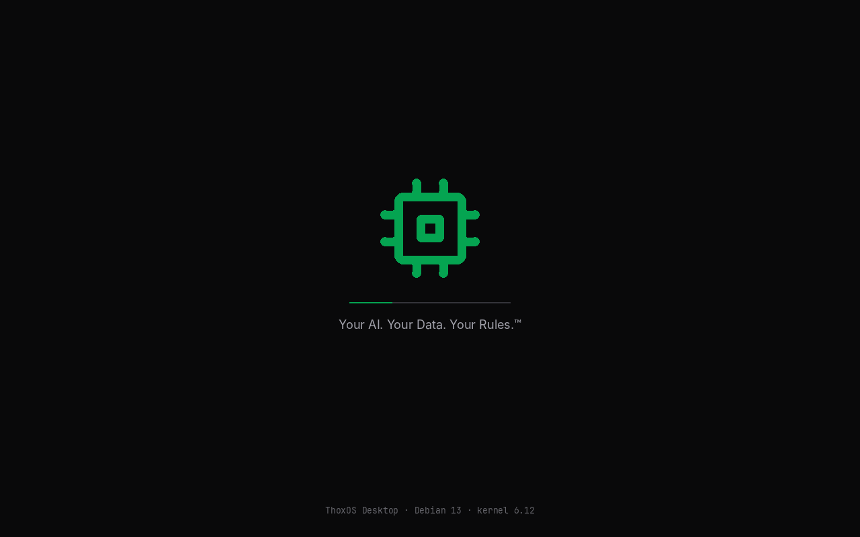
Boot splash on the VGA console (QEMU)
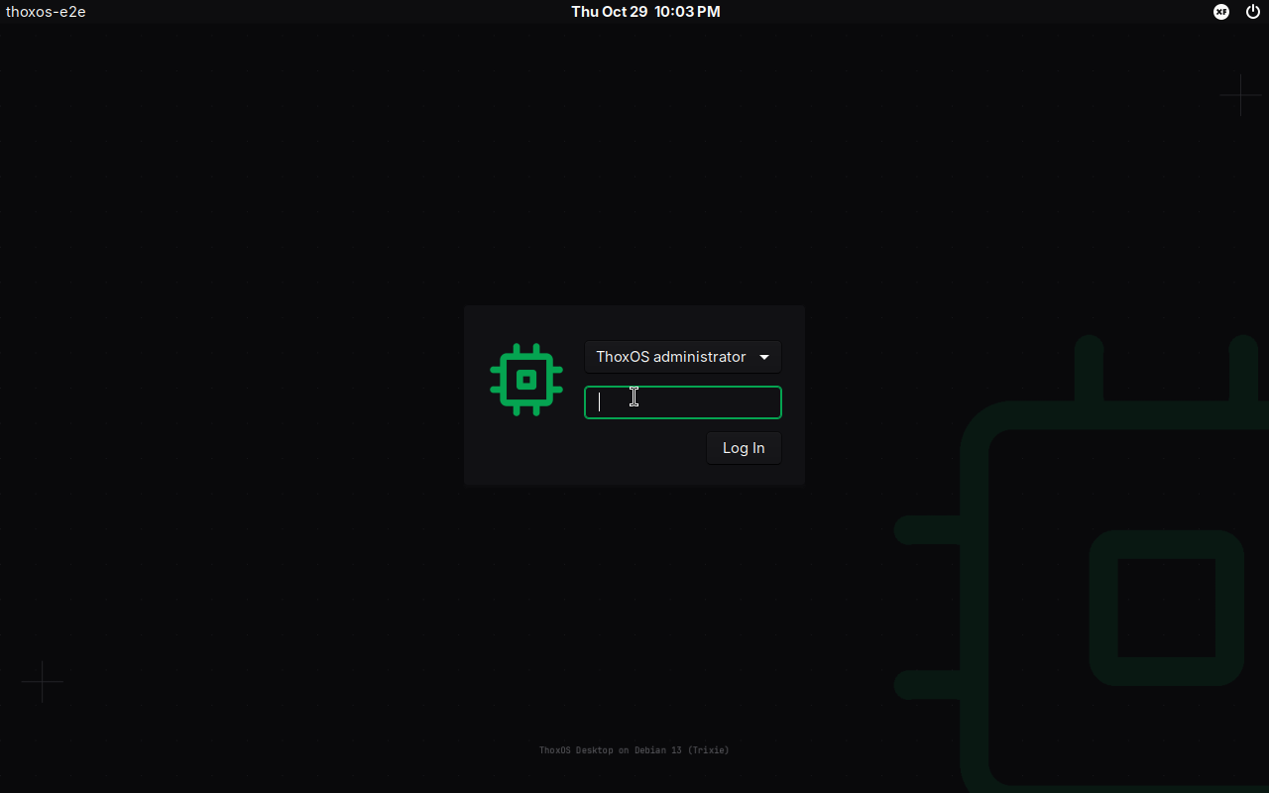
Console greeter (QEMU)
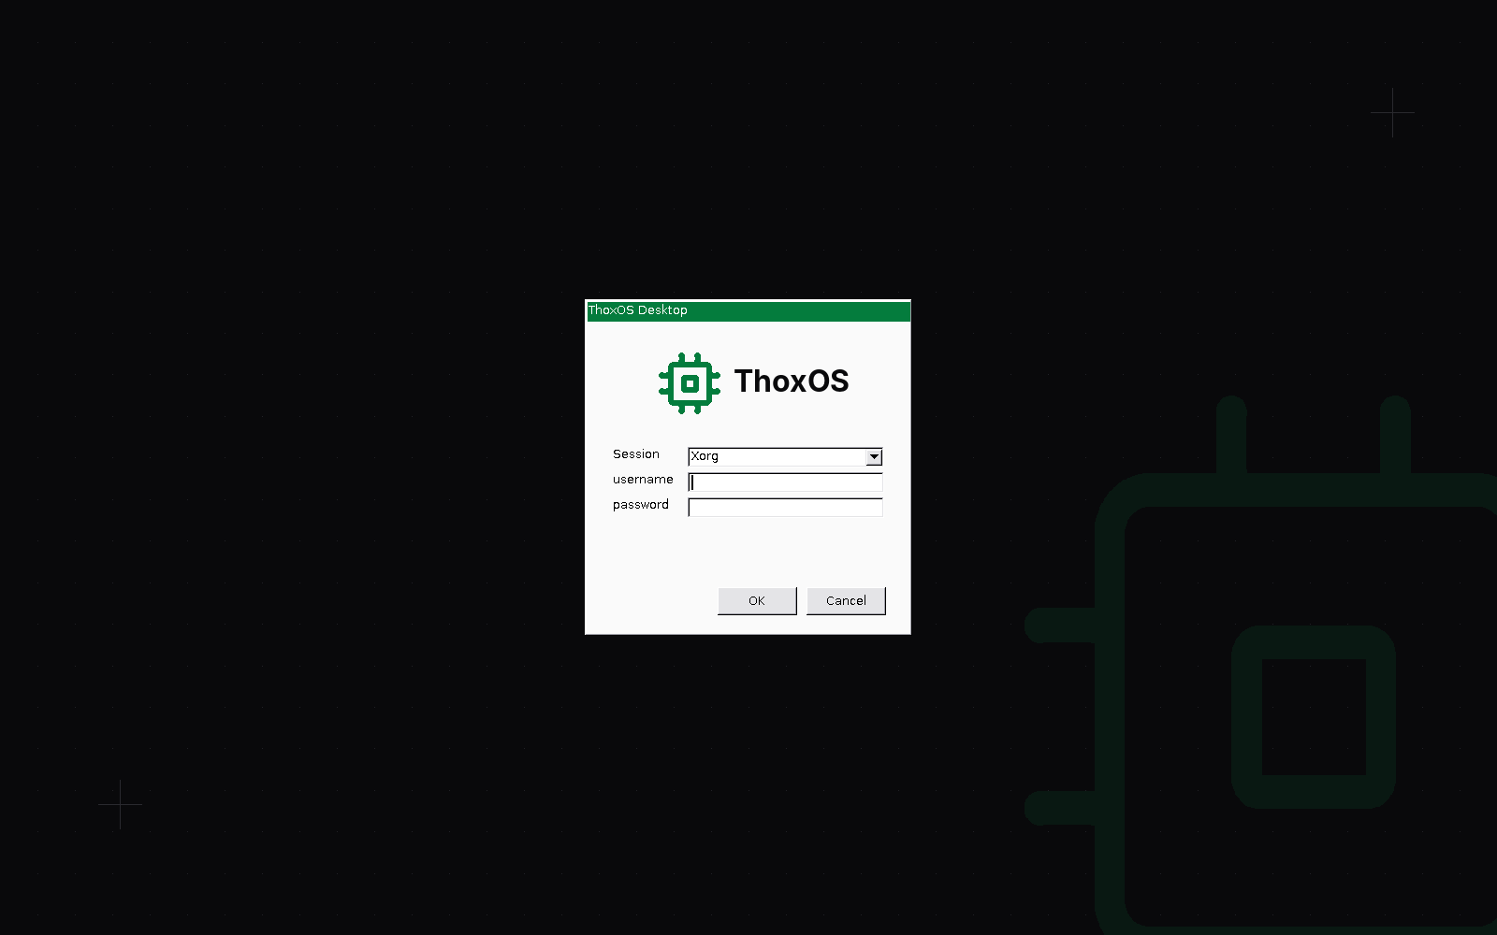
RDP login (QEMU capture over RDP)
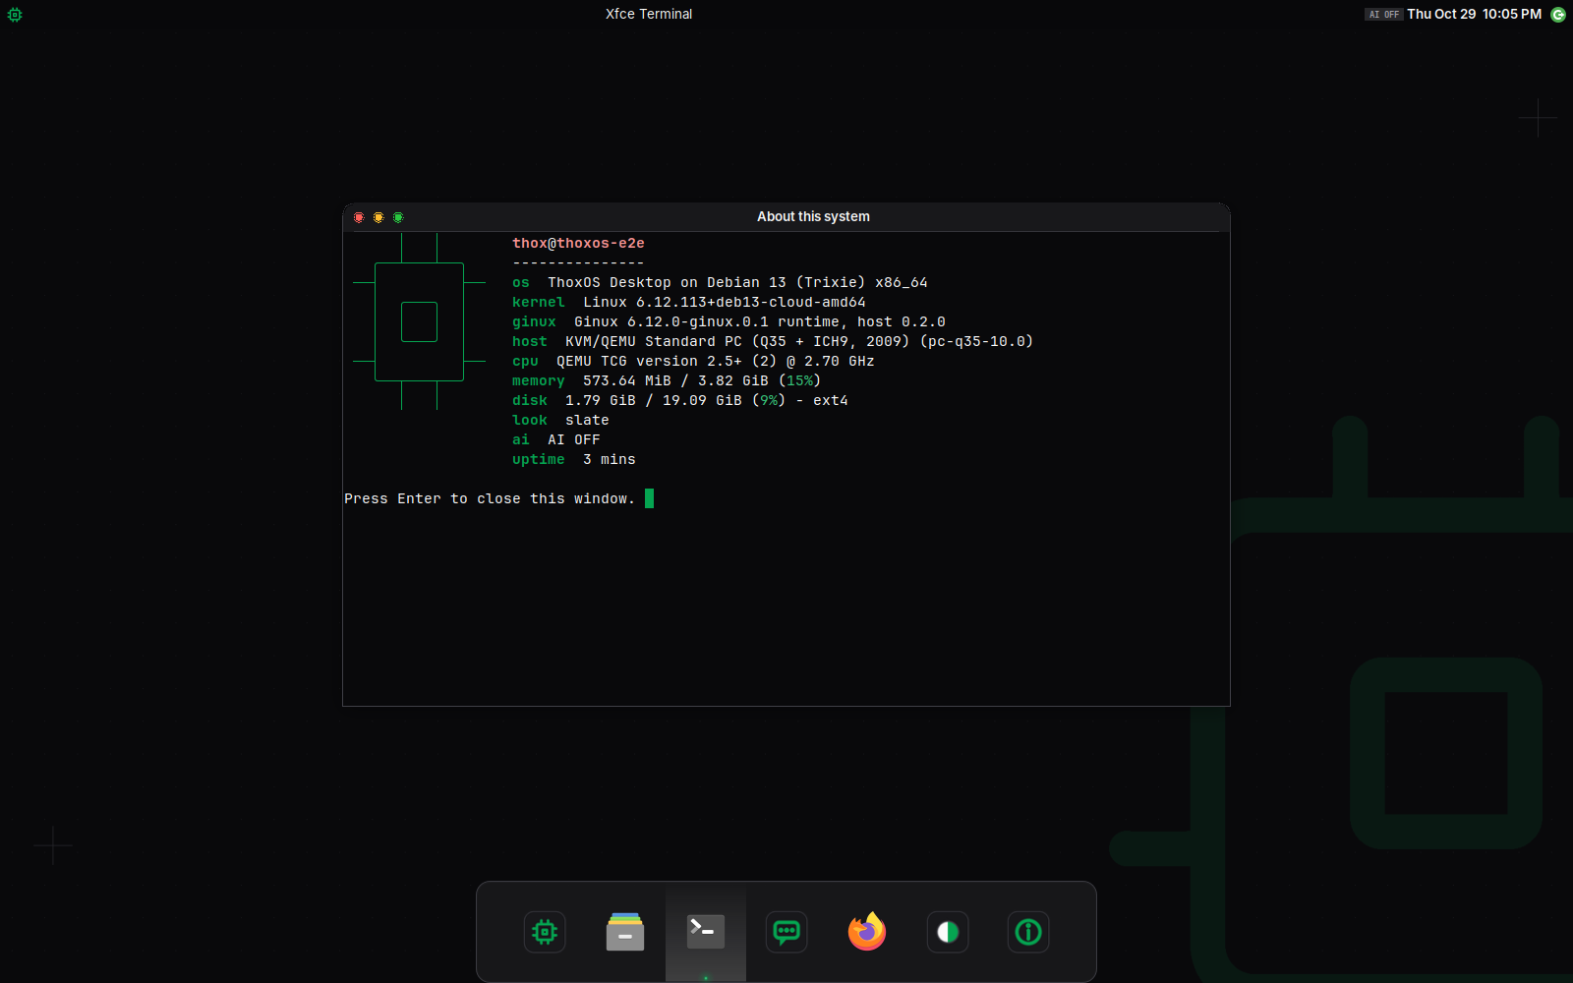
TXF Slate with About this system (QEMU capture over RDP)
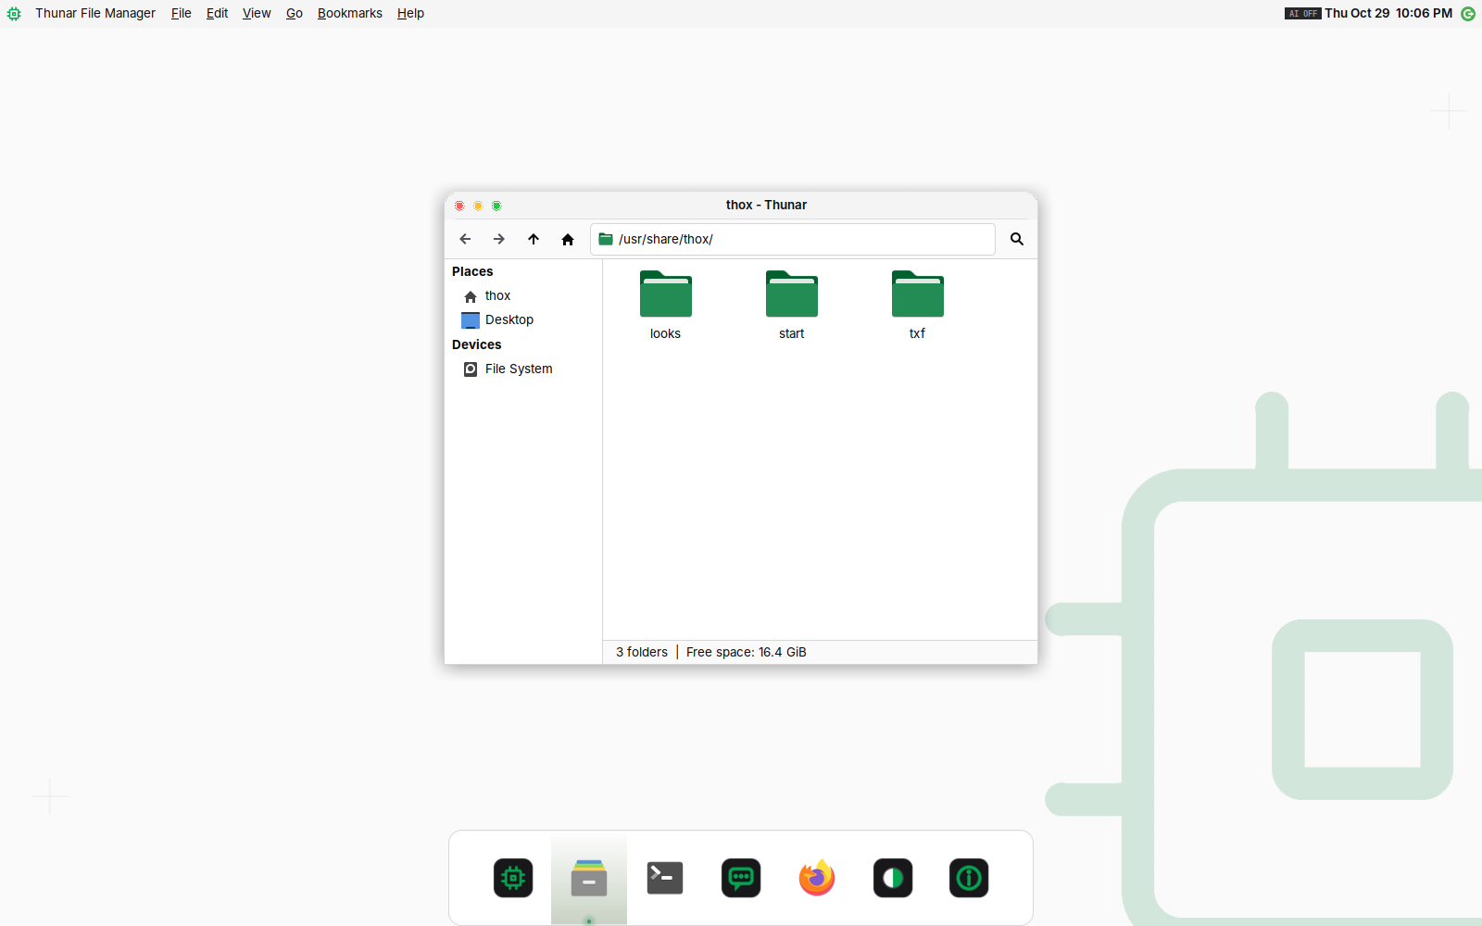
Porcelain with the file manager (QEMU capture over RDP)
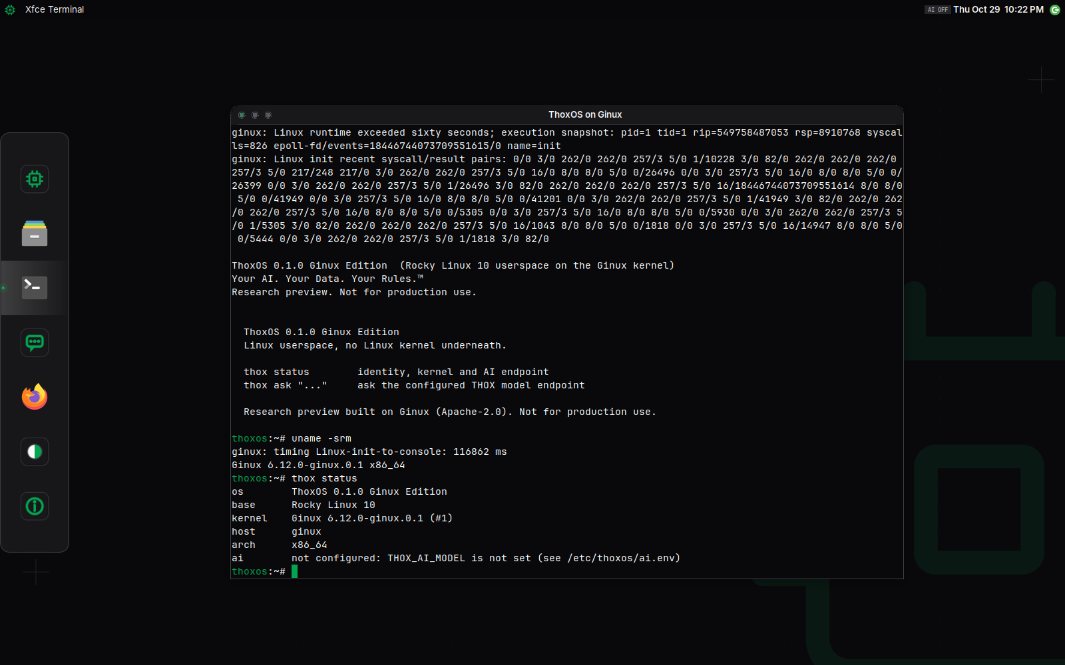
Console Pro with ThoxOS on Ginux in the terminal (QEMU capture over RDP, nested software emulation)

05 Deploy on Azure
- Build the VHD: installer/build-host-image.sh --target azure --desktop desktop (about 2 minutes with a warm Docker cache).
- Publish: azure/publish-image.sh --vhd build/azure/thoxos-ginux-azure-desktop-0.2.0.vhd --resource-group thoxos-images --location eastus. It prints the image version ID.
- Deploy: az deployment group create with azure/azuredeploy.json, the image version ID, allowedSourceCidr set to your address and an administrator password.
- Connect with RDP to the VM's DNS name; pick a look; open ThoxOS on Ginux from the dock.
- Optional: set aiUpstream, aiAuth, aiApiKey and aiModel to route thox ask to a hosted model.

Exposure
SSH and RDP open only to the one source range you pass; there is no default. Ginux has no security audit: keep it a research VM.

06 Two records, kept apart
A second runtime answered the same request in pull request #2: an Ubuntu 24.04 marketplace host with a bootstrap artifact, a private VM behind NAT, Trusted Launch, a kernel startup patch with five fixes plus an Azure profile patch, and no desktop. The two records agree that AVD cannot host Ginux and that nothing ran on Azure. They differ on image strategy, security type, exposure and the kernel patch set. RECONCILIATION_2026-10-29.md lists each point for a ruling; neither record was changed to match the other.

Next steps
- Tommy: provide a subscription and resource group; Hermes publishes the desktop VHD and deploys it on Standard_D4s_v5 from one source IP.
- Tommy: rule on the two Azure records (RECONCILIATION_2026-10-29.md) and on where the ThoxOS Desktop implementation lives.
- Hermes and Claude: connect an Azure OpenAI deployment through thox-ai-relay and record thox ask from the host and from ThoxOS on Ginux.

