

## FACULTY OF INFORMATION TECHNOLOGY

Information systems 511

**1ST SEMESTER ASSIGNMENT**

402411681

Thozamile Madela

**Name & Surname: ITS No:**

Information Systems

1

BSC in IT

**Qualification: Semester: Module Name:**

**Date Submitted:**

|  |  |  |  |
| --- | --- | --- | --- |
| **ASSESSMENT CRITERIA** | **MARK ALLOCATION** | **EXAMINER MARKS** | **MODERATOR MARKS** |
| **MARKS FOR CONTENT** | | | |
| **QUESTION ONE** | **30** |  |  |
| **QUESTION TWO** | **30** |  |  |
| **QUESTION THREE** | **30** |  |  |
| **TOTAL** | **90** |  |  |
| **MARKS FOR TECHNICAL ASPECTS** | | | |
| **TABLE OF CONTENTS**  Accurate numbering according to the numbering in text and page numbers. | **2** |  |  |
| **LAYOUT AND SPELLING**  Font – Calibri 12 Line Spacing – 1.0  Margin should be justified. | **3** |  |  |
| **REFERENCES**  According to the Harvard Method | **5** |  |  |
| **TOTAL** | **10** |  |  |
| **TOTAL MARKS FOR ASSIGNMENT** | **100** |  |  |
| **Examiner’s Comments:** | | | |
|  | | | |
| **Moderator’s Comments:** | | | |
|  | | | |
| **Signature of Examiner: Signature of Moderator:** | | | |

Table of Contents

Question 1…………………………………………………………………………………………………………………………………… 2

Question 2…………………………………………………………………………………………………………………………………… 4

Question 3…………………………………………………………………………………………………………………………………… 7

Bibliography………………………………………………………………………………………………………………………………...... 9

Question 1

* 1. a) According (Almeida, 2021), common types of viruses that usually affects a network:
* Keylogger: detects and stores keystrokes made by the user, then transmits the stored info to the person who installed the software.
* Spyware: as the name implies spyware gathers information and is able to manipulate the target’s computer.
* Adware: unprompted malicious advertisements that display on the screen.
* Ransomware: harmful programs that cripples a computer by encrypting essential files.
* Trojan Horse: a virus that infects your computer by masking itself as a trustworthy program to trick users.

b) File Infecting viruses target exe files. Altering the file’s code by removing and embedding its own code into the file or modifying a segment of the file’s code. This type of malware is triggered the moment an unsuspecting user runs the exe file. The virus will then proceed to spread to other files. (Rouse, 2023)

c) Effective antivirus software such as Norton or Bitdefender can be integrated into the company’s systems, to pre-empt destructive infections, not only can this type of software detect but it can also remove software. Companies should regularly ensure that the software on every device connected to their networks is updated to prevent cyber criminals from exploiting flaws in their device’s operating systems or other applications. Disabling suspicious websites via browser-based protection or DNS filtering. Backing up systems in the cloud, is an effective solution to prevent file-infecting viruses from dealing serious damage to the organisation, because in the event that a file infecting virus destroys important files, the organisation can wipe their systems and restore their files. (Stouffer, 2018)

* 1. a) According to (Vermaat, 2017), technology addiction is the overuse of technology by a person in an unhealthy manner which has a negative impact on their social life. Technologyaddiction may cause health issues such as:
* Repetitive Strain Injury (RSI) which happen as a result of: Tendonitis, a condition in which the tendon is inflamed and Carpal Tunnel Syndrome (CTS), a condition in which the nerve is inflamed.
* Computer Vision Syndrome (CVS), induced by staring at a computer screen for long periods of time resulting in: blurred vision, headaches and double vision.
* Poor posture, working on a computer can cause lower back pain and muscle fatigue.

b) Organizations could set up health evaluation sessions, to determine the health of every employee by having medical professionals diagnose employees by identifying symptoms of technology overload as mentioned by (Vermaat, 2017); symptoms of RSI such as pain, numbness and tingling of the hands as well as symptoms of CVS which is: higher light sensitivity, muscle fatigue and sore eyes.

c) According to (Schachter, 2021) In order to strike a balance between digital and analog, organizations can:

1. For analog exercises:

* Implement digital detox exercises by creating a space for employees to learn new hobbies without using technology, for instance learning a how to play the piano with actual instructors as opposed to using an app.
* Creating a play area with gaming equipment such as ping pong tables and board games, where employees can relax by engaging in such activities.
* Encourage employees to limit the use of smartphones by at least 30 minutes daily or more and attend some nature retreats, to experience nature and momentarily free themselves from the technological world.

1. For digital exercises:

* Organizations could encourage employees to perform tasks that require efficiency such as managing finances, formulating travel plans and writing books by recommending applications they can use to facilitate such tasks such as Word and Excel.

d) To measure the effectiveness of of interventions aimed at addressing technology overload and addiction organisations make use of:

* Questionnaires.
* One on one interviews.

Key indicators that should be considered by the organizations are:

* Effectiveness surveys and interviews.
* Employee stress levels.
* Employee overall efficiency.

Question 2

2.1

**EMPLOYMENT APPLICATION FORM**

|  |  |  |  |  |  |  |  |
| --- | --- | --- | --- | --- | --- | --- | --- |
| PLEASE COMPLETE ALL THE INFORMATION REQUESTED  IN PRINT (PAGES 1-5), EXCEPT SIGNATURE | | | | | | | |
| NOTE: APPLICANTS MAY BE TESTED FOR ILLEGAL DRUGS | | | | | | | |
| **Date:** 2024/03/05 | | | | | | | |
| **Name:** | | | | | | | |
| Last Madela First Thozamile Middle Motheo Maiden | | | | | | | |
| **Present Address:** | | | | | | | |
| Number 3519 Street City Johannesburg State Gauteng Zip 1852 | | | | | | | |
| **How Long:** 5 years | | | | **Social Security No.:** | | | |
| **Telephone:** 0784567624 | | | | | | | |
| **If under 18 please list age:** | | | | | | | |
| **Position Applied For:** IT technician | | | | | | **Days/Hours Available to Work:** | |
| **Salary Desired:** R100000 | | | | | | **No Pref Thur** 8  **Mon**  7 **Fri** 8  **Tue** 5  **Sat** 12  **Wed** 9 **Sun** 6 | |
| **How many hours can you work weekly?** 7 | | | **Can you work nights?** Yes | | | | |
| **Employment Desired:**  FULL-TIME ONLY PART-TIME ONLY FULL-OR PART-TIME | | | | | | | |
| **When available for work?** Now | | | | | | | |
| EDUCATION & OTHER INFORMATION | | | | | | | |
| TYPE OF SCHOOL | NAME OF SCHOOL | LOCATION (Complete Mailing Address) | | | NO. OF YEARS COMPLETED | | MAJOR & DEGREE |
| High School | | | | | | | |
|  | West Ridge | Roodepoort Road | | | 12 | | None |
| College | | | | | | | |
|  | Richfield | Smart Road | | | 0 | | Degree |
| Bus. Or Trade School | | | | | | | |
|  |  |  | | |  | |  |
| Professional School | | | | | | | |
|  |  |  | | |  | |  |

2.2



**Thozamile Motheo Madela**



Mad

SCHOOL: Richfield Graduate Institute of Technology

STUDENT ID NUMBER: 402411681

QUALIFICATION: BSC in Information Technology

YEAR OF STUDY: First Year

EXPIRATION DATE: 2026

ADDRESS: 1082 PACTOR STREET, GAUTENG SOUTH AFRICA

Blood Type: A



Question 3

3.1

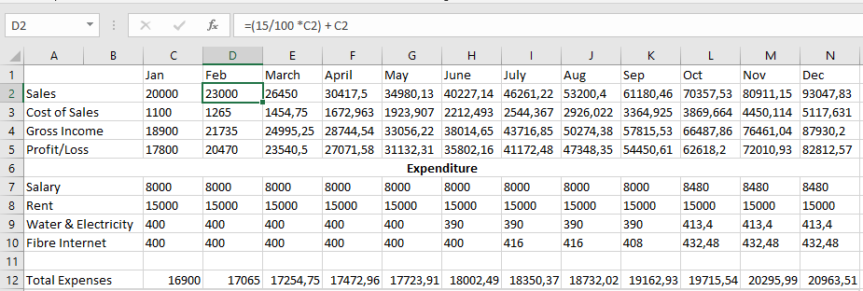

# Bibliography

Almeida, A., 2021. *Hosts Green.* [Online]   
Available at: https://blog.hosts.green/types-of-viruses/  
[Accessed 10 March 2024].

Rouse, M., 2023. *Techopedia.* [Online]   
Available at: https://www.techopedia.com/definition/55/file-infecting-virus  
[Accessed 10 March 2024].

Schachter, H., 2021. *article-the-digital-vs-analog-seesaw-how-to-use-those-spaces-to-get-the-most.* [Online]   
Available at: https://www.theglobeandmail.com/business/careers/management/article-the-digital-vs-analog-seesaw-how-to-use-those-spaces-to-get-the-most/  
[Accessed 12 March 2024].

Stouffer, C., 2018. [Online]   
Available at: https://us.norton.com/blog/how-to/avoid-getting-a-virus-on-the-internet  
[Accessed 10 March 2024].

Vermaat, 2017. *Discovering Computers, Essentials: Digital Technology.* 16 ed. s.l.:Cengage Learning, 2017.