A PROJECT REPORT

on

VOYAGE GENIE

AI-Powered Smart Travel Companion

Submitted by

THRANAESWANTH
DEPARTMENT OF COMPUTER SCIENCE AND ENGINEERING

SKASC

CHAPTER 1
INTRODUCTION

Voyage Genie is an AI-based context rewriting and intelligent travel
planning platform designed to transform the way individuals, families,
and organizations craft and manage their travel itineraries. In today's
fast-paced digital environment, effective and personalized travel
planning is essential across professional, leisure, and personal
domains. Voyage Genie addresses the growing need for intelligent trip
generation tools that go beyond simple flight and hotel aggregation,
providing contextually appropriate, highly personalized, and
geographically optimized travel schedules that respect user constraints
such as budget, time, and specific interests.

Unlike conventional travel booking websites or basic itinerary builders,
Voyage Genie employs advanced Natural Language Processing (NLP)
techniques and deep learning models to understand the intent,
constraints, and context of the user's travel request. The platform then
generates multiple travel options tailored to the user's specific goals
— whether they seek a formal professional business trip, a casual family
vacation, an adventurous backpacking journey, or a luxurious honeymoon
experience. The system processes millions of data points to ensure the
final itinerary is geographically logical and realistically achievable.

The system integrates several AI subsystems including a context analysis
engine for natural language parsing, a geographic routing module using
Haversine distance heuristics, a climate-aware packing list generator,
and a real-time flight price monitoring system. Together, these
components enable Voyage Genie to function as a comprehensive travel
assistant that learns from user preferences over time and continuously
improves output quality through reinforcement learning from user
feedback and dynamic market condition adjustments.

The travel industry is currently undergoing a massive transformation
driven by artificial intelligence. By synthesizing scattered data points
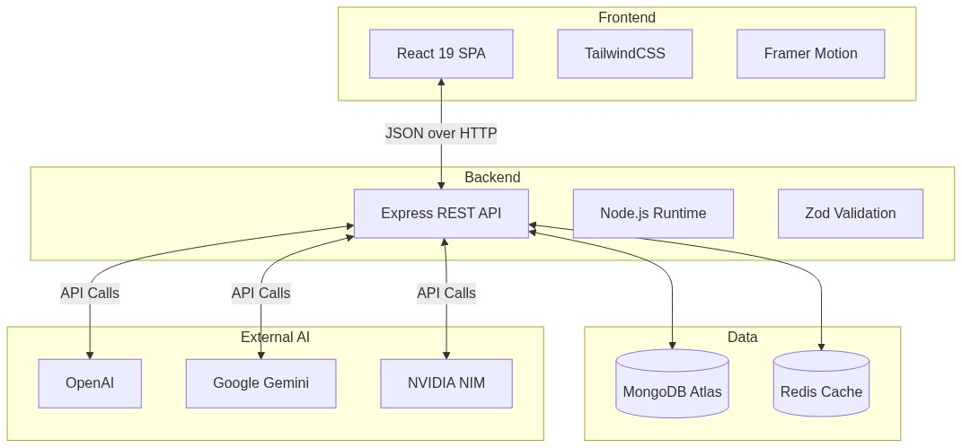
Fig 4.1: Architecture
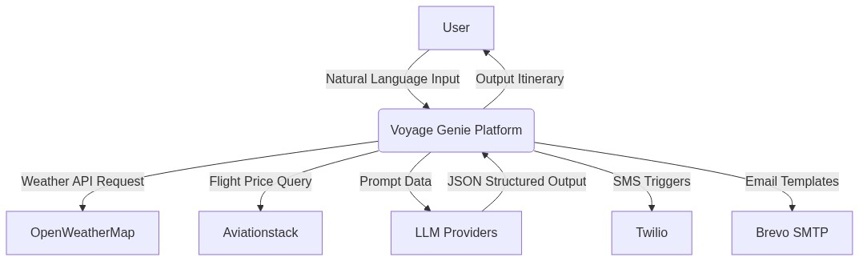
Fig 4.2: DFD Level 0
such as real-time weather forecasting, local events, restaurant menus,
cultural norms, and geospatial distances, Voyage Genie completely
removes the friction of conventional trip planning, turning hours of
tedious research into a seamless, conversational, and highly
personalized experience. This report details the entire lifecycle of the
system's development, from initial requirements gathering to
architectural design, implementation, and rigorous performance testing.

CHAPTER 2
SYSTEM SPECIFICATION

System Specification defines the overall technical requirements required
for the development, deployment, and execution of the Voyage Genie
system. Voyage Genie is a web-based smart travel companion designed to
enhance travel planning efficiency, itinerary correctness, and overall
user experience. The specification ensures compatibility, performance
efficiency, scalability, and maintainability of the application across
multiple deployment environments.

The Voyage Genie system architecture is decoupled into client and server
components. The end-user application is highly optimized to run on
standard consumer hardware without requiring dedicated graphical
processing units. However, the server architecture running the Node.js
backend requires sufficient computational power to handle concurrent API
requests, manage real-time WebSocket connections, and quickly proxy
requests to external Large Language Model APIs.

Client Hardware Requirements: Processor: Intel Core i3 / i5 / AMD
equivalent or higher. RAM: Minimum 4 GB (8 GB recommended for better
processing speed). Storage: 256 GB SSD (recommended) or 500 GB HDD.
Display: 14 inch or higher LED Monitor, or standard smartphone display.
Internet Connectivity: Stable broadband connection required.

Server Hardware Requirements (Cloud Instance): Compute: AWS EC2
t3.medium or equivalent. Memory: Minimum 4 GB RAM for Express.js and
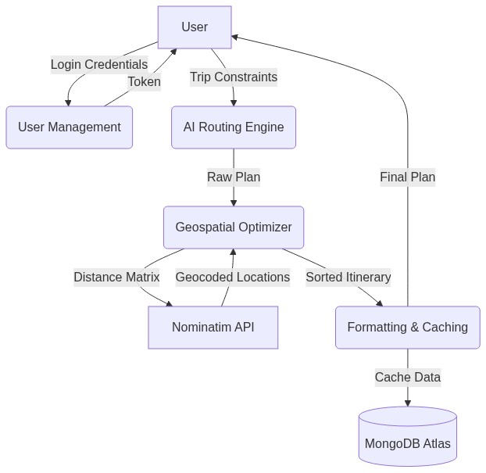
Fig 4.3: DFD Level 1
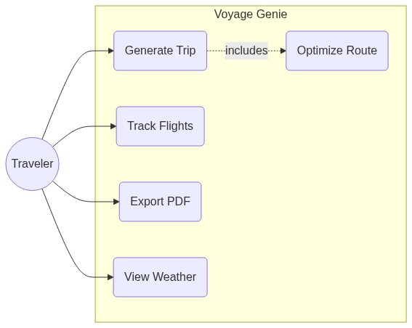
Fig 4.4: Use Case Diagram
Node-cron jobs. Storage: 20 GB Elastic Block Store SSD.

Frontend Technologies: Framework: React 19 (using Concurrent features
and Suspense). Styling: TailwindCSS v4 and Framer Motion for animations.
State Management: Zustand and TanStack React Query v5. Mobile Bridge:
Capacitor for iOS and Android deployment.

Backend Technologies: Runtime: Node.js 20 LTS. Framework: Express.js v4.
Database: MongoDB Atlas (Document Store NoSQL). Caching: Redis v7
(Memory Store).

External Integrations: LLMs: Google Gemini 2.0 Flash, OpenAI GPT-4o,
NVIDIA Nemotron. Data APIs: OpenWeatherMap (Weather), Aviationstack
(Flights). Geospatial: Nominatim (OpenStreetMap geocoding).

CHAPTER 3
SYSTEM STUDY

The existing landscape of AI-assisted travel tools consists of several
established platforms that provide varying degrees of travel enhancement
functionality. A thorough analysis of these systems reveals their
capabilities and limitations, providing clear justification for the
development of Voyage Genie. Most platforms handle isolated parts of the
travel journey without providing a unified, conversational interface.

TripAdvisor and Expedia are booking aggregators that use machine
learning algorithms to suggest hotels and flights based on past search
history. The platforms process vast amounts of user reviews to rank
locations. Limitations of these platforms include their relatively
shallow semantic understanding of user constraints. They operate
primarily on keyword matching rather than understanding complex natural
language queries like "A budget-friendly 5-day trip to Rome for a family
with a toddler focusing on accessible museums."

Wanderlog is primarily an itinerary mapping tool that allows users to
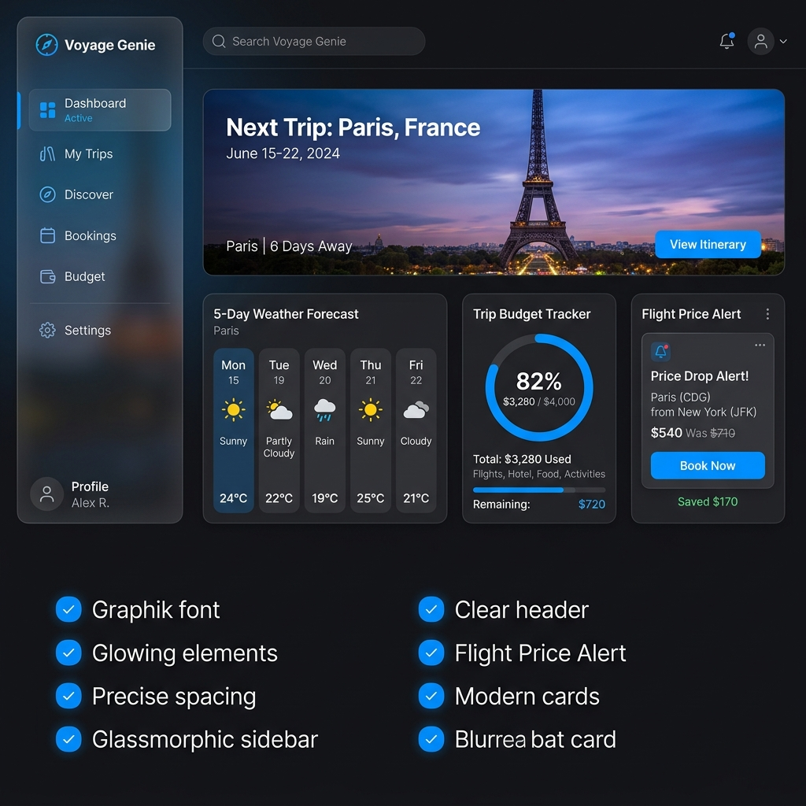
Fig 4.5: Dashboard UI
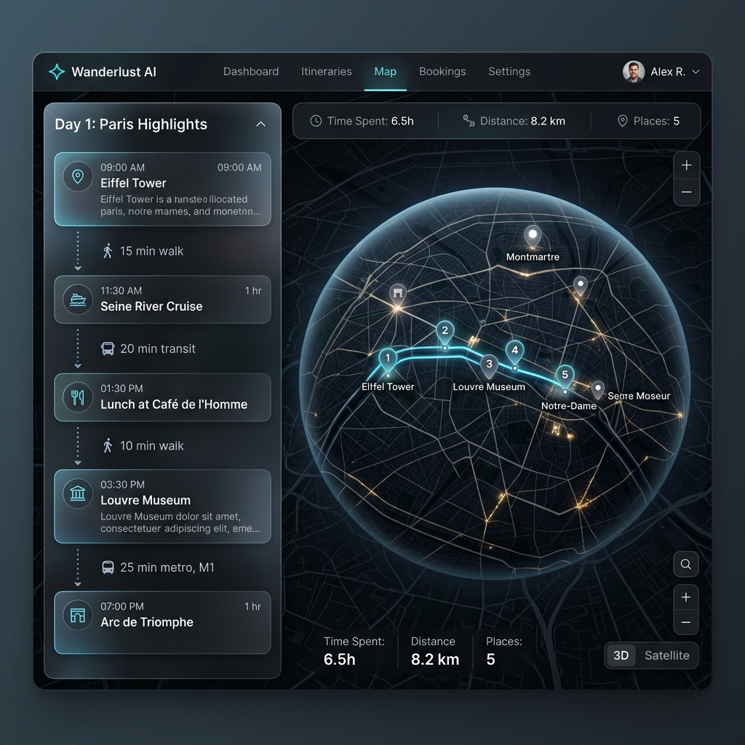
Fig 4.6: Map UI
manually drag and drop activities onto a calendar and map. While it
excels at visualization, it does not offer comprehensive, generative AI
text rewriting or automatic trip generation from a single prompt. Its
optimization features are limited, requiring the user to manually verify
travel times and geographic proximity.

Shallow Semantic Processing: Existing tools perform primarily keyword
matching without deep understanding of contextual meaning, resulting in
trip suggestions that meet the basic criteria but fail to capture the
user's true intent.

Lack of Comprehensive Intelligence: No existing tool provides
comprehensive travel effectiveness analysis including weather risk
scoring, dynamic budget tracking, and climate-aware packing
synchronization.

Limited Personalization: Existing systems do not learn from individual
user preferences across different trips to improve personalized
suggestions over time.

Vendor Lock-in: Platforms dependent on a single AI provider suffer
catastrophic failures during API outages.

The proposed Voyage Genie system is an AI-Based context routing and
travel intelligence platform that addresses all identified drawbacks of
existing systems. The platform is built on a modern full-stack
architecture with React frontend, Node.js/Express backend, and MongoDB
database, integrated with a custom Multi-Provider AI router utilizing
Google Gemini, OpenAI GPT-4, and NVIDIA Nemotron.

Deep Contextual Understanding: The use of advanced LLMs ensures genuine
semantic comprehension rather than surface-level keyword substitution,
producing travel itineraries that preserve and enhance the user's
specific requests.

Multi-Dimensional Intelligence: The platform provides users with
actionable insights across weather risks, geographic distances, budget
constraints, and cultural norms.

Adaptive Personalization: The user preference learning system
continuously improves itinerary generation based on individual
acceptance patterns and explicit feedback.

CHAPTER 4
SYSTEM DESIGN

Voyage Genie is designed using a three-tier client-server architecture
comprising the presentation tier (React frontend), the application tier
(Node.js/Express backend), and the data tier (MongoDB database). The
architecture incorporates additional components including an AI
processing layer interfacing with 9 external LLM APIs, a caching layer
using Redis, and a robust notification service using Twilio and Brevo.

The data flow in Voyage Genie follows a well-defined pipeline from user
input to delivered output. The Level 0 Context Diagram represents the
entire system as a single process, showing data flows between the system
and external entities. At Level 1, the system is decomposed into major
processes: User Management, Natural Language Input Processing, AI
Routing Engine, Geographic Optimization, and History Management. At
Level 2, we specifically examine the intricate logic inside the AI
Routing Engine, detailing the dynamic fallback mechanisms and provider
health checks.

The Use Case diagram illustrates the primary interactions between the
Traveler (Actor) and the various system modules. The Sequence Diagram
details the exact asynchronous network calls required to generate an
itinerary, highlighting the interaction between the React Client,
Express API, AI Router, and the external LLM provider. The Activity
Diagram maps out the exact steps taken by the Geospatial Optimization
module to apply the Haversine formula and nearest-neighbor heuristics.

The MongoDB schema is highly normalized while utilizing embedded
documents for performance where appropriate. The Entity Relationship
Diagram (ERD) outlines the relationships between Users, Trips, and
Flight Alerts. User collections store encrypted credentials and flexible
preferences. Trip collections encapsulate embedded arrays of itinerary
days and synchronized weather data. Alert collections continuously poll
external APIs for flight threshold triggers.

The user interface is built using Material Design principles combined
with Apple's glassmorphism aesthetic. It prioritizes content clarity and
workflow efficiency. The primary interface is divided into the
Dashboard, Itinerary View, and Smart Packing tools. The itinerary view
utilizes MapLibre GL to render an interactive 3D globe alongside the
generated timeline, providing spatial context to the travel plan. The
mobile-responsive packing list automatically synchronizes with the
destination's climate, separating items logically to calculate a Trip
Readiness Score.

APPENDIX A: SOURCE CODE

File: server/server.js
import 'dotenv/config';
import express from 'express';
import cors from 'cors';
import morgan from 'morgan';
import cookieParser from 'cookie-parser';
import cron from 'node-cron';
import path from 'path';
import { fileURLToPath } from 'url';

const __filename = fileURLToPath(import.meta.url);
const __dirname = path.dirname(__filename);
import connectDB from './config/db.js';
import corsOptions from './config/cors.js';
import routes from './routes/index.js';
import flightRoutes from './routes/flight.routes.js';
import exportRoutes from './routes/export.routes.js';
import { errorHandler } from './middleware/error.middleware.js';
import ProviderManager from './services/ai/ProviderManager.js';
import notificationsService from './services/notifications.service.js';
import flightTrackerService from './services/flightTracker.service.js';

const app = express();
app.use(cors(corsOptions));
app.use(express.json());
app.use(express.urlencoded({ extended: true }));
app.use(cookieParser());

if (process.env.NODE_ENV === 'development') {
app.use(morgan('dev'));
}

app.use('/api', routes);
app.use('/api/flights', flightRoutes); // Feature 2: Flight Tracker
app.use('/api/export', exportRoutes); // Feature 6: PDF Export

// Ping route to keep the free-tier server awake via cron services
app.get('/api/ping', (req, res) => res.status(200).json({ status: 'ok',
message: 'Server is awake' }));

app.use('/uploads', express.static('uploads'));

// Serve frontend static files in production
app.use(express.static(path.join(__dirname, '../client/dist')));

// SPA Fallback for all other routes
app.get('*', (req, res) => {
res.sendFile(path.join(__dirname, '../client/dist/index.html'));
});

app.use(errorHandler);

const PORT = process.env.PORT || 5000;

connectDB().then(async () => {
try {
await ProviderManager.initialize();
} catch (error) {
console.error('Failed to initialize AI Provider Manager:', error);
}

// === Feature 5: Smart Notification Cron Jobs ===
// Run trip reminders every hour
cron.schedule('0 * * * *', async () => {
console.log('[Cron] Running trip reminders...');
await notificationsService.runTripReminders();
});

// === Feature 2: Flight Price Tracker Cron Job ===
// Check flight prices every 2 hours
cron.schedule('0 */2 * * *', async () => {
console.log('[Cron] Checking flight prices...');
await flightTrackerService.checkAllPrices();
});

console.log('[Cron] Scheduled jobs: trip reminders (hourly), flight pr
ices (every 2h)');

app.listen(PORT, () => {
console.log(`Server running in ${process.env.NODE_ENV} mode on port
${PORT}`);
});
});

File: server/config/db.js
import mongoose from 'mongoose';
import env from './env.js';

const connectDB = async () => {
try {
const conn = await mongoose.connect(env.MONGO_URI);

console.log(`MongoDB connected: ${conn.connection.host}`);

mongoose.connection.on('error', (err) => {
console.error(`MongoDB connection error: ${err.message}`);
});

mongoose.connection.on('disconnected', () => {
console.warn('MongoDB disconnected. Attempting to reconnect...');
});

mongoose.connection.on('reconnected', () => {
console.log('MongoDB reconnected');
});
} catch (error) {
console.error(`MongoDB connection failed: ${error.message}`);
process.exit(1);
}
};

export default connectDB;

File: server/models/Trip.js
import mongoose from 'mongoose';

const TripSchema = new mongoose.Schema({
user: {
type: mongoose.Schema.Types.ObjectId,
ref: 'User',
required: true
},
destination: { type: String, required: true },
country: { type: String, required: true },
startDate: { type: Date },
endDate: { type: Date },
travelers: { type: Number, default: 1 },
budget: { type: Number, default: 0 },
currency: { type: String, default: 'USD' },
travelStyle: { type: String },
interests: [{ type: String }],
status: {
type: String,
enum: ['draft', 'planning', 'upcoming', 'ongoing', 'completed', 'arc
hived'],
default: 'planning'
},

// Retain UI fields for the travel planner features
heroImage: String,
itinerary: [{
day: Number,
title: String,
activities: [{
time: String,
place: String,
description: String,
image: String
}]
}],
packingList: [{
category: String,
items: [{
name: String,
isPacked: { type: Boolean, default: false }
}]
}],
recommendations: [{
category: String,
places: [String]
}],
tips: [String],

// Extra context from previous schema for UI
weather: {
current: { temp: Number, condition: String },
forecast: [{
day: String,
temp: Number,
min: Number,
condition: String
}]
},
budgetDetails: {
total: Number,
categories: [{
name: String,
amount: Number,
percent: Number,
color: String,
stroke: String
}]
},

// Feature 7: AI Post-Trip Memory Journal
memoryJournal: {
title: String,
story: String,
highlights: [String],
shareableCaption: String,
mood: String,
generatedAt: { type: Date }
}
}, { timestamps: true });

const Trip = mongoose.model('Trip', TripSchema);

export default Trip;

File: server/models/User.js
import mongoose from 'mongoose';
import bcrypt from 'bcryptjs';

const userSchema = new mongoose.Schema(
{
name: {
type: String,
required: [true, 'Name is required'],
trim: true,
minlength: [2, 'Name must be at least 2 characters'],
maxlength: [50, 'Name must be at most 50 characters'],
},
displayName: {
type: String,
trim: true,
maxlength: [30, 'Display Name must be at most 30 characters'],
default: '',
},
email: {
type: String,
required: [true, 'Email is required'],
unique: true,
trim: true,
lowercase: true,
match: [
/^[a-zA-Z0-9._%+-]+@[a-zA-Z0-9.-]+\.[a-zA-Z]{2,}$/,
'Please provide a valid email address',
],
},
googleId: {
type: String,
sparse: true,
unique: true,
},
password: {
type: String,
required: function() {
return !this.googleId;
},
minlength: [6, 'Password must be at least 6 characters'],
select: false,
},
otp: {
type: String,
select: false,
},
otpExpires: {
type: Date,
select: false,
},
gender: {
type: String,
enum: {
values: ['male', 'female', 'other', 'prefer-not-to-say'],
message: '{VALUE} is not a valid gender option',
},
default: 'prefer-not-to-say',
},
travelPreference: {
type: String,
enum: {
values: ['solo', 'couple', 'family', 'group', 'business'],
message: '{VALUE} is not a valid travel preference',
},
default: 'solo',
},
isVerified: {
type: Boolean,
default: false,
},
hasReceivedWelcomeEmail: {
type: Boolean,
default: false,
},
theme: {
type: String,
enum: {
values: ['light', 'dark'],
message: '{VALUE} is not a valid theme',
},
default: 'dark',
},
dietaryRestrictions: {
type: [String],
default: [],
},
travelPreferences: {
budget: {
type: String,
enum: ['Budget', 'Medium', 'Luxury'],
default: 'Medium',
},
males: {
type: Number,
default: 1,
},
females: {
type: Number,
default: 1,
},
styles: {
type: [String],
default: [],
},
},
profileImage: {
type: String,
default: '',
},
homeAirport: {
type: String,
trim: true,
maxlength: [10, 'Home Airport must be at most 10 characters'],
default: '',
},
},
{
timestamps: true,
toJSON: {
transform(doc, ret) {
delete ret.password;
delete ret.__v;
return ret;
},
},
toObject: {
transform(doc, ret) {
delete ret.password;
delete ret.__v;
return ret;
},
},
}
);

// Hash password before saving
userSchema.pre('save', async function (next) {
if (!this.isModified('password')) return next();

try {
const salt = await bcrypt.genSalt(12);
this.password = await bcrypt.hash(this.password, salt);
next();
} catch (error) {
next(error);
}
});

// Compare candidate password with hashed password
userSchema.methods.comparePassword = async function (candidatePassword)
{
return bcrypt.compare(candidatePassword, this.password);
};

const User = mongoose.model('User', userSchema);

export default User;

File: client/src/App.jsx
import { lazy, Suspense, useState, useEffect } from 'react';
import { InstallPromptWidget } from '@/components/pwa/InstallPromptWidge
t';
import { Routes, Route, useLocation, useNavigate, Navigate, useSearchPar
ams } from 'react-router-dom';
import { App as CapacitorApp } from '@capacitor/app';
import { Capacitor } from '@capacitor/core';
import { AnimatePresence, motion } from 'framer-motion';
import { ThemeProvider } from './contexts/ThemeContext';
import { AuthProvider } from './contexts/AuthContext';
import { ToastProvider } from './contexts/ToastContext';
import { TransitionProvider } from './contexts/TransitionContext';
import { TripProvider } from '@/context/TripContext';
import { PremiumProvider } from './context/PremiumContext';
import { useAuth } from './hooks/useAuth';
import { useToast } from './hooks/useToast';
import { ROUTES } from './constants/routes';
import { cn } from './utils/cn';
import { Loader2, Compass, PlaneTakeoff } from 'lucide-react';
import { LogoIcon } from '@/components/ui/Logo';
import { ErrorBoundary } from './components/common/ErrorBoundary';
import { OnboardingTutorial } from './components/common/OnboardingTutori
al';
import { TravelProfileOnboarding } from './components/onboarding/TravelP
rofileOnboarding';

import { WifiOff } from 'lucide-react';
// ---------------------------------------------------------------------
------
const HomePage = lazy(() => import('./pages/HomePage'));
const LoginPage = lazy(() => import('./pages/authentication/LoginPage'))
;
const SignupPage = lazy(() => import('./pages/authentication/SignupPage'
));

const OverviewPage = lazy(() => import('./pages/overview/OverviewPage'))
;
const CostIntelligencePage = lazy(() => import('./pages/budget/CostIntel
ligencePage'));
const ProfilePage = lazy(() => import('./pages/ProfilePage'));
const SettingsPage = lazy(() => import('./pages/SettingsPage'));
const OnboardingPage = lazy(() => import('./pages/authentication/Onboard
ingPage'));
const NotFoundPage = lazy(() => import('./pages/NotFoundPage'));

// New Modules
const TripsPage = lazy(() => import('./pages/trips/TripsPage'));
const PackingPage = lazy(() => import('./pages/packing/PackingPage'));
const DocumentsPage = lazy(() => import('./pages/documents/DocumentsPage
'));
const AssistantPage = lazy(() => import('./pages/assistant/AssistantPage
V2'));
const AssistantBuilderPage = lazy(() => import('./pages/assistant/Assist
antPage'));
const ExplorePage = lazy(() => import('./pages/explore/ExplorePage'));
const CalendarPage = lazy(() => import('./pages/calendar/CalendarPage'))
;
const JournalPage = lazy(() => import('./pages/journal/JournalPage'));
const FlightsPage = lazy(() => import('./pages/flights/FlightsPage'));
const SharedTripPage = lazy(() => import('./pages/public/SharedTripPage'
).then(m => ({ default: m.SharedTripPage })));

// ---------------------------------------------------------------------
------
// Full-page loading spinner (Liquid Shimmer)
// ---------------------------------------------------------------------
------
function Spinner() {
return (
<motion.div
initial={{ opacity: 0 }}
animate={{ opacity: 1 }}
exit={{ opacity: 0 }}
transition={{ duration: 0.4 }}
className="fixed inset-0 z-[1000] flex flex-col items-center justi
fy-center bg-[#030712]"
>
<div className="flex-1 flex flex-col items-center justify-center r
elative w-full h-full">
{/* Ultra-Premium Minimalist Logo Reveal */}
<motion.div
initial={{ scale: 0.95, opacity: 0 }}
animate={{ scale: 1, opacity: 1 }}
transition={{ duration: 0.8, ease: 'easeOut' }}
className="relative flex items-center justify-center w-28 h-28
sm:w-32 sm:h-32 mb-8 rounded-[32px] bg-white/[0.02] border border-w
hite/5 transform-gpu"
>
{/* Very subtle static glow behind the icon */}
<div className="absolute inset-0 rounded-[32px] bg-gradient-to
-br from-blue-500/5 to-purple-500/5" />

{/* The icon stays perfectly straight and stable */}
<div className="relative z-10 scale-[1.2]">
<LogoIcon size="xl" className="text-white" />
</div>
</motion.div>
</div>

{/* Powered By Footer */}
<motion.div
initial={{ opacity: 0, y: 10 }}
animate={{ opacity: 1, y: 0 }}
transition={{ delay: 0.6, duration: 0.8 }}
className="pb-12 sm:pb-16 text-center"
>
<span className="text-[10px] font-bold tracking-[0.3em] uppercas
e text-white/30">
Powered by
</span>
<div className="text-[14px] sm:text-[15px] font-semibold trackin
g-[0.2em] uppercase text-white/80 mt-1">
Thranaeswanth
</div>
</motion.div>
</motion.div>
);
}

// ---------------------------------------------------------------------
------
// Route guards
// ---------------------------------------------------------------------
------

/** Redirects authenticated users away from guest-only pages (login/sign
up). */
function GuestRoute({ children }) {
const { isAuthenticated, isLoading } = useAuth();

if (isLoading) return <Spinner />;
if (isAuthenticated) return <Navigate to={ROUTES.OVERVIEW} replace />;

return children;
}
/** Redirects unauthenticated users to the login page. */
function ProtectedRoute({ children }) {
const { isAuthenticated, isLoading, user } = useAuth();

if (isLoading) return <Spinner />;
if (!isAuthenticated) return <Navigate to={ROUTES.LOGIN} replace />;

// Force onboarding if travel preferences aren't set
const needsPreferences = user && (!user.travelPreferences || !user.tra
velPreferences.budget);

return (
<>
{children}
{needsPreferences && <TravelProfileOnboarding />}
</>
);
}

import { AppLayout } from './components/layout/AppLayout';
import { AuthLayout } from './components/layout/AuthLayout';

function AssistantRouterWrapper() {
const [searchParams] = useSearchParams();
const mode = searchParams.get('mode');
if (mode === 'builder') return <AssistantBuilderPage />;
return <AssistantPage />;
}

// ---------------------------------------------------------------------
------
// Toast container — renders active toasts in a fixed overlay
// ---------------------------------------------------------------------
------
function ToastContainer() {
const { toasts, removeToast } = useToast();

const typeStyles = {
success: 'border-success-500/30 bg-success-500/10 text-success-500',
error: 'border-error-500/30 bg-error-500/10 text-error-500',
warning: 'border-warning-500/30 bg-warning-500/10 text-warning-500',
info: 'border-info-500/30 bg-info-500/10 text-info-500',
};

if (toasts.length === 0) return null;

return (
<div className="fixed top-[calc(16px+var(--safe-top))] left-1/2 -tra
nslate-x-1/2 sm:left-auto sm:translate-x-0 sm:right-6 z-[9999] flex
flex-col items-center sm:items-end gap-3 pointer-events-none w-[90%]
sm:w-auto max-w-sm">
<AnimatePresence mode="popLayout">
{toasts.map((toast) => (
<motion.div
key={toast.id}
className={cn(
'pointer-events-auto flex items-center gap-3 rounded-[16px
] border border-white/10 px-4 py-3 shadow-[0_10px_30px_rgba(0,0,0,0.
5)] backdrop-blur-lg bg-[#030712]/90',
'text-sm font-medium transition-all w-full relative overfl
ow-hidden',
typeStyles[toast.type] || typeStyles.info,
)}
role="alert"
initial={{ opacity: 0, scale: 0.95, y: -20 }}
animate={{ opacity: 1, y: 0, scale: 1 }}
exit={{ opacity: 0, scale: 0.95, y: -20 }}
transition={{ duration: 0.25, ease: 'easeOut' }}
>
<span className="flex-1">{toast.message}</span>
<button
onClick={() => removeToast(toast.id)}
className="ml-2 rounded-md p-1 opacity-60 hover:opacity-10
0 transition-opacity"
aria-label="Dismiss toast"
>
✕
</button>
</motion.div>
))}
</AnimatePresence>
</div>
);
}

// ---------------------------------------------------------------------
------
// App routes (wrapped in AnimatePresence for page transitions)
// ---------------------------------------------------------------------
------
function AppRoutes() {
const location = useLocation();
const navigate = useNavigate();

// Handle Capacitor Hardware Back Button
useEffect(() => {
let listener = null;
const setupListener = async () => {
listener = await CapacitorApp.addListener('backButton', () =
> {
if (location.pathname === ROUTES.HOME) {
CapacitorApp.exitApp();
} else {
navigate(-1);
}
});
};
setupListener();
return () => {
if (listener) listener.remove();
};
}, [location.pathname, navigate]);

// Scroll to top on route change
useEffect(() => {
window.scrollTo({ top: 0, left: 0, behavior: 'instant' });
}, [location.pathname]);

return (
<Suspense fallback={<Spinner />}>
<Routes location={location}>
<Route path={ROUTES.HOME} element={<HomePage />} />

<Route
path={ROUTES.LOGIN}
element={
<GuestRoute>
<AuthLayout>
<LoginPage />
</AuthLayout>
</GuestRoute>
}
/>
<Route
path={ROUTES.SIGNUP}
element={
<GuestRoute>
<AuthLayout>
<SignupPage />
</AuthLayout>
</GuestRoute>
}
/>

{/* Public Shared Trip Page */}
<Route path="/shared/:tripId" element={<SharedTripPage />} />

<Route
path={ROUTES.ONBOARDING}
element={
<ProtectedRoute>
<OnboardingPage />
</ProtectedRoute>
}
/>

<Route
path={ROUTES.OVERVIEW}
element={
<ProtectedRoute>
<AppLayout>
<OverviewPage />
</AppLayout>
</ProtectedRoute>
}
/>

<Route
path={ROUTES.BUDGET}
element={
<ProtectedRoute>
<AppLayout>
<CostIntelligencePage />
</AppLayout>
</ProtectedRoute>
}
/>

<Route
path={ROUTES.PROFILE}
element={
<ProtectedRoute>
<AppLayout>
<ProfilePage />
</AppLayout>
</ProtectedRoute>
}
/>
<Route
path={ROUTES.SETTINGS}
element={
<ProtectedRoute>
<AppLayout>
<SettingsPage />
</AppLayout>
</ProtectedRoute>
}
/>
<Route
path={ROUTES.TRIPS}
element={
<ProtectedRoute>
<AppLayout>
<TripsPage />
</AppLayout>
</ProtectedRoute>
}
/>
<Route
path={ROUTES.TRIPS_NEW}
element={
<ProtectedRoute>
<AppLayout>
<AssistantBuilderPage />
</AppLayout>
</ProtectedRoute>
}
/>
<Route
path={ROUTES.PACKING}
element={
<ProtectedRoute>
<AppLayout>
<PackingPage />
</AppLayout>
</ProtectedRoute>
}
/>

<Route
path={ROUTES.DOCUMENTS}
element={
<ProtectedRoute>
<AppLayout>
<DocumentsPage />
</AppLayout>
</ProtectedRoute>
}
/>
<Route
path="/assistant/builder"
element={
<ProtectedRoute>
<AppLayout>
<AssistantBuilderPage />
</AppLayout>
</ProtectedRoute>
}
/>
<Route
path={ROUTES.ASSISTANT}
element={
<ProtectedRoute>
<AppLayout>
<AssistantRouterWrapper />
</AppLayout>
</ProtectedRoute>
}
/>
<Route
path={ROUTES.EXPLORE}
element={
<ProtectedRoute>
<AppLayout>
<ExplorePage />
</AppLayout>
</ProtectedRoute>
}
/>
<Route
path={ROUTES.CALENDAR}
element={
<ProtectedRoute>
<AppLayout>
<CalendarPage />
</AppLayout>
</ProtectedRoute>
}
/>
<Route
path={ROUTES.JOURNAL}
element={
<ProtectedRoute>
<AppLayout>
<JournalPage />
</AppLayout>
</ProtectedRoute>
}
/>
<Route
path={ROUTES.FLIGHTS}
element={
<ProtectedRoute>
<AppLayout>
<FlightsPage />
</AppLayout>
</ProtectedRoute>
}
/>

<Route path="*" element={<NotFoundPage />} />
</Routes>
</Suspense>
);
}

// ---------------------------------------------------------------------
------
// Root App component — context providers & global overlays
// ---------------------------------------------------------------------
------
import { GlobalSpotlight } from './components/common/GlobalSpotlight';
import { SplashScreen } from './components/common/SplashScreen';

function OfflineIndicator() {
const [isOffline, setIsOffline] = useState(!navigator.onLine);

useEffect(() => {
const handleOffline = () => setIsOffline(true);
const handleOnline = () => setIsOffline(false);

window.addEventListener('offline', handleOffline);
window.addEventListener('online', handleOnline);

return () => {
window.removeEventListener('offline', handleOffline);
window.removeEventListener('online', handleOnline);
};
}, []);

return (
<AnimatePresence>
{isOffline && (
<motion.div
initial={{ y: -100, opacity: 0 }}
animate={{ y: 0, opacity: 1 }}
exit={{ y: -100, opacity: 0 }}
transition={{ type: "spring", stiffness: 400, damping: 30 }}
className="fixed top-0 left-0 right-0 z-[100000] flex justify-
center pt-[calc(12px+var(--safe-top))] pointer-events-none"
>
<div className="flex items-center gap-2.5 px-4 py-2.5 rounded-
full bg-black/40 backdrop-blur-3xl border border-white/20 shadow-[0_
16px_32px_rgba(0,0,0,0.5),inset_0_2px_4px_rgba(255,255,255,0.3)] ios
-3d-element">
<WifiOff className="w-4 h-4 text-rose-400" />
<span className="text-[12px] font-bold text-white tracking-w
ide">You're offline — viewing saved trips</span>
</div>
</motion.div>
)}
</AnimatePresence>
);
}

function AppContent() {
const [splashComplete, setSplashComplete] = useState(false);

useEffect(() => {
if (Capacitor.isNativePlatform() && Capacitor.getPlatform() === 'and
roid') {
document.documentElement.classList.add('native-android');
}
}, []);

return (
<>
<GlobalSpotlight />
<OfflineIndicator />
<AnimatePresence mode="wait">
{!splashComplete && <SplashScreen onComplete={() => setSplashCom
plete(true)} />}
</AnimatePresence>
<AppRoutes />
<InstallPromptWidget />
<ToastContainer />
</>
);
}

export default function App() {
return (
<ThemeProvider>
<AuthProvider>
<PremiumProvider>
<TripProvider>
<ToastProvider>
<TransitionProvider>
<ErrorBoundary>
<AppContent />
<OnboardingTutorial />
</ErrorBoundary>
</TransitionProvider>
</ToastProvider>
</TripProvider>
</PremiumProvider>
</AuthProvider>
</ThemeProvider>
);
}

File: client/src/main.jsx
import { StrictMode } from 'react';
import { createRoot } from 'react-dom/client';
import { QueryClient, QueryClientProvider } from '@tanstack/react-query'
;
import { BrowserRouter } from 'react-router-dom';
import App from './App';
import './styles/index.css';

import { GoogleOAuthProvider } from '@react-oauth/google';
import { Capacitor } from '@capacitor/core';
import { StatusBar, Style } from '@capacitor/status-bar';

// Configure native status bar on Capacitor platforms
if (Capacitor.isNativePlatform()) {
StatusBar.setStyle({ style: Style.Dark }).catch(() => {});
StatusBar.setBackgroundColor({ color: '#060B14' }).catch(() => {});
StatusBar.setOverlaysWebView({ overlay: true }).catch(() => {});
// Set a CSS class so we can apply native-specific padding
document.documentElement.classList.add('native-app');
if (Capacitor.getPlatform() === 'android') {
document.documentElement.classList.add('native-android');
} else if (Capacitor.getPlatform() === 'ios') {
document.documentElement.classList.add('native-ios');
}
}

// Only unregister service workers on native Capacitor builds where PWA
caching
// would conflict with the native shell. In a browser PWA, keep them for
offline support.
if (Capacitor.isNativePlatform() && 'serviceWorker' in navigator) {
navigator.serviceWorker.getRegistrations().then((registrations) => {
for (let registration of registrations) {
registration.unregister();
}
});
}

const queryClient = new QueryClient({
defaultOptions: {
queries: {
retry: 1,
refetchOnWindowFocus: false,
staleTime: 5 * 60 * 1000,
},
},
});

const GOOGLE_CLIENT_ID = import.meta.env.VITE_GOOGLE_CLIENT_ID || 'dummy
-client-id';

createRoot(document.getElementById('root')).render(
<StrictMode>
<GoogleOAuthProvider clientId={GOOGLE_CLIENT_ID}>
<QueryClientProvider client={queryClient}>
<BrowserRouter>
<App />
</BrowserRouter>
</QueryClientProvider>
</GoogleOAuthProvider>
</StrictMode>,
);

