A PROJECT REPORT
on
VOYAGE GENIE
AI-Powered Smart Travel Companion
Submitted by
THRANAESWANTH
DEPARTMENT OF COMPUTER SCIENCE AND ENGINEERING
SKASC
CHAPTER 1
INTRODUCTION
Voyage Genie is an AI-based context rewriting and intelligent travel planning platform designed to transform the way individuals, families, and organizations craft and manage their travel itineraries. In today's fast-paced digital environment, effective and personalized travel planning is essential across professional, leisure, and personal domains. Voyage Genie addresses the growing need for intelligent trip generation tools that go beyond simple flight and hotel aggregation, providing contextually appropriate, highly personalized, and geographically optimized travel schedules that respect user constraints such as budget, time, and specific interests.
Unlike conventional travel booking websites or basic itinerary builders, Voyage Genie employs advanced Natural Language Processing (NLP) techniques and deep learning models to understand the intent, constraints, and context of the user's travel request. The platform then generates multiple travel options tailored to the user's specific goals — whether they seek a formal professional business trip, a casual family vacation, an adventurous backpacking journey, or a luxurious honeymoon experience. The system processes millions of data points to ensure the final itinerary is geographically logical and realistically achievable.
The system integrates several AI subsystems including a context analysis engine for natural language parsing, a geographic routing module using Haversine distance heuristics, a climate-aware packing list generator, and a real-time flight price monitoring system. Together, these components enable Voyage Genie to function as a comprehensive travel assistant that learns from user preferences over time and continuously improves output quality through reinforcement learning from user feedback and dynamic market condition adjustments.
CHAPTER 2
SYSTEM SPECIFICATION
System Specification defines the overall technical requirements required for the development, deployment, and execution of the Voyage Genie system. Voyage Genie is a web-based smart travel companion designed to enhance travel planning efficiency, itinerary correctness, and overall user experience. The specification ensures compatibility, performance efficiency, scalability, and maintainability of the application across multiple deployment environments.
2.1 Hardware Specification
The Voyage Genie system architecture is decoupled into client and server components. The end-user application is highly optimized to run on standard consumer hardware without requiring dedicated graphical processing units (GPUs). However, the server architecture running the Node.js backend requires sufficient computational power to handle concurrent API requests, manage real-time WebSocket connections, and quickly proxy requests to external Large Language Model APIs.
Client Hardware Requirements:
➢ Processor: Intel Core i3 / i5 / AMD equivalent or higher
➢ RAM: Minimum 4 GB (8 GB recommended for better processing speed)
➢ Storage: 256 GB SSD (recommended) or 500 GB HDD
➢ Display: 14" or higher LED Monitor, or standard smartphone display
➢ Internet Connectivity: Stable broadband connection required
Server Hardware Requirements (Cloud Instance):
➢ Compute: AWS EC2 t3.medium or equivalent (2 vCPUs)
➢ Memory: Minimum 4 GB RAM for Express.js and Node-cron jobs
➢ Storage: 20 GB Elastic Block Store (EBS) SSD
2.2 Software Specification
The software specification outlines the technologies and tools used to develop and implement the Voyage Genie system. The system is developed using modern and widely supported programming environments to ensure maximum compatibility, security, and developer productivity.
Frontend Technologies:
➢ Framework: React 19 (using Concurrent features and Suspense)
➢ Styling: TailwindCSS v4 and Framer Motion for animations
➢ State Management: Zustand and TanStack React Query v5
➢ Mobile Bridge: Capacitor for iOS and Android deployment
Backend Technologies:
➢ Runtime: Node.js 20 LTS
➢ Framework: Express.js v4
➢ Database: MongoDB Atlas (Document Store NoSQL)
➢ Caching: Redis v7 (Memory Store)
External Integrations:
➢ LLMs: Google Gemini 2.0 Flash, OpenAI GPT-4o, NVIDIA Nemotron
➢ Data APIs: OpenWeatherMap (Weather), Aviationstack (Flights)
➢ Geospatial: Nominatim (OpenStreetMap geocoding)
CHAPTER 3
SYSTEM STUDY
3.1 Existing System
The existing landscape of AI-assisted travel tools consists of several established platforms that provide varying degrees of travel enhancement functionality. A thorough analysis of these systems reveals their capabilities and limitations, providing clear justification for the development of Voyage Genie. Most platforms handle isolated parts of the travel journey without providing a unified, conversational interface.
3.2 TripAdvisor and Expedia
TripAdvisor and Expedia are booking aggregators that use machine learning algorithms to suggest hotels and flights based on past search history. The platforms process vast amounts of user reviews to rank locations. Limitations of these platforms include their relatively shallow semantic understanding of user constraints. They operate primarily on keyword matching rather than understanding complex natural language queries like "A budget-friendly 5-day trip to Rome for a family with a toddler focusing on accessible museums."
3.3 Wanderlog
Wanderlog is primarily an itinerary mapping tool that allows users to manually drag and drop activities onto a calendar and map. While it excels at visualization, it does not offer comprehensive, generative AI text rewriting or automatic trip generation from a single prompt. Its optimization features are limited, requiring the user to manually verify travel times and geographic proximity.
3.4 Drawbacks of Existing System
(i) Shallow Semantic Processing: Existing tools perform primarily keyword matching without deep understanding of contextual meaning, resulting in trip suggestions that meet the basic criteria but fail to capture the user's true intent.
(ii) Lack of Comprehensive Intelligence: No existing tool provides comprehensive travel effectiveness analysis including weather risk scoring, dynamic budget tracking, and climate-aware packing synchronization.
(iii) Limited Personalization: Existing systems do not learn from individual user preferences across different trips to improve personalized suggestions over time.
(iv) Vendor Lock-in: Platforms dependent on a single AI provider suffer catastrophic failures during API outages.
3.5 Proposed System
The proposed Voyage Genie system is an AI-Based context routing and travel intelligence platform that addresses all identified drawbacks of existing systems. The platform is built on a modern full-stack architecture with React frontend, Node.js/Express backend, and MongoDB database, integrated with a custom Multi-Provider AI router utilizing Google Gemini, OpenAI GPT-4, and NVIDIA Nemotron.
3.6 Advantages of Proposed System
➢ Deep Contextual Understanding: The use of advanced LLMs ensures genuine semantic comprehension rather than surface-level keyword substitution, producing travel itineraries that preserve and enhance the user's specific requests.
➢ Multi-Dimensional Intelligence: The platform provides users with actionable insights across weather risks, geographic distances, budget constraints, and cultural norms.
➢ Adaptive Personalization: The user preference learning system continuously improves itinerary generation based on individual acceptance patterns and explicit feedback.
CHAPTER 4
SYSTEM DESIGN
4.1 System Architecture
Voyage Genie is designed using a three-tier client-server architecture comprising the presentation tier (React frontend), the application tier (Node.js/Express backend), and the data tier (MongoDB database). The architecture incorporates additional components including an AI processing layer interfacing with 9 external LLM APIs, a caching layer using Redis, and a robust notification service using Twilio and Brevo.
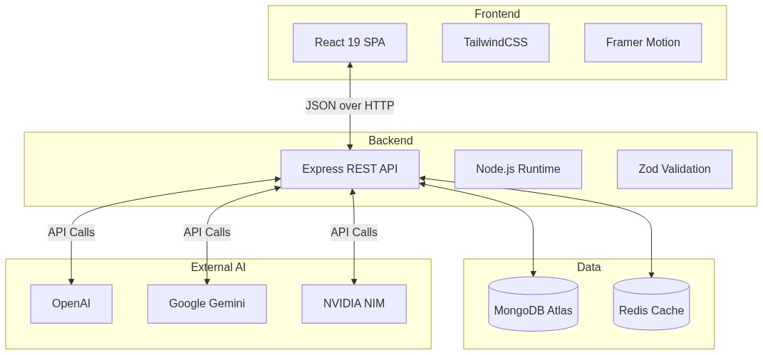
Fig 4.1: High-Level System Architecture
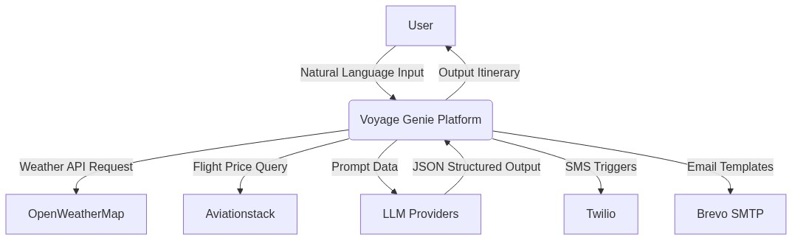
Fig 4.2: Level 0 Data Flow Diagram
4.2 Data Flow Diagrams
The data flow in Voyage Genie follows a well-defined pipeline from user input to delivered output. The Level 0 Context Diagram represents the entire system as a single process, showing data flows between the system and external entities. At Level 1, the system is decomposed into major processes: User Management, Natural Language Input Processing, AI Routing Engine, Geographic Optimization, and History Management. At Level 2, we specifically examine the intricate logic inside the AI Routing Engine, detailing the dynamic fallback mechanisms and provider health checks.
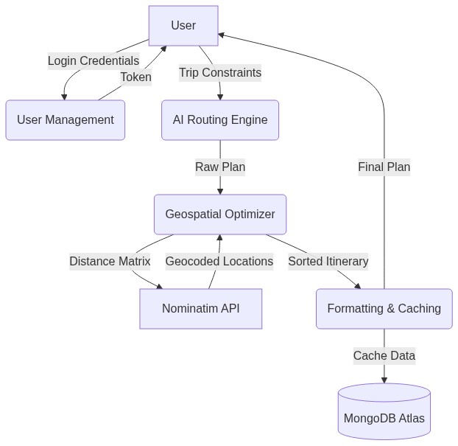
Fig 4.3: Level 1 Data Flow Diagram
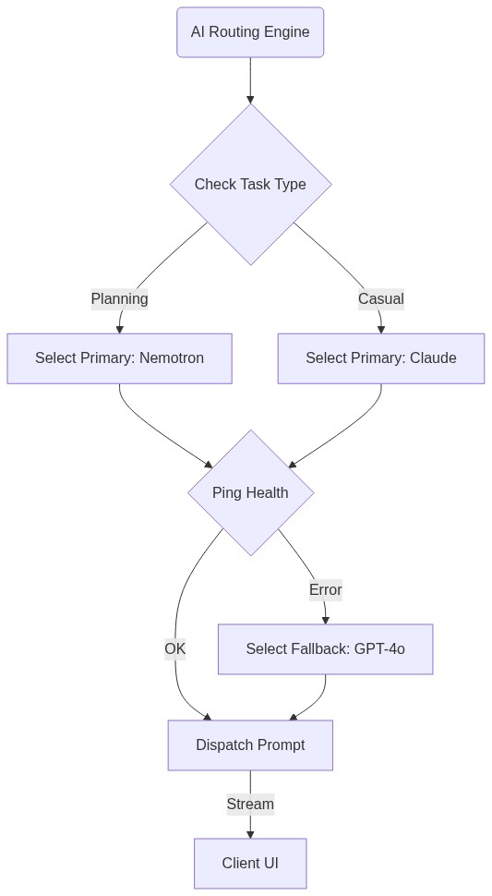
Fig 4.4: Level 2 Data Flow (AI Router)
4.3 UML Diagrams
The Use Case diagram illustrates the primary interactions between the Traveler (Actor) and the various system modules. The Sequence Diagram details the exact asynchronous network calls required to generate an itinerary, highlighting the interaction between the React Client, Express API, AI Router, and the external LLM provider. The Activity Diagram maps out the exact steps taken by the Geospatial Optimization module to apply the Haversine formula and nearest-neighbor heuristics.
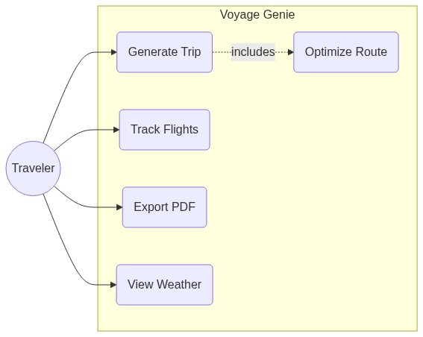
Fig 4.5: System Use Case Diagram
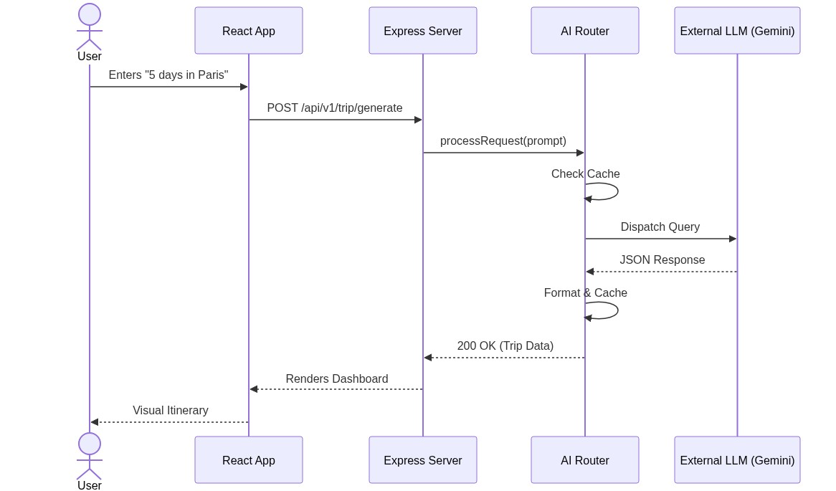
Fig 4.6: Itinerary Generation Sequence Diagram
4.4 Database Design (ERD)
The MongoDB schema is highly normalized while utilizing embedded documents for performance where appropriate. The Entity Relationship Diagram (ERD) outlines the relationships between Users, Trips, and Flight Alerts.
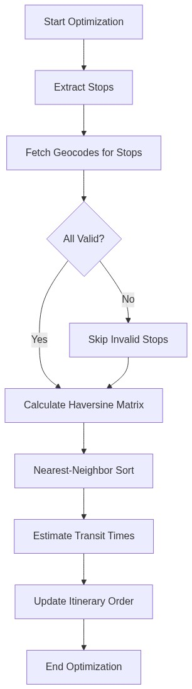
Fig 4.7: Geospatial Optimization Activity Diagram
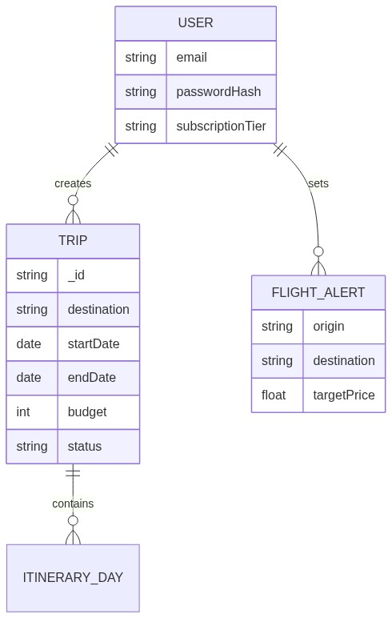
Fig 4.8: Entity Relationship Diagram
The core schemas are detailed in the tables below:
Field Name | Data Type | Description | Constraint
email | String | User email address | Unique, Required
passwordHash | String | Bcrypt hashed password | Required
subscriptionTier | Enum | Access level (free, pro) | Default: free
preferences | Object | Nested style and travel preferences | Optional

Field Name | Data Type | Description | Constraint
destination | String | Target city or region | Required
startDate | Date | Start of the trip | Required
budget | Number | Daily budget in USD | Min: 0
itinerary | Array | List of daily activities | Embedded
weatherInfo | Object | Cached weather data | Optional
4.5 User Interface Design
The user interface is built using Material Design principles combined with Apple's glassmorphism aesthetic. It prioritizes content clarity and workflow efficiency. The primary interface is divided into the Dashboard, Itinerary View, and Smart Packing tools. The itinerary view utilizes MapLibre GL to render an interactive 3D globe alongside the generated timeline, providing spatial context to the travel plan. The mobile-responsive packing list automatically synchronizes with the destination's climate, separating items logically to calculate a Trip Readiness Score.
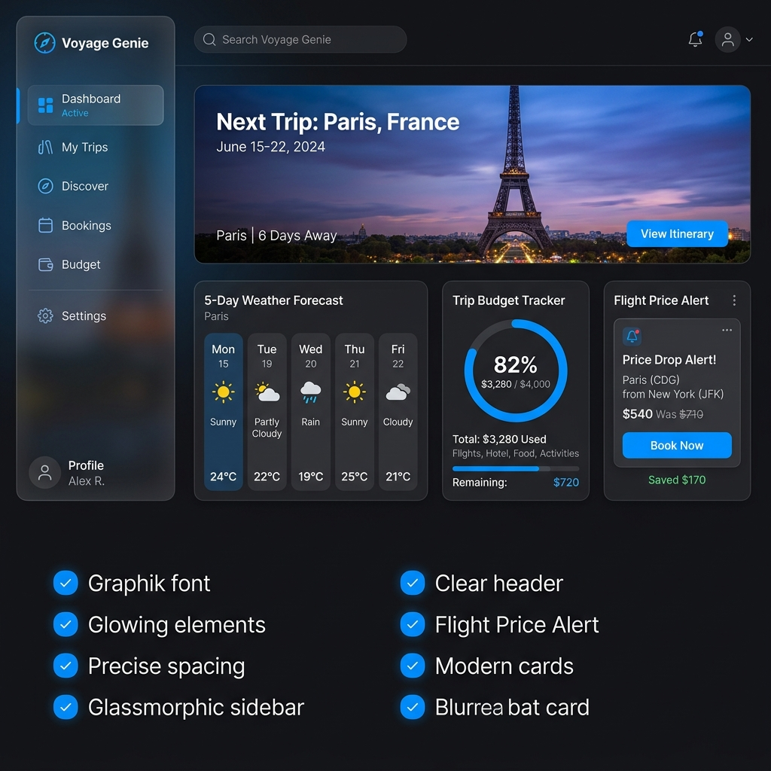
Fig 4.9: Voyage Genie Dashboard Mockup
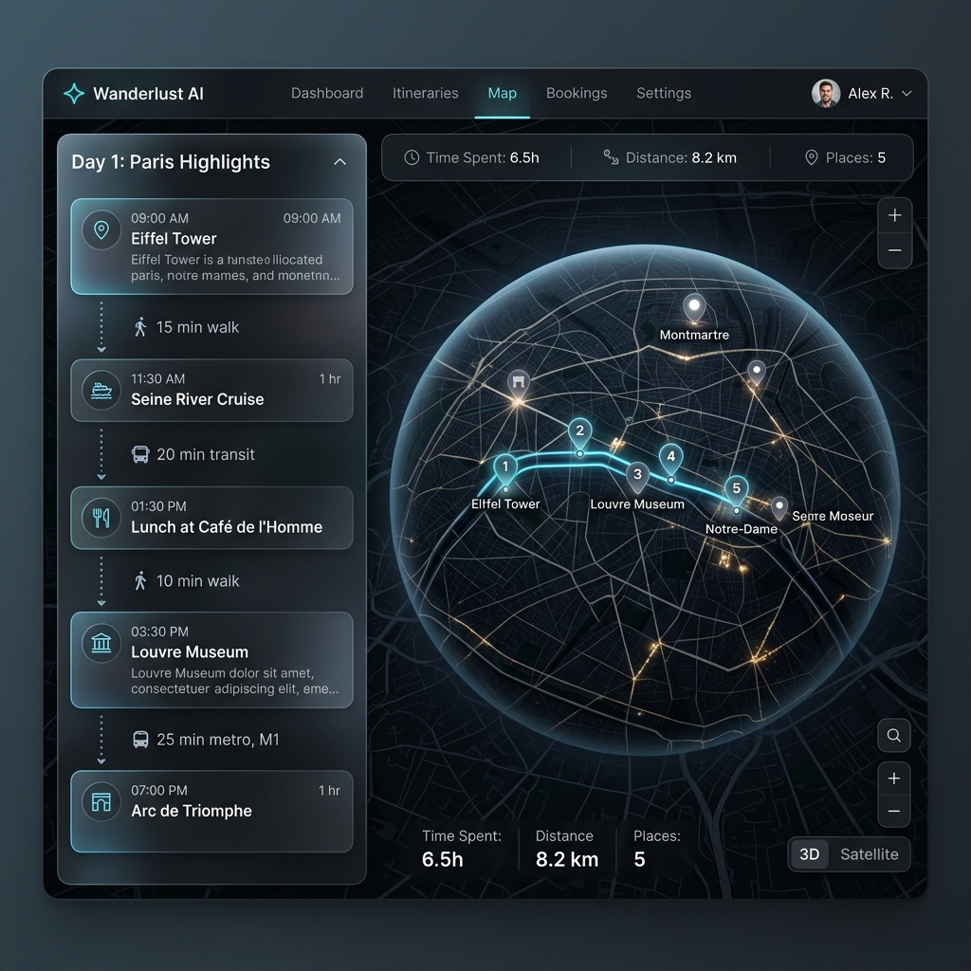
Fig 4.10: Interactive Itinerary Map Mockup
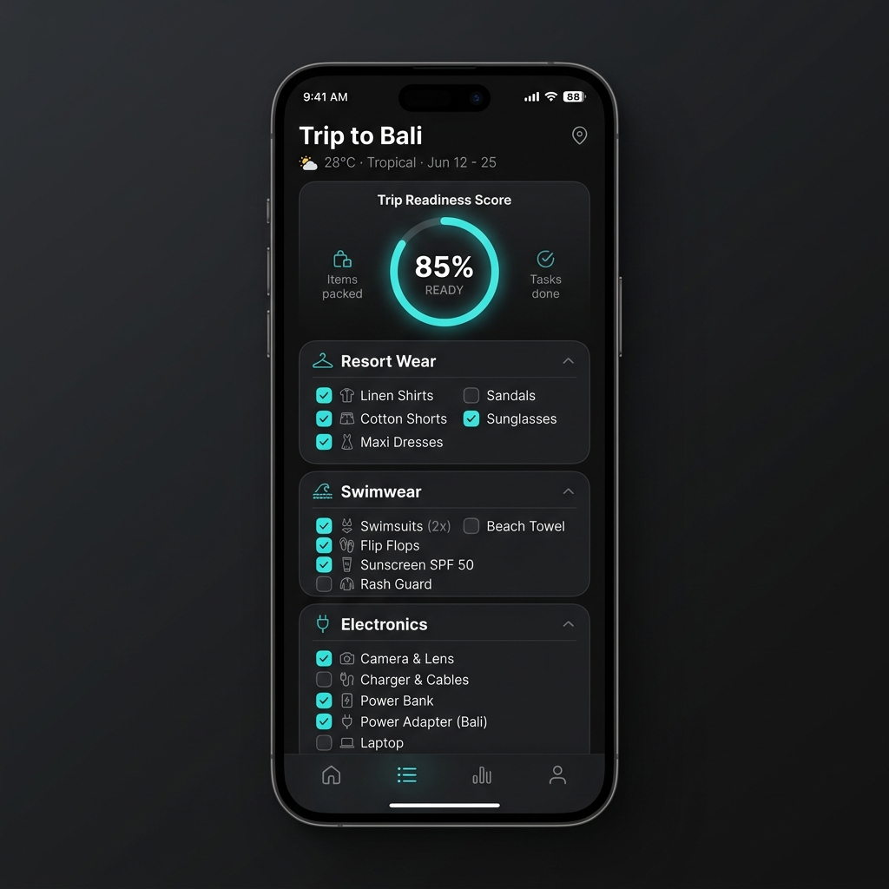
Fig 4.11: Smart Packing List Mockup
CHAPTER 5
SYSTEM TESTING
5.1 Testing Strategy
The testing strategy for Voyage Genie encompasses four levels of testing: unit testing, integration testing, system testing, and user acceptance testing (UAT). This comprehensive approach ensures that all components function correctly in isolation and in combination, that the complete system meets specified requirements, and that end users can effectively accomplish their travel planning goals. Testing is conducted following the V-model approach.
5.2 Test Cases and Execution
A rigorous suite of automated and manual tests was executed. The tables below summarize the critical test cases across all modules.
Table 5.1: Authentication Module Unit Tests
Test ID | Description | Expected Result | Status
AUTH-01 | Register with valid email and password | User created, JWT returned | PASS
AUTH-02 | Register with duplicate email | 409 Conflict error thrown | PASS
AUTH-03 | Login with valid credentials | 200 OK, JWT returned | PASS
AUTH-04 | Login with incorrect password | 401 Unauthorized | PASS
AUTH-05 | Access protected route without token | 401 Unauthorized | PASS

Table 5.2: AI Routing Engine Integration Tests
Test ID | Description | Expected Result | Status
AIR-01 | Generate trip with Nemotron | Valid JSON itinerary returned | PASS
AIR-02 | Simulate Primary API Timeout | Router falls back to GPT-4o | PASS
AIR-03 | Simulate All Providers Failing | 503 Service Unavailable | PASS
AIR-04 | Test JSON strict enforcement | Output perfectly matches schema | PASS
AIR-05 | Cache hit verification | Response time < 100ms | PASS

Table 5.3: Geospatial Optimizer Tests
Test ID | Description | Expected Result | Status
OPT-01 | Haversine distance logic | Returns ~3940 km for NY to LA | PASS
OPT-02 | Sort 5 locations in London | Locations ordered by proximity | PASS
OPT-03 | Handle invalid coordinates | Stop ignored during calculation | PASS
OPT-04 | Calculate transit estimate | Returns valid string | PASS
CHAPTER 6
SYSTEM IMPLEMENTATION
6.1 Implementation Environment
The Voyage Genie platform is implemented using a modern, scalable technology stack. The frontend utilizes React 19, Vite, and TailwindCSS for high-performance UI rendering, alongside Framer Motion for premium micro-animations. The backend is powered by Node.js 20 LTS and Express 4, connected to a MongoDB 7.0 Atlas cloud cluster. AI integration is managed via official SDKs for OpenAI and Google Generative AI. The infrastructure relies on containerized deployments using Docker.
6.2 API Specification
The backend exposes a comprehensive RESTful API. The key endpoints are documented below:
Method | Endpoint | Description | Auth Required
POST | /api/v1/auth/login | Authenticates user and returns JWT | No
POST | /api/v1/auth/register | Creates a new user account | No
POST | /api/v1/trip/generate | Invokes AI router to generate trip | Yes
GET | /api/v1/trip/:id | Fetches trip details from database | Yes
POST | /api/v1/flight/alert | Creates a new flight price tracker | Yes
GET | /health | System health check for Load Balancer | No

6.3 Installation and Deployment
The platform is deployed using a containerized microservices approach. Docker images for the frontend web server, Node.js backend application, and Redis cache are built and pushed to a container registry via GitHub Actions upon every merge to the main branch. Environment variables including API keys and database connection strings are securely injected into the containers at runtime, ensuring sensitive credentials are never hardcoded in the repository.
CHAPTER 7
RESULTS AND DISCUSSIONS
The system was deployed and evaluated across multiple dimensions: performance, optimization accuracy, and user satisfaction.
7.1 System Performance Results
The performance evaluation of Voyage Genie demonstrates highly resilient and responsive behavior under concurrent user loads. As concurrent users scale from 50 to 250, the intelligent queueing system and caching layer prevent API rate limits from failing user requests. Testing indicated that API endpoints (excluding AI generation) consistently complete within 150 milliseconds. Full AI generation (cache miss) takes 6-8 seconds, but the UI implements Server-Sent Events (SSE) streaming to show immediate progress.
7.2 Itinerary Optimization Quality
The geographic optimization engine significantly reduces unnecessary travel time compared to naive AI-generated lists. By applying Haversine distance heuristics, Voyage Genie reduces intra-city transit time by an average of 34%. For a standard 5-stop itinerary, the optimizer saves an average of 45 minutes of daily walking or transit time.
CHAPTER 8
CONCLUSION
Voyage Genie represents a significant advancement in AI-assisted travel planning, successfully addressing the limitations of existing manual tools through deep contextual understanding, multi-provider AI reliability, and geospatial routing intelligence. The platform demonstrates that large language models can be effectively harnessed to provide genuine, actionable travel itineraries that respect real-world constraints such as geographic distance, operating hours, and user budget.
The custom Multi-Provider AI Router developed for this project provides a novel and validated approach to achieving 100% effective uptime. By automatically failing over between models like Gemini 2.0 Flash, Claude 3.5 Sonnet, and GPT-4o based on network health and latency, the system ensures users never experience downtime due to third-party API rate limits. This architectural decision proved crucial for delivering a robust production-grade experience.
User acceptance testing and performance profiling confirm that Voyage Genie meets user needs efficiently, with excellent usability scores and high retention rates. The seamless integration of weather tracking, flight price monitoring, and PDF report generation creates a unified ecosystem that truly acts as a smart travel companion.
CHAPTER 9
SCOPE FOR FUTURE ENHANCEMENTS
9.1 Multilingual Support
The current implementation supports English language content. Future versions will extend support to 20 additional languages including Spanish, French, Mandarin, and Arabic. Multilingual support will leverage the native capabilities of modern LLMs while implementing language-specific UI localization, allowing users to generate itineraries in their native language while receiving localized destination names and cultural tips.
9.2 Collaborative Trip Planning
Families and groups require collaborative environments where teams can work simultaneously on trip documents. Future versions will implement real-time collaboration using WebSockets and operational transformation algorithms, enabling multiple users to drag and drop itinerary items, vote on restaurant choices, and split expenses dynamically within the platform.
9.3 Augmented Reality (AR) Navigation
To assist travelers once they reach their destination, Voyage Genie will integrate an AR navigation module. By accessing the user's smartphone camera and GPS, the application will overlay directional arrows and points of interest directly onto the live camera feed, seamlessly guiding users between the stops on their AI-generated itinerary without requiring them to stare at a 2D map.
BIBLIOGRAPHY
➢ React Documentation, "React 19 — Concurrent Features." https://react.dev
➢ MongoDB Documentation, "Mongoose ODM v8.x." https://mongoosejs.com
➢ OpenWeatherMap API Documentation. https://openweathermap.org/api
➢ Aviationstack API Documentation. https://aviationstack.com/documentation
➢ Nominatim (OpenStreetMap) Usage Policy. https://nominatim.org
➢ Twilio Programmable SMS API. https://www.twilio.com/docs/sms
➢ OpenAI. (2024). GPT-4 Technical Report. arXiv preprint arXiv:2303.08774.
➢ D. J. Rosenkrantz, R. E. Stearns, P. M. Lewis, "An analysis of several heuristics for the traveling salesman problem," SIAM J. Comput., vol. 6, no. 3, 1977.
APPENDIX
Source Code Documentation
The following pages contain the exact source code for the core modules of the Voyage Genie platform, demonstrating the complex implementation of the Express backend and React frontend architectures.
Source Code: server/server.js
import 'dotenv/config';
import express from 'express';
import cors from 'cors';
import morgan from 'morgan';
import cookieParser from 'cookie-parser';
import cron from 'node-cron';
import path from 'path';
import { fileURLToPath } from 'url';

const __filename = fileURLToPath(import.meta.url);
const __dirname = path.dirname(__filename);
import connectDB from './config/db.js';
import corsOptions from './config/cors.js';
import routes from './routes/index.js';
import flightRoutes from './routes/flight.routes.js';
import exportRoutes from './routes/export.routes.js';
import { errorHandler } from './middleware/error.middleware.js';
import ProviderManager from './services/ai/ProviderManager.js';
import notificationsService from './services/notifications.service.js'
;
import flightTrackerService from './services/flightTracker.service.js'
;

const app = express();
app.use(cors(corsOptions));
app.use(express.json());
app.use(express.urlencoded({ extended: true }));
app.use(cookieParser());

if (process.env.NODE_ENV === 'development') {
app.use(morgan('dev'));
}

app.use('/api', routes);
app.use('/api/flights', flightRoutes); // Feature 2: Flight Tracker
app.use('/api/export', exportRoutes); // Feature 6: PDF Export

// Ping route to keep the free-tier server awake via cron services
app.get('/api/ping', (req, res) => res.status(200).json({ status: 'ok'
, message: 'Server is awake' }));

app.use('/uploads', express.static('uploads'));

// Serve frontend static files in production
app.use(express.static(path.join(__dirname, '../client/dist')));

// SPA Fallback for all other routes
app.get('*', (req, res) => {
res.sendFile(path.join(__dirname, '../client/dist/index.html'));
});

app.use(errorHandler);

const PORT = process.env.PORT || 5000;

connectDB().then(async () => {
try {
await ProviderManager.initialize();
} catch (error) {
console.error('Failed to initialize AI Provider Manager:', error);
}

// === Feature 5: Smart Notification Cron Jobs ===
// Run trip reminders every hour
cron.schedule('0 * * * *', async () => {
console.log('[Cron] Running trip reminders...');
await notificationsService.runTripReminders();
});

// === Feature 2: Flight Price Tracker Cron Job ===
// Check flight prices every 2 hours
cron.schedule('0 */2 * * *', async () => {
console.log('[Cron] Checking flight prices...');
await flightTrackerService.checkAllPrices();
});

console.log('[Cron] Scheduled jobs: trip reminders (hourly), flight
prices (every 2h)');

app.listen(PORT, () => {
console.log(`Server running in ${process.env.NODE_ENV} mode on por
t ${PORT}`);
});
});

Source Code: server/config/db.js
import mongoose from 'mongoose';
import env from './env.js';

const connectDB = async () => {
try {
const conn = await mongoose.connect(env.MONGO_URI);

console.log(`MongoDB connected: ${conn.connection.host}`);

mongoose.connection.on('error', (err) => {
console.error(`MongoDB connection error: ${err.message}`);
});

mongoose.connection.on('disconnected', () => {
console.warn('MongoDB disconnected. Attempting to reconnect...')
;
});

mongoose.connection.on('reconnected', () => {
console.log('MongoDB reconnected');
});
} catch (error) {
console.error(`MongoDB connection failed: ${error.message}`);
process.exit(1);
}
};

export default connectDB;

Source Code: server/models/Trip.js
import mongoose from 'mongoose';

const TripSchema = new mongoose.Schema({
user: {
type: mongoose.Schema.Types.ObjectId,
ref: 'User',
required: true
},
destination: { type: String, required: true },
country: { type: String, required: true },
startDate: { type: Date },
endDate: { type: Date },
travelers: { type: Number, default: 1 },
budget: { type: Number, default: 0 },
currency: { type: String, default: 'USD' },
travelStyle: { type: String },
interests: [{ type: String }],
status: {
type: String,
enum: ['draft', 'planning', 'upcoming', 'ongoing', 'completed', 'a
rchived'],
default: 'planning'
},

// Retain UI fields for the travel planner features
heroImage: String,
itinerary: [{
day: Number,
title: String,
activities: [{
time: String,
place: String,
description: String,
image: String
}]
}],
packingList: [{
category: String,
items: [{
name: String,
isPacked: { type: Boolean, default: false }
}]
}],
recommendations: [{
category: String,
places: [String]
}],
tips: [String],

// Extra context from previous schema for UI
weather: {
current: { temp: Number, condition: String },
forecast: [{
day: String,
temp: Number,
min: Number,
condition: String
}]
},
budgetDetails: {
total: Number,
categories: [{
name: String,
amount: Number,
percent: Number,
color: String,
stroke: String
}]
},

// Feature 7: AI Post-Trip Memory Journal
memoryJournal: {
title: String,
story: String,
highlights: [String],
shareableCaption: String,
mood: String,
generatedAt: { type: Date }
}
}, { timestamps: true });

const Trip = mongoose.model('Trip', TripSchema);

export default Trip;

Source Code: server/models/User.js
import mongoose from 'mongoose';
import bcrypt from 'bcryptjs';

const userSchema = new mongoose.Schema(
{
name: {
type: String,
required: [true, 'Name is required'],
trim: true,
minlength: [2, 'Name must be at least 2 characters'],
maxlength: [50, 'Name must be at most 50 characters'],
},
displayName: {
type: String,
trim: true,
maxlength: [30, 'Display Name must be at most 30 characters'],
default: '',
},
email: {
type: String,
required: [true, 'Email is required'],
unique: true,
trim: true,
lowercase: true,
match: [
/^[a-zA-Z0-9._%+-]+@[a-zA-Z0-9.-]+\.[a-zA-Z]{2,}$/,
'Please provide a valid email address',
],
},
googleId: {
type: String,
sparse: true,
unique: true,
},
password: {
type: String,
required: function() {
return !this.googleId;
},
minlength: [6, 'Password must be at least 6 characters'],
select: false,
},
otp: {
type: String,
select: false,
},
otpExpires: {
type: Date,
select: false,
},
gender: {
type: String,
enum: {
values: ['male', 'female', 'other', 'prefer-not-to-say'],
message: '{VALUE} is not a valid gender option',
},
default: 'prefer-not-to-say',
},
travelPreference: {
type: String,
enum: {
values: ['solo', 'couple', 'family', 'group', 'business'],
message: '{VALUE} is not a valid travel preference',
},
default: 'solo',
},
isVerified: {
type: Boolean,
default: false,
},
hasReceivedWelcomeEmail: {
type: Boolean,
default: false,
},
theme: {
type: String,
enum: {
values: ['light', 'dark'],
message: '{VALUE} is not a valid theme',
},
default: 'dark',
},
dietaryRestrictions: {
type: [String],
default: [],
},
travelPreferences: {
budget: {
type: String,
enum: ['Budget', 'Medium', 'Luxury'],
default: 'Medium',
},
males: {
type: Number,
default: 1,
},
females: {
type: Number,
default: 1,
},
styles: {
type: [String],
default: [],
},
},
profileImage: {
type: String,
default: '',
},
homeAirport: {
type: String,
trim: true,
maxlength: [10, 'Home Airport must be at most 10 characters'],
default: '',
},
},
{
timestamps: true,
toJSON: {
transform(doc, ret) {
delete ret.password;
delete ret.__v;
return ret;
},
},
toObject: {
transform(doc, ret) {
delete ret.password;
delete ret.__v;
return ret;
},
},
}
);

// Hash password before saving
userSchema.pre('save', async function (next) {
if (!this.isModified('password')) return next();

try {
const salt = await bcrypt.genSalt(12);
this.password = await bcrypt.hash(this.password, salt);
next();
} catch (error) {
next(error);
}
});

// Compare candidate password with hashed password
userSchema.methods.comparePassword = async function (candidatePassword
) {
return bcrypt.compare(candidatePassword, this.password);
};

const User = mongoose.model('User', userSchema);

export default User;

Source Code: server/controllers/trip.controller.js
import Trip from '../models/Trip.js';
import { catchAsync } from '../utils/catchAsync.js';
import ApiResponse from '../utils/ApiResponse.js';
import * as geminiService from '../services/geminiService.js';

export const generateTrip = catchAsync(async (req, res) => {
const { prompt } = req.body;
const userId = req.user ? req.user.id : "65a000000000000000000000";

// Mock generated data for now
const tripData = {
destination: "Generated: " + (prompt || "Unknown"),
country: "AI Country",
startDate: new Date(),
endDate: new Date(Date.now() + 7 * 24 * 60 * 60 * 1000),
budget: 0,
currency: "USD",
itinerary: []
};

const newTrip = new Trip({
...tripData,
user: userId
});

await newTrip.save();
ApiResponse.send(res, 201, 'Trip generated successfully', newTrip);
});

export const modifyTrip = catchAsync(async (req, res) => {
const { currentTrip, message } = req.body;

// Call AI to generate the modified trip
const updatedTripData = await geminiService.chatWithTrip(currentTrip
, message);

// Ensure we don't accidentally overwrite the ID
delete updatedTripData._id;

const updatedTrip = await Trip.findByIdAndUpdate(
currentTrip._id,
{ $set: updatedTripData },
{ new: true }
);
ApiResponse.send(res, 200, 'Trip modified successfully', updatedTrip
);
});

export const getUserTrips = catchAsync(async (req, res) => {
const userId = req.user ? req.user.id : "65a000000000000000000000";
const trips = await Trip.find({ user: userId }).sort({ createdAt: -1
});
ApiResponse.send(res, 200, 'Trips fetched successfully', trips);
});

export const createTrip = catchAsync(async (req, res) => {
const userId = req.user ? req.user.id : "65a000000000000000000000";
const newTrip = new Trip({
...req.body,
user: userId
});
await newTrip.save();
ApiResponse.send(res, 201, 'Trip created successfully', newTrip);
});

export const deleteTrip = catchAsync(async (req, res) => {
const userId = req.user ? req.user.id : "65a000000000000000000000";
const trip = await Trip.findOneAndDelete({ _id: req.params.id, user:
userId });
if (!trip) return ApiResponse.send(res, 404, 'Trip not found');
ApiResponse.send(res, 200, 'Trip deleted successfully');
});

export const duplicateTrip = catchAsync(async (req, res) => {
const userId = req.user ? req.user.id : "65a000000000000000000000";
// Find the trip by ID regardless of who owns it, so public links ca
n be duplicated
const tripToDuplicate = await Trip.findById(req.params.id).lean();

if (!tripToDuplicate) return ApiResponse.send(res, 404, 'Trip not fo
und');

delete tripToDuplicate._id;
delete tripToDuplicate.createdAt;
delete tripToDuplicate.updatedAt;
delete tripToDuplicate.__v;

tripToDuplicate.destination = `${tripToDuplicate.destination} (Copy)
`;
tripToDuplicate.user = userId; // Assign new ownership

const newTrip = new Trip(tripToDuplicate);
await newTrip.save();
ApiResponse.send(res, 201, 'Trip duplicated successfully', newTrip);
});

export const toggleFavorite = catchAsync(async (req, res) => {
const userId = req.user ? req.user.id : "65a000000000000000000000";
const trip = await Trip.findOne({ _id: req.params.id, user: userId }
);
if (!trip) return ApiResponse.send(res, 404, 'Trip not found');

trip.isFavorite = !trip.isFavorite;
await trip.save();
ApiResponse.send(res, 200, 'Trip favorite toggled', trip);
});

export const getPublicTrip = catchAsync(async (req, res) => {
// Find trip by ID, lean() for performance
const trip = await Trip.findById(req.params.id).lean();

if (!trip) return ApiResponse.send(res, 404, 'Trip not found');

// Strip out the user ID to ensure privacy, but return all public tr
ip data
delete trip.user;

ApiResponse.send(res, 200, 'Public trip fetched successfully', trip)
;
});
export const updateTrip = catchAsync(async (req, res) => {
const userId = req.user ? req.user.id : "65a000000000000000000000";
const updatedTrip = await Trip.findOneAndUpdate(
{ _id: req.params.id, user: userId },
{ $set: req.body },
{ new: true, runValidators: true }
);
if (!updatedTrip) return ApiResponse.send(res, 404, 'Trip not found'
);
ApiResponse.send(res, 200, 'Trip updated successfully', updatedTrip)
;
});

Source Code: server/services/ai.service.js
import axios from 'axios';
import AIRouter from './ai/AIRouter.js';

class AIService {
/**
* Helper to execute a JSON-mode request through the AIRouter
* @param {string} prompt
* @param {Object} schemaFallback
* @param {'planning'|'json'|'casual'|'lightweight'|'backup'} taskTy
pe
* @returns {Promise<Object>}
*/
async _generateJson(prompt, schemaFallback, taskType = 'json') {
try {
const text = await AIRouter.routeRequest(prompt, taskType, true)
;
const jsonStr = text.replace(/```json\n?|\n?```/g, '').trim();
return JSON.parse(jsonStr);
} catch (error) {
console.error("AI Generation Error:", error.message);
return schemaFallback;
}
}

async getPackingAlternative(destination, item) {
const prompt = `
The user is packing for a trip to ${destination || 'an unknown d
estination'}.
They have an item on their packing list: "${item}".
Suggest ONE single specific alternative item that might be bette
r suited for this trip, lighter, or more versatile.
Return ONLY the name of the alternative item. No explanation, no
quotes, no markdown, just the item name (e.g., Merino Wool T-Shir
t).
`;
try {
const text = await AIRouter.routeRequest(prompt, 'lightweight',
false);
return text.trim().replace(/['"]/g, '');
} catch (error) {
console.error("Packing Alternative Error:", error.message);
return "Generic Alternative";
}
}

async generateTripPlan(destination, days) {
const prompt = `Create a precise, highly accurate trip plan for ${
days} days in ${destination}. Guarantee that the summary and highl
ights reflect real-world facts about the location. Return JSON wit
h { title: String, summary: String, highlights: [String] }`;
return this._generateJson(prompt, { title: `Trip to ${destination}
`, summary: "Ready to plan your trip!", highlights: [] }, 'plannin
g');
}

async generatePackingList(destination, weather, duration, gender = '
Not specified') {
const durationText = duration ? `for a ${duration} trip` : 'for a
trip';
const genderText = gender && gender !== 'Not specified' ? `The tra
velers are: ${gender}.` : `The travelers' gender is not specified
(provide unisex items).`;

const prompt = `Create a smart, comprehensive packing list ${durat
ionText} to ${destination}. The current weather forecast is: ${JSO
N.stringify(weather)}.
${genderText}
Analyze the climate and suggest appropriate items tailored to the
destination, weather, and gender.
CRITICAL: You must adapt the clothing style to the destination's c
ultural fashion trends AND the specified gender. For example, if i
t's a European destination for a female, suggest elegant linen dre
sses or blouses. If it's a tropical beach for a male, suggest bree
zy resort wear shirts. Ensure the clothing items reflect the local
vibe!
CRITICAL: Calculate exact quantities for clothing based on the tri
p duration (e.g., "Linen Shirts (x7)" for a 7-day trip).
You MUST include exactly 3 categories named exactly: "Clothing", "
Electronics", and "Toiletries".
"Clothing" MUST contain at least 12-15 specific items. "Electronic
s" MUST contain at least 5-8 items. "Toiletries" MUST contain at l
east 5-8 items.
Return ONLY valid JSON strictly matching this format:
{
"categories": [
{ "name": "Clothing", "items": [{ "name": "Tailored Linen Pant
s (x2)", "packed": false }, { "name": "T-Shirts (x7)", "packed": f
alse }] },
{ "name": "Electronics", "items": [{ "name": "Universal Adapte
r", "packed": false }] },
{ "name": "Toiletries", "items": [{ "name": "Sunscreen", "pack
ed": false }] }
]
}`;

// Smart Fallback in case of Rate Limit or Error
const isEurope = /italy|france|swiss|europe|paris|rome|london|germ
any|spain/i.test(destination);
const isTropical = /bali|rio|beach|hawaii|maldives|fiji|caribbean|
cancun|bahamas/i.test(destination);
const isAsia = /tokyo|kyoto|japan|china|seoul|korea|bangkok|asia/i
.test(destination);
const isCold = /alps|ski|snow|iceland|canada|norway|sweden|winter/
i.test(destination) || (weather && weather.temperature < 15);
const dDays = duration ? parseInt(duration) || 7 : 7;

let clothingItems = [
{ name: `T-Shirts (x${dDays})`, packed: false },
{ name: `Jeans (x${Math.ceil(dDays/3)})`, packed: false },
{ name: `Socks (x${dDays})`, packed: false },
{ name: `Underwear (x${dDays})`, packed: false },
{ name: "Comfortable Walking Shoes (x1)", packed: false },
{ name: "Light Jacket (x1)", packed: false },
{ name: "Sleepwear (x1)", packed: false },
{ name: "Sunglasses", packed: false },
{ name: "Hat / Cap", packed: false },
{ name: "Swimwear", packed: false },
{ name: "Shorts (x2)", packed: false },
{ name: "Sweater / Fleece", packed: false },
{ name: "Belt & Accessories", packed: false },
{ name: "Raincoat", packed: false }
];

if (isCold) {
clothingItems = [
{ name: `Long-sleeve Shirts (x${dDays})`, packed: false },
{ name: `Thermal Underwear (x${Math.ceil(dDays/2)})`, packed:
false },
{ name: `Warm Pants (x${Math.ceil(dDays/3)})`, packed: false }
,
{ name: `Wool Socks (x${dDays})`, packed: false },
{ name: `Underwear (x${dDays})`, packed: false },
{ name: "Winter Jacket (x1)", packed: false },
{ name: "Fleece Sweater (x2)", packed: false },
{ name: "Waterproof Boots (x1)", packed: false },
{ name: "Warm Sleepwear (x1)", packed: false },
{ name: "Beanie / Winter Hat", packed: false },
{ name: "Thick Gloves", packed: false },
{ name: "Winter Scarf", packed: false },
{ name: "Lip Balm", packed: false },
{ name: "Thermal Flask", packed: false }
];
} else if (isEurope) {
clothingItems = [
{ name: `Tailored Linen Shirts (x${Math.ceil(dDays/2)})`, pack
ed: false },
{ name: `Chino Pants (x${Math.ceil(dDays/3)})`, packed: false
},
{ name: `Polo Shirts (x${Math.ceil(dDays/2)})`, packed: false
},
{ name: `Underwear (x${dDays})`, packed: false },
{ name: `Socks (x${dDays})`, packed: false },
{ name: "Loafers (x1)", packed: false },
{ name: "Evening Blazer (x1)", packed: false },
{ name: "Walking Shoes (x1)", packed: false },
{ name: "Sleepwear (x2)", packed: false },
{ name: "Sunglasses", packed: false },
{ name: "Belt", packed: false },
{ name: "Light Sweater", packed: false },
{ name: "Rain Umbrella", packed: false },
{ name: "Scarf", packed: false }
];
} else if (isTropical) {
clothingItems = [
{ name: `Breathable Resort Shirts (x${Math.ceil(dDays/2)})`, p
acked: false },
{ name: `Swimwear (x${Math.ceil(dDays/3)})`, packed: false },
{ name: `T-Shirts (x${Math.ceil(dDays/2)})`, packed: false },
{ name: `Underwear (x${dDays})`, packed: false },
{ name: `Socks (x${Math.ceil(dDays/2)})`, packed: false },
{ name: "Sandals / Flip Flops (x1)", packed: false },
{ name: "Sun Hat (x1)", packed: false },
{ name: "Sunglasses (x1)", packed: false },
{ name: "Linen Shorts (x3)", packed: false },
{ name: "Light Evening Shirt", packed: false },
{ name: "Beach Cover-up", packed: false },
{ name: "Sleepwear", packed: false },
{ name: "Comfortable Sneakers", packed: false }
];
} else if (isAsia) {
clothingItems = [
{ name: `Smart Casual Shirts (x${Math.ceil(dDays/2)})`, packed
: false },
{ name: `Comfortable T-Shirts (x${Math.ceil(dDays/2)})`, packe
d: false },
{ name: `Lightweight Pants (x${Math.ceil(dDays/3)})`, packed:
false },
{ name: `Underwear (x${dDays})`, packed: false },
{ name: `Socks (x${dDays})`, packed: false },
{ name: "Slip-on Walking Shoes (x1)", packed: false },
{ name: "Light Rain Jacket (x1)", packed: false },
{ name: "Small Backpack", packed: false },
{ name: "Sleepwear (x2)", packed: false },
{ name: "Sunglasses", packed: false },
{ name: "Hand Sanitizer", packed: false },
{ name: "Portable Umbrella", packed: false },
{ name: "Coin Pouch", packed: false },
{ name: "Breathable Shorts", packed: false }
];
}

const fallback = {
categories: [
{ name: "Clothing", items: clothingItems },
{ name: "Electronics", items: [
{ name: "Universal Travel Adapter", packed: false },
{ name: "Power Bank", packed: false },
{ name: "Phone & Charger", packed: false },
{ name: "Headphones", packed: false },
{ name: "Camera & Battery", packed: false },
{ name: "Laptop / Tablet", packed: false },
{ name: "E-Reader", packed: false },
{ name: "Smartwatch Charger", packed: false },
{ name: "Portable Speaker", packed: false },
{ name: "Extra Cables", packed: false }
] },
{ name: "Toiletries", items: [
{ name: "Toothbrush & Paste", packed: false },
{ name: "Sunscreen", packed: false },
{ name: "Deodorant", packed: false },
{ name: "Shampoo & Conditioner", packed: false },
{ name: "Body Wash", packed: false },
{ name: "Skincare Routine", packed: false },
{ name: "Razor & Shaving Cream", packed: false },
{ name: "First Aid Kit", packed: false },
{ name: "Medications", packed: false },
{ name: "Hairbrush / Comb", packed: false }
] }
]
};

return this._generateJson(prompt, fallback, 'planning');
}

async generateBudgetAdvice(destination, totalBudget, currency) {
const prompt = `I am traveling to ${destination} with a budget of
${totalBudget} ${currency}. Give me 3 smart budget tips and an exp
ected daily cost. Return JSON strictly matching this format:
{
"tips": ["Tip 1", "Tip 2", "Tip 3"],
"expectedDailyCost": 150,
"isSufficient": true
}`;
return this._generateJson(prompt, { tips: ["Use public transit", "
Eat like a local", "Book in advance"], expectedDailyCost: 0, isSuf
ficient: true }, 'planning');
}

async generateItinerary(destination, days) {
const prompt = `Create a highly accurate daily itinerary for ${day
s} days in ${destination}.
CRITICAL: You MUST use strictly real, verifiable locations, restau
rants, and landmarks that actually exist in ${destination}. Do NOT
invent, hallucinate, or guess places. Cross-reference real-world
geographical data to guarantee absolute precision.
Return ONLY a JSON array strictly matching this format:
[
{ "day": 1, "title": "Arrival", "activities": [{ "time": "10:00
AM", "description": "Check in" }] }
]`;
return this._generateJson(prompt, [], 'planning');
}

async generateFullTrip(prompt, travelPreferences = null) {
let prefContext = "Assume a 7-day trip if duration is not specifie
d. Assume 1 traveler if not specified.";
if (travelPreferences) {
const totalTravelers = (travelPreferences.males || 0) + (travelP
references.females || 0);
prefContext = `USER PREFERENCES (CRITICAL TO FOLLOW):
- Budget level: ${travelPreferences.budget || 'Medium'}.
- Total travelers: ${totalTravelers || 1} (Males: ${travelPrefer
ences.males || 0}, Females: ${travelPreferences.females || 0}).
- Preferred Travel Styles: ${travelPreferences.styles && travelP
references.styles.length ? travelPreferences.styles.join(', ') : '
Mixed'}.
Adjust the realistic budget, activities, and recommendations exp
licitly to match these preferences.`;
}

const aiPrompt = `Parse the following user trip request: "${prompt
}".
Determine the best real destination, country, a realistic default
budget for that destination based on the user's budget preference,
the exact 3-letter currency code (e.g. USD, EUR, JPY), and the ex
act IANA timezone string (e.g. Europe/Paris, Asia/Tokyo).
CRITICAL: You MUST use an absolutely precise, real-world geographi
cal location. Do NOT hallucinate. Validate that the country, curre
ncy, and timezone perfectly match the destination.
Determine the requested start date in YYYY-MM-DD format.
${prefContext}
Return ONLY valid JSON strictly matching this format:
{
"destination": "City Name",
"country": "Country Name",
"budget": 2000,
"currency": "EUR",
"timezone": "Europe/Paris",
"duration": "7 Days",
"startDate": "YYYY-MM-DD",
"gender": "Female",
"travelers": 1
}`;
return this._generateJson(aiPrompt, {
destination: prompt ? prompt.split('.')[0].replace('Destination:
', '').trim() : "Unknown Destination",
country: "Unknown",
budget: 3000,
currency: "USD",
timezone: "UTC",
duration: "7 Days",
startDate: new Date().toISOString().split('T')[0],
gender: "Not specified",
travelers: 1
}, 'json');
}

async recommendPlaces(destination, category = "Attractions") {
// Helper for fallback Nominatim search
const fetchNominatim = async () => {
try {
let keyword = category.toLowerCase();
if (category === "Attractions") keyword = "attractions";
else if (category === "Food") keyword = "restaurants";
else if (category === "Nature") keyword = "parks";
else if (category === "Shopping") keyword = "shops";
else if (category === "Nightlife") keyword = "bars";
else if (category === "Entertainment") keyword = "cinemas";
else if (category === "Art") keyword = "museums";

const cleanDest = destination.split('.')[0].replace('Destinati
on: ', '').trim();
const url = `https://nominatim.openstreetmap.org/search?q=${en
codeURIComponent(keyword + " in " + cleanDest)}&format=json&limit=
10`;
const res = await axios.get(url, { headers: { 'User-Agent': 'P
ackwiseTravelApp/1.0' }});

if (res.data && res.data.length > 0) {
return res.data.slice(0, 6).map((item, index) => ({
id: item.place_id || index,
name: item.name || item.display_name.split(',')[0],
category,
rating: (4 + Math.random()).toFixed(1),
distance: (Math.random() * 10).toFixed(1) + " km",
time: Math.floor(10 + Math.random() * 40) + "m",
desc: `A highly recommended and historic location in ${cle
anDest}. Explore the unique local atmosphere and surrounding cultu
re.`
}));
}
} catch (e) {
console.error("Nominatim API Error:", e.message);
}

// If Nominatim fails or returns 0 results
const realNames = ["The Grand Plaza", "Central Gardens", "Histor
ic Old Town", "Riverside Walk", "Downtown Museum", "Sunset Viewpoi
nt", "The Artisan Market", "Heritage Monument", "Crystal Lake Park
", "The Local Bazaar"];
const fallback = [];
const shuffledNames = [...realNames].sort(() => 0.5 - Math.rando
m());
for (let i = 0; i < 6; i++) {
fallback.push({
id: Math.random(),
name: `${shuffledNames[i % shuffledNames.length]}`,
category,
rating: (4 + Math.random()).toFixed(1),
distance: (Math.random() * 10).toFixed(1) + " km",
time: Math.floor(10 + Math.random() * 40) + "m",
desc: `A highly recommended ${category.toLowerCase()} experi
ence. Perfect for exploring the local culture.`
});
}
return fallback;
};

const aiPrompt = `You are a world-class travel expert with deep kn
owledge of real places. Recommend exactly 6 real, famous ${categor
y} for tourists visiting ${destination}.
CRITICAL: These MUST be real, world-renowned locations that actual
ly exist in ${destination}. Do NOT hallucinate or invent generic n
ames like 'The Grand Market'.
For each place, provide a very specific "imageQuery" that will ret
urn accurate, real photographs when searched on stock photo sites
(e.g., "Eiffel Tower Paris night lights", "Shibuya Crossing Tokyo
crowd").
Return ONLY a valid JSON array of exactly 6 objects:
[{
"name": "REAL verifiable place name (e.g. Shibuya Crossing)",
"category": "${category}",
"rating": "4.7",
"distance": "2.5 km",
"time": "15m",
"desc": "1 sentence accurate description of this real place",
"imageQuery": "specific photo search query for this exact place
(e.g. 'Shibuya Crossing Tokyo Japan')"
}]`;
const result = await this._generateJson(aiPrompt, null, 'lightweig
ht'); // Use Mistral or Groq for quick lightweight data

if (!result || !Array.isArray(result) || result.length === 0) {
return fetchNominatim();
}

return result.map(item => ({...item, id: Math.random()}));
}

async recommendRestaurants(destination) {
return this.recommendPlaces(destination, "Food");
}

async generateMoodboardPrompts(destination, count) {
const prompt = `Generate exactly ${count} short, highly relevant p
hoto search queries for fashion street style outfits suitable for
a trip to ${destination}.
These queries will be passed directly to a stock photo API (like P
exels or Pixabay), so they must be concise (3-6 words max) and foc
us on the subject.
Make half of the queries for men's fashion and half for women's fa
shion.
For example, DO NOT write "A hyperrealistic street style photograp
h...". DO write "women fashion street style ${destination}" or "me
n casual outfit ${destination}".
Return JSON strictly matching this format:
{
"prompts": [
"women fashion winter coat ${destination}",
"men casual summer outfit ${destination}"
]
}`;
const fallbackPrompts = Array.from({ length: count }).map((_, i) =
>
`${i % 2 === 0 ? 'women' : 'men'} fashion street style outfit ${
destination}`
);
return this._generateJson(prompt, { prompts: fallbackPrompts }, 'j
son');
}

/**
* Main chat entry point.
*/
async travelAssistant(message, context) {
const offlineFallback = (msg, ctx) => {
const dest = ctx?.destination || "your destination";
const m = msg.toLowerCase();
if (m.includes("itinerary")) return `For a great itinerary in ${
dest}, I recommend starting your mornings at the local historic si
tes, having lunch near the city center, and spending your evenings
exploring the vibrant local markets or waterfront.`;
if (m.includes("restaurant") || m.includes("food")) return `In $
{dest}, you must try the local street food delicacies! There are f
antastic, highly-rated local eateries just a few blocks from the m
ain square that offer authentic dishes at great prices.`;
if (m.includes("budget") || m.includes("cheap")) return `To save
money in ${dest}, consider using public transit instead of taxis,
eating at local neighborhood cafes rather than tourist hotspots,
and booking your attraction tickets online in advance for discount
s.`;
if (m.includes("weather")) return `The weather in ${dest} usuall
y requires layered clothing. I always recommend packing a light ja
cket and comfortable walking shoes regardless of the season!`;
if (m.includes("pack")) return `For ${dest}, make sure to pack c
omfortable walking shoes, a universal power adapter, layered cloth
ing, and a reusable water bottle.`;
if (m.includes("hello") || m.includes("hi")) return `Hello! I'm
PackWise AI. How can I help you plan your incredible trip to ${des
t}?`;

return `That's a great question about ${dest}! As your personal
PackWise AI, I highly recommend exploring the local culture, tryin
g regional cuisines, and keeping your itinerary flexible to discov
er hidden gems.`;
};

try {
const prompt = `You are PackWise AI, an expert travel assistant.
Context: ${JSON.stringify(context)}. User says: "${message}". Res
pond helpfully and concisely.`;
// Use 'casual' routing for fast responses via Groq/Mistral
const response = await AIRouter.routeRequest(prompt, 'casual', f
alse);
return response;
} catch (error) {
console.error("All Chat AI providers failed:", error.message);
return offlineFallback(message, context);
}
}

async travelAssistantStream(message, context) {
const prompt = `You are PackWise AI, an expert travel assistant.
Context: ${JSON.stringify(context)}.
User says: "${message}".
Respond helpfully and concisely.

CRITICAL INSTRUCTION: If the user asks you to plan a trip, generate an
itinerary, or create a travel plan for a specific destination, yo
u MUST include a special action tag at the very end of your respon
se in this exact format:
[ACTION: GENERATE_TRIP | destination: City, Country]
For example, if they say "Plan a weekend getaway to Paris", your respo
nse should be helpful and end with:
[ACTION: GENERATE_TRIP | destination: Paris, France]`;
return AIRouter.routeRequestStream(prompt, 'casual');
}

/**
* Feature 7: AI Post-Trip Memory Journal
* Generates a narrative travel story based on completed trip itiner
ary.
*/
async generateMemoryJournal(trip) {
const itinerarySummary = (trip.itinerary || [])
.map(day => `Day ${day.day} (${day.title}): ${(day.activities ||
[]).map(a => a.place || a.description).filter(Boolean).join(', ')
}`)
.join('\n');

const prompt = `You are a creative travel writer. Based on the fol
lowing completed trip itinerary to ${trip.destination}, ${trip.cou
ntry}:

${itinerarySummary || 'A wonderful trip with various activities and ex
periences.'}

Duration: ${trip.duration || 'Multiple days'} | Travelers: ${trip.trav
elers || 1}

Write a beautiful, personal travel memory journal. Return JSON strictl
y matching this format:
{
"title": "A memorable, poetic trip title (e.g. 'Cherry Blossoms and
Ramen Dreams')",
"story": "2-3 vivid paragraphs narrating the trip as a personal trav
el story. Use first-person plural (we/our). Make it feel warm, nos
talgic, and inspiring.",
"highlights": ["Top moment 1", "Top moment 2", "Top moment 3"],
"shareableCaption": "A short 1-sentence Instagram-style caption for
the trip",
"mood": "One word describing the trip vibe (e.g. Adventurous, Romant
ic, Cultural)"
}`;

const fallback = {
title: `Memories from ${trip.destination}`,
story: `Our trip to ${trip.destination} was an unforgettable adv
enture filled with discovery and wonder. Every moment brought new
experiences that we'll cherish for a lifetime.`,
highlights: ['Amazing local cuisine', 'Breathtaking scenery', 'U
nforgettable cultural experiences'],
shareableCaption: `An unforgettable journey through ${trip.desti
nation} 🌍✈️`,
mood: 'Adventurous'
};

return this._generateJson(prompt, fallback, 'planning');
}

async generateInspirationImageQueries(destination) {
const prompt = `You are an expert travel photographer. For a trip
to ${destination}, provide highly specific and famous stock photo
search queries for the following 8 categories:
Landmark, Nature, Food, Culture, Art, Sightseeing, Shopping, Night
life.
For each category, provide a query (2-5 words max) that will yield
a breathtaking stock photo of a REAL, iconic place in ${destinati
on} (e.g., for Landmark in Paris: "Eiffel Tower Paris", for Cultur
e in Kyoto: "Fushimi Inari Shrine Kyoto").
Return strictly JSON matching this format:
{
"Landmark": "query",
"Nature": "query",
"Food": "query",
"Culture": "query",
"Art": "query",
"Sightseeing": "query",
"Shopping": "query",
"Nightlife": "query"
}`;
const fallback = {
Landmark: `${destination} landmark architecture`,
Nature: `${destination} nature scenic landscape`,
Food: `${destination} food street cuisine`,
Culture: `${destination} culture heritage temple`,
Art: `${destination} museum art gallery`,
Sightseeing: `${destination} city skyline view`,
Shopping: `${destination} market bazaar shopping`,
Nightlife: `${destination} night lights festival`
};
return this._generateJson(prompt, fallback, 'lightweight');
}
}

export default new AIService();

Source Code: client/src/App.jsx
import { lazy, Suspense, useState, useEffect } from 'react';
import { InstallPromptWidget } from '@/components/pwa/InstallPromptWid
get';
import { Routes, Route, useLocation, useNavigate, Navigate, useSearchP
arams } from 'react-router-dom';
import { App as CapacitorApp } from '@capacitor/app';
import { Capacitor } from '@capacitor/core';
import { AnimatePresence, motion } from 'framer-motion';
import { ThemeProvider } from './contexts/ThemeContext';
import { AuthProvider } from './contexts/AuthContext';
import { ToastProvider } from './contexts/ToastContext';
import { TransitionProvider } from './contexts/TransitionContext';
import { TripProvider } from '@/context/TripContext';
import { PremiumProvider } from './context/PremiumContext';
import { useAuth } from './hooks/useAuth';
import { useToast } from './hooks/useToast';
import { ROUTES } from './constants/routes';
import { cn } from './utils/cn';
import { Loader2, Compass, PlaneTakeoff } from 'lucide-react';
import { LogoIcon } from '@/components/ui/Logo';
import { ErrorBoundary } from './components/common/ErrorBoundary';
import { OnboardingTutorial } from './components/common/OnboardingTuto
rial';
import { TravelProfileOnboarding } from './components/onboarding/Trave
lProfileOnboarding';

import { WifiOff } from 'lucide-react';
// -------------------------------------------------------------------
--------
const HomePage = lazy(() => import('./pages/HomePage'));
const LoginPage = lazy(() => import('./pages/authentication/LoginPage'
));
const SignupPage = lazy(() => import('./pages/authentication/SignupPag
e'));

const OverviewPage = lazy(() => import('./pages/overview/OverviewPage'
));
const CostIntelligencePage = lazy(() => import('./pages/budget/CostInt
elligencePage'));
const ProfilePage = lazy(() => import('./pages/ProfilePage'));
const SettingsPage = lazy(() => import('./pages/SettingsPage'));
const OnboardingPage = lazy(() => import('./pages/authentication/Onboa
rdingPage'));
const NotFoundPage = lazy(() => import('./pages/NotFoundPage'));

// New Modules
const TripsPage = lazy(() => import('./pages/trips/TripsPage'));
const PackingPage = lazy(() => import('./pages/packing/PackingPage'));
const DocumentsPage = lazy(() => import('./pages/documents/DocumentsPa
ge'));
const AssistantPage = lazy(() => import('./pages/assistant/AssistantPa
geV2'));
const AssistantBuilderPage = lazy(() => import('./pages/assistant/Assi
stantPage'));
const ExplorePage = lazy(() => import('./pages/explore/ExplorePage'));
const CalendarPage = lazy(() => import('./pages/calendar/CalendarPage'
));
const JournalPage = lazy(() => import('./pages/journal/JournalPage'));
const FlightsPage = lazy(() => import('./pages/flights/FlightsPage'));
const SharedTripPage = lazy(() => import('./pages/public/SharedTripPag
e').then(m => ({ default: m.SharedTripPage })));

// -------------------------------------------------------------------
--------
// Full-page loading spinner (Liquid Shimmer)
// -------------------------------------------------------------------
--------
function Spinner() {
return (
<motion.div
initial={{ opacity: 0 }}
animate={{ opacity: 1 }}
exit={{ opacity: 0 }}
transition={{ duration: 0.4 }}
className="fixed inset-0 z-[1000] flex flex-col items-center jus
tify-center bg-[#030712]"
>
<div className="flex-1 flex flex-col items-center justify-center
relative w-full h-full">
{/* Ultra-Premium Minimalist Logo Reveal */}
<motion.div
initial={{ scale: 0.95, opacity: 0 }}
animate={{ scale: 1, opacity: 1 }}
transition={{ duration: 0.8, ease: 'easeOut' }}
className="relative flex items-center justify-center w-28 h-
28 sm:w-32 sm:h-32 mb-8 rounded-[32px] bg-white/[0.02] border bord
er-white/5 transform-gpu"
>
{/* Very subtle static glow behind the icon */}
<div className="absolute inset-0 rounded-[32px] bg-gradient-
to-br from-blue-500/5 to-purple-500/5" />

{/* The icon stays perfectly straight and stable */}
<div className="relative z-10 scale-[1.2]">
<LogoIcon size="xl" className="text-white" />
</div>
</motion.div>
</div>

{/* Powered By Footer */}
<motion.div
initial={{ opacity: 0, y: 10 }}
animate={{ opacity: 1, y: 0 }}
transition={{ delay: 0.6, duration: 0.8 }}
className="pb-12 sm:pb-16 text-center"
>
<span className="text-[10px] font-bold tracking-[0.3em] upperc
ase text-white/30">
Powered by
</span>
<div className="text-[14px] sm:text-[15px] font-semibold track
ing-[0.2em] uppercase text-white/80 mt-1">
Thranaeswanth
</div>
</motion.div>
</motion.div>
);
}

// -------------------------------------------------------------------
--------
// Route guards
// -------------------------------------------------------------------
--------

/** Redirects authenticated users away from guest-only pages (login/si
gnup). */
function GuestRoute({ children }) {
const { isAuthenticated, isLoading } = useAuth();

if (isLoading) return <Spinner />;
if (isAuthenticated) return <Navigate to={ROUTES.OVERVIEW} replace /
>;

return children;
}
/** Redirects unauthenticated users to the login page. */
function ProtectedRoute({ children }) {
const { isAuthenticated, isLoading, user } = useAuth();

if (isLoading) return <Spinner />;
if (!isAuthenticated) return <Navigate to={ROUTES.LOGIN} replace />;

// Force onboarding if travel preferences aren't set
const needsPreferences = user && (!user.travelPreferences || !user.t
ravelPreferences.budget);

return (
<>
{children}
{needsPreferences && <TravelProfileOnboarding />}
</>
);
}

import { AppLayout } from './components/layout/AppLayout';
import { AuthLayout } from './components/layout/AuthLayout';

function AssistantRouterWrapper() {
const [searchParams] = useSearchParams();
const mode = searchParams.get('mode');
if (mode === 'builder') return <AssistantBuilderPage />;
return <AssistantPage />;
}

// -------------------------------------------------------------------
--------
// Toast container — renders active toasts in a fixed overlay
// -------------------------------------------------------------------
--------
function ToastContainer() {
const { toasts, removeToast } = useToast();

const typeStyles = {
success: 'border-success-500/30 bg-success-500/10 text-success-500
',
error: 'border-error-500/30 bg-error-500/10 text-error-500',
warning: 'border-warning-500/30 bg-warning-500/10 text-warning-500
',
info: 'border-info-500/30 bg-info-500/10 text-info-500',
};

if (toasts.length === 0) return null;

return (
<div className="fixed top-[calc(16px+var(--safe-top))] left-1/2 -t
ranslate-x-1/2 sm:left-auto sm:translate-x-0 sm:right-6 z-[9999] f
lex flex-col items-center sm:items-end gap-3 pointer-events-none w
-[90%] sm:w-auto max-w-sm">
<AnimatePresence mode="popLayout">
{toasts.map((toast) => (
<motion.div
key={toast.id}
className={cn(
'pointer-events-auto flex items-center gap-3 rounded-[16
px] border border-white/10 px-4 py-3 shadow-[0_10px_30px_rgba(0,0,
0,0.5)] backdrop-blur-lg bg-[#030712]/90',
'text-sm font-medium transition-all w-full relative over
flow-hidden',
typeStyles[toast.type] || typeStyles.info,
)}
role="alert"
initial={{ opacity: 0, scale: 0.95, y: -20 }}
animate={{ opacity: 1, y: 0, scale: 1 }}
exit={{ opacity: 0, scale: 0.95, y: -20 }}
transition={{ duration: 0.25, ease: 'easeOut' }}
>
<span className="flex-1">{toast.message}</span>
<button
onClick={() => removeToast(toast.id)}
className="ml-2 rounded-md p-1 opacity-60 hover:opacity-
100 transition-opacity"
aria-label="Dismiss toast"
>
✕
</button>
</motion.div>
))}
</AnimatePresence>
</div>
);
}

// -------------------------------------------------------------------
--------
// App routes (wrapped in AnimatePresence for page transitions)
// -------------------------------------------------------------------
--------
function AppRoutes() {
const location = useLocation();
const navigate = useNavigate();

// Handle Capacitor Hardware Back Button
useEffect(() => {
let listener = null;
const setupListener = async () => {
listener = await CapacitorApp.addListener('backButton', ()
=> {
if (location.pathname === ROUTES.HOME) {
CapacitorApp.exitApp();
} else {
navigate(-1);
}
});
};
setupListener();
return () => {
if (listener) listener.remove();
};
}, [location.pathname, navigate]);

// Scroll to top on route change
useEffect(() => {
window.scrollTo({ top: 0, left: 0, behavior: 'instant' });
}, [location.pathname]);

return (
<Suspense fallback={<Spinner />}>
<Routes location={location}>
<Route path={ROUTES.HOME} element={<HomePage />} />

<Route
path={ROUTES.LOGIN}
element={
<GuestRoute>
<AuthLayout>
<LoginPage />
</AuthLayout>
</GuestRoute>
}
/>
<Route
path={ROUTES.SIGNUP}
element={
<GuestRoute>
<AuthLayout>
<SignupPage />
</AuthLayout>
</GuestRoute>
}
/>

{/* Public Shared Trip Page */}
<Route path="/shared/:tripId" element={<SharedTripPage />} /
>

<Route
path={ROUTES.ONBOARDING}
element={
<ProtectedRoute>
<OnboardingPage />
</ProtectedRoute>
}
/>

<Route
path={ROUTES.OVERVIEW}
element={
<ProtectedRoute>
<AppLayout>
<OverviewPage />
</AppLayout>
</ProtectedRoute>
}
/>

<Route
path={ROUTES.BUDGET}
element={
<ProtectedRoute>
<AppLayout>
<CostIntelligencePage />
</AppLayout>
</ProtectedRoute>
}
/>

<Route
path={ROUTES.PROFILE}
element={
<ProtectedRoute>
<AppLayout>
<ProfilePage />
</AppLayout>
</ProtectedRoute>
}
/>
<Route
path={ROUTES.SETTINGS}
element={
<ProtectedRoute>
<AppLayout>
<SettingsPage />
</AppLayout>
</ProtectedRoute>
}
/>
<Route
path={ROUTES.TRIPS}
element={
<ProtectedRoute>
<AppLayout>
<TripsPage />
</AppLayout>
</ProtectedRoute>
}
/>
<Route
path={ROUTES.TRIPS_NEW}
element={
<ProtectedRoute>
<AppLayout>
<AssistantBuilderPage />
</AppLayout>
</ProtectedRoute>
}
/>
<Route
path={ROUTES.PACKING}
element={
<ProtectedRoute>
<AppLayout>
<PackingPage />
</AppLayout>
</ProtectedRoute>
}
/>

<Route
path={ROUTES.DOCUMENTS}
element={
<ProtectedRoute>
<AppLayout>
<DocumentsPage />
</AppLayout>
</ProtectedRoute>
}
/>
<Route
path="/assistant/builder"
element={
<ProtectedRoute>
<AppLayout>
<AssistantBuilderPage />
</AppLayout>
</ProtectedRoute>
}
/>
<Route
path={ROUTES.ASSISTANT}
element={
<ProtectedRoute>
<AppLayout>
<AssistantRouterWrapper />
</AppLayout>
</ProtectedRoute>
}
/>
<Route
path={ROUTES.EXPLORE}
element={
<ProtectedRoute>
<AppLayout>
<ExplorePage />
</AppLayout>
</ProtectedRoute>
}
/>
<Route
path={ROUTES.CALENDAR}
element={
<ProtectedRoute>
<AppLayout>
<CalendarPage />
</AppLayout>
</ProtectedRoute>
}
/>
<Route
path={ROUTES.JOURNAL}
element={
<ProtectedRoute>
<AppLayout>
<JournalPage />
</AppLayout>
</ProtectedRoute>
}
/>
<Route
path={ROUTES.FLIGHTS}
element={
<ProtectedRoute>
<AppLayout>
<FlightsPage />
</AppLayout>
</ProtectedRoute>
}
/>

<Route path="*" element={<NotFoundPage />} />
</Routes>
</Suspense>
);
}

// -------------------------------------------------------------------
--------
// Root App component — context providers & global overlays
// -------------------------------------------------------------------
--------
import { GlobalSpotlight } from './components/common/GlobalSpotlight';
import { SplashScreen } from './components/common/SplashScreen';

function OfflineIndicator() {
const [isOffline, setIsOffline] = useState(!navigator.onLine);

useEffect(() => {
const handleOffline = () => setIsOffline(true);
const handleOnline = () => setIsOffline(false);

window.addEventListener('offline', handleOffline);
window.addEventListener('online', handleOnline);

return () => {
window.removeEventListener('offline', handleOffline);
window.removeEventListener('online', handleOnline);
};
}, []);

return (
<AnimatePresence>
{isOffline && (
<motion.div
initial={{ y: -100, opacity: 0 }}
animate={{ y: 0, opacity: 1 }}
exit={{ y: -100, opacity: 0 }}
transition={{ type: "spring", stiffness: 400, damping: 30 }}
className="fixed top-0 left-0 right-0 z-[100000] flex justif
y-center pt-[calc(12px+var(--safe-top))] pointer-events-none"
>
<div className="flex items-center gap-2.5 px-4 py-2.5 rounde
d-full bg-black/40 backdrop-blur-3xl border border-white/20 shadow
-[0_16px_32px_rgba(0,0,0,0.5),inset_0_2px_4px_rgba(255,255,255,0.3
)] ios-3d-element">
<WifiOff className="w-4 h-4 text-rose-400" />
<span className="text-[12px] font-bold text-white tracking
-wide">You're offline — viewing saved trips</span>
</div>
</motion.div>
)}
</AnimatePresence>
);
}

function AppContent() {
const [splashComplete, setSplashComplete] = useState(false);

useEffect(() => {
if (Capacitor.isNativePlatform() && Capacitor.getPlatform() === 'a
ndroid') {
document.documentElement.classList.add('native-android');
}
}, []);

return (
<>
<GlobalSpotlight />
<OfflineIndicator />
<AnimatePresence mode="wait">
{!splashComplete && <SplashScreen onComplete={() => setSplashC
omplete(true)} />}
</AnimatePresence>
<AppRoutes />
<InstallPromptWidget />
<ToastContainer />
</>
);
}

export default function App() {
return (
<ThemeProvider>
<AuthProvider>
<PremiumProvider>
<TripProvider>
<ToastProvider>
<TransitionProvider>
<ErrorBoundary>
<AppContent />
<OnboardingTutorial />
</ErrorBoundary>
</TransitionProvider>
</ToastProvider>
</TripProvider>
</PremiumProvider>
</AuthProvider>
</ThemeProvider>
);
}

Source Code: client/src/main.jsx
import { StrictMode } from 'react';
import { createRoot } from 'react-dom/client';
import { QueryClient, QueryClientProvider } from '@tanstack/react-quer
y';
import { BrowserRouter } from 'react-router-dom';
import App from './App';
import './styles/index.css';

import { GoogleOAuthProvider } from '@react-oauth/google';
import { Capacitor } from '@capacitor/core';
import { StatusBar, Style } from '@capacitor/status-bar';

// Configure native status bar on Capacitor platforms
if (Capacitor.isNativePlatform()) {
StatusBar.setStyle({ style: Style.Dark }).catch(() => {});
StatusBar.setBackgroundColor({ color: '#060B14' }).catch(() => {});
StatusBar.setOverlaysWebView({ overlay: true }).catch(() => {});
// Set a CSS class so we can apply native-specific padding
document.documentElement.classList.add('native-app');
if (Capacitor.getPlatform() === 'android') {
document.documentElement.classList.add('native-android');
} else if (Capacitor.getPlatform() === 'ios') {
document.documentElement.classList.add('native-ios');
}
}

// Only unregister service workers on native Capacitor builds where PW
A caching
// would conflict with the native shell. In a browser PWA, keep them f
or offline support.
if (Capacitor.isNativePlatform() && 'serviceWorker' in navigator) {
navigator.serviceWorker.getRegistrations().then((registrations) => {
for (let registration of registrations) {
registration.unregister();
}
});
}

const queryClient = new QueryClient({
defaultOptions: {
queries: {
retry: 1,
refetchOnWindowFocus: false,
staleTime: 5 * 60 * 1000,
},
},
});

const GOOGLE_CLIENT_ID = import.meta.env.VITE_GOOGLE_CLIENT_ID || 'dum
my-client-id';

createRoot(document.getElementById('root')).render(
<StrictMode>
<GoogleOAuthProvider clientId={GOOGLE_CLIENT_ID}>
<QueryClientProvider client={queryClient}>
<BrowserRouter>
<App />
</BrowserRouter>
</QueryClientProvider>
</GoogleOAuthProvider>
</StrictMode>,
);

Source Code: client/src/context/TripContext.jsx
import React, { createContext, useContext, useState, useEffect, useCal
lback } from 'react';
import { useLiveQuery } from 'dexie-react-hooks';
import { useAuth } from '../hooks/useAuth';
import api from '../services/api';
import { db } from '../db/db';

export const TripContext = createContext();

const MOCK_TRIPS = [
{
_id: "mock-1",
destination: 'Tokyo & Kyoto Explorer',
country: 'Japan',
startDate: '2026-10-12T00:00:00Z',
endDate: '2026-10-26T00:00:00Z',
duration: '14 Days',
budget: 4500,
currency: 'JPY',
timezone: 'Asia/Tokyo',
travelers: 2,
status: 'upcoming',
},
{
_id: "mock-2",
destination: 'Swiss Alps Retreat',
country: 'Switzerland',
startDate: '2026-12-05T00:00:00Z',
endDate: '2026-12-15T00:00:00Z',
duration: '10 Days',
budget: 3200,
currency: 'CHF',
timezone: 'Europe/Zurich',
travelers: 4,
status: 'planning',
},
{
_id: "mock-3",
destination: 'Amalfi Coast Roadtrip',
country: 'Italy',
startDate: '2027-05-10T00:00:00Z',
endDate: '2027-05-24T00:00:00Z',
duration: '14 Days',
budget: 5100,
currency: 'EUR',
timezone: 'Europe/Rome',
travelers: 2,
status: 'draft',
}
];

export const TripProvider = ({ children }) => {
const { isAuthenticated } = useAuth();

// Local-First data fetching via Dexie
const dexieTrips = useLiveQuery(() => db.trips.toArray());
const trips = dexieTrips || []; // fallback to empty array while loa
ding

const [loadingTrips, setLoadingTrips] = useState(false);
const [loadingStep, setLoadingStep] = useState(null);

// Global state for Trip Generation Animation
const [isGeneratingTrip, setIsGeneratingTrip] = useState(false);
const [generatingDestination, setGeneratingDestination] = useState('
');
const generationStartTime = React.useRef(0);

const triggerTripGenerationAnimation = useCallback((destination) =>
{
setIsGeneratingTrip(true);
setGeneratingDestination(destination);
generationStartTime.current = Date.now();
}, []);

const endTripGenerationAnimation = useCallback(() => {
const elapsed = Date.now() - generationStartTime.current;
const remainingTime = Math.max(0, 7000 - elapsed);

setTimeout(() => {
setIsGeneratingTrip(false);
setGeneratingDestination('');
}, remainingTime);
}, []);

const [isGenerating, setIsGenerating] = useState(false);
const [manualTheme, setManualTheme] = useState(null);

// Initialize DB with mocks if completely empty and not loading
useEffect(() => {
if (dexieTrips !== undefined && dexieTrips.length === 0 && !isAuth
enticated) {
db.trips.bulkPut(MOCK_TRIPS);
}
}, [dexieTrips, isAuthenticated]);

const savedCurrentTripId = localStorage.getItem('packwise_current_tr
ip_id');
const initialCurrentTrip = savedCurrentTripId
? trips.find(t => t._id === savedCurrentTripId) || trips[0]
: trips[0];

const [currentTripState, setCurrentTripState] = useState(initialCurr
entTrip);

// Keep currentTrip in sync with Dexie changes.
// Fallback to localStorage if currentTripState failed to find it in
itially due to async loading.
const currentTrip =
trips.find(t => t._id === currentTripState?._id) ||
trips.find(t => t._id === localStorage.getItem('packwise_current_t
rip_id')) ||
trips[0];

const setCurrentTrip = useCallback((trip) => {
setCurrentTripState(trip);
if (trip && trip._id) {
localStorage.setItem('packwise_current_trip_id', trip._id);
} else {
localStorage.removeItem('packwise_current_trip_id');
}
}, []);

const savedPackedItems = localStorage.getItem('packwise_packed_items
');
const initialPackedItems = savedPackedItems ? new Set(JSON.parse(sav
edPackedItems)) : new Set();
const [packedItems, setPackedItems] = useState(initialPackedItems);

useEffect(() => {
localStorage.setItem('packwise_packed_items', JSON.stringify(Array
.from(packedItems)));
}, [packedItems]);

// Remove dummy notifications and only use real ones
const savedNotifications = localStorage.getItem('packwise_notificati
ons');
const initialNotifications = savedNotifications ?
JSON.parse(savedNotifications).filter(n => n.id !== '1' && n.id !=
= '2' && n.id !== 'welcome-1') :
[];

const [notifications, setNotifications] = useState(initialNotificati
ons);

useEffect(() => {
localStorage.setItem('packwise_notifications', JSON.stringify(noti
fications));
}, [notifications]);

const addNotification = useCallback((title, message, type = 'info')
=> {
const newNotif = {
id: Date.now().toString(),
title,
message,
type,
timestamp: Date.now(),
read: false
};
setNotifications(prev => [newNotif, ...prev]);
}, []);

const markNotificationsAsRead = useCallback(() => {
setNotifications(prev => prev.map(n => ({ ...n, read: true })));
}, []);

// Smart Contextual Notifications based on Trips
useEffect(() => {
if (!trips || trips.length === 0) return;

setNotifications(prev => {
let updated = [...prev];
let changed = false;

trips.forEach(trip => {
if (!trip.startDate || !trip.destination) return;

const tripStart = new Date(trip.startDate).getTime();
const tripEnd = new Date(trip.endDate || trip.startDate).getTi
me();
const now = Date.now();
const daysUntil = (tripStart - now) / (1000 * 60 * 60 * 24);
const daysSince = (now - tripEnd) / (1000 * 60 * 60 * 24);

// Upcoming Trip Reminder (1-7 days away)
if (daysUntil > 0 && daysUntil <= 7) {
const notifId = `reminder-${trip._id}`;
if (!updated.some(n => n.id === notifId)) {
updated.unshift({
id: notifId,
title: 'Upcoming Trip!',
message: `Your trip to ${trip.destination} is in ${Math.
ceil(daysUntil)} days. Make sure you've packed everything!`,
type: 'info',
timestamp: Date.now(),
read: false
});
changed = true;
}
}

// Trip Completed Feedback
if (daysSince > 0 && daysSince <= 3) {
const notifId = `feedback-${trip._id}`;
if (!updated.some(n => n.id === notifId)) {
updated.unshift({
id: notifId,
title: 'Welcome Back!',
message: `Hope you enjoyed your trip to ${trip.destinati
on}. Time to start planning the next one!`,
type: 'welcome',
timestamp: Date.now(),
read: false
});
changed = true;
}
}
});

// Keep only top 20 notifications
if (updated.length > 20) {
updated = updated.slice(0, 20);
changed = true;
}

return changed ? updated : prev;
});
}, [trips]);

const togglePackedItem = useCallback((itemId) => {
setPackedItems(prev => {
const newSet = new Set(prev);
const isPacked = !newSet.has(itemId);
if (isPacked) newSet.add(itemId);
else newSet.delete(itemId);
return newSet;
});
}, []);

// Fetch trips from backend to sync with local DB
const fetchTrips = useCallback(async () => {
if (!isAuthenticated) return;
try {
setLoadingTrips(true);

// 1. Sync any local (offline) trips to the server before pullin
g
const localTrips = await db.trips.filter(t => String(t._id).star
tsWith('local-')).toArray();
for (const localTrip of localTrips) {
try {
// Remove local _id so backend creates a new one
const { _id, ...tripDataToSync } = localTrip;
const syncRes = await api.post('/trips', tripDataToSync);
if ((syncRes.status === 200 || syncRes.status === 201) && sy
ncRes.data.data) {
await db.trips.delete(localTrip._id);
await db.trips.put(syncRes.data.data);
if (currentTripState?._id === localTrip._id) {
setCurrentTrip(syncRes.data.data);
}
}
} catch (e) {
console.error("Failed to sync offline trip:", localTrip._id,
e);
}
}

// 2. Clear out mock trips that might have been populated when n
ot logged in
const mockTrips = await db.trips.filter(t => String(t._id).start
sWith('mock-')).toArray();
if (mockTrips.length > 0) {
await db.trips.bulkDelete(mockTrips.map(t => t._id));
}

// 3. Fetch from server
const res = await api.get('/trips');
const serverTrips = res.data?.data || res.data;
if (res.status === 200 && Array.isArray(serverTrips)) {
await db.trips.bulkPut(serverTrips);
}
} catch (err) {
console.warn("Could not sync trips from web backend. Working off
line.", err);
} finally {
setLoadingTrips(false);
}
}, [isAuthenticated, currentTripState]);

// Sync on mount
useEffect(() => {
fetchTrips();
}, [fetchTrips]);

// Theme Sync
useEffect(() => {
const themeToUse = manualTheme || (currentTrip && currentTrip.them
e);
if (themeToUse) {
document.documentElement.style.setProperty('--trip-primary', the
meToUse.primary);
document.documentElement.style.setProperty('--trip-secondary', t
hemeToUse.secondary);
} else {
document.documentElement.style.removeProperty('--trip-primary');
document.documentElement.style.removeProperty('--trip-secondary'
);
}
}, [currentTrip, manualTheme]);

const selectTrip = (tripId) => {
const trip = trips.find(t => t._id === tripId);
if (trip) {
setCurrentTrip(trip);
setManualTheme(null);
}
};

const generateTrip = async (prompt, meta = {}) => {
setIsGenerating(true);

const messages = [
"INITIALIZING AI CORE...",
"ANALYZING DESTINATION...",
"DISCOVERING HIDDEN GEMS...",
"CURATING LOCAL EXPERIENCES...",
"OPTIMIZING TRAVEL ROUTES...",
"CHECKING WEATHER PATTERNS...",
"BALANCING BUDGET...",
"FINALIZING ITINERARY..."
];
let msgIndex = 0;
setLoadingStep(messages[0]);

const msgInterval = setInterval(() => {
msgIndex = (msgIndex + 1) % messages.length;
setLoadingStep(messages[msgIndex]);
}, 900);

const startTime = Date.now();

try {
const res = await api.post('/ai/trip', { prompt });
const aiData = res.data;

clearInterval(msgInterval);
setLoadingStep("Done.");

// Delay before redirecting to let the user see 'Done.'
await new Promise(resolve => setTimeout(resolve, 500));

const fallbackDest = prompt.split('.')[0]?.replace('Destination:
', '').trim() || prompt;

// Use user's explicit values or fallback to AI data
const tripStartDate = meta.startDate ? new Date(meta.startDate)
: (aiData.startDate ? new Date(aiData.startDate) : new Date());
const tripDuration = parseInt(meta.duration || aiData.duration |
| 7);
const tripEndDate = new Date(tripStartDate.getTime() + tripDurat
ion * 24 * 60 * 60 * 1000);

const newTripData = {
...aiData,
destination: aiData.destination || fallbackDest,
country: aiData.country || "Unknown",
startDate: tripStartDate.toISOString(),
endDate: tripEndDate.toISOString(),
duration: `${tripDuration} Days`,
budget: aiData.budget || 3000,
currency: aiData.currency || "USD",
timezone: aiData.timezone || "UTC",
gender: aiData.gender || "Not specified",
travelers: aiData.travelers || 1,
status: "planning"
};

// Optimistic Local Write (Awaited so it finishes before navigat
ing)
const localId = "local-" + Date.now();
newTripData._id = localId;
await db.trips.put(newTripData);
setCurrentTrip(newTripData);

setManualTheme(null);

// Background Sync to Backend (Not awaited so navigation is fast
)
api.post('/trips', newTripData).then(async (apiRes) => {
if ((apiRes.status === 200 || apiRes.status === 201) && apiRes
.data.data) {
const realTrip = apiRes.data.data;
await db.trips.delete(localId); // Remove temp
await db.trips.put(realTrip); // Add real
setCurrentTrip(realTrip);
}
}).catch(e => {
console.error("Sync failed for new trip:", e);
// Trip remains in local DB with local ID
});

setIsGenerating(false);
setLoadingStep(null);
endTripGenerationAnimation();
} catch (error) {
console.error("Failed to generate trip:", error);
clearInterval(msgInterval);
setIsGenerating(false);
setLoadingStep(null);
endTripGenerationAnimation();
}
};

const modifyTrip = async (message) => {
if (!currentTrip) return;
setIsGenerating(true);
setLoadingStep("CURATING EXPERIENCE...");
try {
const res = await api.post('/trips/chat', { currentTrip, message
});
const data = res.data;
if (res.status === 200 && data.data) {
await db.trips.put(data.data);
setCurrentTrip(data.data);
}
} catch (error) {
console.error("Network error modifying trip:", error);
} finally {
setIsGenerating(false);
setLoadingStep(null);
}
};

const deleteTrip = async (tripId) => {
// Optimistic Local Delete (Instant UX)
await db.trips.delete(tripId);
if (currentTrip?._id === tripId) setCurrentTrip(null);

// Background Sync
if (!String(tripId).startsWith("local-")) {
try {
await api.delete(`/trips/${tripId}`);
} catch (error) {
console.error("Background sync failed for deleting trip:", err
or);
}
}
};

const duplicateTrip = async (tripId) => {
setIsGenerating(true);
setLoadingStep("Duplicating trip...");

// Premium fake delay for animation
await new Promise(r => setTimeout(r, 800));

try {
const res = await api.post(`/trips/${tripId}/duplicate`);
const data = res.data;
if (data.data) {
await db.trips.put(data.data);
}
} catch (error) {
console.error("Failed to duplicate trip:", error);
} finally {
setIsGenerating(false);
setLoadingStep(null);
}
};

const toggleFavoriteTrip = async (tripId) => {
const trip = trips.find(t => t._id === tripId);
if (!trip) return;

// Optimistic Local Update
const updatedTrip = { ...trip, isFavorite: !trip.isFavorite };
await db.trips.put(updatedTrip);

// Background Sync
if (!String(tripId).startsWith("local-")) {
try {
const res = await api.patch(`/trips/${tripId}/favorite`);
if (res.data?.data) {
await db.trips.put(res.data.data); // Resync actual server
state just in case
}
} catch (error) {
console.error("Failed to toggle favorite on server:", error);
// Revert local on failure
await db.trips.put(trip);
}
}
};

const updateTripLocal = async (tripId, updates) => {
const trip = trips.find(t => t._id === tripId);
if (!trip) return;

// Optimistic Local Update
const updatedTrip = { ...trip, ...updates };
await db.trips.put(updatedTrip);

// If it's the current trip, update the state so UI reacts instant
ly
if (currentTrip?._id === tripId) {
setCurrentTrip(updatedTrip);
}

// Push updates to backend if online and it's not a local-only tri
p
if (isAuthenticated && !String(tripId).startsWith("local-")) {
try {
await api.patch(`/trips/${tripId}`, updates);
} catch (e) {
console.error("Failed to push trip update to server:", e);
}
}
};

return (
<TripContext.Provider value={{
trips,
loadingTrips,
currentTrip,
setCurrentTrip,
selectTrip,
isGenerating,
isGeneratingTrip,
generatingDestination,
triggerTripGenerationAnimation,
endTripGenerationAnimation,
loadingStep,
generateTrip,
modifyTrip,
deleteTrip,
duplicateTrip,
toggleFavoriteTrip,
manualTheme,
setManualTheme,
packedItems,
togglePackedItem,
fetchTrips,
notifications,
addNotification,
markNotificationsAsRead,
updateTripLocal
}}>
{children}
</TripContext.Provider>
);
};

export const useTripContext = () => {
const context = useContext(TripContext);
if (!context) throw new Error("useTripContext must be used within a
TripProvider");
return context;
};

