TASK – 1 (Create a Cloud Storage Bucket and Upload Files)
📌 Task Overview
This task involves creating a Cloud Storage Bucket, uploading files to it, and configuring public access policies using a JSON policy generator. The goal is to make the uploaded files publicly accessible over the internet.
🚀 Steps Performed
1. Created a Cloud Storage Bucket
- Logged into the AWS account
- Navigated to the S3 bucket section.
- Clicked “Create Bucket” and provided:
  - A unique bucket name i.e. (arsh-task-1)
  - Region selection for storage location (Asia Pacific (Mumbai) ap-south-1)

2. Uploaded Files
- Uploaded files (e.g., images) to the created bucket using:
  - The Cloud Console UI
3. Configured Public Access (Bucket Policy)
- Block Public Policy set to off
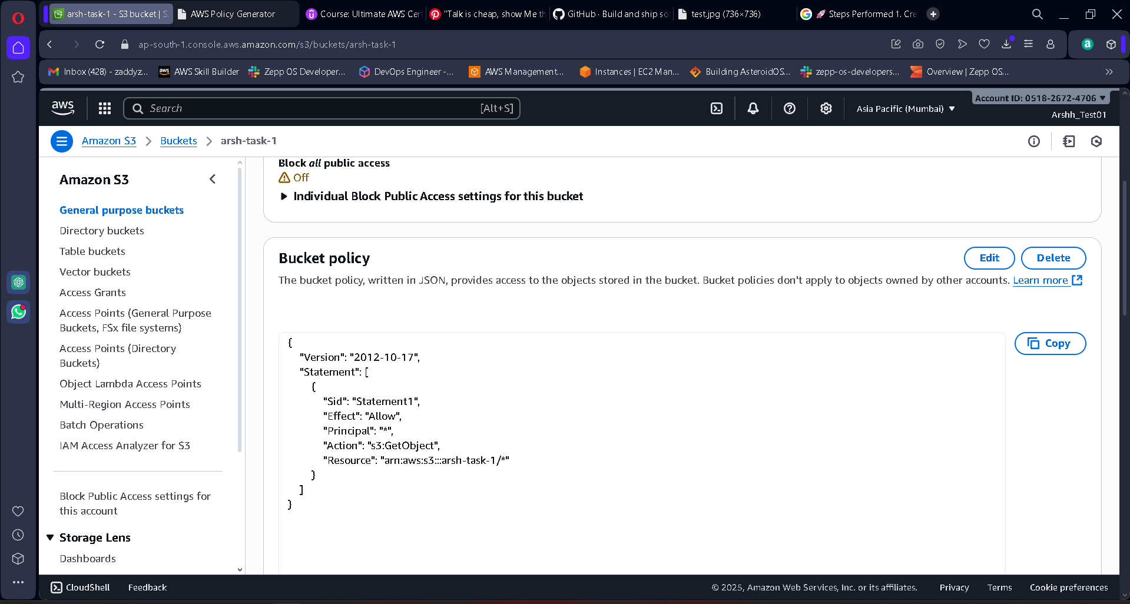
- Bucket policy configures by the JSON file

4. Verified Public Access
- Public Access URL: https://arsh-task-1.s3.ap-south-1.amazonaws.com/test.jpg
- Confirmed the file loads publicly without authentication.
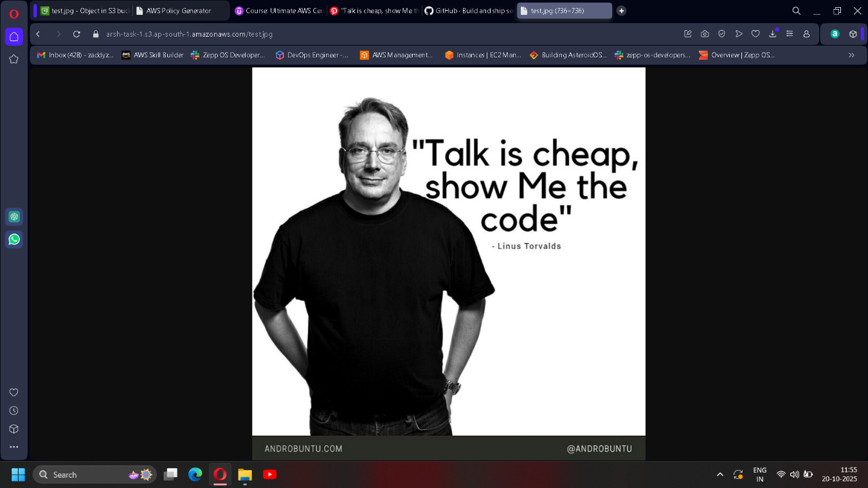

Outcome
- Successfully created a Cloud Storage Bucket
- Uploaded files to the bucket
- Configured public access via a JSON policy
- Verified that files are accessible publicly

