

课程实验报告

课 程 名 称： 计算机结构与组成
实验项目名称： 程序性能调优实验
专 业 班 级： 软件1401
姓 名： 宗玉芬
学 号： 201426010124
指 导 教 师：
完 成 时 间： 2016 年 11 月 23 日

信息科学与工程学院
实验题目：perflab性能优化实验
实验目的：理解编译器，实现代码的优化，并学会对其性能分析
实验环境：Ubuntu 、 VMware workstation
实验要求：本次实验，要求针对每个函数、每个人均至少写出3种优化版本、并根据driver报告的结果进行性能分析
实验内容及操作步骤：
一．实验步骤
- 理解代码，读懂rotate和smooth函数，并对其进行优化。
- 优化rotate和smooth函数后保存代码。我们可以make clean后，再make all，从而生成driver执行文件。用./driver 直接执行，则会在终端打印出对此目录下的kernel.c文件中的Registered的函数的性能评价
二．优化方案
常见优化方法有：减少函数调用，提前计算，循环展开，并行运算，提高cache利用率等
Rotate函数：将图像的每个像素逆时针旋转90°，从而达到整副图像旋转90°
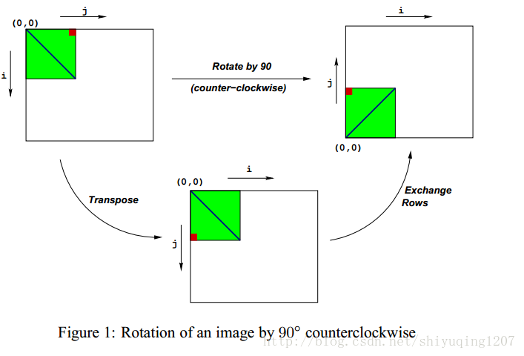
- 分成32*1块，按32路循环展开，使dest地址连续，减少写入存储器的次数。如此内循环就得写出32句代码。同时利用宏定义也可小幅优化。
#define fun(d,s) *(d)=*(s)
void rotate(int dim, pixel *src, pixel *dst)
{
int i,j;
for (i = 0; i< dim; i+=32)
for (j = dim-1; j>=0; j-=1){
pixel *dptr=dst+RIDX(dim-1-j, i, dim);
pixel *sptr=src+RIDX(i, j, dim);
fun(dptr,sptr);sptr+=dim;
fun(dptr+1,sptr);sptr+=dim;
fun(dptr+2,sptr);sptr+=dim;
fun(dptr+3,sptr);sptr+=dim;
fun(dptr+4,sptr);sptr+=dim;
fun(dptr+5,sptr);sptr+=dim;
fun(dptr+6,sptr);sptr+=dim;
fun(dptr+7,sptr);sptr+=dim;
fun(dptr+8,sptr);sptr+=dim;
fun(dptr+9,sptr);sptr+=dim;
fun(dptr+10,sptr);sptr+=dim;
fun(dptr+11,sptr);sptr+=dim;
fun(dptr+12,sptr);sptr+=dim;
fun(dptr+13,sptr);sptr+=dim;
fun(dptr+14,sptr);sptr+=dim;
fun(dptr+15,sptr);sptr+=dim;
fun(dptr+16,sptr);sptr+=dim;
fun(dptr+17,sptr);sptr+=dim;
fun(dptr+18,sptr);sptr+=dim;
fun(dptr+19,sptr);sptr+=dim;
fun(dptr+20,sptr);sptr+=dim;
fun(dptr+21,sptr);sptr+=dim;
fun(dptr+22,sptr);sptr+=dim;
fun(dptr+23,sptr);sptr+=dim;
fun(dptr+24,sptr);sptr+=dim;
fun(dptr+25,sptr);sptr+=dim;
fun(dptr+26,sptr);sptr+=dim;
fun(dptr+27,sptr);sptr+=dim;
fun(dptr+28,sptr);sptr+=dim;
fun(dptr+29,sptr);sptr+=dim;
fun(dptr+30,sptr);sptr+=dim;
fun(dptr+31,sptr);sptr+=dim;
}
}
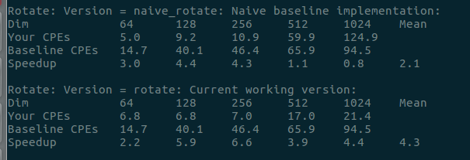
2.充分利用一级缓存32kb,将其分块为32.里面两层循环是在实现外循环跳过的32部分。与上一种思路一致但实现代码不一样
void rotate(int dim, pixel *src, pixel *dst)
{
int i,j,i1,j1,im,jm;
int t=32;
for(i=0;i<dim;i+=t)
for(j=0;j<dim;j+=t)
{
im=i+t;
for(i1=i;i1<i+t;i1++)
{
jm=j+t;
for(j1=j;j1<j+t;j1++)
dst[RIDX(i1, j1, dim)] = src[RIDX(j1, dim-1-i1, dim)];
}
}

}
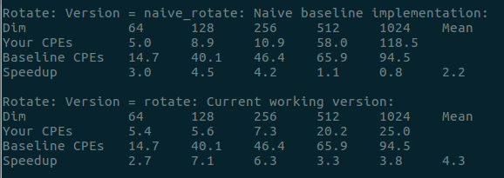
3.
void rotate(int dim, pixel *src, pixel *dst)
{
int i;
int j;
int tmp1=dim*dim;
int tmp2=dim *31;
int tmp3=tmp1-dim;
int tmp4=tmp1+32;
int tmp5=dim+31;
dst+=tmp3;

for(i=0; i< dim; i+=32)
{
for(j=0;j<dim;j++)
{
*dst=*src;
dst++;src+=dim;
//共32次展开，代码相同故省略
*dst=*src;
src++;
src-=tmp2;
dst-=tmp5;
}
src+=tmp2;
dst+=tmp4;
}
}
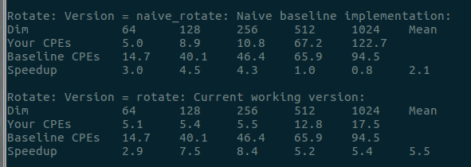

Smooth函数：用来实现类似于求图片中每个元素所在的九宫格的平均值，然后将该值放到该元素
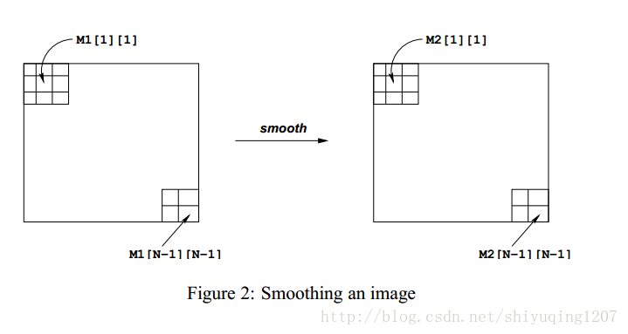

原函数的最大缺陷在于过多重复的读取元素。

1.把计算平均像素过程中要用到的计算点先定义为宏，如上面截图。然后分为顶点，边界，中间三部分来分别计算平均像素，不同的是中间部分循环计算时按4路展开，因为列数为32的倍数去掉边界之后可能除不尽4所以要加上计算除不尽的部分
void smooth_v6(int dim, pixel *src, pixel *dst)
{
int i,j;
pixel *p_s=src;
pixel *p_d=dst;
pixel *p_s_nextRow=src+dim;
pixel *p_s_next2Row=src+dim*2;
int dim1=dim-1;
int dim4=dim-4;
//the 1st row
// (0,0) pixel
{
p_d->red=AVG4(p_s,red);
p_d->blue=AVG4(p_s,blue);
p_d->green=AVG4(p_s,green);
p_d++;
}

//pixels from (1,1) to (1,dim-2)
for (j = 1; j <dim1; j++)
{
p_d->red=AVG6_33(p_s,red);
p_d->blue=AVG6_33(p_s,blue);
p_d->green=AVG6_33(p_s,green);
p_s++;
p_s_nextRow++;
p_d++;
}
//pixel (1,dim-1)
{
p_d->red=AVG4(p_s,red);
p_d->blue=AVG4(p_s,blue);
p_d->green=AVG4(p_s,green);
//for the next row
p_s=src;
p_s_nextRow=src+dim;
p_d++;

}

// the central parts
for (i = 1; i < dim1; i++)
{
// 1st pixel of the row (i,0);
p_d->red=AVG6_222(p_s,p_s_nextRow,red);
p_d->blue=AVG6_222(p_s,p_s_nextRow,blue);
p_d->green=AVG6_222(p_s,p_s_nextRow,green);

p_d++;

{
pixel *p_d2=p_d+1;
pixel *p_d3=p_d+2;
pixel *p_d4=p_d+3;
pixel *p_s2=p_s+1;
pixel *p_s2nextRow=p_s_nextRow+1;
pixel *p_s2next2Row=p_s_next2Row+1;

pixel *p_s3=p_s+2;
pixel *p_s3nextRow=p_s_nextRow+2;
pixel *p_s3next2Row=p_s_next2Row+2;

pixel *p_s4=p_s+3;
pixel *p_s4nextRow=p_s_nextRow+3;
pixel *p_s4next2Row=p_s_next2Row+3;

// central pixels from (i,1) to (i,dim-2);
for (j = 1; j < dim4; j+=4)
{
p_d->red=AVG9(p_s,p_s_nextRow,p_s_next2Row,red) ;
p_d->blue=AVG9(p_s,p_s_nextRow,p_s_next2Row,blue) ;
p_d->green=AVG9(p_s,p_s_nextRow,p_s_next2Row,green) ;

p_d2->red=AVG9(p_s2,p_s2nextRow,p_s2next2Row,red) ;
p_d2->blue=AVG9(p_s2,p_s2nextRow,p_s2next2Row,blue) ;
p_d2->green=AVG9(p_s2,p_s2nextRow,p_s2next2Row,green) ;

p_d3->red=AVG9(p_s3,p_s3nextRow,p_s3next2Row,red) ;
p_d3->blue=AVG9(p_s3,p_s3nextRow,p_s3next2Row,blue) ;
p_d3->green=AVG9(p_s3,p_s3nextRow,p_s3next2Row,green) ;

p_d4->red=AVG9(p_s4,p_s4nextRow,p_s4next2Row,red) ;
p_d4->blue=AVG9(p_s4,p_s4nextRow,p_s4next2Row,blue) ;
p_d4->green=AVG9(p_s4,p_s4nextRow,p_s4next2Row,green) ;

p_d+=4;
p_d2+=4;
p_d3+=4;
p_d4+=4;
p_s+=4;
p_s_nextRow+=4;
p_s_next2Row+=4;
p_s2+=4;
p_s2nextRow+=4;
p_s2next2Row+=4;
p_s3+=4;
p_s3nextRow+=4;
p_s3next2Row+=4;
p_s4+=4;
p_s4nextRow+=4;
p_s4next2Row+=4;
}
for (; j < dim1; j++)
{
p_d->red=AVG9(p_s,p_s_nextRow,p_s_next2Row,red) ;
p_d->blue=AVG9(p_s,p_s_nextRow,p_s_next2Row,blue) ;
p_d->green=AVG9(p_s,p_s_nextRow,p_s_next2Row,green) ;

p_d++;
p_s++;
p_s_nextRow++;
p_s_next2Row++;
}
}
// the end of the row (i,dim-1)

p_d->red=AVG6_222(p_s,p_s_nextRow,red);
p_d->blue=AVG6_222(p_s,p_s_nextRow,blue);
p_d->green=AVG6_222(p_s,p_s_nextRow,green);

p_d++;
p_s+=2;
p_s_nextRow+=2;
p_s_next2Row+=2;
}

//last row
// 1st pixel of the last row (dim-1,0)
{
p_d->red=AVG4(p_s,red);
p_d->blue=AVG4(p_s,blue);
p_d->green=AVG4(p_s,green);
p_d++;
}
// pixels from (dim-1,1) to (dim-1,dim-2);
for (j = 1; j <dim1; j++)
{
p_d->red=AVG6_33(p_s,red);
p_d->blue=AVG6_33(p_s,blue);
p_d->green=AVG6_33(p_s,green);
p_s++;
p_s_nextRow++;
p_d++;
}

//the last pixel!finally!!
{
p_d->red=AVG4(p_s,red);
p_d->blue=AVG4(p_s,blue);
p_d->green=AVG4(p_s,green);
}

}
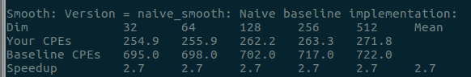
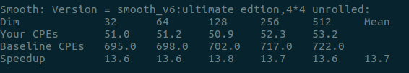

3.将整副图像的像素分为4+4+1块。分别为4个顶点，4条边界，1个中间部分。顶点处需要对4个像素点求平均值，边界处需要对6个顶点求平均值。中间部分需要求9个的平均值。分块计算减少不必要的计算和判断来优化。
void smooth(int dim, pixel *src, pixel *dst) {
int i,j;
int dim0=dim;
int dim1=dim-1;
int dim2=dim-2;
pixel *P1, *P2, *P3;
pixel *dst1;
P1=src;
P2=P1+dim0; //左上角像素处理
dst->red=(P1->red+(P1+1)->red+P2->red+(P2+1)->red)>>2;
dst->green=(P1->green+(P1+1)->green+P2->green+(P2+1)->green)>>2;
dst->blue=(P1->blue+(P1+1)->blue+P2->blue+(P2+1)->blue)>>2;
dst++; //上边界处理
for(i=1;i<dim1;i++) {
dst->red=(P1->red+(P1+1)->red+(P1+2)->red+P2->red+(P2+1)->red+(P2+2)->red)/6;
dst->green=(P1->green+(P1+1)->green+(P1+2)->green+P2->green+(P2+1)->green+(P2+2)->green)/6;
dst->blue=(P1->blue+(P1+1)->blue+(P1+2)->blue+P2->blue+(P2+1)->blue+(P2+2)->blue)/6;
dst++;
P1++;
P2++;
} //右上角像素处理
dst->red=(P1->red+(P1+1)->red+P2->red+(P2+1)->red)>>2;
dst->green=(P1->green+(P1+1)->green+P2->green+(P2+1)->green)>>2;
dst->blue=(P1->blue+(P1+1)->blue+P2->blue+(P2+1)->blue)>>2;
dst++;
P1=src;
P2=P1+dim0;
P3=P2+dim0; //左边界处理
for(i=1;i<dim1;i++) {
dst->red=(P1->red+(P1+1)->red+P2->red+(P2+1)->red+P3->red+(P3+1)->red)/6;
dst->green=(P1->green+(P1+1)->green+P2->green+(P2+1)->green+P3->green+(P3+1)->green)/6;
dst->blue=(P1->blue+(P1+1)->blue+P2->blue+(P2+1)->blue+P3->blue+(P3+1)->blue)/6;
dst++;
dst1=dst+1; //主体中间部分处理
for(j=1;j<dim2;j+=2) { //同时处理2个像素
dst->red=(P1->red+(P1+1)->red+(P1+2)->red+P2->red+(P2+1)->red+(P2+2)->red+P3->red+(P3+1)->red+(P3+2)->red)/9;
dst->green=(P1->green+(P1+1)->green+(P1+2)->green+P2->green+(P2+1)->green+(P2+2)->green+P3->green+(P3+1)->green+(P3+2)->green)/9;
dst->blue=(P1->blue+(P1+1)->blue+(P1+2)->blue+P2->blue+(P2+1)->blue+(P2+2)->blue+P3->blue+(P3+1)->blue+(P3+2)->blue)/9;
dst1->red=((P1+3)->red+(P1+1)->red+(P1+2)->red+(P2+3)->red+(P2+1)->red+(P2+2)->red+(P3+3)->red+(P3+1)->red+(P3+2)->red)/9;
dst1->green=((P1+3)->green+(P1+1)->green+(P1+2)->green+(P2+3)->green+(P2+1)->green+(P2+2)->green+(P3+3)->green+(P3+1)->green+(P3+2)->green)/9;
dst1->blue=((P1+3)->blue+(P1+1)->blue+(P1+2)->blue+(P2+3)->blue+(P2+1)->blue+(P2+2)->blue+(P3+3)->blue+(P3+1)->blue+(P3+2)->blue)/9;
dst+=2;dst1+=2;P1+=2;P2+=2;P3+=2;
}
for(;j<dim1;j++) {
dst->red=(P1->red+(P1+1)->red+(P1+2)->red+P2->red+(P2+1)->red+(P2+2)->red+P3->red+(P3+1)->red+(P3+2)->red)/9;
dst->green=(P1->green+(P1+1)->green+(P1+2)->green+P2->green+(P2+1)->green+(P2+2)->green+P3->green+(P3+1)->green+(P3+2)->green)/9;
dst->blue=(P1->blue+(P1+1)->blue+(P1+2)->blue+P2->blue+(P2+1)->blue+(P2+2)->blue+P3->blue+(P3+1)->blue+(P3+2)->blue)/9;
dst++; P1++;P2++;P3++;
} //右侧边界处理
dst->red=(P1->red+(P1+1)->red+P2->red+(P2+1)->red+P3->red+(P3+1)->red)/6;
dst->green=(P1->green+(P1+1)->green+P2->green+(P2+1)->green+P3->green+(P3+1)->green)/6;
dst->blue=(P1->blue+(P1+1)->blue+P2->blue+(P2+1)->blue+P3->blue+(P3+1)->blue)/6;
dst++; P1+=2; P2+=2; P3+=2;
} //左下角处理
dst->red=(P1->red+(P1+1)->red+P2->red+(P2+1)->red)>>2;
dst->green=(P1->green+(P1+1)->green+P2->green+(P2+1)->green)>>2;
dst->blue=(P1->blue+(P1+1)->blue+P2->blue+(P2+1)->blue)>>2;
dst++; //下边界处理
for(i=1;i<dim1;i++) {
dst->red=(P1->red+(P1+1)->red+(P1+2)->red+P2->red+(P2+1)->red+(P2+2)->red)/6;
dst->green=(P1->green+(P1+1)->green+(P1+2)->green+P2->green+(P2+1)->green+(P2+2)->green)/6;
dst->blue=(P1->blue+(P1+1)->blue+(P1+2)->blue+P2->blue+(P2+1)->blue+(P2+2)->blue)/6;
dst++; P1++; P2++;
} //右下角像素处理
dst->red=(P1->red+(P1+1)->red+P2->red+(P2+1)->red)>>2;
dst->green=(P1->green+(P1+1)->green+P2->green+(P2+1)->green)>>2;
dst->blue=(P1->blue+(P1+1)->blue+P2->blue+(P2+1)->blue)>>2;
}
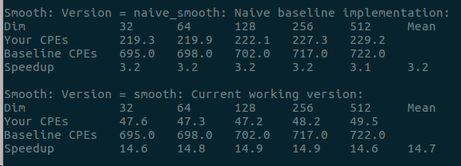
char smooth_descr_v3[] = "smooth:ultimate and current edition,make up a array[3][3] to store tmp data!";
void smooth_v3(int dim, pixel *src, pixel *dst)
{
int i,j;
pixel *p_s=src;
pixel *p_d=dst;
pixel *p_s_nextRow=src+dim;
pixel *p_s_next2Row=src+dim*2;
int s00,s01,s02,s10,s11,s12,s20,s21,s22;
int dim1=dim-1;
int dim8=dim-8;
//the 1st row
// (0,0) pixel
{

}

//pixels from (0,1) to (0,dim-2)
for (j = 1; j <dim1; j++)
{//省略
}
//pixel (0,dim-1)
{
省略
}
// the central parts
for (i = 1; i < dim1; i++)
{
// 1st pixel of the row (i,0);
省略
//start of center 8 unit
pixel *p_d2=p_d+1;
pixel *p_d3=p_d+2;
pixel *p_d4=p_d+3;
pixel *p_d5=p_d+4;
pixel *p_d6=p_d+5;
pixel *p_d7=p_d+6;
pixel *p_d8=p_d+7;

// 从p_s 到p_s4分别是第一、二、三列和下一列（待计算）
pixel *p_s2=p_s+1;
pixel *p_s2nextRow=p_s_nextRow+1;
pixel *p_s2next2Row=p_s_next2Row+1;

pixel *p_s3=p_s+2;
pixel *p_s3nextRow=p_s_nextRow+2;
pixel *p_s3next2Row=p_s_next2Row+2;

pixel *p_s4=p_s+3;
pixel *p_s4nextRow=p_s_nextRow+3;
pixel *p_s4next2Row=p_s_next2Row+3;

//例如s00 第一个数字表示列，第二个表示颜色 就是第1列的RED之和，s11就是第2列的Blue之和
s00=p_s->red+p_s_nextRow->red+p_s_next2Row->red;
s01=p_s->blue+p_s_nextRow->blue+p_s_next2Row->blue;
s02=p_s->green+p_s_nextRow->green+p_s_next2Row->green;
s10=p_s2->red+p_s2nextRow->red+p_s2next2Row->red;
s11=p_s2->blue+p_s2nextRow->blue+p_s2next2Row->blue;
s12=p_s2->green+p_s2nextRow->green+p_s2next2Row->green;
s20=p_s3->red+p_s3nextRow->red+p_s3next2Row->red;
s21=p_s3->blue+p_s3nextRow->blue+p_s3next2Row->blue;
s22=p_s3->green+p_s3nextRow->green+p_s3next2Row->green;
//每次进行内循环前的初始化，即每个指针都跳到下一行
p_s+=dim;p_s2+=dim;p_s3+=dim;
p_s_nextRow+=dim;p_s2nextRow+=dim;p_s2next2Row+=dim;
p_s_next2Row+=dim;p_s3nextRow+=dim;p_s3next2Row+=dim;

// central pixels from (i,1) to (i,dim-2);
for (j = 1; j < dim8; j+=8)
{
//开始并行的第一个smooth计算
p_d->red=(s00+s10+s20)/9 ;
p_d->blue=(s01+s11+s21)/9 ;
p_d->green=(s02+s12+s22)/9;
//顺移过去，然后把下一列的值计算给s20,s21,s22
s00=s10;s01=s11;s02=s12;
s10=s20;s11=s21;s12=s22;
s20=p_s4->red+p_s4nextRow->red+p_s4next2Row->red;
s21=p_s4->blue+p_s4nextRow->blue+p_s4next2Row->blue;
s22=p_s4->green+p_s4nextRow->green+p_s4next2Row->green;
//把下一列指针后移一位
p_s4++;p_s4nextRow++;p_s4next2Row++;
//又下一个并行smooth计算
p_d2->red=(s00+s10+s20)/9 ;
p_d2->blue=(s01+s11+s21)/9 ;
p_d2->green=(s02+s12+s22)/9;

s00=s10;s01=s11;s02=s12;
s10=s20;s11=s21;s12=s22;
s20=p_s4->red+p_s4nextRow->red+p_s4next2Row->red;
s21=p_s4->blue+p_s4nextRow->blue+p_s4next2Row->blue;
s22=p_s4->green+p_s4nextRow->green+p_s4next2Row->green;
p_s4++;p_s4nextRow++;p_s4next2Row++;
//p_d3到p_d7类似
p_d8->red=(s00+s10+s20)/9 ;
p_d8->blue=(s01+s11+s21)/9 ;
p_d8->green=(s02+s12+s22)/9;

s00=s10;s01=s11;s02=s12;
s10=s20;s11=s21;s12=s22;
s20=p_s4->red+p_s4nextRow->red+p_s4next2Row->red;
s21=p_s4->blue+p_s4nextRow->blue+p_s4next2Row->blue;
s22=p_s4->green+p_s4nextRow->green+p_s4next2Row->green;
p_s4++;p_s4nextRow++;p_s4next2Row++;
//8 unit并行结束，准备下一轮循环
p_d+=8;
p_d2+=8;
p_d3+=8;
p_d4+=8;
p_d5+=8;
p_d6+=8;
p_d7+=8;
p_d8+=8;
}
//因为中间是N*32-2个元素，所以经过上面8unit的内循环之后，必定只剩下6个pixel未经过smooth计算，所以接着p_d,p_d2....p_d6
{
p_d->red=(s00+s10+s20)/9 ;
p_d->blue=(s01+s11+s21)/9 ;
p_d->green=(s02+s12+s22)/9;

s00=s10;s01=s11;s02=s12;
s10=s20;s11=s21;s12=s22;
s20=p_s4->red+p_s4nextRow->red+p_s4next2Row->red;
s21=p_s4->blue+p_s4nextRow->blue+p_s4next2Row->blue;
s22=p_s4->green+p_s4nextRow->green+p_s4next2Row->green;
p_s4++;p_s4nextRow++;p_s4next2Row++;
//p_d2到p_d5类似….
p_d6->red=(s00+s10+s20)/9 ;
p_d6->blue=(s01+s11+s21)/9 ;
p_d6->green=(s02+s12+s22)/9;

s00=s10;s01=s11;s02=s12;
s10=s20;s11=s21;s12=s22;
s20=p_s4->red+p_s4nextRow->red+p_s4next2Row->red;
s21=p_s4->blue+p_s4nextRow->blue+p_s4next2Row->blue;
s22=p_s4->green+p_s4nextRow->green+p_s4next2Row->green;
p_s4++;p_s4nextRow++;p_s4next2Row++;
}
//这里是每行的最后一个pixel
//p_s4已经指向下一行的第一列了，所以恢复到第四列，所以+3
p_s4+=3;p_s4nextRow+=3;p_s4next2Row+=3;
// the end of the row (i,dim-1)
//因为p_d仍然停留在原地，所以+6得到最后一个元素的位置，同时上面最后一次仍然计算了s00~s22，所以这里应该取s10和s00 前2列
p_d+=6;
p_d->red=(s10+s00)/6;
p_d->blue=(s11+s01)/6;
p_d->green=(s12+s02)/6;

p_d++;
//计算完之后，让p_d指向下一行的开头
}

//last row省略
// 1st pixel of the last row (dim-1,0)省略

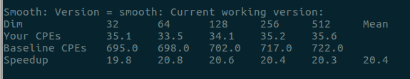

实验结果及分析：
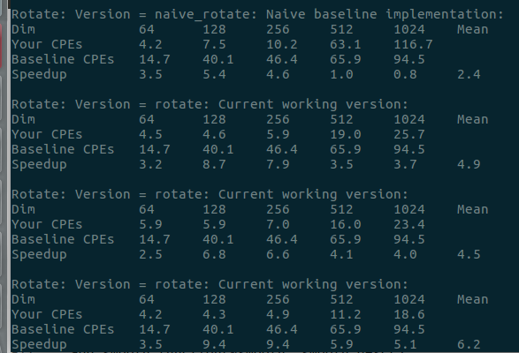
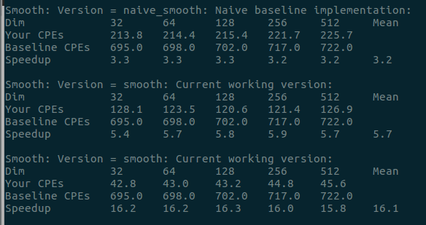

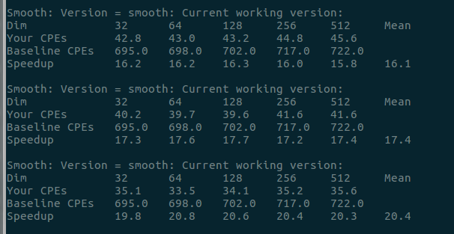

收获与体会：本次实验是进行代码的优化。通过减少函数调用，提前计算，分块计算和循环展开等方法进行优化。但其实越是为计算机做很多准备工作达到优化显得代码的可读性差。不是那么优美。不过性能优化后确实提升不少
实
验成绩

