Low Level Design (add Asset module)

|  |  |
| --- | --- |
| **Project Code** | Group 2 |
| **Project Name** | Asset Management System |

|  |  |  |
| --- | --- | --- |
| **Prepared/Modified by** | **Role** | **Date of Preparation** |
| Chitranjan Trivedi | Software Engineer | 25/11/2016 |
| **Reviewed by** | **Role** | **Date of Review** |
| Khushboo Kumar | Software Engineer | 25/11/2016 |
| **Approved by** | **Role** | **Date of Approval** |
| Mrs. Vaishali Srivastava |  |  |
| **Circulation List** | vaishali.srivastava@capgemini.com  khushboo.kumar@capgemini.com,  chitranjan.trivedi@capgemini.com,  divakar.rana@capgemini.com,  nidhi.barnwal@capgemini.com,  girjesh.soni@capgemini.com,  sneha.pandey@capgemini.com,  aman.jogi@capgemini.com, | **Version Number of the document:1.0** |
| **Version Number** | 1.0 |  |

Table of Contents

1. Description Of The Unit 3

2. References 4

3. Dependencies / Assumptions 5

4. Class Diagrams 6

5. Sequence Diagrams 7

6. Design Components 8

6.1 List Of UI Components 8

6.2 List Of Design Classes 8

7. Re-Usable Routines/Components 9

8. Messages 10

9. Configuration Files 11

10. Crud Matrix Table 12

11. Data Mapping Matrix 13

12. Action Flow Matrix 14

13. Stored Procedures 15

14. Program Specification / Pseudo Code 16

REVISION HISTORY OF THE WORK PRODUCT 17

# Description Of The Unit

The add asset module allows the admin of the application to add new assets into the database. This module can be used only by the admin of the application.

On clicking on the add button in the admin home page, the admin is redirected to a add page. The admin enters all the details of the product like asset name, asset description, asset quantity and asset status. If the entered product details are invalid, appropriate error messages are displayed.

After entering all the asset details, the details are inserted into the database on clicking the add button. The admin can also cancel the add asset functionality by clicking on the cancel button.

# References

| **Reference** | **Description** |
| --- | --- |
| Repository reference | https://github.com/ThreadPoll/FinalServletJspProjects/blob/master/AssetManagement.txt |
| Class Diagram | /Project Documents/Design Documents/HLD/Class Diagrams |
| URS | /Project Documents/Requirements/Case Study/Group 2-Asset Management System.doc |
| UTP | /Project Documents/Test Plan/UTP/Test Cases/AddAsset /UTP_AddAssetModule.xlsm |
| DB Design | /Project Documents/Design Documents/HLD/DB Design/AssetManagement_GROUP2_DBDESIGN.xls |

# Dependencies / Assumptions

**Dependencies:**

The admin should be logged in.

**Assumptions:**

The admin details are stored in the database.

The admin will not have any manager.

A person who is a manager is his own manager.

# Class Diagrams

[Class Diagram](../../HLD/Class%20Diagrams)

# Sequence Diagrams

|  |
| --- |
| **Sequence Diagram** |
| NA |

# Design Components

## List Of UI Components

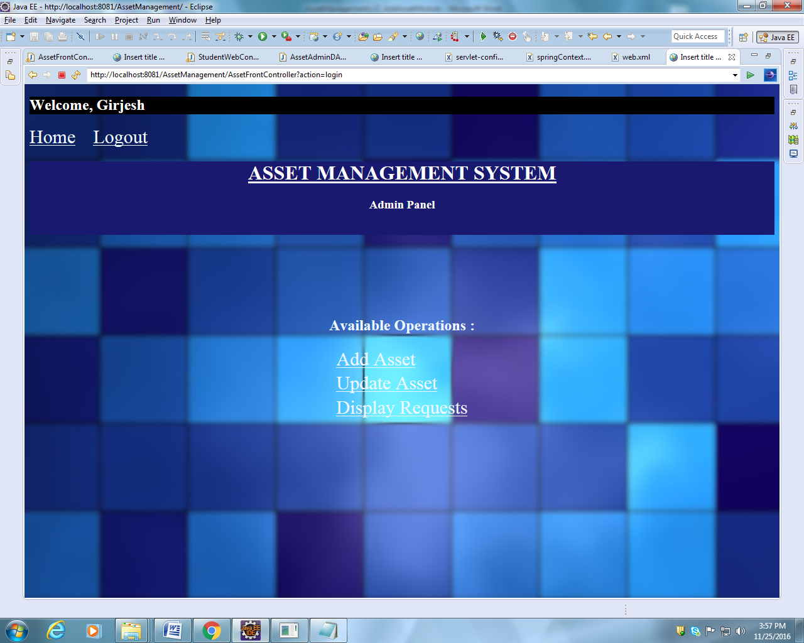

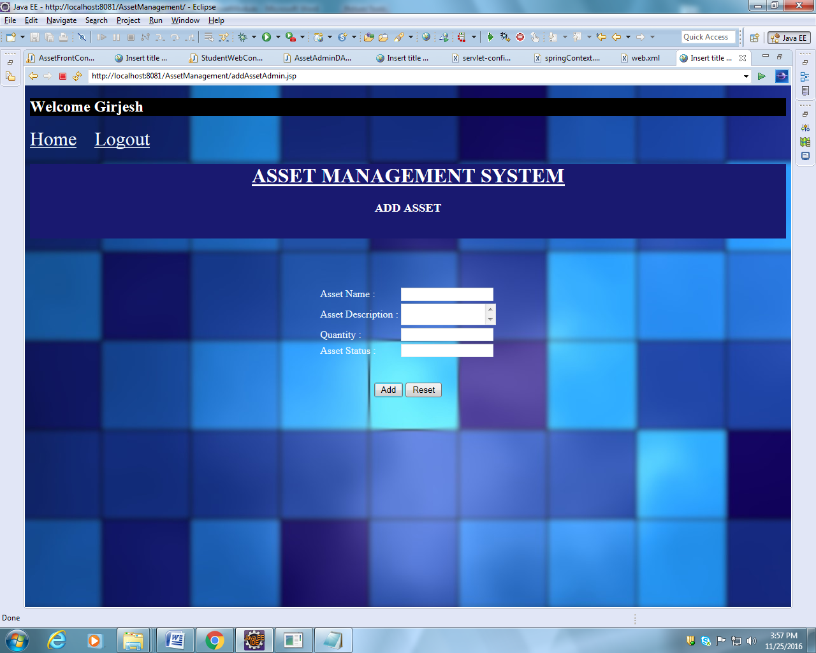

## List Of Design Classes

|  |  |  |  |  |
| --- | --- | --- | --- | --- |
| **Sr. No.** | **LLD Name** | **Class Name** | **Method Name** | **Method Description** |
| 1 | Add Asset  Module | UserType,  Asset | Appropriate getters and setters methods,  toString methods | Getters retrieve the property values and setters set the property values. Returns a string representation of the object. In general, the toString method returns a string that "textually represents" this object. |
| 2 | Add Asset Module | AssetFrontController | addAssetAdmin(@RequestParam("file") String filename,@ModelAttribute("Asset") @Valid Asset asset,BindingResult result,Model model):String | Calls addAssetAdmin () of AssetServiceImpl-  mentation class. If it returns object then it redirects to home page else it redirects to add page with appropriate error message. |
| 3 | Add Product Module | AssetServiceImpl | addAsset(HashMap<String, String> assetDetails) | Sets attributes of asset in an asset object and returns the object to addAsset method of the DAO |
| 4 | Add Product Module | AssetAdminDAOImpl | addAsset(Asset asset) | .  Inserts the asset details into the database and returns the result to AssetServiceImpl. |

# Re-Usable Routines/Components

Re-Usable Routines/Components

* CSS files
* Javascript files
* DataAccessException class
* Database properties files
* Logger properties files

# Messages

|  |  |  |
| --- | --- | --- |
| **#.** | **Type** | **Message Text** |
| M1 | Error | Enter a valid asset name. It should contain alphabet only and should not be empty. |
| M2 | Error | Enter a valid asset description. It shouldn’t be empty. |
| M3 | Error | Quantity can only be numerical and should not be blank. |
| M4 | Error | Enter either allocated or available. This field should not be blank. |

# Configuration Files

|  |  |  |
| --- | --- | --- |
| File Name | Path | Description |
| springContext.xml | /WebContent/WEB-INF/ config | To configure database connection.  To configure application context. |
| Web.xml | /WebContent/WEB-INF | To deploy the webapplication to any Java Servlet container. |
| servlet-config.xml | /WebContent/WEB-INF/ config | To configure the request mapping and view resolver. |

# Crud Matrix Table

|  |  |  |  |  |  |
| --- | --- | --- | --- | --- | --- |
| **#** | **Table Name** | **Create** | **Read** | **Update** | **Delete** |
| 1. | Add_Asset | Y | N | N | N |

# Data Mapping Matrix

|  |  |  |  |  |  |  |  |
| --- | --- | --- | --- | --- | --- | --- | --- |
| **Sr. No.** | **Screen Label** | **Field Source** | **Field Type** | **Data Type** | **Max Length** | **Data Flow** | **Mandatory** |
| 1 | Asset Name | NA | Label | NA | NA | UI | NA |
| 2 | assetName | Asset.assetName | TextBox | Varchar2 | 50 | UI🡪D | Yes |
| 3 | Asset Description : | NA | Label | NA | NA | UI | NA |
| 4 | assetDes | Asset.assetDes | TextBox | Varchar2 | 50 | UI🡪D | Yes |
| 5 | Quantity : | NA | Label | NA | NA | UI | NA |
| 6 | quantity | Asset.quantity | TextBox | Varchar2 | 50 | UI🡪D | Yes |
| 7 | Asset Status : | NA | Label | NA | NA | UI | NA |
| 8 | status | Asset. status | TextBox | Varchar2 | 50 | UI🡪D | Yes |
| 13 | Add | NA | Button | NA | NA | UI | NA |
| 14 | Reset | NA | Button | NA | NA | UI | NA |

**Legend**

D 🡪 UI (Database to User Interface)

UI 🡪 D (User Interface to Database)

UI (User Interface Only)

# Action Flow Matrix

|  |  |  |  |
| --- | --- | --- | --- |
| **Sr. No.** | **Action** | **Description** | **Process** |
| 1 | On click of Add Button in Admin Homepage | Redirected to the Add page | The admin clicks on the add button in the admin homepage and gets redirected to the add page. |
| 2 | On click of Add button in add page | The asset details are inserted into the database. | Data entered in the fields by the admin gets inserted into the database when add button is pressed. |
| 3 | On click of Reset button in Add page | The asset details are not added into the database. | The admin on clicking on the reset button in add page gets redirected to the same page with no entries. |

# Stored Procedures

|  |  |  |  |  |
| --- | --- | --- | --- | --- |
| **#** | **Stored Procedure Name**  **(with Description)** | **Input/Out Parameters** | **Type** | **Size** |
| 1. | NA | NA | NA | NA |

# Program Specification / Pseudo Code

## <ACTION :ADD_ASSET >

**Pseudo Code:**

1. **Client Side Scripting:**

None

1. **Server Side Scripting:**

**BEGIN**

Call addAssetAdmin in Controller class

Navigate to addAssetAdmin page

**END**

**14. 2 <ACTION: addAssetAdmin _CLICK>**

**Pseudo Code:**

1. **Client Side Scripting:**

IF invalid assetName or assetName isEmpty

Print Error Message M1

IF invalid assetDes or assetDes isEmpty

Print Error Message M2

IF invalid quantity or quantity isEmpty

Print Error Message M3

IF invalid status or status isEmpty

Print Error Message M4

1. **Server Side Scripting:**

**BEGIN**

addAssetAdmin(@RequestParam("file") String filename,@ModelAttribute("Asset") @Valid Asset asset,BindingResult result,Model model) in Controller class in Presentation Layer

**BEGIN**

Call addAsset (Asset asset) in AssetServiceImpl class in Service Layer

**BEGIN**

Call addAsset (Asset asset) in AssetAdminDAOImpl class in Data Access Layer

**BEGIN**

Create query for insert records into Add_Asset table

Return Integer value.

**END**

Return Integer value. to Service Layer

**END**

Return Integer value to Presentation Layer

**END**

IF successful,

navigate to home page

Else

navigate to add page and show error.

**END**

**14. 2 <ACTION: RESET_CLICK>**

**Pseudo Code:**

**1. Client Side Scripting:**

None

1. **Server Side Scripting:**

None

REVISION HISTORY OF THE WORK PRODUCT

|  |  |  |  |  |  |
| --- | --- | --- | --- | --- | --- |
| # | Date | Version # | Section Changed | Details of changes made | Approved By |
| 1 | 25/11/2016 | 1.0 | LLD prepared | N/A |  |