Low Level Design (add Asset module)

|  |  |
| --- | --- |
| **Project Code** | 2_AMS |
| **Project Name** | Asset Management System |

|  |  |  |
| --- | --- | --- |
| **Prepared/Modified by** | **Role** | **Date of Preparation** |
| Chitranjan Trivedi | Software Engineer | 25/11/2016 |
| **Reviewed by** | **Role** | **Date of Review** |
| Khushboo Kumar | Software Engineer | 25/11/2016 |
| **Approved by** | **Role** | **Date of Approval** |
| Mrs. Vaishali Srivastava |  |  |
| **Circulation List** | vaishali.srivastava@capgemini.com  khushboo.kumar@capgemini.com,  chitranjan.trivedi@capgemini.com,  divakar.rana@capgemini.com,  nidhi.barnwal@capgemini.com,  girjesh.soni@capgemini.com,  sneha.pandey@capgemini.com,  aman.jogi@capgemini.com, | **Version Number of the document:1.0** |
| **Version Number** | 1.0 |  |

Table of Contents

1. Description Of The Unit 3

2. References 4

3. Dependencies / Assumptions 5

4. Class Diagrams 6

5. Sequence Diagrams 7

6. Design Components 8

6.1 List Of UI Components 8

6.2 List Of Design Classes 8

7. Re-Usable Routines/Components 9

8. Messages 10

9. Configuration Files 11

10. Crud Matrix Table 12

11. Data Mapping Matrix 13

12. Action Flow Matrix 14

13. Stored Procedures 15

14. Program Specification / Pseudo Code 16

REVISION HISTORY OF THE WORK PRODUCT 17

# Description Of The Unit

The login module allows the admin and the manager of the application to login. This module can be used only by the admin and the manager of the application.

On clicking on the login button on the index page, the admin is redirected to its home page to add asset, update asset and display request. The admin enters all the details of the asset like asset name, asset description, asset quantity and asset status. If the entered product details are invalid, appropriate error messages are displayed.

And for the manager, on clicking login button on the index page, the manager is redirected to its home page to view asset, raise request and view request status.

# References

| **Reference** | **Description** |
| --- | --- |
| Repository reference | https://github.com/ThreadPoll/FinalServletJspProjects/blob/master/AssetManagement.txt |
| Class Diagram | /Project Documents/Design Documents/HLD/Class Diagrams |
| URS | /Project Documents/Requirements/Case Study/Group 2-Asset Management System.doc |
| UTP | /Project Documents/Test Plan/UTP/Test Cases/AddAsset /UTP_AddAssetModule.xlsm |
| DB Design | /Project Documents/Design Documents/HLD/DB Design/AssetManagement_GROUP2_DBDESIGN.xls |

# Dependencies / Assumptions

**Dependencies:**

Only admin and manager can login and for new user, he/she should register as an employee to login.

**Assumptions:**

The admin details are stored in the database.

The admin will not have any manager.

A person who is a manager is his own manager.

# Class Diagrams

[Class Diagram](../../HLD/Class%20Diagrams)

# Sequence Diagrams

|  |
| --- |
| **Sequence Diagram** |
| NA |

# Design Components

## List Of UI Components

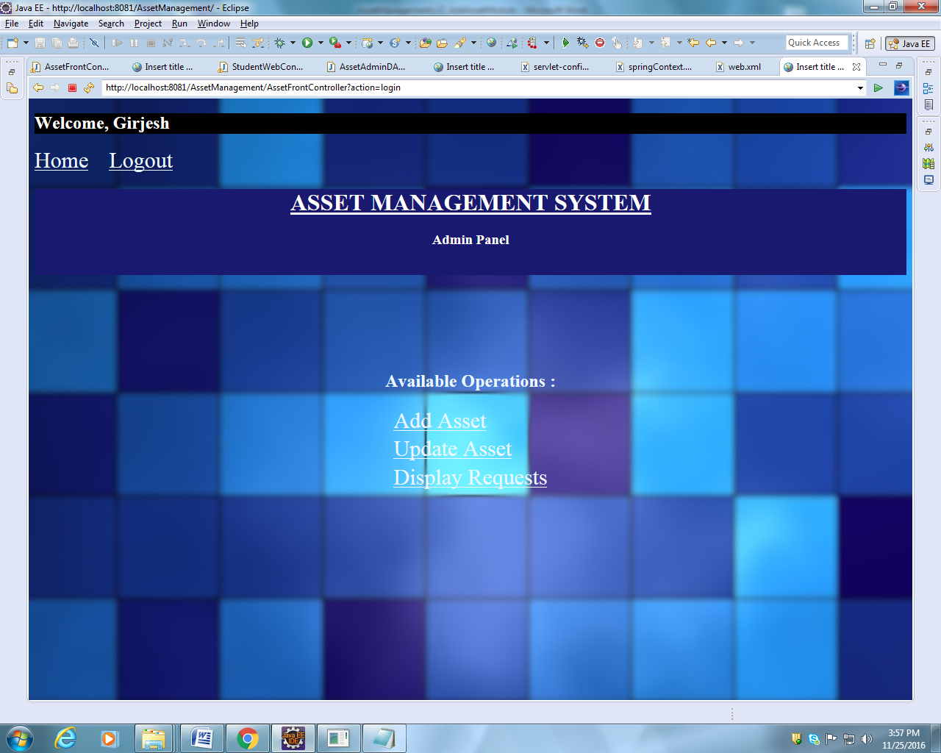

## List Of Design Classes

|  |  |  |  |  |
| --- | --- | --- | --- | --- |
| **Sr. No.** | **LLD Name** | **Class Name** | **Method Name** | **Method Description** |
| 1 | Add Login  Module | UserType,  Asset | Appropriate getters and setters methods,  toString methods | Getters retrieve the property values and setters set the property values. Returns a string representation of the object. In general, the toString method returns a string that "textually represents" this object. |
| 2 | Add Login Module | AssetFrontController | addAssetAdmin(@RequestParam("file") String filename,@ModelAttribute("Asset") @Valid Asset asset,BindingResult result,Model model):String | Calls addAssetAdmin () of AssetServiceImpl-  mentation class. If it returns object then it redirects to home page else it redirects to add page with appropriate error message. |
| 3 | Add Product Module | AssetServiceImpl | addAsset(HashMap<String, String> assetDetails) | Sets attributes of asset in an asset object and returns the object to addAsset method of the DAO |
| 4 | Add Product Module | AssetAdminDAOImpl | addAsset(Asset asset) | .  Inserts the asset details into the database and returns the result to AssetServiceImpl. |

# Re-Usable Routines/Components

Re-Usable Routines/Components

* CSS files
* Javascript files
* DataAccessException class
* Database properties files
* Logger properties files

# Messages

|  |  |  |
| --- | --- | --- |
| **#.** | **Type** | **Message Text** |
| M1 | Error | Enter a valid asset name. It should contain alphabet only and should not be empty. |
| M2 | Error | Enter a valid asset description. It shouldn’t be empty. |
| M3 | Error | Quantity can only be numerical and should not be blank. |
| M4 | Error | Enter either allocated or available. This field should not be blank. |

# Configuration Files

|  |  |  |
| --- | --- | --- |
| File Name | Path | Description |
| springContext.xml | /WebContent/WEB-INF/ config | To configure database connection.  To configure application context. |
| Web.xml | /WebContent/WEB-INF | To deploy the webapplication to any Java Servlet container. |
| servlet-config.xml | /WebContent/WEB-INF/ config | To configure the request mapping and view resolver. |

# Crud Matrix Table

|  |  |  |  |  |  |
| --- | --- | --- | --- | --- | --- |
| **#** | **Table Name** | **Create** | **Read** | **Update** | **Delete** |
| 1. | Add_Asset | Y | N | N | N |

# Data Mapping Matrix

|  |  |  |  |  |  |  |  |
| --- | --- | --- | --- | --- | --- | --- | --- |
| **Sr. No.** | **Screen Label** | **Field Source** | **Field Type** | **Data Type** | **Max Length** | **Data Flow** | **Mandatory** |
| 1 | Asset Name | NA | Label | NA | NA | UI | NA |
| 2 | assetName | Asset.assetName | TextBox | Varchar2 | 50 | UI🡪D | Yes |
| 3 | Asset Description : | NA | Label | NA | NA | UI | NA |
| 4 | assetDes | Asset.assetDes | TextBox | Varchar2 | 50 | UI🡪D | Yes |
| 5 | Quantity : | NA | Label | NA | NA | UI | NA |
| 6 | quantity | Asset.quantity | TextBox | Varchar2 | 50 | UI🡪D | Yes |
| 7 | Asset Status : | NA | Label | NA | NA | UI | NA |
| 8 | status | Asset. status | TextBox | Varchar2 | 50 | UI🡪D | Yes |
| 13 | Add | NA | Button | NA | NA | UI | NA |
| 14 | Reset | NA | Button | NA | NA | UI | NA |

**Legend**

D 🡪 UI (Database to User Interface)

UI 🡪 D (User Interface to Database)

UI (User Interface Only)

# Action Flow Matrix

|  |  |  |  |
| --- | --- | --- | --- |
| **Sr. No.** | **Action** | **Description** | **Process** |
| 1 | On click of Add Button in Admin Homepage | Redirected to the Add page | The admin clicks on the add button in the admin homepage and gets redirected to the add page. |
| 2 | On click of Add button in add page | The asset details are inserted into the database. | Data entered in the fields by the admin gets inserted into the database when add button is pressed. |
| 3 | On click of Reset button in Add page | The asset details are not added into the database. | The admin on clicking on the reset button in add page gets redirected to the same page with no entries. |

# Stored Procedures

|  |  |  |  |  |
| --- | --- | --- | --- | --- |
| **#** | **Stored Procedure Name**  **(with Description)** | **Input/Out Parameters** | **Type** | **Size** |
| 1. | NA | NA | NA | NA |

# Program Specification / Pseudo Code

## <ACTION :ONPAGE_LOAD >

**Pseudo Code:**

1. **Client Side Scripting:**

None

1. **Server Side Scripting:**

**BEGIN**

Call loginPage in Controller class

Navigate to Login Page.

**END**

**14. 2 <ACTION: LOGIN_CLICK>**

**Pseudo Code:**

1. **Client Side Scripting:**

IF UserId isEmpty

Print Error Message M1

IF Password isEmpty

Print Error Message M1

IF invalid UserId

Print Error Message M1

IF invalid Password

Print Error Message M1

IF length of UserId > 10 characters

Print Error Message M1

IF length of Password > 16 characters

Print Error Message M1

1. **Server Side Scripting:**

**BEGIN**

Call checkLogin(@ModelAttribute(value=” username”)ValidUser user,BindingResult result,Model model) in Controller class in Presentation Layer

**BEGIN**

Call isValidUser(User user) in AssetServiceImpl class in Service Layer

**BEGIN**

Call isValidUser(User user) in AssetDAOImpl class in Service Layer

**BEGIN**

Create query to search if the user exists or not

**END**

Return int to AssetServiceImpl

**END**

Return int to Controller class

**END**

If return==1

**BEGIN**

Call searchUser(User user) in AssetServiceImpl class in Service Layer

**BEGIN**

Call searchUser(User user) in AssetDAOImpl class in Service Layer

**BEGIN**

Create query to retrieve the role of the user

**END**

Return role to AssetServiceImpl

**END**

Return role to Controller class

Navigate to respective pages based on their roles

Else navigate to login page

**END**

**14. 2 <ACTION: RESET_CLICK>**

**Pseudo Code:**

**1. Client Side Scripting:**

None

1. **Server Side Scripting:**

None

REVISION HISTORY OF THE WORK PRODUCT

|  |  |  |  |  |  |
| --- | --- | --- | --- | --- | --- |
| # | Date | Version # | Section Changed | Details of changes made | Approved By |
| 1 | 25/11/2016 | 1.0 | LLD prepared | N/A |  |