**Undergraduate Final Year Project Proposal**

**Developing A Social Network Application for IT Experts**

**Nguyen Duy Quang**

**COMP1682 Project Proposal**

**001353659**

**Table of Contents**

I Overview 3

II Aim 5

III Objectives 5

1. Interview or survey user requirements 5

2. Review 5

3. Design database and user interface 5

3.1 Database Design 5

3.2 User Interface Design 6

4. Implement and deployment 6

4.1 Implement 6

4.2 Deployment 6

5. Testing and Evaluation 6

5.1 Testing 6

5.2 Evaluation 7

6. Writing Report 7

IV Legal, Social, Ethical, and Professional 7

1. Legal Considerations 7

2. Social Implications 7

3. Ethical Considerations 7

4. Professional Aspects 8

V Planning 8

1. Methodology used 8

2. Gantt chart 10

VI Initial References 13

**List of Figures**

Figure 1. Overview Architecture 4

Figure 2. Depicting the implementation in development life cycle 9

Figure 3. Gantt chart (1) 10

Figure 4. Gantt chart (2) 11

# Overview

Social network applications tailored to technology experts have gained prominence as the technology sector continues its rapid growth. This report explores the landscape of these specialized platforms, examining their motivations, challenges, and critical success factors. These networks are essential in connecting professionals, sharing knowledge, and staying updated in a rapidly evolving field (Smith, 2021).

The rise of social networks for technology experts is driven by the need to stay abreast of rapid technological changes. These networks offer a hub for knowledge exchange and best practices. Additionally, technology experts benefit from niche platforms that facilitate connections with peers who share similar skills and interests (Smith, 2021).

While the development of these networks is promising, it's not without challenges. Maintaining relevance in a fast-changing industry is critical. Data security and privacy are concerns due to the sensitive nature of the information shared. Attracting and retaining users requires a thoughtful strategy, balancing community building with professional networking (Brown, 2020).

Success in technology expert social networks relies on user engagement, achieved through features encouraging meaningful interactions and knowledge sharing. An effective content curation system, user-friendly interface, data security, and trust-building measures are vital. Fostering a sense of community where experts feel valued and heard is crucial for long-term success (Williams, 2019).

In conclusion, social network applications for technology experts are vital for professional development and networking in a dynamic industry. Overcoming challenges through user engagement, trust, and community building is key to success. As technology continues to evolve, these platforms remain essential for connecting, learning, and growing within the field (Johnson, 2018). The “Develop Social Network Applications for Technology Experts” initiative aspires to create a pivotal online domain wherein technology professionals can engage, collaborate, and remain apprised of advancements in their respective domains. The fulfillment of this vision is expected to make substantial contributions to technological progress and innovation. This report serves as a comprehensive guide to the project's goals, objectives, and the strategies devised for its execution.

The technology stack that I use comprises a robust set of tools and technologies for developing modern web and mobile applications. At its core, we have HTML5 and CSS3 for building responsive and visually appealing user interfaces, with the added flexibility and styling capabilities of Bootstrap. Angular (Front-end) and Spring Boot (Back-end) serve as the foundation for creating powerful, scalable, and maintainable web applications, while Flutter offers a versatile framework for building cross-platform mobile apps. Docker simplifies the deployment and management of application containers, ensuring consistency across different environments. Keycloak enhances security and identity management. PostgreSQL is a reliable and feature-rich database choice, that supports data storage needs. Real-time communication is facilitated through WebSocket for instant notifications. For hosting, AWS or Digital Ocean offers scalable and reliable infrastructure options. Version control is managed through Git, typically hosted on GitHub, allowing for collaborative development and code management. This well-rounded technology stack provides the tools necessary for building efficient, secure, and high-performing applications across web and mobile platforms.

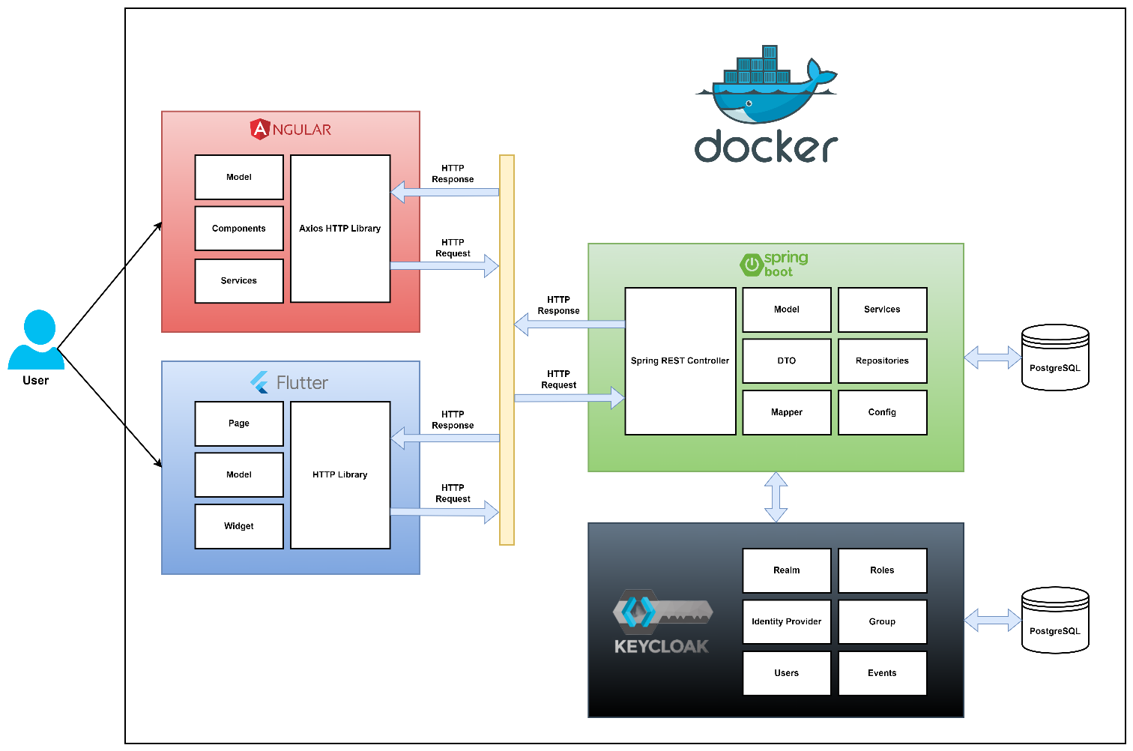

1. Overview Architecture

# Aim

The project aims to create a user-friendly and engaging online multiple platform that fosters connections, discussions, and opinion sharing among its users.

# Objectives

## Interview or survey user requirements

* Conduct in-depth interviews with a diverse group of technology experts to understand their specific needs, goals, and pain points.
* Develop a structured survey to collect quantitative and qualitative data, asking about their preferences in terms of features, user experience, and networking goals.
* Analyze the data, segment users based on their roles and objectives, and create detailed user personas to guide the development process.
* Use user stories and user journey maps to illustrate how users will interact with the application.

**Output:** In this phase, gather user insights through interviews and surveys to create user personas and understand their needs.

## Review

* Thoroughly investigate existing social network platforms within the technology sector, analyzing their strengths and weaknesses.
* Create a competitive analysis matrix to compare features and user engagement strategies.
* Analyze trends and emerging technologies in the field to inform my application's design.

**Output:** Analyze existing platforms and industry trends to inform my application's design.

## Design database and user interface

### Database Design

* Create an Entity-Relationship Diagram (ERD) to model the database, specifying the relationships between tables and the attributes of each entity.
* Define data access patterns, considering how data will be retrieved and updated.
* Choose a suitable database management system.

### User Interface Design

* Develop low-fidelity wireframes and high-fidelity mockups for different screens and user flows.
* Design the user interface with a focus on accessibility, adhering to industry best practices for UI/UX design.
* Prototype the interface to allow for user testing and refinement.

**Output:** Create the database structure and user interface design, emphasizing accessibility and usability.

## Implement and deployment

### Implement

* Follow an Agile development methodology with sprints and regular stand-up meetings.
* Code the front end using modern web technologies and choose an appropriate framework.
* Develop the back end using a programming language and select a suitable framework.
* Implement user authentication, authorization, and role-based access control.
* Integrate third-party APIs for features like authentication via social media accounts.

### Deployment

* Set up production and staging environments to facilitate testing and deployment.
* Use containerization and orchestration tools to manage the application's scalability.
* Deploy the application on cloud servers or on-premises infrastructure.

**Output:** Develop the application's front-end and back-end, and deploy it using scalable infrastructure.

## Testing and Evaluation

### Testing

* Conduct unit testing, integration testing, and regression testing to identify and fix bugs and ensure code quality.
* Perform load testing to assess the application's performance and scalability.
* Conduct security testing, including penetration testing and vulnerability scanning.
* Usability testing to evaluate the user experience and gather user feedback.

### Evaluation

* Collect feedback from beta users and conduct surveys or interviews to gauge their satisfaction and identify areas for improvement.
* Monitor key performance indicators (KPIs) related to user engagement, retention, and growth.
* Analyze server logs and application usage data to identify patterns and areas for optimization.

**Output:** Thoroughly test the application for functionality, performance, security, and usability. Collect user feedback.

## Writing Report

* Technical design specifications, including database schemas, API documentation, and system architecture diagrams.
* Code documentation, such as comments and README files for developers.
* Testing documentation, detailing test cases, test results, and bug reports.

**Output:** Document the development process with technical specifications, code documentation, and testing details for reference and maintenance.

# Legal, Social, Ethical, and Professional

## Legal Considerations

Developing social network applications for technology experts involves numerous legal considerations. Compliance with data protection regulations such as the General Data Protection Regulation (GDPR) in Europe and the California Consumer Privacy Act (CCPA) is crucial to ensure user data privacy and legal compliance (Cohen, 2019).

## Social Implications

The development of specialized social networks for technology experts has social implications, offering a platform for professionals to connect, collaborate, and share knowledge. These networks can foster a sense of belonging and professional community, as exemplified by LinkedIn's role in professional networking (Smith, 2021).

## Ethical Considerations

Ethically, it is essential to prioritize user data privacy and security when developing social network applications for technology experts. Transparent data handling practices, clear privacy policies, and robust security measures are ethical imperatives to protect user data and prevent breaches (Anderson, 2018).

## Professional Aspects

From a professional perspective, successful technology expert social networks should maintain high standards of content and interactions. Features should facilitate meaningful professional interactions and peer-to-peer learning. Ensuring adherence to professional standards and codes of conduct, similar to those on platforms like GitHub, fosters a professional environment (Brown, 2020).

# Planning

## Methodology used

In today's highly competitive IT industry, the focus has shifted towards developing high-quality products. Speedy delivery is no longer the sole priority; customer satisfaction is equally important. This shift has led to the adoption of rigorous testing techniques and tools, creating complex challenges in project management and team coordination at all levels.

Companies are now prioritizing the delivery of quality products that meet customer expectations. Each software development life cycle model has its significance and limitations. Choosing a specific model allows for tailored processes and structures to suit various types of products and projects. For my project, I have opted for the Agile methodology as it aligns well with these goals and requirements (Singh, et al., 2019).

As per the definition from "AgileAlliance.org," "Agile" serves as a broad term encompassing methodologies and practices aimed at improving software development through collaborative efforts. It is rooted in the Agile Software Development Manifesto and its 12 principles.

These principles are inspired by the insights found in the Agile Manifesto by Cunningham and include the following key ideas:

* The highest priority is to satisfy the customer through continuous and early software development.
* It's crucial to maximize the amount of work not done, emphasizing efficiency.
* Development teams should regularly reflect on their processes during fixed intervals to enhance productivity and make necessary adjustments.
* Creating a conducive environment for motivated individuals and entrusting them with the responsibility of delivering results is vital.
* Agile processes support accommodating changes in requirements even during the later stages of development to ensure the software's benefits for the customer (Singh, et al., 2019).

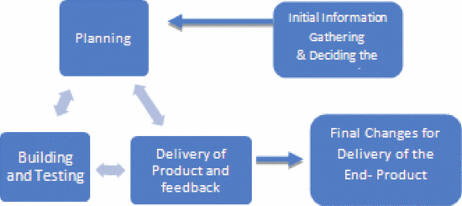

1. Depicting the implementation in development life cycle

Effective software development is a multi-faceted process that demands meticulous planning, rigorous testing, and responsive adaptation to client needs. To ensure the successful creation of a software product, a systematic approach is essential. The following steps provide a structured framework for navigating the software development journey, from gathering initial requirements to delivering a fully refined and client-approved end product. These steps form a comprehensive roadmap to guide software development teams toward achieving excellence in their projects.

**Step 1:** Information Gathering for Optimal Approach

During this initial phase, the project team collects essential information from the client and assembles a scope document outlining the project's feasibility and requirements. The client's product needs are carefully gathered and analyzed by the project manager and team members. Business managers review each requirement to ensure its inclusion in the software, along with its associated functionalities.

**Step 2:** Planning

The IT department's management devises two distinct plans as follows:

* Physical Plan: This plan involves selecting the right individuals for the project team, establishing in-house communication channels, and allocating necessary computational and physical resources.
* Analytical Plan: Various technical refinements are decided upon, including user interface design, the timing of open-source package releases, database configuration, end-user utilities, and more.

**Step 3:** Development and Testing

In accordance with the established plan, the development phase commences, and a working prototype is rigorously tested to verify its functionality. During testing, developers assess if their code and programming align with client requirements. While it may be impossible to catch all potential issues during this phase, the results from testing serve to minimize software errors.

**Step 4:** Product Delivery and Feedback

A beta version of the software is released to various sections within organizations to gather early feedback. If errors are identified in the current version, this feedback is incorporated into the subsequent software iterations. Additionally, any client-requested features are considered and may be added in later stages. Steps 2 (Planning), 3 (Development and Testing), and 4 (Product Delivery and Feedback) are repeated until the feedback collected is entirely positive.

**Step 5:** Finalizing Changes for Product Delivery

All the necessary final adjustments are made to the product. After thorough testing and client acceptance, ensuring all required features are met, the software is delivered to the client (Singh, et al., 2019).

## Gantt chart

As seen in Figures 3 and 4, I have created a Gantt chart below using the time estimates and tasks.

* **Start day:** October 28th, 2023
* **Finish day:** May 15th, 2024

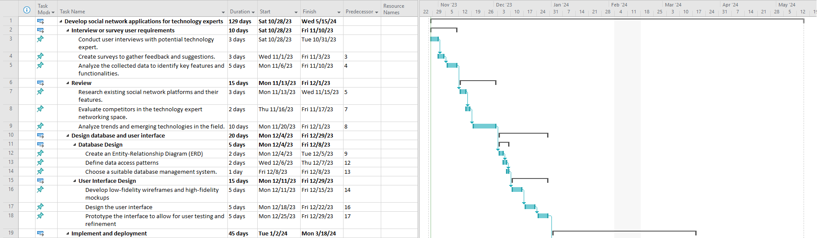

1. Gantt chart (1)

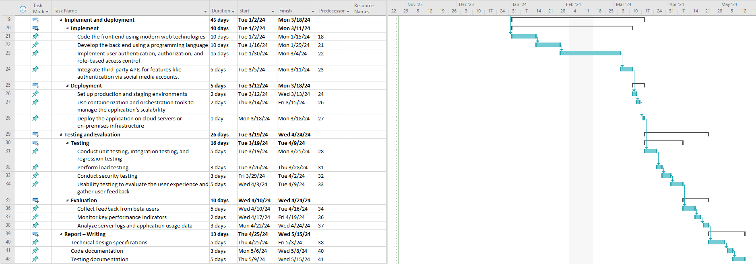

1. Gantt chart (2)

The Gantt chart for our software development project presents a detailed roadmap for building a specialized social network application designed for technology experts. The breakdown of the estimated timeline for each phase is as follows:

**User Requirements Phase (1-2 weeks):** In this phase, we will conduct in-depth interviews with technology experts to grasp their unique needs, goals, and pain points. We will also create a structured survey to collect quantitative and qualitative data on user preferences, analyze the data to segment users based on their roles, and craft detailed user personas. Additionally, we will develop user stories and user journey maps to visualize how users will interact with the application.

Review Phase (2-3 weeks): This phase is dedicated to a comprehensive review of existing social network platforms within the technology sector, where we will analyze their strengths and weaknesses. We will create a competitive analysis matrix to compare features, user engagement strategies, and monetization models. Additionally, we will research cutting-edge technologies in the field.

**Design Phase (3-4 weeks):** During the design phase, we will create the database design, which includes the development of an Entity-Relationship Diagram (ERD) and definition of data access patterns. We will also choose a suitable database management system. Simultaneously, our user interface design will take shape as we develop low-fidelity wireframes and high-fidelity mockups for various screens and user flows. The design of the user interface will prioritize accessibility and adhere to industry best practices for UI/UX design. Prototyping will also be undertaken to allow for user testing and refinement.

**Implementation and Deployment Phase (5-6 weeks):** This is the most extensive phase, where development takes center stage. We'll follow an Agile development methodology with sprints. Front-end development will involve the use of modern web technologies like HTML, CSS, and JavaScript, coupled with a suitable framework, such as React or Angular. Back-end development will use a programming language (e.g., Java or Node.js) along with a suitable framework like Spring Boot or Express. We will implement essential features such as user authentication, authorization, and role-based access control. Integration of third-party APIs, including social media authentication, will be carried out. Deployment involves setting up production and staging environments, employing containerization (e.g., Docker) for scalability, and finally deploying the application on cloud servers (e.g., AWS) or Digital Ocean.

**Testing and Evaluation Phase (3-4 weeks):** This phase is crucial for ensuring the application's quality and user satisfaction. Testing will encompass unit testing, integration testing, regression testing, load testing, security testing, and usability testing. Evaluation includes collecting feedback from beta users, conducting surveys and interviews to gauge user satisfaction, monitoring key performance indicators related to user engagement, retention, and growth, and analyzing server logs and application usage data to identify patterns and optimization opportunities.

**Report Writing Phase (1-2 weeks):** In the final phase, we will compile comprehensive documentation. This includes documenting user requirements and feedback, technical design specifications, code documentation, testing documentation with detailed test cases, results, and bug reports, and a post-mortem analysis that summarizes the development process, challenges faced, and lessons learned. Additionally, a roadmap for future enhancements will be created, and prioritized based on user feedback and evolving technology trends.

# Initial References

Anderson, R. B., 2018. Ethical Considerations in Data Privacy for Social Networks.. *Journal of Information Ethics,* 7(4), pp. 121-136.

Brown, L. C., 2020. The Evolution of Online Communities for Technology Enthusiasts.. *International Journal of Computer Science and Technology,* 9(2), pp. 78-91.

Brown, M. E., 2020. Maintaining Professionalism in Online Communities: A Case Study of GitHub.. *Journal of Professional Network,* 15(2), pp. 73-88.

Cohen, D. L., 2019. Privacy and Data Protection in the Digital Age: A Comparative Analysis of the GDPR and CCPA.. *International Journal of Digital Ethics,* 1(2), pp. 45-58.

Johnson, M. S., 2018. Building Successful Online Communities for Technology Experts.. *Technology and Innovation,* 15(2), pp. 73-88.

Singh, R., Kumar, D. & Sagar, B. B., 2019. *Analytical Study of Agile Methodology in Information Technology Sector.* Mathura, India, IEEE.

Smith, J., 2021. The Impact of LinkedIn on Professional Networking.. *Journal of Social Networking,* 20(3), pp. 78-91.

Smith, J. A., 2021. Social Networking and Professional Development: The Role of Technology Experts.. *Journal of Technology Advancements,* 12(3), pp. 45-58.

Williams, R. D., 2019. Networking in the Digital Age: Strategies for Technology Professionals.. *Journal of Information Technology Networking,* 7(4), pp. 121-136.