Problems 4
- Construct a Turing machine that accepts L = { w ∈ {a, b}* | w has an equal number of a’s and b’s}.
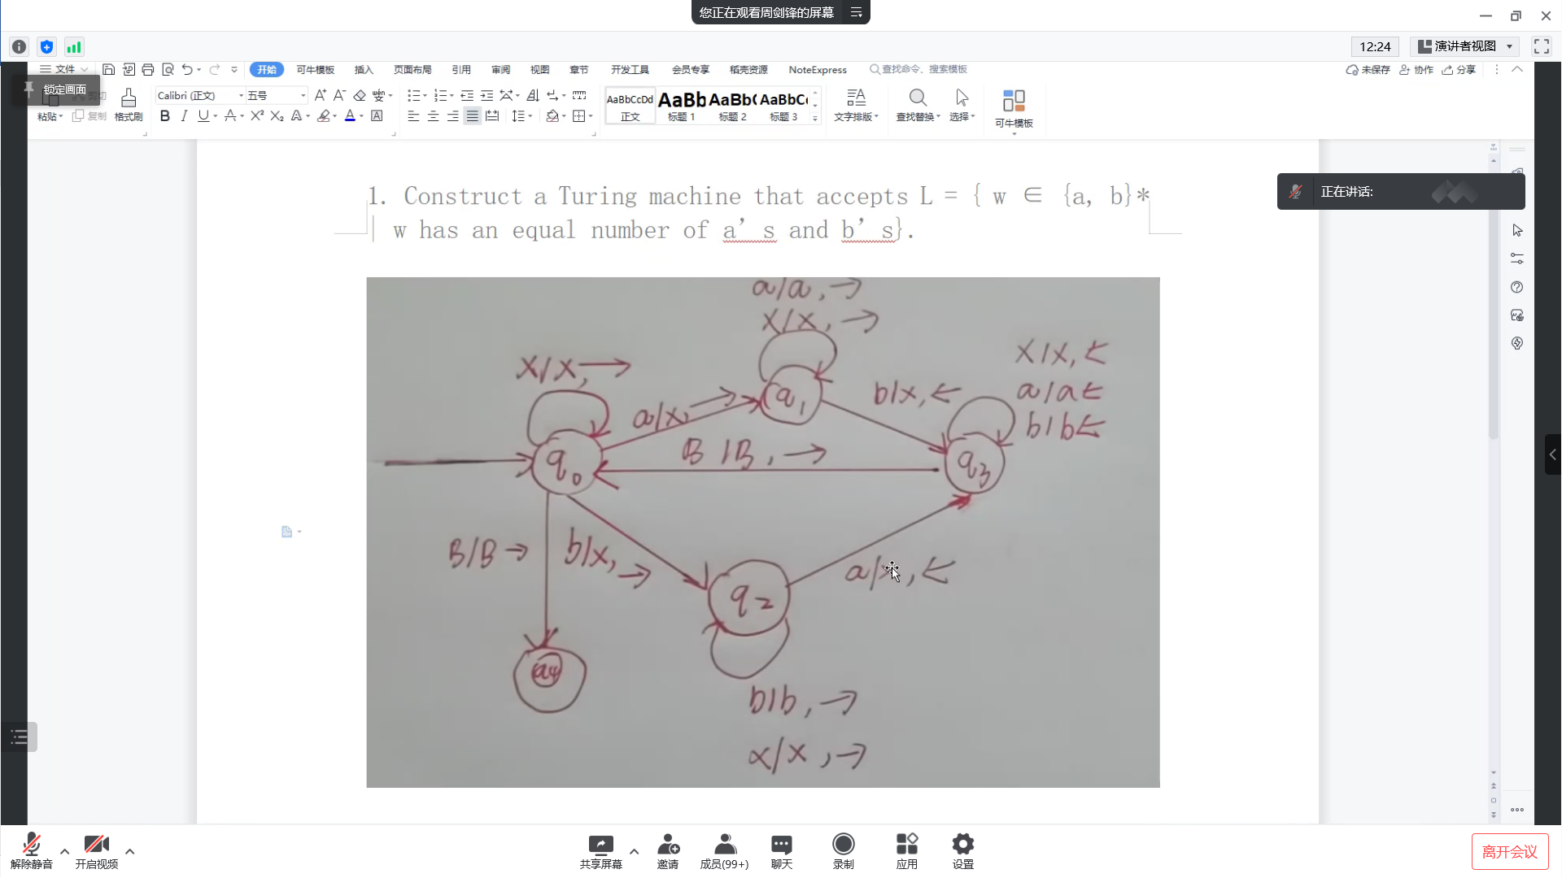
- Let x and y are positive numbers. Please design a Turing Machine (diagram) to compute x – y of x and y). You should explain the notation of x and y. Hint : you may get the notation as simple as you can.
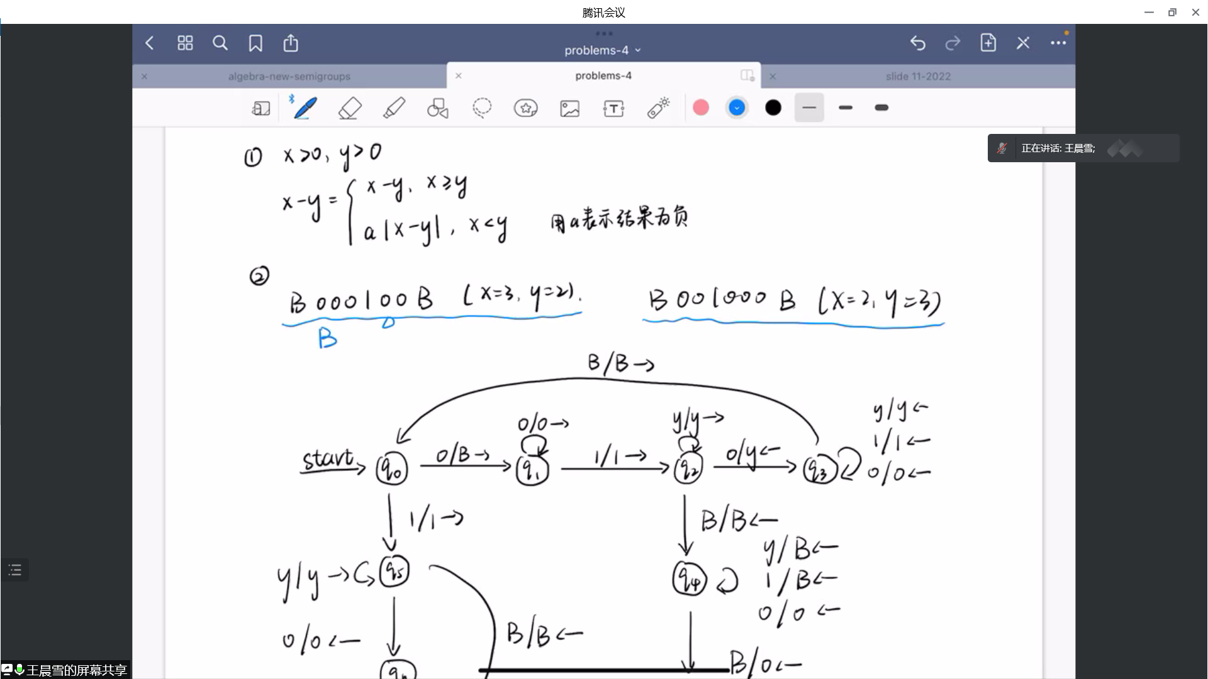
3. Use the CFL pumping lemma to show that the following language is not context free
{ a^{i} b^{j} c^{k} | i < j < k }
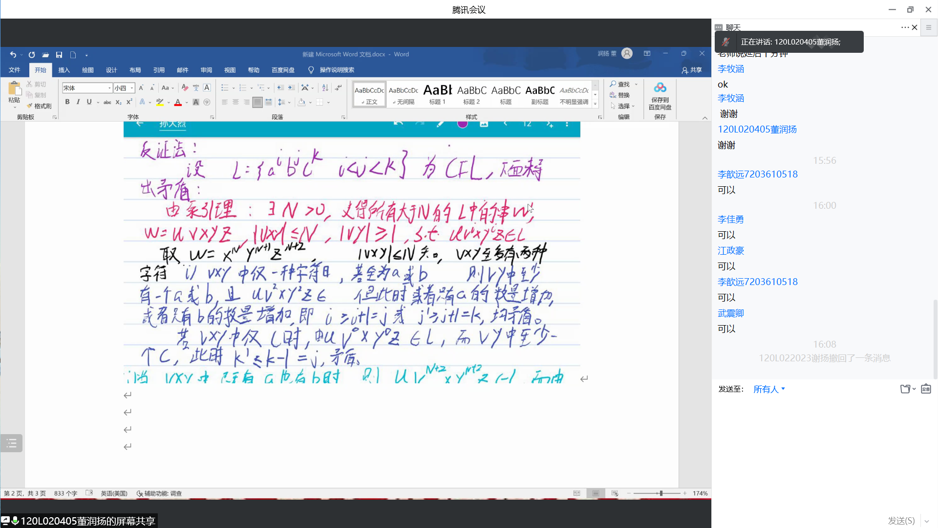
4. If L₁ and L₂ be two CFL’s. Is it necessarily true that L₁ − L₂ is also a CFL? Prove your answer.
5. Show that the regular languages are closed under the following operations: min(L) = { w | w is in L, but no proper prefix of w is in L }.
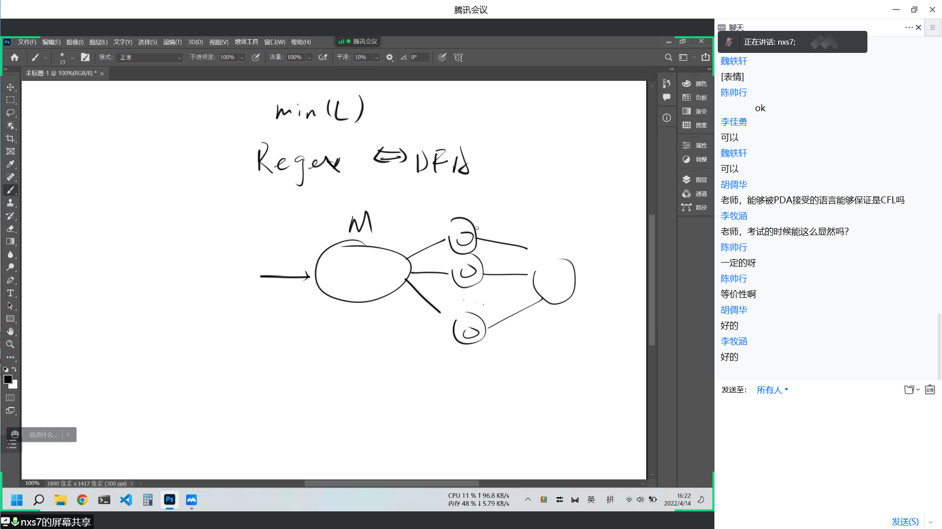
6. Prove. For every context-free language L, the language L` = { 0^{|w|} | w ∈ L } is also context-free.

