*Save Time In Canteen:*

*Intelligent Food Cabinet*

C-Time

*Team Members：*

*Yi Xinhao*

*Luo Man*

*Zeng Hui*

*Sheng Xiaqing*

*Wei Zhenyu*

*Wang Pengfei*

*Submission Date*

*29/01/2019*

**Summary**

Food is the first necessity of people, and everyone’s daily chat will inevitably involve eating. When talking with Chinese college students, the most frequently heard are complaints that the canteen in the university is too crowded and leads to a long line which wastes time. This is a common problem that our team members have met. Therefore, we decided to use it as our topic. We will combine what we have learned in the lectures over the past few days to deeply analyze our problem, propose solutions and improve the situation.

In Jeff's lecture, we learned that the "insight" of our problem is ‘HMW save time by shorting the line’. Then we determined that the ultimate goal of our problem is ‘save time’, the central idea is ‘short the line’. After that, we provided solutions for the central idea. Under the guidance of ‘design thinking’, we proposed many solutions and classified them. And there are four categories: Take away, Order in advance, Expansion and Pack in advance. We chose ‘Take Away’ as the main focus and got a preliminary solution to the problem. Later, according to ‘IoT’ in George’s lecture, the robot technology taught by Amy, and the AI technology mentioned by Vincent, we improved our solutions, and their ideas have been applied to reach the final solution which is ‘Automatic Take Away System’, aka ‘ATAS’. That means a student can order his meal in advance, and take it away from a ‘Intelligent Food Cabinet’. The Intelligent food cabinet is an automatic container where staff put students’ food, thus students can get their food whenever they want without standing in line.

For the final solution, we combined our improved idea with Rosemary's Agile idea. Then we shared our questions with other project teams, got feedback and further improvements. After finishing a complete solution, we will write a recommendation letter to our university to explain the feasibility of our project.

The advantage of our program is that it can solve the problem of canteen congestion, which frees students from the trouble of queuing and save a lot of time. A large amount of data and feedback can be obtained to analyze students' habits and preferences, which will help to make corresponding adjustments. The disadvantages of our solution are that the cost and the technical requirements will be relatively high, and the freshness of the food cannot be guaranteed.

We believe that our research results will definitely help the improvement of the Chinese canteen.

**Key words:** Canteen,Save Time, Lecture, Intelligent Food Cabinet

**Contents**

I. Introduction 4

II. Description of the problem in detail 4

III. Description of research 5

Jan.22 5

Jan.23 6

Jan.24 8

Jan.25 11

Jan.28 [11](#_Toc536251860)

Jan.29 12

IV. Description of solution 13

V. Conclusion 14

VI. Recommendation 15

# I. Introduction

We build a creative team of six with two girls and four boys. Besides, each team member comes from another city or university and our majors are all different. The majors include Physics, Clinical Medicine, Flight Control, Materials Chemistry, Chemistry and Mechanical Design and Automation. Furthermore, based on our own expertise and strengths and weaknesses, our group has a clear division of labor.[1]

Under the leadership of the group leader, we wrote down the five biggest problems in our own university and discussed them with other team members, we finally settled on a co-existence issue—the problem of wasting a lot of time waiting in line at the canteen. After collecting a lot of data and investigations, it shows that this is a very common phenomenon in China. Therefore, wasting time queuing in the canteen is an extremely urgent problem to be solved.

Food, clothing, housing and transportation are all important parts of college life, among which eating is the most concerned issues for students. During the peak time, the dining hall is always crowded and inefficient, so that students have to wait for a long time to get their meal. Even if they do get a meal, they always have to face the dilemma of lack of seats. In this case, it is very necessary for us to find a practical solution to deal with this universal issue.

# II. Description of the problem in detail

During the peak time when classes are over, students leave classrooms and swarm into the dining hall at the same time. As a consequence, the dinning hall is crowded and inefficient to distribute food. Students have to wait in line for a long time to get their meal. Standing in the hall tired and bored, most of them are hungry and angry which is called ‘hangry’. Consequently, students might just pick dishes at random and there would be a great chance that he chooses food he doesn’t like in order to save time. They might also jump a queue unconsciously or not, which would cause the disorder of waiting lines and waste other students’ time. Besides, Some students may not start thinking about what to eat until he has already reached the service window while others have difficulty finding out what food each window serves. These are all the reasons causing the long line problem.

For students who have a tight schedule, they have limited lunch time and need to get their food quickly. If they waste a lot of time waiting in line, there would be less time to have a nap or do something else. It would be a great help to them if they can get food without delay. As for the dining hall, reducing the waiting time can help relieve the workload and increase the profit simultaneously.

In conclusion, it will cut the time cost of the students and increase the efficiency and quality of service in dining hall if the problem is solved. Thus by reducing the waiting of students, both the campus and the student will benefit in the long term.

# III. Description of research

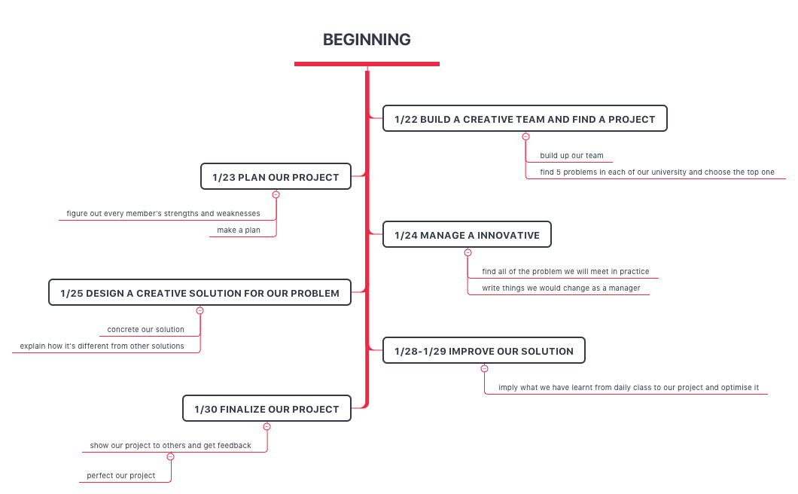

Process of our research

# 1.22

**Team’s Problems：**

1. The dining hall is crowded at peak times, students have to spend a lot of time waiting in line to get food.
2. There are many street cats and dogs that may disturb students in the campus.
3. The design of the green area of the campus is unbefitting.
4. The river running through the campus is polluted, which causes a negative impact both on students and on the campus.
5. The distribution of sharing bikes in campus is unreasonable, which not only blocks traffic but also is waste of social resources.
6. The course selection system is unstable, which means it could break down when a large amount of students visit it.
7. The teaching quality evaluation system is not effective, which makes it hard to evaluate teachers’ ability and collect students’ feedback. Moreover, neither students nor teachers pay enough attention to it.
8. The maintenance of public facilities is not in time.

**Main Problem Description:**

Food, clothing, housing and transportation are all important parts of college life, among which eating is the most concerned issues for students. During the peak time, the dining hall is always crowded and inefficient, so that students have to wait for a long time to get their meal. Standing in the hall tired and bored, most of the students are hungry and angry which is called ‘hangry’. ‘Hangry’ students might just pick dishes at random and there would be a great chance that he chooses food he doesn’t like in order to save time. For students who have tight schedules, they waste a lot of time that could have been better spent doing something else.

The problem is caused by several reasons. First, someone may not start thinking about what to eat until he has already reached the service window, which leads to the delay. Also, the dinning hall may be so crowded that the line is not obvious and students may jump a queue unconsciously or get in the wrong line, which all cost the time. There are many other things causing this problem and deserving to be discussed.

It will cut the time cost of the students and increase the efficiency and quality of service in dining hall if the problem is solved. Thus by reducing the waiting of students, both the campus and the student will benefit in the long term.

Some students even don’t know whether they are waiting for their favored food and some students don’t decide what they want to eat in advance and the number of the windows is limited ,which may cause long line and disordered. The time is valuable , the students may have tight schedules, and only adding the windows will increase the cost and the dining hall doesn’t have enough room, so shorting the line to save time may provide student’s more time doing other useful things such as reading and studying. the first problem about canteen is the most urgent issue to be solved in my university .

**Reasons why not choosing other problems:**

The problem of street cats and dogs is not strongly associated with all students, and the problem of unreasonable distribution of sharing bikes can be solved by set some located parking place. It is also different from optimization in education, which is hard to quantify and implement appropriate solutions. What’s more, this problem happens to almost everyone every day, and it doesn’t vary much from school to school. Thus, the vital issue is exactly universal as well as urgent. Furthermore, That’s why we choose to deal with it among others.

# 1.23

| **Member** | **Strengths** | **Weaknesses** |
| --- | --- | --- |
| Yi Xinhao | Be willing to accept others’ different opinions.  Deal with affairs cool-headed.  Hold serious attitude to work.  Hard-working as well as easygoing.  Be able to think about the problem from a variety of perspectives.  Open-minded and flexible. | Sometimes the thinking patterns are a little bit limited and not wide enough.  Some ideas may not be innovative.  English pronunciation is not very good. |
| Sheng Xiaqing | Active and patient, handsome and humorous.  Have extraordinary courage to speak his mind.  Clear thinking, with strong verbal communication skills, interpersonal skills and analysis, strain capacity.  Energetic as well as optimistic. | Usually point out others’ shortcomings and express himself directly, not euphemistically enough.  Too active. |
| Wei Zhenyu | Have good comprehension and an excellent memory.  Have a clear logic.  Patient and humorous, with strong sense of responsibility, as well as communication skills and interpersonal skills.  Have a good command of English. | Introvert, not good at expressing ideas.  Sometimes unwilling to take on additional tasks.  A little censorious, expect perfection from others or even himself. |
| Luo Man | Calm and steady, with strong learning ability and good memory.  Can handle problems independently.  Have strong sense of responsibility, adaptability and affinity.  Diligent as well as rigorous , energetic and have innovative spirit. | Timid, lack of courage.  Procrastinating, and sometimes will bring trouble to other group members.  A little picky, stubborn and occasionally speak too much or interrupt unconsciously. |
| ZengHui | Creative, always come up with many interesting ideas.  Be good at communicating and listen to others carefully during group discussion.  Industrious, be responsible for working on a project.  Be able to guide the orientation of the teamwork. | Eager to seek success and sometimes can’t consider problems completely. |
| *Wang Pengfei | Good at mathematical molding.  Good at using logical thinking to analyze specific problems.  Humorous, always help liven things up. | Sometimes a little bit stubborn.  Kind forgetful |

Based on our characteristics of personality as well as strengths and short comings, everyone plays an vital role in the group to keep the discussion going on. Yi Xinhao, along with ZengHui, will organize the work shop and correct the discussion direction in time when we sometimes deviate from the subject. Sheng Xiaqing and Luo Man always come up with plenty of innovative ideas. Wei Zhenyu is able to remember the details of each member’s speech then sort them out quickly afterwards. Wang Pengfei has ability to think critically, so he can give us a lot of advice on our project. What’s more, we are all assiduous and enthusiastic about our tasks. We respect others’ different opinions, consider them carefully and make improvements. Besides, those handsome boys are so humorous, therefore we all enjoy the team work together during the whole process. Moreover, we help each other as well as learn from each other, in this way make a excellent team by using the advantages to compensate for the weaknesses of each individual member.

# 1.24

List out the problem we meet and 5 solutions.

**Problem:**

1. Take away
2. more stuffs are needed
3. lunch box cost
4. Expansion
5. Funds
6. area
7. Order
8. APP Research and development
9. Maintenance
10. Propaganda
11. Food accumulation
12. Package in advance
13. Hard to cater to taste

**Solution:**

A1: give students a par-time job or volunteer work.

A2:set up extra meal box fees.

B1: find sponsor or foreign resident

C1: working with student who major in computer or software

C3:put up posters.

C4: turntable and conveyor belt

D1: questionnaire

Take-out is actually a good way to decrease the length of the line, though it might increases the cost of human resources and materials wastes. So if I were the manager, I would like to hire some students to deliver food as part-time jobs or find some volunteers to work for that. This method can not only reduce the cost, but also help students who need financial support. As for the cost of the lunch box, I prefer to let students pay for it, which means setting up extra meal box fees. In this way, it is no longer a problem at all.

When it comes to the issue about ordering meals, I probably ask some senior students who major in computer science or software engineering to develop an APP and maintain it frequently. By doing so, they can put what they have learned into practice and also earn pocket money at the same time. Thus, it benefits us all. What’s more, propaganda matters, too. I will consider using posters to let students know our APP and then encourage them to use it. Last but not the least, if students can’t take away their food ordered before in time, those food maybe pile up. Meanwhile, the canteen will be in a mass. Therefore, I plan to set up a transport to collect the accumulated food to another fixed point in order to make the dining hall more orderly.

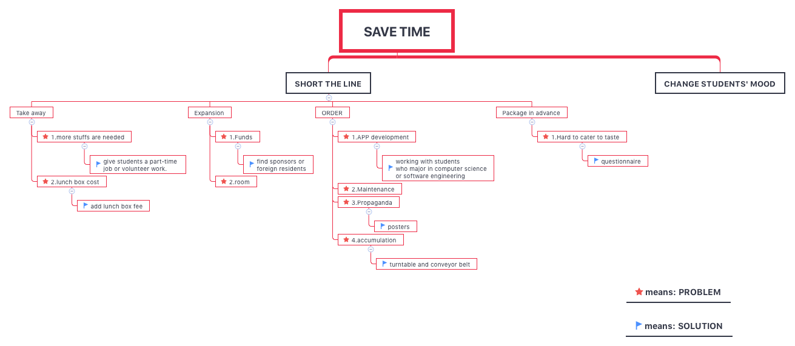

# Our Ideas About AI

**Sheng Xiaqing**

I think AI can be used in medical diagnosis. As we all know, AI has gone into our life, such as Siri, unmanned car and AI robot. In medicine, disease diagnosis is a very important process that tests the ability of many young doctors to work. But once diagnosed wrong, treatment is also likely to be wrong, which may worsen the disease. In order to avoid that disaster, AI appear as the time require. By deep learning and giving AI large sample data, artificial intelligence can diagnose most cases, which will be a great help for young doctors.

**Zeng Hui**

A new wave of artificial intelligence opened by “deep learning” has become a boom, and the application of big data artificial intelligence technology in various fields has become increasingly mature. The artificial intelligence (AI) has applied in medical field greatly, such as medical robots, smart drug research and development and intelligent diagnosis and treatment. This is an inevitable phenomenon in the application of artificial intelligence to the medical process. The big data needs to be classified and regulations are needed to encourage big data collaboration. For the scientific research of public health, the big data should be shared. Although it will help for the public health , sometimes it may be associated with people’s privacy.

**Wei Zhenyu**

I would like to make a brand new earphone that help people to communicate with foreigners. It can record and comprehend your words, and then analyze grammatical or literal mistake. That means when you communicate with foreigners, the earphone will recognize you mistakes and give you some useful hints. If you miss a specific word or have difficulty expressing your idea, it can help you do it quickly and correctly. What’s more, the earphone can connect with the internet to send data to the serving system. Then the system can analyze your dialogue and send you recommendation to improve your language skills.

**Wang Pengfei**

With regard to the new AI design ideas, the newly developed quantum computer technology can be applied to the main computing system of AI. The quantum computer can perform a large number of calculations in a short time, which can make the AI more intelligent.

Scientists who study AI have been distressed by human imitation. However, the speed of quantum computers can match the human brain, thus making human-like technology feasible.

I believe that bionic humans will have a large number of markets, such as AI girlfriends, will certainly be the inevitable choice of the majority of single men, thus driving the development of the entire bionic human industry.

Let me irresponsibly believe that this is feasible.

**Yi Xinhao**

The artificial intelligence product I have conceived is a growth power robot.

As we all know, the technologies that affect the world are used for military and some big companies, such as computers and GPS.

So I believe that artificial intelligence will certainly go into every household like these technologies. This growth-assisted robot is based on a product of this kind of thinking. He will be purchased into a family when a child is born, accompany the child to grow up, collect the child's body index, collect his behavioral language, collect his habits, collect and collect His mood swings, collecting his ability index in different fields. On the basis of learning data for more than ten years or even decades, it will understand the child's personality and understand the child's habits than anyone else. To understand the child's talents, and even combine some psychological knowledge to understand the child's inner personality.

He will give advice to children, career planning, work schedule planning, what problems need to be paid attention to in life, and how to make the most choices when faced with major choices. It will become the mentor of this child's life, helping the child to take less detours and learn more about himself. This is my idea. A growth booster robot.

**Luo Man**

When it comes to the word “ Artificial Intelligence” or commonly known as “ AI”, we’ve only begun to scratch the surface of it on the Web, and sometimes maybe through science fiction movies. It sounds so advanced to us and also too far away from our daily life.

However, there are many current technologies, such as speech recognition, machine translation, and IBM’s human-beating chess grandmaster Deep Blue, that would have seemed like AI at the beginning. Believe it or not, Artificial Intelligence will be applied to every aspect of life.

My preliminary thoughts about a brand new Artificial Intelligent product that I would like to materialize is a smart sensor for anti-theft. It would be built into products such as mobile phones, computers and other valuables. When the marked item is separated from the signal source carried by the owner for a certain distance, the signal will be sent to remind him. Then the AI location system in them will show him where his items are. Besides the host can remotely control the protection system to be turned on while the location is still displayed. In this case, the privacy of the owner’s information is protected. What’s more, the smart sensor will be able to be made in such a weeny size that it cannot be removed from the product.

Even though this is just a preliminary idea, I’m sure it will be used in the future and make a positive difference in our society.

# 1.25

**A:List of all the things our solution will be able to do and what it will not be able to do.**

**Able to do**: a: App (has menu / order meal system/ comment function)

b: provide some big bargain and discount

c:Intelligent transport cabinet :the staff in the dining hall will pack their food, and the express staff will deliver the food to the near Intelligent transport cabinet, put the meal into the locker.

d:The students can choose when they can take the meal .

e:GPS: the students can know the information of real-time position of their food on the App. f:students use the phone to open the locker and taking out the meal .The efficiency can be g:our system connect to the sponsors and we will put some advertisement on the cabinet.

**Not able to do**: the material of packing box may be plastic but greasy and is difficult to be recycled.

**B: Description of our solution and explain how it is different from other solutions.**

**Description of our main solution will be showed in part IV.**

**Other solutions:**

1. Expansion: add more windows which require funds and area.

2. Package in advance: to some extent , it will reduce the time because students don’t need time to decide what they want to eat , but it’s hard to cater everyone’s taste.

**Differences**： The take away system change the traditional dining mode, other solutions are just improve the current dining mode but will not have good profits or have better results. In this way, students don’t need to come to dining hall and enjoy their meal. The students can express the opinion on the App and using the phone to order food will save time and short the line in the dining hall.

# 1.28

The theme of today’s lecture isIoT, the internet of things.

The Internet of things (IoT) is the network of devices such as vehicles, and home appliances that contain electronics, software, actuators, and connectivity which allows these things to connect, interact and exchange data.

The IoT involves extending Internet connectivity beyond standard devices, such as desktops, laptops, smartphones and tablets, to any range of traditionally *dumb* or non-internet-enabled physical devices and everyday objects. Embedded with technology, these devices can communicate and interact over the Internet, and they can be remotely monitored and controlled. ----From Wikipedia, the free encyclopedia

We think the most interesting part of today's course is some of the examples used by teachers to explain the Internet of Things. We can rationally transform these examples that have been applied to practice, and apply the ideas to our projects so that our projects will be more perfect and improved.

Below we will explain one by one:

1.UPS.

The problem of transporting goods from one point to another is such a simple matter. However, the route of transportation is like the number of stars. Even if the life of the earth is calculated in seconds, it is less than one ten-thousandth of the type of transportation plan. Therefore, our solution should not be limited to only one or a certain aspect. For example, for the problems in our project to improve the canteen takeaway, we can have a variety of solutions such as adding windows, quick meals, and setting up take-out cabinets. Of course, we can find solutions from other major aspects, such as expanding or providing reservation services such as improving the original canteen and so on.

2. Real-time adjusted data.

One of the secrets of Amazon's success is that it adjusts the price of his goods over time, based on changes in one's mood throughout the day. It first understands the life patterns of most people, conducts surveys to obtain data, gets people's mood changes at different times in a day, and then raises prices when people are in a good mood, and vice versa. Based on this, we can apply this method to our solution, and transform the mood changes of people into one day, and convert them into mood changes during the meal time. For example, most students who have lunch before 11 o'clock are not very hungry, you can lower the price slightly, and students who have lunch after twelve will be more eager to eat, and the price can be increased to make a profit. Since our original intention was to save students' time and shorten the queues in the cafeteria, whether this method can be further deepened remains to be studied.

3. Tesla as a platform.

Mr.George said, "Tesla is not a car, but a platform." Tesla brings together a wealth of information to provide customers with more choices and the best and most complete experience. And Tesla's approach gives us new ideas for our solutions. Therefore, we will do research and statistics on relevant aspects in order to understand the real preferences of students and understand what students really need. Of course, we also use the customer feedback system to obtain and update information in real time, providing most of the students' favorite foods every day, and even adjusting the price and take-out extraction methods.

4. The more data, the better you are.

In this era of data explosion, there is no doubt that mastering information is very important. Information makes everything possible. When the international aircraft is in operation, the data transmitted by the sensors all over the body is 20TB, based on that the plane can take off safely and landed safely. If you use a laptop to hold the data, at least 30 units will be used. It can be seen that mastering information is also the key to the realization and application of new technologies. "Data is king". For our project, we collect the footprints of each student when using the new system, and get a lot of data and analyze it with user feedback, trying to improve the usability of our system.

# 1.29

**Most interesting part：**

Today, Professor Amy gave us a course in robotics. In the class, the teacher introduced us a lot of robots, from the home rake robot to the production robot used in the planting industry, and to the Boston Power Robot----its Level jump and back flip. The teacher told us that the technology is gradually moving from the academic field to the society. The situation of robotic is similar to it. As the technology continues to mature, the cost is continuously reduced, and the functions are continuously improved, it will eventually enter most of the family, becoming a common part of everyone's life.

The most interesting part for me and my team members is the Boston Power Robot with amazing performance. This robot called Atlas is a biped humanoid robot developed by Boston Dynamics and originally developed by the US Department of Defense. Funding and supervision by the Planning Department (DARPA). The 6.2-foot (1.9-meter) robot was designed for a variety of search and rescue missions and was first shown to the public on July 11, 2013.

its most amazing ability is to walk and climb on rugged terrain, including uneven gravel, snow, etc. It can maintain balance, walk fast, carry boxes, and even climb up after being kicked. And the movements and ecology it learns to walk are strikingly similar to humans.

And thanks to the configured Lidar and stereo sensors, as well as indoor and outdoor positioning capabilities, Altas has been able to navigate indoors and outdoors. As you can see from the video on YouTube, Altas' target search recognition is also very powerful. Testers often kick the box to be lifted, and Altas can quickly locate the box and perform heavy lifting.

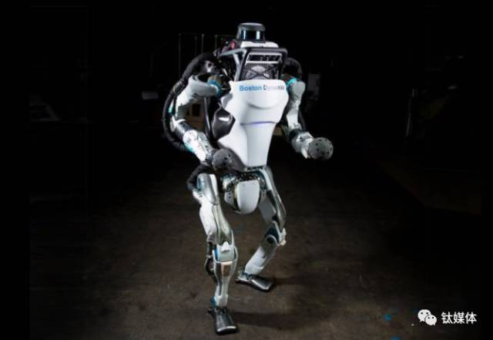

**All the interesting topics and their help for our project：**

1. Robots can reduce labor costs

The teacher's “last mile cost” gave me such an inspiration. In our project solution, in order to divert, a meal box was set up outside the dining hall, and it is undoubtedly a repeat but the meal box was sent to the corresponding take-out box. Why don’t we consider using robots instead of labor-intensive work? Mature robot products can effectively reduce our labor costs and doing this work more efficiently, it can also attract more eyes because of the novelty.

2. Robots are currently novel

At present, robot technology has begun to affect our lives, but it has not reached the point of entering thousands of households, let us take it for granted, and make robot technology into our project, for example, the use of robots to deliver lunch boxes mentioned above is very useful to get attention from more people, which makes it easier to promote our projects.

# IV. Description of solution

**Intelligent Food Cabinet:**

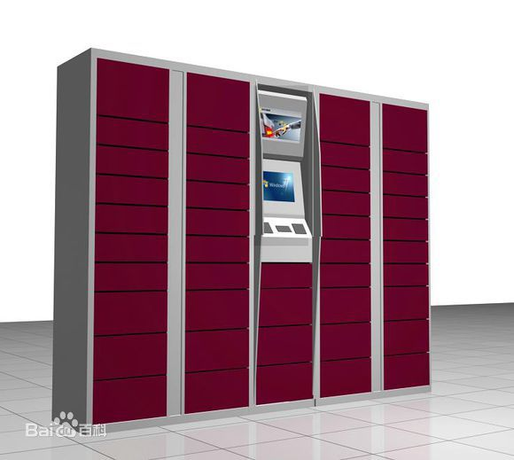

Take away system: First, we will develop an App which has menu of the food that dining hall offers every day. College students can order their meal before lunch time and they have enough time to decide what to eat on the App. Second, the App have the comment function, the students can express their opinions about the food or the system and whatever they want. Also we provide some big bargain and discount on the food to encourage students use this take away system. Once the students order their food, the staff in the dining hall will pack their food, and the express staff will deliver the food to the near Intelligent transport cabinet, put the meal into the locker(we set about three cabinets in the university, the number can be change depend on the scale of the university) . The students can choose when they can take the meal and they can know the information of real-time position of their food on the App. Because the cabinet is network connecting, the system will automatically send the students' mobile phone message including express address . All the students need to do next are coming to the locker, using the phone to open the locker and taking out the meal .The efficiency can be improved . Besides, our system can connect to the sponsors and we will put some advertisement on the cabinet.

# V. Conclusion

We finally decide to make a app which has menu，order meal system and comment function，College students can order their meal before lunch time and they have enough time to decide what to eat on the App. Once the students order their food, the staff in the dining hall will pack their food, and the express staff will deliver the food to the near Intelligent food cabinet, put the meal into the locker. The students can choose when they can take the meal and they can know the information of real-time position of their food on the App.

It will help to reduce the number of the student in the dining hall and create a wonderful dining experience for even every one.

Our solution Catering to the trend of the Internet of Things, It also does not occupy too many spaces and money, However, it requires technical support on the software, as well as the school’s specific approval of small places where we set Intelligent food cabinet, These things are sort of difficult to implement. However, if our project is truly in place, it will do bring a new and efficient canteen dining model that will give our students a lot of traversal and great experience.

# VI. Recommendation

Dear director：

In view of our real experience in the school, we found that the canteen in the school was very crowded, which seriously affected the students to eat.

To this end, we have developed a new takeaway system that can be used in canteens to help the canteen ease or solve problems.

Below I will briefly introduce our technology:

Take away system: First, we will develop an App which has menu of the food that dining hall offers every day. College students can order their meal before lunch time and they have enough time to decide what to eat on the App. Second, the App have the comment function, the students can express their opinions about the food or the system and whatever they want. Also we provide some big bargain and discount on the food to encourage students use this take away system. Once the students order their food, the staff in the dining hall will pack their food, and the express staff will deliver the food to the near Intelligent transport cabinet, put the meal into the locker(we set about three cabinets in the university, the number can be change depend on the scale of the university) . The students can choose when they can take the meal and they can know the information of real-time position of their food on the App. Because the cabinet is network connecting, the system will automatically send the students' mobile phone message including express address. All the students need to do next are coming to the locker, using the phone to open the locker and taking out the meal .The efficiency can be improved . Besides, our system can connect to the sponsors and we will put some advertisement on the cabinet.

The advantage of our program is that it can solve the problem of canteen congestion, which will save students from the trouble of queuing and save a lot of time for queuing. A large amount of data and feedback can be obtained to analyze students' lifestyle habits and dietary preferences, which will help to deepen the understanding of students in the cafeteria and make corresponding adjustments. As for the cost issue, I believe that the cost of this project is within the capacity of the school, and its profitability to the canteen will make up for development costs in a relatively short period of time. Improving the canteen is also beneficial to the students to improve their evaluation of the school.

Application Analysis

1、 We believe:（capabilities:）

a: App (has menu / order meal system/ comment function).

b: Provide some big bargain and discount.

c: Intelligent transport cabinet :the staff in the dining hall will pack their food, and the express staff will deliver the food to the near Intelligent transport cabinet, put the meal into the locker.

d:The students can choose when to take the meal.

e:GPS: the students can know the information of real-time position of their food on the App. f:Students use the phone to open the locker and taking out the meal.

g:Our system will connect to the sponsors and we will put some advertisement on the cabinet.

2、 Will result in :（outcomes:）

a:The dining hall will not be crowded.

b:No long line

c:Save time

d:improve efficiency

3、 We will have confidence to proceed when:

Hand out questionnaires to vote, if > 75% suppose, then the we can implement the solution.

4、 We will measure Progress with these results:

a:The line is shorter, students feel good about the system.

b:Save time

c:The sales are increased.

d:The number of App users is increased.

e: make good profit f: the feedback on App is perfect.

5、 Otherwise we will adapt:

a: Increase publicity

b: Do a survey to get what was wrong and what is the students really want to know

c: Cooperate with takeaway company

We believe that our research results will definitely help the improvement of the Chinese canteen.

Hope to adopt.