[Caro Game]

DETAILED SPECIFICATION

Rev. (doc) | 1.0
Creation date | April 6, 2017
Product | Eclipse IDE
Author | Thanh Ly, Phu Truong, Thai Ho
Checker | Hoang Nguyen, Phuong Nguyen

Revision History
Version | Date | Comment | Author | Checked by
1.00 | April 6, 2017

Bidirectional traceability matrix
Products requirement No | Requirement contents | Chapter No | Checked by
REQ_01 | Game (application) can load board with default size 20 x 20 cells.
REQ_02 | Size of board can be initialized by user (Minimum Width/Height is 10. Maximum Width/Heights 50).
REQ_3 | When user clicks the cell, a chess-man appears.
REQ_4 | User can change setting of win condition: whether to check boundary or not.
REQ_5 | Check condition to win or draw (Notice: Check/Not-check boundary condition).
REQ_6 | Program follows MVC model. At least, it must have 3 classes:  -Model.java: Manage data of program, size of board, setting of user, score, etc.  -Controller.java: Check win/draw, etc.  -GraphicUI.java: Create board, etc.
REQ_7 | Source code follows coding style: All functions, classes must have description
REQ_8 | Having Detailed Design specification (describes main classes and functions)
REQ_9 | Having User Manual(describes the functions of program, limitation, guide user how to play Caro with your application)
REQ_10 | Having review minutes (Design,Coding, Test)  5

Preface

Scope
This document describes the detailed specification of [Caro Game] for Eclipse IDE (version 1.0).

References
Document | Rev. | Created by
JavaTM 2 Enterprise Edition |  | Hoang Trong The  Nguyen Duy Tan
Core Java for the Impatient |  | Cay S. Horstmann
Table 1. Reference documents

Abbreviation
There is not any abbreviation in this document.

Requirement
[Caro game] will support following functions:
+ [Function 1]: <public void paintControl(PaintEvent e)>
+ [Function 2]: <private void drawIcons(GC gc, int turn, int x, int y)>
+ [Function 3]: <private void setBoundary(int val)>
+ [Function 4]: <public boolean checkWiner(int[][] player, int flag, int size)>
+ [Function 5]: <public boolean checkDraw(int[][] player, int size, int x, int y)>

Development environment
The development platform of [Caro Game] is Eclipse Mars.1 Release (4.5.1)
Java environment: Java(TM) SE Runtime Environment (build 1.8.0_60-b27)
Required software:
+ CDT 8.6.0 SDK
+ WindowBuilder 1.8.0 (UI Editor)

[Guide: Contact your mentor to get the development environment.]

Detail information

[Function 1]: <public void paintControl(PaintEvent e)>

External function
This function is used to initialize the size of board by user.

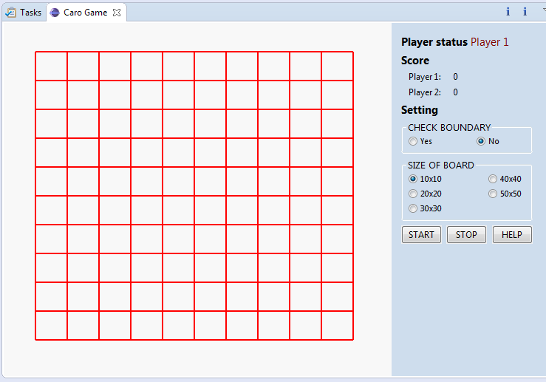

Size 10x10

Figure 1: When user set the size of board is 10x10

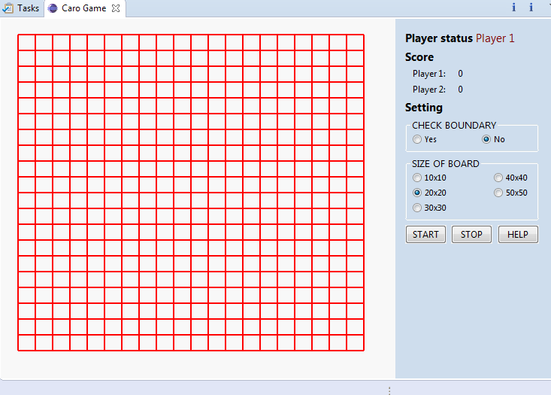

Size 20x20

Figure 2: When user set the size of board is 20x20

Used class:
<public class Board extends Composite implements IBoard>
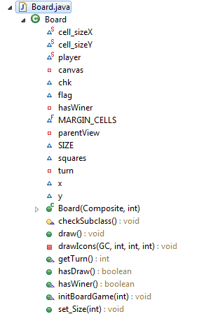

Figure 3: Class diagram of function 1

Implement method
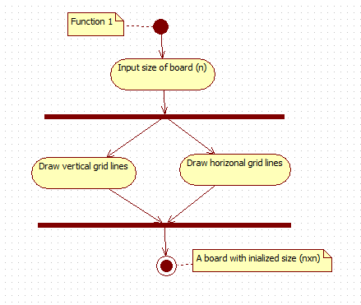

Figure 4: Activity diagram of function 1

[Function 2]: <private void drawIcons(GC gc, int turn, int x, int y)>
    - External function
This function is used to draw a icon when user click on board.
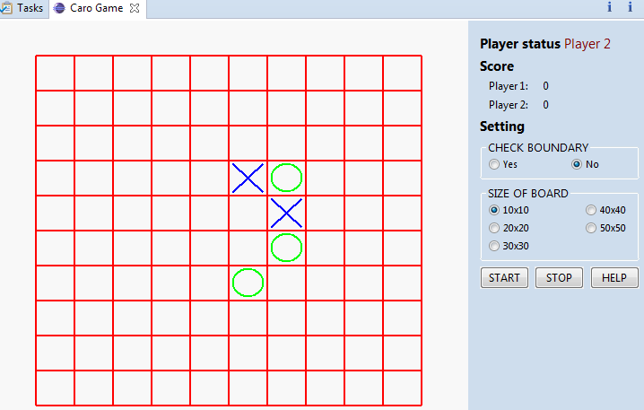

Figure5: Chess-man appear when user click

Used class:
<public class Board extends Composite implements IBoard>

Figure 6: Class diagram of function

    - Implement method

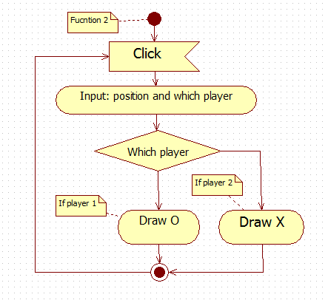

Figure 7: Activity diagram of function 2

[Function 3]: <private void setBoundary(int val)>
    - External function
This function is used to setting of win condition: whether to check boundary or not.
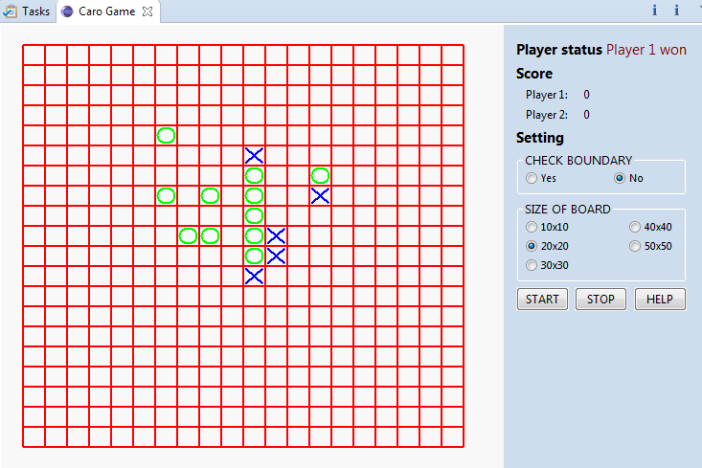

Figure 8: When choose No, boundary condition is not activated

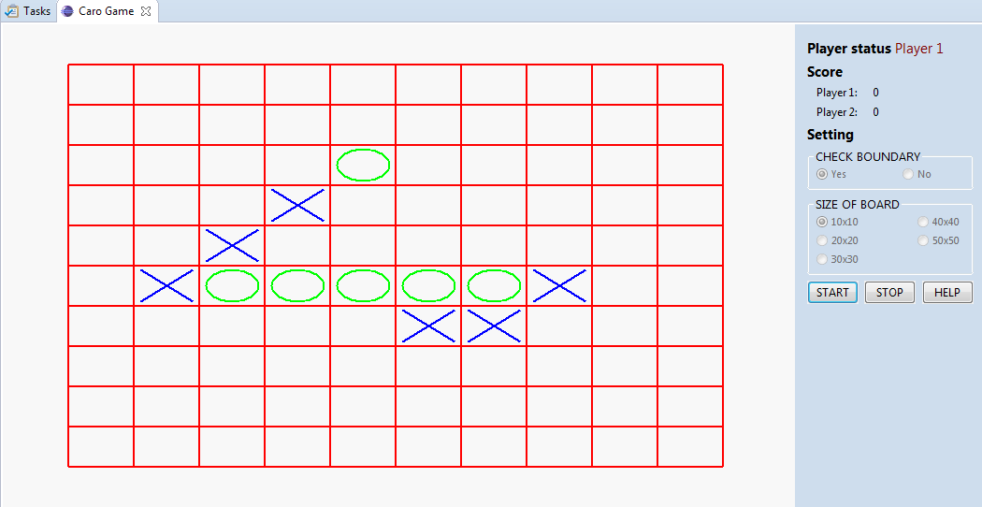

Figure 9: When choose Yes, boundary condition is activated

Used class:
<public class CaroGameView extends ViewPart>

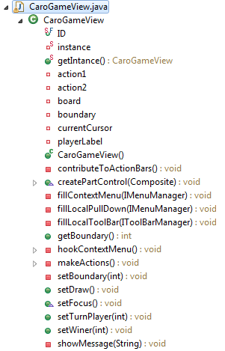

Figure 10: Class diagram of function 4

    - Implement method

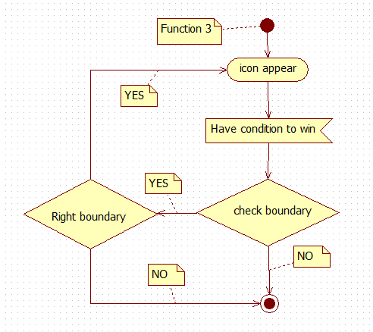

Figure 11: Activity diagram of function 3

[Function 4]: <public boolean checkWiner(int[][] player, int flag, int size)>
    - External function
This function is used to check condition to win.

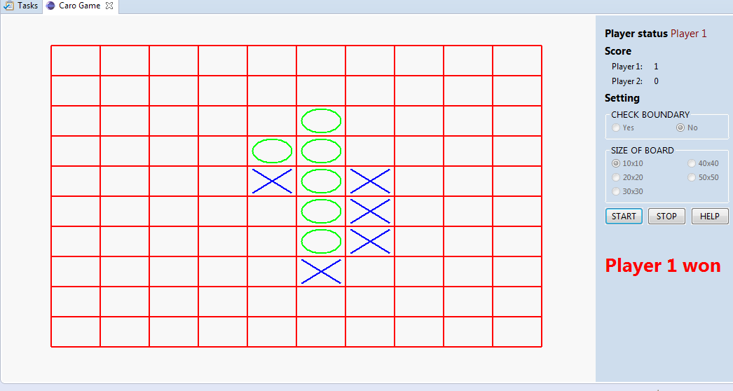
Figure 12: Condition to win
Used class:
<public class Check>
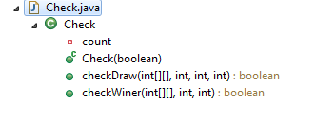

Figure 13: Class diagram of function 4

    - Implement method

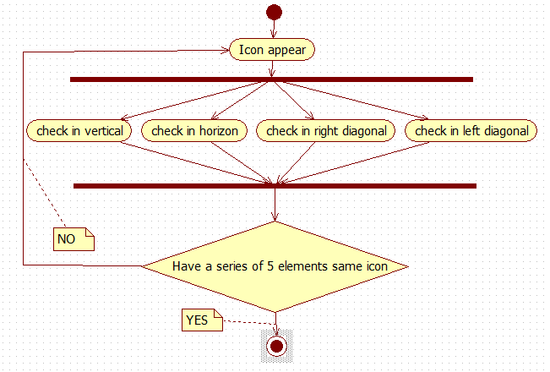

Figure 14: Activity diagram of function 4

Function 5: <public boolean checkDraw(int[][] player, int size, int x, int y)>
    - External function
This function is used to check condition to draw.

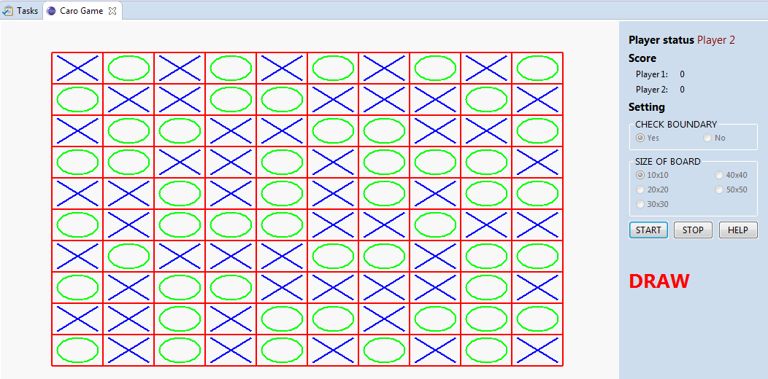
Figure 15: Example of condition to draw
Used class:
<public class Check>
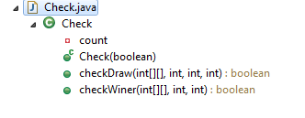

Figure 16: Class diagram of function 5
    - Implement method

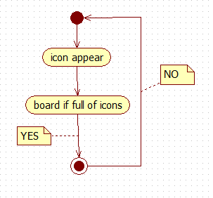
Figure 17: Activity diagram of function

Appendix
[Guide: Add reference information into this chapter.]

