# 

# Created by

# Dario Castellanos, Jon Otwell, David Truong, & Alex Yan

# Problem Scenarios

The original idea was inspired by the problem of having too many choices to eat at, and the general lack of decision making ability of a lot of people. Consider the following is a possible problem scenario:

John is out with his friends and they start to get hungry. However, none of them are sure what they want to eat, with so many possible choices around the area. They end up standing around wondering and talking about the different kinds of foods they can eat and the different places they could go to, all of them too indecisive to reach a conclusion on a single restaurant.

This inspired a basic design that just chooses a restaurant for you, and if you really don’t like it you can input a way to choose another restaurant.

As the idea developed, it seemed this was too constricting. Maybe you like the type of food but not that particular restaurant. So instead the design would be to choose a specific type of food (not just a category, like Chinese or American, but more specific like a Hamburger), and then from there give a few options of restaurants that would serve you that food.

One problem we encountered was picky eaters. We didn't want them to have to keep dismissing suggestions because they dislike that whole category of food, like they won’t eat fish. An ability to get rid of certain categories of food that users don’t like was then considered as a solution to this.

Another problem that came up later in design is that people often choose based on what they’ve had recently. A common exchange for a couple might go: “Do you want to have pizza?” “No, we had pizza on Tuesday” “No, it was definitely more than a week ago” or similarly. Being able to see a food history including dates you had items selected through the app would make such decisions less ambiguous, and could be quite helpful in the decision making process. For those that eat out a lot, this could be further improved by having a graph of recent types of food.

# Design

Our first design was very simplistic, and based off of the second idea and third ideas in our problem scenarios. We decided to start with a splash page with an ability to get to options disabling certain categories. Then would pull up a yelp search of that type of food.

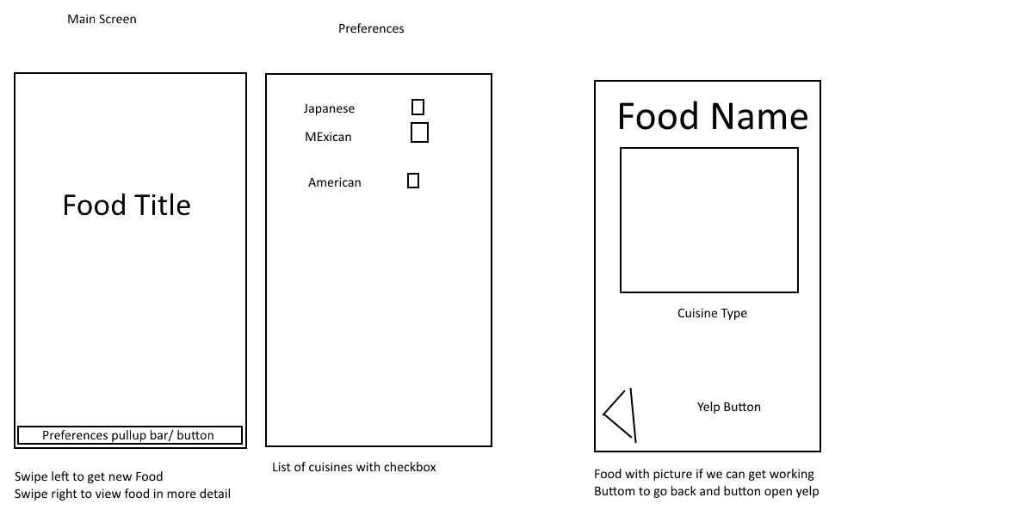

The splash page felt like an extra step in the way of the user, reducing the quickness of getting an option, and also felt unnecessary. In a brainstorming session that included many new potential use cases and ideas, we first developed a new interface. This is much faster, by opening right to an option. Then you could either choose a new food, or select it which would pull up a list of restaurants and rating rather than making you open yelp immediately. Then you could select a restaurant to open its yelp page for more details. The option to simply perform a full Yelp search is also still there if users wish to do that.

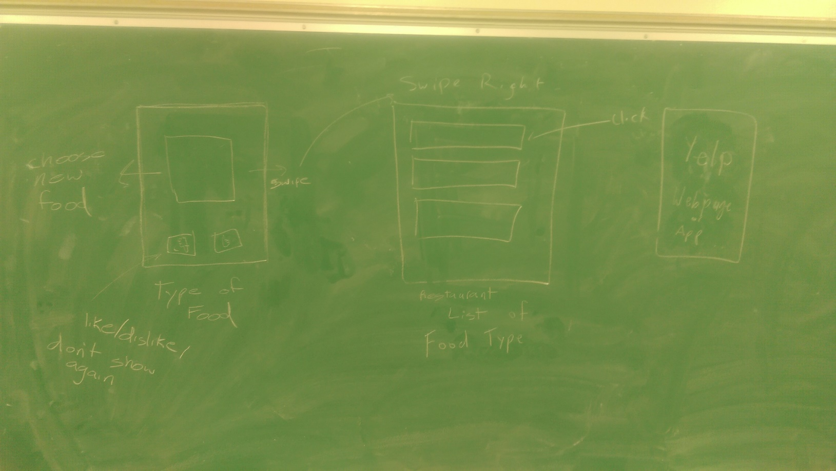

Since one main goal we wanted to achieve was to reduce the vast number of food choices to just one at a time in order to get indecisive people to act, we were unsure at first how many restaurant choices should be displayed once a food type was chosen. We decided to test users with versions of the app with one, three, or five restaurant recommendations from yelp. This test and its results are described in more detail in Page 4.

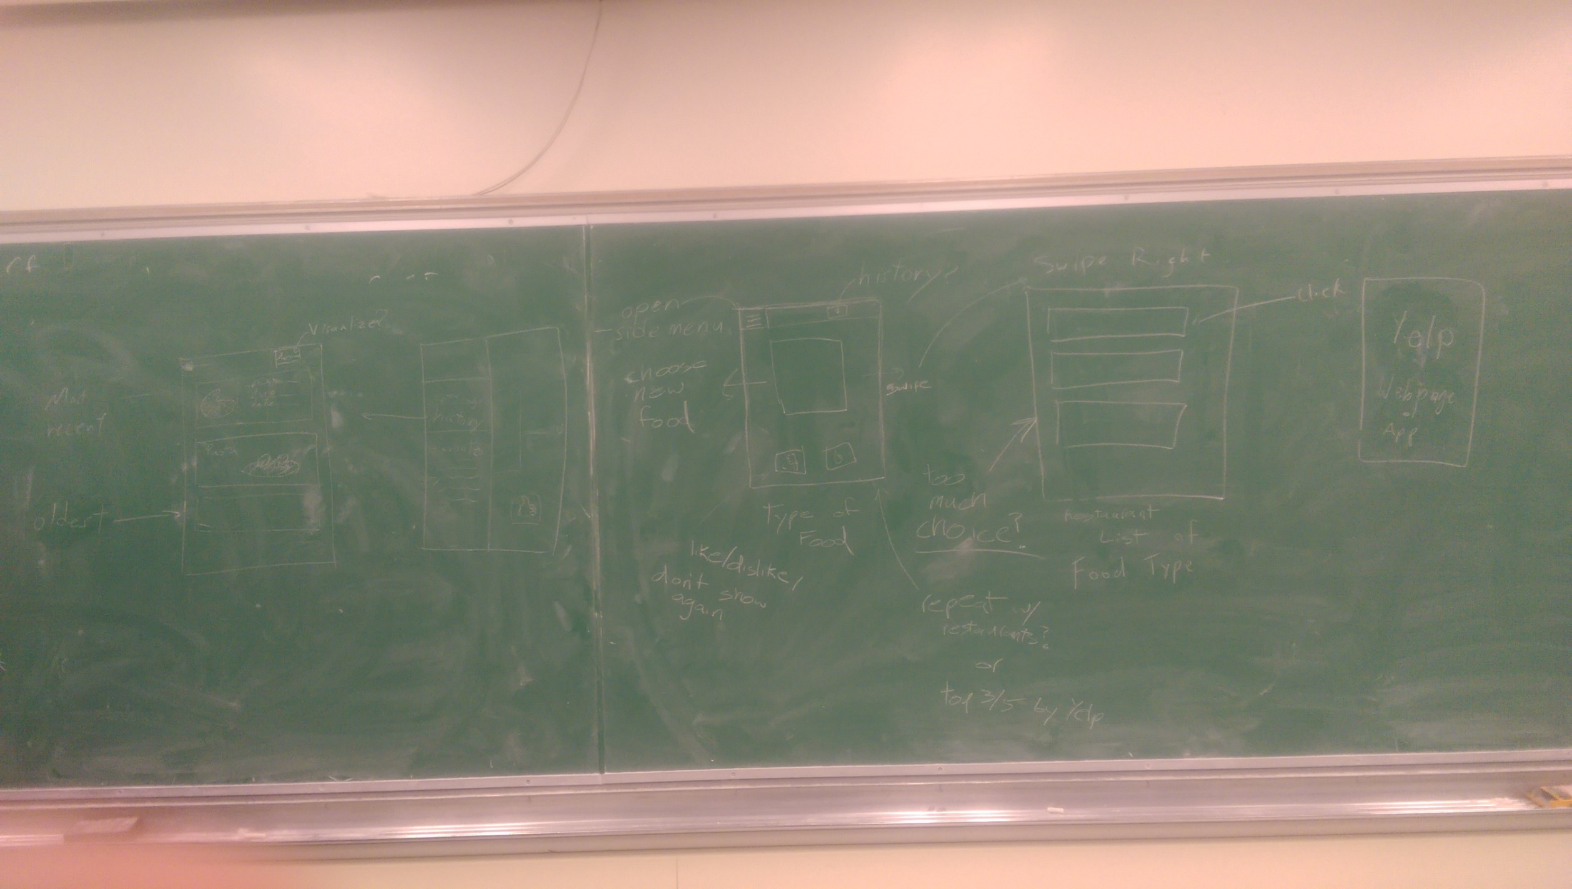

Originally we were just going to have the initial preferences page as a button on the actionbar, or as a swipe up or down, but decided a full android style hamburger menu would work better as we had come up with more scenarios and use cases, namely checking the history of previously ordered foods in order to help form a decision on what to eat.

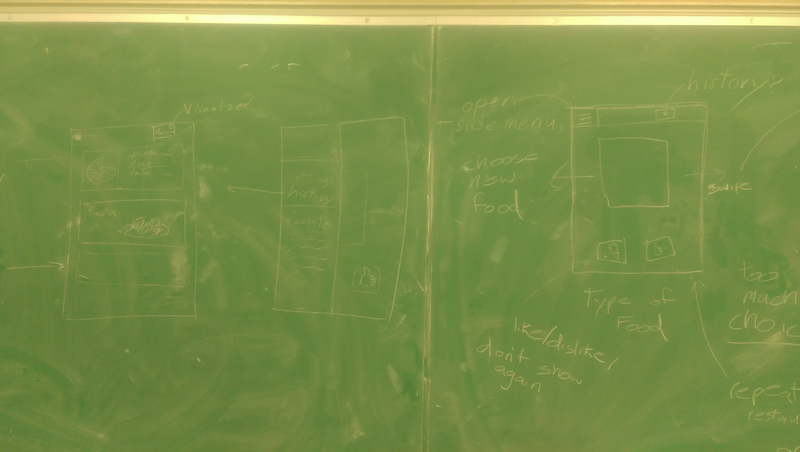

Following the blackboard design, we went on to create mock-up of more realistic looking designs. Starting with basic paint designs, then moving onto mockups made with hardcoded data in Android studio.

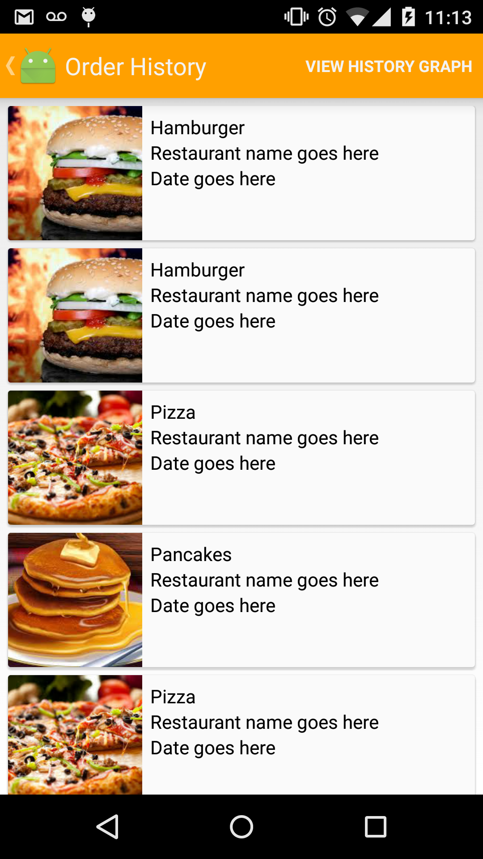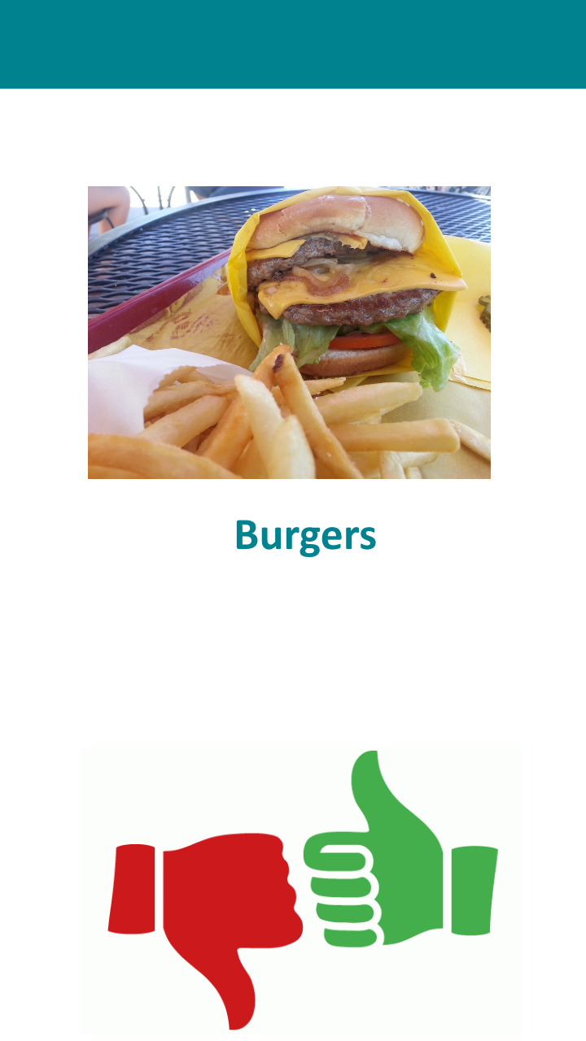

# User Tests

A first test was conducted to determine how many restaurant options were too many. To do this, members of our group tried different versions of the app (with one, three, or five restaurant choices) when they went out to eat with friends, and observed the effects it had on how long it took to make a decision.

It seemed that most of the time, the part of the decision making process that people had the most trouble with was deciding on what kind of food to eat. Once that was reached, even when the number of choices were high most people did not have any more trouble deciding where to go than if they were presented with fewer options. Save for specific restaurants that some users especially liked or disliked, it did not matter where they went to eat their particular target food. On the contrary, having fewer options only increased the chance that the suggested restaurant options were all no good, forcing the users to have to run a yelp search instead. The raw, unformatted data is shown below:

5/30: Jon, Kevin, and Krutik. 3 options – around 3 minutes

6/2: Jon and Krutik. 1 option at a time – around 3 minutes and 40 seconds, backed out to get a different food type twice, ended up clicking on Yelp search option instead of recommended restaurant

6/3: Jon, Kevin, Krutik, and Quincy. 5 options – around 3 minutes and 30 seconds

6/5: Jon and Kevin. 3 options – around 3 minutes and 10 seconds.

Our data is biased in that all of our subjects had lived in the area quite some time and already had preferences and knowledge of the local restaurants. Results may be different for users who are new to the area and do not have the prior knowledge about these restaurants, in which case more choices may in fact only serve to confuse them. In order to fix this, in the future we may show the star rating on yelp in each restaurant card.

Conclusion: We decided to go with five options, as that would prevent excessive scrolling, but still provide a good number of choices so that there are both a smaller chance of users rejecting them all due to dislikes, and a higher chance of finding one restaurant they really like so that they can reach an immediate decision.

Another test that was done early in the design process was making the activity of swiping pictures of foods to be as intuitive and user friendly as possible. Swiping food choices is the centerpiece of the app and we wanted to find out any design flaws or user preferences. David's roommates, Chris and Sammy, were asked to participate in this user study. We coded the early version of the activity below and recorded their actions and their answers to a few questions. 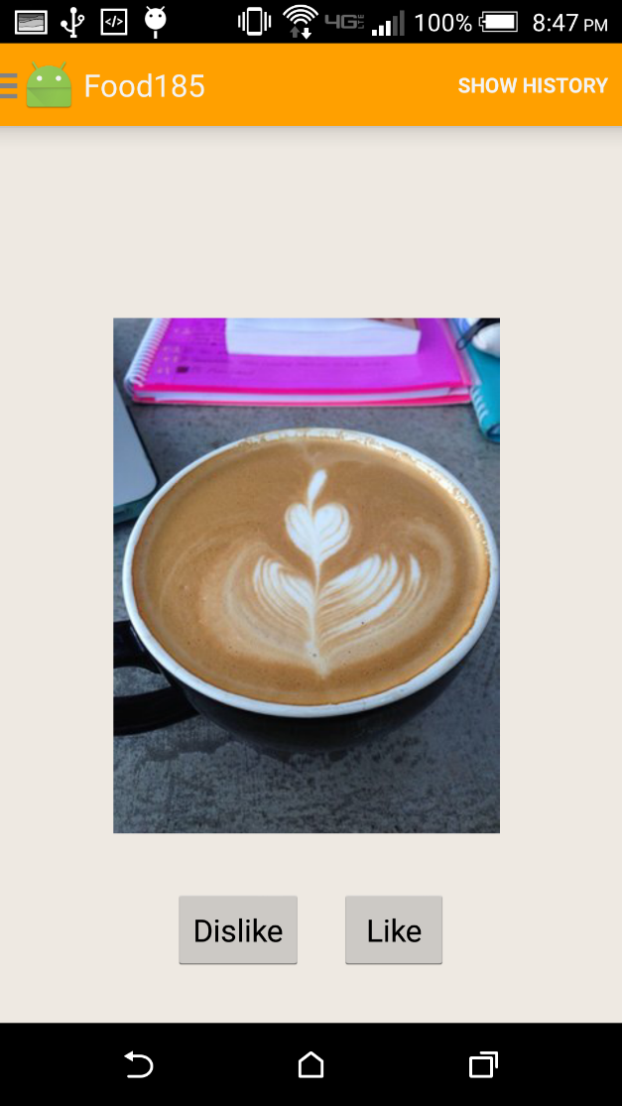

Question: What are your initial reactions to the app?

Sammy: At first I was a confused thinking I was supposed to choose the food I wand by clicking Like and clicking Dislike to get something else, but after that I figured out I can drag the cards when I touched the screen.

Chris: I like the animation for sliding and swiping the cards around, it feels good

Question: Anything you would change to the function or look?

Sammy: There is a lot of whitespace around the image. It looks empty.

Chris: If I like a food but then want to choose again, it would be good to start off where it was last left off so I don't have to scroll through the ones I've disliked already.

Observations:

Both users began by using the Like and Dislike buttons on the screen to choose foods instead of swiping to the left or right. Sammy was quickly able to figure out he can swipe the images, but we had to explain it to Chris. The difference between pressing the Like and Dislike buttons to make foods appear more or less often, and swiping left or right to select and dismiss foods required an explanation from us.

Conclusions: Less whitespace to look more appealing. Save the position so users can go back and change their decision. We decided to remove the Like and Dislike buttons in order to prevent user confusion, since the Preferences dialog serves a similar purpose anyway, making these buttons somewhat redundant.

We will also implement a transparent overlay with instructions explaining that the user must swipe the items upon booting up the app, but making the image the only thing covering the entire screen aside from the task bar should make it much easier to realize that the images can be swiped, as touching anywhere will cause the images to be dragged.