Design Report
https://threeheads420.github.io/Websitedevelopment/
My design will include 5 pages. My index page will have three main sections. They will include two pictures, one of me and one of the building where most of my practical classes take place. It will have a timetable and some details about me and the Walton building.
My next page is called ‘Hobbies.’ This page will have pictures also. It will have a bullet point list of reasons why people have hobbies. It will have a table with examples of common types of hobbies and some of the benefits of these hobbies.
My third page will explain one of my hobbies and is called ‘Chess.’ It will include an explanation of what chess is with a picture and a table included.
My third page is called ‘Science.’ It will contain an interactive model of the universe but I was only able to create this feature with the aid of AI. I would not have been able to create this myself as it is far advanced on what I have learned so far, but I will be able to integrate it into my web site after carefully and explicitly explaining to the AI what I am looking for. It will most likely take several attempts to get it as I want it
My last page is a mish-mash of styles, this is simple to show that I can create such pages, so it’s called, ‘GiveMeStyle,’ this is written in camelCase. It will have pictures and links to places on the page. I will also use for AI for ideas on how to complete this assignment and for help with the overall design.
Below are the wireframes I will use as my map to build my site and I will use blue as my main colour scheme across my site.

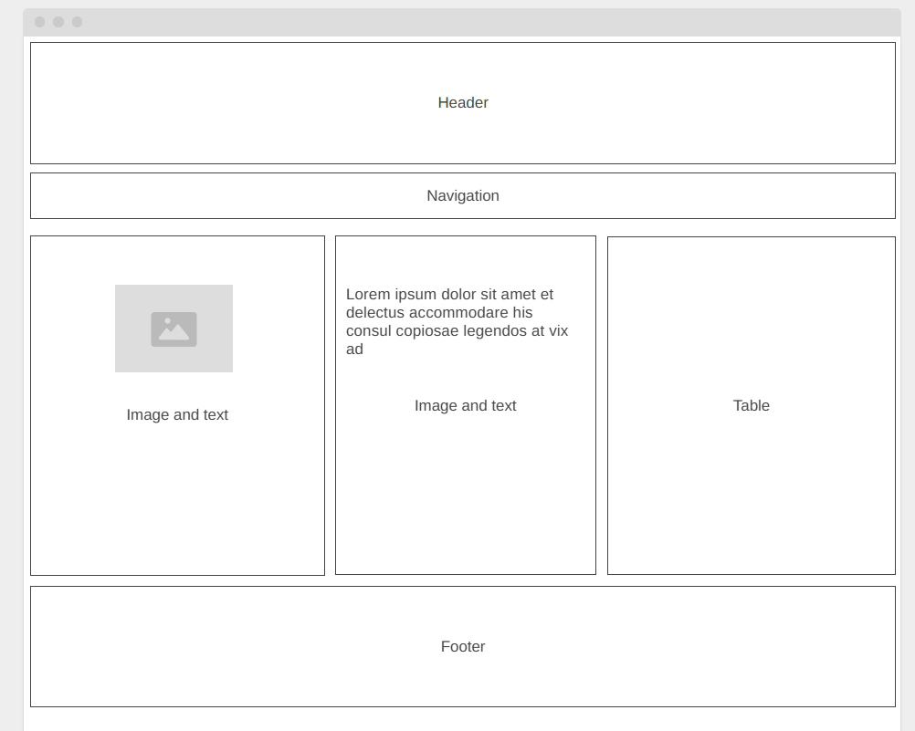
index.html and hobbies.html (Home & Hobbies)
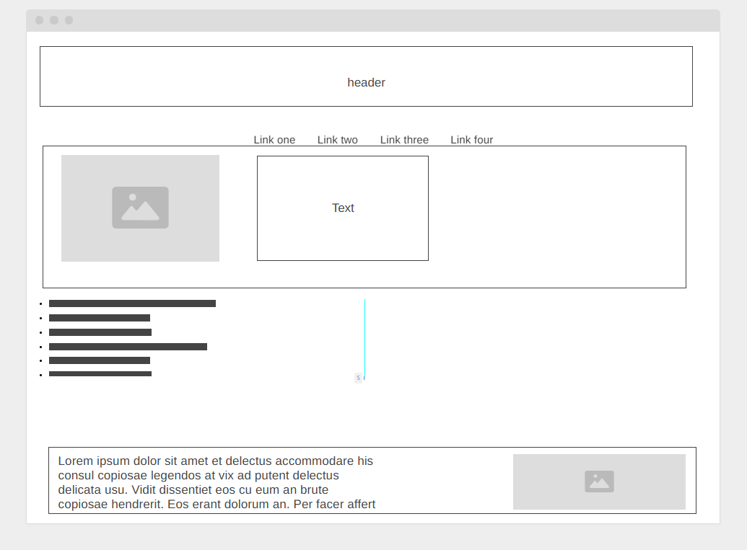
chess.html (Chess) 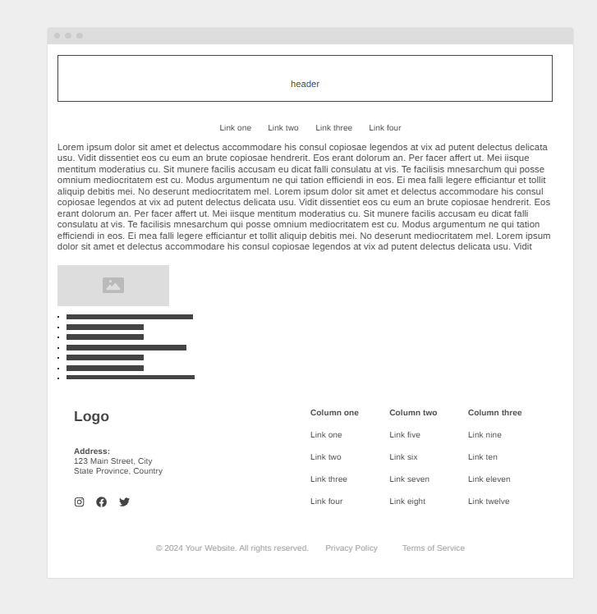

Christmas-tree.html (Science) 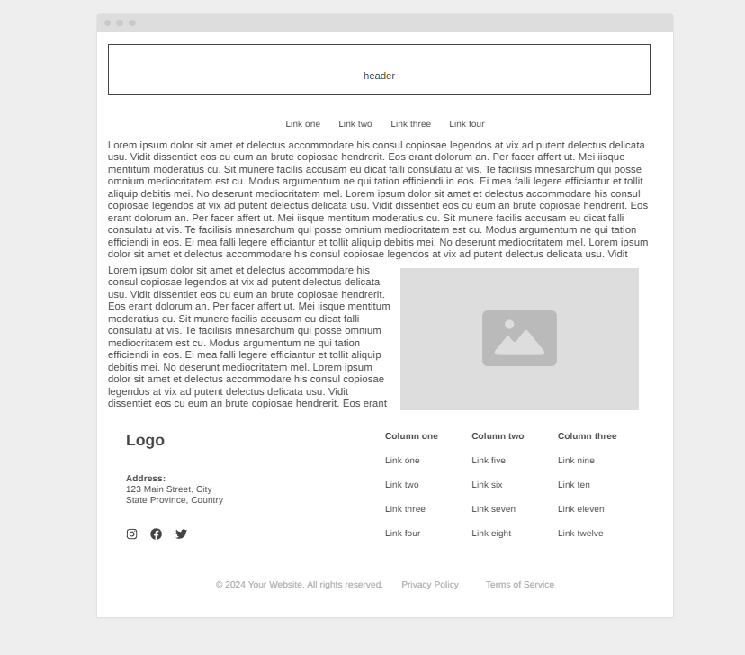

Stylist.html (GiveMeStyle)

