The Components of the Soul

How Genetics, Epigenetics, Lifelong Learning, Mind-at-Large, and the Dissociated Mind Form an Individual Soul
Author: Thomas Riebl (Luxembourg)
Date: September 1, 2026
Theoretical Framework: The Conative-Integrative Framework (CIF)

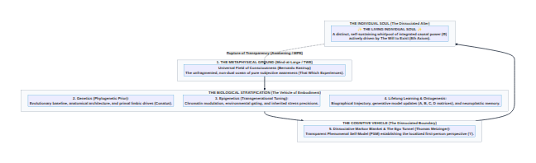
Diagram 1

Table of Contents
- Executive Summary: De-Mystifying the Soul
- 1. The Ontological Ground: Mind-at-Large (TWE)
- 2. The Phylogenetic Anchor: Genetics as the Ancient Prior
- 3. The Transgenerational Resonance: Epigenetics as Environmental Gating
- 4. The Ontogenetic Tapestry: Lifelong Learning and the Predictive Self
- 5. The Dissociative Boundary: Markov Blankets and the Ego Tunnel
- 6. The Synthesis: The Architecture of the Individual Soul
- 7. Death, Dissolution, and Minimal Phenomenal Experience (MPE)
- 8. References & Academic Bibliography
- 9. Tool Attribution & Colophon

Executive Summary: De-Mystifying the Soul
Throughout human history, the concept of the “Soul” (Seele / Anima / Psyche) has oscillated between two unsatisfactory extremes: 1. Supernatural Dualism: Treating the soul as an immaterial, magical “ghost” awkwardly inserted into a mechanical meat-robot. 2. Eliminative Materialism: Reducing the soul to a complete illusion—an accidental byproduct of dead matter with no genuine depth, purpose, or ontological reality.
Within The Conative-Integrative Framework (CIF), we formulate a rigorous, post-materialist and naturalistic definition:
The Individual Soul is a localized, self-sustaining whirlpool (dissociated alter) within the universal field of Mind-at-Large. It is uniquely shaped by the fivefold intersection of: Universal Consciousness, Phylogenetic Genetics, Transgenerational Epigenetics, Biographical Lifelong Learning, and the Dissociative Boundary of the Phenomenal Self-Model (PSM).
The soul is neither magical nor an illusion; it is the concrete 1st-person interiority of an autopoietic living network actively sustaining its integrated causal power ($Φ$) across time.

1. The Ontological Ground: Mind-at-Large (TWE)
In Bernardo Kastrup’s Analytic Idealism, the ultimate reality of nature is mental: there is only one universal field of consciousness—Mind-at-Large or That Which Experiences (TWE).
- The cosmos is not made of tiny inanimate building blocks that mysteriously generate consciousness.
- Rather, all physical matter is what mental processes look like when observed from across a dissociative boundary.
- Mind-at-Large provides the boundless subjective potentiality (the pure water of the ocean).
Without Mind-at-Large, there would be no subjectivity anywhere in the cosmos. Mind-at-Large is the shared, irreducible qualitative substrate of every living entity.

2. The Phylogenetic Anchor: Genetics as the Ancient Prior
How does universal consciousness take on a specific biological form? Through the Phylogenetic Prior:
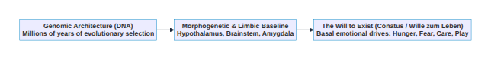
Diagram 2
- Evolutionary Priors ($D_{0}$ in Active Inference):
The genetic sequence is not merely a recipe for proteins; in predictive processing, it establishes the deep evolutionary generative priors of the organism. It encodes the expected homeostatic ranges (temperature, blood sugar, oxygen) necessary for physical survival.
- The Limbic Seat of Will (Gerhard Roth):
Genetics hardwires the deep subcortical structures (brainstem, hypothalamus, amygdala) that generate what Spinoza termed Conatus, Schopenhauer termed the Wille zum Leben, and our framework defines as The Will to Exist.
- Temperament Baseline:
Genetics provides the initial affective temperament (introversion/extraversion, novelty seeking, stress threshold) that forms the baseline coloration of the individual soul.

3. The Transgenerational Resonance: Epigenetics as Environmental Gating
Genetics alone is too rigid to capture the adaptive dynamism of life. The bridge between ancestral history and immediate reality is Epigenetics:
- Molecular Memory (DNA Methylation & Histone Modification):
Epigenetics regulates gene expression without altering the underlying genetic code. It acts as a dynamic volume dial on genetic potential.
- Transgenerational Trauma and Resilience:
Environmental pressures, existential shocks, nutritional deprivations, and profound emotional experiences endured by parents and grandparents leave chemical imprints on the germline and developmental epigenome.
- Predictive Precision Tuning:
In Active Inference terms, epigenetics adjusts the prior precisions ($γ$) of the sensory apparatus. An organism born from a lineage that survived famine or danger inherits heightened vigilance and hyper-sensitive stress responses.
Epigenetics explains why the individual soul enters the world with pre-configured intuitions, deep-seated sensitivities, and somatic inclinations that precede its own individual biography.

4. The Ontogenetic Tapestry: Lifelong Learning and the Predictive Self
While genetics and epigenetics provide the canvas and initial palette, the unique biographical portrait of the soul is painted through lifelong learning and ontogenesis:
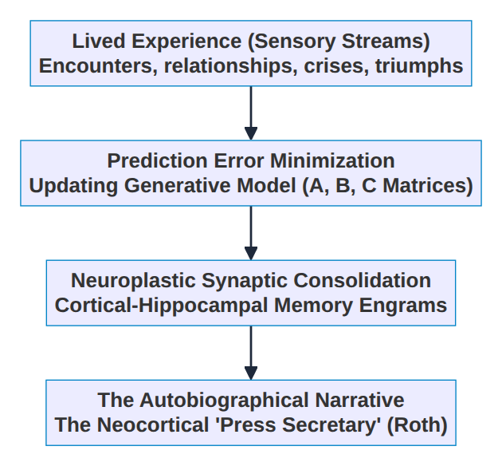
Diagram 3
- Continuous Updating of the Generative Model:
Every interaction with the world updates the agent’s internal Transition Tensor ($B$) and Likelihood Matrix ($A$). The soul learns what causes pain, what brings joy, and what sustains coherence.
- Memory Engrams and Biographical History:
Personal trauma, formative relationships, intellectual discoveries, and cultural immersions are physically etched into synaptic weight distributions and cortical networks.
- The Narrative Self (Gerhard Roth’s “Press Secretary”):
The neocortex weaves these distributed memories into a continuous, coherent story: „I am someone who survived bankruptcy; I am someone who raised children in Cameroon; I am someone who seeks the ultimate truth of mind.“
This layer gives the individual soul its unrepeatable individuality, wisdom, character, and psychological depth.

5. The Dissociative Boundary: Markov Blankets and the Ego Tunnel
Why does the individual soul feel separate from the rest of the universe?
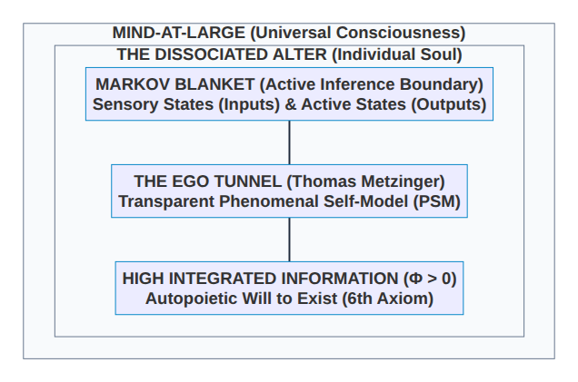
Diagram 4
- The Dissoziative Markov Blanket (Karl Friston):
A living organism maintains a boundary of internal states separated from external states by sensory and active states. Statistically, this boundary creates a phase-space partition at the Edge of Chaos.
- The Transparent Phenomenal Self-Model (Thomas Metzinger):
The brain generates a simulation of the organism as a whole within its world-model. Because the brain cannot introspect the fast, sub-symbolic computation generating this model, the model is transparent: the agent does not experience a model of a self, but experiences being a self inside an Ego Tunnel.
- The Phenomenological Illusion of Dualism:
The transparent PSM is the cognitive mechanism that causes Mind-at-Large to experience itself as a localized, vulnerable, striving individual ego (Alter).

6. The Synthesis: The Architecture of the Individual Soul
Combining all five components yields the Structural Equation of the Individual Soul:
$$\text{Individual Soul}=\underset{\text{Ontological Ground (TWE)}}{\underset{⏟}{\text{Mind-at-Large}}} ∩ \underset{\text{Phylogenetic Prior}}{\underset{⏟}{\text{Genetics}}} ∩ \underset{\text{Transgenerational Memory}}{\underset{⏟}{\text{Epigenetics}}} ∩ \underset{\text{Biographical Learning}}{\underset{⏟}{\text{Ontogenesis}}} ∩ \underset{\text{Dissociative Boundary}}{\underset{⏟}{\text{PSM}}}$$

The 5 Components of the Soul at a Glance:
Component | Scientific / Philosophical Domain | Role in the Formation of the Soul | Formal Framework Metric
1. Mind-at-Large | Analytic Idealism (Kastrup) | The irreducible qualitative ground; pure capacity for experience | That Which Experiences (TWE)
2. Genetics | Evolutionary Biology (Spinoza / Schopenhauer) | Physical blueprint, basal temperament, and primal Will to Exist | Baseline Priors ($D_{0}$) & Limbic Conatus
3. Epigenetics | Molecular Epigenetics & Epigenomics | Transgenerational tuning, ancestral vigilance, and stress thresholds | Precision Weighting Parameters ($γ$)
4. Learning | Cognitive Neuroscience (Roth) | Biographical memory, personal history, and generative model updates | POMDP Matrices ($A,B,C$) & Synaptic Engrams
5. Dissociation | Self-Model Theory & FEP (Metzinger / Friston) | The Markov Blanket & transparent PSM creating the localized “I” | Integrated Causal Power ($Φ$) across Boundary
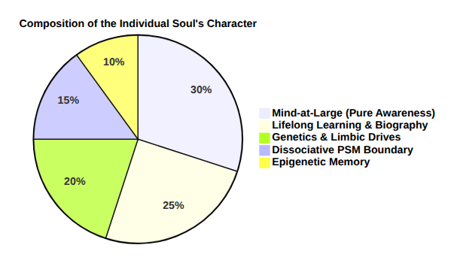
Diagram 5

7. Death, Dissolution, and Minimal Phenomenal Experience (MPE)
What happens when the physical vehicle dies, or when consciousness undergoes profound mystical/non-dual realization?

1. Mystical Awakening / Minimal Phenomenal Experience (MPE):
When meditative inquiry, psychedelics, or deep philosophical insight destabilize the transparency of the Ego Tunnel, the system experiences what Thomas Metzinger calls Minimal Phenomenal Experience (MPE): * The cognitive boundary (PSM) becomes opaque—recognized as merely a predictive model. * The illusion of the separate ego dissolves. * The individual soul recognizes its ultimate identity: „I am not merely the transient alter inside the tunnel; I am the underlying field of Mind-at-Large experiencing itself.“

2. Biological Death (Physical Dissolution):
When the biological organism dies, the Markov Blanket breaks down and the internal cause-effect structure collapses ($Φ→0$). * What dies: The localized dissociative boundary (the PSM), the genetic machinery, and the active predictive loop. * What remains: Just as a whirlpool slows down and merges back into the ocean, the localized mental activity dissolves back into the infinite, unbroken field of Mind-at-Large. * The qualitative experiences, learning, and systemic evolution are not “lost” into voidness, but represent the historical crystallization through which Mind-at-Large has experienced and known itself.

8. References & Academic Bibliography
- Friston, K. (2010). The free-energy principle: a unified brain theory? Nature Reviews Neuroscience, 11(2), 127–138.
- Jablonka, E., & Lamb, M. J. (2014). Evolution in Four Dimensions: Genetic, Epigenetic, Behavioral, and Symbolic Variation in the History of Life. MIT Press.
- Kastrup, B. (2019). The Idea of the World: A Multi-Disciplinary Argument for the Mental Nature of Reality. Iff Books.
- Kastrup, B. (2021). Science Ideated: The Fall of Matter and the Contours of the Next Mainstream Scientific Worldview. Iff Books.
- Metzinger, T. (2003). Being No One: The Self-Model Theory of Subjectivity. MIT Press.
- Metzinger, T. (2009). The Ego Tunnel: The Science of the Mind and the Myth of the Self. Basic Books.
- Metzinger, T. (2024). The Elephant and the Blind: The Experience of Pure Consciousness: Philosophy, Science, and 500+ Experiential Reports. MIT Press.
- Riebl, T. (2026). The Conative-Integrative Framework (CIF): How Active Inference Networks, Integrated Information ($Φ$), and the 6th Axiom Fit Together to Unite Analytic Idealism, the Free Energy Principle, and Consciousness. Master Paper & Working Treatise, Luxembourg.
- Roth, G. (2003). Aus Sicht des Gehirns. Suhrkamp Verlag, Frankfurt am Main.
- Roth, G. (2021). Wie das Gehirn die Seele macht: Emotionen, Bewusstsein, Unbewusstes. Klett-Cotta, Stuttgart.
- Schopenhauer, A. (1819/1844). Die Welt als Wille und Vorstellung (The World as Will and Representation). F. A. Brockhaus, Leipzig.
- Spinoza, B. (1677). Ethica, ordine geometrico demonstrata. Posthumous Publication.
- Tononi, G., Boly, M., Massimini, M., & Koch, C. (2016). Integrated information theory: from consciousness to its physical substrate. Nature Reviews Neuroscience, 17(7), 450–461.
- Yehuda, R., & Lehrner, A. (2018). Intergenerational transmission of trauma effects: putative role of epigenetic mechanisms. World Psychiatry, 17(3), 243–257.

9. Tool Attribution & Colophon
[!NOTE] Tooling Colophon:
This theoretical treatise, philosophical architecture, and scientific synthesis were conceptualized and authored by Thomas Riebl (Luxembourg) as part of The Conative-Integrative Framework (CIF).
The conceptual formulation, structural structuring, vector diagram styling, and multi-format document compilation (Word .docx, Print-Ready PDF, and Markdown) were developed with the assistance of Google Gemini (Antigravity Advanced Agentic Coding System) (September 2026).

Vault & Repository References
- Master Framework Paper (CIF): /home/thr/Documents/The_Conative_Integrative_Framework_Thomas_Riebl.pdf
- GitHub Project Repository: https://github.com/Thriebl/active-inference-phi-network
- Vault Archive: /home/thr/Documents/ThRNotes/03-professional/braindumps/

