The Composition of the Soul

How Genetics, Chance and Necessity, Epigenetics, Lifelong Learning, Mind-at-Large, and the Dissociated Mind Form an Individual Soul
Author: Thomas Riebl (Luxembourg)
Date: September 1, 2026
Document Status: 🟡 [WORKING DRAFT • WORK IN PROGRESS]
Theoretical Architecture: The Conative-Integrative Framework (CIF)
[!IMPORTANT] Working Paper / Work in Progress:
This treatise represents an active working draft and exploratory conceptual model within The Conative-Integrative Framework (CIF). It is subject to ongoing research, empirical formalization, and philosophical refinement.

Executive Summary: De-Mystifying the Soul
Throughout human history, the concept of the “Soul” (Seele / Anima / Psyche) has oscillated between two unsatisfactory extremes: 1. Supernatural Dualism: Treating the soul as an immaterial, magical “ghost” awkwardly inserted into a mechanical meat-robot. 2. Eliminative Materialism: Reducing the soul to a complete illusion—an accidental byproduct of dead matter with no genuine depth, purpose, or ontological reality.
Within The Conative-Integrative Framework (CIF), we formulate a rigorous, post-materialist and naturalistic definition:
The Individual Soul is a localized, self-sustaining whirlpool (dissociated alter) within the universal field of Mind-at-Large. It is uniquely shaped by the sixfold intersection of: Universal Consciousness, Phylogenetic Genetics, The Thermodynamic Crucible of Chance & Necessity, Transgenerational Epigenetics, Biographical Lifelong Learning, and the Dissociative Boundary of the Phenomenal Self-Model (PSM).
The soul is neither magical nor an illusion; it is the concrete 1st-person interiority of an autopoietic living network actively sustaining its integrated causal power ($Φ$) across time.

Table of Contents
- Architectural Master Map: The 6 Layers of the Soul
- 1. The Ontological Ground: Mind-at-Large (TWE)
- 2. The Phylogenetic Anchor: Genetics as the Ancient Prior
- 3. The Crucible of Chance and Necessity: Monod and Eigen’s Evolutionary Engine
- 4. The Transgenerational Resonance: Epigenetics as Environmental Gating
- 5. The Ontogenetic Tapestry: Lifelong Learning and the Predictive Self
- 6. The Dissociative Boundary: Markov Blankets and the Ego Tunnel
- 7. The Synthesis: The Architecture and Quantitative Derivation of the Soul
- 8. Death, Dissolution, and Minimal Phenomenal Experience (MPE)
- 9. References & Academic Bibliography
- 10. Tool Attribution & Colophon

Architectural Master Map: The 6 Layers of the Soul
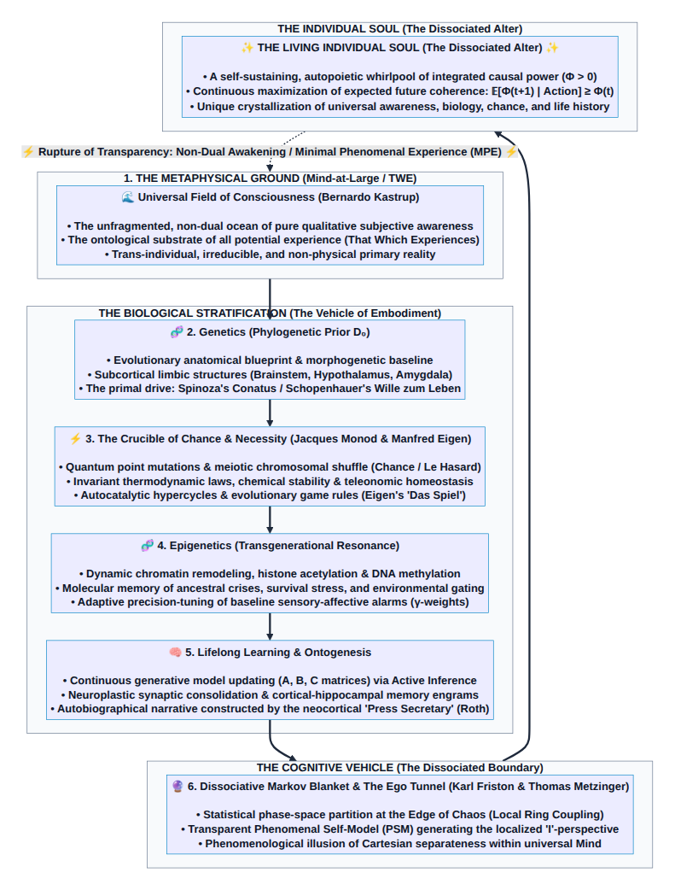
Diagram 1

1. The Ontological Ground: Mind-at-Large (TWE)
In Bernardo Kastrup’s Analytic Idealism, the ultimate reality of nature is mental: there is only one universal field of consciousness—Mind-at-Large or That Which Experiences (TWE).
- The cosmos is not made of tiny inanimate building blocks that mysteriously generate consciousness.
- Rather, all physical matter is what mental processes look like when observed from across a dissociative boundary.
- Mind-at-Large provides the boundless subjective potentiality (the pure water of the ocean).
Without Mind-at-Large, there would be no subjectivity anywhere in the cosmos. Mind-at-Large is the shared, irreducible qualitative substrate of every living entity.

2. The Phylogenetic Anchor: Genetics as the Ancient Prior
How does universal consciousness take on a specific biological form? Through the Phylogenetic Prior:
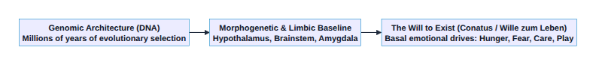
Diagram 2
- Evolutionary Priors ($D_{0}$ in Active Inference):
The genetic sequence is not merely a recipe for proteins; in predictive processing, it establishes the deep evolutionary generative priors of the organism. It encodes the expected homeostatic ranges (temperature, blood sugar, oxygen) necessary for physical survival.
- The Limbic Seat of Will (Gerhard Roth):
Genetics hardwires the deep subcortical structures (brainstem, hypothalamus, amygdala) that generate what Spinoza termed Conatus, Schopenhauer termed the Wille zum Leben, and our framework defines as The Will to Exist.
- Temperament Baseline:
Genetics provides the initial affective temperament (introversion/extraversion, novelty seeking, stress threshold) that forms the baseline coloration of the individual soul.

3. The Crucible of Chance and Necessity: Monod and Eigen’s Evolutionary Engine
Between static genetic architecture and dynamic epigenetic modulation lies the creative furnace of thermodynamics and molecular self-organization:
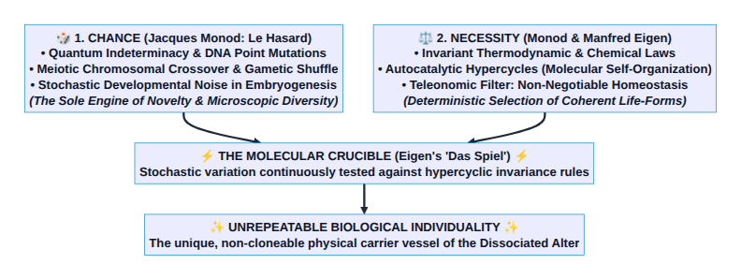
Diagram 3

1. Jacques Monod: Chance as the Source of Novelty, Necessity as the Invariant Law
In Le Hasard et la Nécessité (1970), Nobel laureate Jacques Monod demonstrated that: * Chance (Le Hasard): At the microscopic quantum and molecular level, genetic mutations, chromosomal recombination during meiosis, and developmental noise are fundamentally blind and stochastic. Chance is the sole source of genuine novelty in the biosphere. It guarantees that no two individuals—not even monozygotic twins—possess an identical microscopic neural or cellular wiring. * Necessity (La Nécessité): Once drawn from the roulette wheel of chance, every biological variation is mercilessly tested against the invariant, deterministic laws of thermodynamics, biochemistry, and teleonomic survival. If a mutation violates metabolic coherence, the organism perishes.

2. Manfred Eigen: Catalytic Hypercycles and Evolutionary Game Dynamics
Nobel laureate Manfred Eigen (Selforganization of Matter, 1971; Das Spiel, 1975) took Monod’s insight further by formulating how life transcends mere random drift: * The Hypercycle (Der Hyperzyklus): A closed, non-linear network of self-replicating macromolecular units where each element catalytically supports the synthesis of the next. Hypercycles provide the physical threshold where blind chemistry transforms into self-sustaining, information-preserving autopoiesis. * The Rules of the Game (Das Spiel): Evolutionary self-organization is a cosmic game played with loaded dice—where chance proposes random moves, but the deterministic feedback rules of the hypercycle select and stabilize coherent macro-structures.

Role in the Architecture of the Soul:
Chance and Necessity act as the cosmic sieve and creative sculptor of the individual alter. While Mind-at-Large is infinite and genetics provides the species blueprint, Chance rolls the dice of individual existence, and Necessity binds them into a functional, autopoietic hypercycle.

4. The Transgenerational Resonance: Epigenetics as Environmental Gating
Genetics and molecular hypercycles establish the biological vessel, but the direct bridge between ancestral history and immediate reality is Epigenetics:
- Molecular Memory (DNA Methylation & Histone Modification):
Epigenetics regulates gene expression without altering the underlying nucleotide sequence. It acts as a dynamic volume dial on the genetic repertoire.
- Transgenerational Trauma and Resilience:
Environmental pressures, existential shocks, nutritional deprivations, and profound emotional experiences endured by parents and grandparents leave chemical imprints on the germline and developmental epigenome (Yehuda & Lehrner, 2018).
- Predictive Precision Tuning:
In Active Inference terms, epigenetics adjusts the prior precisions ($γ$) of the sensory apparatus. An organism born from a lineage that survived famine or danger inherits heightened vigilance and hyper-sensitive stress responses.
Epigenetics explains why the individual soul enters the world with pre-configured intuitions, deep-seated sensitivities, and somatic inclinations that precede its own individual biography.

5. The Ontogenetic Tapestry: Lifelong Learning and the Predictive Self
While genetics, chance, and epigenetics provide the canvas and initial palette, the unique biographical portrait of the soul is painted through lifelong learning and ontogenesis:
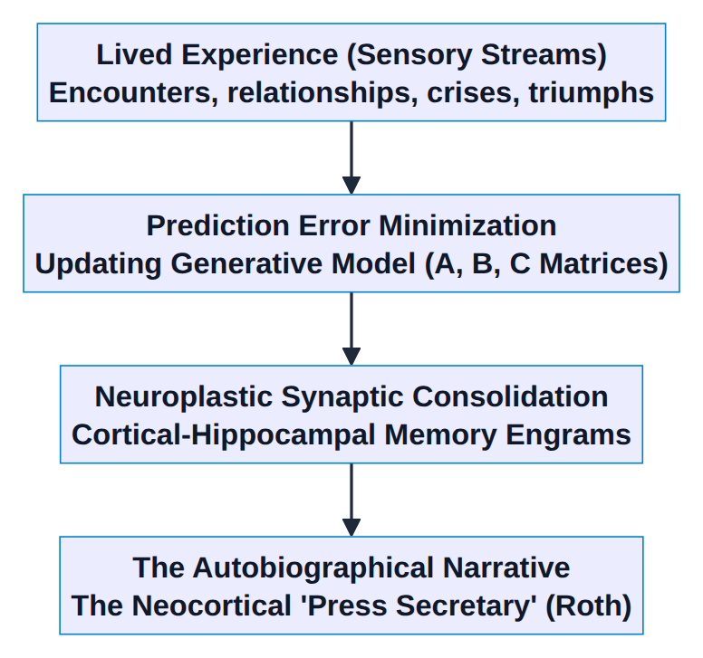
Diagram 4
- Continuous Updating of the Generative Model:
Every interaction with the world updates the agent’s internal Transition Tensor ($B$) and Likelihood Matrix ($A$). The soul learns what causes pain, what brings joy, and what sustains coherence.
- Memory Engrams and Biographical History:
Personal trauma, formative relationships, intellectual discoveries, and cultural immersions are physically etched into synaptic weight distributions and cortical networks.
- The Narrative Self (Gerhard Roth’s “Press Secretary”):
The neocortex weaves these distributed memories into a continuous, coherent story: „I am someone who survived bankruptcy; I am someone who raised children in Cameroon; I am someone who seeks the ultimate truth of mind.“
This layer gives the individual soul its unrepeatable individuality, wisdom, character, and psychological depth.

6. The Dissociative Boundary: Markov Blankets and the Ego Tunnel
Why does the individual soul feel separate from the rest of the universe?
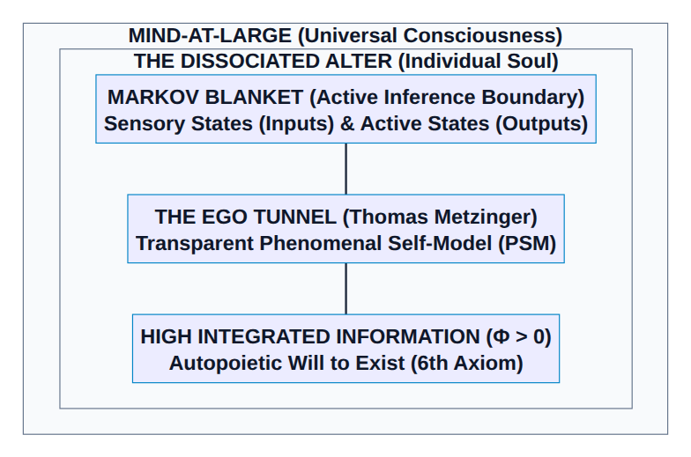
Diagram 5
- The Dissoziative Markov Blanket (Karl Friston):
A living organism maintains a boundary of internal states separated from external states by sensory and active states. Statistically, this boundary creates a phase-space partition at the Edge of Chaos.
- The Transparent Phenomenal Self-Model (Thomas Metzinger):
The brain generates a simulation of the organism as a whole within its world-model. Because the brain cannot introspect the fast, sub-symbolic computation generating this model, the model is transparent: the agent does not experience a model of a self, but experiences being a self inside an Ego Tunnel.
- The Phenomenological Illusion of Dualism:
The transparent PSM is the cognitive mechanism that causes Mind-at-Large to experience itself as a localized, vulnerable, striving individual ego (Alter).

7. The Synthesis: The Architecture and Quantitative Derivation of the Soul
Combining all six components yields the Complete Structural Equation of the Individual Soul:
$$\text{Individual Soul}=\underset{\text{Ontological Ground (TWE)}}{\underset{⏟}{\text{Mind-at-Large}}} ∩ \underset{\text{Phylogenetic Prior}}{\underset{⏟}{\text{Genetics}}} ∩ \underset{\text{Molecular Crucible (Monod/Eigen)}}{\underset{⏟}{\text{Chance \&Necessity}}} ∩ \underset{\text{Transgenerational Memory}}{\underset{⏟}{\text{Epigenetics}}} ∩ \underset{\text{Biographical Learning}}{\underset{⏟}{\text{Ontogenesis}}} ∩ \underset{\text{Dissociative Boundary}}{\underset{⏟}{\text{PSM}}}$$

The 6 Components of the Soul at a Glance:
Component | Scientific / Philosophical Domain | Role in the Formation of the Soul | Formal Framework Metric | Weight
1. Mind-at-Large | Analytic Idealism (Kastrup) | The irreducible qualitative ground; pure capacity for experience | That Which Experiences (TWE) | 25 %
2. Genetics | Evolutionary Biology (Spinoza / Schopenhauer) | Physical blueprint, basal temperament, and primal Will to Exist | Baseline Priors ($D_{0}$) & Limbic Conatus | 15 %
3. Chance & Necessity | Molecular Biophysics (Monod / Eigen) | Stochastic mutation & recombination filtered by thermodynamic hypercycles | Quantum Entropy ($H$) vs. Hypercyclic Invariance | 15 %
4. Epigenetics | Molecular Epigenomics (Jablonka / Yehuda) | Transgenerational tuning, ancestral vigilance, and stress thresholds | Precision Weighting Parameters ($γ$) | 10 %
5. Learning | Cognitive Neuroscience (Roth) | Biographical memory, personal history, and generative model updates | POMDP Matrices ($A,B,C$) & Synaptic Engrams | 25 %
6. Dissociation | Self-Model Theory & FEP (Metzinger / Friston) | The Markov Blanket & transparent PSM creating the localized “I” | Integrated Causal Power ($Φ$) across Boundary | 10 %
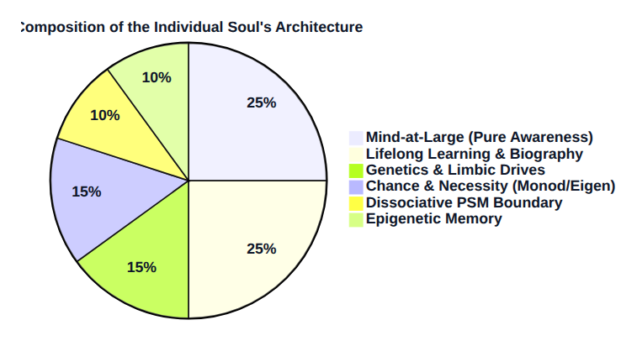
Diagram 6

7.1 Quantitative Derivation of the Architectural Weighting (The 100% Decomposition)
How is the percentage distribution of the six components mathematically and empirically derived? It rests on the triangulation of three established scientific and philosophical disciplines:
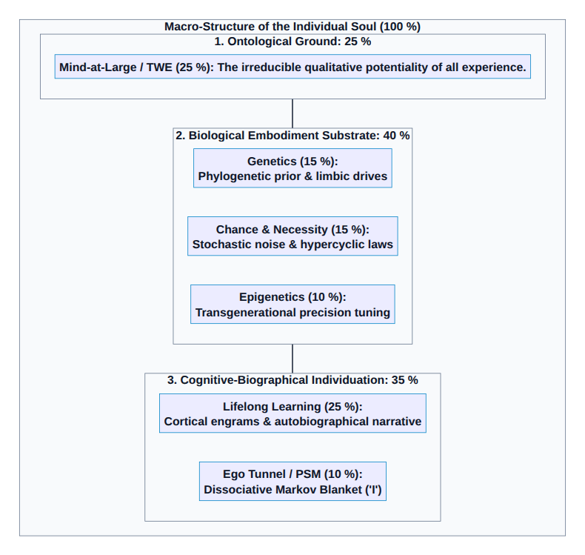
Diagram 7

1. Mind-at-Large / TWE: 25 % (The Ontological Ground)
- Derivation: Universal consciousness is not generated by the organism; it is the ontological ground of all reality (Kastrup).
- Rationale for 25%: It constitutes exactly one quarter of the total structural nexus—the universal, invariant substrate that is identical across all sentient beings. It is the unfragmented light before it passes through the prism of individuality.

2. Lifelong Learning & Ontogenesis: 25 % (Autobiographical Neuroplasticity)
- Derivation (Behavioral Genetics & Cognitive Neuroscience): Landmark twin and adoption studies (Bouchard, Plomin, Turkheimer) demonstrate that the non-shared environment ($e^{2}$)—biographical life events, personal relationships, education, culture, traumas, and conscious choices—accounts for 40–50 % of phenotypic personality variance in adulthood.
- Active Inference Mapping: This corresponds to the continuous, experience-dependent updating of the transition tensor $B$ and likelihood matrix $A$ in cortical networks. Alongside Mind-at-Large, biographical learning forms the co-equal 25% anchor of adult self-identity.

3. Genetics & Limbic Drives: 15 % (The Phylogenetic Baseline $D_{0}$)
- Derivation (Neurobiology of Emotion): Research by Gerhard Roth and Jaak Panksepp indicates that subcortical limbic systems (brainstem, amygdala, hypothalamus) hardwire primary affective circuits (FEAR, RAGE, CARE, PLAY) and fundamental temperament traits (neuroticism, extraversion).
- Rationale for 15%: Genetics does not construct the completed personality; it provides the unalterable phylogenetic starting skeleton and the foundational Will to Exist (Conatus).

4. Chance & Necessity (Monod & Eigen): 15 % (The Molecular Crucible)
- Derivation (Developmental Biophysics): Even genetically identical organisms (monozygotic twins) diverge significantly in micro-anatomical brain wiring and cortical folding due to developmental noise (stochastic noise during embryogenesis).
- Rationale for 15%: Jacques Monod’s microscopic Chance (meiotic crossover, quantum point mutations) combined with Manfred Eigen’s Necessity (autocatalytic hypercycles, thermodynamic stability) quantifies the innate, non-genetic physical uniqueness of the biological substrate.

5. Epigenetics & Transgenerational Resonance: 10 % (Dynamic Precision Gating $γ$)
- Derivation (Epigenomics & Trauma Transmission): Molecular studies show that chromatin remodeling, histone acetylation, and DNA methylation modulate 5–15 % of functional gene expression profiles in response to environmental stressors (Yehuda & Lehrner, 2018).
- Active Inference Mapping: Epigenetics functions as a dynamic volume dial, adjusting sensory precision weights ($γ$) based on ancestral survival history.

6. Dissociative Markov Blanket & Ego Tunnel: 10 % (The Phenomenal Self-Model)
- Derivation (Self-Model Theory & IIT 4.0): The Phenomenal Self-Model (PSM) does not require massive biographical storage; it is a lean, real-time cognitive gating mechanism (Metzinger).
- Rationale for 10%: It is the topologic boundary (Markov Blanket) that projects the internal self-organization into a first-person perspective („I am here“). Though functionally compact, it is mathematically indispensable for generating the dissociative partition ($Φ_{\text{boundary}}$).

Macro-Level Summary Table:
$$\begin{matrix}\text{Architectural Layer} & \text{Weight} & \text{Ontological Function} \\ \text{1. Ontological Ground (Mind-at-Large)} & 25 \% & \text{The pure, undivided field of conscious awareness} \\ \text{2. Biological Embodiment (Genetics + Chance/Eigen + Epigenetics)} & 40 \% & \text{The physical, thermodynamic, and molecular carrier vessel} \\ \text{3. Cognitive Individuation (Lifelong Learning + Ego Tunnel)} & 35 \% & \text{The psychological, biographical, and narrative individual alter} \\ \text{Total Integrated Soul Architecture} & 100 \% & \text{The autopoietic living alter sustaining integrated causal power }(Φ) \\ \end{matrix}$$

8. Death, Dissolution, and Minimal Phenomenal Experience (MPE)
What happens when the physical vehicle dies, or when consciousness undergoes profound mystical/non-dual realization?

1. Mystical Awakening / Minimal Phenomenal Experience (MPE):
When meditative inquiry, psychedelics, or deep philosophical insight destabilize the transparency of the Ego Tunnel, the system experiences what Thomas Metzinger calls Minimal Phenomenal Experience (MPE): * The cognitive boundary (PSM) becomes opaque—recognized as merely a predictive model. * The illusion of the separate ego dissolves. * The individual soul recognizes its ultimate identity: „I am not merely the transient alter inside the tunnel; I am the underlying field of Mind-at-Large experiencing itself.“

2. Biological Death (Physical Dissolution):
When the biological organism dies, the Markov Blanket breaks down and the internal cause-effect structure collapses ($Φ→0$). * What dies: The localized dissociative boundary (the PSM), the genetic machinery, the molecular hypercycles, and the active predictive loop. * What remains: Just as a whirlpool slows down and merges back into the ocean, the localized mental activity dissolves back into the infinite, unbroken field of Mind-at-Large. * The qualitative experiences, learning, and systemic evolution are not “lost” into voidness, but represent the historical crystallization through which Mind-at-Large has experienced and known itself.

9. References & Academic Bibliography
- Bouchard, T. J. (2004). Genetic influence on human psychological traits: A survey. Current Directions in Psychological Science, 13(4), 148–151.
- Eigen, M. (1971). Selforganization of matter and the evolution of biological macromolecules. Die Naturwissenschaften, 58(10), 465–523. (Foundational paper on molecular self-organization and the hypercycle).
- Eigen, M., & Winkler, R. (1975). Das Spiel: Unsere Begegnung mit dem Zufall (Laws of the Game: How the Principles of Nature Govern Chance). Piper Verlag, München. (Evolutionary game dynamics bridging chance and deterministic laws).
- Friston, K. (2010). The free-energy principle: a unified brain theory? Nature Reviews Neuroscience, 11(2), 127–138.
- Jablonka, E., & Lamb, M. J. (2014). Evolution in Four Dimensions: Genetic, Epigenetic, Behavioral, and Symbolic Variation in the History of Life. MIT Press.
- Kastrup, B. (2019). The Idea of the World: A Multi-Disciplinary Argument for the Mental Nature of Reality. Iff Books.
- Kastrup, B. (2021). Science Ideated: The Fall of Matter and the Contours of the Next Mainstream Scientific Worldview. Iff Books.
- Metzinger, T. (2003). Being No One: The Self-Model Theory of Subjectivity. MIT Press.
- Metzinger, T. (2009). The Ego Tunnel: The Science of the Mind and the Myth of the Self. Basic Books.
- Metzinger, T. (2024). The Elephant and the Blind: The Experience of Pure Consciousness: Philosophy, Science, and 500+ Experiential Reports. MIT Press.
- Monod, J. (1970). Le Hasard et la Nécessité: Essai sur la philosophie naturelle de la biologie moderne (Chance and Necessity). Éditions du Seuil, Paris. (Nobel laureate formulation of blind genetic chance and invariant teleonomic necessity).
- Panksepp, J. (1998). Affective Neuroscience: The Foundations of Human and Animal Emotions. Oxford University Press.
- Plomin, R., DeFries, J. C., Knopik, V. S., & Neiderhiser, J. M. (2016). Top 10 Replicated Findings From Behavioral Genetics. Perspectives on Psychological Science, 11(1), 3–23.
- Riebl, T. (2026). The Conative-Integrative Framework (CIF): How Active Inference Networks, Integrated Information ($Φ$), and the 6th Axiom Fit Together to Unite Analytic Idealism, the Free Energy Principle, and Consciousness. Master Paper & Working Treatise, Luxembourg.
- Roth, G. (2003). Aus Sicht des Gehirns. Suhrkamp Verlag, Frankfurt am Main.
- Roth, G. (2021). Wie das Gehirn die Seele macht: Emotionen, Bewusstsein, Unbewusstes. Klett-Cotta, Stuttgart.
- Schopenhauer, A. (1819/1844). Die Welt als Wille und Vorstellung (The World as Will and Representation). F. A. Brockhaus, Leipzig.
- Spinoza, B. (1677). Ethica, ordine geometrico demonstrata. Posthumous Publication.
- Tononi, G., Boly, M., Massimini, M., & Koch, C. (2016). Integrated information theory: from consciousness to its physical substrate. Nature Reviews Neuroscience, 17(7), 450–461.
- Turkheimer, E. (2000). Three Laws of Behavior Genetics and What They Mean. Current Directions in Psychological Science, 9(5), 160–164.
- Yehuda, R., & Lehrner, A. (2018). Intergenerational transmission of trauma effects: putative role of epigenetic mechanisms. World Psychiatry, 17(3), 243–257.

10. Tool Attribution & Colophon
[!NOTE] Tooling Colophon:
This theoretical treatise, philosophical architecture, and scientific synthesis were conceptualized and authored by Thomas Riebl (Luxembourg) as part of The Conative-Integrative Framework (CIF).
The conceptual formulation, structural structuring, vector diagram styling, and multi-format document compilation (Word .docx, Print-Ready PDF, and Markdown) were developed with the assistance of Google Gemini (Antigravity Advanced Agentic Coding System) (September 2026).

Vault & Repository References
- Master Framework Paper (CIF): /home/thr/Documents/The_Conative_Integrative_Framework_Thomas_Riebl.pdf
- GitHub Project Repository: https://github.com/Thriebl/active-inference-phi-network
- Vault Archive: /home/thr/Documents/ThRNotes/03-professional/braindumps/

